APPLICATION for Sports Placement ETHICAL APPROVAL

This form must be completed and approved prior to undertaking any activity with the organisation. It will need to be signed by the student, placement organisation and a sports lecturer.

SECTION A: About You (Student)

Full Name: | Ryan Durston
Faculty/School/Centre: | Sport, Health and Outdoor Education
Campus: | Swansea Business Campus
E-mail address: | Ryan.durston@ntlworld.com
Contact Telephone Number: | 07789880464
Student Number: | 1702131 | Undergraduate | ☒
Programme of Study: | BA Sport Management | Taught Postgraduate | ☐
Director of Studies/Supervisor: | Andrew Thomas | Research | ☐

SECTION B: Placement Activity Organisation (Employer)

Does the activity involve collaborators outside of the University? |  | YES | ☒ | NO | ☐
If Yes, please provide the name of the external organisation and name and contact details for the main contact person:

Organisation | Morriston Comprehensive school
Contact person name | Phill Jones
Contact person e-mail address | jonesp228@hwbmail.net
Contact telephone number | 01792 797745
Number of agreed contractual hours | 200 hours

Location of activities
Identify all locations where activities will take place.
Look at the pictures above.

The placement student will work within the companies ethical framework
Organization representative name | Andrew Thomas
Signature | Andrew Thomas | Date | 20.6.19

SECTION C: Scope of Activity (Student)

Will the activities include: | YES | NO
Use of a questionnaire or similar research instrument? | ☐ | ☒
Use of interviews? | ☐ | ☒
Use of diaries? | ☐ | ☒
Participant observation with their knowledge? | ☐ | ☒
Participant observation without their knowledge? | ☐ | ☒
Use of picture, video or audio recording? | ☐ | ☒
Access to personal or confidential information without the participants’ specific consent? | ☐ | ☒
Administration of any questions, test stimuli, presentation that may be experienced as physically, mentally or emotionally harmful / offensive? | ☐ | ☒
If you have answered yes to any of the above then please explain below:

NOTE – PICTURE and VIDEO for assessment - make sure you have approval from organisation

SECTION D: Intended Participants (Student)

Who are the intended participants: | YES | NO
Students or staff at the University? | ☐ | ☒
Adults (over the age of 18 and competent to give consent)? | ☐ | ☒
Vulnerable adults? | ☐ | ☒
Children under 18? | ☒ | ☐
Prisoners? | ☐ | ☒
Young offenders? | ☐ | ☒
Those who could be considered to have a particularly dependent relationship with the investigator or a gatekeeper? | ☐ | ☒
People engaged in illegal activities? | ☐ | ☒
Others (please identify): | ☐ | ☒
If you have answered yes to any of the above then please explain below:

Placement was in a school an most of the children were under 18.

SECTION E: Anticipated Risks (Student)

Outline any anticipated risks that may adversely affect any of the participants, the student and/or the University, and the steps that will be taken to address them.
Risks to participants
For example: emotional distress, financial disclosure, physical harm, transfer of personal data, sensitive organisational information
All conversations will be kept private and confidential so information will not be shared with 3rd parties. Unless there is something really bad then I will have to tell the teacher

Risks to student
For example: personal safety, physical harm, emotional distress, risk of accusation of harm/impropriety, conflict of interest
Make sure all the children are safe and happy as they will be under my control and if anything happens they will have to come to me and tell me

University/institutional risks
For example: adverse publicity, financial loss, data protection
None

Control measures
List measures put in place to limit and manage any of the risks identified above
No risks

Disclosure and Barring Service
If the activity involves children or vulnerable adults, a Disclosure and Barring Service (DBS) certificate may be obtained before any contact with such participants. | YES | NO | N/A
Do you need a DBS certificate for this role? | ☒ | ☐ | ☐
Has a DBS certificate been obtained? | ☒ | ☐ | ☐
If yes, add picture copy below

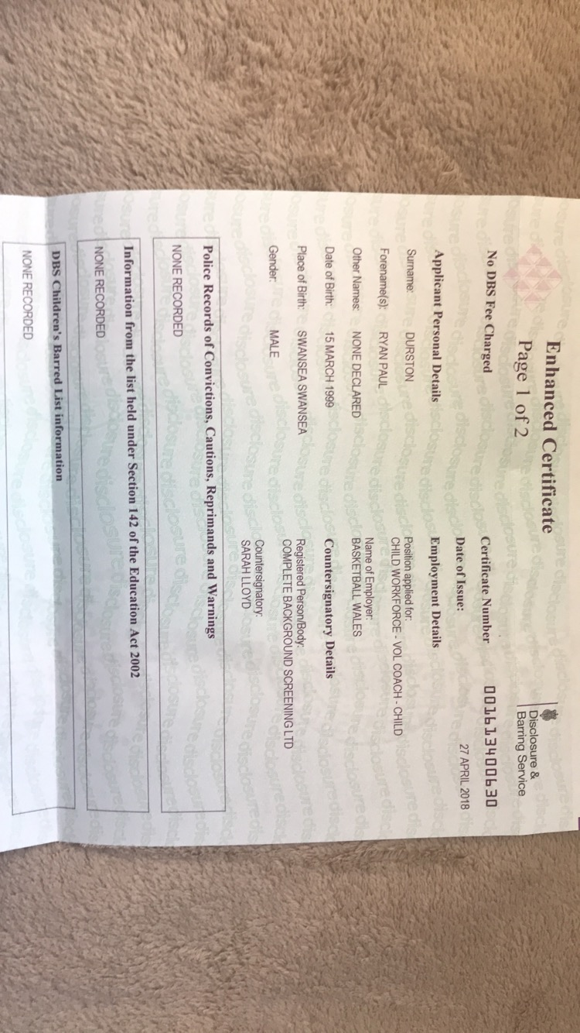

SECTION F: Declaration (Student and Staff)

For Students:
The information which I have provided is correct and complete to the best of my knowledge. I have attempted to identify any risks and issues related to the employment activity.
Name of applicant: Ryan Durston
Signature of student: R.durston |  | Date: | 11.4.19

For Staff:
Placement Coordinator: | Phil Jones
Signature: | P.Jones
Date: | 11.4.19

Staff Checklist: The students completed/ submitted the following:

☒ | Completed all sections of the form in full.
☒ | Attached a copy of the DBS (where appropriate)
☒ | I can confirm that the activities has been approved providing they stay within the scope specified by the student.

