Over the summer we received a brief entitled The Narcissm Epidemic, we were asked to create a visual response to the ‘Narcissm Epidemic’ which would then be shown in a group exhibition with my classmates. In response, I began researching the subject by reading articles about the epidemic, after reading several articles I realised there was a particular focus on the rise of social media in correlation with the rise of Narcisstic traits. While doing this research I began to consider the way in which social media perpetuates societies ideals about identity and self-worth and the effect this has on those who do not fit those ideals. Inspired by this I began to research artists who look at those on the fringes of society, my biggest initial inspirations were Diane Arbus and Nan Goldin as they both photographed people who were considered to be outcasts or didn’t fit into the norms of society, I was also really interested in the way they photographed other people as a way of expressing their own identities.
I decided I wanted to create a body of work responding to this, concentrating specifically on my personal experience with this. As a starting point I decided to freewrite (figure 1) about my own experience with the issue, then I extracted key points from the writing to inspire my visuals. For example, I discussed how Instagram encouraged me to feel dislike towards my body, so I photographed parts of my body I disliked the most (figure 2). Initially I wanted to take these photos using 35mm black and white film as I wanted the work to have a gritty aspect to it to match the mood of the writing but as I was taking self portraits it was difficult to see whether I was in focus without help from an assistant. I also had technical problems with my film camera and decided to use my DSLR and then edit the images using Lightroom to simulate the effect of film instead. During a crit it was suggested that I reshot and edited the images on a smartphone as the smartphone is the vehicle for the social media platforms which perpetuate societies ideals and it follows the same process that those uploading to social media follow. Personally, I found the images shot during both shoots to be visually quite flat and boring, and felt that the viewers may struggle to resonate with the images as they lacked context. I then experimented with writing excerpts of the freewriting over the images, but I felt this didn’t really add anything to the work.
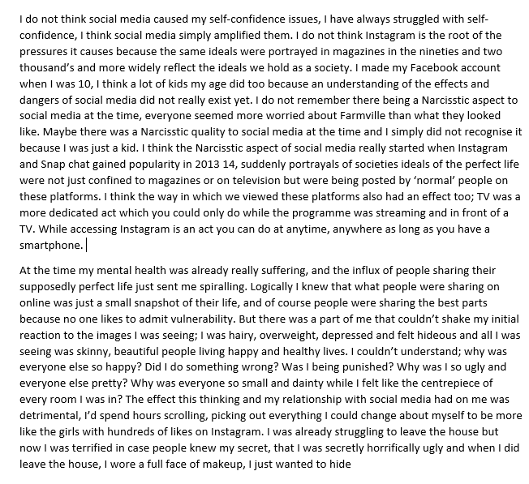
(figure 1)
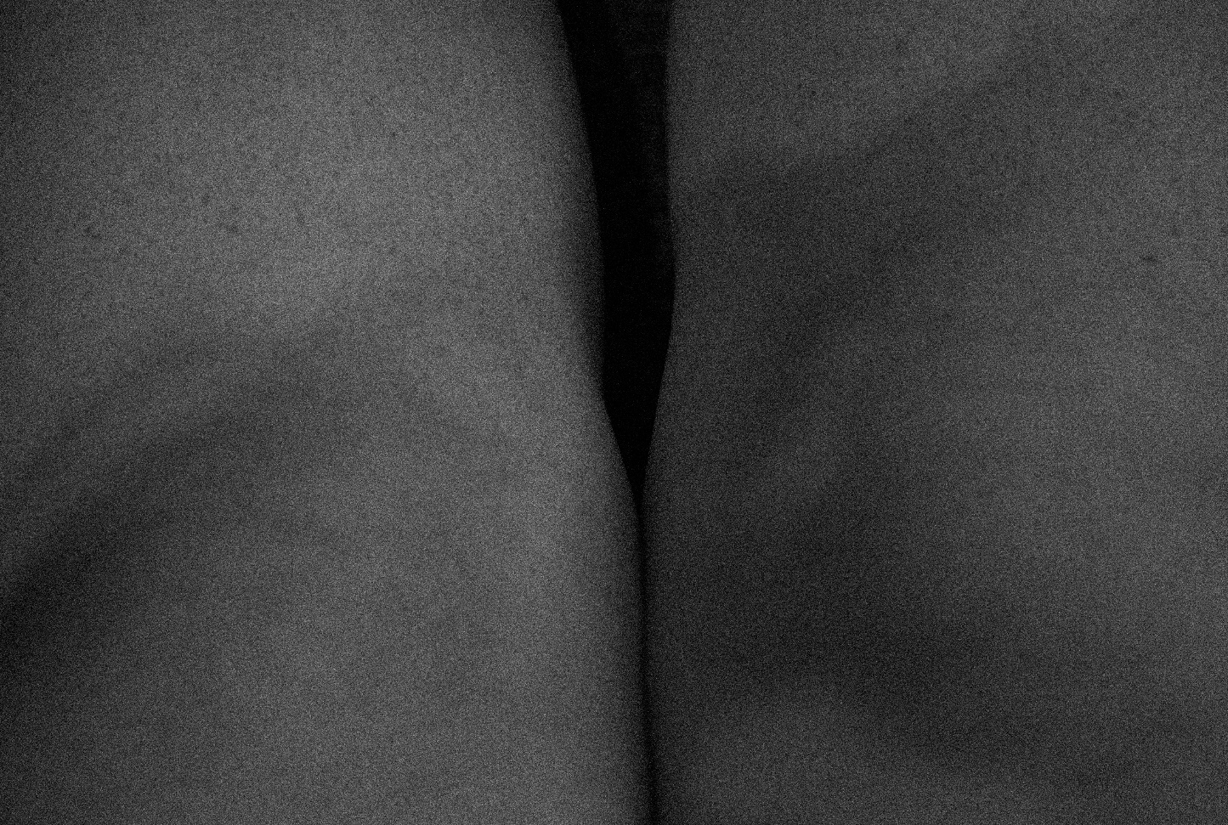
(figure 2)
After discussing this with lecturers and peers, I decided I wanted to create a less literal piece of work and explore how I could translate an image into code which would then be used as part of a multimedia installation. I decided to experiment with code as all digital images are made up of code and each image uploaded to the internet has a unique URL. Translating the image into code also referenced how social media made me want to hide and also how when perfected images are uploaded to social media they are often obscuring the truth. I chose to use an image from my initial shoots which would then be translated into code, referencing how social media made me want to hide and also how when perfected images are uploaded to social media, they are often obscuring the truth. I experimented with 2 ways in which I could transfer the image into code, the first was by changing the file format of the image to a .txt file and then opening it in a word processing programme which generated a set of code (figure 3). The second was by using a website (https://www.dcode.fr/binary-image) which converts a black and white picture into binary code, 0 for black pixels and 1 for white pixels (figure 3). For both of these experiments, I then input the code into a photoshop file with a white background. I decided I favoured the binary code as the image looked more uniform and was also more recognisable than the other code.
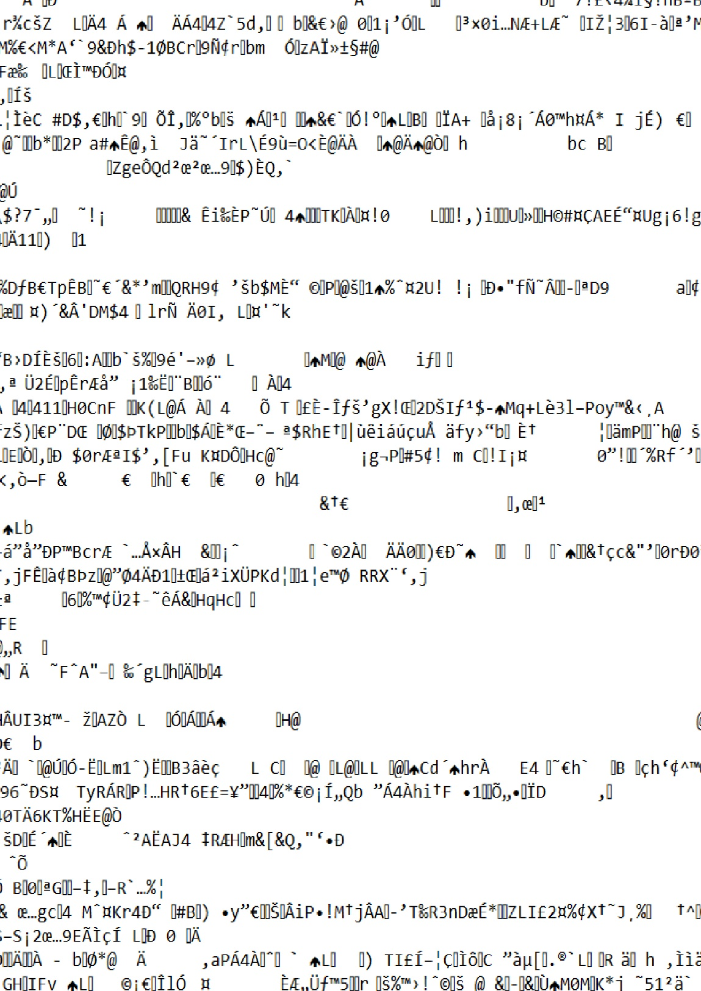
(figure 2)


(figure 3)
The way in which I installed my work became paramount to the effectiveness of the piece. I decided to add an element of understanding to the work there needed to be sound reading out an edited version of my freewriting. I decided to use Adobe Audition to generate a computerized voice; furthering the obscure aspect of the work. I also decided that space and lighting was integral to the way the viewer perceived the piece, I felt that if my work was in the main exhibition space it would be less impactful due to being surrounded by more visually rich work. I also wanted to create an atmosphere; inciting a sense of eeriness within the space. I decided I wanted to exhibit the piece within the project space as the space is quite small, dark and cold. The way I installed my work was heavily inspired by Bill Viola and the way in which he uses sound and light to create atmosphere and evoke emotion.
To culminate the project, we had to collaborate as a year group to arrange an exhibition. A group of us, including myself decided to initiate a conversation in the online year group chat where we discussed the tasks that needed completing and asked people to sign up for the job they were willing to do. Initially I offered to prep and clean the exhibition space and assist putting up work. However, when lots of people offered to do these jobs too, I decided I would help curate instead. In the end, I ended up taking on all these jobs as people who offered to do them simply wouldn’t show up on the days they’d agreed or not be active in the discussion. As I was the only person who was exhibiting in the basement, I also took on the responsibility of modifying the posters to direct people to my work and also clean the space.
I also seemed to unintentionally take on a job that almost mirrored the role of a project manager with another member of the year group; communicating with both lecturers and classmates about the progress of the exhibition and help arranging the days and times in which each job would be undertaken. I really struggled with this aspect of the module as I often felt like I was being bossy and controlling and it caused a lot of friction with some members of the group. At times I felt incredibly disheartened, especially when members of the group felt I hadn’t communicated with them effectively. While I think in future, I would like to take more of a backseat, I think this experience has improved my communication and leadership skills. Overall, I am incredibly proud of the finished exhibition and the contribution I made, I feel that this was our most successful exhibition so far as a year group and that our hard work payed off.

