Content
Introduction 2
Marketing mix 3
1.0 Product 3
1.1 Product adaptation 4
2.0 Pricing 5
3.0 Promotion 6
4.0 Place and location 6
5.0 Physical evidence 8
6.0 People 8
7.0 Process management 9
Conclusion 10
Reference list 11

Introduction
The inevitable trend of globalisation has presented opportunities to business organisation. In the some definitions, the globalisation is sometimes defined as westernisation which is highly emphasising the cultural influences (Baraka, 2016). In the western countries, the culture of Anglo-America has gradually becoming the mainstream culture from the post-Second World War era. Therefore, it might be argued that the business organisations in English speaking countries would be benefit in the cultural perspective. Tomos Watkins, as a Welsh brewery manufacturer, has decided to enter into the international market by proposing the slogan “Made in Wales, enjoyed worldwide”. This business report is mainly proposing a market entry strategy by introducing the target countries and corresponding market entry strategies. As I have previously mentioned destination of an international market, Canada would be the target market. In additional, for a SME, the indirect exporting will be chosen to enter Canada market to avoid risks. This report will be consisted by the latest marketing mix with 7Ps: Price, Place, Product, Promotion, and People. Physical Evidence, and Process.

Marketing mix
Drafting a feasible market strategy for a company to enter a new market, marketing mix, as a combination of product, price, place, promotion, physical evidence, people and process, is inevitable to be made (Renaghan, 1981). To evaluate the suitability for Tomos Watkins’s strategy in a new market, a tailored marketing mix ought to be proposed.

1.0 Product
Product strategy should be based on the competition landscape. TW should provide the beer products with an inclined the alcoholic rate (higher than 5% standard in Canada market).

An overview of Canadian beer market should be provided first. Canadian identity is somehow represented by its beer industry which is the major player in the globalised beer market (Colen and Swinnen，2015). Moreover, the habit of drinking beers was introduced by the early European immigrations in the 17th century (Young, 2008). The consuming behaviours in ales are well-formed 400 years ago. From the 2011 to 2016, Canadian beer industry has experience a slight growth which is approximately 1.5% annually (Couillard, 2018). The market size of beer in Canada was almost doubled from 2010 to 2015, the licensed breweries were increased between 310 and 640 (Couillard, 2018). Considering the weight and the product type, shipping would be the best option for Tomos Watkins to transport its beer from Wales to Canada. However, by understanding the fee from the UK to Canada, specifically from Southampton port to Toronto port, the charging method is based on the 20ft container for £1,340 while 40ft container for £2,278 (Shipit, 2019). This shipping transportation will normally take 20 days travel from Southampton to Toronto. In terms of the cost and the concept of economies of scale, Tomos Watkins may need to export its can-packed beer which has smaller size comparing with the bottle-packed beer. This would distribute the cost to more unit selling to Canada. In addition, tariff and other policy of protectionism have to be taken into account.

1.1 Product adaptation
Based on the proposed macro analysis in social and cultural aspect above in Canada, the product strategy should follow the product adaptation strategy rather than standardisation. The product adaptation strategy is to revise company's product to suit the locals’ preference (Picincu, 2019). Considering the given pie chart, the product has to meet the young consumer’s preference (aged 18 to 34) .The advantages of this strategy are matching the target market and customisation (Couillard, 2018). However, the higher cost generated by the product modification and research (locals’ preference) will be making the selling price per unit higher. The higher prince may reduce the competitiveness to compete local market (Choi, Joe and Mattila, 2018).

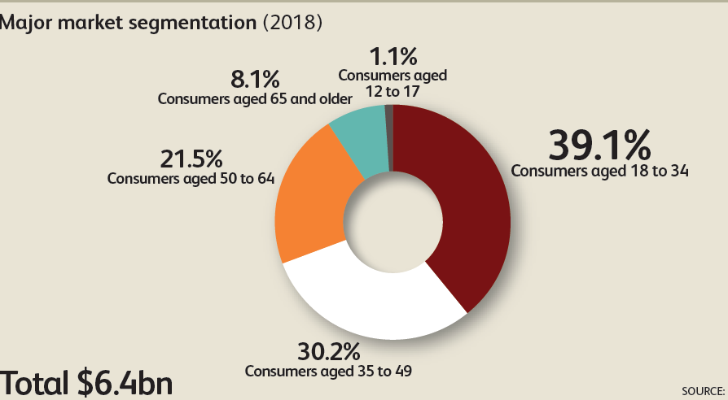
Figure: the market segmentation based on age source from: (Couillard, 2018)

Based on the statistical studies provided by beer industry analysts, young people (aged between 18to 40) normally prefer alcoholic beverage with a stronger alcoholic taste. In addition, considering the geographical features, Canada is nearly located in the North Pole, people need to drink stronger alcoholic beverage to keep warm .

2.0 Pricing
The rule of thumb of pricing strategy is to have a suitable and affordable selling price per unit for all potential customers in Canada, at first, the pricing strategy is the core competency obtained by a company. To avoid trade sanction or some anti-dumping mechanism, the political factors and trade policies should be regarded at first. The politically favoured trade deals, business partnerships and a more closed business connection between Wales and North America were assured by the meeting between the First Minister and business leaders in Philadelphia, New York and Montreal (Welsh Gov, 2018). Canada’s politic is relatively sustainable in modern democratic countries. The politics of Canada were based on the political framework in parliamentary government following the democratic traditions developed from the Anglo-American nations. The trade relationship between Canada and Wales is close, as a member of World Trade Organisation, the trade sanction will not be imposed from Canadian governments to Welsh company (Glavin, 2019). Therefore, the tariff and some anti-dumping punishment will not be a problem for TW.

In addition, considering the well-formed purchasing behaviour in Canada and the idea of switching cost which is the cost generated from switching from local beer brand to Tomos Watkins, selling price ought to be based on the low price strategy to reduce the switching cost (Moshkin and Shachar, 2000). We can regard this strategy as a market penetration strategy which has some advantages and disadvantages: low price is easier to compete market share and generate revenue while low price strategy may require more investment to sustain a healthy cash-follow in case of selling price lower than cost (Moshkin and Shachar, 2000). As an international product, TW’s selling prices should be higher than Molson 6*473ml $12.50 but lower Budwisher 6*473ml $19.25. The 6 cans-package should be priced $15.

3.0 Promotion
The network advertising based on social media and internet will be chosen by TW in Canada market. There are two decisive factors for beer manufacturers in promotion strategy: manufacturing technology and marketing technology. Firstly, for a beer manufacturer, the most critical factor is its product. To assure the greatest taste and quality, developing a decent refined brewing process would be essential for beer manufacturers in Canada (Frue, 2019). On the other hand, the information technology including the online marketing and e-commerce would be also important as a part of marketing strategy (beMarketing, 2019). Online marketing would generate a new distribution channel for retailer selling, a B2C mode would reduce the cost for paying distribution channel significantly (Embitel, 2019).

The advertising slogan will be based on the original text provided by TW to reduce the cost for creating a new slogan. By understanding the critical success factors delivered by (Couillard, 2018), establishment of brand names and effective quality control would be the most essential regardless the two traditional factors: economies of scale/scope. Therefore, the advertising strategy adapted by Tomos Watkins would be critical. The key slogan of Tomos Watkins “Made in Wales, enjoyed worldwide” has to be followed with all the advertisements in Canada market. Moreover, in the customer’s psychological perspective, the other slogan has to be showing on advertisement, the new slogan has to be related to the quality control and high quality (Park, 2010).

4.0 Place and location
Due to the selected market entry mode, TW does not need to invest into the offline store establishment seriously. Because the indirect exporting does not require TW to have an offline store or any factory. However, considering the indirect exporting, as a major method to sell products to other country, indirect exporting has a key advantage which is the risk-aversion. Indirect exporting has the lowest risk comparing with all the other market entry modes. However, it also has some disadvantages: Tomos Watkins will have no control in terms of Canada market because the intermediaries will sell those products to Canada directly. It is unacceptable for Tomos Watkins to develop its international market in a long-term based strategy. In addition, the indirect exporting is to sell the products to an intermediary who will sell those products to the target market (Dev, Brown and Zhou, 2007). Moreover, the profit is the lowest as well, because the selling price and profit is complete depended on the bid price offered by intermediaries who will definitely cut the cost for their sake. Therefore, TW has to establish an office to control its beer business in Canada. However, a question will be given: which area will be located TW’s first office in Canada?

Considering the geographic issues and landscapes in Canada (figure), the place and distribution strategy has to approach to the key cities and states in Canada. The placing strategy has to be intensive distribution in those key states.
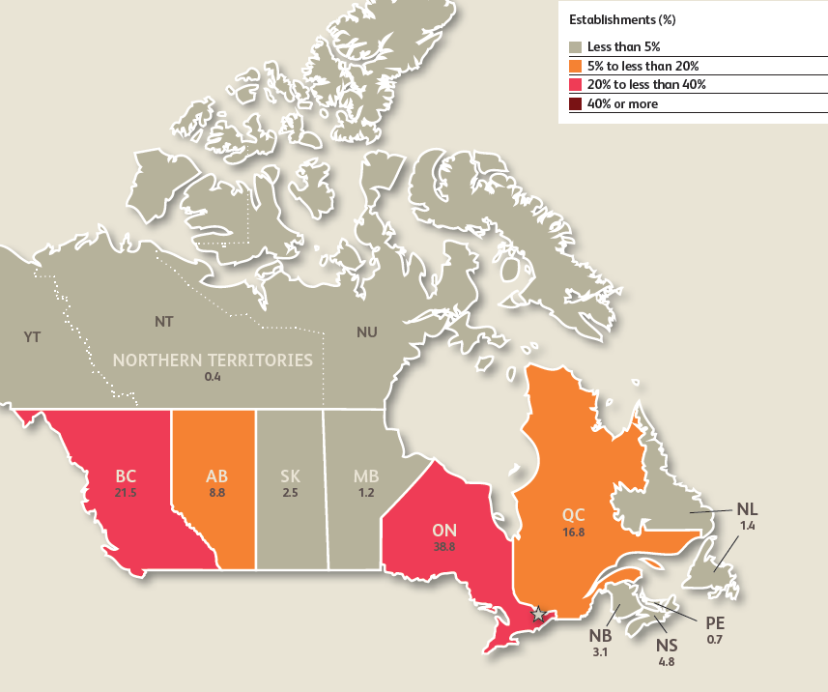
Figure: the geographic distribution of beer distributing channel source from: (Couillard, 2018)

Due to the limited budget as a SME, Tomos Watkins has to choose the British Columbia for its first stage to enter into Canadian market. Considering the competition landscape, H.Y Louie Co. operates would be a suitable intermediary for TW. As a distributor and retailer, H.Y Louie’s IGA marketplace is the best supermarket in the British Columbia. By having an office imposing control on IGA marketplace, the BC would be the best place for TW to enter.

5.0 Physical evidence
The physical evidence can be regarded as a combined idea with promotion. Physical evidence tries to deliver a physical perception to potential customers. To generalise this, TW has to have a specific marketing campaign emphasising the customers’ physical perception on its product in Canada. A very specific market campaign containing the physical evidence and promotion strategy would be given. TW can choose some major cities in Canada, Toronto, Montreal and Vancouver for example (the top 3 largest cities in terms of population) to carry out marketing campaign. Salesforce can deliver the small samples of TW’s beer product to the passengers in city centre by using the slogan provided by TW itself.

6.0 People
As a SME, sending many people as expatriate to Canada would be difficult in terms of cost of transportation and other related aspects. Therefore, the expatriates would not be the key strategy of people in marketing mix. However, a small expatriate team can be sent to Canada from Wales to control the Canadian market.

To explain more, to mitigate the disadvantages generated by indirect exporting, the control over TW’s original products, trademark protection and transparency of the generated revenues in Canada, the expatriate team has to be formed by different people to preserve TW’s originality. This team has to be formed by five people: a market director (as a leader in Canada), business negotiator, a legal consultant (Canadian business law) plus one or two market assistants and a qualified accountant. The market director’s responsibility is to enact TW’s policy in Canada. Business negotiator is to negotiate with Canadian distributors in terms of the profit and margin. Legal consultant will check the agreement and contract between TW and H.Y. Louie. A qualified accountant’s responsibility is to audit the financial statement to assure the healthy cashflow.

7.0 Process management
The concept of process management is to ensure the product of same quality in an international market. In other word, process management is a supervision process in an oversea market to adhere the quality repeatedly. As an indirect market entry strategy, TW does not need to consider the process management (because the product was from Wales to Canada directly, we do not need to adhere any process). However, in the future, to further the market share and cutting the cost of distribution, TW has to adapt some direct entry mode, green-field-investment for example. The following example will be provided to exemplify the competitor’s strategy.

Heineken would be a best example to suggest this. Heineken, a Dutch lager brand, is a world-leader in beer manufacturing sector, it is well known for its green and red bottle as its identity and representative (Heineken, 2019). Heineken has entered into Canada in 1975 and swiftly taken the market share by having its well-known products (Heineken, 2019). As a product manufacturer, the core strategy is the product strategy that Heineken has adapted product adaptation strategy in Canada market. This product adaptation is not simply following the local consumer’s preference, Heineken was hiring some top Canadian beer craftsmen to make the beer with the unique North American taste (Sheppard, 2019). This product strategy is completely successful in terms of sales in Canada market, it was achieved 4 million hl out of 22 million hl in Canada in 2018 (Statista, 2019).

Conclusion
In conclusion, Canada is the target market to enter for TW and TW should carry out an indirect exporting strategy. Meanwhile, the marketing mix which includes 7Ps suggests that TW ought to focus on exporting stronger taste beers (> 5%), and the appropriate price of 6 cans-package should be $15. The promotion strategy adopted by TW is the utilization of social media and other online resources. The place of market entry, British Columbia, is aligning with the indirect exporting strategy, which requires a cost control. The physical evidence of this strategy is revealed in the marketing campaigns implemented by TW. As for the people who conduct the plan, only a small team of TW is needed on board, so as to reduce the cost and satisfy the need of human resource. Finally, the process management would be slightly easier as TW has the direct control rights to assure the quality of their products.

Reference list
Baraka, M. (2016). Westernisation, Modernisation and Colonialism: The Case of teh Egyptian Upper Class. Babylon Nordic Journal of Middle East Studies, 0(1).

beMarketing (2019). Premier Marketing Company in Philadelphia - beMarketing. [online] beMarketing. Available at: https://bemarketing.com/ [Accessed 15 Apr. 2019].

Businesschief (2019). Top Ten Canadian Beers. [online] Canada.businesschief.com. Available at: https://canada.businesschief.com/top10/1001/Top-Ten-Canadian-Beers [Accessed 15 Apr. 2019].

Choi, C., Joe, S. J. and Mattila, A. S. (2018) ‘Reference Price and Its Asymmetric Effects on Price Evaluations: The Moderating Role of Gender’, Cornell Hospitality Quarterly, 59(2), pp. 189–194. doi: 10.1177/1938965517719266.

Colen, L. and Swinnen, J. (2015). Economic Growth, Globalisation and Beer Consumption. Journal of Agricultural Economics, 67(1), pp.186-207.

Couillard, L. (2018). IBISWorld Industry Report 31212CA Breweries in Canada. 1st ed. [ebook] New York: IBIS. Available at: https://www.ibisworld.ca/industry-trends/market-research-reports/manufacturing/breweries.html [Accessed 16 Apr. 2019].

Dev, C. S., Brown, J. R. and Zhou, K. Z. (2007) ‘Global Brand Expansion: How to Select a Market Entry Strategy’, Cornell Hotel and Restaurant Administration Quarterly, 48(1), pp. 13–27. doi: 10.1177/0010880406294472.

Frue, K. (2019). PEST Analysis of the Beer Industry. [online] PESTLE Analysis. Available at: https://pestleanalysis.com/pest-analysis-of-the-beer-industry/ [Accessed 15 Apr. 2019].

Glavin, T. (2019). Why race and immigration are a gathering storm in Canadian politics - Macleans.ca. [online] Macleans.ca. Available at: https://www.macleans.ca/news/canada/why-race-and-immigration-are-a-gathering-storm-in-canadian-politics/ [Accessed 20 Apr. 2019].

Heineken (2019). The HEINEKEN Company - Age Gate. [online] Theheinekencompany.com. Available at: https://www.theheinekencompany.com/About-Us/Our-Global-Presence [Accessed 13 Apr. 2019].

Moshkin, N. and Shachar, R. (2000). Switching Costs or Search Costs?. SSRN Electronic Journal.

Niu, S. (2013). The equivalence of profit-sharing licensing and per-unit royalty licensing. Economic Modelling, 32, pp.10-14.

Picincu, A. (2019). Factors Affecting Product Adaptation. [online] Bizfluent.com. Available at: https://bizfluent.com/list-6903948-factors-affecting-product-adaptation.html [Accessed 15 Apr. 2019].

Ranker (2019). The Best Canadian Beers. [online] Ranker. Available at: https://www.ranker.com/list/best-canadian-beers/bottoms-up [Accessed 15 Apr. 2019].

Renaghan, L. M. (1981) ‘A New Marketing Mix for the Hospitality Industry’, Cornell Hotel and Restaurant Administration Quarterly, 22(2), pp. 31–36. doi: 10.1177/001088048102200208.
Sheppard, J. (2019). Heineken beer's Dutch craftsmen take on Canadian craft beer. [online] Daily Hive. Available at: https://dailyhive.com/calgary/heineken-beer-canada [Accessed 14 Apr. 2019].

Shipit (2019). International Shipping Services. Weekly Shipping for personal effects and household goods.. [online] Shipit.co.uk. Available at: https://www.shipit.co.uk/faster-shipping.htm [Accessed 13 Apr. 2019].

Statista (2019). Topic: Beer market in Canada. [online] www.statista.com. Available at: https://www.statista.com/topics/2292/beer-market-of-canada/ [Accessed 14 Apr. 2019].

Welsh Gov (2018). First Minister in the US and Canada to boost trade with Wales’ most important business partner | GOV.WALES. [online] GOV.WALES. Available at: https://gov.wales/first-minister-us-and-canada-boost-trade-wales-most-important-business-partner [Accessed 15 Apr. 2019].

Zimmerman, A. (1999). Effects of Trade Barrier Perception on International Services Trade. Journal of Global Marketing, 12(4), pp.79-98.

