COMMUNITY ENGAGEMENT- DONCASTER REFURNISH

By Iulian Stratan

Module: Community Engagement
Lecturer’s name: Rula Alousi
Student’s name/ID: Iulian Stratan 2023090

Abstract
Doncaster Refurnish is an entrepreneurial social enterprise delivering economic, environmental, and social targets, with the primary mission of preventing waste and converting materials into usable items. It engages with the local community members and other stakeholders to achieve its objectives. Community engagement "is a strategic process with the definite drive of working with recognized groups of people connected by geographic proximity, distinct interest, or attachment to identify and address issues affecting their well-being." Practically, community engagement is a balance of science and art—Doncaster Refurnish, a UK-based social business that delivers economic, environmental, and social objectives. The primary mission of the company is to prevent waste and convert materials into usable items. The organization was established to solve two problems: “lack of affordable furniture for disadvantaged people who were often exploited by unethical lenders” and “the vast amounts of reusable furniture being buried in a landfill” Doncaster Refurnish was analyzed in relation to its engagement with the community it serves.

Introduction
Community engagement can be described as the process of “working in collaboration with and through groups of individuals united by distinct interests, geographical locations, similar circumstances to tackle issues that affect the welfare of these persons” (Newman, 2006, pp. 302). Essentially, community engagement is an effective means of bringing on behavioural and environmental changes that will advance the community's well-being and its people(Watson, 2007, pp. 2). An example of a community engagement in the UK is Doncaster Refurnish, a social business that delivers economic, environmental, and social objectives. The primary mission of the company is to prevent waste and convert materials into usable items. The organization was established to solve two problems: "lack of affordable furniture for disadvantaged people who unethical lenders often exploited" and "the vast amounts of reusable furniture being buried in a landfill” (DONCASTER REFURNISH: OpenCharities, 2021). This report analyses Doncaster Refurnish in relation to its engagement with the community it serves.
Discussion
Doncaster Refurnish was formed in response to the two issues mentioned above. Currently, the organization works collaboratively with SITA UK and Doncaster City council to offer a regional collection service for furniture and other household commodities. SITA UK is a British water, resource, and waste management and recycling company. Often, these collections are re-used or recycled and used in a way that benefits the community. For instance, Doncaster Refurnish rebrands the furniture and sells them to disadvantaged individuals at low prices. Here, it saves time for the people and the hassle of disposing of their reusable items and uses them to “make a big difference to local people and families in need” (Ahmed & Palermo, 2010, pp. 1384). The organization collects reusable furniture, household items, and electronics from families and businesses, refurbishes them, and supplies them to disadvantaged community members at affordable rates. According to a review on the organization’s website, “Doncaster Refurnish do some amazing work, collecting, restoring and selling furniture on to low-income families, a handyman service, run a women’s group with a focus on anxiety issues.” Also, the organization trains and employs the individuals on the side-lines of the local community rehabilitates and integrates prisoners due to be released, and offers placement opportunities for young offenders (Bowen, Newenham-Kahindi, & Herremans, 2010, pp. 12). Generally, the organization constantly evolves to meet the community's needs. The current scope of Doncaster Refurnish is domestic bulky household waste, electric waste (WEEE), trade waste (furniture and household goods), unused paint, training, and development of community members.
Principles of Community Engagement
Various scholars and organizations have defined and identified core principles of community engagement. These principles assist leaders and organizations form effective partnerships and engagement processes (Schalke, 2015, pp. 8). In essence, these principles are grouped into three groups: items to consider before starting, items essential for engagement, and items necessary for successful engagement. Before starting to work with a community, organizations must define purposes, goals, and populations. Here, an organization must clearly state the purpose of the community activity. It is also essential to determine in advance who is engaged in the process as this assists set the parameters of the engagement. For instance, participants may be based on age groups, ethnic or racial groups, or geographic boundaries, as in the case of Doncaster Refurnish. The second principle is about knowing the community. Here, an organization should do research and learn about the community, its experiences, history, demographics, economic conditions, social networks, and culture. Knowing the community can assist in building consensus, communication, and decision-making (Schalke, 2015, pp. 16). Most importantly, this can help in building a basis for meaningful partnerships.
The second set of principles involves items necessary for engagement. The first principle here is about going to the community. According to Thompson and Doherty (2006), engagement is a community process, and the community will benefit more if its members are a fundamental part of the process of development and implementation. Community engagement organizations should first meet with crucial leaders and groups in the community to establish their issues, concerns, and obstacles to participation. Based on the activity's goals, the most successful approach may be a small group of important stakeholders. Nevertheless, expanding the group involves different communities, formal and informal leaders, interests, and age groups can improve community support and participation. Another principle is looking for collective self-determination, which is vital to the community engagement process. Organizations need to assist communities in ascertaining their specific issues, identifying the problem, creating action plans, implement strategies, and appraise outcomes. At times, the process of engagement can be complex, with different groups giving diverse ideas and views (Schalke, 2015, pp. 48). Nevertheless, if community members can embrace the problem, agree it is significant, have influence, and contribute, they will tend to participate in the whole engagement process.
The third group of principles is about the success of the engagement process. The first principle is about vital community partnerships. Openings for successful engagement include impartial community partnerships and open discussions on decision-making and power. According to Ridley-Duff and Bull (2011), partnering individuals and organizations should identify co-learning openings, levels of contribution, and how they will benefit from engagement partnership. Another principle is about respecting community culture and diversity. Here, diversity can include health, employment, education, and economics. On the other hand, culture can be defined by literacy, gender, age, ethnicity, race, language, or other individual interests. Individual and community participation in engagement can be affected by diversity and culture. Organizations should use techniques, strategies, and processes to engage individuals to minimize participation barriers.
Another critical principle is about mobilizing community assets and developing capacity. However, these assets may vary based on the participating individuals and communities. Social networks, individual experiences, skills, and interests are examples of assets, which can be built into the engagement process. Other assets like economic power, materials, and facilities can also be utilized to implement actions. Maintaining flexibility is another essential principle of engagement (Ridley-Duff & Bull, 2011, pp. 126). The process of community engagement can change individuals and their organizations. For instance, new relationships may develop through the formation of new assets, social networks, and alliances. Also, resource allocations, public policies, and programs of engaged communities may change. Therefore, being flexible to adjust and change with the community's needs and issues is vital to a long-term partnership. The last principle here is the commitment to collaboration. Although community engagement may be short-term and focused on a specific initiative, continuing partnerships have the highest potential for fruitful results that influence societal issues.
Communication Model
Key to the success of Doncaster Refurnish has been engagement with the community and partnership working, with all stakeholders being correspondingly interested and dedicated towards service delivery. The stakeholders have succeeded in working with Doncaster Refurnish since there is synergy and they share mutual goals. The partnership with stakeholders has been straightforward, whereby the long association between the different organizations has assisted forge the working relations such that any issues are addressed quickly and effectively. Regular communication has maintained good working relations and has ensured there is a three-way flow of information.
Social entrepreneurs are often visionaries and realists who are always concerned with implementing their vision above everything else. According to Ridley-Duff and Bull (2011), a well-defined purpose propels social entrepreneurs and motivates them to fight against any hurdle to accomplish the purpose. Social businesses are created around their purpose. However, in many instances, this purpose is not communicated correctly to clients, partners, employees, and any other stakeholders that contribute to the achievement of that purpose. Therefore, the potential social impact that the organization could achieve becomes limited. Proper communication of the organization's purpose to all stakeholders created greater commitment on the employees' part, who become more motivated to achieve the purpose. Processes of income generation like sales and fundraising are also improved, attracting potential investors and other partners. The communication model of Doncaster Refurnish is shown in figure 1 below.
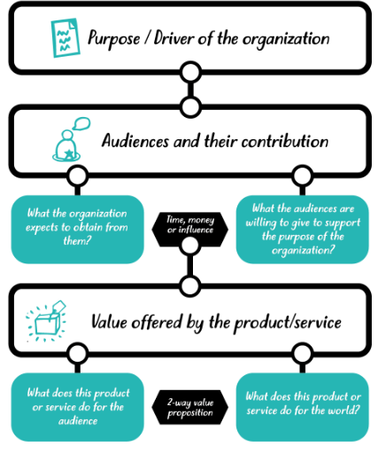
Figure 1: Communication model of Doncaster Refurnish
Communication Tools and Platforms Used
Doncaster Refurnish employs various communication strategies while engaging with its stakeholders. For example, the organization uses social media as a primary stakeholder engagement tool. As much of the world migrates to online, stakeholder engagement through social media offers organizations openings to communicate directly to groups with whom keeping in touch previously would have been difficult (Hoffmann, & Lutz, 2013, pp. 6). For instance, Doncaster Refurbish uses smartphone apps to reach employees, business partners, and the local community members. Instead of previously limited contact via third-party audits, this extensive and direct contact enables the organization to instantly address stakeholder concerns or questions. Also, community members contact the company through social media networks whenever they have household products to dispose of. The organization has a strong presence across numerous social media networks like Instagram, Twitter, Facebook, WhatsApp, and so on. Most importantly, the organization uses social media for advertising the training, placement, and employment opportunities they may be having. Besides, all the refurbished furniture and household items available for the local community members can be viewed on their social media handles.
Standards
Because maximizing profits and wealth generation are not the primary goals of social businesses like Doncaster Refurnish operate differently than typical companies. Doncaster was established with the primary purpose of averting perfectly usable furniture and other household waste from ending up in landfills. The company aims at promoting the tenets of recycling and environmental sustainability by collecting and refurbishing these commodities and selling them to the local people cheaply. People are at the core of the organization's business. Also, most of those working at this company have special needs or come from disadvantaged backgrounds, or were facing continuing unemployment. The organization also provides volunteering, training, as well as placement openings. Furthermore, the organization enables local community members to fulfill their potential by "providing a supportive and friendly working environment where confidence, skills, and experience can be developed." In 2010, Doncaster Refurnish won the year’s award as the best employer for its outstanding achievement (Limb et al.,2016 pp. 2).
Sustainability
Doncaster Refurnish was established to lighten or lessen poverty and diminish disparities within and around Doncaster. The organization collects, refurbishes, rebrands, and sells furniture and other bulky household items to low-income families, providing training and employment to the disadvantaged members of the local community. The organization also provides rehabilitation and integration openings for prisoners released from prison and placement opportunities for young wrongdoers. As such, Doncaster Refurnish has a “strong social and environmental impact” by averting functional furniture and other bulky household waste from going to landfills and addressing other social issues that range from mental health to declining reoffending.
Evaluation
Social businesses are purpose-driven organizations that employ and assist individuals who are willing to work but face considerable challenges in obtaining employment. Evaluation should be a fundamental and ongoing component of any social enterprise and may include approaches taken during inception and other strategies implemented during its life cycle. Doncaster Refurnish started in a small way with few staffs in 2003. However, it became successful and has grown into an exceptional and lively social business with operations in multiple locations around Doncaster. The organization has positively impacted the lives of the community members of the Doncaster area. By accessing the unsecured loans, the organization has been able to expand the volunteering openings. According to Head (2007), “Doncaster Refurnish gets the right money at the right time for the development and growth of the sustainable and impactful community and social enterprises that are unable to secure support from elsewhere." The organization makes fundamental differences by deterring loads of reusable and recyclable commodities from landfills and assisting in transforming the livelihoods of volunteers and employees by offering them life-changing opportunities. Through the functions of Doncaster Refurbish, community members have grown and diversified and are a significant model of what a social business can achieve (DONCASTER REFURNISH: OpenCharities, 2021).
In the process of gathering, recycling, and re-using household items, the organization offers a training program, a volunteering, work placement program to the community members facing long-standing unemployment, mental health issues, and those detached from mainstream society. The organization allows community members to achieve or realize their full potential by offering a friendly and supportive workplace to develop experience, skills, and confidence. Also, the organization assists the local community, predominantly those with no or low income, by providing them household items. Doncaster Refurnish has helped more than 20 thousand low-income families by providing them low-cost furniture and other household products since 2009 (Wells et al., 2011, pp. 6). Doncaster Refurnish employs very many individuals with flexible self-employment opportunities, and provides endless volunteering placements, providing accredited and work-based training to socially disadvantaged persons; therefore, increasing their self-esteem, skills, and employability. Most importantly, the organization saves the Doncaster Council thousands of dollars in disposal costs.
Relationship with Stakeholders
Doncaster Refurnish’s working relationship with Doncaster's Council began in 2003 when EU and UK Neighbourhood Renewal Funds (NRF) were available. The council funded a trial collection and re-use of bulky household items. At this time, SITA held the waste collection contract, and the trial assisted create the formal organization of the charity. The different stakeholders involved were Doncaster MBC's waste management head of service, SITA's contracts manager, and Doncaster Council's manager (Mastrangelo, Benitez, & Cruz-Ros, 2017, pp. 441). These organizations work collaboratively to assist Doncaster Refurnish in achieving its objectives.
Conclusion
Community engagement is an effective means of bringing on behavioural and environmental changes that will advance the community's well-being and people. Doncaster Refurnish is a social business delivering economic, environmental, and social targets, with the primary mission of preventing waste and converting materials into usable items. It engages with the local community members and other stakeholders to achieve its objectives. Doncaster Refurnish employs social media to engage with its stakeholders, contributing significantly to its success. However, the organization should adopt a forward-thinking approach in training its employees and volunteers on multiculturalism and other external features that should help develop and sustain business relationships between the organization and its business partners or stakeholders.

Bibliography
Ahmed, S.M. and Palermo, A.G.S., 2010. Community engagement in research: frameworks for education and peer review. American journal of public health, 100(8), pp.1380-1387.
Bowen, F., Newenham-Kahindi, A. and Herremans, I., 2010. When suits meet roots: The antecedents and consequences of community engagement strategy. Journal of Business Ethics, 95(2), pp.297-318.
Gibbons, D., Vaid, L. and Gardiner, L., 2011. Can consumer credit be affordable to households on low incomes. London. Centre for Responsible Credit and Friends Provident Foundation.
Head, BW, 2007. Community engagement: participation on whose terms?. Australian Journal of Political Science, 42(3), pp.441-454.
Hoffmann, C.P. and Lutz, C., 2013. The impact of social media on stakeholder engagement.
Ridley-Duff, R. and Bull, M., 2011. Understanding social enterprise: Theory and practice. London: Sage.
Thompson, J., and Doherty, B., 2006. The diverse world of social enterprise: A collection of social enterprise stories. International journal of social economics, 33(5-6), pp.361-375.
Limb, A., Brighouse, T., Facer, K., de Alwis, A. and Brewster, N., 2016. One Doncaster: The report and recommendations of the Independent Commission on Education and Skills in Doncaster.
Mastrangelo, L.M., Benitez, D.G. and Cruz-Ros, S., 2017. How social entrepreneurs can influence their employees' commitment. Journal of Promotion Management, 23(3), pp.437-448
Newman, P.A., 2006. Towards a science of community engagement. The Lancet, 367(9507), p.302.
Opencharities.org. 2021. DONCASTER REFURNISH :: OpenCharities. [online] Available at: <http://opencharities.org/charities/1118160> [Accessed 30 April 2021].
Schlake, M.R., 2015. Community Engagement: Nine Principles.
Watson, D., 2007. Managing civic and community engagement. McGraw-Hill Education (UK).
Wells, P., Dayson, C., Batty, E., Crisp, R. and Parr, S., 2011. Social Investment and Its Impact: The Evaluation of Charity Bank in the North.

Appendices
Appendix I: Stake Holder Engagement Plan
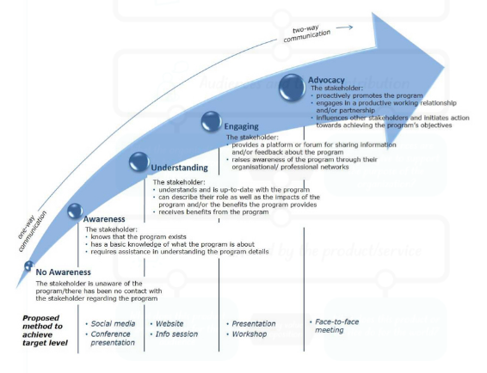

Appendix II: Communication Plan
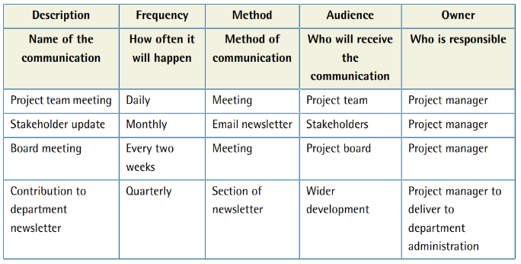

Appendix III: Social Value


