

Psychological Wellbeing and Job Performance of Police Officers:
How are serving police officers impacted by their well-being?
Amaar Ghafoor
2124684
BSc (Hons) Professional Policing Practice
2024
Word Count: 7593

Acknowledgements
I want to thank my supervisor, Jane Davies, and my dissertation tutor, Kate Colcough, for their unwavering support throughout the dissertation process.
I want to thank the University staff and the police training centre police staff for their support and knowledge during the initial training.
I want to extend my heartfelt gratitude to my partner and my entire family for their unwavering support, not only during my final year but throughout the entirety of my academic journey and efforts toward earning this degree.

Declaration
This work has not previously been accepted in substance for any degree and is not being concurrently submitted in candidature for any degree.
Signed: A. Ghafoor
Date: 23/09/2024

Statement 1
This dissertation is being submitted in partial fulfilment of the requirements for the degree of BSc.
Signed: A. Ghafoor
Date: 23/09/2024

Statement 2
This dissertation is the result of my own independent work/investigation, except where otherwise stated.
Other sources are acknowledged by footnotes giving explicit references. A bibliography is appended.
Signed: A. Ghafoor
Date: 23/09/2024

Statement 3
I hereby give consent for my dissertation, if accepted, to be available for photocopying and for interlibrary loan, and for the title and summary to be made available to outside organisations.
Signed: A. Ghafoor
Date: 23/09/2024

Statement 4
I hereby give consent for my dissertation, if accepted, to be available on the university’s IT system to those who have consent to use the system.
Signed: A. Ghafoor
Date: 23/09/2024

Abstract
This dissertation examines the effects of mental health challenges, including post-traumatic stress disorder (PTSD), complex PTSD, depression, and alcohol misuse, on the effectiveness of police officers. The main goal is to investigate how police officers cope with mental health issues and to suggest frameworks for future interventions to address these challenges. This dissertation will be non-biased by providing evidenced to support assertions with research and resources.
The research is based on a comprehensive review of secondary sources and existing studies, with a focus on police’s mental health in the UK, specifically in the South Wales Police. Key frameworks such as Agnew’s General Strain Theory and Hobfoll’s Conservation of Resources theory are used to comprehend the relationship between work-related stressors and mental health.
The findings show that police officers have significantly higher rates of PTSD (10%-15%), complex PTSD (12.6%), and depression (9.8%) compared to the general population. These mental health issues are exacerbated by exposure to trauma, high workloads, and insufficient support. Additionally, male officers, particularly those in the early stages of their careers, are especially prone to alcohol misuse.
The dissertation concludes by emphasising the need for improved mental health support within police departments. Recommendations include routine mental health assessments, increased access to professionals, and specialised training to identify and manage stress. Addressing resource shortages and organisational pressures is also crucial. Future research should include primary data collection, such as surveys and interviews, and expand cross-nationally to examine mental health across different policing sectors.

Contents
Chapter 1: Introduction 7
1.2 Background 7
1.3 Research Rationale 8
1.4 Aims and Objectives 8
Chapter: 2 Literature Review 9
2.1Introduction 10
Literature Review 10
Mental health conditions 10
2.2 Post traumatic stress disorder (PTSD) 10
2.3 Depression 11
2.4 Alcohol abuse 12
2.5 Police-related stressors 12
2.6 Homicide 12
2.7 Resource Depletion 13
2.8 Natural disasters 14
2.9 Psychological wellbeing 15
2.10 Adverse Impact of Mental Health on Policing Performance and Effectiveness 16
Conclusion 17
Chapter 3: Methodology 17
3.1 Introduction 18
3.2 Research Objectives 18
3.3 Rationale for the Research 18
3.4 Research Strategies 19
Chapter 4: Analysis of results 21
Chapter 5 - Conclusion and Recommendations 35
5.1 Recommendations for Practice 35
5.2 Contribution to Theory 35
5.3 Limitations 36
5.4 Areas for Further Research 36
5.5 Conclusion 36
Chapter 7: Bibliography 38
Chapter 8: Appendix 43

Chapter 1: Introduction The purpose of this dissertation is to investigate the impact of psychological wellbeing on the job performance of police officers in South Wales, UK. Specifically, it aims to explore the relationship between officers' mental health and their ability to perform their duties effectively, offering valuable insights into how psychological factors influence job performance within the context of a high-stress profession. Central to this research is the question: "Psychological Wellbeing and Job Performance of Police Officers: How are serving police officers impacted by their wellbeing?" This chapter provides an overview of the background and context of the study, highlighting the significance of the topic and the need for a deeper investigation into the wellbeing of police officers.

1.2 Background

Being a police officer is a demanding position that exposes individuals to stressful situations, violence, trauma, and unpredictable circumstances. Even in the midst of danger, police officers must remain composed, act quickly, and perform their tasks precisely. However, these work-related obligations come with a major psychological cost. Prolonged exposure to stress, trauma, and work-related pressures can seriously impact officers' mental health, leading to anxiety, depression, post-traumatic stress disorder (PTSD), and burnout.
Police officers are at a higher risk of developing PTSD due to their frequent exposure to trauma. Those with PTSD tend to perform poorly on the job, affecting the public, their families, and colleagues. Surprisingly, there is little research on PTSD in police officers, especially in England and Wales (Foley and Massey, 2019), particularly regarding the impact of cumulative trauma. Early intervention should include risk assessments, training, and strong social support. However, the impact of peer support among officers has not been extensively researched. It is crucial to reduce the stigma surrounding mental health in the police force , which requires cultural changes and training at all levels.
In order to evaluate the accuracy of research findings on PTSD and Complex Post-Traumatic Stress Disorder (CPTSD), Brewin et al (2022) highlighted the importance of gathering data from England and Wales. CPTSD results from prolonged trauma and includes difficulties with emotional control and feelings of worthlessness, while PTSD is characterised by symptoms such as flashbacks and intense anxiety. According to the study, CPTSD increased from 12.79% to 13.01%, and that of PTSD rose from 7.71% to 7.97%. This highlights that PTSD is on the rise across both Wales and England.

1.3 Research Rationale
The circumstances with regards to the research rationale for the significant psychological challenges that police officers face, including high rates of depression, alcohol abuse, PTSD, and CPTSD. These mental health issues impact officers’ performance, their interactions with the community, and their overall well-being. Despite the urgency of these issues, there is limited understanding of how effective South Wales Police and operational pressures contribute to these challenges.
In a study by Foley and Massey (2021), it was found that when police officers in England and Wales deal with traumatised victims, they often experience secondary trauma. This highlights the significant emotional toll of caring for others. The article discusses the various stresses that police officers face in their work, including burnout, vicarious trauma, and compassion fatigue.

1.4 Aims and Objectives
The aims of this study are to examine the prevalence and impact of mental health challenges among police officers, specifically focusing on PTSD, CPTSD, depression, and alcohol abuse, while exploring the theoretical frameworks that inform effective interventions.
Objectives:
- Evaluate the impact of alcohol abuse, depression, PTSD, and CPTSD among police officers.
- Identify the primary causes of mental health challenges in Police Officers, including high-stress work environments, burnout, exposure to traumatic events, and resource depletion.
- Review relevant theoretical frameworks such as Hobfoll's Conservation of Resources theory and Agnew's General Strain Theory to gain insight into the mental health issues experienced by police officers.
- Explore the impact of gender differences in alcohol consumption and coping strategies on the mental well-being of both male and female police officer.
To ensure that this literature study achieves its objectives, I will be thoroughly investigating each objective. By addressing each objective, this review will effectively fulfil the study's purpose.
The review will include both primary and secondary data. Primary data will be obtained from recent studies and surveys on police mental health, while secondary data will be derived from previously published works and relevant research findings.

Chapter: 2 Literature Review

To what extent does psychological wellbeing influence the effectiveness of police officers?

2.1 Introduction
This literature review explores prevalent mental health challenges experienced by police officers, specifically focusing on Post-Traumatic Stress Disorder (PTSD), Complex PTSD (CPTSD), depression, and alcohol abuse. The objective is to analyse the underlying factors contributing to these disorders and examine theoretical frameworks guiding interventions.
Existing research demonstrates that exposure to traumatic incidents, such as homicides, significantly impacts officers' mental health, resulting in heightened rates of PTSD and CPTSD. Furthermore, the unique stressors inherent in police work, including resource depletion and burnout, contribute to elevated levels of depression within the police force.
Theoretical frameworks such as Agnew's General Strain Theory and Hobfoll's Conservation of Resources theory provide valuable insights into the origins of mental health disorders within policing contexts. Understanding these theoretical perspectives is essential for developing evidence-based interventions to alleviate the adverse effects of stress and trauma on officers.
By examining the complex landscape of mental health issues in the police force and reviewing theoretical frameworks, this literature review aims to contribute to a comprehensive understanding of strategies supporting officers' psychological well-being and enhancing their effectiveness in serving communities.

Mental health conditions

2.2 Post traumatic stress disorder
PTSD occurs in around 10% of the population but is higher in women. The main cause of PTSD is the exposure to a traumatic event, although there are genetic and social risk factors. The symptoms of PTSD can include flashbacks to the traumatic event evoking intense emotions, distressing memories, negative thoughts and emotions, and hypervigilance. Treatments include a combination of talking therapy and medications (Yehuda et al., 2015). PTSD has a higher prevalence in the police population and has been estimated as 10-15% (Klimley et al., 2018).
The study found that 8.0% of participants had PTSD and 12.6% had CPTSD. All types of exposure were linked to both PTSD and CPTSD. Male police officers were more likely to have these disorders, especially if they were frequently exposed to traumatic incidents and traumatic visual material, as well as humiliating behaviours and sexual harassment. Surprisingly, verbal abuse, threats, and physical violence were not significant factors . CPTSD has been showed to be strongly associated with humiliating behaviours, sexual harassment, lower rank, and longer years of service compared to PTSD (Brewin et al., 2022).

2.3 Depression
Depression is associated with a low mood, loss of interest in previous hobbies and recurrent negative thoughts. The cause of depression is complex and has biological, environmental and psychological factors. The treatment of depression involves medications such as anti-depressants. The prevalence of depression in the general population is around 4.4% (WHO, 2017), while in the UK police force it is estimated at 9.8% (Gullon-Scott and Longstaff, 2024)
Research on police depression, despite lacking a solid theoretical foundation, highlights the necessity of theory-driven investigations for understanding and predicting behaviours to inform policymaking. Two key theories, Agnew's General Strain Theory (GST) and Hobfoll's Conservation of Resources (COR) theory, shed light on the phenomenon. GST, applied in policing, emphasises the link between stress, negative emotions, and misconduct, focusing on adverse environmental conditions. COR theory, proposed by Hobfoll, elucidates human responses to stress and their impact on well-being. Individuals strive to maintain resources; loss leads to stress and further depletion, while resource possession fosters accumulation to cope with losses.
The Job Demands-Resources (JD-R) model, an extension of COR theory, explains the relationship between work conditions and health outcomes. It distinguishes job demands (linked to poor health) from resources (promoting well-being), integrating earlier stress models to elucidate mechanisms in stressful work environments (Agrawal & Singh, 2020).

2.4 Alcohol abuse
Alcohol stands as one of the most extensively used psychoactive substances worldwide. Engaging in hazardous drinking, as determined by the amount and regularity of consumption, correlates with both short-term and long-term health issues. Alcohol use disorders (AUDs) represent psychiatric conditions marked by difficulties in regulating alcohol intake and other related symptoms (MacKillop et al., 2022).
Alcohol misuse poses a notable challenge within the police force. Violanti et al. (2011) investigated the association between alcohol usage and the psychological impact of stress related to alcohol consumption among police personnel. The study found significant differences in alcohol use among police officers. Male officers had higher AUDIT scores than females, especially in hazardous alcohol use and dependent symptoms. Younger female officers tended to have hazardous drinking patterns. Male officers with hazardous drinking reported more life stress. These results emphasise the need to address alcohol issues in the police force, particularly among males, considering age and gender differences (Violanti et al., 2011).

2.5 Police-related stressors
Research on the mental health problems police face, reports a range of risk factors contribute to the stress and distress experienced by police officers. These are mainly composed of two main stressors: operational and organisational stressors (Purba and Demou, 2019). Operational stressors within the police force stem when dealing with high-risk situations such as homicide response. These situations can lead to acute stress reactions and may contribute to long-term psychological effects. Organisational stressors involve factors such as heavy workloads, lack of support due to e.g. resource depletion. Some other stressors could be both operational and organisational. One such example is natural disaster response, which poses challenges to not only the mental state of the individual on duty but also to the police department as a whole. More details and illustration into these examples will be provided below.

2.6 Homicide
Homicide response is a significant operational stressor for police officers as the nature of the crime is highly distressing, involving violence, and gruesome scenes. Frequent exposure to such traumatic sights and experiences by the police officers can lead to suffering from psychological distress and trauma (Violanti et al., 2016). Killing or severely injuring a member of the public seems to have a negative impact on police officers’ mental health. Komarovskaya et al. (2011) assessed the mental health of 400 police officers five times over three years, of which 10% had killed or seriously injured another human while on duty. The study found that killing or seriously injuring another human had a positive correlation with both PTSD and depression. The role of the media in response to a killing of another human may also add additional pressure to the officers, such as the potential loss of job and negative perceptions by the public. Saleh et al. (2018) found that 23% of individuals killed by the police in the US may have had mental health issues. The response by the public and negative emotions of the police officer may be amplified in the case of killing an individual who are innocent and/or have mental health problems.

2.7 Resource Depletion
Resource depletion is primarily an organisational stressor for police officers. It refers to the inadequate or shortage of resources within the police department, such as manpower, equipment, training, and support services. This subsequently leads to burnout in the police officers, exacerbated by the overwhelming volume of emergency calls, the struggle to keep victims updated, and limited resources which significantly impacts the image and trust in the police force (Giblin and Nowacki, 2018). When officers are stretched thin and unable to provide adequate support and communication to victims, it can erode public trust in the police. Victims and community members may perceive the police as overwhelmed, unresponsive, or uncaring, leading to a loss of confidence in their ability to protect and serve. Furthermore, the visible effects of burnout, such as reduced quality of work and increased stress levels among officers, can tarnish the image of the police force in the eyes of the public. This erosion of trust and confidence in the police force not only undermines community safety but also creates barriers to effective crime prevention and collaboration between the police and the communities they serve.
Research reveals that these workers tend to favour Engaged (active) coping strategies over Disengaged (avoidant) ones. Notably, sixty-two percent scored high on Emotional Exhaustion, considered a core aspect of Burnout by some researchers. Those employing Engaged coping methods were less prone to depersonalisation and more likely to experience personal accomplishment. Conversely, those using Disengaged coping strategies were more susceptible to emotional exhaustion, depersonalisation, and reduced personal accomplishment. These findings stem from a study examining how child protective service (CPS) investigations workers handle job-related stress and the connection between coping strategies and levels of emotional exhaustion, depersonalisation, and diminished personal accomplishment (Anderson, 2000).
Research indicates that four key factors appear to elevate the risk of compassion fatigue: inadequate self-care, past-traumatic experiences, dissatisfaction in the workplace, and a sense of powerlessness at work. Preventative measures against compassion fatigue may involve role adjustments, promoting a positive mindset at work, boosting personal resilience, handling workloads effectively, scheduling sufficient time off, cultivating a supportive work atmosphere, continuously improving professional skills, establishing boundaries with traumatised individuals, and feeling empowered to seek assistance when necessary (Radey & Figley, 2007).

2.8 Natural disasters
Natural disasters response can be both an operational and organisational stressor for police officers. A natural disaster refers to the significant adverse consequences experienced by the society or community in the aftermath of a natural hazard event. Examples of such events encompass flooding, drought, earthquakes, tropical cyclones, lightning strikes, tsunamis, volcanic eruptions, and wildfires (Kellenberg & Mobarak, 2011).
Operationally, responding to these unpredictable events requires immense focus and responsibility from the police officers such as evacuating residents from dangerous sites to the safety, and maintaining public order amidst chaos and devastation (Adams and Anderson2019). The physical and emotional demands of such response efforts can lead to acute stress reactions and potential trauma (Mao et al., 2018). The study examines the frequency of PTSD symptoms and evaluates subjective well-being, overall distress, and social functioning among police officers 18 months after they participated in a rescue operation during a fire at a nightclub. Emotional reactions, encompassing self-reported responses during and following the fire incident, were scrutinised. A total of forty-one police officers took part in the research, providing responses to a questionnaire and a series of self-assessment tools. Psychological distress was gauged utilising standardised scales, all of which demonstrated high internal consistency. Findings indicated that some officers continued to experience stress, with one officer showing clinically significant stress reactions. Additionally, a small percentage exhibited high levels of psychological distress. Most officers displayed varying degrees of reduced social functioning. Following the fire, debriefing was conducted by the police department, with 75% of officers perceiving it positively. However, 18 months post-disaster, some officers still reported being under stress.
Organisationally, the stressors include logistical challenges such as resource allocation, coordination with other emergency services, and managing increased workloads. Due to resource constraint (discussed above), police departments often face excessive pressure on manpower, equipment, and facilities. Additionally, overloaded work shifts demand certain sacrifices from the police officers, who may experience uncertainty about their own home and family, ultimately contributing to their stress level.

2.9 Psychological wellbeing
Psychological wellbeing refers to a state of optimal mental health where an individual is able to cope effectively with the normal stresses of life, work productively, and contribute to their community. The extent to which psychological wellbeing influences the effectiveness of police officers can vary significantly and is influenced by numerous factors. Psychological wellbeing encompasses various aspects of mental health, including stress levels, coping mechanisms, resilience, job satisfaction, and overall emotional stability. Police effectiveness, on the other hand, can be measured by factors such as job performance, decision-making abilities, community relations, response to critical incidents, and overall public safety outcomes.
Research suggests that there is a strong relationship between psychological wellbeing and police effectiveness. Officers who experience high levels of psychological wellbeing are often more resilient in the face of stressors commonly encountered in the police force, leading to better decision-making abilities and job performance. Conversely, officers who struggle with poor psychological wellbeing may be more prone to burnout, reduced job satisfaction, and impaired performance on the job (Jackman et al., 2020).
The findings from Gask et al. (2012) could carry considerable implications for improving the psychological health of police officers through evidence-based psychosocial interventions. Initially, interventions designed to enhance perceptions of accessible and received support among operational and professional service personnel within police organizations could be beneficial. By increasing awareness about the significance of social support among police officers, individuals may develop a better understanding of their roles as potential sources of support within the organization. This heightened awareness can also encompass existing support systems, such as supervisors and close colleagues, fostering a deeper appreciation of the support available from peers (Gask et al., 2012).
Secondly, providing education to police personnel about behaviours and types of support beneficial in their line of work may enhance perceptions of available support and awareness of support received, thereby potentially improving psychological wellbeing (Bell & Eski, 2016).
Thirdly, fostering a culture within police organisations that encourages employees to seek support from their peers and line managers could be beneficial. Finally, assessing employees' personality traits, particularly extraversion and emotional stability, may offer insights into individuals who may be more susceptible to experiencing diminished psychological wellbeing. Tailored support programs aimed at enhancing psychological wellbeing could then be provided to these individuals (Murray et al., 2016).

2.10 Adverse Impact of Mental Health on Policing Performance and Effectiveness
Mental health problems can significantly hinder police performance and effectiveness. Issues like stress, anxiety, depression, and burnout can impair decision-making, job performance, and relationships with colleagues and the community. Untreated mental health issues may lead to absenteeism, presenteeism, and higher turnover rates in police departments. Research indicates that the expression and management of mental health issues within police forces vary from those in other occupational groups (Kumarasamy et al. 2016; Tewksbury and Copenhaver, 2016). Thus, prioritising mental health support for officers is essential for their wellbeing and the effectiveness of police officers (Lucia & Halloran, 2020).
Research shows that organisational stressors significantly impact police officers, often viewed as oppressive, unnecessary, unavoidable, and beyond their control. These stressors encompass a lack of support, heavy workloads, interpersonal conflicts, inadequate resources, time pressures, and rigid bureaucratic structures. These challenges are consistent across cultural contexts worldwide. For example, Purba & Demou (2019) showed that such stressors lead to adverse outcomes like occupational stress, anxiety, depression, psychiatric symptoms, burnout, and even suicidal ideation among police officers.

Conclusion
In conclusion, this literature review underscores the complex interplay between mental health conditions, police-related stressors, and the effectiveness of police personnel. PTSD, depression, alcohol abuse, and compassion fatigue emerge as prevalent challenges within the police forces, impacting officers' psychological wellbeing and job performance.
However, challenges persist in addressing mental health issues within the police departments, including stigma, limited resources, and organisational barriers. Addressing these challenges requires a multifaceted approach, encompassing policy reforms, enhanced training, and destigmatisation efforts to create a supportive environment for officers to seek help.
Prioritising the mental health and wellbeing of police personnel is essential not only for their individual health and safety but also crucial for maintaining public trust and ensuring effective policing outcomes. By acknowledging the complex dynamics between mental health conditions, police-related stressors, and job performance, efforts can be made to implement evidence-based strategies to support the psychological resilience and effectiveness of police officers.

Chapter 3: Research Methodology

3.1 Introduction
This research focuses on the psychological wellbeing of police officers and its impact on their job performance. Police work inherently involves exposure to traumatic incidents and unique stressors, leading to significant mental health challenges. Key mental health issues prevalent among officers include Post-Traumatic Stress Disorder (PTSD), Complex Post-Traumatic Stress Disorder (CPTSD), depression, and alcohol abuse. Understanding these challenges and their implications is essential for developing strategies to support officers' wellbeing and enhance their effectiveness.

3.2 Research Objectives
The primary objectives are:
- To investigate the prevalence and impact of PTSD, CPTSD, depression, and alcohol abuse among police officers.
- To explore the underlying factors contributing to these mental health issues.
- To examine theoretical frameworks such as General Strain Theory (GST) and Conservation of Resources (COR) theory.
- To identify gaps in current interventions and propose evidence-based strategies to support officers' psychological wellbeing.

3.3 Rationale for the Research
This research addresses significant mental health challenges faced by police officers and their impact on job performance and public safety. Existing studies highlight a high prevalence of mental health issues among officers but lack comprehensive, theory-driven investigations linking these issues to practical outcomes in policing. This study aims to fill that gap by providing detailed research on how these mental health conditions affect professional effectiveness and how best to mitigate these impacts through targeted interventions.
The importance of this research lies in its potential to enhance the wellbeing of police officers, thereby improving their performance and ensuring public safety. By understanding the prevalence and impact of mental health issues and identifying effective interventions, this study aims to contribute to the development of supportive strategies that can be implemented within police departments.

3.4 Research Strategies

Methods of Data Collection
The primary method of data collection will be a survey administered to police officers. This survey will gather both quantitative data on the prevalence of PTSD, CPTSD, depression, and alcohol abuse, and qualitative data on the officers' experiences and coping mechanisms. Microsoft Forms will be used to create the survey, ensuring ease of distribution and collection. This mixed-method approach will allow for a comprehensive analysis, providing both statistical prevalence and personal insights into mental health challenges among police officers.

Participants
Participants will include a diverse sample of police officers from various departments, ensuring representation across different ranks, years of service, and demographics such as gender and age. This diversity is crucial for understanding the varying impacts of mental health issues across different segments of the police force.
A representative sample is essential for the validity and reliability of the study's findings. It ensures that the data collected reflects the experiences and challenges of a broad spectrum of officers, thereby enhancing the generalizability of the results.

Ethical Considerations
Ethical considerations are paramount due to the sensitive nature of the topic. The following measures will be implemented to ensure ethical compliance:
- Informed Consent: Participants will be fully informed about the purpose of the research, the nature of their involvement, and their right to withdraw at any time without penalty.
- Confidentiality: All responses will be kept confidential, and data will be anonymized to protect the identities of the participants.
- Support Resources: Participants will be provided with information on support resources available to them in case they experience distress during or after the survey.

Development of Research Instrument
The survey instrument will be developed based on validated scales for measuring PTSD, CPTSD, depression, and alcohol abuse. These scales include:
- PTSD Checklist for DSM-5 (PCL-5) for PTSD and CPTSD.
- Patient Health Questionnaire-9 (PHQ-9) for depression.
- Alcohol Use Disorders Identification Test (AUDIT) for alcohol abuse.
The survey will also include custom questions designed to gather qualitative data on participants' experiences, coping strategies, and perceptions of support within their departments. These custom questions will be created using Microsoft Forms, enabling tailored questions that address specific aspects of the officers' mental health and departmental support.

Justification of Choices
The choice of a survey method is justified by its ability to collect data from a large sample efficiently. Surveys are effective in quantifying the prevalence of mental health issues and can be distributed widely to reach a diverse group of participants. The use of validated scales ensures reliability and validity. The mixed-method approach, combining quantitative and qualitative data, provides a comprehensive understanding, facilitating the development of targeted interventions.

Limitations & Potential Problems
This research is subject to several limitations and potential problems:
- Response Bias: Participants may underreport or overreport their mental health issues due to stigma or fear of repercussions. Efforts will be made to assure participants of confidentiality and the importance of honest responses.
- Sample Representativeness: Ensuring a truly representative sample may be challenging, particularly in obtaining participation from officers of various ranks and backgrounds. Strategies will be implemented to reach out to a wide range of officers to enhance representativeness.
- Self-Reported Data: The reliance on self-reported data may introduce inaccuracies due to participants' subjective perceptions and recall biases. While self-reported data is valuable, it is essential to acknowledge its limitations and interpret the findings accordingly.
- Ethical Sensitivity: The sensitive nature of the topic requires careful handling to avoid causing distress to participants, which may limit the depth of data collected. Ethical guidelines will be strictly followed to minimize harm and support participants.
- Generalizability: The findings from this study may not be generalizable to all police departments due to variations in departmental policies, support systems, and cultural contexts. While the study aims to provide valuable insights, the specific context of each department should be considered when applying the findings.
By acknowledging and addressing these limitations, the research aims to provide valuable insights while maintaining ethical standards and methodological rigor.

Conclusion
This research methodology outlines a systematic approach to investigating the mental health challenges faced by police officers and their impact on job performance. By addressing the gaps identified in the literature, this study aims to contribute valuable insights into the development of evidence-based strategies to support the psychological wellbeing of police officers. Ultimately, enhancing the mental health of officers will improve their effectiveness and public safety outcomes. This research has the potential to inform policies and practices within police departments, ensuring that officers receive the support they need to perform their duties effectively while maintaining their psychological wellbeing.

Chapter 4: Analysis of results

Analysis results of Questionnaire on Psychological Wellbeing and Job Performance of Police Officers
Introduction
The following analysis presents the results of a comprehensive questionnaire on the psychological well-being and job performance of police officers and staff within the South Wales Police Force. Conducted anonymously and will continue throughout the dissertation, this survey aimed to explore the intricate relationship between mental health and professional efficacy among police officers and police staff.
Aim and Objectives
The primary aim of this questionnaire was to assess the psychological well-being of South Wales police officers and police staff and to understand how it correlates with their job performance. This analysis seeks to achieve several key objectives:
- Identify Psychological Well-being Levels: The overall psychological health of the respondents, identifying prevalent mental health issues and levels of well-being.
- Examine Job Performance: To evaluate the self-reported job performance of the participants, encompassing aspects such as job satisfaction, efficiency, and work-related stress.
- Correlate Well-being and Performance: To analyse the relationship between psychological well-being and job performance, determining how mental health impacts professional duties and responsibilities.
The questionnaire was methodically developed using Microsoft Forms and distributed to members of the South Wales Police Force and Police staff.

The questionnaire initially comprised yes-or-no questions, followed by multiple-choice questions for certain sections, and concluded with an open-ended question. However, not all 74 respondents answered the final question, with only 43 individuals responding to the open-text query.
74 Responses
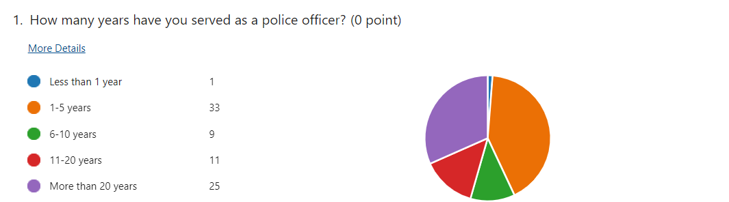
The majority of respondents (33 out of 74) have served between 1-5 years in the police force. A significant portion, 25 respondents, have served for more than 20 years. This spread indicates a broad range of experience levels within the force, which can impact perceptions of job stress and satisfaction differently. Only one respondent has served less than a year, suggesting most respondents have substantial experience in their roles
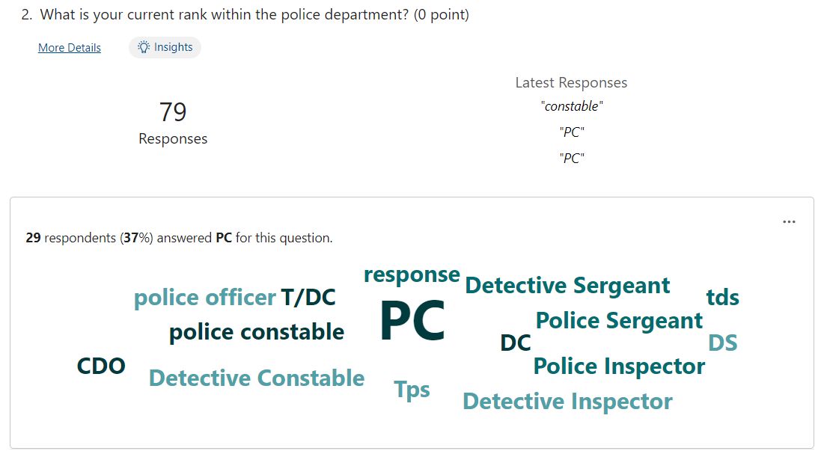
Respondents hold various ranks within the police department, with the most common being Police Constable (PC), indicated by 29 respondents. Other ranks include Detective Constable, Police Inspector, and Detective Inspector, among others. This diversity in rank highlights the inclusion of perspectives across different levels of responsibility and job functions within the force.
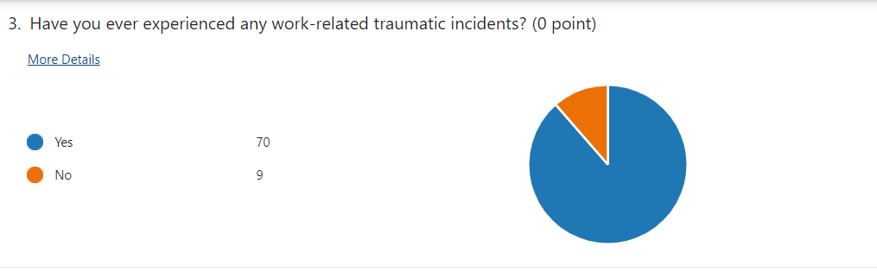

A large majority of the respondents (70 out of 79) reported experiencing work-related traumatic incidents, illustrating the high exposure to potentially distressing situations inherent in police work. Only 8 respondents have not experienced such incidents, underscoring the prevalent nature of traumatic events in this profession.
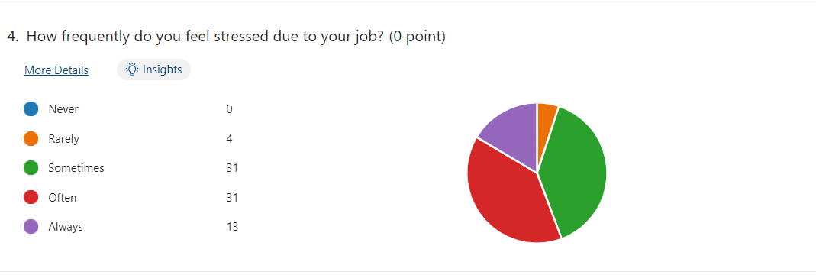

Job stress is a common experience among the respondents, with only 4 reporting that they rarely feel stressed. Most respondents experience stress sometimes (31), often (31), or always (13). This high frequency of stress underscores the demanding nature of police work and the potential impact on officers' mental health and job performance.
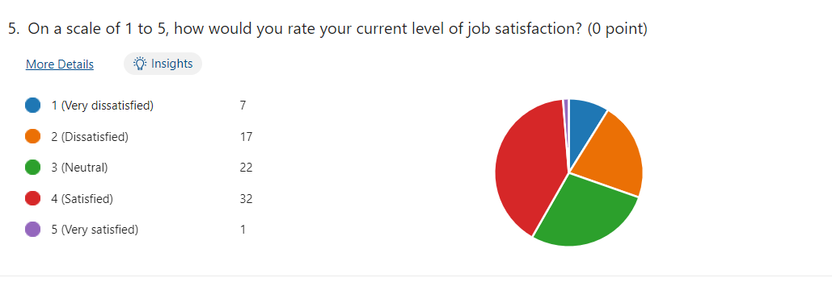
Job satisfaction levels among respondents vary, with a majority indicating a neutral (22) or satisfied (32) stance. However, a notable portion reported dissatisfaction, with 7 very dissatisfied and 17 dissatisfied. Only one respondent reported being very satisfied. This spread suggests that while many officers find their work fulfilling to some extent, there is a significant portion that struggles with job satisfaction.
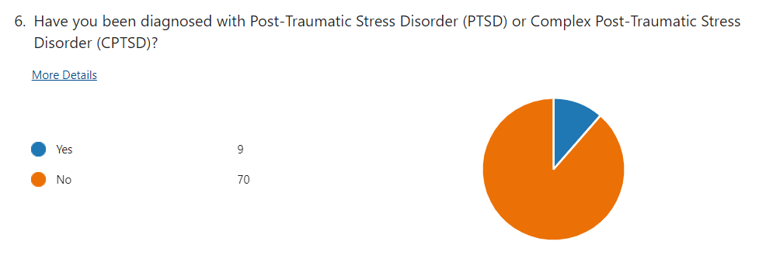

Despite the high exposure to traumatic incidents, only 9 respondents have been diagnosed with PTSD or CPTSD. The majority, 70 respondents, have not been diagnosed with these conditions, which might indicate underdiagnosis or that some officers manage to cope with trauma without developing these disorders.
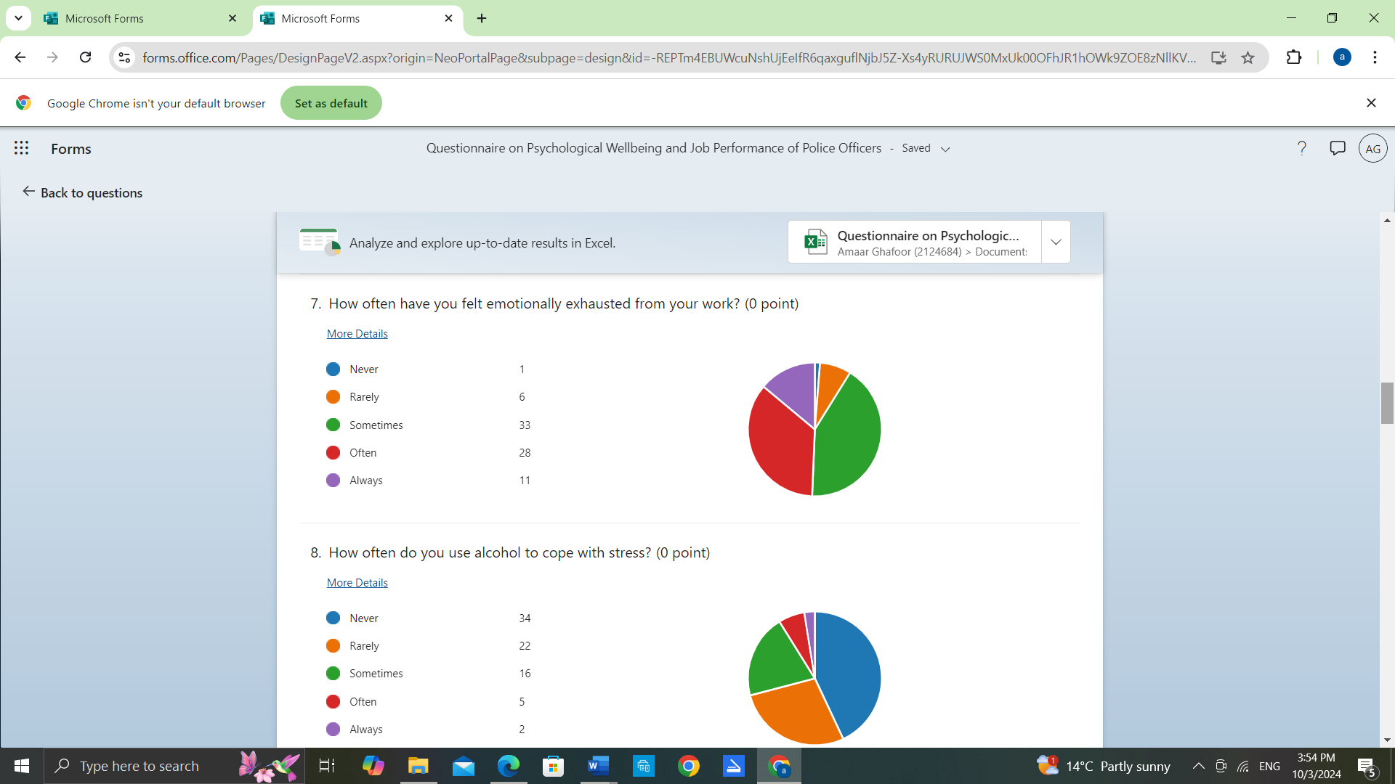
Emotional exhaustion is a common issue, with 33 respondents sometimes, 28 often, and 11 always feeling emotionally exhausted from work. Only 1 respondent never feels this way, and 6 rarely do. This indicates that emotional fatigue is a significant concern for most officers, potentially affecting their overall well-being and job performance.

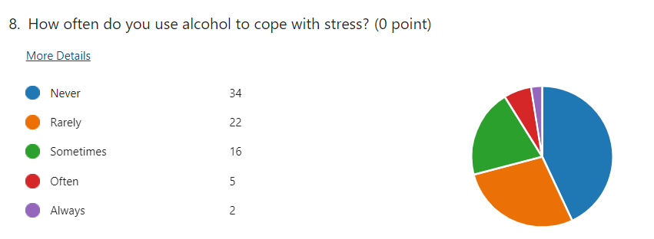

Alcohol use as a coping mechanism varies, with 34 respondents never using alcohol to cope with stress and 22 rarely doing so. However, 16 sometimes use alcohol, 5 often, and 2 always. This suggests that while many officers avoid using alcohol for stress, a significant minority rely on it, which could have implications for their health and well-being.
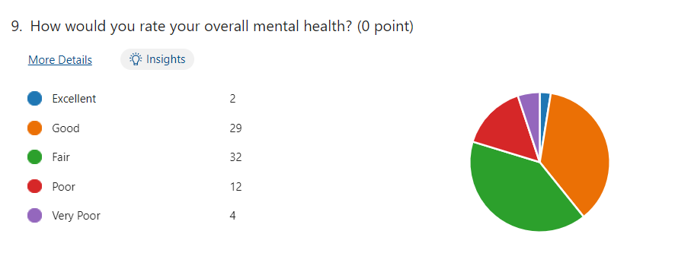
Respondents' overall mental health ratings are mixed, with most rating their health as fair (32) or good (29). Only 2 rate their mental health as excellent, while 12 consider it poor and 4 very poor. This distribution indicates that while many officers feel their mental health is average to good, there is a considerable number who struggle with poor mental health.

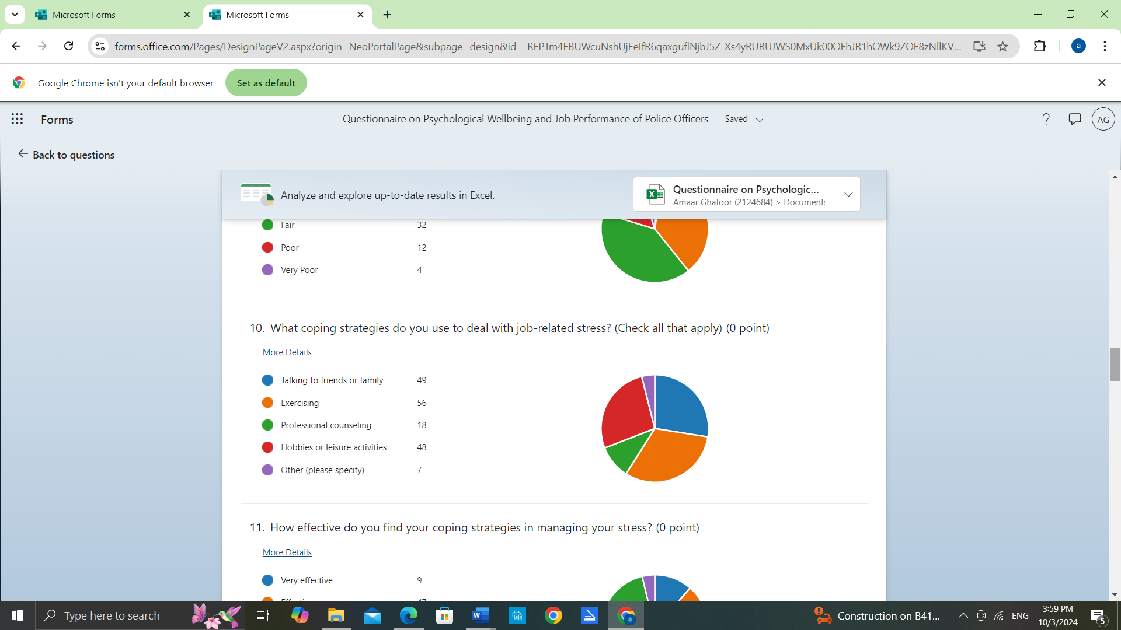

The most common coping strategies include exercising (56), talking to friends or family (49), and engaging in hobbies or leisure activities (48). Professional counselling is used by 18 respondents, and 7 mentioned other strategies. These findings suggest that physical activity and social support are key methods for managing stress among officers.
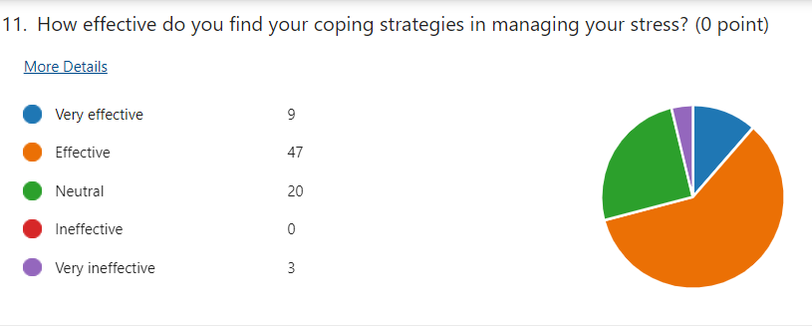

Most respondents find their coping strategies effective, with 47 rating them as effective and 9 as very effective. Eighteen respondents are neutral about the effectiveness of their strategies, and only 3 find them very ineffective. This indicates that while most officers are satisfied with their stress management methods, some still struggle to find effective coping mechanisms.

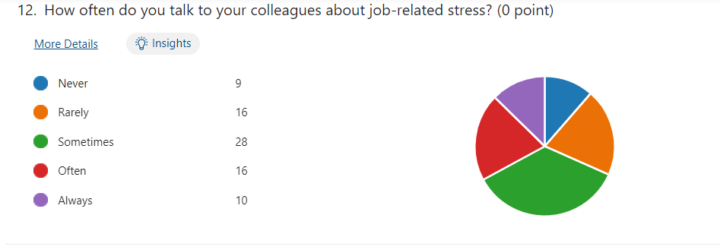
Communication about job-related stress varies, with 28 respondents sometimes discussing it with colleagues, 16 often, and 10 always. However, a significant portion rarely (16) or never (9) talk about stress with colleagues. This suggests that while peer support exists, it is not universally applied, and some officers may feel isolated in their experiences.

Department Support for Managing Stress
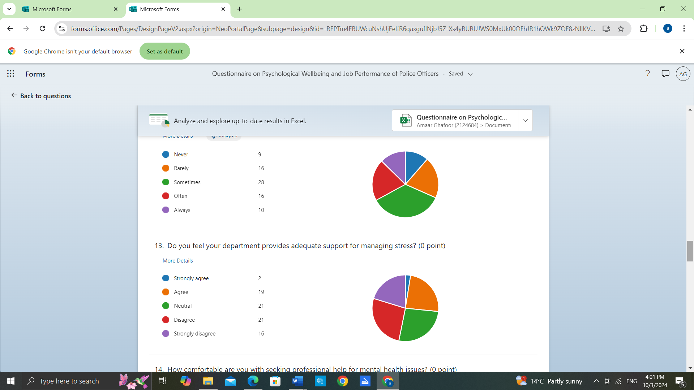
Opinions on departmental support for managing stress are divided. Only 2 respondents strongly agrees that the department provides adequate support, and 19 agree. Twenty-one respondents are neutral, while 21 respondents disagree or strongly disagree. This highlights a perceived lack of sufficient institutional support for stress management.

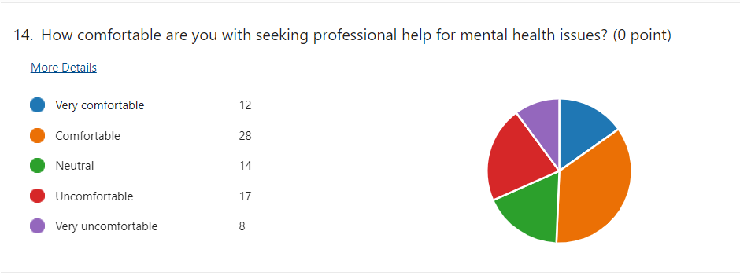
Comfort levels with seeking professional help for mental health issues vary widely. Twelve respondents are very comfortable, and 28 are comfortable, with seeking help. fourteen are neutral, but 17 are uncomfortable and 8 very uncomfortable. This suggests that while many are open to professional help, a significant number still feel hesitant or uneasy about it.
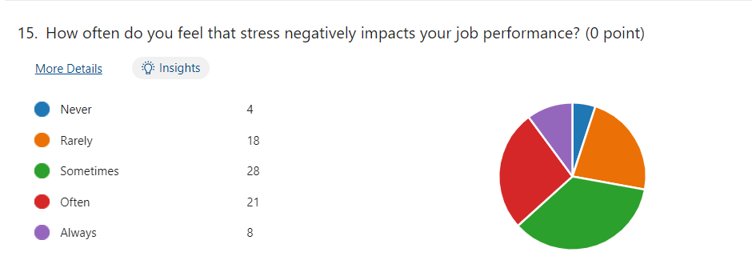

Stress frequently impacts job performance, with 28 respondents sometimes, 18 often, and 8 always feeling its effects. Eight rarely experience this impact, and only 4 never do. This indicates that job performance is commonly affected by stress, which could have broader implications for police work effectiveness.

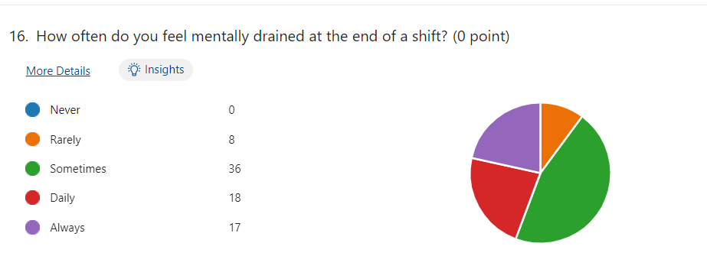

Feeling mentally drained at the end of a shift is a common experience, with 36 respondents sometimes, 18 daily, and 17 always feeling this way. Only 8 respondents rarely feel drained, and none never do. This highlights the high mental demands of police work and its toll on officers' energy levels.
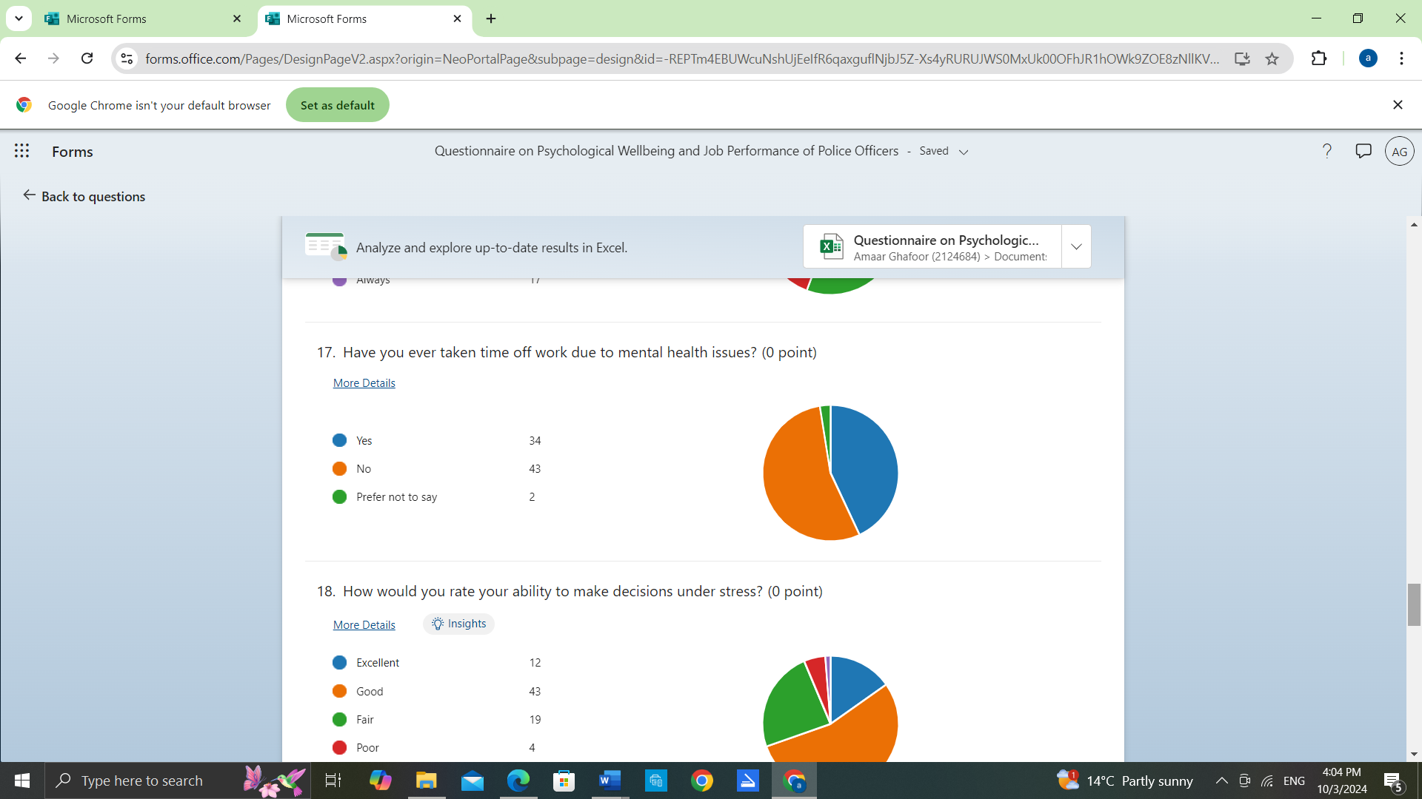
Feeling mentally drained at the end of a shift is a common experience, with 34 respondents yes and 43 respondents no. This highlights the high mental demands of police work and its toll on officers' energy levels.
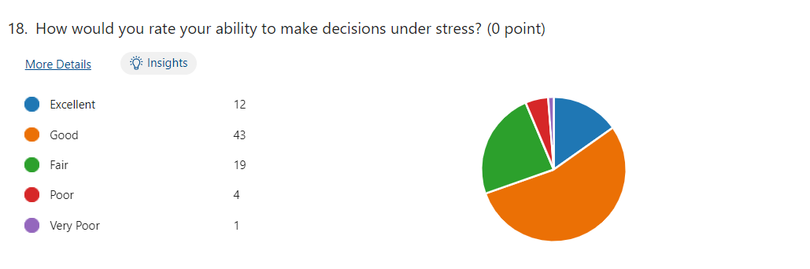
Most respondents rate their decision-making ability under stress as good (43) or excellent (12). Eighteen consider it fair, while only 4 rate it as poor and 1 as very poor. This suggests that despite high stress levels, many officers feel confident in their decision-making capabilities.
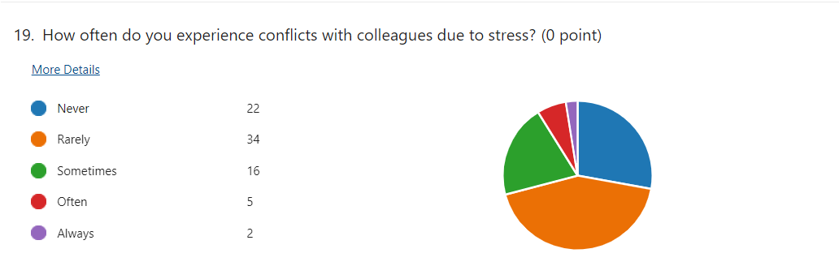
Conflicts with colleagues due to stress are relatively rare, with 34 respondents rarely and 22 never experiencing them. Sixteen respondents sometimes have conflicts, and only 5 report often or always experiencing them. This indicates that while stress can lead to interpersonal issues, it is not a widespread problem.

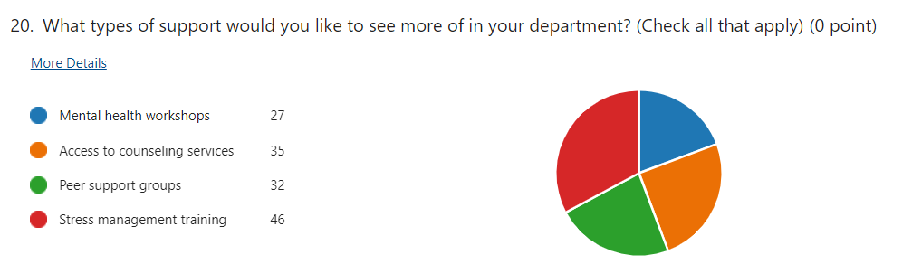
Respondents expressed a desire for more stress management training (46), access to counselling services (35), peer support groups (32), and mental health workshops (27). This shows a clear demand for enhanced mental health resources and support mechanisms within the department.
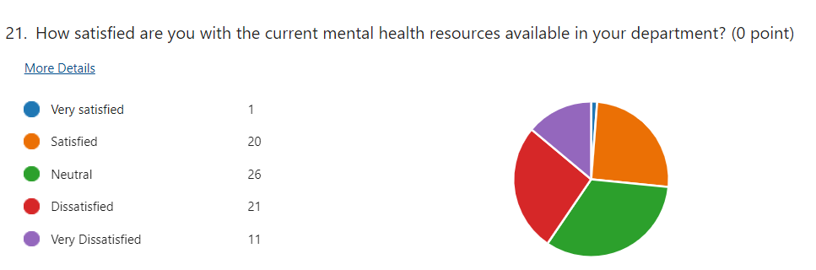
Satisfaction with current mental health resources is low, with 21 respondents dissatisfied and only 1 very dissatisfied. Twenty-six are neutral, while only 20 are satisfied and 1 very satisfied. This suggests a need for improvement in the mental health resources available to officers.
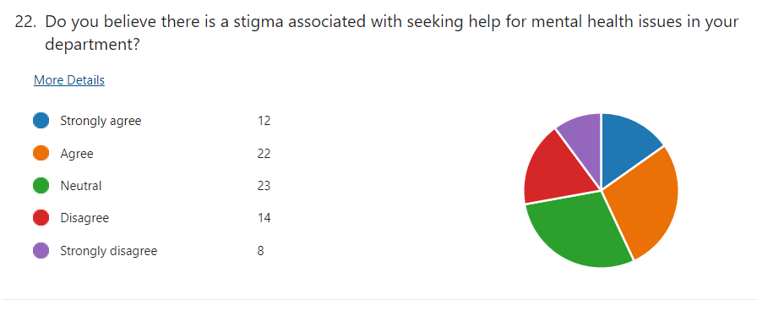

Perceptions of stigma associated with seeking mental health help are mixed. Twelve respondents strongly agree that there is a stigma, 22 agree, and 23 are neutral. Fourteen disagree, and 8 strongly disagree. This indicates that while stigma is a concern for many, there are varying views on its frequency within the department.

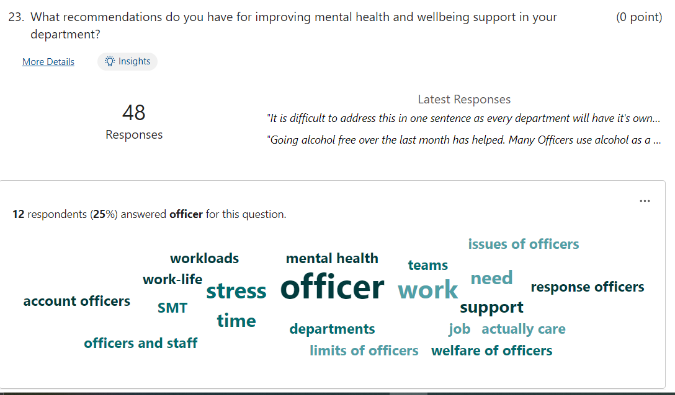

Out of 48 responses, individuals have indicated a strong desire for improved well-being support within the police force. Many respondents have highlighted a noticeable lack of adequate support across the South Wales Police, suggesting that current resources and services may not be meeting their needs effectively. This feedback underscores the urgent need to enhance and expand well-being initiatives to ensure that all personnel receive the support they require.

Chapter 5 - Conclusion and Recommendations

5.1 Recommendations for Practice
Based on the findings of this dissertation, several recommendations can significantly improve police officers’ mental health and well-being. Enhancing mental health support is crucial; police departments should prioritise mental health by implementing regular assessments and ensuring easy access to mental health professionals. This approach can include mandatory debriefings following traumatic events, which foster an environment that encourages seeking help. Additionally, comprehensive training programs focused on stress management and recognising mental health issues in oneself and colleagues should be established.
Another vital recommendation is the effective allocation of resources. Addressing organisational pressures, such as inadequate resources, is essential. Police forces should ensure sufficient staffing, tools, and support systems to prevent burnout and improve job satisfaction. Increased staffing levels, effective communication, and proper organisation can mitigate stress from heavy workloads. Implementing targeted interventions for alcohol abuse is also critical, with initiatives such as peer support groups and confidential counselling services for officers struggling with substance use.

5.2 Contribution to Theory
This research contributes to the theoretical understanding of police officer mental health by applying various frameworks. The General Strain Theory suggests that pressures and negative experiences can lead to maladaptive behaviours, such as substance abuse and depression, highlighting the influence of occupational stressors on mental health. Furthermore, the Conservation of Resources Theory explains how officers strive to preserve their mental, physical, and emotional resources amidst demanding work conditions. The Job Demands-Resources Model extends this understanding by highlighting the need for balance between job demands and resources to sustain officers' mental health.
The integration of these theories illustrates the complex interplay between operational pressures and mental health outcomes, enriching the academic discourse on police psychology. This research underscores the importance of resource management in mitigating stress and promoting well-being within police forces.

5.3 Limitations
While this study offers valuable insights, it has limitations. Relying primarily on secondary data restricts a deep understanding of police officers' nuanced experiences. The findings may not fully represent the diverse challenges faced by officers across different regions and contexts due to the focus on the South Wales Police Force. Additionally, the absence of primary data collection methods, such as interviews, limits the ability to capture the intricacies of officers' mental health experiences.
These limitations highlight the need for comprehensive research that includes diverse police contexts and employs direct data collection methods. Future studies should aim to integrate qualitative approaches to enhance the understanding of police officers' mental health issues.

5.4 Areas for Further Research
First, collecting primary data through surveys and interviews could provide more detailed insights into the lived experiences and challenges faced by police officers regarding mental health. This would help overcome the limitations of relying solely on secondary sources. Additionally, cross-national research is crucial to explore how different policing environments and organisational structures impact mental health outcomes. Moreover, studies should address the long-term effects of mental health support interventions on officers’ well-being and job performance. Investigating institutional barriers, such as departmental stigma and support discrepancies, will also be vital to understanding how to foster healthier work environments.

5.5 Conclusion
The literature review highlights the significant impact of operational and organisational pressures on the mental health of police Officers. Officers are particularly affected by conditions such as PTSD, CPTSD, depression, and alcohol abuse due to the inherent stressors in their roles. The study effectively assessed the prevalence of these mental health issues among police officers and evaluated the impact of organisational pressures on their mental health. It also provided recommendations for interventions, but further research is needed to evaluate theireffectiveness across different contexts. The study contributed to the theoretical understanding of police officer mental health through the application and integration of multiple theories. While the research objectives have been largely met, there is still significant scope for further inquiry to improve the mental health landscape for police officers.

Chapter 7: Bibliography
Adams, T.M. and Anderson, L.R. (2019). Policing in natural disasters: stress, resilience, and the challenges of emergency management (p. 221). Philadelphia: Temple University Press.
Agrawal, M., & Singh, R. (2020). Factors associated with police depression: A systematic review. International Journal of Criminal Justice Sciences, 15(1), 34–50. https://doi.org/10.5281/ZENODO.3819100
Anderson, D. G. (2000). Coping strategies and burnout among veteran child protection workers. Child Abuse & Neglect, 24(6), 839–848. https://doi.org/10.1016/s0145-2134(00)00143-5
Bell, S., & Eski, Y. (2016). ‘Break a Leg—It’s all in the mind’: Police Officers’ Attitudes towards Colleagues with Mental Health Issues. Policing A Journal of Policy and Practice, 10(2), 95–101. https://doi.org/10.1093/police/pav041
Brewin, C. R., Miller, J. K., Soffia, M., Peart, A., & Burchell, B. (2022). Posttraumatic stress disorder and complex posttraumatic stress disorder in UK police officers. Psychological Medicine, 52(7), 1287–1295. https://doi.org/10.1017/s0033291720003025
Brewin, C.R. et al. (2022) ‘Posttraumatic stress disorder and complex posttraumatic stress disorder in UK police officers’, Psychological medicine, 52(7), pp. 1287–1295. Available at: https://doi.org/10.1017/S0033291720003025
Demou, E., Hale, H., & Hunt, K. (2020). Understanding the mental health and wellbeing needs of police officers and staff in Scotland. Police Practice & Research: An International Journal, 21(6), 702–716. https://doi.org/10.1080/15614263.2020.1772782
Foley, J. and Massey, K. (2019) ‘Police officers and post-traumatic stress disorder: Discussing the deficit in research, identification and prevention in England and Wales’, Police journal (Chichester), 92(1), pp. 23–34. Available at: https://doi.org/10.1177/0032258X18761284
Foley, J. and Massey, K. L. D. (2021) “The ‘cost’ of caring in policing: From burnout to PTSD in police officers in England and Wales,” The police journal, 94(3), pp. 298–315. doi: 10.1177/0032258x20917442
Fox, J., Desai, M.M., Britten, K., Lucas, G., Luneau, R. and Rosenthal, M.S., 2012. Mental-health conditions, barriers to care, and productivity loss among officers in an urban police department. Connecticut medicine, 76(9), p.525.
Gask, L., Bower, P., Lamb, J., Burroughs, H., Chew-Graham, C., Edwards, S., Hibbert, D., Kovandžić, M., Lovell, K., Rogers, A., Waheed, W., Dowrick, C., & AMP Research Group. (2012). Improving access to psychosocial interventions for common mental health problems in the United Kingdom: narrative review and development of a conceptual model for complex interventions. BMC Health Services Research, 12(1). https://doi.org/10.1186/1472-6963-12-249
Giblin, M.J. and Nowacki, J.S. (2018). Organisational decline and fiscal distress in municipal police agencies. Police Quarterly, 21(2), pp.171-195.
Gullon-Scott, P. and Longstaff, L., 2024. The prevalence of depression, anxiety, stress and their relationship to length of service in the UK police force. The Police Journal, 97(1), pp.131-149.
Jackman, P. C., Henderson, H., Clay, G., & Coussens, A. H. (2020). The relationship between psychological wellbeing, social support, and personality in an English police force. International Journal of Police Science & Management, 22(2), 183–193. https://doi.org/10.1177/1461355720907620
Kellenberg, D., & Mobarak, A. M. (2011). The economics of natural disasters. Annual Review of Resource Economics, 3(1), 297–312. https://doi.org/10.1146/annurev-resource-073009-104211
Klimley KE, Van Hasselt VB, Stripling AM. Posttraumatic stress disorder in police, firefighters, and emergency dispatchers. Aggression and violent behavior. 2018 Nov 1;43:33-44.
Komarovskaya, I., Maguen, S., McCaslin, S.E., Metzler, T.J., Madan, A., Brown, A.D., Galatzer-Levy, I.R., Henn-Haase, C. and Marmar, C.R., 2011. The impact of killing and injuring others on mental health symptoms among police officers. Journal of psychiatric research, 45(10), pp.1332-1336.
Kumarasamy, M.M., Pangil, F. and Mohd Isa, M.F. (2016). The effect of emotional intelligence on police officers’ work–life balance: The moderating role of organisational support. International Journal of Police Science & Management, 18(3), pp.184-194.
Lucia, D. G., & Halloran, M. J. (2020). An investigation of the efficacy of programs to prevent stress in the police force . Officers: A program manager’s perspective. Journal of Police and Criminal Psychology, 35(1), 35–47. https://doi.org/10.1007/s11896-019-09341-6
MacKillop, J., Agabio, R., Feldstein Ewing, S. W., Heilig, M., Kelly, J. F., Leggio, L., Lingford-Hughes, A., Palmer, A. A., Parry, C. D., Ray, L., & Rehm, J. (2022). Hazardous drinking and alcohol use disorders. Nature Reviews. Disease Primers, 8(1), 1–25. https://doi.org/10.1038/s41572-022-00406-1
Mao, X., Fung, O. W. M., Hu, X., & Loke, A. Y. (2018). Psychological impacts of disaster on rescue workers: A review of the literature. International Journal of Disaster Risk Reduction: IJDRR, 27, 602–617. https://doi.org/10.1016/j.ijdrr.2017.10.020
Martinussen, M., Richardsen, A.M. and Burke, R.J., 2007. Job demands, job resources, and burnout among police officers. Journal of criminal justice, 35(3), pp.239-249.
Mclean, N., & Marshall, L. A. (2010). A front line police perspective of mental health issues and services. Criminal Behaviour and Mental Health: CBMH, 20(1), 62–71. https://doi.org/10.1002/cbm.756
Murray, M., Murray, L., & Donnelly, M. (2016). Systematic review of interventions to improve the psychological well-being of general practitioners. BMC Family Practice, 17(1). https://doi.org/10.1186/s12875-016-0431-1
Ohayon, M.M., (2007). Epidemiology of depression and its treatment in the gene ral population. Journal of psychiatric research, 41(3-4), pp.207-213.
Purba, A., & Demou, E. (2019). The relationship between organisational stressors and mental wellbeing within police officers: a systematic review. BMC Public Health, 19(1). https://doi.org/10.1186/s12889-019-7609-0
Radey, M., & Figley, C. R. (2007). The social psychology of compassion. Clinical Social Work Journal, 35(3), 207–214. https://doi.org/10.1007/s10615-007-0087-3
Regehr, C., Carey, M. G., Wagner, S., Alden, L. E., Buys, N., Corneil, W., Fyfe, T., Matthews, L., Randall, C., White, M., Fraess-Phillips, A., Krutop, E., White, N., & Fleischmann, M. (2021). A systematic review of mental health symptoms in police officers following extreme traumatic exposures. Police Practice & Research: An International Journal, 22(1), 225–239. https://doi.org/10.1080/15614263.2019.1689129
Saleh, A.Z., Appelbaum, P.S., Liu, X., Stroup, T.S. and Wall, M., 2018. Deaths of people with mental illness during interactions with the police force. International journal of law and psychiatry, 58, pp.110-116.
Soomro, S., & Yanos, P. T. (2019). Predictors of Mental Health Stigma among Police Officers: the Role of Trauma and PTSD. Journal of Police and Criminal Psychology, 34(2), 175–183.
Tewksbury, R. and Copenhaver, A. (2016). How cops see themselves: Self-regard and physical confidence. International Journal of Police Science & Management, 18(4), pp.273-280.
Violanti, J. M., Slaven, J. E., Charles, L. E., Burchfiel, C. M., Andrew, M. E., & Homish, G. G. (2011). Police and alcohol use: A descriptive analysis and associations with stress outcomes. American Journal of Criminal Justice: AJCJ, 36(4), 344–356. https://doi.org/10.1007/s12103-011-9121-7
Violanti, J.M., Fekedulegn, D., Hartley, T.A., Charles, L.E., Andrew, M.E., Ma, C.C. and Burchfiel, C.M. (2016). Highly rated and most frequent stressors among police officers: Gender differences. American journal of criminal justice, 41, pp.645-662.
Yehuda, R., Hoge, C.W., McFarlane, A.C., Vermetten, E., Lanius, R.A., Nievergelt, C.M., Hobfoll, S.E., Koenen, K.C., Neylan, T.C. and Hyman, S.E., 2015. Post-traumatic stress disorder. Nature reviews Disease primers, 1(1), pp.1-22.

Chapter 8: Appendix

Appendix B – Participant information Sheet



