Teguchi Catapult Experiment

John Hamilton

Contents
1 Objective 2
2 Method and Equipment 2
2.1 First Launch Experiment 2
2.2 Second Launch Experiment 2
2.3 Third Launch Experiment 3
3 Experimental Data and Interpretation of Results 3
3.1 First Launch Experimental Data and Results 3
3.2 Second Launch Experiment Data and Results 4
3.3 Third Launch Experiment Data and Results 5
4 Key Control Factors From this Experiment 5
4.1 Operator Selected. 5
4.2 Clamped Catapult System 6
4.3 Ball Weight 6
4.4 Personnel Undertaking the Experiment 6
5 Conclusion 6
6 Reflection 6

Table of Figures
Figure 1- Labelled Catapult System [1] 2
Figure 2-G-Clamp [2] 6

Table of Tables
Table 1-First Launch Experiments 2
Table 2- Second Launch Experiment 3
Table 3-Third Launch Experiment 3
Table 4-First launch Experiment Results 4
Table 5-Second Launch Experiment Results 5
Table 6-Third Launch Experiment Launches 5
Table 7-Key Control Factors 5

1 Objective

The objective for the catapult Taguchi experiment is to undertake multiple launches of a catapult whilst also altering the positions of the variable launching positions (band anchor position, band front position, stop position and pull back scale) to understand and analyse noises which may affect the results of this test. This therefore meant that control measures could be implemented to reduce the likelihood of the noises from occurring during the testing stage. Operators were also changed throughout the experiment to understand the potential human factors elements which could affect the results of successful test results. The benefit to conducting a Taguchi experiment model is that it improves a product or the process in which case would be the catapult system [1]. Taguchi analysis is used early in the product development stage as this allows for cost effective solutions to be met for quality and reliability [2]. Figure 1 demonstrates a labelled diagram of the catapult system used for this experiment.

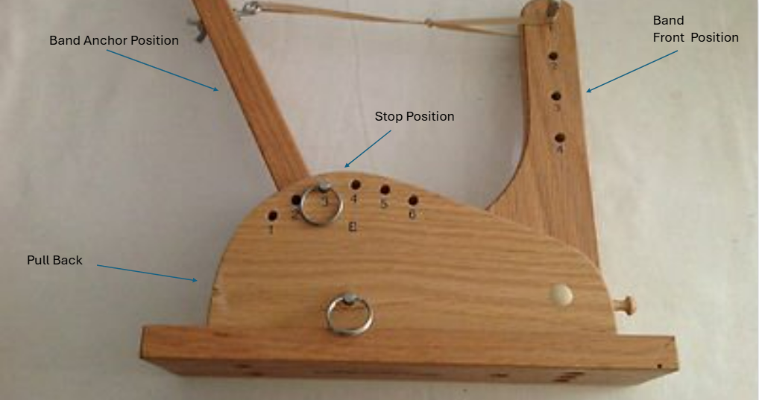
Figure 1- Labelled Catapult System [3]

2 Method and Equipment

2.1 First Launch Experiment
To start this experiment 8 experiment launches with variable launching methods and operators was undertaken to understand the best positions to assemble the catapult equipment to ensure successful test results as well as the most successful operator. For this procedure a catapult was used as the launching platform with a G clamp which enabled the launch to be conducted without the system moving edging forward and hence affecting the reliability of the test results. 3 results were recorded, and an average was therefore taken from this to get an accurate and consistent result from each firing. A ball was launched by the catapult and a measuring tape used to measure the distance at which the ball travelled through the variable positions. This is demonstrated in table 1 below.
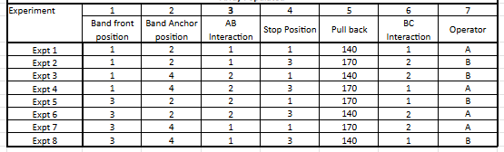
Table 1-First Launch Experiments

2.2 Second Launch Experiment
A further 12 launches were conducted using the same equipment as the previous launches, the most successful operator was used for these 12 launches. There were 4 experimental firings and completed 3 firings for each experiment to get an average distance which the ball travelled. The catapult positions were based off the successful launches from the first 8 experiments, and this can be seen below in table 2.

Table 2- Second Launch Experiment
Experiment | Band Front  Position | Pull Back | Anchor  Position | Stop Position |  | Result 1 | Result 2 | Result 3 | Average
Firing 1 | 1 | 140 | 2 | 3 | Range
Firing 2 | 3 | 140 | 2 | 3 | Range
Firing 3 | 1 | 170 | 2 | 3 | Range
Firing 4 | 3 | 170 | 2 | 3 | Range

2.3 Third Launch Experiment
There was one final launch experiment, and this was using the best test results gathered from the first 2 launch experiment tables and used the most successful operator. There was a target of 150 set for this experiment. There were 3 launches completed to gather an average which was similarly completed to the previous launch experiments, for this firing a target for successful launch was projected prior to starting. This can be viewed below in table 3.

Table 3-Third Launch Experiment
Experiment | Band Front  Position | Pull Back | Anchor  Position | Stop Position |  | Result 1 | Result 2 | Result 3 | Average
Firing 1 | 2 | 155 | 2 | 3 | Range

3 Experimental Data and Interpretation of Results

3.1 First Launch Experimental Data and Results
The data gathered from the first launch experiment gave a grounding for the second and third launch experiments conducted. This enabled experimenters’ to understand the most accurate operator and from the results displayed in table 4, it is determined that operator B was the most accurate and displayed a further range during firing. The results shown demonstrate that the 170 pullback allows the ball used to travel further and hence recorded better average range. Operator B demonstrated a greater consistency level to operator A which is demonstrated in table 4. It can also be determined from table 4 that band front position 1 and anchor position 2 provide the elastic band with greater strain and therefore this allows the arm of the catapult to propel the ball forward at a fast rate and a greater distance. The best result achieved was the second firing as this produced a range of 306.33cm as seen below in table 4.

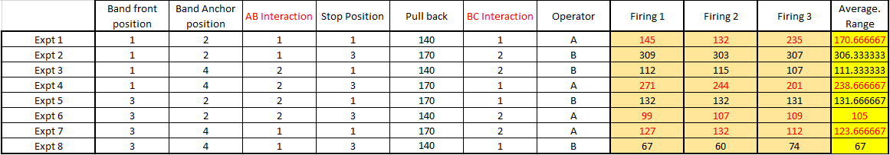
Table 4-First launch Experiment Results

3.2 Second Launch Experiment Data and Results

The second experiment consisted of taking the most successful results from the first experiment and using the same operator to ensure accurate and consistent results were achieved. This consisted of using the best variable launching positions that were achieved during the first launch experiment. For this experiment anchor position 2 and stop position 3 was set for all firings. The greatest average result as seen in table 5 was firing 3 as the ball travelled an average distance of 261.67cm across the three firings.

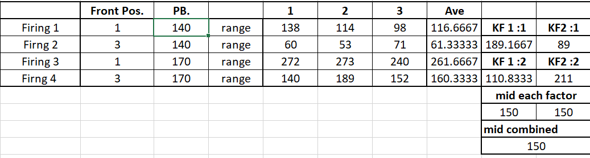
Table 5-Second Launch Experiment Results

3.3 Third Launch Experiment Data and Results
The third and final launched consisted of taking the data captured from the second experimental catapult launch and using this to achieve an overall average that would meet the 150cm target set. For this experiment anchor position 2 and stop position 3 was set for all firings. The front position for this was set to position 2 and the pull back was set to 155 and the front position set to two as these results were both based off the last experiments averages to obtain accurate results. Table 6 demonstrates the results gained from the 3 firings and it can be viewed that the target was not met with an average of 132.33 cm the range achieved.
Table 6-Third Launch Experiment Launches

4 Key Control Factors From this Experiment
Key Control Factors | Mitigation
Operator selected | Automated catapult system
Stable catapult system | G clamp onto robust object
Ball weight | Undertake experiment using a ball with sufficient weight
Personnel undertaking the experiment | Personnel that are trained and understand the system
Table 7-Key Control Factors

4.1 Operator Selected
The operator was an important factor which affected the accuracy of the results collated during the experimental process. This is primarily due to a range of human factors that each individual operator may be faced with whilst striving to achieve accurate results such as concentration and the accuracy of the pull back angle. This factor could be eliminated by introducing an automated catapult system which could perform without human interaction and therefore reduce human influence during system firing.

4.2 Clamped Catapult System
The benefit to clamping the catapult system to an object is that it allows the user to accurately direct the ball in a straight and forward direction without the system edging forward or backward during the firing process. This therefore allows for accurate data to be recorded across each of the firings. The catapult was clamped to a table during the experiment which provided the the catapult to be strong and sturdy especially during the firing stage. However, the clamp was attached to the system too tightly and impacted the rear end of the system and caused for this to raise slightly due to strain pressed on the rear end of the system. Figure 1 shows the G clamp which was used throughout the experimental firings.

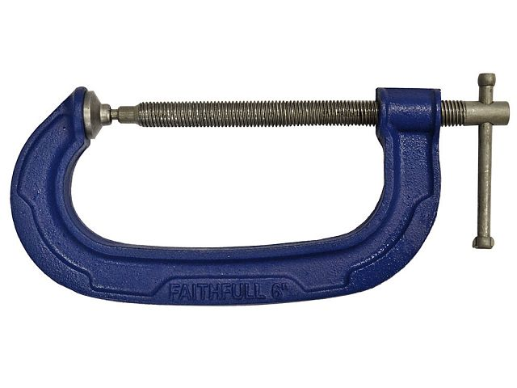

Figure 2-G-Clamp [4]

4.3 Ball Weight
The ball weight is a significant control factor which needs serious consideration to undertake this experiment accurately. If the ball is too heavy this therefore restricts the catapult from projecting the ball into the distance at which the catapult can perform at. For this experiment the ball was too heavy for the catapult to perform at its capability and therefore did not allow for accurate results to be represented during the experiment.

4.4 Personnel Undertaking the Experiment
The personnel undertaking the experiment is another control factor which was considered during the experiment, this is due to human error leading to the catapult system set-up being avoided and more accurate results being produced. If the catapult system was not set up correctly this would mean the system would be restricted from performing at its potential range and could not propel the ball as far a distance as possible.

5 Conclusion and Reflection
In conclusion the Taguchi catapult experiment was conducted unsuccessfully as the target distance was not achieved during the final launch average. This was down to a range of control factors but particularly stated in section 4 of this report and for future firing these will be considered to ensure credible results are obtained.
Should this experiment be to be repeated, the control factor mitigations would be implemented to analyse and conduct accurate experiment that achieves the specified target distance. All operators would be suitably qualified to undertake this experiment and have a full understanding on how the system operates. The ball used would be at the correct weight for optimal performance and the system would be G clamped to a robust surface which can handle the strain of the catapult during the firing process. Finally, a competent operator would be selected to ensure the system is being fired correctly and supply the best opportunity for results to be credible.

References

[1] | C. S. Z. Z. H. W. a. Y. L. Ning Li, “A review on mixture design methods for geopolymer concrete,” Composites Part B: Engineering, vol. 178, 2019.
[2] | Quality Inspection.org, “How The Taguchi Method Leads To Consistently-Manufactured Products,” Quality Inspection.org, [Online]. Available: https://qualityinspection.org/taguchi-method-consistently-manufactured-products/#:~:text=The%20Taguchi%20method%20is%20a,into%20it%20in%20detail%20here.. [Accessed 16 April 2025].
[3] | Wordpoint Logo, Wordpoint Logo, [Online]. Available: https://www.worthpoint.com/worthopedia/ncmr-wooden-statapult-catapult-2003-411198554. [Accessed 16 April 2025].
[4] | Faithful Quality Tools, “G-Clamp Heavy Duty,” Faithful Quality Tools, [Online]. Available: https://www.faithfulltools.com/p/FAIG2/G-Clamp---Heavy-Duty. [Accessed 16 April 2025].

