

Effective Team Working and Communication
BMSW4002

Student Name : Cadyjatu Balde
Student Number : 1815903
Teacher: Dr. Gulnar Ali

University of Wales Trinity Saint David – London Campus

Introduction

The following is a report about effective team working and communication. This is an evidence and indication of how the demonstration of skills is put into practice in a workplace. I will be guiding you and analysing communication while giving a brief description and examples of how we use it without even knowing. This will mean I will also give advices on how this can be improved if used wrongly. I will start of by describing what we mean by communication. Describing the models and relevant theories of communications and methods also. Then I will give out my own experience and how I handled it while using one of the model of communicating and finalise this report with a conclusion of this report.

How can we make communication amongst us be successful?

I will start out by defining the word communication and giving examples. Communication is easily a information process which is eventually transferred between people through a system. This can be symbols , written and verbal. We have different types of relevant theories, starting with Shannon and Weaver communication. I will start out by describing two of the most well known form models of communication and these are Shannon and Weaver and Schram.
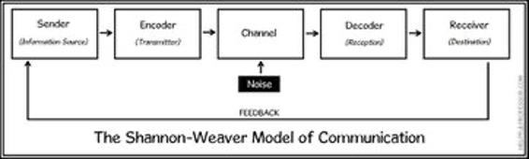
Shannon and Weaver is known to be the most used model of communication amongst people today, because who doesn’t use phones or any digital device? It was first proposed in 1948 . This model is also known for being broken down to 7 different concepts and these are , sender, encoder, channel, noise, decoder, receiver and feedback. However feedback was added as a seventh concept by Warren Weaver . It explains how a message can be easily misinterpreted while in the process of being sent to the receiver. In here I will be showing a graph explaining more how it works.

The sender as we can see is the person who is about to send the message across or holds the information, he/she/it will choose how to interpret a message to the receiver. This can be send in many different ways such as verbally , non verbally and through a phone message, call or even video chat. We then move to the Encoder also known as the transmitter. This is where the message is being changed up into signals. This can be any sort of code such as binary digits or radio waves. The following is the channel, this is the method used for the information you’re trying to get across , it can be landline and via internet and much. Feedback was not introduced until later on. This happens when the receiver responds to senders message in order to conclude the communication. They will respond to let the sender be aware that they have received the message passed through to them. they will also give feedback towards how the message was successfully received and if there were any misspelled words… This will only occur when having a chat between people such as friends, family member and such through digital, letters, facial expressions or body language. This was added by Weaver in response of criticism of the linear nature of the approach which means that the message was only being transmitted one way.
Noise is also part of this meaning that the message being sent can get interrupted if there is a mistake with the decoding the message and this can include a misspelled word in a text or when someone misinterprets a sentence when reading something. But when on a call surrounding noise can also be part of this as its interfering with the message being sent making the receiver have trouble hearing. Decoder comes next and it’s the exact opposite of encoding. When this model was made it was more influence by devices such as telephones or any digital device. So what the decoder does it decodes the binary codes or sound waves into pixels on a device screen that turns it into words or speech used in voice notes. Then lastly we have the receiver the end point of this model. This is where the person gets the message.
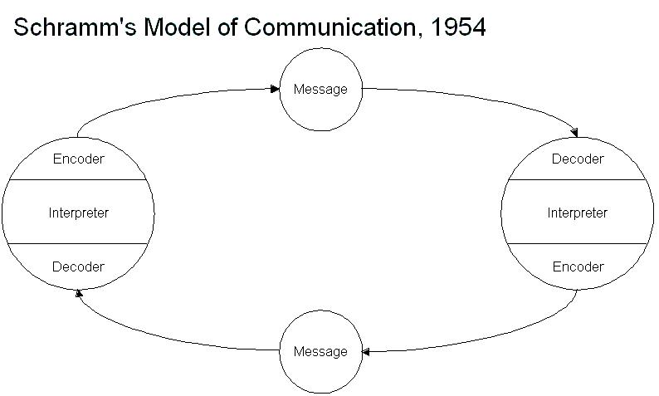
We know move into Schram model of communication which is nothing but circular communication. This basically means that there’s only a sender and a receiver in this model rather than being like the Shannon and Weaver model which had six concepts that then turned into seven later on.. This method of communication only requires two participants. This model of communication is most used when talking with someone face to face. I will show a brief diagram of this model down below.

It provides an initiative and clear approach of communication amongst both participants while each one of them shares their feedback equally. But of course there will be a down side for this model. How a person will interpret the message received can always vary that’s why the biggest focal point of this model is the interpretation of the communication.

Now lets talk about how noise can interfere between encoded and decoded messages. Not just any noise such as physical noise. Noise is anything that disrupts the communication being held. Its anything that prevents a message being received they way that they were intended to be received. Examples of different noises are internal and external noise. Internal noise occurs when the senders makes a mistake encoding the message or vice versa. Misspelling can be one of the examples for internal noise when communicating. External noise happens when a message is trying to get across and this most of the time include phone calls or video calls and this may include failed/poor internet connection. Bad signal on the line due to interruptions and much more.
Encoding is simply the process of turning what we think into communication while decoding is turning what we call communication into thoughts and putting it into practice. Encoding uses phone calls, text messages, face to face communication which then travels throughout a sensory route or channel to be delivered to the receiver. Encoding is most used in models such as Shannon and Weaver which have more than two concepts in them.
While on the other hand decoding uses communication into thoughts. This can be a definition of a the receiver interpreting the message and coming to a conclusion of the meaning of the message. These sensory routes can be sight, touch, smell taste or sound but most communications occur through visual or auditory channels. For example if you’re trying to get a hold of a friend which is with you but too busy on their phone, the best way to get their attention is by using body language such as waving your hands or touching them. However sometimes it can be difficult due to difficulties either the sender or receiver may have.

Other methods of communications are the ones we all know about which are verbal, written, non verbal and such. We use one of these everyday even if its once. Like non verbal communication is where you use more body language. Its basically when you listen, pay attention, move and then react and then verbal is how you express your message across with your tone of voice, gestures.

The importance of effective communication ( my own experience example in a workplace)

Most of the time in my workplace I use the model Schram as there is only two participants. If you didn’t know I work at a hotel as a receptionist and in the hotels bar also when we are short of members. My job allows me to have a one to one conversation with guests basically everyday meaning I’m always around people all around the world. I constantly meet guests who English isn’t their first language which can sometimes be very hard for me to understand their needs and what they are requesting also guests who have zero waiting tolerance and start t become aggressive towards the staff and rude.
After being three months in the job you get removed from being part of the trainee program and now you are an employee like the supervisors and have the same duties and roles as them. While on my first week as a non trainee there was something that had happened. During my shift seven already checked in men came down to reception where me and my colleague were .They arrived very frustrated and agitated, screaming at us and not being cooperative about the matter. Both me and my colleague couldn’t understand what message each men was trying to get across due to all of them talking in high pitch at once which left me without an excuse but to raise my voice slightly to get their attention. After having all of their attention drawn to me and my colleague, I asked them what the matter was and they simply explained it to myself and my colleague . The problem was that these seven men were charged double on their own credit cards when in fact their staying was already pre booked by their companies which meant no payment was needed to be taken. This was not the first time this had occurred. I kindly apologised to the gentlemen and made them assure that the money would be refunded to them as soon as possible. That made them be more relieved and calm. After this matter was fixed I had to investigate what had happened.
The previous shift , as in the morning shift made these mistakes. I don’t blame them for this. However if this matter was not handled professionally and calmly it could lead to something else because of a little mistake made in the previous shift about misunderstanding on how to handle different types of payments had me and my colleague to sort out a huge problem. The message shown on the system was misinterpreted which then lead to this problem. They rushed the work and checked ins and made mistakes. If it was read and scanned with cautious there would be no complaining.

I of course had to record about this matter to our management as its my duty. When speaking to the manager the next day I explained to him what had happened. I guided him by the steps and how this problem occurred while having a clear toned voice which he could understand. I spoke to him in English even though he speaks the same language as me (Portuguese) and I only did this because another supervisor was in the room taking notes of the situation. We used verbal communication as you can see. I kept it simple while detailed and formally afterwards he checked the cameras just for evidence and to back up my story which at the end it turned out to be true. This was how my communication with my management and my the employee worked out. This mistake as you can see includes noise which interfered with the message being transferred to my shift .

Conclusion
To conclude this report I have explained different types of model of communication while giving a brief description. I also gave out examples of how these are put into practice while giving out examples. Yes I can say we do use these mostly and I have described the most used methods of communication models that we all use step by step. I’ve also added diagrams to show and make it more clear to who’s reading this. I also talk about how we use different methods of communication to make it successful. Then I move on to talking about my own workplace experience and how much of a problem misinterpreted communication can cause at a time it can be small but later on it will be huge. I also explained how I communicate with my manager and other higher in the job than me.
References
Websites

(21-12-2019 ) https://www.merriam-webster.com/dictionary/communication

https://helpfulprofessor.com/shannon-weaver-model/

https://study.com/academy/lesson/osgood-schramm-model-of-communication-definition-application.html

https://ecampusontario.pressbooks.pub/commbusprofcdn/chapter/1-2/

https://www.marketingstudyguide.com/communications-process-encoding-decoding/

In class work sheets scans



