LastMinuteGames Trading and Classification

- Mission Statement

We are on a voyage to create an immersive world and unforgettable experiences by crafting unique mechanics with awe-inspiring narratives. We aim to create engaging and unpredictable gameplay to our players and commit fully to creativity to reshape the rogue-like genre.

- Naming

Our legal name will be LastMinuteGames Limited – I have searched the Companies House and found that his is not taken.
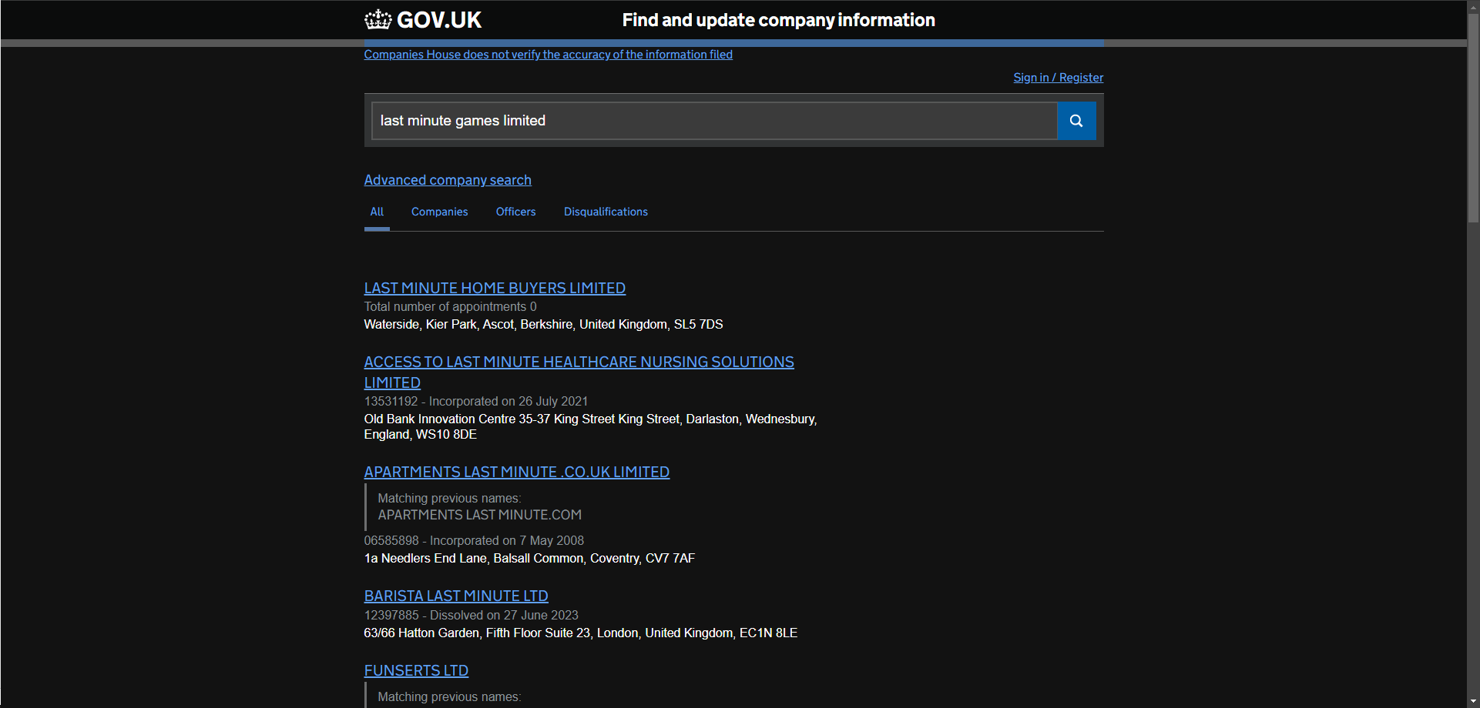

- Objectives and Values

Objectives:

Innovate Gameplay: Implement exciting gameplay mechanics of which are totally foreign from the rogue-like genre to spice up each playthrough.
Procedural Generation: Develop our Procedural Generation Algorithm to create dynamic and diverse maps to foster replayability and ensure a unique experience every time.
Compelling Narrative: Integrate engaging narratives into the genre allowing players to discover interesting stories that react depending on their choices.
Community Engagement: Foster a supportive and committed community Continuously innovate the games by acting upon player feedback, keep up consistent updates and transparent communication to fans.

Values:

Creativity: Inspire creativity and innovation within the team to push the boundaries of the conventional rogue-like genre.
Player-Oriented Approach: Respect the players’ time by ensuring their experience is enjoyable, challenging and rewarding at the same time.
Excellence: Aim to create the best product possible, in every aspect, from game art, to character design, enemy encounters and the narrative, we want to release a high quality and rogue-like every time.
Adaptability: Keep games relevant by harbouring a mindset mentality within team members to keep to the front of the rogue-like industry trends.

