

Assignment Title: Employability Skills Assignment
Student Name: Edwin Akaolisa
Student Number: 2508937
Module Code : LCLM4005

Lecturer's Name: Trinh Nguyen Thi Ngoc

JOB ADVERTISEMENT

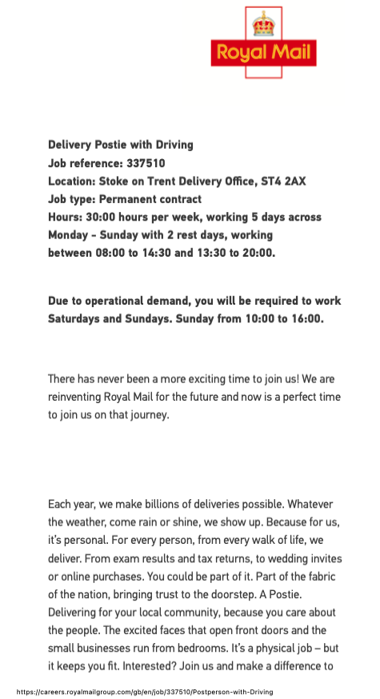

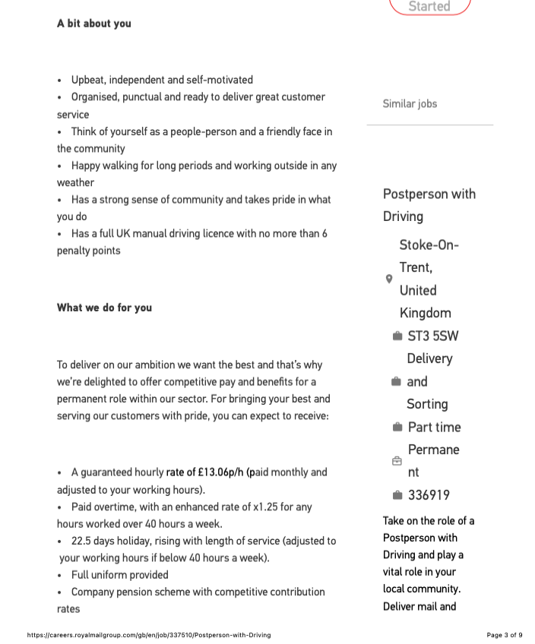

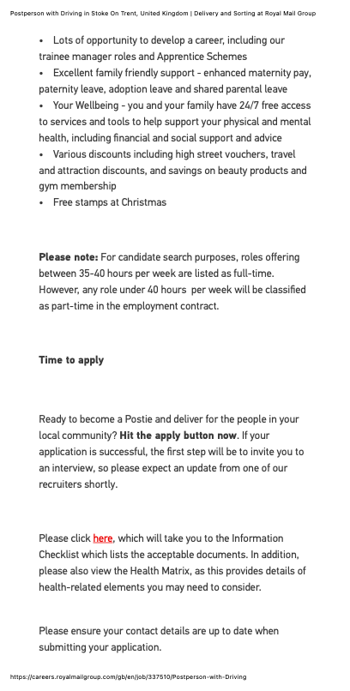

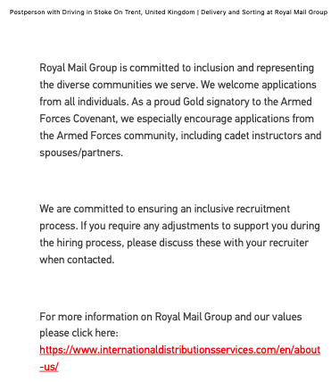

Amazon Flex Delivery Driver – Stoke-on-Trent
Location: Stoke-on-Trent
Role: Self-Employed Delivery Driver (Amazon Flex)
Pay:
- Earn approximately £14–£18 per hour (before vehicle running costs and taxes). Actual earnings depend on the delivery block accepted.
- Weekly payments direct to your bank account.

About the Role
As an Amazon Flex Delivery Partner, you'll use your own vehicle and a smartphone to deliver Amazon parcels to customers. You choose when you work by accepting delivery blocks through the Amazon Flex app.
You are self-employed, meaning you control your schedule but are responsible for your own tax, National Insurance, fuel, insurance, and vehicle maintenance.

Key Responsibilities
- Collect parcels from the Amazon delivery station.
- Load your vehicle efficiently.
- Deliver parcels safely and on time.
- Use the Amazon Flex app for navigation and proof of delivery.
- Provide excellent customer service.
- Follow all road safety and delivery procedures.

Requirements
- Minimum age: 18 years
- Full UK driving licence.
- A suitable vehicle (typically a 5-seat car, SUV, estate or van).
- Smartphone (Android or iPhone).
- Right to work in the UK.
- Pass Amazon's background checks.
No previous delivery experience is normally required.

Working Hours
Flexible delivery blocks are available throughout the week, including:
- Morning
- Afternoon
- Evening
- Weekend
You choose which blocks to accept based on availability.

Benefits
- Flexible working around your existing job or studies.
- Choose your own schedule.
- Weekly payments.
- Know your earnings before accepting a delivery block.
- Access to partner discounts on fuel, shopping and other services.

Things to Consider
As a self-employed driver, you'll need to cover:
- Fuel or charging costs.
- Vehicle maintenance and tyres.
- Insurance (including hire-and-reward insurance where required).
- Income tax and National Insurance.
Availability of delivery blocks can vary depending on demand, and some drivers report that popular blocks are claimed quickly. Local reviews also mention that routes and parcel volumes can vary significantly.

Typical Driver Feedback (Stoke-on-Trent)
Drivers commonly mention:
- Good flexibility for earning extra income.
- Friendly depot staff.
- Wear and tear on personal vehicles.
- Variable route lengths and parcel volumes.
- Best suited as a side income rather than guaranteed full-time work.

Task A: Compare Two Job Adverts

Comparison of Job Adverts
This assignment compares two delivery driver vacancies: Royal Mail Postperson with Driving and Amazon Flex Delivery Driver, both based in Stoke-on-Trent. Although the jobs are offered by different organisations and have different employment arrangements, they require many of the same skills and knowledge.
The Royal Mail role is a permanent position with contracted working hours, paid holidays, pension contributions and career development opportunities. Employees are expected to work five days per week, including weekends when required. The role involves delivering letters and parcels, providing excellent customer service, and walking long distances in all weather conditions.
In contrast, Amazon Flex is a self-employed role where drivers choose their own working hours through the Amazon Flex app. Drivers use their own vehicles to deliver parcels and are responsible for paying their own fuel, insurance, taxes and vehicle maintenance. The role offers flexibility but does not guarantee regular work or employee benefits.
Despite these differences, both adverts highlight several common skills and knowledge areas.
The most important shared skills include:
- Excellent customer service
- Good communication skills
- Time management
- Reliability and punctuality
- Safe driving ability
- Organisation and planning
- Ability to work independently
- Following health and safety procedures
- Problem-solving skills
Both employers also require applicants to have:
- A full UK driving licence
- Knowledge of road safety
- Ability to use mobile technology for navigation and deliveries
- Physical fitness to complete deliveries
- A positive and professional attitude
One of the most important skills is time management. Delivery drivers work with strict schedules and must ensure parcels are delivered safely and on time. Poor time management can lead to delayed deliveries, dissatisfied customers and reduced productivity.
In a future delivery role, time management would help by allowing deliveries to be completed efficiently while maintaining excellent customer service. Planning routes carefully, organising parcels before leaving the depot and responding calmly to unexpected delays would improve performance. Effective time management would also reduce stress, increase productivity and help achieve delivery targets.
Overall, both job adverts demonstrate that successful delivery drivers require strong customer service, organisational skills, safe driving knowledge and the ability to work independently. These transferable skills are valuable across many employment sectors.

Task B: Self-Assessment Using SWOT Analysis
A SWOT analysis is an effective method for evaluating personal strengths, weaknesses, opportunities and threats. It helps individuals understand their employability and identify areas for personal development.

Strengths
I found myself as a person with good communication skills. Effective communication is essential when interacting with customers, colleagues and managers. Being polite, respectful and able to listen carefully helps build positive relationships and resolve issues quickly.
Another strength is reliability. Completing tasks on time, and following instructions demonstrates professionalism and responsibility. Employers value dependable workers because they can be trusted to complete their duties without constant supervision.
Adaptability is another important strength. I am able to adjust to different working environments, changing schedules and new technology is valuable in modern workplaces. Both Royal Mail and Amazon Flex require employees to adapt to different delivery routes and customer needs. I also possess a good organisational skill also contribute to employability and planning work effectively helps improve efficiency and reduces mistakes.
Finally, willing to learn is my significant strength. I can develop new skills through training and accept constructive feedback that demonstrates commitment to continuous improvement.

Weaknesses
Although there are many strengths, there are also areas that require improvement.
One of my weakness is limited professional work experience within the delivery industry. Practical experience would improve confidence and understanding of customer expectations.
Another weakness is public speaking confidence. While my communicating skills with customers is comfortable, speaking confidently in front of larger groups can be challenging, but I am gaining the confident through making presentations at my university. Occasionally, my perfectionism can also slow task completion because extra time may be spent checking work.
I am attempting to advance my digital skills, particularly when learning new workplace software or technology quickly because developing these areas would improve my overall employability.

Opportunities
There are many opportunities available to improve for my future career prospects.
Completing additional training in customer service would improve my interactions with clients, leading to better feedback. Training and becoming a health and safety and first aider would strengthen my employability.
Obtaining experience through part-time employment, volunteering or temporary delivery work would provide valuable practical skills. Many employers also offer internal training and promotion opportunities, which I will join whenever the opportunity comes.
Royal Mail, for example, provides apprenticeship programmes and career progression into supervisory roles. Technology also creates opportunities for online learning through free courses in communication, teamwork, leadership and digital skills. Networking with employers and attending recruitment events could increase my future employment opportunities, and I am willing to tap into the mention opportunities whenever is available.

Threats
Several external factors may affect future employment. Competition for jobs is increasing as more people apply for similar roles. Economic uncertainty may reduce recruitment opportunities within the industries. Rapid technological developments require employees to continually update their digital skills. Changes in fuel prices and living costs may also affect self-employed delivery drivers, particularly those working for Amazon Flex. Finally, maintaining good physical health is important because delivery work requires lifting parcels, walking long distances and driving safely for long distance.

Evidence of Readiness for Employability
I am attending the level 4 course at University of Wales Trinity Saint David, which provides me fundamental knowledge in terms of business and management domain. In addition to that, this course also equips me with different transferable and digital skills such as Teamworking and Communication, Employability and Career Development, using Microsoft Word, PowerPoint and online learning platforms. These skills is increasingly important in modern workplaces.
Preparing my CV, Cover letter, learning more about interview technics, and as a business student doing my assignments independently has improved my organisational and time management skills. Balancing multiple deadlines demonstrates my responsibility and self-discipline, all the mention update demonstrate my readiness for Employability.
Working on group projects has strengthened my communication, cooperation and leadership skills. Sharing ideas, resolving disagreements and supporting other team members demonstrate the ability to work effectively within a team. Everyday responsibilities such as managing personal schedules, travelling independently and communicating respectfully with others also demonstrate maturity and responsibility.
Positive feedback from tutors often highlights punctuality, good attendance and commitment to completing work to a high standard. These qualities are highly valued by employers, because this is the skills they expect from my character/ work references when they write them
Overall, this evidence demonstrates readiness to enter employment while recognising that continued learning and practical experience will further improve my career prospects.

Task C: Employment Goals and Personal Development Plan

Employment Goals

Short-Term Goal (Within 12 Months)
My plan is to secure employment as a delivery driver to gain practical workplace experience. This goal is important because it will improve confidence, customer service skills and professional experience while developing knowledge of workplace expectations.

Long-Term Goal
Progress into a supervisory or management position within the logistics, delivery or transport industry. This career path offers increased responsibility, leadership opportunities and professional development. Achieving these goals will provide my financial stability, continuous learning, and opportunities for career progression.

Personal Development Plan
Weaknesses | Action | Timeline | Resources | Success Measure
Limited delivery experience | Apply for part-time delivery and update  My digital skills | Within 6 months | Job websites, CV, applications | Secure employment
Public speaking confidence | Practise presentations and communication | 6–12 months | College presentations, online courses | Increased confidence
Advanced digital skills | Complete Microsoft Office and digital skills training | 3 months | Microsoft Learn, LinkedIn Learning | Certificates completed
Time management | Use a planner and prioritise tasks | Ongoing | Calendar, planner apps | Meet all deadlines consistently
Industry knowledge | Research logistics and transport careers | Ongoing | Company websites, professional articles | Improved interview performance
Following this personal development plan will improve my employability by developing practical experience, confidence, communication and digital skills. Regular reflection and continuous learning will support long-term career success.

References:
Amazon Flex (2024) Amazon Flex Delivery Driver Opportunities. Available at: https://flex.amazon.co.uk (Accessed: 2025).
Royal Mail Group (2024) Postperson with Driving Job Description. Available at: https://careers.royalmailgroup.com(Accessed: 2025).

