DS 1 Template

My Screenshots/Photos

Screenshot/Photo 1
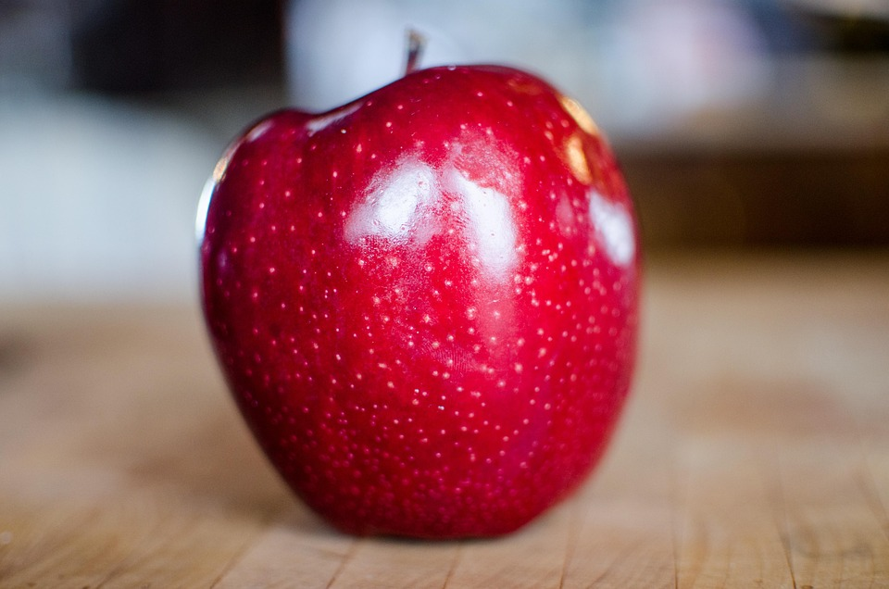
Apple is healthy, and I went on Internet to download the picture to paste it here

Screenshot/Photo 2
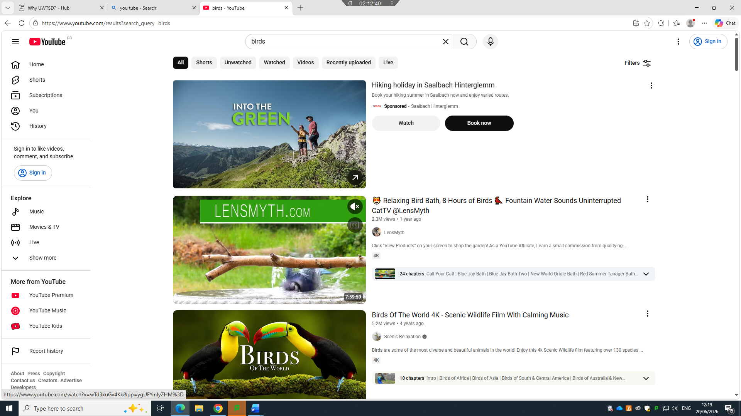
I love birds and to watch beautiful videos about birds, I go on YouTube

Screenshot/Photo 3
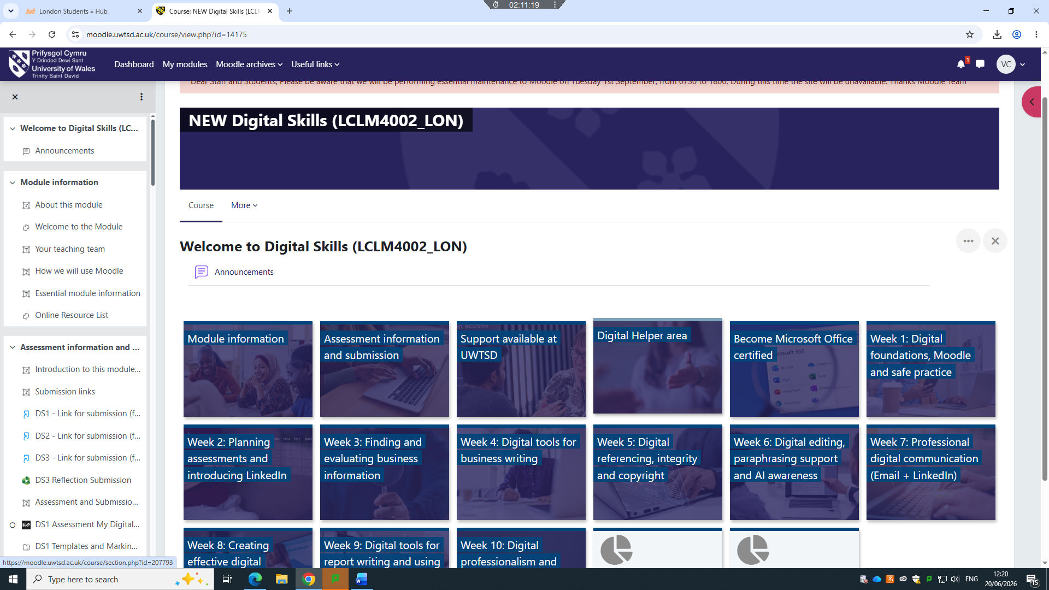 At university for my studies I use Moodle and this is accessible online, Moodle is helpful because that’s where all my lecture notes are available

Screenshot/Photo 4
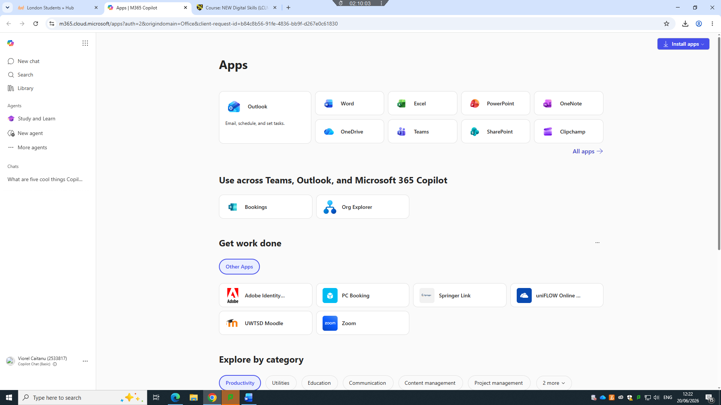
This screenshot is O365, from this point I can use different digital tools to be active using technology

Screenshot/Photo 5

[Write what this shows of your digital life]

Screenshot/Photo 6
[Insert Photo/Screenshot below]

[Write what this shows of your digital life]

