University of Wales Trinity Saint David
Faculty of Architecture, Computing and Engineering
School of Applied Computing

Implementing Web Application for Hair Salon Business

Student name: Gabor Jonas
Student number: 1705136

Module Number: ACCA5012
Module: Application Development
Lecturer: Kemi Ademoye

Submission date: 07/05/2019
Table of Contents
1. Introduction 3
2. Application Development Concepts 3
2.1 MVC Design Pattern 3
Application Security Vulnerabilities 4
3. Requirements 4
3.1 Introduction 4
3.2 Software requirements 4
4. Design 5
5. Implementation 5
5.1 Models and Views 5
5.2 Screenshots 5
6. Evaluation 17
6.1 User Story Acceptance Criteria 17
6.2 Reflection 17

Introduction
The purpose of this report is to give a basic explanation of web application design and development using Microsoft ASP .NET Core.

Application Development Concepts
OOP Design patterns solve common programming problems. Experienced programmers, after solving similar problems, invented reusable design patterns.

2.1 MVC Design Pattern
It was invented by Trygve Reenskaug in the 70s for Smalltalk. As the web has gained space in the late 2000s, it has become a standard.
The model - view – controller pattern is a tried and tested method of separating the user interface and application logic. The primary goal is to separate the code for displaying the user interface. Thus, modifying or extending it does not entail modifying or changing the application logic code.
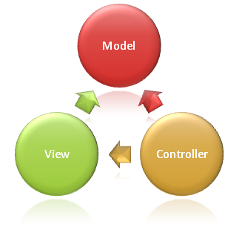
Figure 1 MVC components

Model
Data mapped and used in views are stored in instances of the model classes. The model can work from any data source, not just from relational databases.
View
The view is responsible for displaying the user interface to the user and pass on or receive data from the controller.
Controller
The role of the controller is to respond to user input, often making modifications to the model, depending on the input. Controllers take care of the application logic, process incoming data and provide outbound data for the appropriate View.

Application Security Vulnerabilities

Requirements

3.1 Introduction
Hair Studio application is suitable for hair salons businesses and hairdressers who would like to create an online presence to promote services and increase customer satisfaction.

3.2 Software requirements
Requirements are specified with agile user stories
Users
- Customer
- Admin
Features and user stories
- Staff page
  - As a user, I want to view the team so that I can decide which person to choose.
  - As an admin, I want to see the list of my staff so that I can manage them.
  - As an admin, I want to add staff to the page so that I can update the list when I hire someone
  - As an admin, I want to delete staff from the list so that I can remove someone who doesn’t work at the company anymore.
  - As an admin, I want to edit staff details, so that I can change her photo, bio or job role.
- Services page
  - As a user, I want to view the available services, so that I can decide which services are available.
  - As an admin, I want to see a list of the services, so that I can manage them.
  - As an admin, I want to add service to the page, so that it will be displayed to the user.
  - As an admin, I want to delete service from the page, so that it will not be visible to the customer if it is not offered.
  - As an admin, I want to edit service details so that I can change the price and duration.
- Registration
  - As a user, I want to register to the page so that I can book appointment.
  - As an admin, I want to register to the page so that I can manage the features.
- Login
  - As a user, I want to login to the page so that I can book appointment.
  - As an admin, I want to login to the page so that I can use my admin permissions.
- Mange user profile
- Book appointment

Design

Implementation

5.1 Models and Views
- Services
- Staff
- Appointments

5.2 Screenshots
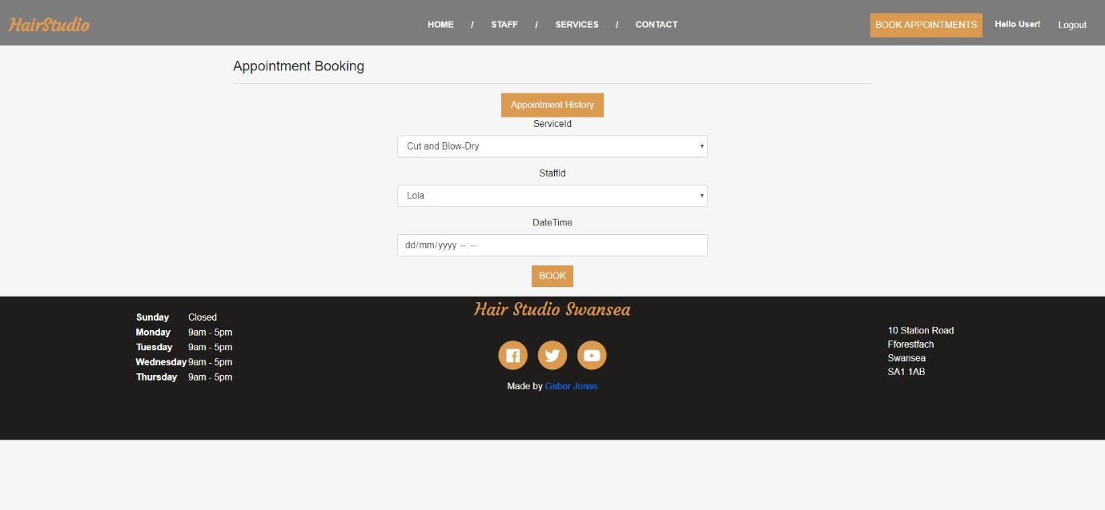
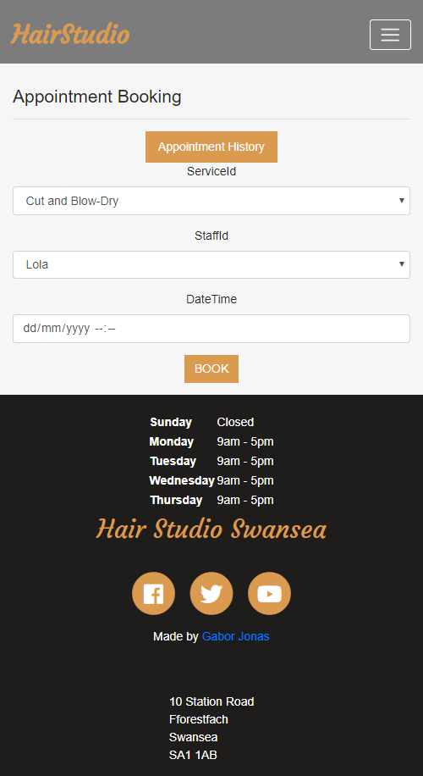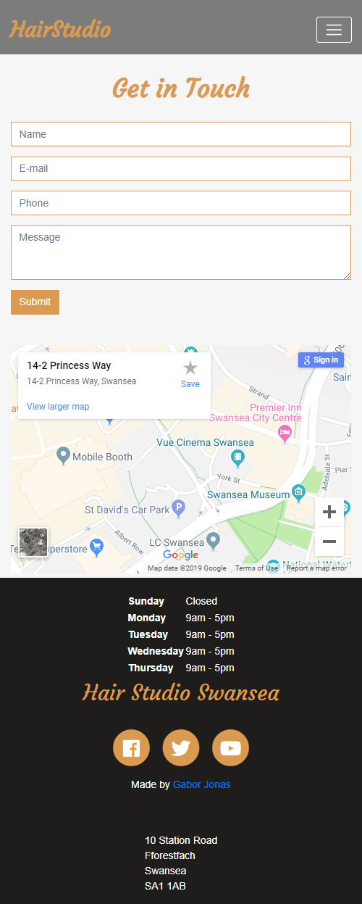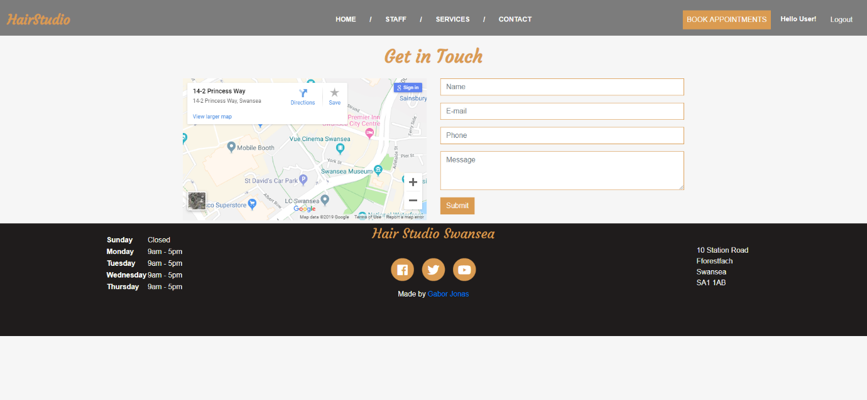
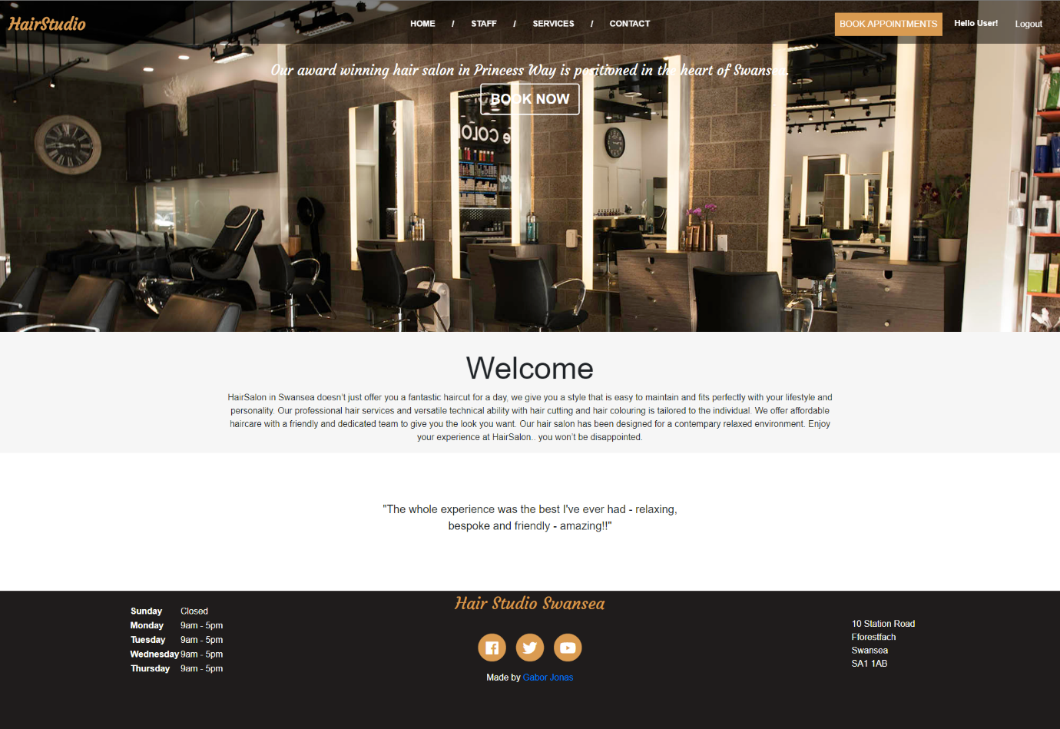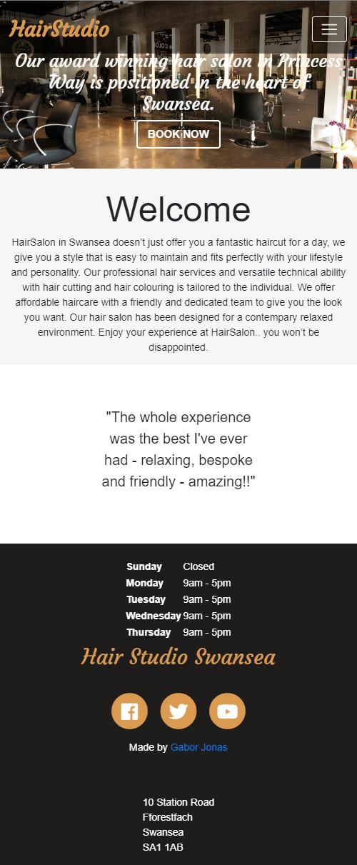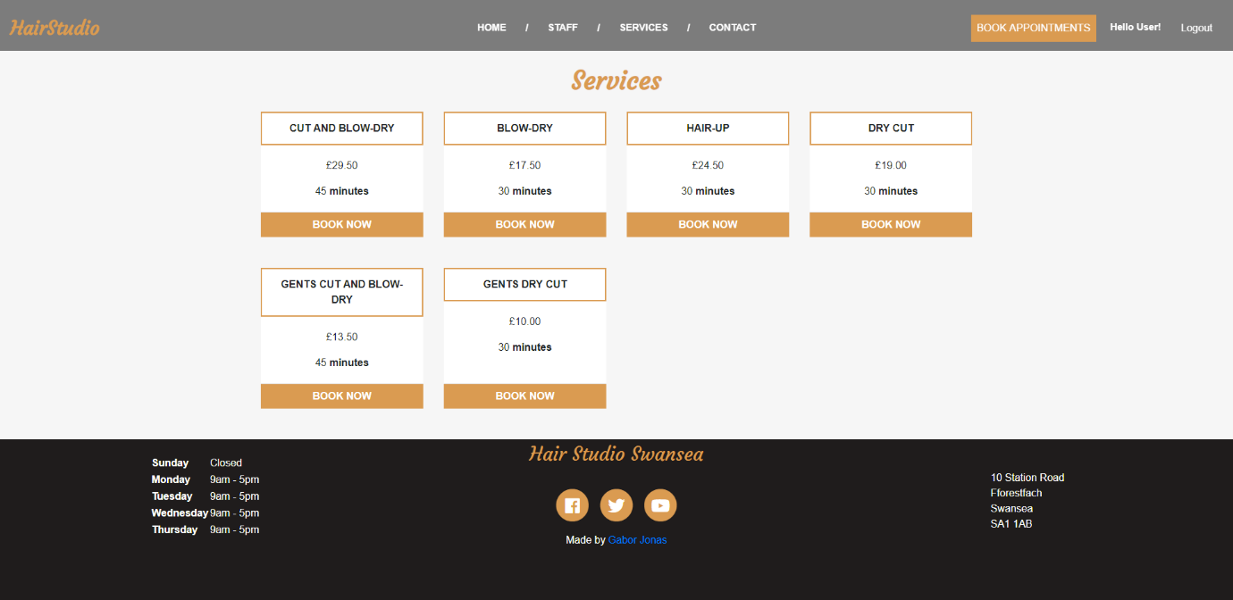
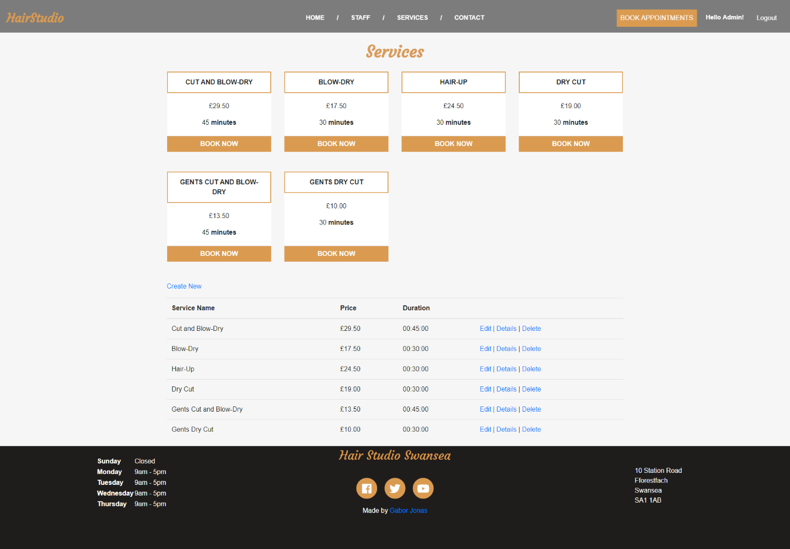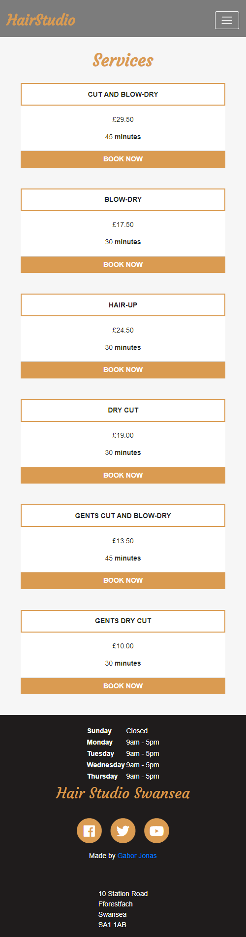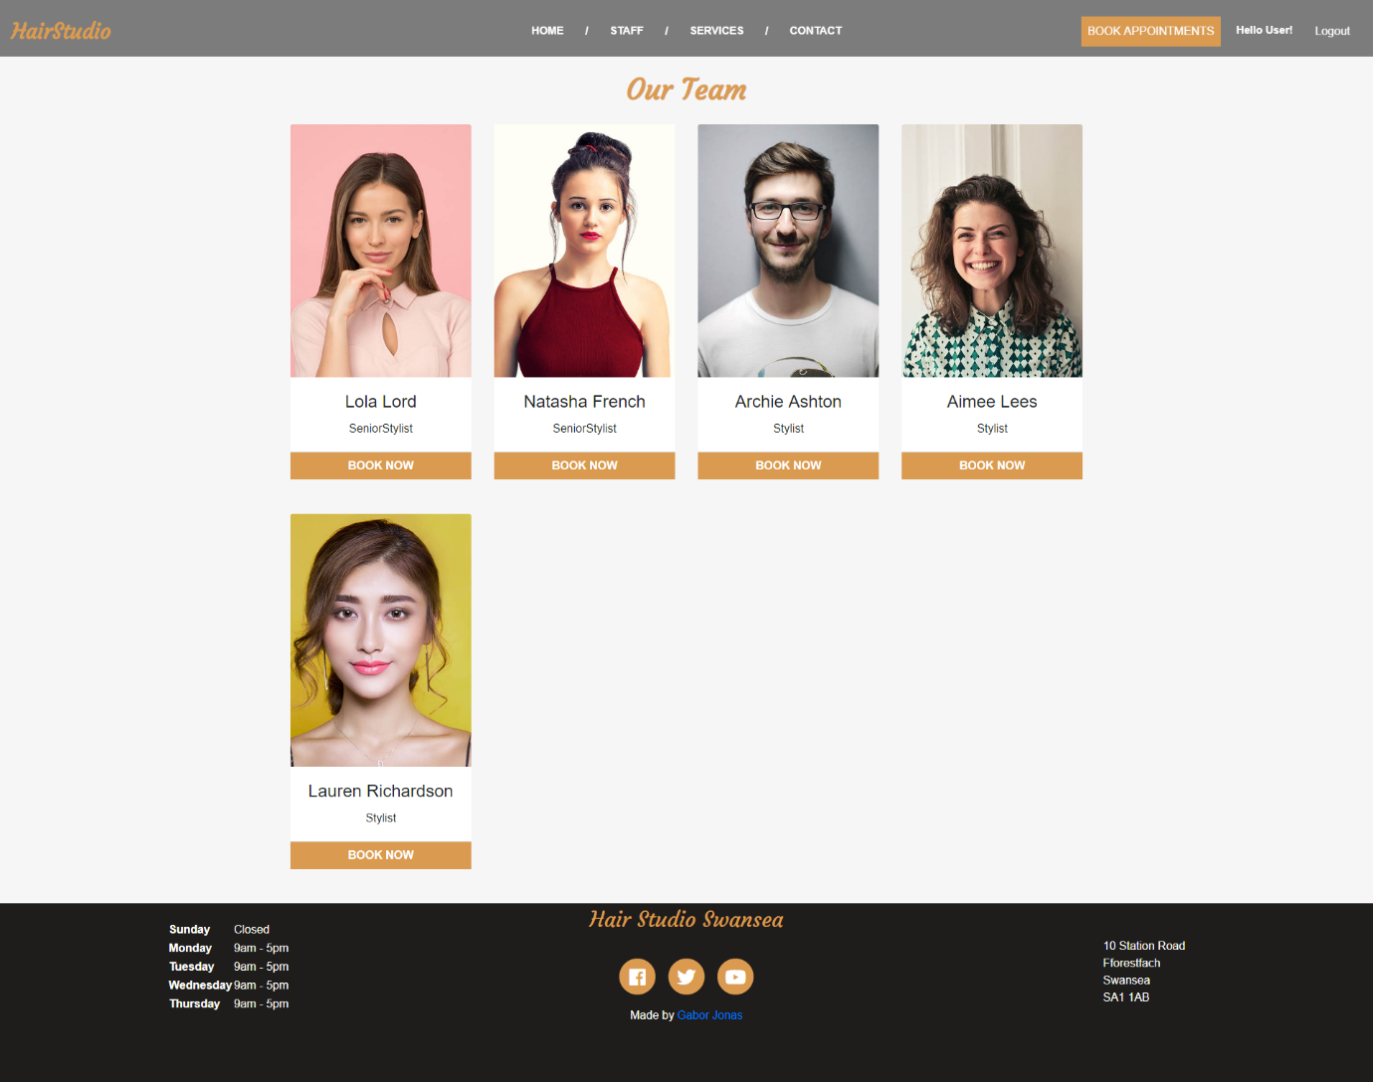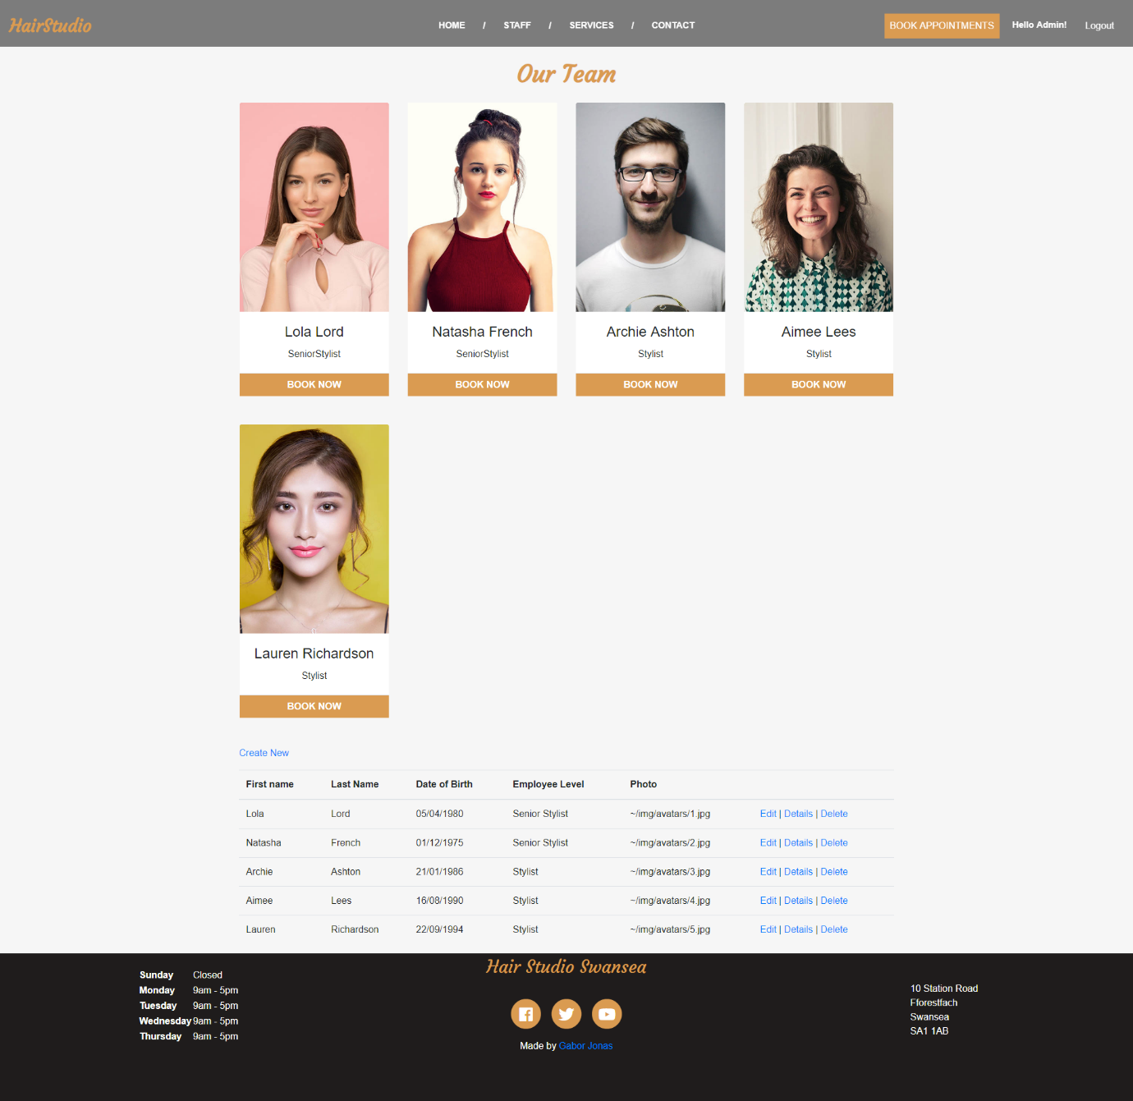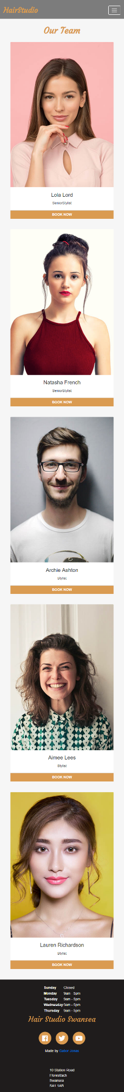

Evaluation

6.1 User Story Acceptance Criteria
As an admin, I want to add service to the page, so that it will be displayed to the user.
#001 | Admin enters staff details
Description |  | User enter invalid details
 |  | Test Steps:
1 | Form is displayed
2 | User leaves any input field empty
3 | User click on create

Response |  | Red warning should be displayed below the required field
Status |  |  | Date |  |  | Description
Pass |  |  | 07/05/19

As an admin, I want to edit service details so that I can change the price and duration.
#002 | Admin enters staff details
Description |  | User enter negative number as a price
 |  | Test Steps:
1 | Form is displayed
2 | User enters -5.00 in the price field
3 | User click on create/save

Response |  | Red warning should be displayed below the price field
Status |  |  | Date |  |  | Description
FAIL |  |  | 07/05/19 |  |  | The price can be set to negative

6.2 Reflection
- The image in the jumbotron have to be replaced. No text colour is visible on it, this is an accessibility issue.
- The admin table in each section is not responsive and user friendly on mobile device. There should be a separate admin menu instead of admin section each page.
- Appointments can be overbooked. The database design has to be changed, Staff should be scheduled in a rota table and have separate appointment slots for each staff that can be booked.
- Appointment booking is not user friendly. After choosing Staff, only the available booking slots should be displayed to the user.

Resources
- Google fonts – free
- Font awesome icons – free
- Pexels – Free stock fotos

