Daniels Zelinskis (2104718)
Computer Networks and Cybersecurity
Introduction to Web and Database Concepts
Beverley Holland
University of Wales Trinity Saint David

Contents

Introduction 3
Requirements 4
Implementation 5
Validation 6
Context diagram 8
Entity Relationship Diagram (ERD) 9
3NF 10
References 11

Introduction

A database is a collection of structured data or information stored electronically that is controlled by database management system (DBMS) (Database Management Systems, 2019). The database is made of five key areas: 1) hardware, 2) software, 3) data, 4) procedure and 5) database access language (Corporate Finance Institute, 2022). The aim of this project was to develop a user-friendly database that will the processing needs of growing “Dylan’s Book Store”. Therefore, the current project utilised the use of computerised data base with a range of attributions, including the collection of customers details, record of supply orders by staff, record of supple orders by customers and the newsletter release details. Dylan’s bookshop will benefit from the updated systemised scheme by time-saving algorithms that in turn will gather financial cost-effective techniques. The design of this project was developed based on the requirements and examples of the standardised bookstore database, including, but not limited to, book details, customer information and order history, with further modifications (Kondatek et al., 2018).

Based on the requirements of “Dylan’s Book Store” enquiry, the database was provided with a simple design, saving time, user-friendly interface, and customer and bookstore processing details. The menu-driven navigation systems allowed to process the information efficiently and effectively. Firstly, the database includes a customer form, that allows to gather customer information that could be also utilised to process customers interests for the newsletter. In addition, the customer database allows to store history of purchases that also links to the bookstore product store and purchase direction. The ability to edit or add/delete customer database allows data protection and the ability for customer to rapidly update the information upon their request. Secondly, a product form with the ability to add/edit the book stock that allows to track the inventory amount, details and general information of the bookstore, including price of the books. Thirdly, the database includes orders that allows to view the current and past orders. This feature would help to analyse and report financial income for the company. Within the order, the sale report describes the sales made on the day(s) that is linked to the stock inventory that could be updated.

Requirements

The current module “Introduction to Web and Database Concepts” allows to demonstrate the understanding of the concepts of database and the methodology of database design. The current module allows to develop and design a database for “Dylan’s Book Store”, a popular bookstore with increasing customer demands and book supply in Swansea, with the following requests:
- To computerise a menu-driven database for:

- Orders placed by staff and customers
- Friendly customer database
- National coverage
- User-friendly interface with the ability to add or delete information, view the database, view the ongoing customer orders, able to query and to print the reports.

- To maintain friendly service and customer care

Implementation

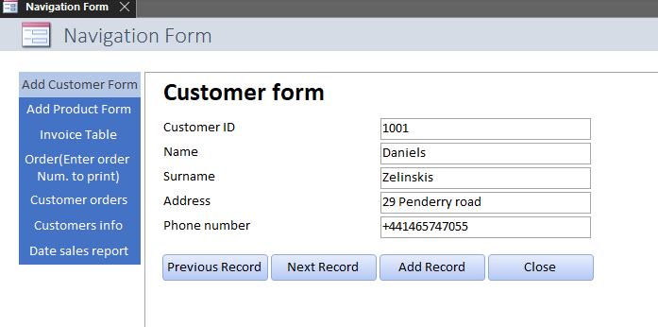
This data system was created at the request of Dylan’s bookstore in Swansea. It was created to manage and improve efficiency., and it was decided that all data could be managed by a menu. A screenshot of the menu you can see below:

This system includes all types of database objects, except "Modules", there are only 6 different objects in MS Access:

- Tables - is the basis of all bases.
- Queries - allows you to quickly perform the actions you have set.
- Forms - exist to change the data, as well as the form of decor.
- Reports - print information.
- Macros - a set of instructions informing the program about further action and its sequence.
- Modules - files that contain Visual Basic code.

It was thanks to these objects that the user was able to view the entire database, the records of all books, their price and current number, view the information about customers and their orders, the ability to edit all this information, as well as print out the necessary reports, which are updated depending on the added information by the user.

Validation

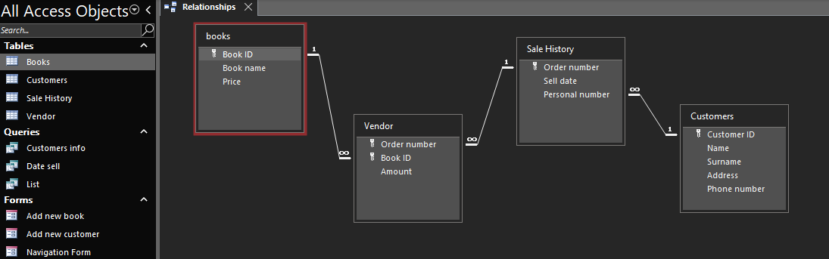
Most values are related between themselves, if you break one value, the whole database can change, which can lead to big problems, so you need to be careful when creating. The screenshot below shows that the in object "Tables", objects have relationships with each other and are locked, thereby setting a certain course of action.

Also, each of the values has it is own format and size, depending on the task.
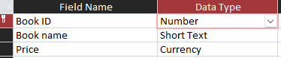

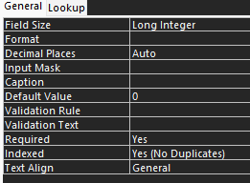
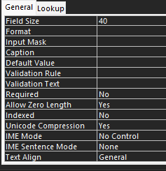

The "Order" section has been created in the "Forms" object, it plays the role of a cash register in shops, which calculates the final order value, all the information about the order will be displayed there. How many books the buyer has bought, perhaps he has bought the same book twice, the prices that are added using the usual formula, the quantity multiplied by the summary and the total summary. The name of the customer, his number, the number of the order and the date. All this is included. The buttons are also present at the bottom, after pressing them a scheduled action occurs, which is provided. There is nothing unusual about them, but also, I added the "print" button, in which I used a set of instructions that helped the program perform a certain cycle of actions to perform my task, which is to print a bill to the customer, after simple click the button print, need to type order number.
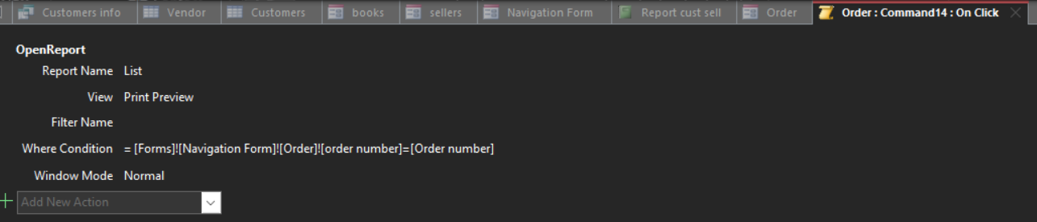
The function Query design played an important role in the task, this function allowed us to set all tables to had relations with each other, for example, query date was created with this function. First, I connected the relationships between all tables, from which I chose sales date, customer name, book title and quantity, then I chose to use the sum operation to express the last section with quantity. To sort purchases by date, you had to enter a filter condition, which means that before someone wants to see a list of sales for a certain day, you will need to enter a date (for example, 01/05/2022). After that, the entire list of sales for a particular day will be provided.

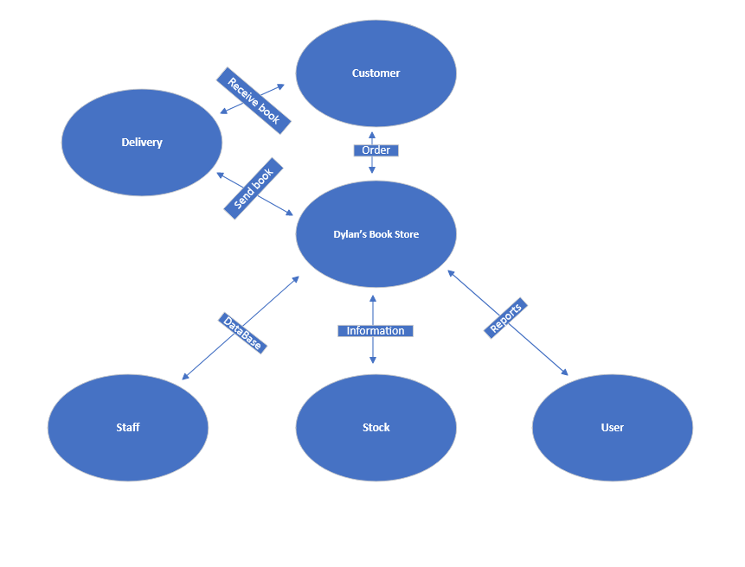
Context diagram
Diagram created by Microsoft Visio

In this diagram, I showed how to Dylan’s bookstore would work when they used my database

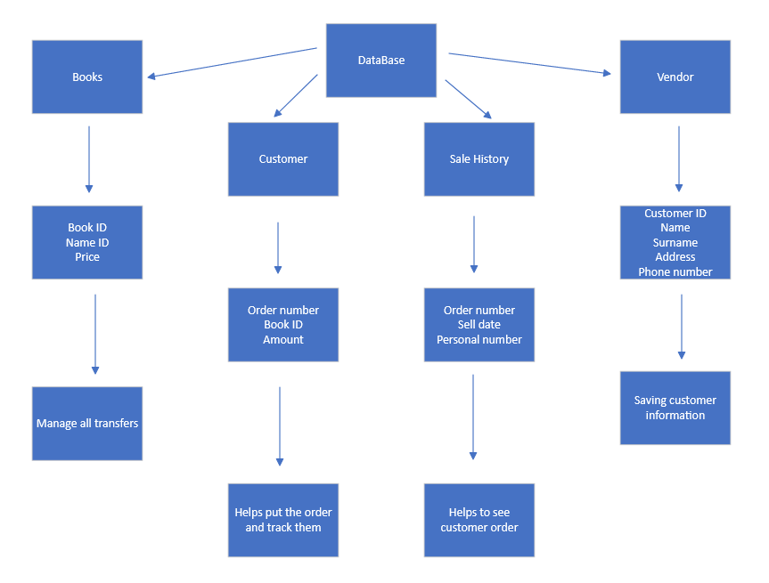
Entity Relationship Diagram (ERD)
Diagram created by Microsoft Visio

This screenshot briefly shows how the objects are related and what they are responsible for.

3NF
Book ID, Book name, Price.
Customer ID, Name, Surname, Address, Phone number.
Order number, Sell date, Personal number.
Order number, Book ID, Amount

References
Chapter 1. Creating Your First Database. (2022). Retrieved from oreilly.com: https://www.oreilly.com/library/view/access-2013-the/9781449359447/ch01.html
mkondratek, G. . (2022, May 3). Bookstore-Database-Design. Retrieved from https://github.com/mkondratek/Bookstore-Database-Design
Resources, C. F. (2022, May 3). Retrieved from https://corporatefinanceinstitute.com/resources/
Silverschatz, H. K. (2002). Database System Concepts.

