HPEN 5005 / 6005
The Book, the Body, and the World: Renaissance Humanism, Medicine, and Exploration

Virginia and English Humanism

- Samuel Purchas, from 1613-14 Rector of St Martin’s, Ludgate, Chaplain to the Archbishop of Canterbury; from 1622, member of the Virginia Company of London.

- Purchas contributed significantly to the arguments in favour of settlement and commercial exploitation of the lands then called Virginia, after Queen Elizabeth I, the ‘Virgin Queen’.

- Following failed attempts to establish a settlement on Roanoke Island, off the coast of then Virginia, now North Carolina, the English established their first surviving settlement in the Chesapeake Bay in 1607, and called it Jamestown. Responsible for the enterprise, purely commercial to begin with, was the Virginia Company of London.

- Geographical exploration, in Purchas’ essay ‘Virginias Verger’, is imagined as a kind of pilgrimage into the interior of another land that is simultaneously spiritual.
  - Medieval ideas about ‘cosmographical pilgrimage’ are reconceived by Purchas in terms of ‘peregrination’ that is simultaneously literal and figural, that is, actual geographical travel and an allegorical travelling from the limitations of one’s ‘owne [‘Earthly’] Wisdome and Selfe-conceit’ to ‘the great Mysteries of Godlinesse’ revealed in the world previously hidden.
  - Purchas insists on pilgrimage or peregrination in the world as an exploration of that which in the divinely designed creation or ‘Gods Providence’ lay hidden (at least to the English).

- Pilgrimage is also construed as conversion. Purchas’s ‘Virginias Verger’ contends that because of the evangelical mission to the Virginian Indians, Christian conversion and education, not material enrichment, ought to be the basis for colonial enterprise and plantation.
  - At least during the administration of the Virginia Company of London by Sir Edwin Sandys after 1619, with the earl of Southampton as treasurer of the Virginian Colony from 1620, this ‘higher purpose’ was in some measure shared by the Virginia Company.
  - Inseparable from national geo-political struggles against Catholic Spain.
  - Although not ‘the chief motive of the enterprise’, it found tangible expression in plans for a proposed college at Henrico, for the education of indigenous children.

- Besides providing a model for the colony’s structure, functions, order, and diagnosis, in times of difficulty, the topic of ‘anatomy’ (perhaps surprisingly) made an especially apt analogy for the encounter with the New World because it already connoted the following:
  - methodical exploration (through dissection) of that which was not ‘conteyned and circumscribed in the discovered and knowne travailed bounds’;
  - the concomitant disruption of intellectual certainty and contextual understanding that accompanies wonder;
  - the ‘invention’ and assimilation of that which has been discovered in texts.

- Lord de la Ware, or Laware, was appointed Governor of Virginia in 1610, and before his departure to the settlement, William Crashaw preached a sermon that was printed in London by William Welby. A copy of this is contained in the RBLA Tract Collection (T475).
  - The function of anatomy as a mode of apprehension of the colonial enterprise may be discerned in the letter written by Lord de la Ware to the Patentees in England, on his arrival as Governor in Virginia in 1610, where it says that ‘the sinews […] of this action’ are ‘men of qualitie’ and ‘quantity of provision’.
  - The letter draws on the rhetorical resources of allegorical romance, as well as pre-existing sexual and geographic associations of anatomy, to feminise ‘the countrey’, insisting that ‘in the womb thereof there lay […] those ellimentall seedes which could produce […] many goodly birthes of plenty and increase’.
  - Such productivity depends, as Strachey pointed out, on the colony being ‘enabled truly to dissect’ Virginia’s ‘heart and bosome’, this prospect (in both senses of the ‘view’ and ‘expectation’) ‘making tender unto the eye of the surveyor her fertility and pleasure, […] which would be much more […] by clensing away her wooddes’, ‘converting’ her to pasture and timber.

- Facilitated by the body-political analogy, but also by the analogy of human anatomy with the terrestrial globe or geocosm, anatomy (sometimes sexualised) was used figuratively as a vehicle for discovering (or inventing), understanding, representing, commercially exploiting, and colonising the land of Virginia and its indigenous inhabitants.

- In Pilgrimes, Purchas justifies international trade, and the settlement of commercial colonies like Jamestown, on religious and functional-anatomical grounds, saying that God ‘hath made all Nations of one bloud’, ‘that thus the whole World might bee as one Body of mankind, the Nations as so many members, the superabundance in each, concocted, distributed, retained or expelled by merchandising (as by the Naturall bodily Offices and Faculties in nourishment)’. This law is said to have been ‘written’ by Nature, its ‘efficient’ cause, ‘in the hearts of men’ and in the ‘naturall inducements’ of ‘Windes’ and of coastal and fluvial geography, and is applicable to all nations.

- On March 22nd, 1621/22, there occurred an uprising by indigenous people against the settlers. This, particularly in its connection in some minds (including that of Purchas) with the disappearance of the ‘former Colonies’ at Roanoke, precipitated a change in the prevailing attitude of the settlers and adventurers to the Indians away from the view described by Margaret Hodgen, in which the indigenous people, although different from English settlers and less civilised, were ‘assumed to be in […] a natural, or a prelapsarian condition of […] purity and goodness’, and capable of assimilation into European culture.

- Purchas in 1613, in Pilgrimage, spoke of the natives of America as examples of ‘originall mankind’, or ‘first men’, claiming that ‘the sin of our first parents had not erased all memory of the dignity of God from their posterity’. Until 1622 there had been greater scope for idealization and invention of Virginia as a rediscovered Garden of Eden or earthly Paradise. The following quote is from a pamphlet issued by the Company (T94):

the Countrey is rich, spacious and well watered; temperate as for the Climate; very healthfull after men are a little accustomed to it; abounding with all Gods naturall blessings: The Land replenished with the goodliest Woods in the world, and those full of Deere, and other Beasts for sustenance: The Seas and Riuers (whereof many are exceeding faire and nauigable,) full of excellent Fish, and of all sorts desirable; both Water and Land yielding Fowle in very great store and variety: In Summe, a Countrey, too good for ill people; […].

- The ‘very rich’ and fertile ‘soyle’ reduced the need for Art, or cultivation, and the land’s inhabitants were un-fallen naturals living ‘after the manner of the golden age’, who were ‘generally very loving and gentle’, and ‘do entertaine and relieve our people with great kindnesse’. Being not only ‘mild and good’, but ‘simple and innocent’, ‘void of all guile, and treason,’ they were ‘like raced and unblotted tables, apt to receive what forme soever shallbe first drawne theron’, and therefore receptive to Christianity and ‘our customs’.

- In numerous travel accounts, a vision of combined innocence and plenty was communicated as though a pre-lapsarian state in which there existed no risk of sinning had been recovered or was at least in prospect.

- The Edenic image was perhaps always already poised for tragedy and impending loss, but the uprising of 1622 shattered what remained of it in the representation of the indigenous population. ‘Virginias Verger’ stages a decisive shift towards a view that had already been articulated, in which the indigenous people are conceptualised as not only different but opposed, not merely uncivilised or ‘savage’, but even inhuman, in a fallen condition of corruption and lawlessness, and therefore to be conquered or destroyed as enemies.

- When considering the question of whether Britain has a commission from God to ‘plant’ in Virginia, ‘Virginias Verger’ turns not only to law but to the human constitution. Purchas expounds the meaning of having been created after God’s ‘owne Image’.

  - While advocating settlement, Purchas had argued that in principle this should be without dispossession of the Indians, which would breach their rights under the Law of Nations; besides the Kingdom of God is not of this world and ‘Christian Charity seeketh not her owne things (much less obtrudes on others)’.
  - After the uprising and ‘massacre’, Purchas appraises the situation: by unnaturally ‘murdering’ 347 settlers, the Indians have transgressed Natural Law (which God had written ‘in their hearts’) and become ‘Out-lawes of Humanity’, ‘having little of Humanitie but shape, ignorant of Civilitie, of Arts, of Religion; more brutish then the beasts they hunt’.
  - Purchas justifies usurpation and colonial settlement on the basis of the Indians’ infraction of Natural Law, the sparseness of their population, and their being ‘wilde and Savage’, ‘more wild and unmanly then that unmanned wild Countrey, which they range rather then inhabite’, holding ‘no settled possession in any parts’, being or becoming in legal rhetoric ‘vagabonds’, and thereby either forfeiting their proprietorial rights or by the legal argument res nullius never having had them.
  - The explorer John Smith had described the region as sparsely inhabited, his map plots the locations of many permanent settlements which by diligent husbandry cultivated a variety of crops (see Figure below).
  - James A. Boon has argued, if Purchas ‘knew perfectly well that the Virginian Indians were sedentary and agricultural’, ‘rather than a mere conspiratorial distortion’, it is likely that his evaluation ‘reflected developments in the perception of “Vagrancy.”’
  - It has been argued that the view espoused by Purchas ‘was a total misperception of the careful and well-worked-out patterns of Indian land use’.
  - According to Boon, Purchas’ rhetoric reflects ‘changing views on the rights of native “inhabitants” as rural smallholders’, and ‘communicates’ with English vagrancy, the Poor Laws, ‘the 1621 prohibition on the propertyless dwelling in towns or cities’, philanthropic obligations of the local parish, and related Tudor and Stuart “ideas of settlement.”’
  - Many settlers had been convicted of vagrancy in England and consented to travel to America to evade their legal punishment.

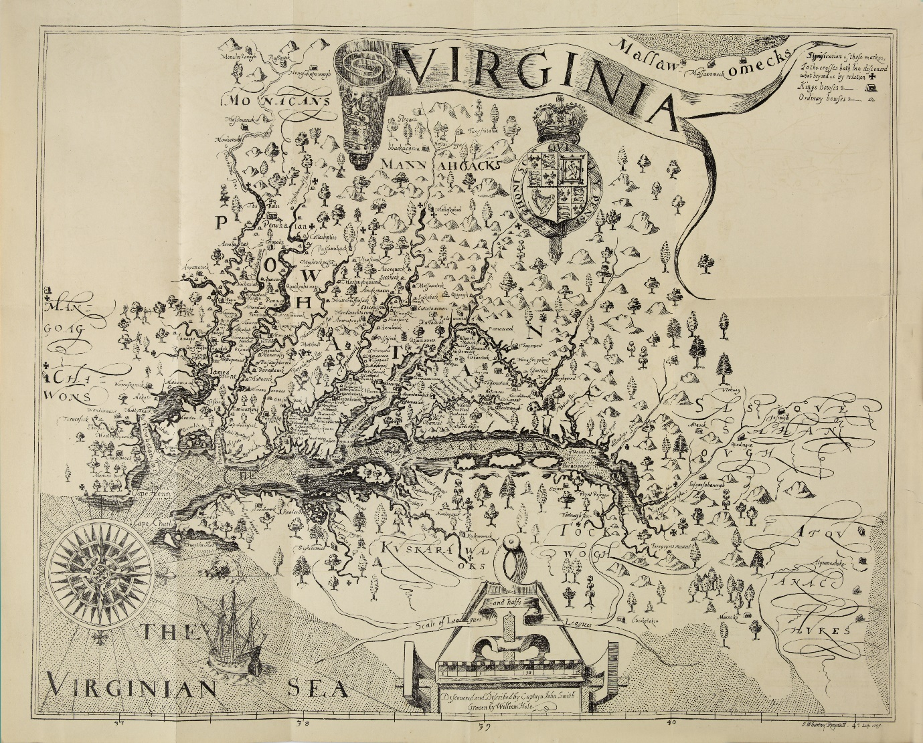

In ‘Virginias Verger’, Pilgrimes (1905-1907), XIX, 222, Purchas identifies Captain John Smith as the source of the estimation of the Indian population in the region around Chesapeake Bay, which Smith had explored, mapped, and written about.

Samuel Purchas, Hakluytus Posthumus; or, Purchas His Pilgrimes, Contayning a History of the World, in Sea Voyages, & Lande-Travells, by Englishmen & Others (London: Printed for Henry Fetherston, 1624 [or ‘1625’]). The most recent, scholarly edition, quoted in the text above, is Hakluytus Posthumus; or, Purchas His Pilgrimes (1625), 20 vols, Hakluyt Society, Extra Series (Glasgow: James MacLehose, 1905-1907), I, 6. Pilgrimes is the short-title abbreviation used.
On ‘cosmographical pilgrimage’ in the late Middle Ages, see Joan-Pau Rubiés, ‘Travel Writing and Ethnography’, Ch. IV of Travellers and Cosmographers: Studies in the History of Early Modern Travel and Ethnology, Variorum Collected Studies series; 888 (Aldershot, Hants: Ashgate, 2007), p. 14.
Pilgrimes, I, 6.
Pilgrimes (1905-1907), ‘To the Reader’, I, xliii.
On ‘cosmographical pilgrimage’ and mission, see Rubiés, ‘Travel Writing and Ethnography’, pp. 14-15.
‘Virginias Verger’, Pilgrimes (1905-1907), XIX, 230.
According to Susan Kingsbury: ‘The company was not only interested in the economic and industrial development and the necessary political forms of the colony, but, as Sir Edwin Sandys declared, it had a higher purpose than the Muscovy or the other commercial corporations. This high ideal is proved by the attention which is devoted to plans for the college [for the education of the children of the indigenous population], by the appointment of ministers, by the collections in the churches, and by the gifts received, but the theory that the chief motive of the enterprise was religious is not supported by the spirit or by the data of the records.’ The Records of the Virginia Company of London, ed. by Susan Myra Kingsbury, 4 vols (Washington, D.C.: Library of Congress, 1906-33), I (1906), 72, 98.
William Strachey, The Historie of Travaile into Virginia Britania; Expressing the Cosmographie and Comodities of the Country, Togither with the Manners and Customes of the People. Gathered and observed by those who went first thither as collected by William Strachey, Gent., the First Secretary of the Colony, now first edited from the original manuscript, in the British Museum, by R.H. Major, Esq., of the British Museum, Hakluyt Society, No. 6 (London: Printed for the Hakluyt Society, 1849), p. 44.
‘Letter from the Lord Delawarr, Governor of Virginia, to the Patentees in England’, MS. Harl. 7009, fol. 58, reproduced in Strachey, The Historie of Travaile into Virginia Britania, pp. xxv-xxxvi (p. xxxiii).
Strachey, The Historie of Travaile into Virginia Britania, pp. 116, 160
Pilgrimes (1905-1907), I, 10-11.
Pilgrimes (1905-1907), I, 11.
Hodgen, Early Anthropology in the Sixteenth and Seventeenth Centuries, pp. 196.
Hodgen, Early Anthropology in the Sixteenth and Seventeenth Centuries, p. 490.
Pilgrimage, ‘To the Reader’, sig. Hhh6^{r}.
A Declaration of the State of the Colony and Affaires in Virginia (1620), Va. Co. Rec., III, 308.
Strachey, The Historie of Travaile into Virginia Britania, pp. 30-31, 120.
Arthur Barlowe, ‘The first voyage made to the coastes of America, with two barkes, wherein were Captaines Master Philip Amadas, and Master Arthur Barlowe, who discouered part of the Countrey, now called Virginia, Anno 1584: Written by one of the said Captaines, and sent to sir Walter Raleigh, knight, at whose charge, and direction, the said voyage was set foorth’, in Richard Hakluyt, The Principall Navigations, Voiages and Discoueries of the English Nation (1589), pp. 728-33, collated with The Principall Navigations, III (1600), 246-51, in Quinn, ed, The Roanoke Voyages, 1584-1590, I, 91-117 (p. 108); Robert Johnson, Nova Britannia (1609), cited in Roy Harvey Pearce, Savagism and Civilization: A Study of the Indian and the American Mind (Baltimore and London: Johns Hopkins University Press, 1953; revised edn 1965; repr. 1971), p. 12.
Strachey, The Historie of Travaile into Virginia Britania, pp. 11, 160; Barlowe’s ‘Discourse of the First Voyage’, p. 108.
‘Virginias Verger’, Pilgrimes (1905-1907), XIX, 219-221.
‘Virginias Verger’, Pilgrimes (1905-1907), XIX, 224, 231.
‘Virginias Verger’, Pilgrimes (1905-1907), XIX, 222-224, 231.
James A. Boon, Other Tribes, Other Scribes: Symbolic Anthropology in the Comparative Study of Cultures, Histories, Religions, and Texts (Cambridge: Cambridge University Press, 1982), p. 170.
Kirkpatrick Sale, The Conquest of Paradise: Christopher Columbus and the Columbian Legacy (London: John Curtis Book from Hodder & Stoughton, 1990), p. 286.
Boon, Other Tribes, Other Scribes, p. 171.

