Duty Cycle Report of a 3-Cylinder Petrol Buggy During an Off-road Track Lap
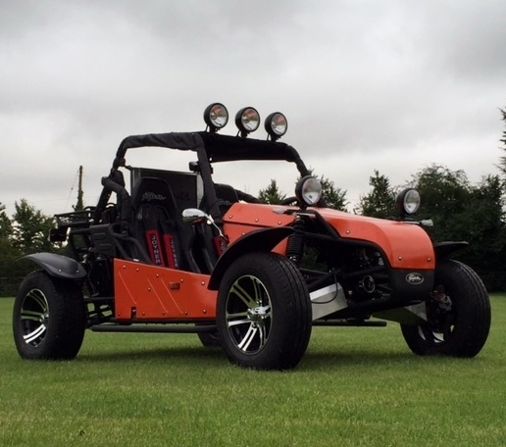
By
YOUSOUF BOUKRA
1700055
Submitted to the Faculty of Engineering
Automotive/Motorsport Department
University of Wales Trinity Saint David

Series Hybrid Vehicle Part ‘a’ Assignment
Alternative Powertrain Technology Module
December 2019.

Contents
1. Introduction: 2
2. Joyner 800i Buggy: 3
Specifications of the Selected Buggy: 3
3. Off-road Track: 4
Specifications of the Designed Track: 4
4. Results Analysis: 5
5. Conclusion: 7
References 8

Table of Figures
Figure 1 Joyner 800i buggy Figure 2 buggy Specefications 3
Figure 3 Track Map Figure 4 Track Details 4
Figure 5 Power requirement for each section 5
Figure 6 Average power requirement Vs Time 5
Figure 7 Vehicle Acceleration 6
Figure 8 BSFC Vs Distance 6
Figure 9 duty cycle summary Table 7

Introduction:
As a response to the request of typical duty cycle the vehicle will undergo during the designed off road track lap, this paper along with the supporting document (Excel sheet) will identify the requested report. The study will encompass all of the vehicle performance details including, top speed, acceleration, and grade ability of the selected buggy.
JOYNER 800i Buggy (figure 1) was selected for this investigation, vehicle specification can be found in figure 2. The buggy will undergo a designed off-road track (figure 3) which has; 23 meters total climb, 20 meters total drop, and a lap distance of 703 meters. The Track is situated at 42 meters above sea-level, and has a maximum gradient of 56.44 degree, it also combines three different surfaces (i.e., Gravel, Mud, and Grass).
All detailed results of the investigation could be found in the multiple graphs plotted in the excel sheet. However, some of the important results were analysed further down in this report document.

Joyner 800i Buggy:

Specifications of the Selected Buggy:
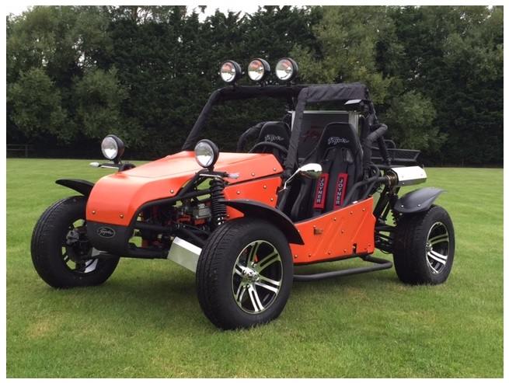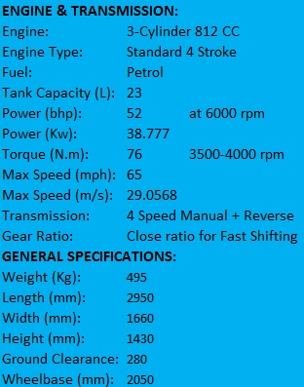
Figure 1 Joyner 800i buggy Figure 2 buggy Specefications
Joyner 800i was selected for this event due to multiple reasons which set the key parameters of this project. The buggy has a low centre of gravity, which positively impacts the handling and stability of the vehicle, allowing it to easily outperform other buggies on the twisty off road track. The 812 cc 3-cylinder engine which generates almost 39 Kw at 6000 rpm, makes the buggy weigh less and pull better than a larger 4 cylinder engine buggy. Also due to the reduced size of the engine, the buggy would be suitable for a hybrid system setup if that is considered.
(StormBuggies, 2016)

Off-road Track:

Specifications of the Designed Track:
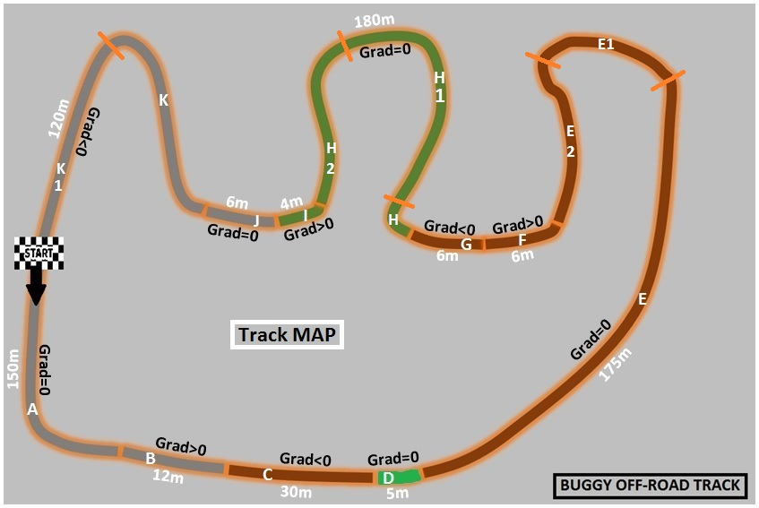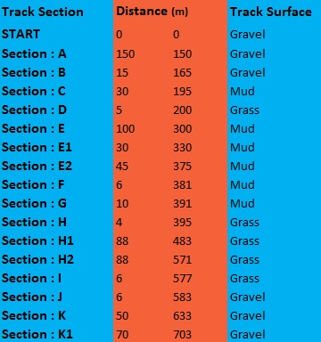
Figure 3 Track Map Figure 4 Track Details
The off road track have been designed specifically for the selected vehicle, that to enable maximum performance for maximum entertainment. The track includes 10 tight corners to push the vehicle to its limits of handling performance, as the buggy built with a low centre of gravity. Different surfaces were considered (Gravel, Mud, and Grass) to enable variety of rolling resistance the buggy would be experiencing, this was considered to examine the difference on power requirement with relation to different track surfaces. Also, the track comprises a total climb of 23 meters and a total drop of 20 meters. The total drop on the track will be crucial to the regeneration of energy if considering a hybrid series powertrain installation.

Results Analysis:
The resistive forces have been calculated for each section of the track utilising the formulas below:
Rolling resistance = Total weight x RR coefficient x Gravity
Aerodynamic resistance = (Cd x Frontal Area x Air Density x V²) / 2
Gradient Resistance = (Total weight x Gravity) –sinα
(EngineeringToolBox, 2019)
(Buggies.builtforfun, 2011)

The final total tractive force was calculated for each section using the sum of all resistive forces, this the power requirement for each section to be calculated as well as max and average power requirements. Results are presented in the graphs bellow:

Figure 5 Power requirement for each section

Figure 6 Average power requirement Vs Time

The graphs and figures presented above and in the excel work sheet, were made upon a realistic assumption of vehicle behaviour such as velocity and power. It is evident from the power graphs, that the input values were made under a realistic assumption as both of the velocity (see excel sheet) and power curves, do not exceed the maximum velocity or power line which represents the maximum values the buggy can produce.
The power requirement for each section bar graph, highlights an important case. At the green bars where the power values are negative, the vehicle could be used to regenerate power and store it for a useful application, for instance, powering an electric motor if the vehicle were to fit a hybrid system.

Figure 7 Vehicle Acceleration
The graph of velocity against time also identifies the potential areas where energy could be harvested and used if the buggy would fit an electric motor. The green lines highlights the time spent on the track where the buggy is either unthrottled (engine is under no load) or experiencing braking forces.

Figure 8 BSFC Vs Distance

Brake specific fuel consumption graph above, could be used to investigate fuel economy of the series Hybrid powertrain system. The expectation of a hybrid system concerning fuel consumption would be significantly less than the current engine, however, the BSFC graph allows a detailed comparison between the two systems.

Conclusion:
The duty cycle of the selected vehicle around the designed off-road track, are summarised in the table presented below.
Time to Complete one Lap | 57.79 Seconds
Maximum Speed Vehicle Can Produce | 29.06 m/s | 65 m/h
Maximum Speed per Lap | 28 m/s | 62.6 m/h
Minimum Speed per Lap | 3 m/s | 6.7 m/h
Max Total Tractive Force per Lap | 4772.11 N
Min Total Tractive Force per Lap | -4717.91 N
Maximum Power Vehicle Can Produce | 38777.00 W | 52 bhp
Max Average Power Requirement per Lap | 37187.91 W | 49.9 bhp
Min Average Power Requirement per Lap | -32620.99 W | -43.7 bhp
Maximum Acceleration per Lap | 11 m/s²
Maximum Deceleration per Lap | 7.5 m/s²
Maximum RPM per Lap | 6000 rpm
Minimum RPM per Lap | 2000 rpm
Maximum BSFC per Lap | 535.34 g/kw.h
Minimum BSFC per Lap | 178.45 g/kw.h
Figure 9 duty cycle summary Table
The maximum time for the buggy to finish one lap on the track is almost one minute, going through a maximum acceleration of 11 m/s² hitting maximum speeds of 62 miles per hour, the buggy will decelerate to a maximum of 11 m/s² going through the tightest corner of the lap at a minimum speed of 6.7 miles per hour. The vehicle will also be running on medium to high rpm during the majority of the track distance, operating at a maximum BSFC of 535.34 g/kw.h.
Positive average power requirement for the whole lap is 7991.47 Watt, reaching its maximum of 37187.91 Watt. Whereby the total average power requirement per lap is 1941.11 Watt, with a minimum of -32620.99 Watt.

References
Buggies BuiltforFun (2011) Rolling Resistance & Drag Coefficients. Available at: http://buggies.builtforfun.co.uk/Calculator/calculator-data.html/ (Accessed: 26th November 2019).
Engineering ToolBox (2001) Drag Coefficients. Available at: https://www.engineeringtoolbox.com/drag-coefficient-d_627.html/ (Accessed: 26th November 2019).
StormBuggies (2016) NEW 2016 JOYNER 800i SPORTS ROAD LEGAL BUGGY . Available at: https://www.stormbuggies.com/products/new-2016-joyner-800i-sports-road-legal-buggy/ (Accessed: 28th November 2019).

