

Assignment Title: Workplace Culture and its Impact on Organisational Efficiency

Student name: Jeremie-Mukanda
Student No: 1816426
Module Name: Workplace Culture and its Impact on Organisational Efficiency (BMSW 5105)

Module Tutor: Syed-Jeffry

1.Excecutive Summary

The purpose of this report is to critically evaluate how Biffa company could enhance their understanding and knowledge of the organization culture during this pandemic period of Covid-19 also , how to eliminate the external and internal environment issues in addition , how to confront the challenges the business culture are confronting during Covid-19.
As well the report pinpoint how the organization could utilize the right systems and information to maintain the organization culture and, demonstrate the knowledge of environment and cultural analysis tools with suitable models for the organization. The report as well look at the organization responsibilities if they are following their own culture with respect of the current pandemic period by evaluating the organization actual culture as well as how culture affect the business competencies.

2.Table of Content
1………………………...Executive Summary
2…………………………Introduction
2.1………………………. Chosen Organization
2.2 ………………………The Key Management Theories/Models Suitable for the Organization
2.2.a …………………… Pestle analysis
2.3………………………. Hofstede Culture Dimension
2.2.b …………………… SWOT analysis
2.3 ………………………. Hofstede Culture Dimension
2.4 ………………………… Hofstede Culture Definition
2.5 …………………………. Hofstede identified factors that determine the culture
3……………………………... Implementation of theories/models in Biffa Company

3.1 …… ……………………...Biffa SWOT Analysis
3.2 ………………………... Biffa PESTLE Analysis
3.3 … …………………………. Biffa Hofstede Culture Dimension
3.4) ……………………………...The first collective value dimension: Power Distance Power in Biffa
3.5 ……………………………… The second collective value dimension in Biffa: Group Attachment

3.6 ………………………………. The third dimension: Gender Association

3.7) ………………………………. The fourth dimension: Uncertainty Avoidance

3.8) ………………………………. The fifth value dimension: Time Orientation
4)…………………………………... Appendices
5)……………………………………. Conclusion
6)……………………………………...References

2.INTRODUCTION

2.1 Chosen Organization
I have decided to choose Biffa company because is one of the biggest waste management and recycling company and I am working in the organization.
Biffa was Founded over 100 years ago; Biffa has continuously been leading of expansion and revolution within the waste management industry. Called after the founder, Richard Biffa, the organization was first created as a haulage company to provide services to coal "re power stations in London. Then in the 21st century, they became UK leading integrated waste management and recycling business. (Biffa, 2020)
Right now, Biffa are delighted to lead the waste and recycling industry. Biffa are operating at over 195 sites across the length and breadth of the country, they service over 2.2 million households and collect 4.3 million bins per week just within them municipal division. From the company conception in 1912, the business has improved far beyond waste collection and into recycling, treatment and energy generation service as well they are the UK’s no.1 Industrial & Commercial waste collection service provider, the organization is covering a gigantic range of UK business sectors, counting manufacturing, retail and hospitality. The company household waste division is a leading service provider to local authorities, providing household waste and recycling collections, street cleansing (Biffa ,2020). The Biffa business have over 6000 employees with the biggest mixed recycling capacity and plays important role in the country resource management capabilities and the company has nearly 2,500 collection vehicles and recycling around 750,000 tons of waste yearly as well generate 607 million kwh renewable energy per year (Biffa ,2020).

2.2 The Key Management Theories/Models Suitable for the Organization

The report will use tools and models such as PESTLE, SWOT, and Hofstede analyses that the reporter believes it matches the organization culture and could as well enhance the business culture.

2.2.a) Pestle analysis

Is the idea of promoting the values (standards). Additionally, the idea is applied as tools by the organization to identify the environment they are functioning with them or else the companies are proposing to unveil a new product /project /service, etc. (Groupmap,2020)

According to Groupmap (2020) PESTLE is aide-memoire which in enlarge form signifies P for Political, E for Economic, S for social, T for Technological, L for Legal, and E for Environmental. It offers a good view of the whole environment from several various perspectives mainly externally that allows the organizations to see where they are and where they want to go also anticipating different ideas or plans for company development.

PESTLE helps the organizations to ask the right questions while they are conducting this analysis, and that offers the business a concept of what to think about. They are:

- . Would the political situation of country can affect our business and how that could happen? These reasons are determining how the government may positively or negatively impact the economy or else companies. For example, due to covid-19 the government can impose new taxes on Fiscal policy, trade tariffs etc.., and that could change the whole company revenue structure as well may affect the organization environment or economic environment to a big amount.

- What are the factors that dominant the economic? These components determine the economic performance and directly impact the company positively or damagingly way and as long-term impact on the organization. For example, price rise rate of the economy could influence how the businesses charge them goods and services. Moreover, that will impinge on the buying power of customers and change the requirement or the demand on the products. The economic factors affect the interest rates, economic growth form and foreign exchange rates, etc.

- How much values do culture have in the marketplace also what are its determining factors? These elements examine the social environment of the market, as well determine factors like demographics, culture, etc. For example, purchasing things like clothing from Canada where the requirement is very high in Holiday season.

- what new technology can affect the market structure? Innovations in technology would easily influence the market positively or negatively. For example, electric cars, and various of technology that the market are aware of it.

Currently are any legislations that regulate the organizations or else there is any change or will be change in the legislations for the businesses? These elements have internal and external influence on the industries environment also their certain policies the organization keep it for themselves, however the companies refer to the country legislations. For example, safety standards, customers laws, etc. (Groupmap, 2020)

Are there any concerns environmentally friendly for the organizations? These elements determine and influence the surrounding environment. This characteristic of PESTLE is significant for certain businesses especially for example farming, tourism, agriculture, climate change, weather, geographical location, etc. The technique aspect of PESTLE is very important for any organizations could be in because, is not only explicating the market nonetheless, the framework representing the strength management that define the company, the business goal also the strategies stringed to them. The factors explained above could be different to diverse companies, but it is crucial for any organizations strategies who want to grow to follow the PESTLE analysis and the report sees it as more comprehensive than SWOT analysis.(Groupmap, 2020)

2.2.b) SWOT analysis

According to Mindtools (2020) SWOT analysis is the best way to evaluate the companies plan or people project whether they are two or more, therefore the report will explain how SWOT analysis can improve the internal processes as well the workflows of various organizations. Prior to describe SWOT analysis factors the report will define SWOT analysis.

- what is SWOT analysis?

Is the method of determining and defining your strengths, weakness, opportunities, and threats.

SWOT analysis could be applicable to any organizations or individual plans. Most of the time. SWOT analysis is applied to define how an organization is associated with its progress and success benchmarks; however, the analysis can utilize to describe how well the business can performed about initial plan (Mindtools ,2020).

- Strengths

According to Mindtools (2020), Strengths is what an organization does good as well the qualities that make the business to create the difference with other competitors. Looking at internal resource like skills workers, technologies, intellectual property etc.
There is some of questions the companies would have to ask if they want to determine the organizations strengths such as:
- Regarding your businesses or products what your customers like?
- What makes the companies more attractive compare to others?
- What are the company best style and attributions?
- What makes your company more exceptional?
- What resources the organizations have at their disposal that other companies do not have?
When the company could answer these questions, they will be in great position to begin to start pinpointing and listing the company strengths.
c) weaknesses
according to Mindtools (2020) After the report describe the strengths, it is important to critically do self-awareness on the organization’s weakness. The purpose of this is to know what factors could hold the business or company project? This component could be organizational tasks like lack of skilled workers, budgetary limitations etc,
We can use the same principle we used in strengths to determine the organization’s weaknesses:
- Concerning the company what do their customers do not like?
- What are the issues and complaints are frequently mentioned your negative assessments?
- What could the organization do well?
- What are the obstacles or challenges into the company facing your current sales?
- What assets do the business competitors have that you do not?
The report realised that finding or determining the strengths and the weaknesses factors of the company or projects it seems easier to figure out than opportunities and threats ,because it internal factors than figuring out the opportunities and threats could face the organization for the reason that, is external factors.
D) Opportunities
Next up is the opportunities. Is when the organization is creating or developing a new idea that will open new demographics or markets that’s call an opportunity. The opportunity and theat are view as external factors ,however , they could also be internal.

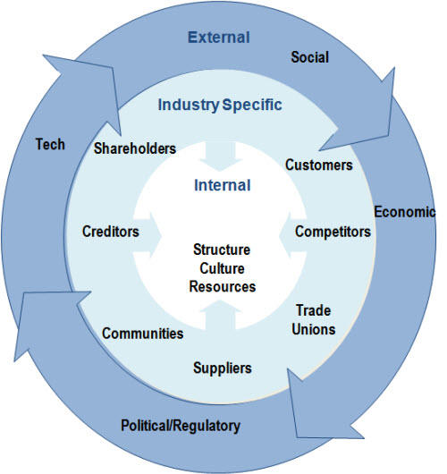
(Google image,2020)
Determining the opportunities and threats need to examine in depth or doing intelligence research what the organization competitors are up to and identifying what influence the economic development could have on the company, however , this doesn’t mean opportunity and threat could not be internal. Some questions a company may ask while describing the organization opportunities these include (Mindtools ,2020):

- How can an organization enhance their sales/customer service?
- What kind of communication could resonate with their customers?
- How can an organization further their visibility?
- Is the business utilizing their resources effectively?
- Is there resource, budget, or tools the organization are not using it to full capacity?
- There are any advertising channels which surpassing the company expectations and why? (Mindtools,2020)

E) Threats
Regarding threats, Mindtools (2020) explained that the organization could start asking various questions for example those questions above as well the report additionally added questions such as:
- What threat can the organization face from an established or emerging competitor?
- Which regulations could affect the company’s growth?

They could be internal threat such as high staff resigned or lack of skilled workers.

2.3) Hofstede Culture Dimension
Hofstede’s culture dimension theory was created by Geert Hofstede in 1980 with the aim to clarify the dimension in which cultures fluctuate.
2.4) Hofstede Culture Definition
Is a structure which understand various culture among countries as well to comprehend the way business happening across multiple cultures. Additionally, the framework is applied to differentiate distinguish dimensions of culture, countries culture and determine their influence on the organization setting. (Google ,2020)

.
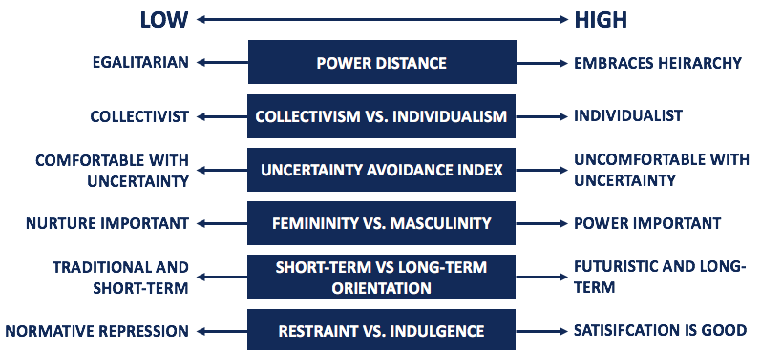
(site Google,2020)
2.5) Hofstede identified factors that determine the culture

According to site google (2020) Hofstede s model explain how the society culture have effect on people and how that relate to the people performance. The model has been used into various field as reference when they are analysing countries cultures and cross-cultural Communication.

Individuals in cultures shows a very high-power distance are admissive to recognised an authority also the inequality of power are permitted to the society ,while the individuals cultures demonstrate when senior member are close to the workers that question his/her authority over them. For example, a manager works in the UK to work in Congo (Africa) and his was very close to the workers ask them to contribute with the ideas while in Congolese culture workers expect for the manager to give order even if they are not happy about that they will have to execute and seeing English managers treating equal it confusing them because , they expecting the order to followed.(site Google,2020)

Uncertainty avoidance (AU) reflect of dealing with vague circumstances and to minimise those situations, the managers on high AU rely on country / organization rules and regulations to avoid uncertainty.

Masculinity (MAS) explain how tough and confidence behaviour is encourage in various cultures. contrarily to the femininity which encourage kindness and affection behaviour.

Time orientation determine how short-term pain is permitted compare to long-term gain; however long-term orientation have less chance to invest. While short-term have much chance to ask for immediate change.
Individualism reflects how people independence are more consider over a team. A society which value individualism score high on personal goal, innovation, and responsibility. contrarily, societies which value collectivistic score more on team objectives and goal over individualism preferences. But it discourages autonomy, privacy, and innovation. (site google,2020)

3) Implementation of theories/models in Biffa Company

Biffa PESTLE analysis is a method to examine the macro environment of the company. As the report explained previously PESTLE stands for -Political, Economic, Social, Technological, Environment and Legal factors that influence the macro environment of Biffa organisation.

3.1) Biffa PESTLE Analysis
Is largely explained the challenge Biffa could face in establishing the macro environment instead of competitive force .for example , Biffa can be escalating in positive way .however , if the Political factors situation is unstable it will still affect the Biffa and other companies. Therefore, the report knows the importance politic plays in any organisations long-term profitability on the market. For example, due to the covid-19 the government order to shut all the pubs and restaurants while more than 50% of Biffa clients are pubs and restaurants. Another example, after Brexit the increase of bureaucracy will affect the organisation because in central London Biffa has about 30% of foreigner’s drivers. (Fernfortuniversity, n.d)
Economic factors increase rate, foreign exchange etc, could affect the organisation profitability growth. For example, during this period of pandemic waste collection volume it decrease while the more volume Biffa collect is the more the power station produced energy more, because the trash they collect it recycled and used in power station. After the Brexit the stability/instability of the currency will positively or negatively impact the Biffa organisation. Some skill workers could leave due the Brexit and let know forget some workers could work during the lockdown due to the childcare situation. (Fernfortuniversity, n.d)
Social factors it is influencing Biffa since covid19 interaction has decrease. For example, meetings, training, Christmas party, and site inspections was suspended and that has impact on workers and client’s attitude and beliefs. Educations level, demographic, language barriers also cause issues into the organisation.
Technological factors are rapidly influencing different organisation around the world and Biffa is facing it the same problem. For example, due to road so many restrictions the and cycle lane lorries should have rear steering wheels and passenger camera inside the cab and the company have installed the cameras in every lorry. Today technology is growing very fast and Biffa must cope with that, looking at other organisations they do have electronic hand sanitiser while Biffa still must implement that. (Fernfortuniversity, n.d)
Environment factors various norms in the country influence the company profitability. For example, the UK give well tax breaks to the companies who are operating in the renewable sector which Biffa is benefiting from it. However, the company should the environmental factors such as: weather, climate change, laws regulating environment pollution, recycling etc, unfortunately Biffa struggling to follow whole those environmental laws .for example, according to laws the driver must switch off the engine while is stopping but with the nature of the job you cannot do so because you need to use the bin lift. (Fernfortuniversity, n.d)
Legal factors the country institutions are robust to protect the Biffa intellectual property rights, but the organisation take in strong consideration when they evaluate some of the legal factors because that could positively or negatively damage the Biffa image. For example, discrimination, copy right, nonetheless Biffa have not power to stop the legal change. for example, next year the extension of ULEZ in London south circular that will have impact on the company profitability. Wearing mask when you are working Biffa workers finding it hard because when you are lifting heavy stuff thing such trash bags , pushing bins you need to breath properly but the organisation want the workers to comply with the government requirement.( Fernfortuniversity, n.d)
3.2) Biffa SWOT Analysis
A SWOT analysis is a basic that Biffa utilised to examine the organisation competitive level in its business sitting. The organisation used the theories to determine it internal Strength (S), Weakness (W), and external and internal Opportunities (O), and Threat (T) aspects. (Williamson ,2018),
Biffa is among the leading firms in waste collection industry and they value their SWOT analysis because it helps to determine strategic decisions in every department such as: finance, marketing operations, human resource, logistic etc.
According to Williamson (2018), the benefit of SWOT analysis is to assist the managers with the 4 types of strategies. These strategies are:
Strengths -opportunities strategies: this show how internal strength can take advantage of opportunities .for example due to covid19 Biffa has lost some of their skilled workers and they have to replaced them by looking at the most skilled staff to do the job instead of recruiting new staff which will demand training and the time to adapt.
Weakness- opportunities strategies: this help the organisation to enhance the business weakness by utilizing the opportunities tools. For example, Biffa rent most of his depot and to be able to regularly pay the rent, the organisation is using their image or brand to attract more customers to cover the cost.
Strength – threat strategies: this includes of using the organisation strength to decrease the weaknesses. For example, Biffa improve their staff skills by training them .another example , during the pandemic period the company nearly redeemed his loaders .however, due to his high quality services clients ( Pret a Manger ) opted to pay for loaders service due to the workload , loaders are required even restaurants are not busy like before.
Weakness – threat strategies: this combines to eliminate weakness to combat the threats. For example, Biffa high quality service will attract customers therefore, the organisation spends fortunes in improving their workers by training and developing them.
Biffa organisation do understand the main objective of SWOT analysis because, it support the organisation to control or to have strategies that help them to build strengths in order to eradicate the weakness while they are creation more opportunities and minimising or opposing threats within the organisation. For more advance on SWOT analysis see appendix one

3.3) Biffa Hofstede Culture Dimension
Biffa organisation considered Hofstede theory as a framework as well great number of cross-cultural Biffa training programs are built on the theory.
As Hofstede theory have five collectives value dimensions like the report explain above, we are going to discuss how Biffa is implementing these values in accordance with the Inverted Pyramid model invented by Mai (2014) due is accuracy in order to obtain the argument across all analysis level.
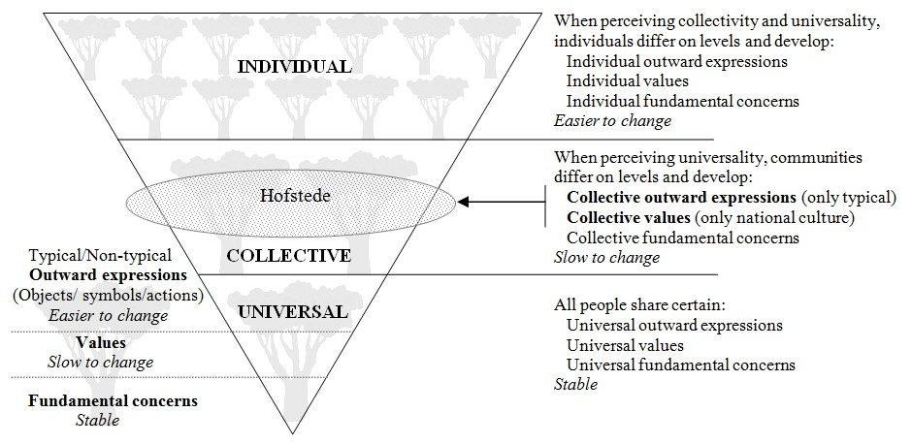

3.1) First collective value dimension: P
according to Mai (2014)

(Mai,2014)

3.4) The first collective value dimension: Power Distance Power in Biffa
The Inverted Pyramid model implies, power is vital element because people are organized into a hierarchy. Naturally when making decisions in the group they look at most powerful. For example, at Biffa the manager is most powerful without contradiction when comes to make decisions, I have witnesses’ employees resining, other being transferred to different depot maybe because the manager is not happy with them. This explicit how the less powerful members (workers) have the obligation to accept and expect the power to be disseminated unevenly. (Mai,2014)
During the lockdown period due to nature of the business not every workers should be on furlough because ,Biffa has contract with shops such Tesco and Sainsbury therefore , the Manager have to choose workers who he wanted them to be on furlough and, after lockdown he called those whom he though was better for them to come back. There were those workers who was not happy to come as well those who were not happy to stay home for such long .however , worldly we all know that in every society there is some people has a degree over others therefore , they do accept that we are not equal and that was the case.(Mai,2014)
However, I have realised that in Biffa we have two types of workers ,those who show much respect and accept and expect the boss decisions ( high Power Distance ) and , those who look at the decisions differently and challenge it by questioning the manager decisions and Will like the manager to explain his decisions ( low Power ).Once this attitude is broadly acceptable at workplace , we can talk about collective value. We see that the power of culture is rank between high and low. (Mai,2014)
3.5) The second collective value dimension in Biffa: Group Attachment
Universally humans being form various group is because the cultural diversity is massively important strategy to protect collective knowledge as well heritage. Biffa organisation value the collectivism because it helps the company to identify workers who give their best for the company, which worker they can trust and share the organisation knowledge and keep. For example , the manager has different views on the employees due to their contributions and hard work when he was transferring workers to different depots because collectivism produce good communication and good team work which can saves and present the company with good image. (Mai,2014)
The collective level can also call group attachment although the company have workers from different background/ culture their expectation is always to build a strong bond within the group and to make workers to feel more support by the company. For example, there are some workers from Spain, Portugal etc, who was employed without speaking English and through the company now they can speak and contribute to the organisation grow. Therefore, Biffa put collectivistic first and sees the individualism something can be misleading because nobody can be completely own his/ her own. However, they do encourage individualism in certain decisions to promote independence at workplace and remain workers to not loose relationship with the team/group. (Mai,2014)

3.6) The third dimension: Gender Association
In today’s life the task/job of a men and women can be done by both genders. You will meet men are occupying the role that people see it as feminine role and vice versa. Due to the culture who don’t give importance on genetic factors because it relies on developing, accumulating knowledge and technology in the society to achieve the optimal labour specification. However, people minds are clearly impacted by contradiction between men and women. For example, in Biffa organisation drivers are men and women also loaders are both genders. But psychologically it looks as masculine job because, competition, heavy duty and aggression are normally attribute to a man. Meanwhile in Biffa, customer service, dispatching jobs, recruitment are given to men while this usually tends to be women role. However, Biffa is expecting men and women to be caring and modest. (Mai,2014)
Biffa understood that Emancipation for feminine societies shows both genders can break free, liberated with choice. Even the masculine jobs in this organisation can be done in a feminine way, because both men and women have equally expectation to get the jobs executed.

3.7) The fourth dimension: Uncertainty Avoidance

Universally predicting and avoidance of harm are human’s basic instinct. Fear is the characteristic of inborn feeling as well social learning. For example, Biffa drivers be afraid to be involve in accident or misbehaving in public, because that can lead to a disciplinary hearing or dismissed. The latter is called Uncertainty. (Mai,2014)
Biffa knows the great way to avoid Uncertainty is putting rules and policies in place, because this makes workers to know how both rules and policies are imposed within the organisation and the and social rules. Example of constitutional rules are Biffa drivers must respect road regulations which is everywhere in the roads and the offices must deal with drivers records like checking licences and digital card (tachograph), appointments, arranging trainings etc. while the social rules is informal because is agreed-upon the Biffa code of conduct. For example, to request leave you must fill the form also like communicate with the high managers should be by appointment. (Mai,2014)

3.8) The fifth value dimension: Time Orientation

Biffa have always planed accordingly to the space and Time because the relationship between human and nature is very valuable. The organisation knows the past, present and future could impact in the business and market. For example, how the organisation can plan in the competitive market and how fast the result, rewards, spending and saving will be. According to Inverted pyramid model short- term Time orientation is to be concentrated to the past and present. For example, after being employed the driver will go on one-week training prior to start driving. While long- term Time orientation, is focusing on the organisation future. For example, Biffa encourage workers to enhance their English and communication skills because when the opportunities come, they should internally recruit them instead of recruiting externally. The following graphic explained how Hofstede’s values system in the framework of the Tree model and inverted pyramid are summarised (Mai,2014). see appendix two for further explanation

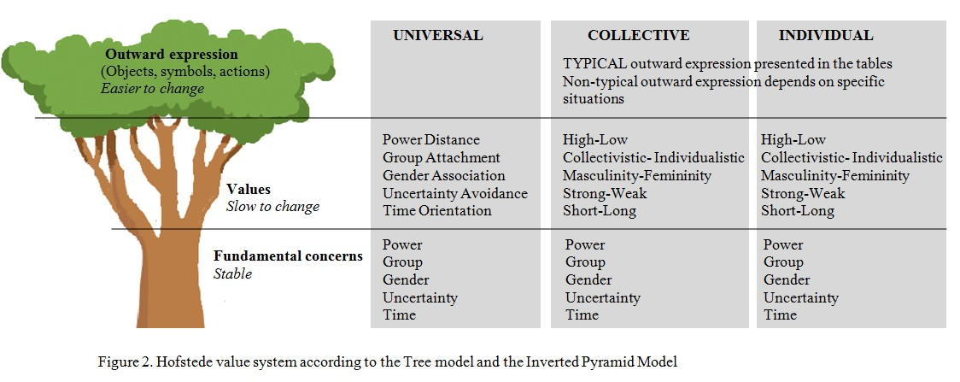

(Mai,2020)

4.Conclusion
The report had explained the urge impact of PESTLE analysis in the organization because , it offers a good view of the whole environment from several various perspectives mainly externally that allows any company to see where they are and where they want to go. Anticipating with different ideas or plans for the company development with the current market struggling with COVID19 will be encouraging also having a deep understanding of PESTLE analysis help the business to deal with the market proactively (Groupmap, 2020).
Differently to PESTLE analysis, SWOT analysis is more internal method to improve the organization and describing how well the business can achieve their initial project. Hofstede culture demonstrated how big influence the culture has in any business internally or externally factors because, comprehending various culture could help the organization to move forward and applying the five collectives’ values dimensions correctly. For example, following the inverted Pyramid model respectively will enhance the business in the market (Mai ,2014).
5. Appendices
Appendix one
Appendix two

6.References

Biffa (2020) Biffa coronavirus business continuity statement. Available at : https://www.biffa.co.uk/media-centre/news/business-continuity-statement ( Accessed 10 December 2020)

Fern fort university (n.d) Biffa Plc PESTLE Environment Analysis. Available at : http://fernfortuniversity.com/term-papers/pestel/nyse4/7793-biffa-plc.php ( Accessed 13 December 2020)

Groupmap (2020) pestle analysis. Available at : https://www.groupmap.com/map-templates/pestle-analysis/ (Accessed 11 December 2020)

Mai, N. P. (2014) Hofstede’s five values Dimensions of culture. Available at: https://www.studocu.com/en-gb/document/coventry-university/business-management/lecture-notes/chapter-3-hofstede-values-on-website/2842399/view ( Accessed 20 December 2020)

Mindtools (2020) swat analysis. Available at : https://www.mindtools.com/pages/article/newTMC_05.htm ( Accessed 11 December 2020)

Sites Google (2020) Organizational culture introduction Hofstede model. Available at : https://sites.google.com/site/organizationalcultureintro/hofstede-s-model ( Accessed 13 December 2020)

Williamson, D. (2018) KBR SWOT analysis/ Matrix analysis. Available at : https://www.essay48.com/term-paper/12002-Biffa-Plc-Swot-Analysis ( Accessed 20 December 2020)

