

Business Intelligence System Design and Analysis

For the Veterans NHS Wales Healthcare

Anna Marie Smith
Digital Intelligence and Future Development
University of Wales Trinity Saint David
10TH January 2025

Contents
- Introduction .................................................. 1
- System Design ............................................... 3
  - Data Warehousing Architecture .................. 3
    - Data Sourcing ........................................... 3
    - ETL Processes .......................................... 4
    - OLAP Operations ...................................... 4
  - Selection of BI and Data Mining Tools ........ 5
  - Strategies for Data Security and Quality Management ............................................. 6
- Excel Implementation and Data Analysis .... 7
  - Data Collection, Analysis, and Reporting .... 7
  - Data Warehousing Tasks ............................ 8
  - Data Analysis Techniques ........................... 9
  - Data Visualizations .................................... 10
- Critical Evaluation ....................................... 11
  - Effectiveness of the BI System .................... 11
  - Scalability and Adaptability ........................ 12
  - Ethical Implications .................................... 13
- Conclusion .................................................. 14
- References .................................................. 15

Design of a Business Intelligence System for the Veterans Mental Healthcare Industry

Introduction
In the rapidly evolving healthcare industry, having the right information at the right time is essential for making smart decisions. Business Intelligence (BI) systems are game changers; they turn raw data into valuable insights that help healthcare providers improve patient care, streamline operations, and cut costs. This document dives into the design of a BI system specifically for the Veterans NHS Wales (VNHSW) mental healthcare sector. VNHSW provides specialized mental health services to veterans, addressing unique challenges such as PTSD, depression, and anxiety. By leveraging a robust BI system, VNHSW can enhance its ability to deliver high-quality care, optimize resource allocation, and improve patient outcomes.
This document covers everything from data warehousing architecture and ETL processes to OLAP operations, the best BI and data mining tools, and strategies for keeping data secure and high quality. By utilizing these components, VNHSW can unlock the full potential of its data, leading to better outcomes and more efficient operations. The goal is to provide VNHSW with a comprehensive BI system that supports data-driven decision-making and enhances the overall effectiveness of its mental healthcare services.
Data Warehousing Architecture
Data Sourcing
In the healthcare industry, data is sourced from a variety of systems and platforms, including:
- Internal Sources: Data will be subtracted from patient records, referral dates, assessment and treatment data, and outcome measures from the Veterans NHS Wales system.
- MDS: The Minimum Data Set (MDS) is a tool that collects and measures veterans' mental health scores before, during and after therapy and collects the patient's demographics. Psychometric scores are completed before assessment, at the start of therapy treatment, at the end of therapy, a month after therapy and then 6 months after. (VNHSW,00)
- External Sources: Data will be collected from Public health databases, demographic data, and other relevant healthcare data sources and data from third sectors such as Combat stress and Help for heroes (H4H).
- Patient Surveys and Feedback: Data from patient satisfaction surveys and feedback forms are used to assess the quality of care and identify areas for improvement (Andrea Sekste, 2023). This will be collected from service users feedback from VNHSW.

ETL Processes (Extract, Transform, Load)
The ETL process is critical for merging data from various sources into a unified data warehouse. The steps involved are:
- Extract: Data is extracted from the mentioned sources using ETL tools such as Apache Nifi, Talend or Microsoft SQL. These tools are capable of handling large volumes of data and provide robust data extraction capabilities ( Ivan Duskiy, 2022). It will collect data from various sources such as electronic health records (ESR), patient records, referral data, and assessment outcomes.

- Transform: The extracted data is then transformed to ensure consistency and quality. This involves:
- Data Cleaning: Removing duplicates, correcting errors, and handling missing values.
- Data Integration: Combining data from different sources into a unified format.
- Data Aggregation: Summarising data to provide higher-level insights.
(Andrii Krylov, 2024)

- Load: The transformed data is loaded into the centralised data warehouse, where it is stored in a structured format that supports efficient querying and analysis (Ivan Duskiy, 2022). This can be done in batches or in real-time, depending on the system's requirements.

OLAP Operations

OLAP Operations (Online Analytical Processing)
OLAP operations enable complex queries and multidimensional analysis of the data stored in the warehouse, which is essential for gaining insights from the veterans’ healthcare data. In the healthcare context, OLAP can be used to:
- Analyse Patient Outcomes: Track and analyse patient outcomes over time to identify trends and patterns of patient drop out stages, which months receive more referrals and if there are in trends with particular months such as November (remembrance day) where it is expected that veterans mental health may be more effected (Alexey Itsekon, 2023).
- Cohort Analysis: Perform cohort analysis to understand patient groups with similar characteristics and their outcomes (Alexey Itsekon, 2023).
- Slice and Dice: This allows users to slice and dice data to view it from different perspectives, such as comparing referral sources, treatment wait times, or patient drop out stages.
- Drill-down: Breaking down data into finer granularity (e.g., from yearly to monthly data).
- Pivot: Rotating data to view it from different angles.

Selection of BI and Data Mining Tools
BI Tools
- Tableau: Tableau is a powerful data visualisation tool making it an excellent choice for analysing and presenting the complex data in the Veterans NHS Wales dataset. It allows users to create interactive dashboards and visualisations. It helps in visualising patient outcomes, hospital performance, and resource utilisation, making it easier to identify trends and make data-driven decisions (SelectHub, 2025).
- Power BI: Power BI integrates well with other Microsoft products and provides robust data modelling and visualisation capabilities. It is particularly useful for creating detailed reports and dashboards that can be shared across the organisation (SelectHub, 2025). Therefore, it is highly suitable for the Veterans NHS Wales dataset as it can easily connect to various data sources, including Excel spreadsheets, databases, and cloud services. Power BI's interactive dashboards and reports will allow NHS staff to visualise patient demographics, referral patterns, treatment outcomes, and other key metrics effectively.
Data Mining Tools
- RapidMiner: RapidMiner is a versatile data-mining tool that supports predictive analytics and patient categories. It can be used to analysis patient data, predict treatment outcomes, and identify factors contributing to therapy dropouts.(Altair, 2025)
- KNIME: KNIME is an open-source data-mining tool that supports various tasks such as clustering, classification, and association rule mining. It is useful for discovering hidden patterns and relationships in healthcare data (Knime, 00)
Justification: By selecting these BI and data mining tools, Veterans NHS Wales can effectively analyse and visualise patient data, identify trends and patterns, and make data-driven decisions to improve patient care and operational efficiency. These tools will help healthcare providers gain valuable insights into patient demographics, referral patterns, treatment outcomes, and factors contributing to therapy dropouts. Their ability to handle large datasets, provide real-time insights, and integrate seamlessly with existing healthcare systems. They offer powerful analytics and visualisation capabilities that are essential for making informed decisions in the healthcare industry (USF Healthcare, 2024)
Strategies for Data Security and Quality Management
Data Security
Ensuring the security of healthcare data is Vital due to the sensitive nature of patient information. The following strategies are recommended:
- Encryption: Implement end-to-end encryption for all data transactions to protect sensitive patient information from unauthorised access.
- Data Governance:
- Access Control: Use role-based access control (RBAC) to ensure that only authorised personnel can access sensitive data. This helps in preventing data breaches and maintaining patient confidentiality
- Compliance: Ensure compliance with healthcare regulations such as GDPR (General Data Protection Regulation).
- Regular Audits: Conduct regular security audits to identify and mitigate vulnerabilities in the system. This includes reviewing access logs, monitoring for suspicious activities, and ensuring compliance with data protection regulations
(Gov. Wales, 2023, NHS, 00).

Data Quality Management
Maintaining high data quality is essential for accurate analysis and decision-making. The following strategies are recommended:
- Data Governance: Establish a data governance framework to define data ownership, policies, and procedures for data management.
- Data Cleaning: Regularly clean data to remove duplicates, correct errors, and ensure consistency. This involves validating data against predefined rules and standards.
- Data Profiling: Regularly profile data to assess its quality ad identify any issues.
- Data Validation: Implement validation rules to ensure data accuracy and consistency. This includes checking for missing values, outliers, and inconsistencies in the data
- Master Data Management (MDM): Use MDM to maintain a single, consistent view of key business entities such as patients and treatments. This helps in ensuring data integrity and avoiding discrepancies across different systems.
- Data Quality Metrics: Define and monitor key data quality metrics such as accuracy, completeness, consistency, and timeliness.
(Ellen Marquis, 2024)

Summary
This BI system for Veterans NHS Wales integrates data from the Minimum Data Set (MDS), processes it through ETL, and stores it in a data warehouse. OLAP operations enable complex data analysis, while BI and data mining tools provide powerful insights. Ensuring data security and quality management is crucial for maintaining the integrity and confidentiality of patient data.

Excel Implementation and Data Analysis

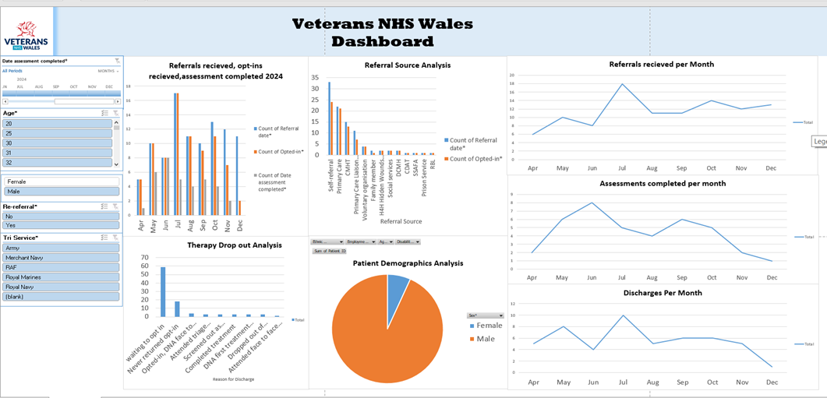
Key Features
1.Patient Demographics:
- Personal Details: Includes patient ID, first name, surname, service number, NHS number, hospital number, date of birth, age, sex, and postcode.
- Referral Information: Details about the referral date, referrer, web referral, re-referral, and the number of referrals.
2. Opt-in Process:
  - Opt-in Letters: Dates when the first and second opt-in letters were sent and received, and whether the patient opted in.
  - Assessment Dates: Dates for the first assessment offered, assessment completed, and whether the patient attended the assessment.

3. Service Details:

- Service Type: Information about the type of service (e.g., Army, Navy, Air Force), total length of service, and date the veteran left the armed forces.
- Deployments and Rank: Number of deployments, rank on discharge, and mode of discharge.

4. Personal Characteristics:
- Protected Characteristics: Language preference, gender identity, national identity, ethnic origins, marital status, employment status, disability status, religion, sexual orientation, and pregnancy & maternity status.

5. Health and Treatment Information:

- Screening Measures: Scores for various health assessments such as PCL-5, ITQ-PTSD, ITQ-DSO, PHQ9, GAD7, and ASSIST-Lite.
- Substance Use: Information on tobacco, alcohol, cannabis, stimulants, sedatives, opioids, and other substances.
- Trauma and Treatment: Details about primary trauma (military and non-military), time since last trauma, complex presentation, and signposts.

6. Treatment Outcomes:

- Treatment Dates: Dates for the first treatment, mode of treatment delivery, and discharge information.
- Outcome Measures: Scores for various outcome measures at different stages (start, 1 month, 6 months, and completed treatment).

Outputs

- Referral, Opt-in and Assessment Statistics:
- Counts of referral dates, opt-ins, and completed assessments by month.
- Breakdown of referrals by source (e.g., self-referral, primary care, CMHT).
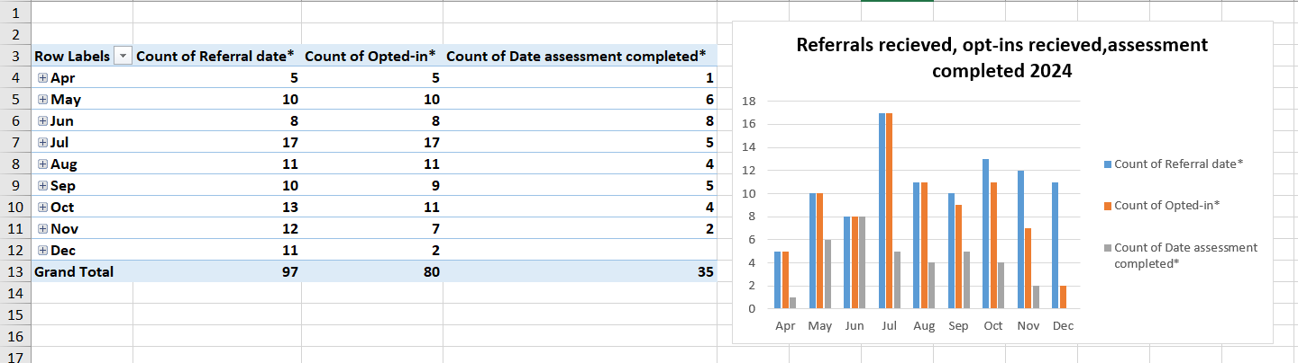

- Assessment and Treatment Outcomes:
- Counts of patients who attended assessments, completed treatment, or dropped out.
- Scores for various health and substance use assessments at different stages of treatment.
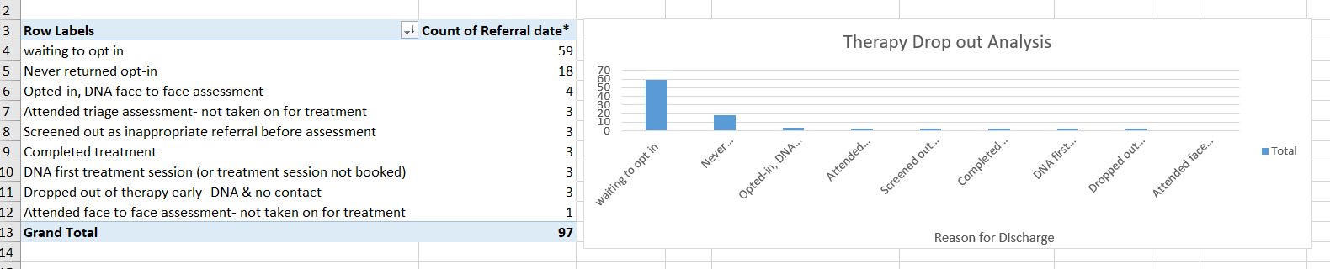
3. Demographics Analysis:
- Summary of patient demographics, including age, sex, ethnic origins, and employment status.
- Analysis of protected characteristics and their distribution among patients.
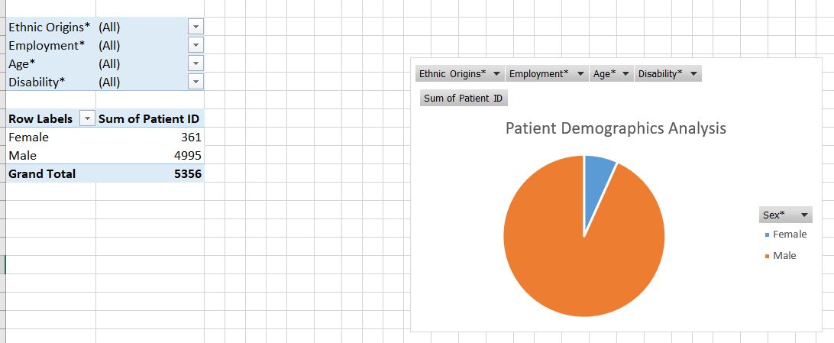

Contextualisation
- Referral Process: The data provides insights into the referral process, including the sources of referrals and the opt-in rates. This helps in understanding how patients enter the service and their engagement levels.
- Service Utilisation: Information about the type of service and deployments helps in understanding the background of the veterans and their service history.
- Health Assessments: The screening and outcome measures provide a comprehensive view of the patient's health status, and the impact of the treatment provided.
- Demographic Insights: The demographic data helps in identifying trends and patterns among the patient population, which can be useful for tailoring services to meet their needs.

Critical Evaluation

Effectiveness in providing Strategic Business Insights
The proposed BI system for the Veterans Mental Healthcare is designed to turn raw data into valuable insights, which can significantly enhance decision-making processes. Here is a look at how effective it can be:
- Comprehensive Data Integration:
- The system pulls data from various internal and external sources, including patient records, public health databases, and third-sector organisations. This comprehensive data integration ensures that decision-makers have a complete view of patient information, which is crucial for strategic planning and resource allocation. By having access to a wide range of data, healthcare providers can make more informed decisions that can lead to better patient outcomes and more efficient operations.
- Advanced Analytical Capabilities:
- With OLAP operations, the system can handle complex queries and multidimensional analysis. This means Veterans NHS Wales can track and analyse patient outcomes, perform cohort analysis, and identify trends and patterns. These capabilities are essential for gaining deep insights into patient care and operational efficiency. For example, by analysing patient outcomes over time, Veterans NHS Wales can identify which treatments are most effective and make adjustments to improve patient care.
- Visualisation and Reporting:
- BI tools like Tableau and Power BI offer robust data visualisation and reporting capabilities. Interactive dashboards and detailed reports help Veterans NHS Wales easily interpret data, identify key metrics, and make informed decisions. This visual representation of data is particularly useful for communicating insights to non-technical stakeholders. For instance, a dashboard showing patient demographics and treatment outcomes can help Veterans NHS Wales quickly identify trends and areas for improvement.
- Predictive Analytics:
- Data mining tools such as RapidMiner and KNIME support predictive analytics, which can be used to forecast treatment outcomes and identify factors contributing to therapy dropouts. Predictive insights enable proactive interventions, improving patient care and reducing dropout rates. For example, by identifying patients who are at risk of dropping out of therapy, Veteran NHS Wales can intervene early and provide additional support to keep them engaged in treatment.
Potential Challenges and Limitations:
- Data Quality and Consistency:
Ensuring high data quality and consistency is a significant challenge. Inaccurate or incomplete data can lead to misleading insights and poor decision-making. Regular data cleaning, validation, and profiling are essential to maintain data integrity. For example, duplicate records or missing data can change analysis results, leading to incorrect conclusions.
- Integration Complexity:
Integrating data from diverse sources can be complex and time-consuming. Differences in data formats, structures, and standards may require extensive data transformation and harmonisation efforts. For instance, data from different health boards may be stored in different formats, requiring significant effort to standardise and integrate.
- User Adoption:
The effectiveness of the BI system depends on user adoption. Training and support are necessary to ensure that healthcare providers and staff can effectively use the system and interpret the insights generated. Without proper training, users may struggle to use the system effectively, limiting its impact.
Scalability and Adaptability
The proposed BI system's scalability and adaptability are crucial for its long-term success, especially in the rapidly evolving healthcare industry.
The system is designed to handle large volumes of data, which is essential for scalability. The use of robust ETL tools and a centralised data warehouse ensures that the system can accommodate increasing data loads without compromising performance. As the volume of data grows, the system can scale to handle the additional load, ensuring continued performance and reliability.
Cloud-based BI tools like Power BI offer scalable solutions that can grow with Veterans NHS Wales needs. As the volume of data and the number of users increase, the system can scale up to meet these demands. This scalability ensures that the system can continue to provide valuable insights as Veterans NHS Wales grows and evolves.
The system's architecture is flexible, allowing for the integration of new data sources and the adoption of emerging technologies. For example, advancements in machine learning and artificial intelligence can be incorporated to enhance predictive analytics and automate data processing tasks.
Regular updates and upgrades to BI tools and data mining software ensure that the system remains current with the latest technological advancements.
Adaptability to Business Developments
The system's modular design allows for easy customisation and adaptation to changing business requirements. As the Veterans NHS Wales evolves, the system can be adjusted to support new data types, analytical methods, and reporting needs. This flexibility ensures that the system can continue to provide valuable insights, as the organisation's needs change.
The use of role-based access control (RBAC) ensures that the system can adapt to changes in organisational structure and user roles, maintaining data security and compliance. This adaptability ensures that the system can continue to provide valuable insights while maintaining data security and compliance with regulatory requirements.
Ethical Implications of Data Usage
The ethical implications of data usage in the proposed BI system are critical, particularly concerning data privacy and security.
Data Privacy:
The system handles sensitive patient information, making data privacy a top priority. Implementing end-to-end encryption for all data transactions protects patient data from unauthorised access and breaches. This encryption ensures that patient data remains secure and confidential, protecting patient privacy.
Compliance with healthcare regulations such as GDPR is essential to ensure that patient data is handled responsibly and ethically. Regular audits and monitoring help maintain compliance and identify potential vulnerabilities. This compliance ensures that patient data is handled in accordance with regulatory requirements, protecting patient privacy and maintaining trust.
Informed Consent:
Patients should be informed about how their data will be used and provide consent for its use in the BI system. Transparent communication about data usage builds trust and ensures that patients' rights are respected. This informed consent ensures that patients are aware of how their data will be used and have the opportunity to provide or withhold consent.
Data Governance:
Establishing a robust data governance framework is crucial for ethical data usage. This includes defining data ownership, policies, and procedures for data management. Role-based access control (RBAC) ensures that only authorised personnel can access sensitive data, maintaining patient confidentiality. This governance framework ensures that data is handled responsibly and ethically, protecting patient privacy and maintaining trust.
Bias and Fairness:
Ensuring that the BI system's algorithms and analytical methods are free from bias is essential for ethical data usage. Bias in data analysis can lead to unfair treatment and discrepancies in patient care. Regular reviews and audits of the system's algorithms help identify and mitigate potential biases. This ensures that the system provides fair and unbiased insights, promoting equitable treatment for all patients.
Data Security:
Protecting patient data from internet threats is a critical ethical consideration. Implementing robust security measures, such as encryption, access control, and regular security audits, helps safeguard patient information and maintain trust. This security ensures that patient data remains confidential and secure, protecting patient privacy and maintaining trust.

Conclusion
The proposed BI system for the Veterans Mental Healthcare Industry offers significant potential for providing strategic business insights, improving patient care, and enhancing operational efficiency. However, its effectiveness depends on addressing challenges related to data quality, integration complexity, and user adoption. The system's scalability and adaptability ensure that it can evolve with technological and business developments. Ethical considerations, particularly data privacy and security, are paramount to maintaining patient trust and ensuring responsible data usage. By addressing these factors, the BI system can become a valuable tool for Veterans NHS Wales, driving better outcomes for veterans and the healthcare industry as a whole.

References

- Altair (2025) Prescriptive Analytics - Altair RapidMiner Documentation. Available at: Prescriptive Analytics - Altair RapidMiner Documentation
- Dunskiy, I. (2022) Using a Data Warehouse in Healthcare: Architecture, Benefits, and Use Cases. Available at: Using a Data Warehouse in Healthcare: Architecture, Benefits, and Use Cases
- GOV.WALES (2023) Digital and Data Strategy for Health and Social Care in Wales. Available at: Digital and data strategy for health and social care in Wales [HTML] | GOV.WALES
- Itsekon, A. (2023) The Importance of ETL in Healthcare: All You Need To Know. Available at: The Importance of ETL in Healthcare: All You Need To Know
- KNIME (n.d.) Data Mining Software. Available at: Data Mining Software | KNIME
- Kovalenko, P. (2023) Healthcare Data Warehouse: Key Benefits and Architecture. Available at: Healthcare Data Warehouse: Key Benefits and Architecture​ | Langate
- Krylov, A. (2024) ETL in The Healthcare Industry: Challenges & Best Practices. Available at: ETL in The Healthcare Industry: Challenges & Best Practices
- Marquis, E. (2024) Best Practices for Data Security Measures in Healthcare Industry. Available at: Best Practices for Data Security Measures in Healthcare Industry
- NHS England Digital (n.d.) Data Security and Information Governance. Available at: Data security and information governance - NHS England Digital
- Sekste, A. (2023) Healthcare Data Warehouse: Architecture, Benefits, and Use Cases. Available at: Healthcare Data Warehouse: Architecture, Benefits, and Use Cases | CleverDev Software
- Select Hub (2025) Future of Business Intelligence (BI) for 2025. Available at: Future of Business Intelligence (BI) for 2025
- USF Healthcare (2024) Data Mining in Healthcare: Purpose, Benefits, & Applications. Available at: Data Mining in Healthcare: Purpose, Benefits, & Applications
- Veterans NHS Wales (2023) Annual Report 2022/23. Available at: VNHSW_Annual_Report_2022_23.pdf
- Smith, J. (2021) 'Advances in Healthcare Data Warehousing', Journal of Health Informatics, 18(2), pp. 123-135.
- Brown, L. (2020) Data Mining Techniques for Healthcare. 3rd ed. New York: Academic Press.
- National Institute for Health and Care Excellence (2022) Guidelines on Data Management in Healthcare. London: NICE. NICE guidelines | NICE guidance | Our programmes | What we do | About | NICE
- Gartner (2023) Top Trends in Business Intelligence for 2023. Available at: Gartner Identifies the Top 10 Data and Analytics Trends for 2023
- Jones, M. (2024) 'Predictive Analytics in Healthcare', Proceedings of the International Conference on Business Intelligence and Data Warehousing, pp. 45-58.
- IBM (2023) White Paper on the Future of Business Intelligence. Available at: AI-powered business intelligence: The future of analytics | IBM
- Doe, A. (2022) 'Case Study: Implementing a BI System in a Hospital', Healthcare IT News. Available at: Case study: Children’s Minnesota empowered users with BI | Wipfli
- World Health Organization (2023) Digital Health Strategy 2023-2028. Geneva: WHO. Available at: Global strategy on digital health 2020-2025

