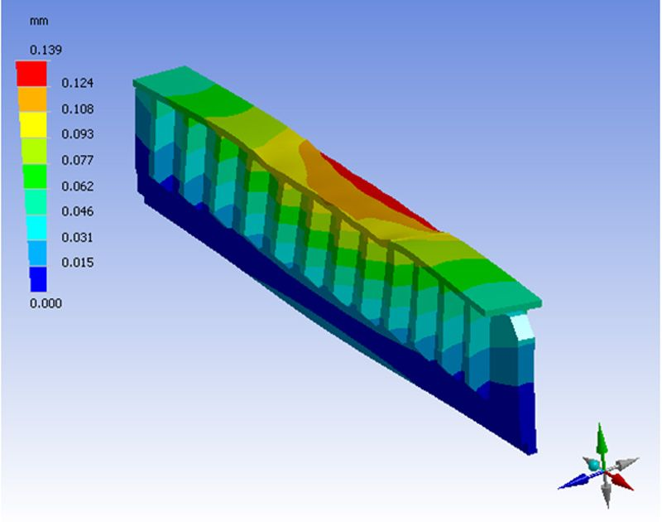
Figure 1 (Mechanical Engineering Portfolio and Samples - cadamen.com, n.d.)

Can FEA replace physical testing?
  - FEA
Milo Ward | Motorcycle Engineering | March 2020
Table of Contents
Table of Figures 1
Introduction 1
Hand Calculations 2
What is FEA? 2
How to produce a reliable FEA model 3
Why do companies carry out FEA alongside physical testing? 4
How a physical test may be correlated to an FEA model. 5
Can FEA ever replace physical testing? 6
Conclusion 7
References 7

Table of Figures
Figure 1 (Mechanical Engineering Portfolio and Samples - cadamen.com, n.d.) 0
Figure 2 Example of hand calculations (Can You do Finite Element Analysis by Hand? | Enterfea, n.d.) 2
Figure 3 Showing the load and the resultant von Mises stress (Finite Element Mesh Refinement Definition and Techniques, n.d.) 3

Introduction
The task for this following report has been split into three separate sections, firstly looking into and analsying the reasons why companies use Finite Element Analysis (FEA) testing alongside physical testing and the positives and negatives of this approach. The second section will be seeing how a physical test has been correlated to a FEA model, looking into why it used for this model and how similar the results were. The final section will be expressing the authors opinion on whether FEA analysis should/can replace physical testing in the future.

Hand Calculations
In modern day, FEA is mostly completed by computers and using software, this is due to its accuracy and the speed when compared to the other method. By using multiple equations and then putting these into matrices, it is possible to calculate basic stresses and loads that the elements would be under. The greatest problem with this is the complexity that is required when more elements are added, each time a new element is calculated, the matrices grows and gets more and more complicated. This means by using hand calculations it is incredibly difficult get accurate results, although it may be able to produce results that are close assumptions.
Using hand calculations can be useful, this along with using the ‘slide ruler’ is the basis to the mathematics for the rocket/lunar lander that managed to put man on the moon. Although the true detail and accuracy cannot be calculated, it is capable of reasonable results.
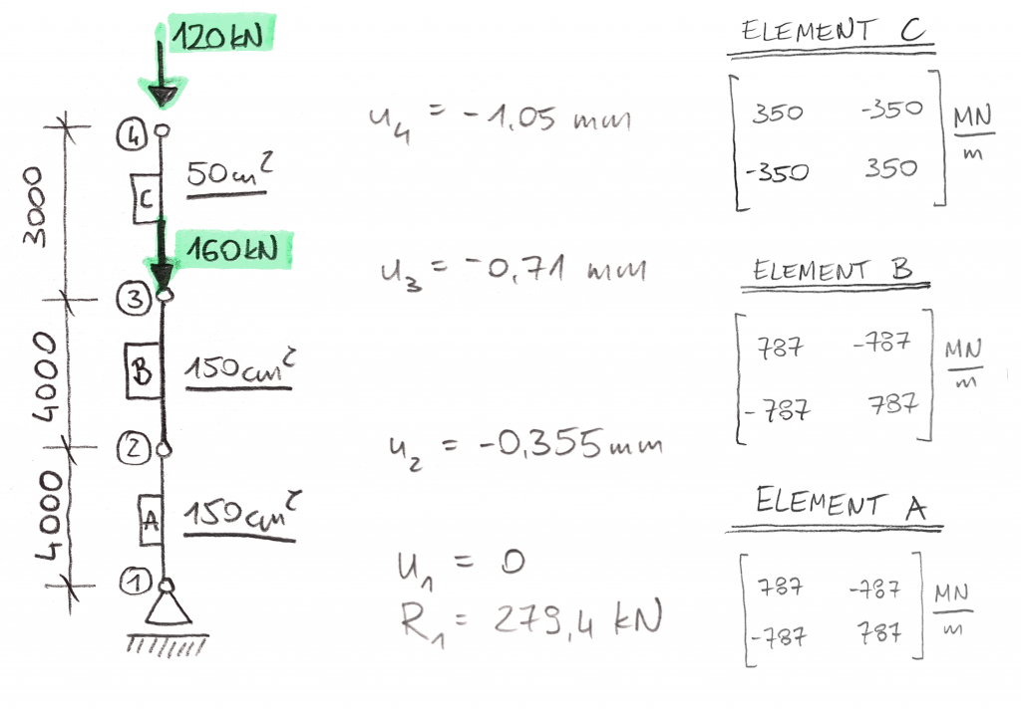
Figure 2 Example of hand calculations (Can You do Finite Element Analysis by Hand? | Enterfea, n.d.)
The key to remember when doing hand calculations for FEA is that the number of equations is equal to the number of unknown degrees of freedom. With each nodal point, three degrees of freedom is added, for more accurate results more nodal points are created. Constantly increasing the complexity of the mathematical equations.

What is FEA?
Finite Element Analysis is the simulation of a part under certain conditions that the part/assembly may be under in real conditions. This is done by using specialist software (such as Solidworks/ANSYS) where the software can use complex mathematical differential equations to analyse how the part will react to certain scenarios. By using a mesh and splitting the part down into potentially hundreds of thousands/millions of smaller elements that can be calculated and then put together at the end. One thing that is worth noting is that these calculations are only assumptions, albeit incredibly accurate assumptions. Interpolation and polynomials are used, which means that at certain points the information is known, these are called nodal points and sit at the end ends of the elements. The middle of these are then the calculated estimations. (What is FEA | Finite Element Analysis? — SimScale Documentation, n.d.) Once the calculations for all elements are competed, a model can be produced like below:
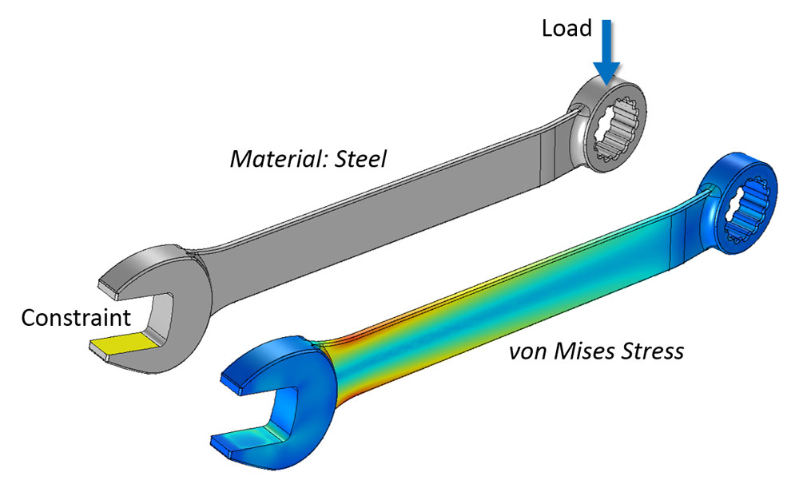
Figure 3 Showing the load and the resultant von Mises stress (Finite Element Mesh Refinement Definition and Techniques, n.d.)
FEA can produce multiple stresses for the results, these include von Mises stress, displacement, and static stress among many others.

How to produce a reliable FEA model
The key to producing a reliable and accurate FEA model is in the preparation of the model and being able to simulate the forces as close to a physical test as possible. This is done through various ways, the first aspect that must be correct is where the load is on the part and the amount of load that will be occurring at each point(s). If this is done incorrectly the part may deform unexpectedly, it is necessary to fully understand how the load would affect the part before applying the load.
Another important part of the model that needs to be correct is that the material is the right one, with different materials having a variety of characteristics. Although a material may be similar, the stiffness, elasticity or how it deals with heat could be different from the physical material and this could have a large impact on the results of the FEA.
Once the load is in the correct place and the material is correct, how the part is restrained and loaded in another crucial part to avoid problems and incorrect results. If the part is over/under restrained it will be unable to perform as it would in real conditions, giving unreliable results. This could be that the results show the part would easily perform the desired tasks, however when physically tested the part would break due to the real forces being loaded into the part in its real conditions. (Donnelly, 2016)

Why do companies carry out FEA alongside physical testing?
FEA is an incredibly useful tool for manufactures of parts, it allows a middle stage of production when compared to not using it. It allows the initial concept to be viewed in 3D and ‘tested’ without having to produce the part in the real world and that additional costs that come with that. Although designers try to get the design right first time for the job that is being required, sometimes other aspects have not been accounted for that could cause the part to fail. If FEA was not completed, to know about this failure the part must first be produced and then tested under the conditions that this part must be under. If the part were to then fail, the time and money put into this part has been wasted, not considering the potential for injuries while testing the part. The designer will then go back to redesigning the part to make sure this issue does not occur again. The process will then be repeated.
Whereas, if FEA was being used alongside this, the failure could have been spotted before the expense was paid for the prototype. By using FEA, the conditions that the part would have been under could have been replicated, for example. When designing a connecting rod in an engine, the part can first be created on CAD and then a FEA study can be conducted on the part. By using cylinder pressure data that the part would be under, this load can be put onto the part to attempt to replicate how the part would perform and the resultant forces that would occur on the road. Once the part can perform in the FEA model, a prototype can be produced from these designed and the physical testing can begin on the part. It is worth noting that many manufactures will continue with the CAD and FEA to continually make improvements on the part so that it can perform better and possibly reduce the material (for weight or cost saving) while physical testing is occurring. Aiming for the results in the physical testing to replicate the results in FEA software’s. FEA software can see stress, thermal conductivity, vibrations, and many other situations that parts may be under while in use. By being able to replicate this before physical testing allows for potential cost saving in the reduction of prototypes that need to be made. (Why Use FEA?, n.d.)
The best option for a company/engineer is to coincide the FEA and the real world prototyping, first starting with the FEA with the design, making sure it is capable of dealing with the desired situation, seeing where the potential weak spots and issues may be. Once the real world prototyping has been completed for the first part, the FEA can then be revisited to adjust for any issues that occurred during the real world testing and seeing if any modifications can be made to the part to improve it more. After this the real-world testing can be completed again, this process can be repeated until the product/part is performing as desired. Moving from older 2D Design to 3D design and FEA saved Joseph Rhodes Limited £114,000 while producing rubber dye presses and knuckle point presses. (Ramakrishnan, n.d.) Supporting the suggestions that using FEA can save a company money over time, while increasing accuracy and the speed.

How a physical test may be correlated to an FEA model.
If done correctly, a FEA model can produce a fair representation of a physical test, for example an ISO Tanker used to transport liquids are required to pass stringent testing. The tanker had failed on the dynamic testing, where the tanker is subject to a 5G crash, it can permanently deform by 3mm, whereas this tanker failed, permanently deforming by 5mm. (Tiernan & Fahy, 2002)
To resolve this a FEA model of the tank crashing was completed and a variety of modifications were made to the tank to make sure that it is capable to passing the test. A redesign was completed on CAD, this required 8mm hexagonal plates and 8mm stiffeners at the bottom of the tank. Although other options were first considered, one option was to just up the 5mm stiffeners to 15mm, however when this was tested, the tank still permanently deformed to 5mm. The next option that was tried 8mm hexagonal plate, under the test conditions this deformed around 1.5mm.
The test was first completed on the FEA model with the new design to see if it was capable to passing, it was predicted and shown through the FEA model that the permanent deformation would be around 1mm compared to the original 5mm. Theoretically passing the inspection and becoming ISO approved. (Tiernan & Fahy, 2002)
Running FEA alongside physical testing also allows errors to be found and this allows errors to be rectified, this was experienced by GKN while testing tooth root stresses on hypoid gears. It was noticed that physical testing differed drastically compared to the FEA projections. These FEA test were rerun followed, followed by rerunning the physical testing, when running this it was noted that a sensor that was being used to measure stress in the physical testing had an issue, this was due to the sensor not being in the correct place. This meant that it did not pick up on the peak stress that the gears were undergoing, whereas on the FEA model it was able to pick up on the highest stress and this is where the largest discrepancies were. (Gregefors, n.d.)

Can FEA ever replace physical testing?
Finite Element Analysis is an incredibly useful tool when designing and manufacturing a part, being able to reduce the number of prototypes that need to be produced and tested cuts down on cost and time. However, this begs the questions on whether physical testing can be completed cut out and using only the FEA results to produce a product.
In a purely theoretical way, FEA could take over from physical testing. In a perfect world if the FEA modelling on the part has been done correctly, including the correct material, correct restraints and loading on the piece, this would show how the part will perform in a physical conditions and as long as the part is perfect and no others forces occur in the part. This would require perfect material that has no cracks or areas of fatigue and is perfectly able to replicate the theoretical model that was produce on CAD for the FEA. There can then be no stress concentrations on the part either as these could break when they did not occur on the FEA model. When loaded into the desired job, it would have to be under the same initial loading and stain that the FEA model was under as well to be able to perform as the FEA did. Although some FEA software’s do allow for fatigue over time and this would be factored into the part and the model. It does not consider corrosion, dirt, and minor damage that some parts may receive, apart from FEA may work straight away for a period of time but could potentially fail at another point.
In the real world, this is impossible to achieve, especially on a mass production level, physical test need to be completed to see how the part would react under the real loading conditions and the potentially imperfect material that may have been used to create the part. One of the potential ways around this is to use nondestructive testing alongside FEA, although a more costly route due to needing to produce the test parts and run the testing as well as the time and cost of running the FEA side. However, by using FEA to find the max stress/load that the part can withstand before failure will allow a part to be produced that has that load well within reach. Then an FEA model can be run where the part would be under normal loading conditions, this data can then be used as a comparison to the nondestructive testing that can be completed with this part.
This manufacture model was used when proposing a new manufacturing technique for part of a fuselage on a small private plane. Previously the part had been made out of multiple sections, due to ‘Joining and assembly accounting for up to 30% of a product’s total manufacturing cost and up to 50% of its total manufacturing time’ (I. Mendoza-Muñoza, 2015) it was decided that producing the part as one piece could potentially save money and time for the company.
Using FEA and nondestructive testing together, it was concluded that the new design was able to deal with the stress better, therefore suggesting that the stiffness of the new one piece part is greater than the original multiple piece that has to be joined together. The nondestructive testing required sensors being put into place, these were rectangular rosette strain gauges. These measured 0.5156mε@46.44N for the physical test for the new piece and 0.7012mε@46.44N for the original multiple piece design. The FEA design supports the nondestructive testing, with the new design getting 0.4796 using FEA, and the original multiple piece design getting 0.7793 using FEA. These results are close in regards of the FEA vs physical testing and they both follow a similar drop in strain measured from the original to the one-piece design.
With this FEA modelling and the physical testing, it can be suggested that this new design is better than the original design that was used on the plane and if it was possible; the new design should be accepted and used on the plane in the future.

Conclusion
In conclusion, finite element analysis is an incredibly useful tool that when implemented into a product at the right stage can be used to reduce cost and time on real world prototyping and testing, potentially even making the process safer for the people testing the components. However, due to FEA considering all parts to be perfectly made to that specification, it does not take into account circumstances that the company may have no control over, such as material that maybe isn’t perfect or dents/knocks that may occur in transport that would inflict stress concentrations in the piece. Meaning that when the product is tested, although it worked perfectly on the computer, with these extra stress concentrations that part has failed. Although the FEA software is always improving and changing to take more of these errors into account so that the FEA can be as close to the real thing.
Overall, FEA is an incredibly important tool when designing and producing various parts/products, however in the real world it currently can not replace real world testing of the product. It can certainly reduce prototypes and give indications of the problems that will occur before the product is produced so that these errors can be changed before the product is made, ,but a part/product should still not go from FEA modelling to mass production in case errors that can not be known to the software occur and the part does fail. For the best results, FEA and real-world testing should be used together to make a inferior product/part in a shorter and most cost effective time frame.

References

Can You do Finite Element Analysis by Hand? | Enterfea. (n.d.). Retrieved March 27, 2020, from https://enterfea.com/finite-element-analysis-by-hand/
Finite Element Mesh Refinement Definition and Techniques. (n.d.). Retrieved March 24, 2020, from https://www.comsol.com/multiphysics/mesh-refinement
Gregefors, C. (n.d.). Correlation study between FEA and physical testing for a hypoid gear set.
Mechanical Engineering Portfolio and Samples - cadamen.com. (n.d.). Retrieved March 24, 2020, from https://www.cadamen.com/portfolio.html
Ramakrishnan, K. (n.d.). Cost benefit analysis of computer aided engineering implementation in bespoke engineering business. Retrieved March 25, 2020, from http://shura.shu.ac.uk/20264/
Tiernan, S., & Fahy, M. (2002). Dynamic FEA modelling of ISO tank containers. Journal of Materials Processing Technology, 124(1–2), 126–132. https://doi.org/10.1016/S0924-0136(02)00196-6
What is FEA | Finite Element Analysis? — SimScale Documentation. (n.d.). Retrieved March 24, 2020, from https://www.simscale.com/docs/content/simwiki/fea/whatisfea.html
Why Use FEA? (n.d.). Retrieved March 25, 2020, from www.caliberdesign.co.nz

