
Student Name: | Balqees Bibi
Student ID Number: | 2530124
Programme: | Certificate of Higher Education Skills for the Workplace (Health and Social Care)
Module Title: | Introduction to Public Health
Module Code: | LCHS4008
Lecturer: | Gillian Weaver (Module Lead)
Internal Verifier: | Dr. Besty Jose
Assignment Title: | Assessment 2 -  Report on a Health Issue
Submission Deadline: | 21st July 2026, 10 am

Table of Contents
1 Introduction ............................................................................................................................... 3
2 Main Body ................................................................................................................................. 4
2.1 Different Approaches Used to Measure and Monitor Type 1 Diabetes ........................ 4
2.2 Control of Type 1 Diabetes ................................................................................................ 5
2.3 Consequences of Type 1 Diabetes on People in the Community ................................... 6
2.4 Health and Social Care Support Services for Individuals with Type 1 Diabetes ......................................................................................................................................................... 7
3 Conclusion ................................................................................................................................. 8
References ..................................................................................................................................... 9

Introduction
Type 1 diabetes (T1D) is a chronic autoimmune condition in which the immune system destroys the insulin-producing beta cells of the pancreas, resulting in an absolute deficiency of insulin and lifelong dependence on insulin therapy (National Institute for Health and Care Excellence (NICE), 2022). Common signs and symptoms include excessive thirst, frequent urination, unexplained weight loss, fatigue, blurred vision and, in severe cases, diabetic ketoacidosis requiring emergency treatment (NICE, 2022). Globally, the International Diabetes Federation (2025) estimates that approximately 9.1 million people are living with T1D, highlighting its growing public health significance. In the United Kingdom, over 400,000 people have T1D, creating substantial demands on NHS services and long-term community care (Diabetes UK, 2024). This report critically examines the approaches used to measure, monitor and control T1D, evaluates its impact on individuals and communities, and discusses the health and social care services required to support effective disease management.
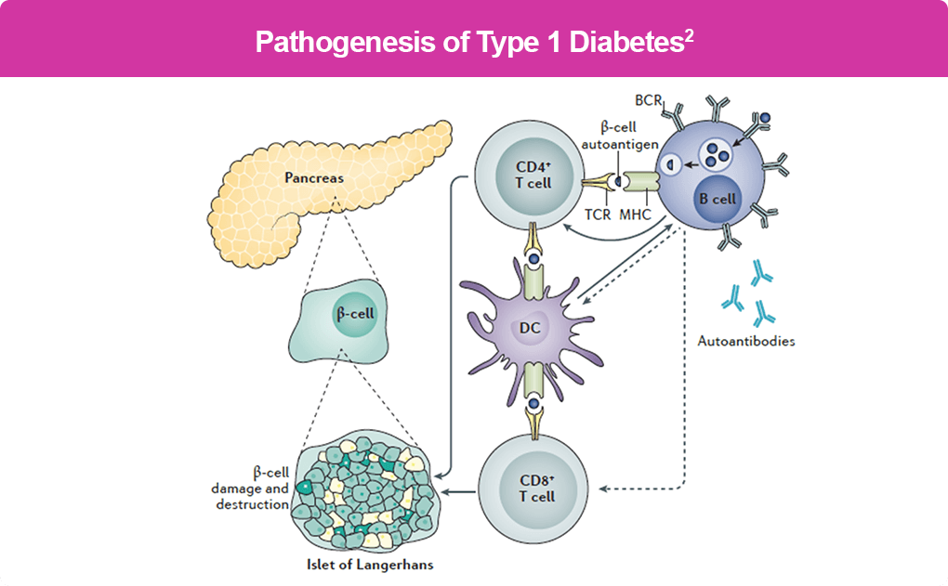
(Atkinson, 202)Atkinson
2.1 Different Approaches Used to Measure and Monitor Type 1 Diabetes
Effective measurement and monitoring are fundamental to the management of Type 1 diabetes (T1D), enabling healthcare professionals to maintain glycaemic control, reduce complications and support person-centred care. In UK clinical practice, individuals with T1D routinely monitor blood glucose using either self-monitoring of blood glucose (SMBG) through finger-prick testing or continuous glucose monitoring (CGM) systems. NICE (2022) recommends offering CGM to all people with T1D because it provides real-time glucose readings, identifies patterns of hyperglycaemia and hypoglycaemia, and supports timely adjustments to insulin therapy. Flash glucose monitoring systems are also widely used within the NHS to improve self-management and treatment adherence (Diabetes UK, 2024).

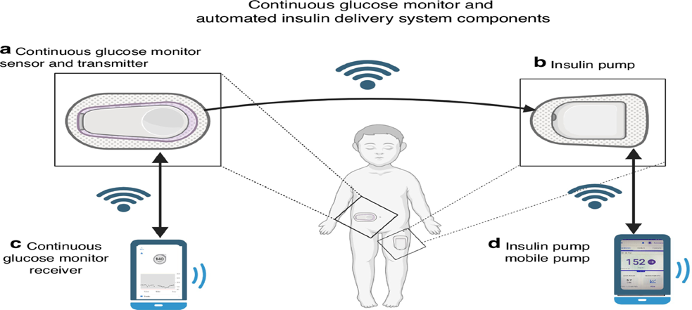
(MacLeish, 2024)
Long-term glycaemic control is assessed using the glycated haemoglobin (HbA1c) test, which reflects average blood glucose levels over the previous two to three months. Regular HbA1c testing enables clinicians to evaluate treatment effectiveness and identify individuals at increased risk of diabetes-related complications (Davies et al., 2022). During periods of illness or persistent hyperglycaemia, blood ketone testing is recommended to detect diabetic ketoacidosis (DKA) at an early stage, allowing prompt intervention and reducing emergency hospital admissions (NICE, 2022).
Routine monitoring also includes blood pressure measurement, lipid profile assessment, kidney function tests, retinal screening and annual foot examinations. These assessments facilitate early detection of microvascular and macrovascular complications, improving long-term clinical outcomes (Holt et al., 2021). At the population level, the National Diabetes Audit (NDA) evaluates care quality, treatment outcomes and complication rates across England, enabling NHS organisations to monitor service performance and implement quality improvement initiatives (NHS England, 2024). Although advances in diabetes technology have transformed disease monitoring, equitable access to CGM devices and structured education remains essential to ensure all individuals benefit from evidence-based diabetes management and achieve improved health outcomes (International Diabetes Federation, 2025).
2.2 Control of Type 1 Diabetes
Effective control of Type 1 diabetes (T1D) requires lifelong insulin replacement combined with structured self-management, regular clinical review and multidisciplinary support to minimise complications and improve quality of life. As individuals with T1D are unable to produce insulin, multiple daily insulin injections (MDI) or continuous subcutaneous insulin infusion (CSII) through an insulin pump are the primary treatment approaches (National Institute for Health and Care Excellence (NICE), 2022). NICE (2022) recommends individualised insulin regimens based on glucose monitoring results, lifestyle and personal preferences to achieve optimal glycaemic control while reducing the risk of hypoglycaemia.
Recent advances in diabetes technology have significantly improved disease control within the NHS. Hybrid closed-loop systems, often referred to as an artificial pancreas, integrate continuous glucose monitoring (CGM) with insulin pumps to automatically adjust insulin delivery according to real-time glucose levels. Evidence indicates that these systems increase the time individuals spend within the target glucose range, improve HbA1c levels and reduce episodes of severe hypoglycaemia compared with conventional insulin therapy (Boughton and Hovorka, 2021). NHS England (2024) has recommended the phased rollout of hybrid closed-loop technology for eligible individuals with T1D across England.
Successful disease control also depends on lifestyle management and structured education. Healthcare professionals support individuals in carbohydrate counting, healthy eating, regular physical activity and sick-day management to maintain stable blood glucose levels and prevent diabetic ketoacidosis (NICE, 2022). Structured education programmes, such as Dose Adjustment For Normal Eating (DAFNE), improve self-management skills, insulin dose adjustment and treatment adherence, leading to better glycaemic control and quality of life (Heller et al., 2022). Through evidence-based insulin therapy, advanced diabetes technologies, structured education and routine multidisciplinary follow-up, the NHS effectively controls T1D while reducing avoidable complications, hospital admissions and long-term healthcare costs (International Diabetes Federation, 2025).
2.3 Consequences of Type 1 Diabetes on People in the Community
Type 1 diabetes (T1D) has significant physical, psychological, social and economic consequences that extend beyond the individual to affect families, communities and health and social care services. Poor glycaemic control increases the risk of acute complications, including severe hypoglycaemia and diabetic ketoacidosis (DKA), while prolonged hyperglycaemia contributes to long-term complications such as diabetic retinopathy, nephropathy, neuropathy and cardiovascular disease (Holt et al., 2021). These complications can reduce independence, impair daily functioning and negatively affect quality of life.
The psychological impact of T1D is equally important. The continuous demands of blood glucose monitoring, insulin administration and dietary management may contribute to stress, anxiety and diabetes-related distress, which can reduce treatment adherence and glycaemic control (International Diabetes Federation, 2025). Children, adolescents and young adults may also experience difficulties participating in education, employment and social activities because of concerns about hypoglycaemia, insulin administration and stigma associated with their condition (Diabetes UK, 2024). These challenges may also affect self-confidence, social relationships and emotional wellbeing, particularly during adolescence when individuals are learning to manage their condition independently.
The consequences of T1D also affect families and the wider community. Parents and caregivers often provide ongoing support with insulin administration, glucose monitoring and emergency management, creating emotional and financial pressures within households. Frequent healthcare appointments, hospital admissions and long-term treatment increase demand on NHS resources and contribute to rising healthcare expenditure (NHS England, 2024). In addition, socioeconomic inequalities may limit access to diabetes technologies, healthy food choices and structured education programmes, resulting in poorer health outcomes among disadvantaged populations (National Institute for Health and Care Excellence (NICE), 2022). Addressing these challenges requires coordinated public health strategies, equitable access to healthcare services and continuous multidisciplinary support to minimise complications, improve self-management and enhance the overall wellbeing of individuals living with T1D within the community.
2.4 Health and Social Care Support Services Required to Meet the Needs of Individuals Affected by Type 1 Diabetes within the Community
Meeting the needs of individuals with Type 1 diabetes (T1D) requires coordinated, person-centred health and social care services that support effective disease management throughout life. In the United Kingdom, General Practitioners (GPs) are usually the first point of contact and play a key role in coordinating care, monitoring treatment outcomes and referring individuals to specialist diabetes services when required (National Institute for Health and Care Excellence (NICE), 2022). Regular reviews in primary care help assess blood glucose control, medication adherence and the development of diabetes-related complications.
Specialist diabetes teams provide comprehensive multidisciplinary care. Diabetes specialist nurses educate individuals on insulin administration, continuous glucose monitoring (CGM), carbohydrate counting and self-management, while endocrinologists oversee complex treatment plans and adjust insulin therapy when necessary (Holt et al., 2021). Dietitians develop personalised nutritional plans that support healthy eating and glycaemic control, whereas podiatrists perform routine foot assessments to prevent ulcers and lower-limb complications. Regular retinal screening by ophthalmology services enables the early detection and treatment of diabetic retinopathy, reducing the risk of vision loss (NHS England, 2024).
Health and social care support extends beyond clinical treatment. Pharmacists promote safe medicine use, provide advice on insulin storage and reinforce treatment adherence during routine consultations. Clinical psychologists help individuals manage diabetes-related distress, anxiety and the emotional demands of living with a lifelong condition, while social workers assist people experiencing financial hardship or reduced independence by facilitating access to welfare benefits, community resources and social care services (Diabetes UK, 2024). Through collaborative working, multidisciplinary teams deliver holistic, person-centred care that addresses both medical and social needs. This integrated approach improves self-management, reduces avoidable hospital admissions and enables individuals with T1D to maintain independence and achieve a better quality of life within the community (International Diabetes Federation, 2025).
Conclusion
Type 1 diabetes is a lifelong condition that requires continuous measurement, monitoring and effective management to reduce complications and improve quality of life. This report has demonstrated that successful management depends on regular blood glucose monitoring, HbA1c testing, continuous glucose monitoring technologies and routine screening for diabetes-related complications. It has also shown that effective disease control requires individualised insulin therapy, structured education and healthy lifestyle practices supported by evidence-based clinical guidelines. The report highlighted the physical, psychological, social and economic consequences of T1D and the importance of coordinated multidisciplinary care in addressing these challenges. Collaboration between General Practitioners, diabetes specialist nurses, endocrinologists, dietitians, psychologists and social care professionals is essential to promote self-management, reduce avoidable hospital admissions and improve long-term health outcomes for individuals living with Type 1 diabetes.

REFERENCES
Boughton, C.K. and Hovorka, R. (2021) ‘Is an artificial pancreas (closed-loop system) for Type 1 diabetes effective?’, Diabetic Medicine, 38(1), e14416.
Davies, M.J., Aroda, V.R., Collins, B.S., Gabbay, R.A., Green, J., Maruthur, N.M., Rosas, S.E., Del Prato, S., Mathieu, C., Mingrone, G., Rossing, P., Tsapas, A., Buse, J.B. and D’Alessio, D.A. (2022) ‘Management of hyperglycaemia in type 1 diabetes: A consensus update’, Diabetes Care, 45(11), pp. 2753–2786.
Diabetes UK (2024) Type 1 diabetes. London: Diabetes UK.
Heller, S., Lawton, J., Amiel, S.A., Cooke, D., Mansell, P., Brennan, A. and Elliott, J. (2022) ‘Structured education for adults with Type 1 diabetes: Current evidence and future directions’, Diabetic Medicine, 39(6), e14744.
Holt, R.I.G., DeVries, J.H., Hess-Fischl, A., Hirsch, I.B., Kirkman, M.S., Klupa, T., Ludwig, B., Nørgaard, K., Pettus, J., Renard, E. et al. (2021) ‘The management of Type 1 diabetes in adults: A consensus report by the American Diabetes Association (ADA) and the European Association for the Study of Diabetes (EASD)’, Diabetologia, 64(12), pp. 2609–2652.
International Diabetes Federation (2025) IDF Diabetes Atlas. 11th edn. Brussels: International Diabetes Federation.
National Institute for Health and Care Excellence (2022) Type 1 diabetes in adults: Diagnosis and management (NG17). London: NICE.
NHS England (2024) National Diabetes Audit. London: NHS England.

