Defining Dark Tourism
A number of academic books, peer reviewed articles and journals have been written about dark tourism; these contain a variety of different theories and concepts on the topic. The majority of academic literature is relatively current and has begun to capture people’s attention of late. More modern studies into dark tourism tend to contradict those that were initially completed.
Although the form of travel to places associated with death, destruction and disaster has more recently been defined as ‘dark tourism’, there has always been a niche target market for this type of tourism. (Sharpley and Stone 2009). Since the mid-20th century, there has been an increase in interest in dark tourism, and tourists are looking for new and exciting experiences, which are increasing in scope and scale. (Seaton and Lennon 2004) The most frequently visited dark tourist destinations are those, which are based around war-tourism. Dark tourists like to visit places where death and suffering has occurred, popular destinations would include Auschwitz, Ground Zero and the sixth floor in Dallas. A number of different forms of tourism have been identified within the general dark tourism definition such as ‘holocaust tourism’ (Ashworth 1996; Beech 2000), atrocity tourism (Ashworth and Hartmann 2005c), slavery-heritage tourism (Dann and Seaton 2001a) and prison tourism (Strange and Kempa 2003).
Although tourism to morbid places and sites of grief is widely known as dark tourism it is also referred to as ‘thanatourism’ (Seaton 1996). Thanatourism identifies tourists as wishing to gain a thrill or a shock experience when they visit such sites, those who wish to visit dark tourist destinations are hoping to be scared and to experience the fear that the history of the place projects. (O’Rourke 1998: Pelton 2003) suggest that tourists visit the sites in order to heighten their own sense of mortality, by going somewhere where death and destruction occurred the tourist/visitor can feel more alive and more appreciative of life. (Stone, 2006) states that dark tourism may be defined simply and more generally as the act of travel to sites associated with death, suffering and the seemingly macabre. Not all places are the original sites; some are representations of a site or a memorial.

(Dann 1998), created a chart suggesting there are different categories within dark tourism and that different sites have different levels of dark, there are five categories, ‘perilous places’, ‘houses of horror’, ‘fields of fatality’, ‘tours of torment’ and ‘themed thanatos’. Under each of these headings Dann lists a number of attractions that are frequently visited by dark tourists including; ‘towns of horror, dangerous destinations, dungeons of death, heinous hotels, bloody battlegrounds, the hell of the holocaust, cemeteries of celebrities, mayhem and murder, the now notorious, morbid museums, and monuments to mortality.’ These destinations all come under one of the sections suggested by Dann; the table presented is not definitive but is an indication to early attempts of defining and sectioning dark tourism when there was a lack of theoretical research.

Figure 1.1 – Dann (1998) A categorisation of dark tourism.
Divisions of the dark
Perilous places  Dangerous destinations from the past and present. | - Towns of horror  - Dangerous destinations
Houses of horror  Buildings associated with death and horror, either actual or represented. | - Dungeons of death  - Heinous hotels
Fields of fatality  Areas/land commemorating death, fear, fame or infamy. | - Bloody battlegrounds  - The hell of the Holocaust  - Cemeteries for celebrities
Tours of torment  Tours/visits to attractions associated with death, murder and mayhem. | - Mayhem and murder  - The now notorious
Themed thanatos  Collections/museums themed around death and suffering. | - Morbid museums  - Monuments to morality

(Dann 1998) acknowledges that these categories of dark tourism are descriptive of the attractions visited by dark tourists, but do not demonstrate tourist motivation for visiting such places. It has only recently been acknowledged as to why people are attracted to sites of death and suffering, little attention was paid to this previously and the motivations for visiting such places were not seen as important.

Typology of dark tourism
There are a number of typologies within dark tourism that different theorists have identified over the years. Miles 2002 states that although there are a number of differing approaches to dark tourism there will always be a high demand and supply for it, whether there are an increased number of attractions within the sector, or whether the behaviour of tourists is becoming darker and more intrigued by the violent death of others.
When looking at the typology of dark tourism there is reference to Seaton’s notion of the continuum of intensity, demonstrating to what extent the interest in death is general rather than specific to one person, but there is also an indication to Holt’s 1995 early study on dark tourism having different ‘shades’ depending on how dark the attraction is seen by those visiting. From looking at Holt’s work Sharpley 2005 conducted a study and came up with a diagram on the different shades of dark tourism and how he identifies each one of them according to what types of tourists go there and what their purpose is for visiting.

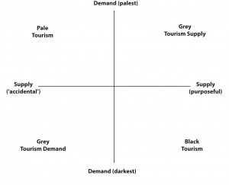

Figure 1.2 – Matrix of dark tourism demand and supply.
Sharpley identifies four ‘shades’ of dark tourism.
Pale tourism - tourists have little interest in death, they visit a site that was unintended to be a tourist attraction.
Grey tourism demand – tourists have a fascination for death but visit an unintended dark tourism site.
Grey tourism supply – the sites that are focused mainly on exploiting death but attract visitors with some but not much interest in death.
Black tourism – tourists that are fascinated by death are satisfied with a supply of experiences intended to satisfy the fascination.

Similar to figure 1.2, Stone also poses a possible spectrum of dark tourism supply.

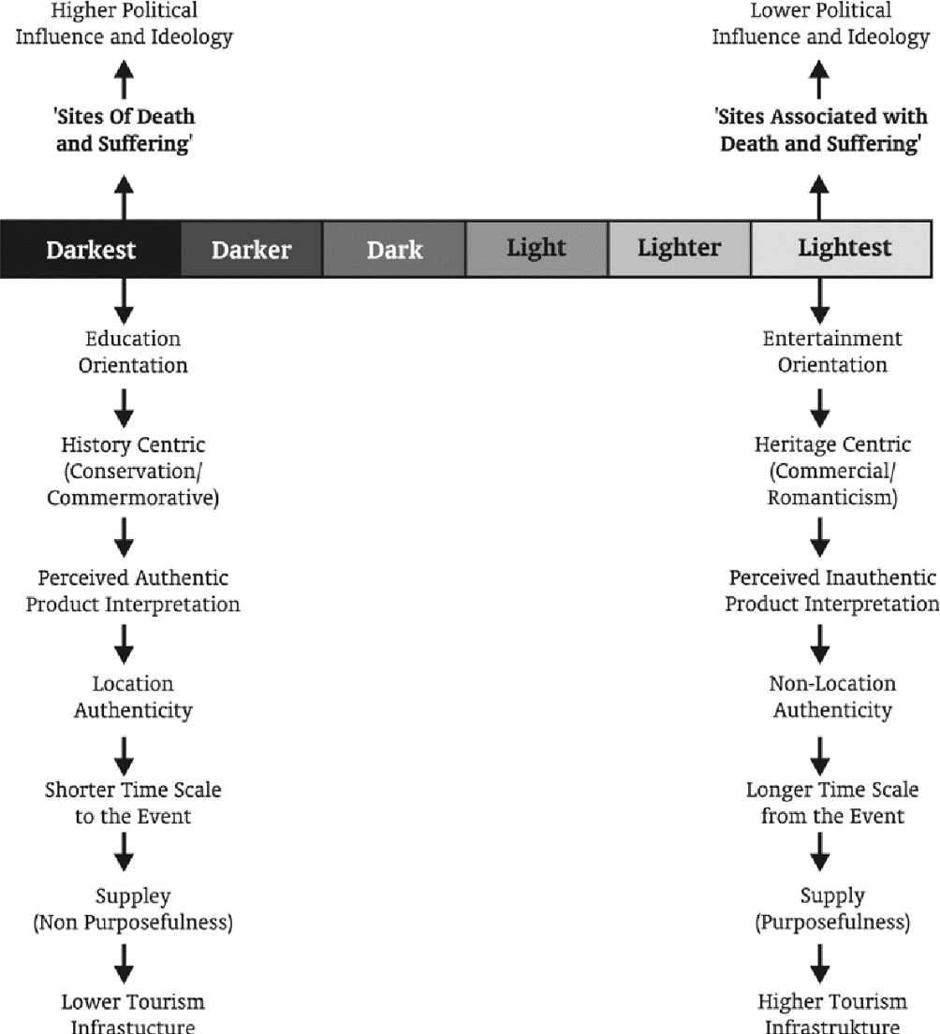

Figure 1.3 A dark tourism spectrum.
Within Stone’s spectrum, the location, objectives and authenticity of the dark tourism site is taken into consideration when deciding where it is located on the darkest and lightest scale. The dark to light scale ranges from ‘Dark Fun Factories’ being one of the lighter types of tourism, to ‘Dark Camps of Genocide’ being on the darker side.
When the theorists link their ideas together, they are able to see a pattern; the ‘lightest’ form of dark tourism is to be found at one end of the continuum created by Seaton, with the ‘darkest’ being at the other end of the continuum. Areas that are not classified as light or dark can be found in Dann’s diagram.
Even though there are a number of typologies, as yet not one has been identified with universal acceptance, and the endeavour into the subject has been under vigorous critique. Dale and Robinson (2011) argue that the majority of typologies are subjective, and the methodologies used to create the typology are rarely or submissively explained. Ashworth and Isaac (2015) claim that the approach would be unending ‘since an infinite overlapping of taxonomies can be conceived and imposed upon the diverse realities of tourism sites.’
Bowman and Pezullo (2010) argue that typologies are underpinned by the positivist concern to categorise and classify, this has been evident in the tourism industry and management sector for a long period.
There is also the issue of sub terms such as ‘war tourism’ and ‘atrocity tourism’, these terms make it even harder to categorise dark tourism as technically they have their own individual categories. The idea of sub terms was meant to bring clarity but instead it took the core meaning away from dark tourism itself.
The term ‘dark’ tourism is considered to be controversial and many think it should either be given a different name, or that theorists should only use the term thanatourism. This is another reason why sub terms were introduced, but theorists do not agree with the diversion and believe it is another positivist spin on the subject. It has been suggested that there was initially a minor difference between dark tourism and thanatourism and that they should be used to describe differing attractions and destinations, but more recently they are used simultaneously and are referred to in the same way in literature and academic writing.
There is also a strong link between tourism and heritage, within dark tourism there is ‘dark heritage’ and ‘dark heritage tourism’. Knudsen (2011) calls it ‘difficult heritage’ or according to Sather-Wagstaff (2011) ‘heritage that hurts’. Due to neither of these terms being accepted, the term dark tourism is still widely used, and will be continue to be used until a more academic term can be formed to describe the process.

Interpretation of dark tourism
There are a number of studies that disagree over the interpretation of some dark tourist sites, specifically war and conflict sites. (Uzzell 1986) focuses on the truth of interpretation and believes that all sites should be interpreted in their original state with no facts changed; this is called ‘hot’ interpretation. In contradiction, (Tunbridge and Ashworth 1996) developed a conceptual framework about the management of such sites. They discovered that heritage dissonance is particularly common in dark tourist sites, heritage dissonance is when facts or memorabilia in an attraction are distorted or disrupted. For some sites such as war sites and sites of atrocity, there are some facts and artefacts that are just too gruesome to include in a tourist attraction, (Ashworth 1996) states that atrocity sites are popular for tourists as they are good for educational purposes as well as entertainment. Some of the facts need to be distorted in order to not frighten tourists away but still educate them. (Muzaini et al 2007) argues that dark tourist destinations focus on the ‘visual’ and ‘experiential’ more than the genuine truth of the historical facts.
Lennon and Foley (2000) conducted a study and found that many attractions do in fact distort and disrupt their displays in order to appeal to tourists and visitors. Murphy (2015) and several other theorists conducted a further study to see Lennon and Foley’s findings were correct and found them to be broadly similar. Sharpley and Stone (2009) wanted to refine the debate by considering issues with kitschification, they argue that the use of kitsch in dark tourism interpretation can allow visitors and tourists to experience feelings of ‘comfort, safety and hope’.

Tourist Motivation to visit dark tourist destinations
A number of theorists have identified that there are certain motivations for tourists to visit such dark and morbid destinations. (Rojek 1993) considers the idea of ‘black spots’ and the up and coming commercialisation of celebrity graves. These graves are located where a celebrity has met a violent death or where a large number of people have died in tragic circumstances at one time.
(Sharpley and Stone 2006) believe that dark tourism is rendered more complex from a number of variables, these being; ‘the spontaneity of ‘sensation’ tourists to sites of contemporary death and disaster compared to premeditated visits to organised sites, the distinction between purposeful sites such as entertainment dungeons and museums compared to accidental sites such as churches and graveyards, whether the interest in death is the main reason for visiting the attraction and why and how dark tourism sites are produced’.
Many theorists like to argue that there are a number of reasons for wanting to visit dark tourist destinations, the main reasons being education and entertainment, however (Reader 2003) has suggested that there is a lack of attention to the motivation of people to visit such places, and that other theorists are reluctant of accepting that people have a desire for ‘dark’ experiences and that they are overlooking the main dimension of dark tourism.
In conjunction to this theory Seaton suggests that dark tourism is in fact a behavioural phenomenon and is defined by a person’s motives to visit the attraction rather than the characteristics of the attraction itself, and that within dark tourism or thanatourism there is a ‘continuum of intensity’ depending on one’s motive for visiting ‘a site and the extent to which the interest in death is general or person specific’.
Based on the behavioural perspective, Seaton suggests that there are five categories of dark travel activities; ‘travel to witness public enactment of death, travel to see the sites of individual or mass death after they have occurred, travel to memorials or internment sites, travel to see evidence or symbolic representations of death and travel for re-enactments or simulation of death.’
Seaton also confirms that thanatourism has increased in popularity over the last two centuries and that this has a direct link to the media, the media is principally linked through increasing the geographical specificity of violent death and murder. With today’s improved technology, videos are streamed showing violent acts as they are happening or immediately after they have taken place. Lennon and Foley 2000 agree that media has a part to play in contemporary society linking to dark tourism; they believe that technologies, sociologies, economics and politics have an impact on dark tourism, as they have an impact on the selection as well as the interpretation of sites which become products for tourism.

Ethics and Morals
Dark tourism will always raise questions with regard to ethics and morals. The most frequently asked question when discussing dark tourism or attractions related to the subject is, ‘why do people go there? And is it morally wrong to visit such an attraction or place?’ Lisle (2004) People visit dark tourism sites for many differing reasons, whether it be for education, entertainment or remembrance.
The question is it morally right to promote death and disaster to tourists and visitors across the world, is frequently raised. One destination where ethics is a particular concern is Ground Zero in New York. Unfortunately, hundreds of innocent victims were killed at this site, yet every year thousands of people visit their graves. They do so primarily because they have seen the site advertised, or have heard of others’ experiences when visiting the site, they have then wanted to experience Ground Zero for themselves.
Lisle (2004) says that this indicates that dark tourism is in fact a very selfish form of tourism. There was initially a tendency to be critical of the tourists that visit such places, some suggesting that they are ill-informed; likely to see the places as nothing more than entertainment, and that there is a possibility they will act inappropriately or disrespectfully. Krisjanous (2016) says that there are only instances of inappropriate behaviour, and these are the ones that catch the media’s attention and are written about in the news, Krisjanous feels that it would not be fair to generalise all dark tourists as being a disturbance to the site.
Cole (1999) suggests that the United States Holocaust Memorial Museum provides evidence that people are creating attractions, which include the use of theatre alongside heritage to engage tourists. Cole questions whether it is morally correct to depict the tragedy of the holocaust in theatrical form.
Stone (2006) states that ‘personal morality and the extent to which these often-provocative narratives are received and are passable according to the moral principles of visitors from widely varying cultural backgrounds.’
Bowman and Pezullo (2010) ‘dispute the notion there is a proper way to present death, and contend that dark tourism research seems inevitably trapped in questions of authenticity versus commodification which falsely present the matter of one of either/or’.

Politics
Dark tourism can be seen as a sensitive subject especially in the area of politics. Roberts and Stone (2014) say that researchers have approached dark tourism and thanatourism with a narrow perspective and ignore the social and political context that surrounds the subject. There is a political dimension to dark tourism, but it does not apply to all types of dark tourist destinations, for example, it is of limited relevance to the entertainment-based attractions and sites. However, it does apply to the sites at the ‘darker’ end of the continuum. A body of research has been carried out into links between dark tourism and broader political projects. The relationship between politics and dark tourism is central to the concept of dissonant heritage.
‘In some cases, the political significance of death, violence and atrocity within state building projects means that some states have to tolerate tourism but do not encourage it especially with dark tourist attractions.’ Ashworth (2005) Other states encouraged dark tourism, visits to attractions are encouraged as the sites are seen as providing historical awareness and have a positive social impact.
In modern society there are websites that people can easily access to witness ‘the most dangerous places on earth’, from here they can book a visit and arrange a guide to show them around. People can also visit places where death, destruction and depravity is currently taking place, this is a niche market within dark tourism where people are literally putting themselves in danger, taking it that one step further to give themselves more of a thrill. (Lennon and Foley 2000) Questions have been raised as to whether this form of tourism is politically correct. It has been suggested that research should be undertaken into the availability and appropriateness of these internet sites, and consideration given to potentially banning them.

Conclusion
To conclude this literature review, there is a reasonable amount of literature based on Dark Tourism, with the majority of research having been conducted on the typology of dark tourism. Additionally, research has looked into what motivates people to visit dark sites and why they are intrigued by them. It is clear that people have always been curious about death; this is evident from the middle ages when public executions were very well attended. Nowadays many people enjoy watching television shows, documentaries and movies based on true crime and real life unfortunate events, these have led to people visiting dark tourist destinations and attractions. As Stone has stated, dark tourism has increased vastly in the last two decades and there is an indication that the popularity of this type of tourism will continue to increase. This is demonstrated by the increasing footfall at memorial museums and attractions like The Dungeons which are now located across Britain and Europe.

