Title: component 1: Online Portfolio Of Set Exercises
Name: Ulfat Parveen
Student Number: 2310942
Module: changemakers: Building your personal brand for sustainable employment
Module Code: BMHP5015
Lecturer: Tiswani

Content Page

Contents
Task 1- Reflecting on my personal brand 3
Task 2 - Network Map and Rationale 4
Task 3- Blog 6
Task 4- NHS Equality, Diversity and Inclusion Quiz 7
Task 5- A Letter to Yourself 9
Task 6 GANNT chart 10
Task 7- Making Changes- Report 12
Task 8- Self-Reflection 13
Reference List 15

Task 1- Reflecting on my personal brand
Personal branding is the way I demonstrate my values, abilities and professional attitude when working towards a career in healthcare. It helps shape how others view my professionalism, compassion and reliability. Greco et al., (2025) states in health and social care, especially when supporting vulnerable people, building trust and showing kindness are very important. I aim to develop a personal brand that reflects empathy, patience and responsibility, which are key qualities needed when working with patients and service users.
At the moment, I believe my personal brand shows that I am caring, willing to learn and able to adapt to different situations. These qualities will support my future goal of working as a support health worker. However, I understand that I need to further improve my communication skills, teamwork and confidence when interacting with patients and healthcare professionals. The Health Foundation, (2024) emphasises patient-centred care, professionalism, and respect, which are values I want to demonstrate in my behaviour and work.
In addition, continuous learning is important in healthcare. Stein, (2016) highlights the importance of developing a competent and motivated health workforce to improve patient wellbeing. To strengthen my personal brand, I will seek learning opportunities, receive feedback from mentors, and improve my communication and teamwork skills. Overall, developing these skills will help me achieve my employment goal in health and social care.

Task 2 - Network Map and Rationale

Peer groups
Family
Close friends
Best friend

Classmates
Trusted mentors
Long term relationships
Family
social
Support
Me

career
Community
local health services
Health care professionals
Charity organisations
Teachers
Community centre
Career mentors
Volunteer groups
Colleagues

My present network can be described as mainly a close or familiar network because most of my connections are with people who share similar experiences, backgrounds and values, such as family members and close friends. These relationships are built on trust, understanding and emotional support, which help maintain my confidence and wellbeing. Having strong and dependable relationships is important because it provides stability and encouragement when working towards personal and career goals. The World Health Organization, (2025) highlights the importance of social wellbeing as part of overall health, showing how supportive relationships contribute to quality of life.
I selected a close network because it offers safety, reliability and emotional security. However, I recognize that relying only on close connections can limit exposure to new knowledge, skills and employment opportunities. Building wider connections is particularly important for career development, especially when aiming to work in health and social care. The NHS promotes teamwork, communication and collaboration in healthcare settings, which requires interaction beyond familiar social groups (NHS England, 2022). Effective teamwork and communication also improve patient safety and outcomes, highlighting the value of professional collaboration in healthcare (Rosen, et al., 2018)
To improve my network, I plan to connect with community activities, professional learning environments and workplace-related groups. Expanding my network will help me gain new perspectives, improve career opportunities and support my long-term employment goal while maintaining my current supportive relationships.

Task 3- Blog
Blog Title: Understanding Self-Harm Among Young People in the UK
Self-harm is a serious public health concern in the UK, particularly among young people. NICE, (2022) states self-harm refers to intentionally hurting oneself as a way of coping with emotional pain, stress or difficult life experiences and it is often a sign that someone needs emotional or psychological support rather than judgment.
Many young people who self-harm are struggling with feelings such as loneliness, anxiety, depression or low self-esteem. According to Hawton et al., (2012) research shows that self-harm is often linked to emotional distress and is used as a coping mechanism to manage overwhelming feelings. Morgan et al., (2017) states factors such as academic pressure, bullying, relationship difficulties and social influences can increase the risk of self-harm in adolescents.
The NHS provides mental health services and guidance to support individuals affected by self-harm, including assessment, treatment and ongoing care (NICE, 2022). Early intervention is essential, as it can reduce the risk of repeated self-harm and support recovery.
Parents and carers play a vital role in supporting young people who may be self-harming. Warning signs can include unexplained injuries, withdrawal from social activities and noticeable changes in mood or behaviour. Responding with understanding, listening without judgment and encouraging professional support can help young people feel safe and supported. Open communication about emotions is important in helping individuals feel less isolated (Morgan et al., 2017).
The World Health Organization highlights that mental health support, community awareness and access to services are essential in preventing self-harm and promoting wellbeing (WHO, 2021). Schools, community organisations and healthcare professionals should work together to provide early intervention, counselling and safeguarding support.
In conclusion, self-harm is a complex issue that requires compassion, understanding and early intervention. Creating supportive environments at home, school and in the community can help protect young people and promote mental wellbeing across the UK. Seeking help from healthcare professionals is an important step towards recovery.

Task 4- NHS Equality, Diversity and Inclusion Quiz
- What is the primary goal of the NHS Equality, Diversity, and Inclusion Improvement Plan?
The primary goal of the NHS Equality, Diversity and Inclusion (EDI) Improvement Plan is to promote fairness, respect and equal opportunities for all staff and patients within the healthcare workforce.
- How does the NHS EDI Improvement Plan propose to tackle the gender pay gap?
The NHS EDI Improvement Plan proposes tackling the gender pay gap by improving transparency in pay reporting, supporting career progression for women and removing structural barriers to promotion.
- What is meant by the term ‘intersectionality’ as used in the NHS EDI Improvement Plan?
Intersectionality refers to recognising that people may experience discrimination or inequality based on overlapping characteristics such as gender, ethnicity, disability or age.
- Why is it important for the NHS to create a psychologically safe work environment?
Creating a psychologically safe work environment is important because it allows staff to speak openly, share ideas and report concerns without fear of bullying, discrimination or punishment.
- How does the NHS EDI Improvement Plan suggest improving the experience of internationally recruited staff?
The NHS EDI Improvement Plan suggests improving the experience of internationally recruited staff by providing cultural support, fair treatment, language assistance and inclusive workplace practices.
- What role does leadership play in advancing EDI objectives according to the NHS Improvement Plan?
Leadership plays a key role by promoting inclusive values, implementing EDI policies, modelling respectful behaviour and ensuring equality objectives are embedded in organisational decision-making.
- Identify one way the NHS EDI Improvement Plan aims to reduce health inequalities within the workforce.
One way the NHS EDI Improvement Plan aims to reduce health inequalities within the workforce is by improving access to training, career development and promotion opportunities for underrepresented groups.
- Why does the NHS EDI Improvement Plan emphasise the importance of collecting and analysing data on protected characteristics?
Collecting and analysing data on protected characteristics helps the NHS identify inequality patterns, monitor progress and develop targeted interventions to improve fairness.
- Explain how flexible working policies can contribute to equality and inclusion in the NHS workforce.
Flexible working policies support equality by helping staff balance work with personal responsibilities, improving job satisfaction, reducing stress and supporting inclusion.
- What is one strategy mentioned in the NHS EDI Improvement Plan to combat bullying and harassment in the workplace?
One strategy to combat bullying and harassment is implementing clear reporting systems, strong disciplinary procedures and promoting a culture of respect across the workplace.

Task 5- A Letter to Yourself
Dear Younger Me,
I want to talk to you about a time when you felt overwhelmed by pressure and uncertainty while trying to manage personal responsibilities and your own expectations of success. You often worried about making mistakes and sometimes doubted your abilities when things did not go as planned. I want you to know that these feelings are normal when facing new or challenging experiences.
If you had understood emotional intelligence better at that time, you would have recognised your emotions without judging yourself harshly. Instead of feeling frustrated when things were difficult, you could have paused, reflected on how you felt and spoken to someone you trusted. Learning to express emotions calmly and clearly would have helped you build stronger relationships and reduce unnecessary stress.
Developing resilience would also have helped you cope with setbacks. You spent too much time worrying about problems that had not happened yet. Resilience would have taught you to focus on solutions, take one step at a time and accept that mistakes are part of learning and growth.
Remember that you did not need to be perfect to be successful. Your effort, patience and determination were already signs of strength. Continue believing in yourself, learn from challenges and do not be afraid to ask for help when you need it.
Be proud of how far you are coming.
With kindness,
Your future self

Task 6 GANNT chart
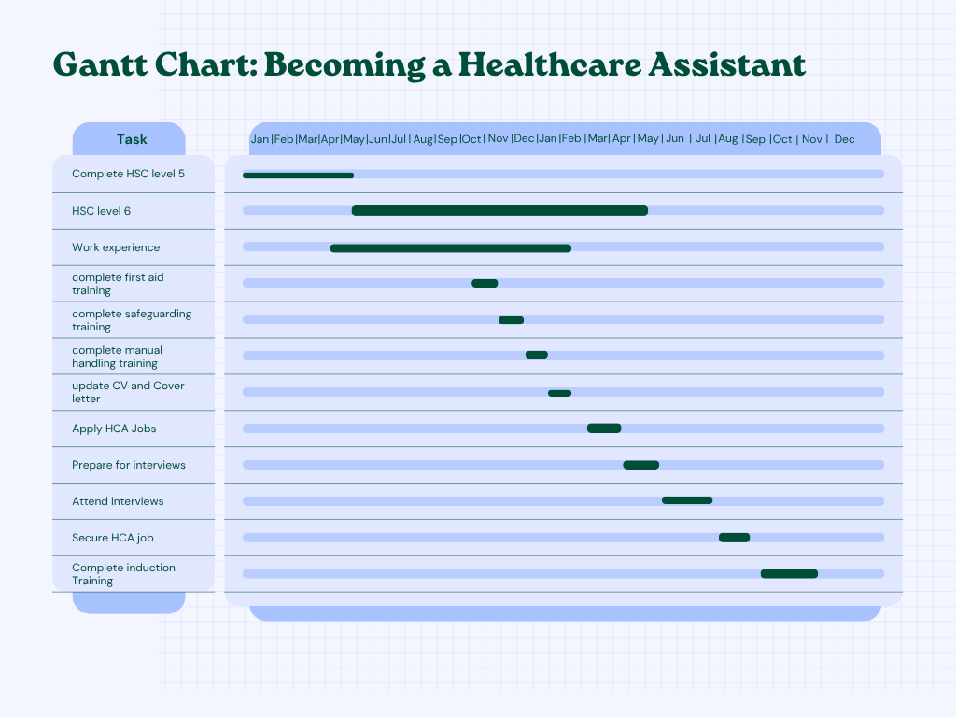
This Gantt chart presents a clear and organised pathway for progressing into a Healthcare Assistant role starting in 2026. It begins with the completion of Health and Social Care Level 5, which provides the essential knowledge and practical understanding required for working within health settings. Alongside this, the plan includes starting Level 6 in May 2026, which further develops advanced skills, critical thinking and professional awareness needed for career progression.
The timeline also incorporates gaining relevant experience through volunteering or placements, which is important for building confidence and applying theoretical knowledge in real-life care environments. In addition, key training courses such as First Aid, safeguarding and manual handling are included, as these are essential requirements for working safely and effectively within healthcare roles.
Professional development is another important focus within the chart. Activities such as updating a CV and cover letter, preparing for interviews and applying for Healthcare Assistant roles are scheduled to ensure readiness for employment. These steps help demonstrate organisation, commitment and employability skills to potential employers.
Towards the later stages of the timeline, the focus shifts to attending interviews and securing a Healthcare Assistant position. The plan concludes with completing induction training, which supports a smooth transition into the workplace and ensures understanding of policies, procedures and responsibilities.
Overall, this Gantt chart provides a structured and realistic plan that combines education, practical experience and professional preparation. It helps create a clear pathway into employment while supporting long-term career development within the health and social care sector.

Task 7- Making Changes- Report
Report: Improving Safeguarding Awareness in the Care Home

As a care home manager, I aim to strengthen safeguarding awareness and reporting procedures within the workplace to ensure that residents are protected from abuse, neglect, and harm. NHS Digital, (2023) states safeguarding is a fundamental aspect of delivering safe and high-quality care for vulnerable adults, and it is a key responsibility within health and social care settings. Effective safeguarding practices help promote dignity, respect and safety for all individuals receiving care.
To implement this improvement, I will follow recognised principles of workforce development and safe service delivery supported by the World Health Organization, (2021). Staff will receive regular safeguarding training to improve their ability to recognise different types of abuse, understand reporting procedures and fulfil their professional responsibilities. Key skills required include communication, observation, ethical decision-making and teamwork, all of which contribute to effective safeguarding practice.
There may be barriers to success. Some staff may feel reluctant to report concerns due to fear of conflict or damaging working relationships, while others may lack confidence in identifying signs of abuse. To address these challenges, I will promote a culture of openness, implement confidential reporting systems and provide ongoing refresher training to build staff confidence (NICE, 2022). Leadership plays a crucial role in modelling appropriate behaviour and reinforcing safeguarding standards within the organisation.
Monitoring compliance and gathering feedback from both staff and residents will help evaluate the effectiveness of these changes. In conclusion, improving safeguarding awareness will protect residents, enhance staff confidence and promote a safe, supportive and respectful care environment.

Task 8- Self-Reflection
Using Gibbs’ Reflective Cycle (1988), I have reflected on my learning throughout this module and how it has supported my personal and professional development within health and social care.
Description:
This module provided me with the opportunity to develop my understanding of key areas such as communication skills, personal branding, safeguarding and emotional intelligence in health and social care. Through class activities, discussions and independent learning, I gained insight into how to support vulnerable individuals effectively and understand workplace values promoted by the NHS. These experiences highlighted the importance of professionalism, teamwork and person-centred care in practice (NICE, 2012).
Feelings:
At the beginning of the module, I felt uncertain about academic expectations and how the content would relate to my future career. As I progressed, my confidence improved and I began to feel more comfortable applying healthcare knowledge and understanding professional responsibilities.
Evaluation:
The module positively supported my development by helping me identify my strengths, particularly my empathy and willingness to learn. It also highlighted areas for improvement, such as building confidence in professional communication and teamwork. Reflective practice is recognised as an important tool in developing professional skills and improving care delivery.
Analysis:
I learned that continuous development is essential in health and social care, as supported by the World Health Organization, (2020), which emphasises the importance of workforce training and high-quality care. This has helped me understand that improving my skills will support better outcomes for individuals I work with.
Conclusion:
Overall, this experience has increased my self-awareness and understanding of the skills required in healthcare. I now recognise the importance of resilience, communication and professionalism in my future role.
Action Plan:
In the future, I will continue to improve my communication skills, seek regular feedback and take part in further training opportunities. I will also aim to build confidence in teamwork and apply reflective practice to support my ongoing professional development.

Reference List
Greco, A., González-Ortiz, L. G., Gabutti, L., and Lumera, D. (2025). ‘What's the role of kindness in the healthcare context? A scoping review’. BMC health services research, 25(1), 207. Available at: https://doi.org/10.1186/s12913-025-12328-1. (Accessed: 21/02/26).
Hawton, K., Saunders, K.E. and O’Connor, R.C. (2012). ‘Self-harm and suicide in adolescents’. The Lancet, 379(9834), pp.2373–2382. Available at: https://doi.org/10.1016/s0140-6736(12)60322-5. (Accessed: 21/02/26).
Morgan, C., Webb, R.T., Carr, M.J., Kontopantelis, E., Green, J., Chew-Graham, C.A., Kapur, N. and Ashcroft, D.M. (2017). ‘Incidence, clinical management, and mortality risk following self harm among children and adolescents: cohort study in primary care’. BMJ, [online] 359(359), p.j4351. Available at: https://doi.org/10.1136/bmj.j4351. (Accessed: 21/02/26).
NHS Digital (2023). Safeguarding Adults, England, 2022-23. Available at: https://digital.nhs.uk/data-and-information/publications/statistical/safeguarding-adults/2022-23#. (Accessed: 21/02/26).
NHS England (2023). Improving Patient Safety Culture – a Practical Guide. Available at: https://www.england.nhs.uk/long-read/improving-patient-safety-culture-a-practical-guide/. (Accessed: 21/02/26).
NICE (2012). Patient Experience in Adult NHS services: Improving the Experience of Care for People Using Adult NHS Services. Available at: https://www.nice.org.uk/guidance/cg138/chapter/Recommendations. (Accessed: 21/02/26).
NICE (2021). Safeguarding Adults in Care Homes NICE Guideline. Available at: https://www.nice.org.uk/guidance/ng189/resources/safeguarding-adults-in-care-homes-pdf-66142030079941. (Accessed: 21/02/26).
NICE (2022). Overview | Self-harm: Assessment, Management and Preventing Recurrence | Guidance | NICE. Available at: https://www.nice.org.uk/guidance/NG225. (Accessed: 21/02/26).
Rosen, M. A., DiazGranados, D., Dietz, A. S., Benishek, L. E., Thompson, D., Pronovost, P. J., and Weaver, S. J. (2018). ‘Teamwork in healthcare: Key discoveries enabling safer, high-quality care’. The American psychologist, 73(4), 433–450. Available at: https://doi.org/10.1037/amp0000298. (Accessed: 21/02/26).
Stein K. V. (2016). ‘Developing a Competent Workforce for Integrated Health and Social Care: What Does It Take?’. International journal of integrated care, 16(4), 9. Available at: https://doi.org/10.5334/ijic.2533. (Accessed: 21/02/26).
The Health Foundation. (2024). Person-centred care made simple. Available at: https://www.health.org.uk/resources-and-toolkits/quick-guides/person-centred-care-made-simple?gad_source=1&gad_campaignid=13881943831&gbraid=0AAAAADunFmTFBAef3wYKctcxVtnqPItmb&gclid=Cj0KCQjwpv7NBhCzARIsADkIfWxbCwmiqWK46U0CU9cganOu8cCUoh0b-oN6A2yGhRvnkrJNRyUbEmQaAiOiEALw_wcB7. (Accessed: 21/02/26).
World Health Organization (2021). Suicide worldwide in 2019. Available at: https://www.who.int/publications/i/item/9789240026643. (Accessed: 21/02/26).
World Health Organization (WHO) (2021). Global Patient Safety Action Plan 2021-2030. Available at: https://www.who.int/teams/integrated-health-services/patient-safety/policy/global-patient-safety-action-plan. (Accessed: 21/02/26).
World Health Organization. (2020). Global strategy on human resources for health: Workforce 2030. Global strategy on human resources for health: Workforce 2030. (Accessed: 21/02/26).

