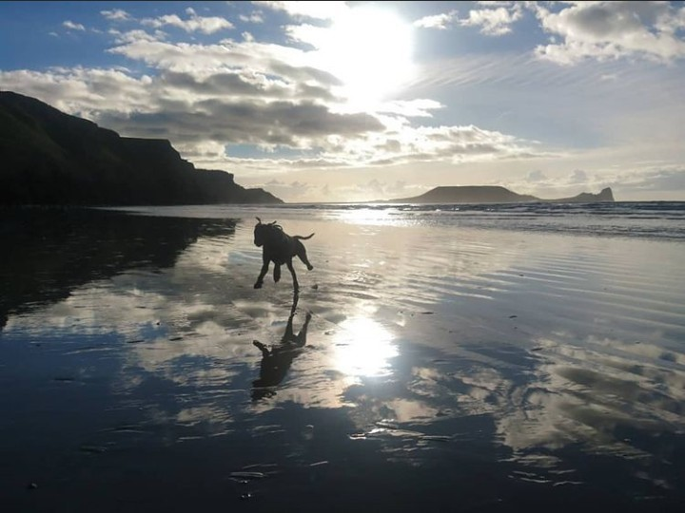  Scenic Assessment of Gower Beaches | coastal and marine science  M2X917  Rebecca Macfarlane  BSc Environmental Conservation

Contents

Contents 1
List of Figures 1
List of Tables 1
Introduction 3
Site Locations 3
Aberavon 3
Swansea Bay 3
Caswell 3
Oxwich 4
Mewslade 4
Rhossili 4
Methodology 5
Results 5
Discussion 5
Conclusion 6
References 7
Appendices 10

List of Figures
Figure 1: Map of beaches (Google Maps, 2020) 10
Figure 2: Aberavon Beach (Tripadvisor, nd) 11
Figure 3: Aberavon Beach (Tripadvisor, nd) 11
Figure 4: Swansea Bay (Google Earth, 2020) 12
Figure 5: Caswell Bay (Parc Le Breos, 2016) 12
Figure 6: Caswell Bay (Parc Le Breos, 2016) 13
Figure 7: Oxwich Bay (Adventure Bagging, 2018) 13
Figure 8: Oxwich Bay (Adventure Bagging, 2018) 14
Figure 9: Oxwich Bay (Adventure Bagging, 2018) 14
Figure 10: Oxwich Bay (Adventure Bagging, 2018) 15
Figure 11: Mewslade Bay (The Beach Guide, 2020) 15
Figure 12: Mewslade Bay (The Beach Guide, 2020) 16
Figure 13: Mewslade Bay (The Beach Guide, 2020) 16
Figure 14: Mewslade Bay (The Beach Guide, 2020) 17
Figure 15: Rhossili Bay (Bristol Live, 2017) 17
Figure 16: Rhossili Bay and Broughton (Bristol Live, 2017) 18
Figure 17: Rhossili Bay (Bristol Live, 2017) 18

List of Tables
Table 1: Beach Rating Scale, Part 1 19
Table 2: Beach Rating Scale, Part 2 20
Table 3: Beach Rating Scale, Part 3 21
Table 4: Beach Rating Scale, Part 4 22
Table 5: Assessment Results: Physical Factors 23
Table 6: Assessment Results: Biological Factors 23
Table 7: Assessment Results: Human Use and Impacts 24
Table 8: Assessment Results: Final Overall Beach Score 24
Table 9: Bar Chart of Scoring Results 25
Table 10: Conflict Matrices for Selected Beaches 25

Introduction
This report aims to carry out a physical, biological, and human assessment of six beaches in Swansea and Port Talbot: Aberavon, Swansea, Caswell, Oxwich, Mewslade and Rhossili. Recommendations for site management considerations will be made using a scoring system and comparing the data found with alternative evaluation methods.

Site Locations

Aberavon
As per Figs 2 & 3, Aberavon is one of the larger beaches on the list. As seen in Fig 1, it is also the only beach that does not sit in the Swansea and Gower area, falling within Neath and Port Talbot county. Previously holding Blue Flag status, due to poor water quality this was lost in 2012 and has not been regained (BBC News, 2012).
Biodiversity: No known vulnerable or protected species in the area despite being relatively diverse in terms of fauna (NPT Council, nd).
Industry: Home to Wales’ largest steelworks, Tata Steel, along with the BP Refinery along the border with Swansea Bay (David Rees MS, nd).
Tourism: A long promenade popular with families and dog walkers, with the bay used for a lot of water sports. There are also a lot of leisure facilities located on the seafront (NPT Council, nd).
Notable Points: Some historic interest, as Neolithic artefacts have been found in the area; an axe on the beach itself (NPT Council, 2004).

Swansea Bay
The Blackpill area of Swansea Bay, sitting to the West of Swansea Bay near Singleton (as can be seen in Fig 4, with the marker pointing in its vicinity in Fig 1) was designated a Site of Special Scientific Interest (SSSI) in 1986 due to the prevalence of local and migratory birds (Swansea County Council, 2019). The bay also incorporates a marina before continuing towards Aberavon, split by the Neath river.
Biodiversity: Similar fauna to Aberavon, though markedly the Blackpill area is home to a number of rare migratory birds, such as sanderling (Calidris alba), oystercatchers (Haematopus ostralegus) and ringed plovers (Charadrius hiaticula) (RSPB, 2020).
Industry: Edged by the BP Refinery to the East, the bay was previously home to a large docks that aided in Swansea’s reputation as ‘Copperopolis’ and still houses a marina (Swansea Museum, nd).
Tourism: Swansea Bay is host to one of the largest tourism industries in this list, with a wide range of activities in the water, on the beach and in the surrounding area (Visit Swansea Bay, 2020). It also has an extremely high level of footfall across the entire stretch due to the proximity to the city centre.
Notable Points: Previously noted for having poor water quality from a history of industry to the East coupled with sewage outlets to the West by Mumbles, this has been slowly improving in recent years; whilst not in the excellent category of the neighbouring Bracelet Bay, it has moved up from sufficient to good (Natural Resources Wales, 2019).

Caswell
Whilst one of the smallest beaches on the list (see figs 5 & 6), at present it’s the only one to hold Blue Flag status; doing so since 1998, it is described by Blue Flag as ‘a firm favourite with families with young children’ (Blue Flag, 2020).
Biodiversity: The reserve in Bishop’s Wood that backs up the shore is home to a number of rare fungi, along with a variety of bats and seabirds present in the caves that are dotted along the cliffs (The Geological Society, nd).
Industry: Relatively little work has been carried out at Caswell compared to other sites, with it mostly being used to pump water to nearby Mumbles (Cope, nd).
Tourism: Very busy despite not being a large beach and only being accessible at low tide; there are holiday homes reaching back up the hillside, along with cafes, shops and hiring facilities for beach and water sport activities (Visit Wales, 2020). It has also recently become a permanent home to Surfability UK, a charity enabling disabled children to surf (Wales Online, 2020).
Notable Points: Along the western side of the bay there is a resurgence known as Caswell Bay West Rising. A concrete structure was placed over it, though exploration has shown that it is linked to a sink based towards Murton and possibly extends elsewhere (Ogof: Caves of South Wales, nd).

Oxwich
A larger beach on the list (see figs 1 & 7 - 10), Oxwich also possesses a unique mix of dunes, woodlands, cliffs, lakes, and both salt and freshwater marshes. It is due to this that it is classed as a National Nature Reserve (NNR) (Natural Resources Wales, nd).
Biodiversity: Due to the uniquely broad range of physical features (Natural Resources Wales, nd), Oxwich is arguably the most biologically diverse of all the listed beaches.
Industry: There is no current industrial work being carried out in Oxwich, partially due to its status as an NNR, and also due to areas being privately owned by the Penrice estate. Historically it was a dock to export limestone quarried from the headland (Johnson, nd).
Tourism: Very busy with a lot of water activities, camping facilities, and also cafes and hotels just a few metres from the beach (The Beach Guide, nd).
Notable Points: Since 2009 the cliffs that make up the old limestone quarry have been susceptible to landslides, with a spike in incidents since 2019 (Cooper, 2020).

Mewslade
As per figs 11 - 14, it is the smallest of the beaches on the list along with Caswell (also sharing only being accessible at low tide), Mewslade has no protected status or notable areas of interest on the beach itself, rather focusing on the nearby Paviland Cave (Enjoy Gower, nd).
Biodiversity: Predatory birds and rockpool species ae in abundance in Mewslade, both taking advantages of the rocky terrain that is submerged at high tide (Gower Camping, 2020).
Industry: No notable industrial work or development is being carried out in the Mewslade area, instead the focus is on farming and light agricultural work in the linked village of Pitton.
Tourism: Due to the lack of easy access and no nearby facilities, Mewslade does not see as much footfall as the other beaches, though it is popular with surfers and more dedicated walkers (Inspirock, 2020).
Notable Points: The quarry on the western side of the bay was excavated in the 19th century, finding the remains of extinct animals and 6-7 humans from the Palaeolithic era (National Trust, nd).

Rhossili
Home to many protected species, Rhossili and the sheltering Down (see figs 15 - 17) are listed as both an SSSI and a Site of Importance for Nature Conservation (SINC), as well has hosting seven Scheduled Ancient Monuments (SAMs) (Swansea County Council, 2019). In addition, it has regularly been voted both the best beach in the UK and sits in the top 10 beaches in the world (BBC News, 2014).
Biodiversity: Rhossili has a high level of biodiversity, with notable birds such as choughs (Pyrrhocorax pyrrhocorax) and Dartford warblers (Sylvia undata) (First Nature, nd).
Industry: No modern industrial work as the area is maintained by both Natural Resources Wales and National Trust Wales, though there are the remains of a WW2 watch tower on the cliffs as well as shipwrecks (more famously the Helvetia, wrecked in 1887) along the shore (Swansea County Council, 2019).
Tourism: A major tourist attraction, immensely popular with walkers and surfers, seeing over 65,000 logged visitors in 2018 alone (Welsh Government, 2020).
Notable Points: Strip-field farming has been reintroduced on the farmland on top of the cliffs to preserve gentler medieval techniques that are more productive and valuable for wildlife (National Trust Wales, 2020).

Methodology
Due to the current COVID-19 pandemic, fieldwork was not possible, so on-site evaluation was replaced with using sourced images of each site. It was permitted to visit the sites individually where possible, but fluctuating governmental restrictions restricted this.
The scoring (see Tables 1-4) was semi-quantitative and broken down into three factors: physical, biological, and human use/impacts. This scoring assessment follows studies undertaken in a similar area, albeit on different beaches (Phillips & House, 2008) and the evaluation criteria is taken from the ‘established beach rating system’ (Leatherman, 1991). Whilst their study involved surveying several different groups to garner a more universal scoring, unfortunately this was not an option and so the scoring was carried out by one individual. Similarly, the same evaluation criteria was used in a study of the Glamorgan Heritage Coast (Phillips, et al., 2010), though notably this was carried out at 500m increments rather than covering individual beaches, and the results were calculated differently based on these readings.
Scoring was graded 1-5 so that fuzzy logic (Tech Target, nd) could be applied to find an overall degree score between 0-1 for each beach and its respective factors. This enabled a more detailed breakdown of the individual focus points for each beach. Respectively, the results of these three factors were also used to calculate an overall beach scoring percentage to reflect which beaches would be classed as best.

Results
The normalized scoring showed a correlation between beaches that are known to have more environmental focus as opposed to human use (see tables 5 – 7 & 9). For these beaches, particularly Mewslade, it is clear that as this outweighs any other scoring, further management should focus on environmental protection and conservation. Comparably where scoring was similar for all three factors (see table 9: Aberavon and Caswell score relatively evenly across the board), development or protection would then be a viable option or, in contrast, areas of high conflict for priority.
Using all of the scoring to create a percentage per beach (see table 8), it was also possible to determine that from the criteria used, all beaches fell within a similar bracket, with Rhossili ranked as best with a score of 73%. Comparatively, Mewslade was scored the worst at 55%, suggesting that the lack of facilities and access for human use plays a large role in coastal evaluation.

Discussion
As previously stated, the basic function analysis assessment method used provides a solid groundwork for noting whether the beaches require more attention in one area or if they are all roughly equal. In addition, the scoring covered more areas than a detailed area of study would be able to incorporate alone. The criteria used was also a selection of both qualitative and quantitative to give a more evened out scoring.
There are notable issues with the methodology used. In the first instance, using photo references rather than visiting the sites presents a number of problems; namely, images taken and published will always show the ‘marketed’ view of a beach and avoid highlighting issues; not all images will be dated or the images provided may be out of date; the authenticity of the images can be questioned if not pulled from reputable sources, and the images will not be able to show everything required to complete the evaluation. A practical site evaluation is always preferable to achieve a more accurate scoring assessment.
The scoring, as noted in a previously carried out study (Phillips & House, 2008), is subjective to the individual carrying it out. As it was completed by an individual studying an environmental conservation course there will naturally be some bias or preference towards physical and biological factors and relatively little interest in human use and impacts. Whilst impartiality is an aim, it is not necessarily evident that this is guaranteed and there is no way to determine whether the scoring would be the same without including more people from a diverse range of groups and preferences.
Markedly, the scoring is only able to provide a ‘snapshot’ of the beach in its current state and does not account for measured differences, such as effects of climate change, which can have an effect on further conservation, development and management needs (Phillips & Jones, 2006). However whilst it only provides a single snapshot, this data can be used on an annual basis to monitor change and develop long-term management strategies (Phillips, et al., 2007).
This style of appraisal also does not provide in-depth information with regards to any vulnerable species or processes that are present at the site; where the wildlife scoring may be low due to low level of biodiversity, the species that is present may be vulnerable, protected or vital to that area. For example, Swansea Bay is marked as having a relatively low scoring for wildlife, yet studies have shown that at least 5 species of bat roost and hunt around the Blackpill area (Hulmes & Hough, 2015). This could also suggest that even in areas of high biodiversity scoring, the wildlife present may not contain species that require intervention to protect their status or boost their numbers; the ‘quality’ of the biodiversity is therefore unclear.
Further studies into coastal assessment have suggested that amending and/or reducing the evaluation criteria gives a more realistic assessment as not all beaches will be the same. It is also suggested that simplifying the criteria makes it more quantifiable for policy-makers that wouldn’t necessarily need to know certain measurements of some characteristics rather than those indicators are present and need addressing (Amyot & Grant, 2014).
To formulate an action plan that suits the needs of the individual sites more efficiently a more comprehensive analysis needs to be studied. Whilst the scoring provided creates solid framework, it would be beneficial to couple this with further information utilised from alternative methods, such as a conflict matrix and DSPIR.
As per table 10, a conflict matrix is able to provide further insight into what management practices are likely to encounter issues if areas of conflict are not taken into consideration. For instance, Rhossili has a higher level of conflict than other beaches and would require much more delicate and flexible management in order to maintain equilibrium as a standard (should equilibrium rather than enhancement be the goal for management in this instance).
Furthermore, by including a DPSIR (Driver-Pressure-State-Impact-Response) analysis for each area provides a much greater understanding of what stresses require more immediate action and what can be safely weathered for a longer period. It also shows where inefficient responses will exacerbate existing drivers unless adequately changed (Atkins, et al., 2011). Arguably using a DPSIR analysis is a lot more time-consuming, especially when attempting to cover all the areas noted in the initial evaluation. Similarly, using DPSIR framework has been known to create hierarchies in priorities, placing anthropogenic needs above environmental requirements (Carr, et al., 2007). However, the hierarchy can be avoided when using DPSIR as suggested, in addition to several evaluation methods, and another benefit of DPSIR is being able to group extensive lists together to create umbrella drivers. This would then counteract the time-consuming nature of attempting to analyse each indicator individually.

Conclusion
A scenic evaluation provides solid groundwork when appraising a coastal area but is too vague to use as a standalone grading to create a management plan that meets the needs of the site as best possible. To carry out an efficient evaluation from a management perspective more detailed analysis and statistics from a variety of sources, individuals and measurement techniques is required to achieve a more accurate rating.

References
Adventure Bagging, 2018. Three Cliffs Bay Costal Walk to Oxwich Bay. [Online]
Available at: https://adventurebagging.co.uk/2019/05/three-cliffs-bay-oxwich-coastal-walk/
[Accessed 29 11 2020].

Amyot, J. & Grant, J., 2014. Environmental Function Analysis: A decision support tool for integrated sandy beach planning. Ocean & Coastal Management, 12, 102(Part A), pp. 317-327.

Atkins, J. P., Burdon, D., Elliott, M. & Gregory, A. J., 2011. Management of the marine environment: Integrating ecosystem services and societal benefits with the DPSIR framework in a systems approach. Marine Pollution Bulletin, 2, 62(2), pp. 215-226.

BBC News, 2012. Six Welsh beaches lose blue flag status but 43 others receive the award. [Online]
Available at: https://www.bbc.co.uk/news/uk-wales-18100203
[Accessed 30 11 2020].

BBC News, 2014. Rhossili Bay retains best UK beach title and comes ninth in world league. [Online]
Available at: https://www.bbc.co.uk/news/uk-wales-south-west-wales-26625340
[Accessed 30 11 2020].

Blue Flag, 2020. Caswell Bay. [Online]
Available at: https://www.blueflag.global/show-site?siteId=9657
[Accessed 30 11 2020].

Bristol Live, 2017. This is one of the world's top 10 beaches - and it's two hours from Bristol. [Online]
Available at: https://www.bristolpost.co.uk/whats-on/whats-on-news/one-worlds-top-10-beaches-162504
[Accessed 29 11 2020].

Carr, E. R. et al., 2007. Applying DPSIR to sustainable development. International Journal of Sustainable Development & World Ecology, 14(6), pp. 543-555.

Cooper, J., 2020. Drone footage reveals fresh landslide near beach where rocks as big as houses tumble into the sea. [Online]
Available at: https://www.walesonline.co.uk/news/wales-news/drone-footage-reveals-fresh-landslide-18550219
[Accessed 3 12 2020].

Cope, W., nd. A History of Mumbles: Caswell Bay. [Online]
Available at: https://sites.google.com/site/ahistoryofmumbles/the-windmill-at-caswell-the-water-supply
[Accessed 2 12 2020].

David Rees MS, nd. About Aberavon. [Online]
Available at: https://www.davidrees.wales/en/about-aberavon/
[Accessed 2 12 2020].

Enjoy Gower, nd. Mewslade Bay. [Online]
Available at: https://enjoygower.com/mewslade-bay
[Accessed 30 11 2020].

First Nature, nd. Gower Coast NNR. [Online]
Available at: https://www.first-nature.com/waleswildlife/sw-nnr-gowercoast.php
[Accessed 3 12 2020].

Google Earth, 2020. Google Earth: Swansea Bay. [Online]
Available at: https://earth.google.com/web/search/Swansea+Bay/@51.59141954,-3.8997218,-0.52138038a,23112.92048536d,35y,0h,0t,0r/data=CnYaTBJGCiUweDQ4NmU2MDNiNzJlNDFmZjE6MHhmN2UyNjVjODViYWQyZmU0GaqOZnYny0lAIU-K-zSTNA_AKgtTd2Fuc2VhIEJheRgCIAEiJgokCW80HoL14jRAEW40HoL14jTA
[Accessed 29 11 2020].

Google Maps, 2020. Google Maps. [Online]
Available at: https://www.google.co.uk/maps/@51.5612275,-4.285434,1842m/data=!3m1!1e3?hl=en&authuser=0
[Accessed 30 11 2020].

Gower Camping, 2020. Mewslade. [Online]
Available at: https://www.gowercamping.co.uk/the-gower/mewslade
[Accessed 3 12 2020].

Hulmes, D. & Hough, T., 2015. Coastal Habitat Use by Bat Species. [Online]
Available at: https://www.bsg-ecology.com/wp-content/uploads/2015/10/Coastal-habitat-use-by-bat-species.pdf
[Accessed 29 November 2020].

Inspirock, 2020. Mewslade Bay. [Online]
Available at: https://www.inspirock.com/united-kingdom/rhossili/mewslade-bay-a3486207037
[Accessed 3 12 2020].

Johnson, B., nd. Oxwich. [Online]
Available at: https://www.historic-uk.com/HistoryMagazine/DestinationsUK/Oxwich/
[Accessed 2 12 2020].

Leatherman, S., 1991. 50 Criteria. [Online]
Available at: https://www.drbeach.org/50criteria
[Accessed 6 12 2020].

National Trust Wales, 2020. The Vile, an ancient landscape, rich in culture. [Online]
Available at: https://www.nationaltrust.org.uk/rhossili-and-south-gower-coast/features/the-vile-an-ancient-landscape-rich-in-culture
[Accessed 3 12 2020].

National Trust, nd. Cave - Mewslade Bay. [Online]
Available at: https://heritagerecords.nationaltrust.org.uk/HBSMR/MonRecord.aspx?uid=MNA131921
[Accessed 3 12 2020].

Natural Resources Wales, 2019. Wales bathing water quality report 2019. [Online]
Available at: https://naturalresources.wales/evidence-and-data/research-and-reports/water-reports/2019-wales-bathing-water-quality-report/?lang=en
[Accessed 2 12 2020].

Natural Resources Wales, nd. Oxwich National Nature Reserve. [Online]
Available at: https://naturalresources.wales/days-out/places-to-visit/south-west-wales/oxwich-national-nature-reserve/?lang=en
[Accessed 30 11 2020].

Natural Resources Wales, nd. Oxwich National Nature Reserve. [Online]
Available at: https://naturalresources.wales/days-out/places-to-visit/south-west-wales/oxwich-national-nature-reserve/?lang=en#:~:text=National%20Nature%20Reserves.-,Wildlife%20highlights,rare%20creatures%20and%20colourful%20wildflowers.&text=Wild%20orchids%20can%20be%
[Accessed 2 12 2020].

NPT Council, 2004. Neath Port Talbot Landmap: Landscape Assessment. [Online]
Available at: https://www.npt.gov.uk/media/9005/spg_landmap_landscape_assessment_2004.pdf
[Accessed 2 12 2020].

NPT Council, nd. A Seashore Guide to Neath Port Talbot. [Online]
Available at: https://www.npt.gov.uk/media/4371/seashore-guide-english-complete.pdf
[Accessed 2 12 2020].

NPT Council, nd. Aberavon Seafront. [Online]
Available at: http://www.visitnpt.co.uk/1809
[Accessed 2 12 2020].

Ogof: Caves of South Wales, nd. South Gower Coast Caves. [Online]
Available at: http://www.ogof.org.uk/areas/south-gower-coast-caves.html
[Accessed 2 12 2020].

Parc Le Breos, 2016. Caswell Bay. [Online]
Available at: https://parc-le-breos.co.uk/things-to-do-in-gower/gower-beach-and-surf-information/caswell-bay/#
[Accessed 29 11 2020].

Phillips, M. & House, C., 2008. An evaluation of priorities for beach tourism: Case studies from South Wales, UK. Science Direct, 9 7, 30(2), pp. 176-183.

Phillips, M. R., Abraham, E. J., Williams, A. T. & House, C., 2007. Function Analysis as a Coastal Management Tool: The South Wales Coastline, UK. Journal of Coastal Conservation, 11(3), pp. 159-170.

Phillips, M. R., Edwards, A. M. & Williams, A. T., 2010. An Incremental Scenic Assessment of the Glamorgan Heritage Coast, UK. The Geographical Journal, 5 11, 176(4), pp. 291-303.

Phillips, M. R. & Jones, A. L., 2006. Erosion and tourism infrastructure in the coastal zone: Problems, consequences and management. Tourism Management, 6, 27(3), pp. 517-524.

RSPB, 2020. Blackpill Wildlife Centre. [Online]
Available at: https://ww2.rspb.org.uk/groups/westglamorgan/places/203915/
[Accessed 2 12 2020].

Swansea County Council, 2019. Blackpill SSSI. [Online]
Available at: https://www.swansea.gov.uk/blackpillSSSI
[Accessed 30 11 2020].

Swansea County Council, 2019. Rhossili. [Online]
Available at: https://www.swansea.gov.uk/rhossili
[Accessed 30 11 2020].

Swansea County Council, 2019. Rhossili. [Online]
Available at: https://www.swansea.gov.uk/rhossili
[Accessed 3 12 2020].

Swansea Museum, nd. Swansea- A Brief History: The Sea. [Online]
Available at: http://www.swanseamuseum.co.uk/swansea-a-brief-history/the-sea
[Accessed 2 12 2020].

Tech Target, nd. Fuzzy Logic. [Online]
Available at: https://searchenterpriseai.techtarget.com/definition/fuzzy-logic#:~:text=Fuzzy%20logic%20is%20an%20approach,at%20Berkeley%20in%20the%201960s.
[Accessed 4 12 2020].

The Beach Guide, 2020. Mewslade Bay. [Online]
Available at: https://www.thebeachguide.co.uk/south-wales/glamorgan/mewslade-bay-east.htm
[Accessed 29 11 2020].

The Beach Guide, nd. Oxwich Bay. [Online]
Available at: https://www.thebeachguide.co.uk/south-wales/glamorgan/oxwich-bay.htm
[Accessed 3 12 2020].

The Geological Society, nd. Caswell Bay. [Online]
Available at: https://www.geolsoc.org.uk/GowerTour3
[Accessed 2 12 2020].

Tripadvisor, nd. Port Talbot. [Online]
Available at: https://www.tripadvisor.co.uk/LocationPhotoDirectLink-g681385-d3422320-i180919797-Aberavon_Beach-Port_Talbot_Neath_Port_Talbot_South_Wales_Wales.html
[Accessed 29 11 2020].

Visit Swansea Bay, 2020. Things To Do: Swansea. [Online]
Available at: https://www.visitswanseabay.com/listings/things-to-do/swansea/
[Accessed 2 12 2020].

Visit Wales, 2020. Caswell Bay Beach. [Online]
Available at: https://www.visitwales.com/attraction/beach/caswell-bay-beach-1443783
[Accessed 2 12 2020].

Wales Online, 2020. The tear-jerking DIY SOS project that transformed Swansea's inclusive surf school. [Online]
Available at: https://www.walesonline.co.uk/lifestyle/tv/diy-sos-nick-knowles-caswell-19265457
[Accessed 2 12 2020].

Welsh Government, 2020. Visits to Tourist Attractions in Wales 2018. [Online]
Available at: https://gov.wales/sites/default/files/statistics-and-research/2020-01/visits-to-tourist-attractions-in-wales-2018.pdf
[Accessed 3 12 2020].

Appendices

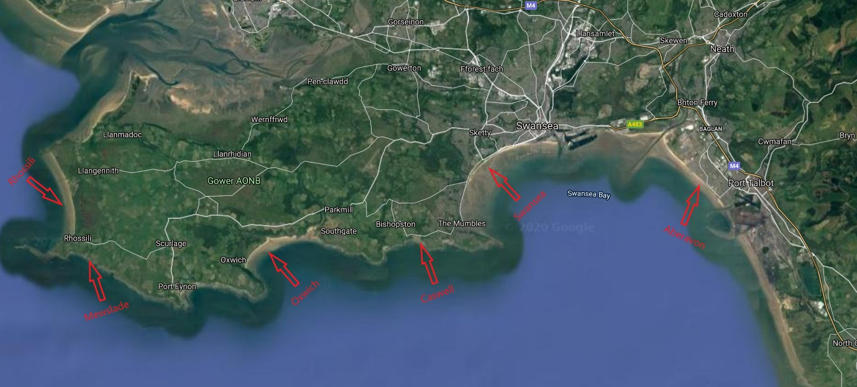
Figure 1: Map of beaches (Google Maps, 2020)

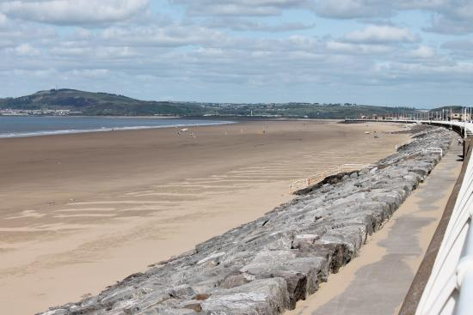
Figure 2: Aberavon Beach (Tripadvisor, nd)

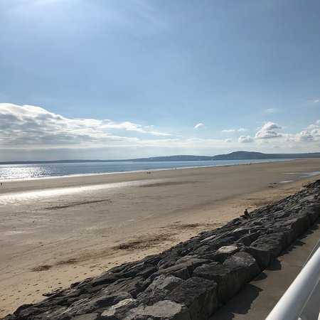
Figure 3: Aberavon Beach (Tripadvisor, nd)

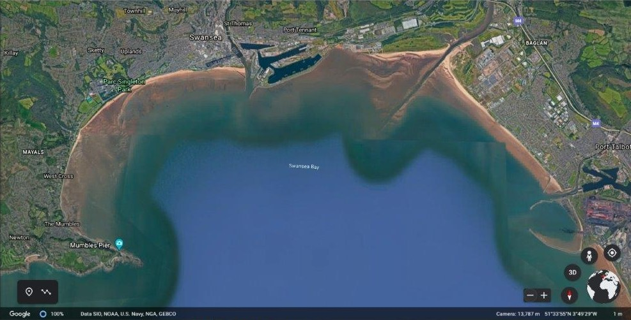
Figure 4: Swansea Bay (Google Earth, 2020)

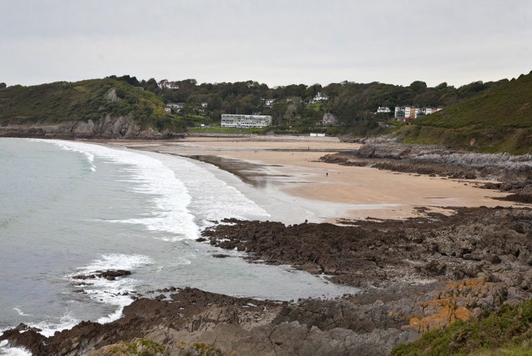
Figure 5: Caswell Bay (Parc Le Breos, 2016)
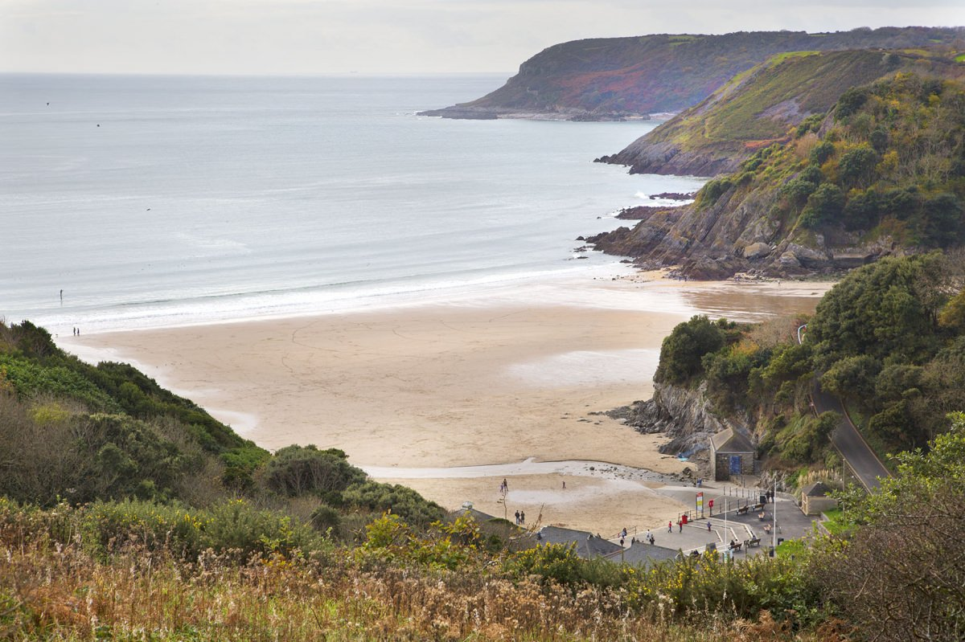
Figure 6: Caswell Bay (Parc Le Breos, 2016)

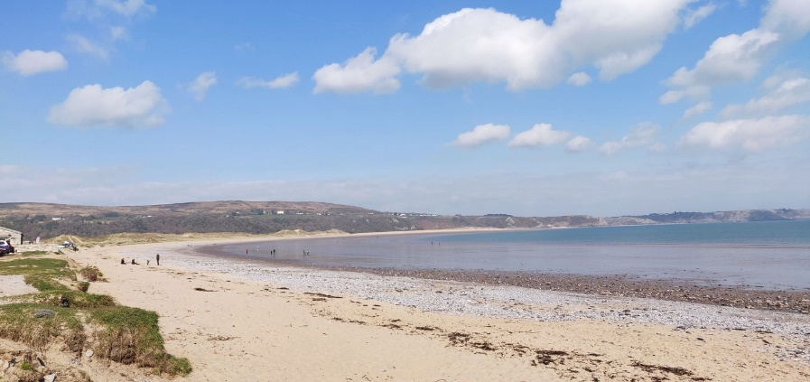
Figure 7: Oxwich Bay (Adventure Bagging, 2018)
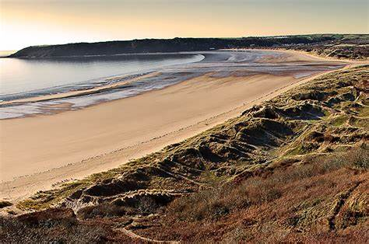
Figure 8: Oxwich Bay (Adventure Bagging, 2018)
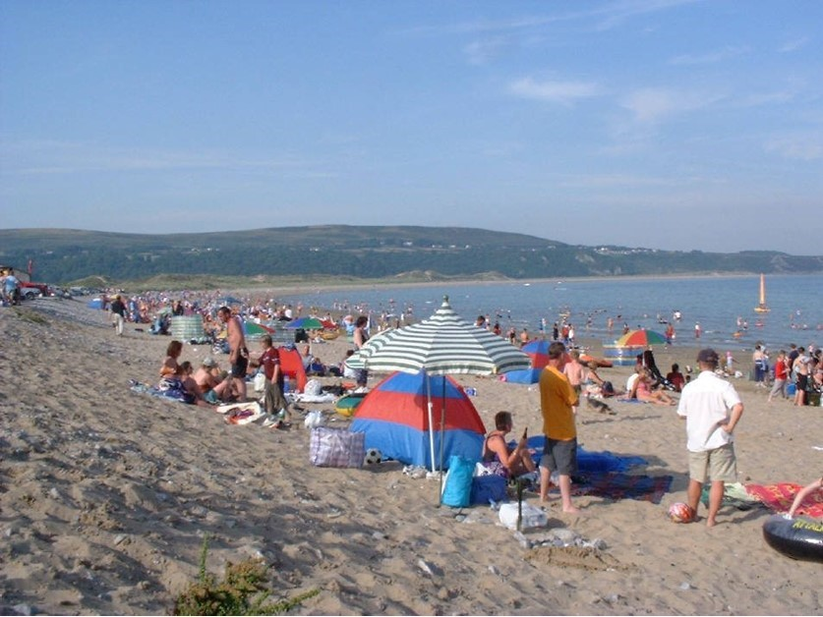
Figure 9: Oxwich Bay (Adventure Bagging, 2018)
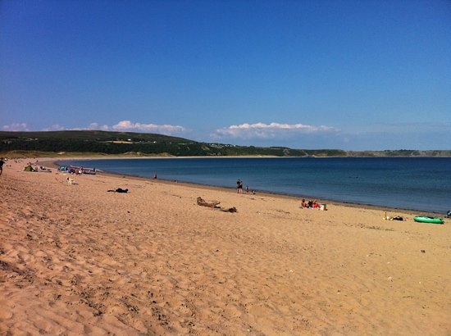
Figure 10: Oxwich Bay (Adventure Bagging, 2018)
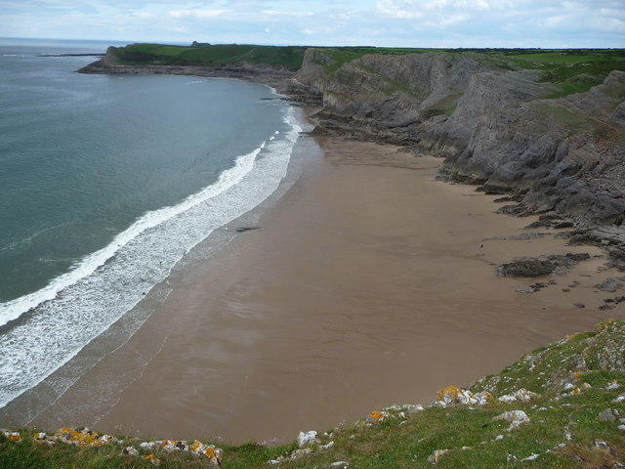
Figure 11: Mewslade Bay (The Beach Guide, 2020)

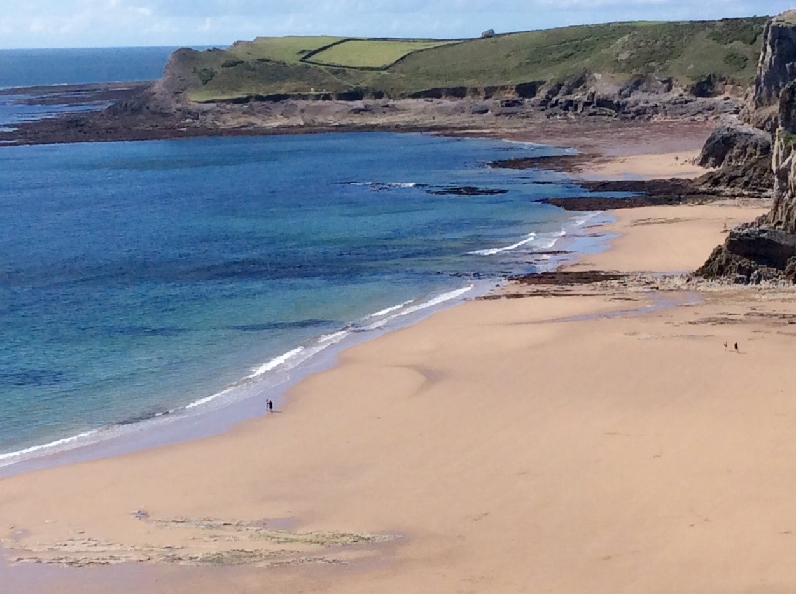
Figure 12: Mewslade Bay (The Beach Guide, 2020)
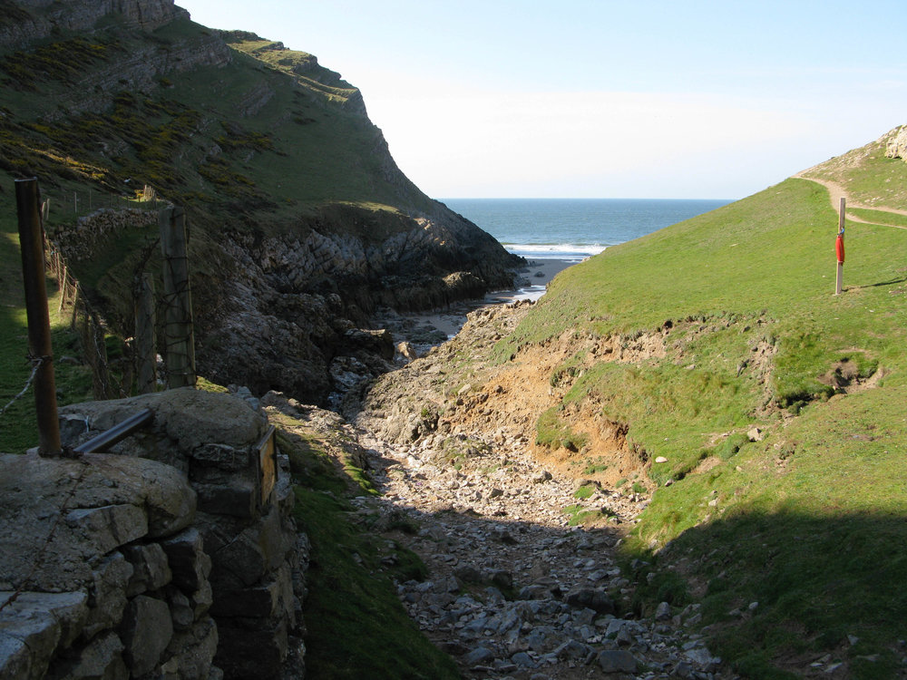
Figure 13: Mewslade Bay (The Beach Guide, 2020)
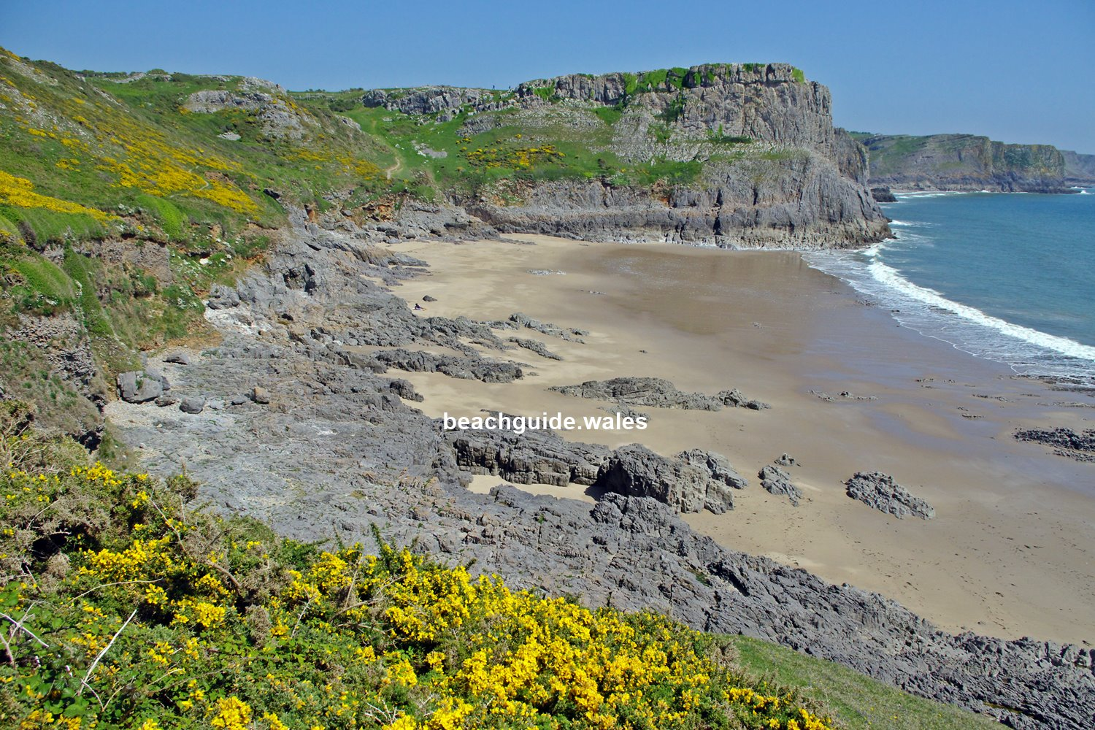
Figure 14: Mewslade Bay (The Beach Guide, 2020)
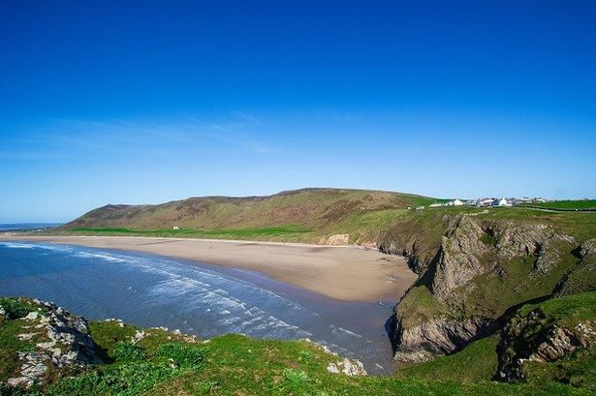
Figure 15: Rhossili Bay (Bristol Live, 2017)

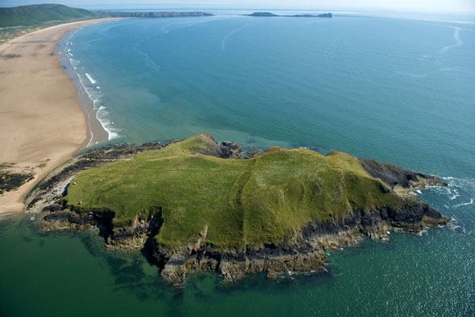
Figure 16: Rhossili Bay and Broughton (Bristol Live, 2017)
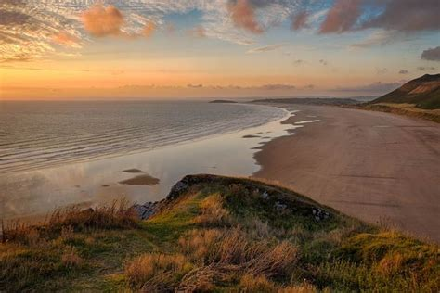
Figure 17: Rhossili Bay (Bristol Live, 2017)

Table 1: Beach Rating Scale, Part 1
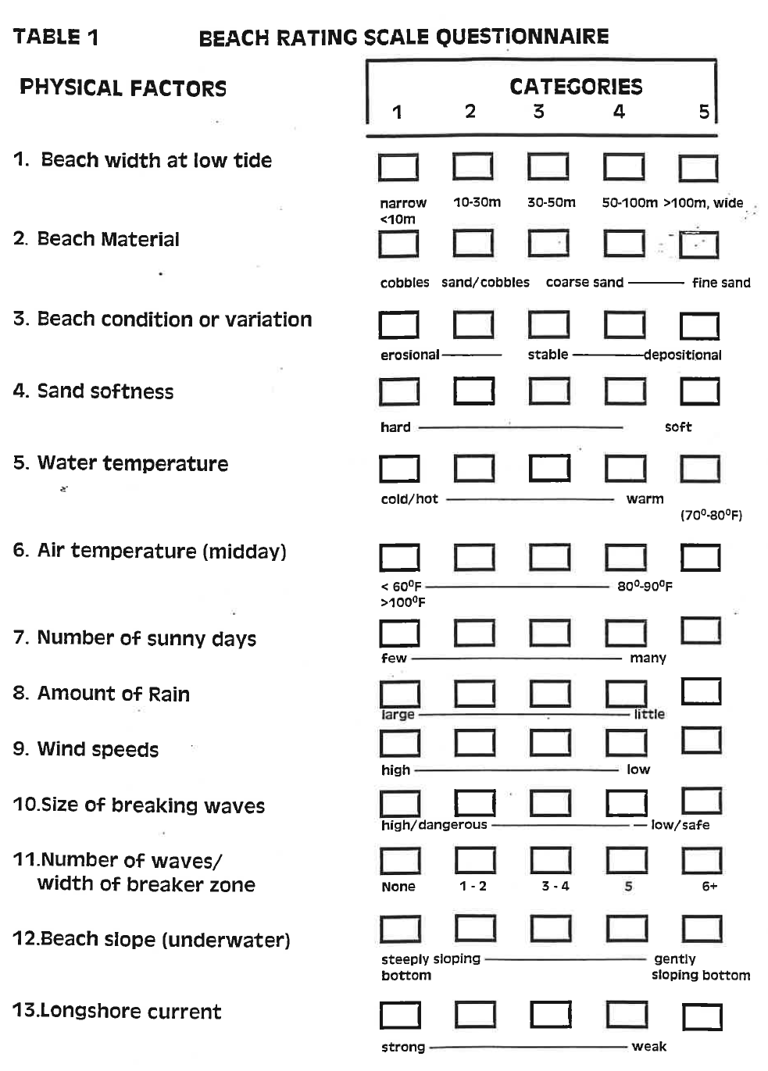

Table 2: Beach Rating Scale, Part 2
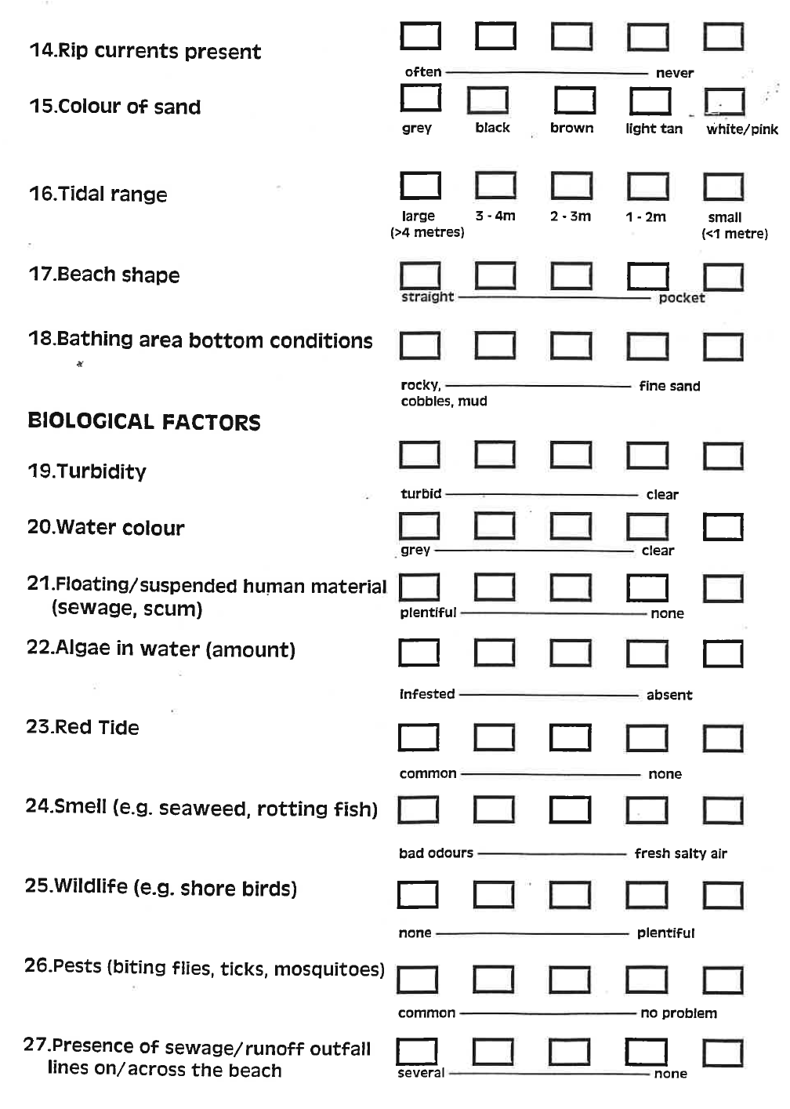

Table 3: Beach Rating Scale, Part 3
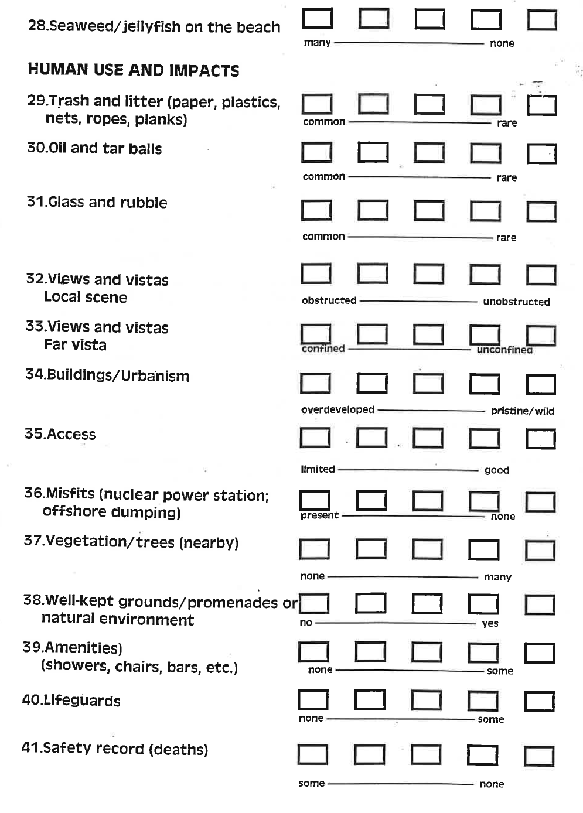

Table 4: Beach Rating Scale, Part 4
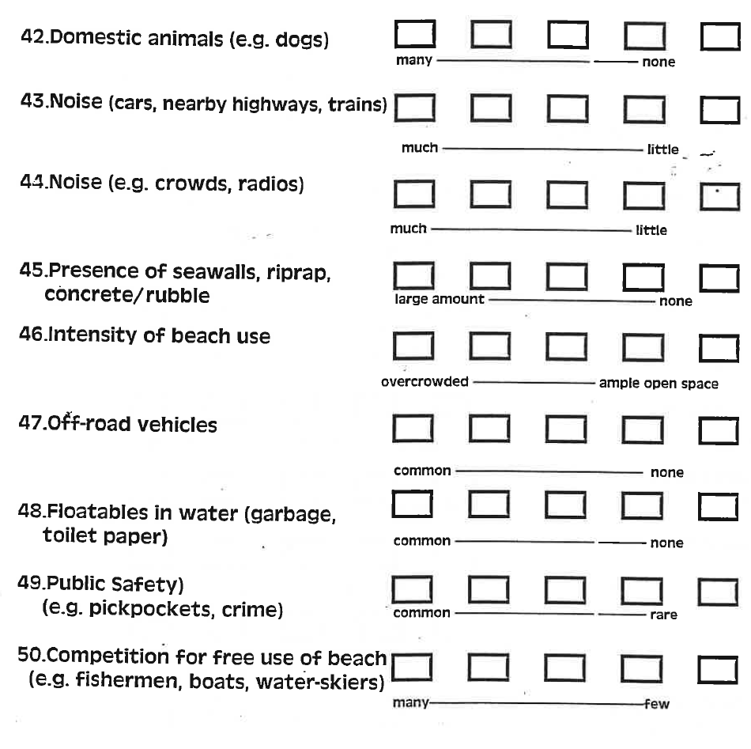
Table 5: Assessment Results: Physical Factors

Table 6: Assessment Results: Biological Factors

Table 7: Assessment Results: Human Use and Impacts

Table 8: Assessment Results: Final Overall Beach Score

Table 9: Bar Chart of Scoring Results
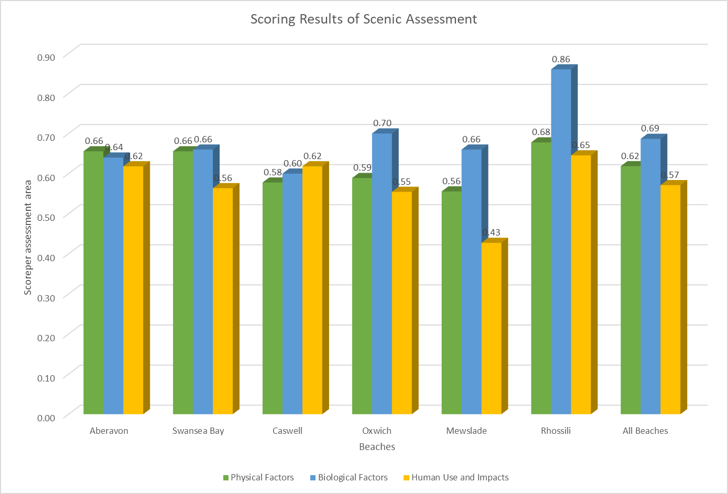

Table 10: Conflict Matrices for Selected Beaches

