NAME: RHIAN STICKLER
STUDENT NO: 1815682
LITERATURE REVIEW
Introduction
The literature review attempts to evaluate police officer mental health prior to the current COVID-19 pandemic. The literature review will also attempt to analyse and review the impact of COVID-19 on police officer mental health and wellbeing in South Wales Police (SWP) force, whilst critically analysing the safety measures that the UK Government has implemented to enhance the wellbeing of police officers working through the pandemic.
The Oxford Dictionary defines mental health as “a person’s condition with regard to their psychological and emotional well-being”. Research suggests that 1 in 4 people experience mental health issues, and working conditions can have a huge impact on someone’s mental health (Mental Health Foundation,2021). The working conditions of police officers can be highly demanding, due to increased exposure to traumatic events. Taking this into consideration, the mental health impacts on police officers could be significantly worse compared to those in roles without the exposure to such traumatic situations.
There is an abundance of literature available regarding public mental health and police officer mental health, but little regarding police officer mental health during the coronavirus pandemic, primarily due to the proximity of the events and ever changing landscape. At the time of conducting this review the UK is still in the midst of the pandemic, and although some research is emerging in relation to officer mental health, attention has not been paid specifically to those officers solely within SWP, highlighting a gap in this research.

Evaluation of Police officer mental health pre COVID 19
Mental health amongst police officers is a serious emerging issue that is at the forefront of modern policing. A 2017 survey of all force across England and Wales proposed that sickness rates amongst police officers are soaring, particularly in relation to mental health, with a total of 9,267 police officers taking time off in 2017 because of it; “there has been a seven per cent increase in the number of police officers experiencing stress, anxiety, depression or other psychological illnesses in the last financial year” (Police Firearms Officers Association (PFOA),2017). This statistic is also reinforced by the outcome of a Police Federation survey in 2016, whereby 39% of 17,000 officers sought help for mental health issues (Police Federation,2017).
Alternatively, conflicting data published by the Home Office in 2017 suggests that sickness rates amongst police officers had actually decreased by 2% compared to 2016; “As at 31 March 2017, there were 2,358 full-time equivalent police officers on long-term sick leave in the 43 forces in England and Wales. This was a decrease of 2% compared with the previous year, and accounted for 2% of police officers in England and Wales.” (Home Office,2017).
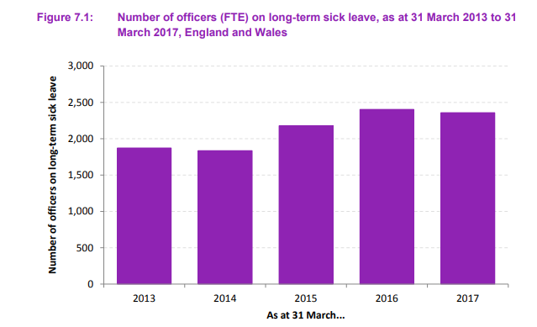
Above: Figure 1
Interpreting this contradictions in this data, PFOA may rely on sickness figures that are not necessarily considered as ‘long-term’, meaning officers could have taken less than 28 calendar days sick due to mental health; “Long-term sickness includes any recognised medical condition, physical or psychological, as reported by the officer or a medical practitioner, which has lasted for more than 28 calendar days” (Home Office,2019).
I would contend it inappropriate to rely on sickness solely categorised as ‘long-term’ to define the significance of this illness, as officers may have experienced pressure to return prior to the 28-day margin. This coupled with a self-stigmatism of mental health suggests that officers could be returning to work quicker. Owing to ever increasing staff shortages; “Some officers felt they would be letting their already stretched teams down by taking time off, while others were concerned about the stigma of disclosing mental health problems” (Police Federation,2017). Police officers are generally perceived as pillars of society, the epitome of resilience and adaptors to adversity, suggesting that any display of emotional response to work stressors will risk them being stigmatised for appearing weak (Kurtz,2008). This is emphasized by Bell and Eski,2016, who state “Police officers suffering from mental ill health are seen as a marginalised community within the police service”.
A survey commissioned and undertaken by MIND reinforces these views, demonstrating that police officers minimise their own mental health issues due to the stigma surrounding mental health. Reflecting upon responding to mental health crisis, a participating officer describes their own mental health as “not such a big problem, as other people we deal with have real mental health issues”.
Evaluating the conflicting data and literature sources, I would summarise that concluding any accurate scale of officer mental health is not easily achievable, as this would rely on police officers being completely honest with their thoughts and feelings, as opposed to self-stigmatising their own mental health. It would also require leadership support and specialist resources to encourage a more open and inclusive culture to remove previously stated stigmas.

Analysing the impact of COVID-19 on Police Officer mental health
Current literature suggests that prior to COVID-19, there was an increasing percentage of UK police officers suffering with their mental health. Taking this into account, it is proposed that working through the growing pressures of a global pandemic would have significantly increased the volume and impact on police officer mental health and sickness rates.
On 23rd March 2020, the UK entered the first national lockdown. People were ordered to “stay at home”, and the Coronavirus Act 2020 was introduced on 25th March 2020. By 26th March 2020, all lockdown measures legally came into force, granting additional powers for police personnel (Institute for Government,2021). Additional controls consisted of the power to issue fixed penalties to anyone over the age of 18 for breaching Coronavirus legislation.
Initially, issuing fines to members of the public was seen as a ‘last resort’, as officers were encouraged to resolve any issues using the ‘4Es’ approach. Primarily officers tried to Engage, Explain the rules, and Encouraged changed behaviour to reduce the risk to public safety, before finally Enforcing the law and issuing them with a fine should they not comply (Police UK,2021).

“Ever changing guidance”
However, as Coronavirus deaths soared, officers were advised against using the ‘4Es’ approach and to issue fixed penalties for first time offenders. Since the onset of the pandemic, there has been an inundation of press coverage surrounding the appropriate use of police powers regarding Coronavirus.
A particular case relating to SWP involved a couple who were fined £60 for driving 20 minutes to see their 94 year old relative in a care home. Since hitting national news, SWP defended the fine, insisting that lockdown rules were broken. Contradictorily, one day later, SWP were forced to withdraw the fine, stating it had “since been reviewed and the notice has been rescinded” (Wales Online,2021).
Understandably, this incident caused great distress to the member of the public, who stated that she felt “totally helpless” and described the officer as "pedantic and inflexible". Controversially, the situation is sure to have a significant impact on the mental health of the officer involved, whose actions were aligned with the change in leadership expectations. SWP officers should remain “Proud, Professional and Positive”, upholding the highest standards, therefore being portrayed in a negative light could have a detrimental impact to an officer already coping with the stresses of the job. Research by MIND mental health charity echoes these views, stating that 42% of the police service were negatively affected by media coverage relating to them in the pandemic, impacting their mental health (MIND,2021).
Being branded as “pedantic and inflexible”, whilst dealing with the added stresses of being an essential worker throughout a global pandemic, putting the safety of others first, whilst trying to maintain the safety of yourself, could have a negative impact on officer mental health. This view is supported by Stogner et AL, who states; “Dealing with evolving regulations, ever-changing departmental policies, enforcing unpopular shutdowns, and the fear of contracting COVID-19 likely diminish officers’ ability to deal with the numerous other stresses that characterize their profession”.

“Your health is not a priority”
Police officers have put themselves at the forefront of protecting communities, whilst simultaneously being dismissed as a priority for the COVID vaccine. Current literature suggests that this had a negative impact on their mental health, particularly in relation to experiencing anxiety. MIND defines anxiety as feeling worried, tense, or afraid, and occurs when we feel as though we are under threat (MIND,2021). An interview participant expressed their concerns, stating “We need the vaccine. We’re dealing with people that have got COVID and we can’t say no. We don’t get a choice”.
A survey undertaken by MIND illustrates that 66% of police officers feel as though their mental health has gotten ‘a bit or much worse since’ the start of the Coronavirus pandemic.
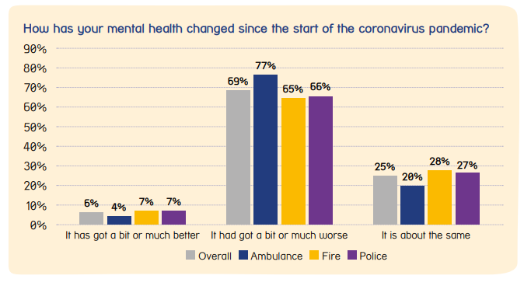
Above: Figure 2
Analysing this data, I would hypothesise that this is due officers putting themselves in the face of danger with minimal protection, intensifying the threat of contracting the virus themselves or passing it on to someone vulnerable or elderly. Moreover, the fear of being responsible for someone’s death. This is evidenced in the same survey, where 67% of police officers were concerned about passing on the virus to family and friends, and 48% of officers were anxious about contracting coronavirus themselves. Although the vaccine is not guaranteed to prevent you from contracting Coronavirus, it is believed to reduce your risk of catching or spreading COVID-19 (NHS,2021).
Assessing the data and analysis, officers receiving the vaccine as a first priority could have reduced mental health conditions and in turn reduced sickness levels, as officers undertake daily close contact interactions as part of their role, for example, arrest. Having that added protection could put officers at ease for the sake of their own mental health whilst physically reducing the risk of contracting the virus. Anna Harvey, Police Federation, supports this analysis; “We’ve seen an increase in psychological and physical conditions. Our sickness rates have risen”.

“Personal Protective Equipment (PPE)”
MIND’s “Behind the Mask” survey states that these anxieties were exacerbated by concerns around PPE. In addition to standard disposable gloves which were already available to police officers, The College of Policing (CoP) recommended that IIR and disposable gloves should be readily available to officers as minimum protection in all scenarios (CoP,2020).
Although specific anxieties of SWP officers have not been assessed and publicised, perceived issues appear to include the miscommunication PPE guidance. John Apter, Police Federation states that there was a stark ambiguity in advice given to officers regarding PPE, branding lack of guidance “Dangerous and completely unacceptable. This is a matter of life or death”.
Other elements potentially impacting officer mental health during COVID-19 is the global shortage of PPE. The WHO states that workers rely on PPE to protect themselves, and that the rising demand has left frontline workers dangerously ill-equipped (WHO,2020). Lack of adequate protection increases the risk of being exposed to the virus, advocating an increase in officer anxiety. This view is further demonstrated by Sim,2020, “risks to the psychological wellbeing of frontline workers are further exacerbated by reports of PPE shortages and defective equipment”.
The Police Federation further necessitates the requirement for the vaccine and sufficient PPE due to an increased weaponisation of the virus. One in three officers have been threatened by someone claiming to have COVID by coughing or spitting at them (Police Federation, 2021), amplifying the risk of contracting COVID and increasing anxiety.
Below, figure 3 does in fact suggest that sickness rates in officers are on the rise in recent years, as opposed to the slight decrease in 2017 as shown in figure 1. Current data for 2021 is yet to be published, therefore it is unlikely that we will be aware of the full effects of the pandemic as of yet.
Contradictorily, as of 31st March 2020, statistics indicate that there was an increase of 208 officers on long-term sick leave compared to 2019 (Home Office,2020). As the definition of “long-term” sick is 28 days, it would be unrealistic to theorise that additional powers magnified officer sickness due to stress, given they were only introduced 6 days prior. However, the threat of contracting Coronavirus in the UK had been prevalent for quite some time, with the first UK case confirmed on 30th January 2020. Owing to this, it could be inferred that the increase in figures of police officers sickness in March 2020 could have been as a result of psychological illness, such as the stress and anxiety of contracting Coronavirus through the workplace.
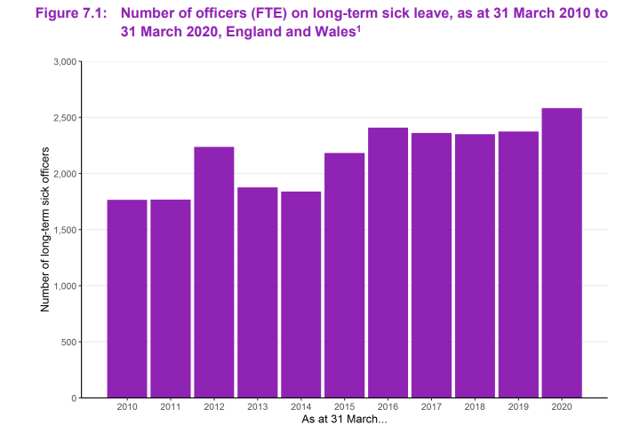
Above: Figure 3
Reflecting on this research, officials state that the full mental health effects of the pandemic may not be uncovered until the future, claiming that they are seeing officers suffering from post-traumatic stress disorder from five years ago. Darren Harris, Suffolk Police Federation states “It may be that we're going to be dealing with the mental health effects of the pandemic for years to come”.

Critical analysis of measures implemented to enhance officer wellbeing during COVID-19

PPE
The Health and Safety at work Executive states that employers must protect workers from injury or harm to health which could happen as a result of work-related activity. This includes taking reasonable steps to protect your workers and others from COVID-19 (HSE,2021).
Protecting workers from COVID-19 in the police force includes supplying them with adequate PPE. Jeff Cuthbert, Police and Crime Commissioner expressed that the PPE supply to officers had been “appropriate”.
Conversely, this response comes after nearly 40% of Gwent Police officers announced they did not have adequate access to PPE during COVID-19. A further study from HMICFRS found that “initially, forces did not have enough existing stocks of PPE, and in the main what they had did not adequately protect from coronavirus.” Further evidencing these views, this study affirms that forces expressed concerns in difficulty obtaining PPE, again indicating that the response was not “appropriate”. Critically analysing these findings, I would argue that the PPE supply to officers had not been appropriate, albeit through no fault of their own due to global shortage.

Wellbeing dogs
As a result of the review by HMICFRS, a recommendation to forces was to introduce measures to help staff with the longer-term health and wellbeing effects of COVID-19. A measure that SWP implemented is introducing wellbeing dogs force wide. The wellbeing and trauma support dogs project was launched through Oskar Kilo, who articulate that the presence of dogs in the workplace reduces the stress hormone cortisol, lowering feelings of stress and anxiety (Oskar Kilo,2021).
Reviewing the implementation of this measure, I believe that this is a valuable initiative in enhancing officer wellbeing. This is considered to have a positive impact on officer mental health, as it is proven that interaction with dogs can lower stress levels through sharing oxytocin, a hormone that engenders affection. This view is echoed by Kaylee Noble of SWP, “It’s amazing to see just how much of an impact the dogs can have on officers” (SWP Federation,2021).

Oskar-Kilo
Oskar-Kilo was launched in 2017 is part of the National Police Wellbeing Service, an online hub providing a wealth of resources in relation to wellbeing across the emergency services. Since the onset of the Coronavirus pandemic, Oskar-Kilo has launched a COVID-19 HUB, providing access to online resilience sessions and guidance on dealing with anxiety and distress in the workplace. This measure is considered beneficial to police officer mental health, as during the Coronavirus pandemic officers are dealing with daily evolving challenges they may not verbally discuss. Providing the opportunity to discreetly obtain mental health advice online, minimises the stigma which could result in officers seeking support, positively impacting their mental health.
Taking the above into consideration, sufficient measures could be preserved as being implemented to improve police officer mental health during COVID-19. Conversely, ‘Behind the Mask’ participants view this differently, with only 35% of police officers agreeing that their organisation has prioritised their mental health during the pandemic.

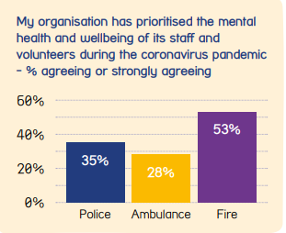

Above: Figure 4

Summarising these findings, under reporting and cultural misalignment is prevalent and a driving factor which hinders the true extent of officer mental health issues.
Exacerbated by the global pandemic, changing leadership expectations coupled with overwhelming lack of resources, PPE and support, further increase wellbeing issues for officers exhausted by the relentless pace at which they were expected to operate.
The overall impact COVID has had on officer wellbeing and mental health is not expected to be truly quantifiable for many months or years, however it seems clear from the data and research already available that the implications are driving increased issues for officers. This is intensified by lack of pandemic operating procedures to handle such a long sustained period of intense pressure.

Word count: 2745

References
Stogner, J., Lee Miller, B., and McLean, K., (2020). Police stress, mental health, and resiliency during the COVID-19 pandemic. American Journal of Criminal justice, Vol 45, P718–730.

Stevelink, S., Opie, E., Pernet, D., Gao, H., Elliott, P., Wessely, S., Fear, N., Hotopf, M. and Greenberg, N., 2021. Probable PTSD, depression and anxiety in 40,299 UK police officers and staff: Prevalence, risk factors and associations with blood pressure.

Owen, C., Neary, H., 2021. Police cancel fine given to couple who visited mother in care home. [online] WalesOnline. Available at: <https://www.walesonline.co.uk/news/wales-news/coronavirus-police-lockdown-fine-bridgend-19621426> [Accessed 26 July 2021].

Steward,M. (2021) Mental health impact of Covid crisis on police could be felt 'for years' [online] EastAnglianDailyTimes. Available at: <https://www.eadt.co.uk/news/crime/impact-of-covid-19-on-suffolk-police-7954966> [Accessed 26 July 2021].

Polfed.org. 2021. Police Federation. [online] Available at: <https://www.polfed.org/norfolk/news/2021/changing-covid-legislation-left-officers-between-a-rock-and-a-hard-place-keeping-the-public-safe/> [Accessed 26 July 2021].

Polfed.org. 2021. News that officers will not be prioritised for Covid vaccine is a “massive blow” for policing. [online] Available at: <https://www.polfed.org/essex/news/2021-articles/news-that-officers-will-not-be-prioritised-for-covid-vaccine-is-a-massive-blow-for-policing/> [Accessed 26 July 2021].

Polfed.org. 2021. Mental Health. [online] Available at: <https://www.polfed.org/our-work/wellbeing/mental-health/> [Accessed 26 July 2021].

The Institute for Government. 2021. Timeline of UK government coronavirus lockdowns. [online] Available at: <https://www.instituteforgovernment.org.uk/charts/uk-government-coronavirus-lockdowns> [Accessed 26 July 2021].

Assets.publishing.service.gov.uk. 2021. Police Workforce, England and Wales, 31 March 2017. [online] Available at: <https://assets.publishing.service.gov.uk/government/uploads/system/uploads/attachment_data/file/630471/hosb1017-police-workforce.pdf> [Accessed 26 July 2021].

2021. Police Firearms Officers Association. [online] PFOA. Available at: <https://www.pfoa.co.uk/blog/categories/police-firearms-officers-association?start=320> [Accessed 26 July 2021].

Admin, P., 2021. Police Mental Health sickness up by 47%. [online] PFOA. Available at: <https://www.pfoa.co.uk/blog/police-mental-health-sickness-up-by-47> [Accessed 26 July 2021].

Assets.publishing.service.gov.uk. 2021. Police workforce, England and Wales: 31 March 2020 second edition. [online] Available at: <https://assets.publishing.service.gov.uk/government/uploads/system/uploads/attachment_data/file/955182/police-workforce-mar20-hosb2020.pdf> [Accessed 26 July 2021].

Körlin, J., Alexanderson, K., Svedberg, P. (2009). Sickness absence among women and men in the police: A systematic literature review. Scandinavian journal of public health. 37. 310-9. 10.1177/1403494808098508.

Edwards, A., Kotera, Y., (2020) Study Protocol: A Pilot Study Investigating Mental Health in the UK Police Force

De Camargo, C. The postcode lottery of safety: COVID-19 guidance and shortages of personal protective equipment (PPE) for UK police officers. The Police Journal. May 2021. doi:10.1177/0032258X211018768

HMICFRS. 2021. Policing in the pandemic - The police response to the coronavirus pandemic during 2020 - HMICFRS. [online] Available at: <https://www.justiceinspectorates.gov.uk/hmicfrs/publication-html/the-police-response-to-the-coronavirus-pandemic-during-2020/> [Accessed 26 July 2021].

Who.int. 2021. Shortage of personal protective equipment endangering health workers worldwide. [online] Available at: <https://www.who.int/news/item/03-03-2020-shortage-of-personal-protective-equipment-endangering-health-workers-worldwide> [Accessed 26 July 2021].

Polfed.org. 2021. One year on since lockdown: Dorset police officers have rose to the challenge of COVID-19. [online] Available at: <https://www.polfed.org/dorset/news/2021/one-year-on-since-lockdown-dorset-police-officers-have-rose-to-the-challenge-of-covid-19/> [Accessed 26 July 2021].

Polfed.org. 2021. 'This is not a training exercise, this is reality'. [online] Available at: <https://www.polfed.org/news/latest-news/2020/this-is-not-a-training-exercise-this-is-reality/> [Accessed 26 July 2021].

Mental Health Foundation. 2021. Mental health statistics: mental health at work. [online] Available at: <https://www.mentalhealth.org.uk/statistics/mental-health-statistics-mental-health-work> [Accessed 26 July 2021].

Oscar Kilo. 2021. OK9 Wellbeing and Trauma Support Dogs • Oscar Kilo. [online] Available at: <https://oscarkilo.org.uk/ok9-wellbeing-and-trauma-support-dogs/> [Accessed 26 July 2021].

Oscar Kilo. 2021. COVID-19 Coronavirus Hub • Oscar Kilo. [online] Available at: <https://oscarkilo.org.uk/category/covid-19-coronavirus-hub/page/4/> [Accessed 26 July 2021].

2021. South Wales Police Federation. [online] Swpf.org. Available at: <https://www.swpf.org/localnewsprint.php?LocalNewsID=119> [Accessed 26 July 2021].

Moody,T. 2021. Study reveals Gwent Police officers' concerns over adequate access to PPE. [online] SouthWalesArgus. Available at: <https://www.southwalesargus.co.uk/news/18936925.gwent-police-respond-officers-concerns-access-ppe/> [Accessed 26 July 2021].

Who.int. 2021. Shortage of personal protective equipment endangering health workers worldwide. [online] Available at: <https://www.who.int/news/item/03-03-2020-shortage-of-personal-protective-equipment-endangering-health-workers-worldwide> [Accessed 26 July 2021].

Polfed.org. 2021. Statement from John Apter, National Chair and Alex Duncan, National Secretary. [online] Available at: <https://www.polfed.org/news/latest-news/2021/statement-from-john-apter-national-chair-and-alex-duncan-national-secretary/> [Accessed 26 July 2021].

Polfed.org. 2021. Federation says it has no confidence in Home Secretary. [online] Available at: <https://www.polfed.org/suffolk/news/2021/federation-says-it-has-no-confidence-in-home-secretary/> [Accessed 26 July 2021].

nhs.uk. 2021. Coronavirus (COVID-19) vaccines. [online] Available at: <https://www.nhs.uk/conditions/coronavirus-covid-19/coronavirus-vaccination/coronavirus-vaccine/> [Accessed 26 July 2021].

MIND.Org, 2021. Behind The Mask. [online] Available at: <https://www.mind.org.uk/media/7246/blue-light-behind-the-mask-report-en-2021.pd> [Accessed 26 July 2021].

Policeprofessional.com. 2021. Police Professional | Survey reveals toll of pandemic on mental health of emergency workers. [online] Available at: <https://www.policeprofessional.com/news/survey-reveals-toll-of-pandemic-on-mental-health-of-emergency-workers/> [Accessed 26 July 2021].

Polfed.org. 2021. Open letter to the Government over police officer vaccines. [online] Available at: <https://www.polfed.org/news/latest-news/2021/open-letter-to-the-government-over-police-officer-vaccines/> [Accessed 26 July 2021].

MentalHealth.Gov, 2021. What is mental health. [online] Available at: <https://www.mentalhealth.gov/basics/what-is-mental-health> [Accessed 26 July 2021].

Mind.org.uk. 2021. Mind Cymru survey reveals toll of pandemic on ambulance workers' mental health. [online] Available at: <https://www.mind.org.uk/news-campaigns/news/mind-cymru-survey-reveals-toll-of-pandemic-on-ambulance-workers-mental-health/> [Accessed 26 July 2021].

Mind.org.uk. 2021. Our Blue Light research. [online] Available at: <https://www.mind.org.uk/news-campaigns/campaigns/blue-light-programme/our-blue-light-research/#BlueLightCovid19ResponseReport2021> [Accessed 26 July 2021].

