Professional Practice in Sport and Exercise (SHSS6060) – James Sudale (1903598)
Student FEEDBACK FORM
Generic Assessment Criteria | Marks available | Marks  awarded
1. Engagement with Literature Skills
.
 | 5
2. Knowledge and Understanding Skills

 | 20
3. Cognitive and Intellectual Skills

 | 25
4. Practical Application Skills

 | 25
5. Transferable Skills for Life and Professional Practice

 | 25

Assessment Mark (Assessment marks are subject to ratification at the Exam Board. These comments and marks are to give feedback on module work and are for guidance only until they are confirmed. ) | Late Submission Penalties (tick if appropriate) |  | %
 | Up to 1 week late (40% Max) |  | %
 | Over 1 week late (0%) |  | %

8)Rehabilitation gym

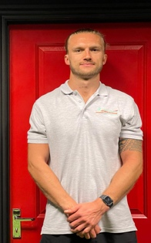
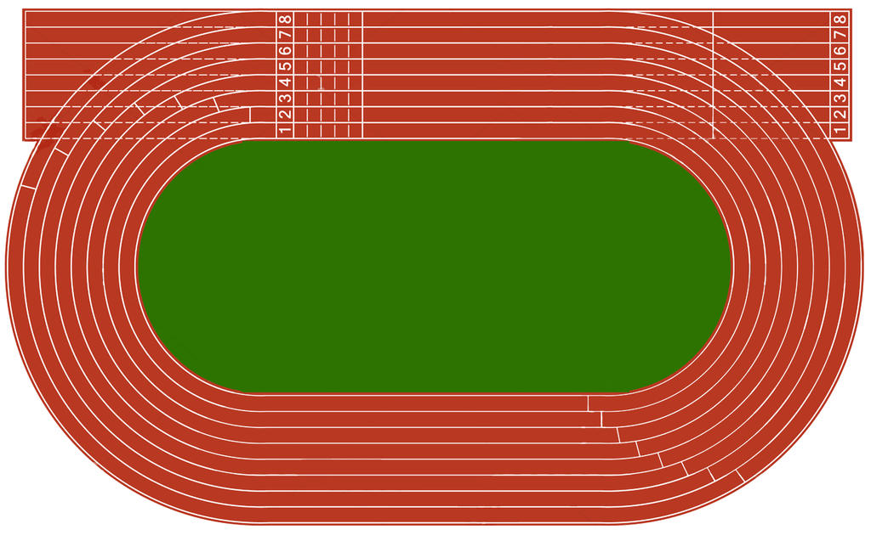
1)Graduation
7) Swansea city FC
6)Specific Pop courses

5)MSc S&C
4)ITMMIF – trauma course

3)Shoulder assessment
2)Design rehab program

Well, where do I start? Where do I see myself in 10 years? We can achieve anything we set our hearts to, and you get out what you put into it, but life has a way of throwing you curveballs, and there are no guarantees. However, “obstacles don’t have to stop you. If you run into a wall, don’t turn around and give up, figure out how to climb it, go through it, or work around it”. If you really believe that you can reach your destiny, your dream goal is much closer than you think. Everyone should set high standards towards their ambition, and before you know it, you will get gratification. My long-term goal would be to open a rehabilitation gym offering numerous services such as fitness classes for younger and older populations with a wide range of abilities. Life is about building blocks and goal settings; build your confidence by setting smaller goals over smaller periods. Goal setting involves the development of an action plan designed to motivate and guide a person or group to achieve the long-term goal (Kelliher et al., 2020). There is always the potential to stumble at hurdles, but you will need to figure out how to overcome every hurdle to reach your goals. Personally, I prefer to have smaller goals over a smaller timeframe.

Firstly, I would be ecstatic with a first-class honours’ degree in Sports Therapy, and my aim is to succeed in this. To reach a first-class honours’, I need to work extremely hard in my final year and pass all the modules. I have multiple modules in the upcoming year to excel in; therefore, I believe I will gain the knowledge required to overcome my desired first hurdle. Over the next 6 months - 1 year, I hope to design and guide a player through a rehabilitation program for ACL surgery under the supervision of the Carmarthen Quins physiotherapies. This will help me build my confidence in using my own initiative to conduct rehab programs under my own guidance, which will further help me accomplish my long-term goal.

I wish to assess and diagnose a shoulder injury confidently at least 5 times over the next year in the clinical setting. I am least confident with shoulder injuries; therefore, in November, I am attending a shoulder course with Jo Gibson, an experienced physiotherapist, to recuperate ideas and better understand this area. I see many clients with shoulder issues in my own clinic at a gym locally to me. As assessment of the shoulder is a weak area for me, I am determined in my final year of studies to practice the shoulder region in my clinic and university clinic to confidently make better decisions through diagnosis and treatment. Providing excellent, tailored treatment can significantly change your confidence and satisfaction. Another goal I aspire to achieve within 1-2 years is to complete a sports trauma course to start pitch side first aid with teams independently. I am required to complete ‘The FA Level 4 Intermediate Trauma Medical Management in Football’ (ITMMIF) and ‘The FA Level 5 Advanced Trauma Medical Management in Football’ (ATMMiF) to work in football up to the standard of the Championship and Premier League, The FA (2021). I am looking to get a position as a sports therapist in Swansea City football club within 3 years. I have gained valuable experience working with Trebanos, Carmarthen Quins and Llanelli Scarlets rugby teams and Briton Ferry Llansawel FC shadowing different physios.

I have always been interested in strength and conditioning; therefore, I desire to begin a MSc degree in this field. I am hoping to pursue this at Cardiff University; this university is accepting a 2:1 or higher. It is approved by Professional Standards Authority for Health and Social Care (PSA) and accredited by the British Association of Sport Rehabilitators and Trainers (BASRaT) (Cardiff Met University, 2021). Maximal strength and power training stimulate different physiological adaptations. Strength training increases neural drive, intermuscular coordination and myofibrillar cross-sectional area of Type II fibres (Suchomel et al., 2018). Ballistic power training increases maximal power output, rate of force development, improves motor unit firing frequency and enhances intermuscular coordination (Rodríguez‐Rosell et al., 2018). The physiological changes are significant for a rehabilitative perception and can lead towards an integrated concept that incorporates robustness and resilience for reduced risk of injury.

Within two years, I will continue to enhance my knowledge by implementing further courses such as exercise and disability through YMCA fit. This will add to my level 3 Personal training diploma. The course will enable me to work with individuals with disabilities such as hearing and visual impairments, spinal injuries, amputation, cerebral palsy and learning difficulties such as Downs syndrome. I have a sister with this condition, and they do not get enough opportunities to use gym facilities and maintain their health like everyone else. Additionally, I will be looking to work with the older population by completing an exercise for older adult’s course also through YMCA fit. The aim is to improve their quality of life by introducing them to resistance training and aerobic exercise. It is suggested that exercise improves functional capacity and reduces disability in individuals with diverse chronic diseases (Pasanen et al., 2017). I am particularly passionate about motivating people of all ages to improve their health and lifestyle. The opportunity to encourage and help individuals of various abilities is a no-brainer for me.

When I first joined the course, I was unsure what I would do after the 3 years of my studies. I am an individual who always keeps my options open because I always think to myself that tomorrow is a new day. As I approach the end of my degree, I believe that I can accomplish anything I set my mind to and work hard towards. Whether that be working at a high level of football or rugby clubs or owning my own rehabilitation gym. No matter what happens in 10 years and where I end up in my career, I will always be proud of the person I have become.
I look forward to further developing and harnessing my own skills and am highly motivated for the future. I would like to be regarded as a great person that succeeded in everything I had planned.

Word count – 1050
Reference List
Cardiff Met University (2021). Msc In Strength and Conditioning At Cardiff Met University. [online] Cardiff Met University. Available at: <https://www.cardiffmet.ac.uk/sportandhealthsciences/courses/Pages/Strength-and-Conditioning.aspx>

Kelliher, F., Murphy, M. and Harrington, D., (2020). Exploring the role of goal setting and external accountability mechanisms in embedding strategic learning plans in small firms. Journal of Small Business and Enterprise Development. Available at: http://dx.doi.org/10.1108/JSBED-12-2019-0411 (Accessed: 9th April 2020)

Pasanen, T., Tolvanen, S., Heinonen, A. and Kujala, U.M., (2017). Exercise therapy for functional capacity in chronic diseases: an overview of meta-analyses of randomised controlled trials. British Journal of Sports Medicine. 51(20). pp.1459-1465. Available at: http://dx.doi.org/10.1136/bjsports-2016-097132 (Accessed: October 2017)

Rodríguez‐Rosell, D., Pareja‐Blanco, F., Aagaard, P. and González‐Badillo, J.J., (2018). Physiological and methodological aspects of rate of force development assessment in human skeletal muscle. Clinical Physiology and Functional Imaging. 38(5). pp.743-762. Available at: http://dx.doi.org/10.1111/cpf.12495 (Accessed: September 2018)

Suchomel, T.J., Nimphius, S., Bellon, C.R. and Stone, M.H., (2018). The importance of muscular strength: training considerations. Sports Medicine. 48(4). pp.765-785. Available at: http://dx.doi.org/10.1007/s40279-018-0862-z (Accessed: April 2018)

The Football Association (2021) The FA. [online] The Football Association. Available at: https://thebootroom.thefa.com/learning/qualifications/the-fa-level-4-intermediate-trauma-medical-management-in-football (Accessed: 10 March 2021)

