

BA Business and Management
Learning and Collaboration for Global Citizenship
BMSP4015D: Personal Learning Environment Portfolio
Student name:Denisa Alexandra Paris
Student id:2520283

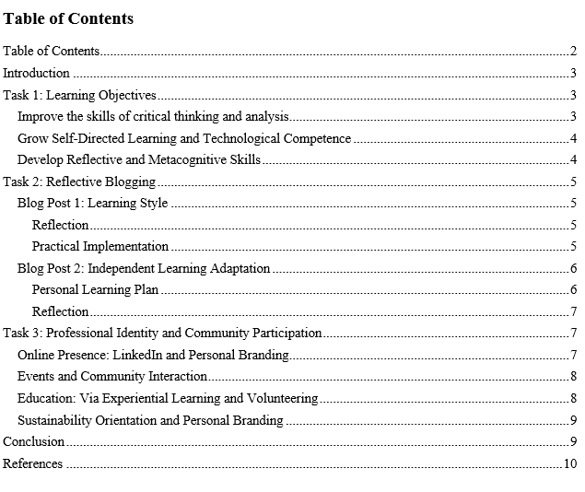

Introduction
A Personal Learning Environment (PLE) is a versatile environment that allows learners to take control of their learning and professional development. Contrary to traditional learning, where structures and resources are pre-determined, a PLE incorporates digital tools, contemplation, and collaborative practices to aid in continual growth (Dabbagh and Kitsantas, 2012). The formation of a PLE promotes the generation of higher-order skills, the independent learning process, and enhances professional identity. The portfolio is designed into three primary areas, including setting learning objectives, reflective blogging, and planning professional identity and engagement with communities. Both research and personal reflection inform every section and focus on the strategies that would ensure the most learning potential and equip the students with future careers.

Task 1: Learning Objectives
Learning objectives are a focus, motivational, and a measurement tool. Three main goals inform my academic, personal, and professional growth in the university, as they are the goals that have been selected to direct my study process.

Improve the skills of critical thinking and analysis
Critical thinking helps students to analyze arguments, integrate information, and make valid decisions. Not only is it necessary to succeed academically, but also to solve problems in the professional environment (Paul & Elder, 2019). I want to become more skilled at critically evaluating literature, data, and real-life situations, detecting biases, and engaging in logical thinking. The studies prove that the students who actively build their critical thinking skills are better positioned to address complex tasks and make decisions in uncertainty (Facione, 2015). In practicality, the skill will enhance academic writing, the quality of the research, and the capacity to make an insightful contribution to the discussions. Improve the communication and collaboration skills.
Communication, both written and oral, is also a key to successful professionalism. The other factor that is equally important is the capacity to work with different teams in order to realize common objectives. I am goal-oriented to enhance my ability to present ideas effectively and engage positively in teamwork. According to Andrews and Higson (2008), one of the highly requested skills by employers is communication and teamwork (Johnson and Smith, 2014). The acquisition of these competencies will also allow me to be effective in working in professional settings and head projects that require communication and negotiation among various stakeholders.

Grow Self-Directed Learning and Technological Competence
The independence, accountability, and lifelong learning habits are encouraged through self-directed learning (Candy, 1991). Living in the age of technology, it is necessary to be able to orient oneself in digital materials, the Internet courses, and virtual learning platforms. I also intend to enhance my self-directed learning capabilities and use technology to enhance learning. Conole (2013) says that digital literacy and self-directed learning are what make employability and adaptability possible. By introducing online tools, reflective practices, and strategy into my learning process. It is also essential in training me to have lifelong learning that I will have once I complete school.

Develop Reflective and Metacognitive Skills
In addition to standard skills, it is important to reflect on the overall processes of learning as a person, metacognition, to engage in constant improvement. Reflective practice is the process of evaluating what measures are effective as well as determining the obstacles and how improvement can be made (Schon, 1983). I intend to make it a habit of reflecting in order to maximize the results of learning. Reflective skills enhance self-knowledge, promote adaptive learning, and facilitate professional development. Through reflective journals, structured feedback, and assessment of my study plans, I would be able to track my progress, identify gaps, and make evidence-based changes. It has been argued that a reflective learner has high chances of adapting well in complex work situations and making prudent decisions (Moon, 2004).

Task 2: Reflective Blogging

Blog Post 1: Learning Style
After taking a series of tests about learning styles and examining the academic data on cognitive preferences, I found out that I am mostly a visual and reflective learner (Fleming & Mills, 1992). This implies that I can learn better when the information is shown visually, in terms of diagrams, charts, space organization, etc., and when I am given time to contemplate the new ideas and apply them to myself. I have always realized that I require time to comprehend ideas in my head, and this is the feature of reflective learners as they demand to observe, think in a structured and internalized way, and act at the end of it.

Reflection
This knowledge is closely related to my current study habits. To illustrate, when I am facing a difficult subject matter, I instinctively use mind maps, flowcharts, colour-coded graphs, and visual summaries as aids in subdividing information.

Practical Implementation
- To maximise on my visual and reflective preferences of learning, I will always employ the following strategies in my academic life:
- Prepare graphical summaries of contents in lectures and reading materials with such tools as Canva, MindMeister, and Notion. They will enable me to mentally map out ideas, theories, and links in a manner that will enable me to memorise them in the long term.
- Apply charts, schedules, and tables in my studies, particularly essays and reports. This will assist me in conveying the complex information in a better manner and also will reinforce my own knowledge as I will organize it visually.
- Add the elements of colour-coding and spatial structuring to my note-taking practice, including the application of various colours to different themes and case studies as well as to key arguments.
- Redo and rewrite visual notes weekly and turn them into study maps, which sum up the whole module before exams.
- To enhance the critical thinking process and metacognition, engage in reflective questioning, i.e., what did I learn, why does this matter, and how can I apply this? This link also helped me to do better mind mapping for increasing my expertise: https://www.mindomo.com/
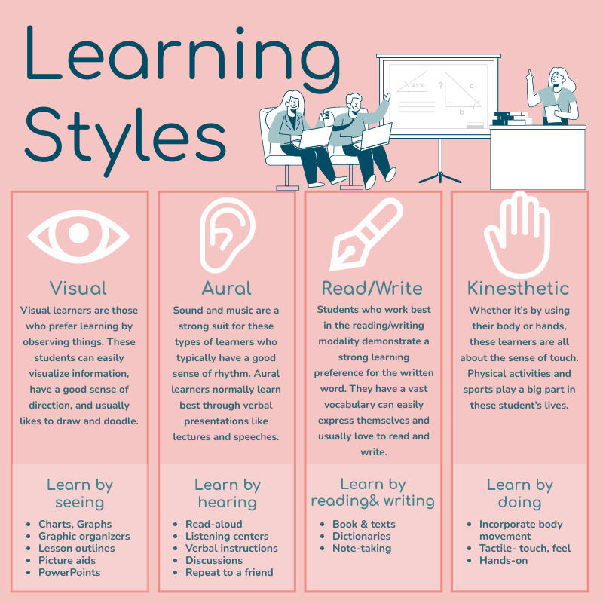

Blog Post 2: Independent Learning Adaptation
My knowledge regarding my learning style has given me a better idea of how to plan and streamline my independent learning plan. Having realised the fact that I best learn by visual learning methods and by contemplating, I can now study more intentionally and systematically. This consciousness also enables me to see what strategies actually work in aiding my understanding and remembering, and which might not be so efficient given my cognition preferences.

Personal Learning Plan
In order to apply all my learning style findings in practical terms, one of the things I have come up with is to create a systematic learning plan, which I will adhere to throughout my academic life.
- I will develop diagrams, charts, timelines, flow charts, and infographics per larger subject or module.
- These visual aids will be useful in deconstructing intricate theories and streamlining information into rational formats that aid in the preservation of information.
- These resources will be designed in a professional and systematized way using such tools as Canva, MindMeester, Notion, and Miro.
- Even reflective writing will be applied as a platform where more profound thinking will be done, relating course material to real-life experiences and future aspirations.
- I will utilize online resources to complete the learning in classrooms, including Coursera, Khan Academy, LinkedIn Learning, and YouTube academic sources.
- The combination of digital sources will allow me to support notions in another dimension and deepen my knowledge, not only with the help of lecture materials.
- To prevent burnout and to be focused, I will apply the Pomodoro Technique (25 minutes focused study + 5 minutes break).

Reflection
It has been postulated that self-directed learning (setting goals, self-monitoring, and taking personal responsibility) is a major predictor of motivation, confidence, and academic achievement (Knowles, Holton, and Swanson, 2015). Including the use of visual tools, systematized reflection, and explicit planning, I am developing a sustainable model that will be consistent with the principles of evidence-based learning.

Task 3: Professional Identity and Community Participation
Establishing a high-quality professional identity and engaging in the corresponding communities are the key elements of long-term career development. These factors not only define the way I am perceived in the industry but also determine the opportunities that I can get. The approach I have is based on establishing a trustworthy online profile, developing professional contacts, and having practical and real-life learning experiences that reinforce my competence as well as my confidence.

Online Presence: LinkedIn and Personal Branding
The LinkedIn platform is one of the main places where I can display the results of my academic performance, current projects, and future skills. It is also an environment where I can define my personal brand and prove my values. To establish a competitive presence, I will:
- Build a profile that shows a detailed listing of my skills, courses, certifications, extracurricular activities, and any other project-based work.
- Contribute to knowledge and information about projects and other new developments in the industry, slowly establishing myself as a discerning and knowledgeable player in my industry.
- Engage with other industry professionals, alumni, faculty, and peers to expand my network and have a greater variety of opinions.
- Kietzmann et al. (2011) claim that having a good online presence improves visibility and opens up opportunities to internships, mentorship, and collaborative programs. I would like to continue having an active digital presence, which would be a sign of professionalism, curiosity, and development.

Events and Community Interaction
Networking offers good resources in building relationships, mentoring, and knowledge that one would not encounter in the classroom. It is a critical ability in contemporary career making. The networking plan that I will have is:
- Visiting career fairs and skill-training seminars, and webinars conducted by universities to be aware of industry opportunities and employer expectations.
- Attending conferences, seminars, and panel talks on sustainability, enterprise management, and responsible business practices.
- Participation in student associations and professional associations, where I will be able to learn together and also gain more exposure to the academic field and professional community.

Education: Via Experiential Learning and Volunteering
Practical experiences are also important in converting theoretical knowledge into practice. The Experiential Learning Theory, created by Kolb (2015), states that active learning contributes to a better understanding and transferable skills since the process is driven by hands-on learning. I plan to:
- Engage in college projects, particularly on advanced innovation and sustainability projects, and management of enterprises.
- Work as a volunteer in the community organisations where I will learn to lead, communicate, coordinate projects, and work with different people.
- Find internships, part-time jobs, or placement programs that are also focused on my career interests so that I can develop industry awareness and practical skills.

Sustainability Orientation and Personal Branding
Besides networking and experience, I strive to build a personal brand that would demonstrate my interest in sustainability and responsible business. This includes:
- Posting blog articles, reflections, or short stories on sustainable business practices, ethical leadership, and social responsibility.
- Distributing scholarly knowledge and learning experience on LinkedIn and other educational sites to show that I am a lifelong learner.
- Engaging in debates, webinars, or community discussions on sustainability issues, and matching my professional identity with my values.

Conclusion
All in all, this personalised plan is a significant step that will lead one to become a successful, independent, and lifelong learner. These visual techniques can assist me in transforming abstract or long information into small, manageable, and well-organized information that increases understanding and recall.

References
Andrews, J., & Higson, H. (2008). Graduate employability, ‘soft skills’ versus ‘hard’ business knowledge: A European study. Higher Education in Europe, 33(4), 411–422.
Burt, R. S. (2000). The network structure of social capital. Research in Organizational Behavior, 22, 345–423.
Candy, P. C. (1991). Self-direction for lifelong learning. Jossey-Bass.
Conole, G. (2013). Designing for learning in an open world. Springer.
Dabbagh, N., & Kitsantas, A. (2012). Personal learning environments, social media, and self-regulated learning: A natural formula for connecting formal and informal learning. The Internet and Higher Education, 15(1), 3–8.
Facione, P. A. (2015). Critical thinking: What it is and why it counts. Insight Assessment.
Fleming, N. D., & Mills, C. (1992). Not another inventory, rather a catalyst for reflection. To Improve the Academy, 11(1), 137–155.
Kietzmann, J. H., Hermkens, K., McCarthy, I. P., & Silvestre, B. S. (2011). Social media? Get serious! Understanding the functional building blocks of social media. Business Horizons, 54(3), 241–251.
Knowles, M. S., Holton, E. F., & Swanson, R. A. (2015). The adult learner: The definitive classic in adult education and human resource development. Routledge.
Kolb, D. A. (2015). Experiential learning: Experience as the source of learning and development. Pearson Education.
Paul, R., & Elder, L. (2019). Critical thinking: Tools for taking charge of your professional and personal life (3rd ed.). Pearson.
Pashler, H., McDaniel, M., Rohrer, D., & Bjork, R. (2009). Learning styles: Concepts and evidence. Psychological Science in the Public Interest, 9(3), 105–119.
Robles, M. M. (2012). Executive perceptions of the top 10 soft skills needed in today’s workplace. Business Communication Quarterly, 75(4), 453–465.

