RHEUMATOID ARTHRITIS
Student Name: Muhammed Atif Sajid Banglawala
Student ID Number: 2514910
Programme: MSc Public Health and Social Care in Practice
Module: Community Care and Management of Longer-term Conditions
Module Code: LCHS7003
Lecturer: Dr raheela shaikh
Submission Date: 27 February 2026
Word Count: 3000

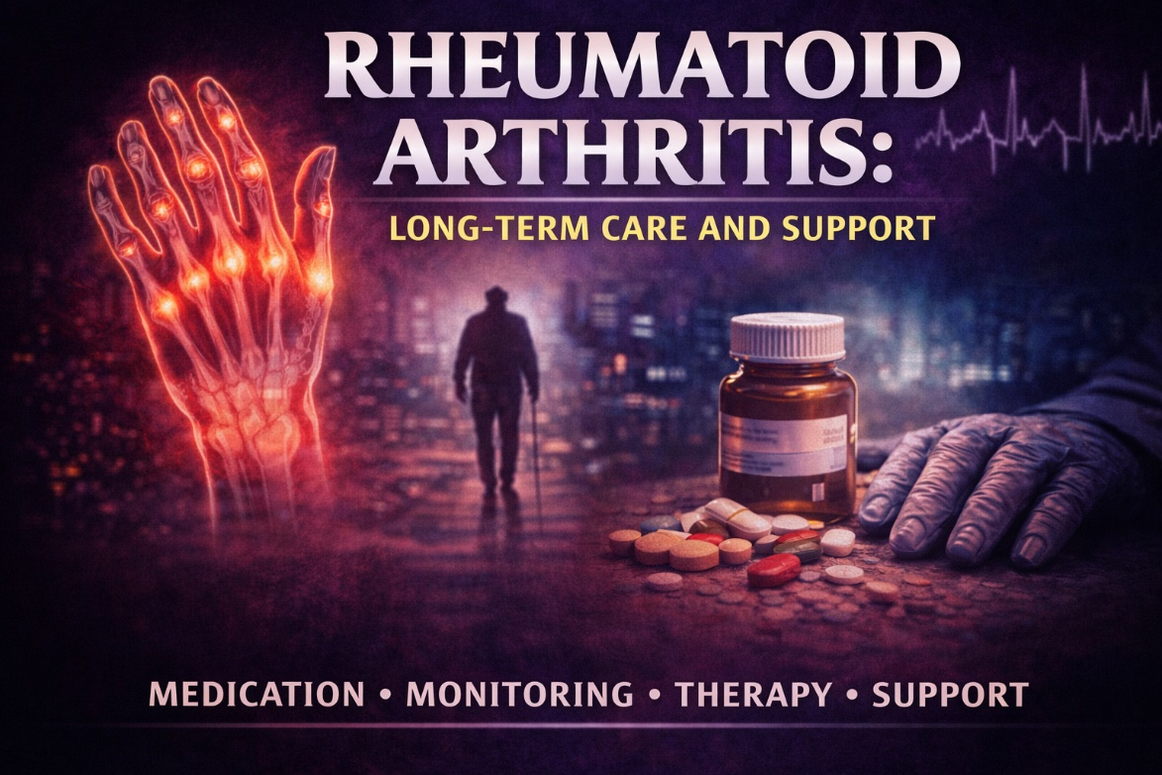
Table of Contents
Introduction 4
1. Definition, Aetiology & Pathophysiology 5
2. Epidemiology & Burden 6
3. Risk Factors 7
4. Physical, Psychological & Social Impact 9
5. Evidence-Based Management in the UK 11
6. Theoretical Models 13
7. Policy & Political Context 14
8. Recommendations 15
Summary 16
References 17

Figure 1: Rheumatoid Arthritis 5
Figure 2: The prevalence of rheumatoid arthritis (RA) 6
Figure 3: Risk Factors of RA 8
Figure 4: Physical Impact 9
Figure 5: Psychological Impact of Rheumatoid arthritis 10
Figure 6: Social Impact of Rheumatoid arthritis 11
Figure 7: Evidence-Based Management in the UK 12
Figure 8: NHS Personalised Care Model 13

Introduction
Rheumatoid arthritis (RA) is a chronic systemic autoimmune inflammatory disease, in the first place associated with synovial damage, and is marked by persistent synovitis, foci of joint destruction and possible extra-articular disease (Firestein et al., 2024; Scott et al., 2020).
The disease has a shifting but progressive disease process; in the absence of treatment, inflammation causes permanent structural damage and impaired functions with more chronic morbidity (Hochberg et al., 2022; Klingemann, Mikuls and England, 2026).
RA has a global prevalence of about 0.5 1 per cent of adults population, with a future rise in disease burden and projections indicating further increases in disease prevalence even to 2050 (Finckh et al., 2022; Black et al., 2023).
RA has been a major issue in the United Kingdom, being an important cause of musculoskeletal disability and utilisation of healthcare services at both primary and specialist levels (Versus Arthritis, 2024; Uke, Maharaj and Adebajo, 2025).
Other than being involved in joint pathology, RA has far-reaching biopsychosocial implications, such as chronic pain, fatigue, depression, and deteriorated quality of life and limitations on social participation (Lwin et al., 2020; Alwhaibi, 2025).
Effective management should thus be based on the integration and approaches that are multidisciplinary and person-centred, to address medical, psychological, and social aspects of care (Conley et al., 2023; Barber et al., 2021).
To make a remission and avoid long-term disability, it is important to diagnose the disease as soon as possible and start disease-modifying therapy (NICE, 2018; NHS UK, 2026).
RA management agrees with broader NHS long-term condition policies that have chosen to focus on tailored care, early detection and integrated service provision in order to maximize results.

1. Definition, Aetiology & Pathophysiology
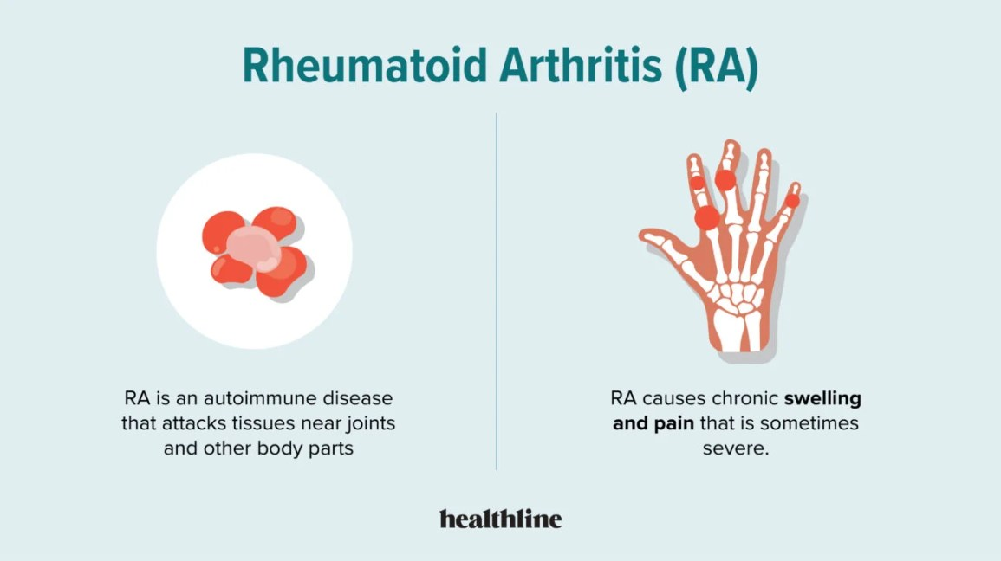

Figure 1: Rheumatoid Arthritis
- Rheumatoid arthritis (RA) is a systemic autoimmune disease, which is associated with the loss of immune tolerance to self-antigens and chronic inflammation of joints of the synovium and the progressive destruction of the structure (Firestein et al., 2024; Scott et al., 2020).
- The autoimmune process entails activation of the autoreactive T and B lymphocytes, generation of rheumatoid factor and anti-citrullinated protein antibodies, and the perpetuation of the cytokine release that perpetuates the synovial inflammation (Hochberg et al., 2022; Finckh et al., 2022).
- Chronic synovitis leads to hypertrophy of the synovial membrane and the development of pannus tissue, which destroys cartilage and bone that causes the erosion and deformity of the joints (Firestein et al., 2024; Zeng et al., 2025).
- In addition to articular symptoms, RA is now known to be a systemic inflammatory disorder, which is linked to cardiovascular disease, pulmonary and other extra-articular manifestations and increases excess morbidity and mortality (Klingemann, Mikuls and England, 2026; Zeng et al., 2025).
- The genetic predisposition is also crucial, especially HLA-DRB1 shared epitope, which interacts with environmental factors like smoking to cause susceptibility (Venetsanopoulou et al., 2022; Ishikawa and Terao, 2020).
- The dysregulation of immune pathways, such as the tumour necrosis factor (TNF), interleukin-6 and Janus kinase signalling, underlies the disease activities and targets of therapy as evidenced by the development of molecular knowledge (Firestein et al., 2024; Finckh et al., 2022).
- The heterogeneity of the progression of the disease is noted; some patients can be cured with initial treatment, and some people develop challenging to treat RA despite the perfect choice of the therapy, which indicates the variability of immunopathogenesis and response to the therapeutic approach (Xie et al., 2025).
- Despite the recent studies broadening knowledge of immune processes, the presentation of RA is still more heterogeneous, implying that with the interaction of genetic and environmental factors with immunological conditions, various disease phenotypes are formed, which do not allow homogenous treatment practices (Venetsanopoulou et al., 2023; Klingemann, Mikuls and England, 2026).

2. Epidemiology & Burden
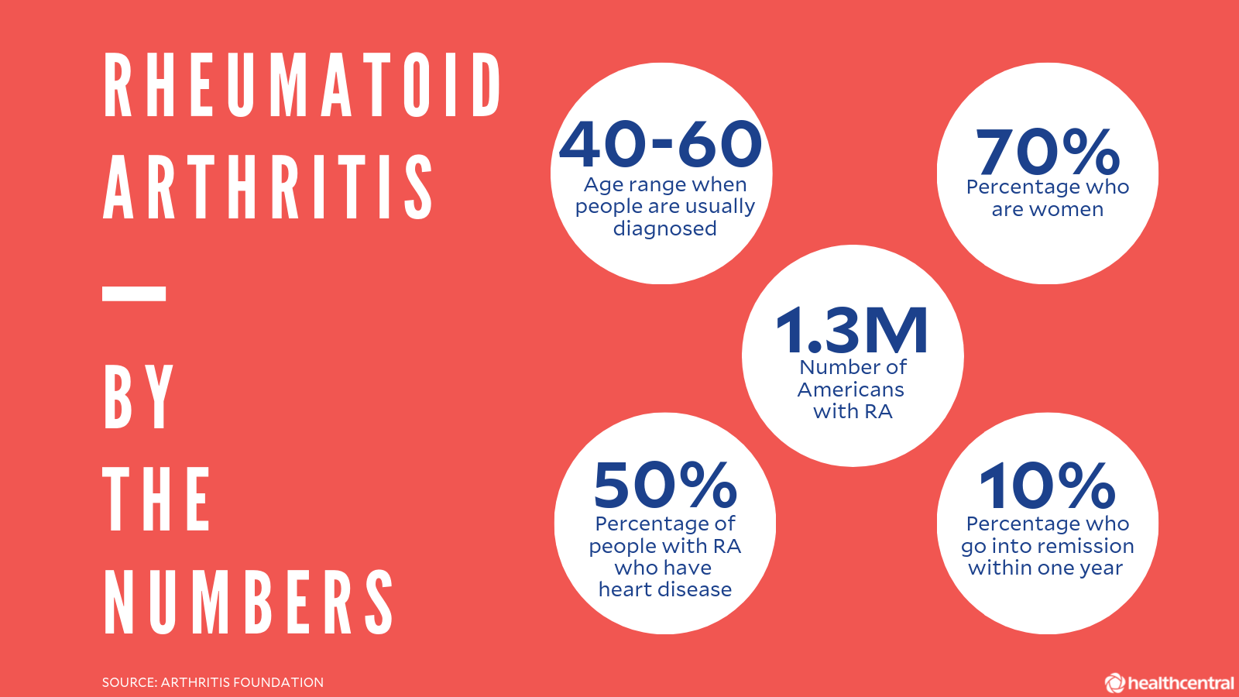

Figure 2: The prevalence of rheumatoid arthritis (RA)
- The prevalence of rheumatoid arthritis (RA) is around 0.510 percent in the world among adults, however, there is wide disparity in its occurrence based on regions which reflects factors contributing to this disease such as genetic, environmental, and healthcare factors (Finckh et al., 2022; Black et al., 2023).
- Trends of incidence indicate that, some regions may be experiencing increasing rates of diagnosed cases, but this may be due to better recognition and classification criteria, but real increases associated to modifiable risk exposures cannot be ruled out (Uke, Maharaj and Adebajo, 2025; Klingemann, Mikuls and England, 2026).
- There is still a significant geographical variance, with reported prevalence higher in high-income nations which could be due to more efficient case ascertainment but not necessarily epidemiological differences between them (Finckh et al., 2022; Venetsanopoulou et al., 2023).
- RA is a significant cause of musculoskeletal morbidity in the United Kingdom, with upwards of hundreds of thousands of adults having it and it constituting a significant share of the burden of inflammatory arthritis in the NHS (Versus Arthritis, 2024; Uke, Maharaj and Adebajo, 2025).
- RA has been linked with a higher rate of premature death, which has primarily been caused by cardiovascular and systemic inflammatory complications, which confirms its status as a major long-term condition as opposed to being merely a disease that limits its activity to the joints (Klingemann, Mikuls and England, 2026; Black et al., 2023).
- The Global Burden Disease study projects indicate that the prevalence of RA would continue to increase to 2050, as the population gains age and demographics grows, which would strain the health system (Black et al., 2023).
- RA itself is economically charged with significant direct healthcare expenses on pharmacological treatments and expensive specialist care as well as indirect expenses on productivity loss and long-term disability (Finckh et al., 2022; Versus Arthritis, 2024).
- Another issue is working disability, which is widespread especially in women, the victims of Arthritis; who has a higher rate of the disease, shows the existing gender inequality, and contributes to gender differences in the long-term functioning of the patient (Uke, Maharaj and Adebajo, 2025; Versus Arthritis, 2024).
- Socioeconomic inequalities, in turn, also have the effect of modifying the end points of disease since people in disadvantaged populations might face diagnostic delays and lack access to expert services, which also increases cumulative disease burden (Finckh et al., 2022; Klingemann, Mikuls and England, 2026).

3. Risk Factors
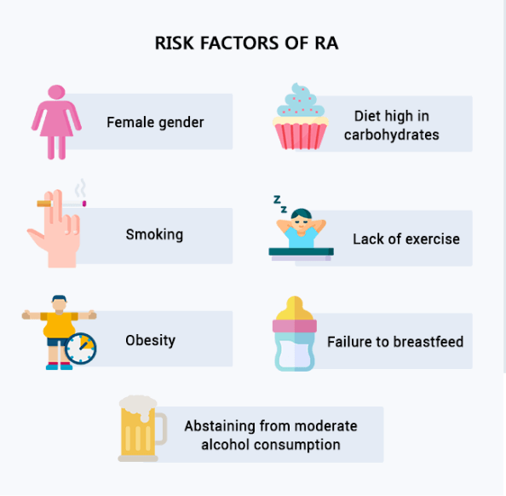

Figure 3: Risk Factors of RA
- Cigarette smoking is the best-established environmental risk factor of rheumatoid arthritis (RA) especially seropositive disease, as evidence shows that it can be linearly related and conjunctly interact with genetic susceptibility (Ishikawa and Terao, 2020; Maisha, El-Gabalawy and O’Neil, 2023).
- Genetic markers, particularly HLA-DRB1 shared epitope alleles, tremendously predispose, with the actual cause being very strong heritable; but the cases of genetics do not relate to the development of the disease, which is multifactorial (Venetsanopoulou et al., 2022; Finckh et al., 2022).
- The incrimination of environmental exposures (such as occupational inhalants and air pollution) has been heterogeneous across studies, which is methodologically incongruent (Venetsanopoulou et al., 2023; Uke, Maharaj and Adebajo, 2025).
- Obesity is progressively being identified as one of the systematic risks that have been linked to systemic inflammation and dysregulation of immunity although the causal mechanisms are currently under study (Maisha, El-Gabalawy and O’Neil, 2023).
- Smoking and other exposures could induce citrullination of proteins and destruction of immune tolerance to induce the formation of autoantibodies among the genetically predisposed people (Ishikawa and Terao, 2020; Firestein et al., 2024).
- Although the influence of sex and genetic background on Type 2 Diabetes cannot be mitigated, there is a preventive potential in the population health approaches that focus on smoking cessation and weight management; however, the translation of the epidemiologic associations into the practical prevention approach remains complicated because of the complicated interactions between genes and the environment determinants (Finckh et al., 2022; Maisha, El-Gabalawy and O’Neil, 2023).

4. Physical, Psychological & Social Impact
Physical Impact
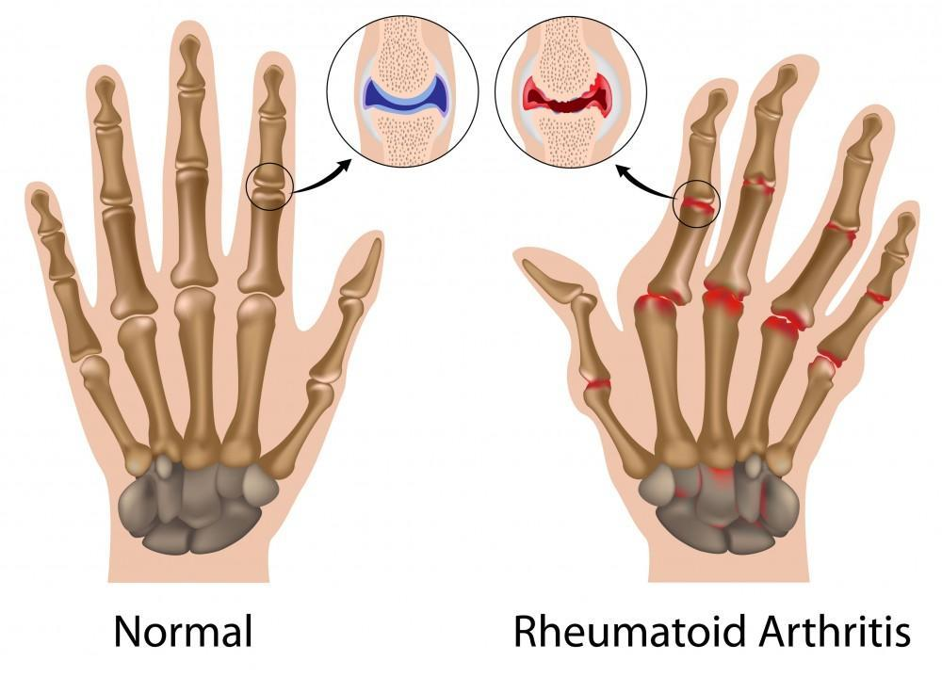

Figure 4: Physical Impact
- Rheumatoid arthritis (RA) is characterized by chronic inflammatory pain, accompanied by morning stiffness and continuous joint swelling, which are relevant factors in the development of a cumulative change in the structure and loss of mobility (Firestein et al., 2024; Hochberg et al., 2022).
- Fatigue is also commonly reported as one of the most disabling symptoms, but it is poorly considered in standard clinical examination even though it is strongly coupled with disease activity and psychiatric distress (Lwin et al., 2020; Zeng et al., 2025).
- This can cause the erosion of progressive joints leading to the deformity of the hands and feet, which impedes motor ability and independence in performing the activities of daily living (Scott et al., 2020; Klingemann, Mikuls and England, 2026).
- Also, cardiovascular disease and pulmonary complications are critical comorbidities of RA that adds the morbidity and adds to the risk of excess mortality (Zeng et al., 2025; Black et al., 2023).
- Long-term disability is often caused by functional impairment, and it becomes more evident when the diagnosis or first-best treatment is not implemented in time, which explains the need to intervene at an early stage (Versus Arthritis, 2024; NICE, 2018).
Psychological Impact
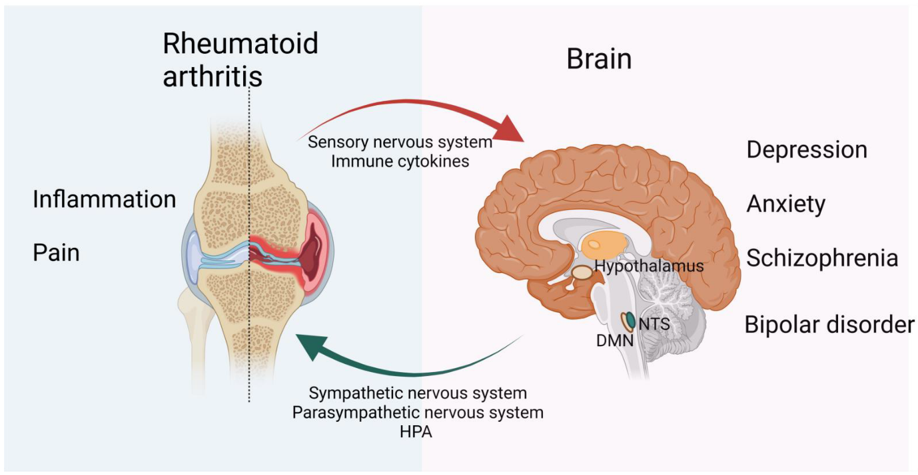

Figure 5: Psychological Impact of Rheumatoid arthritis
- The prevalence of depression in patients with RA is very high, and it was also demonstrated that there are bidirectional correlations between mood disturbance and inflammatory activity (Alwhaibi, 2025; Lwin et al., 2020).
- The symptoms of anxiety are also typical and can be enhanced by the uncertainty of exacerbations and fears regarding the development of the disease (Castro Teixeira, Rocha Castelar-Pinheiro and Rodrigues, 2025).
- Vision deformities of joints can change self-esteem and social confidence, which can be of concern in younger patients (Chen et al., 2026).
- The new research reports self-disgust and negative self-perception as mental attributes associated with worse quality of life and the amplified depressive symptoms (Chen et al., 2026).
- Psychological distress can have a negative impact on medication adherence and involvement with self-management, implying the lack of integrated mental support in rheumatology care (Lwin et al., 2020; Alwhaibi, 2025).
Social Impact
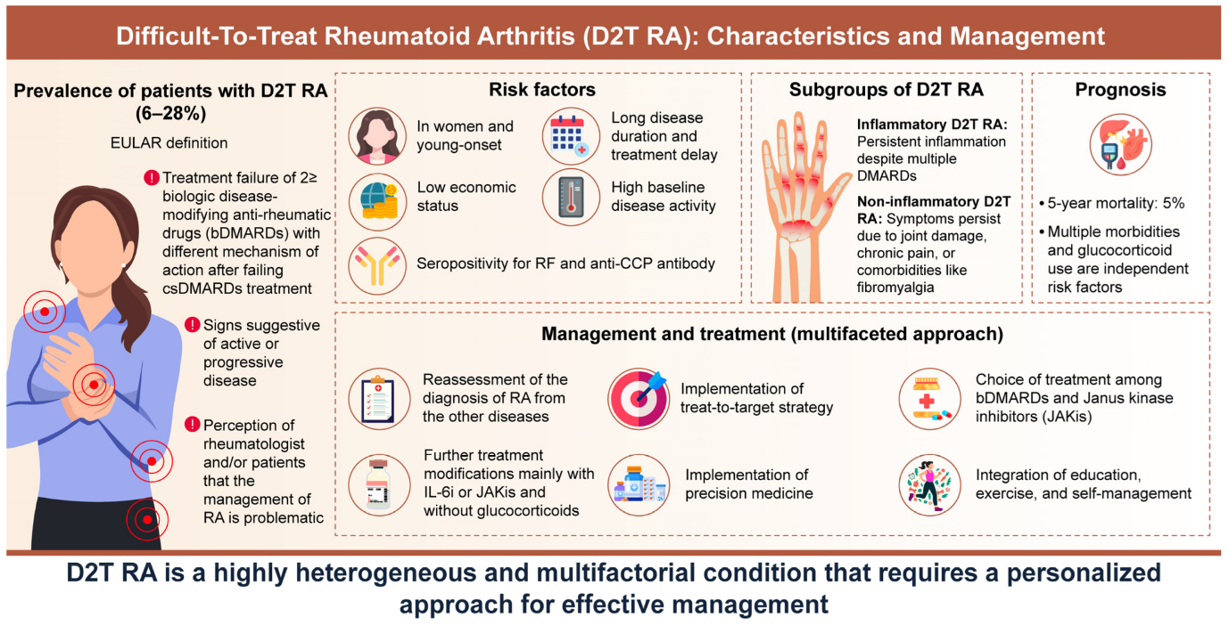

Figure 6: Social Impact of Rheumatoid arthritis
- RA is a significant cause of work disability and worse productivity, with a higher-than-average impact on working women ( Versus Arthritis, 2024; Uke, Maharaj and Adebajo, 2025).
- The isolation may be attributable to social seclusion due to chronic pain, exhaustion, and loss of movement that may be accompanied by lack of engagement in social and recreational activities (Coyle, Kuit and Dunne, 2025).
- Healthcare expenses, loss of work and the use of social support structures result in financial strain (Finckh et al., 2022; Versus Arthritis, 2024).
- Parents, relatives, and friends often face both emotional and practical difficulties of looking after the persons with variable disease activity (Coyle, Kuit and Dunne, 2025).
- The overall quality of life is greatly reduced, especially in situations when the psychosocial needs are not addressed, highlighting the disparity in access to the holistic and multidisciplinary care (Alwhaibi, 2025; Barber et al., 2021).

5. Evidence-Based Management in the UK
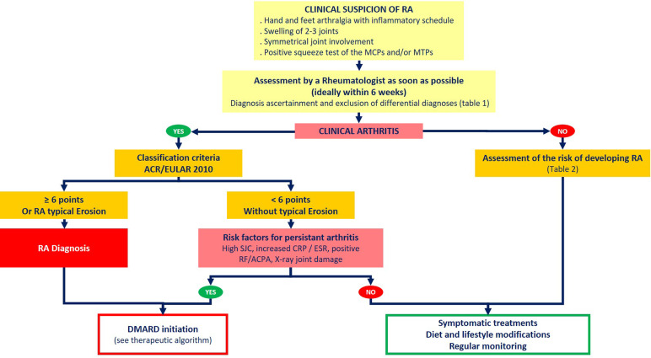

Figure 7: Evidence-Based Management in the UK
- The UK management strategies are fundamentally based on timely referral to special rheumatology services, where NICE suggests that prompt assessment and treatment should be started to avoid a damage of the joints that could not be rescued (NICE, 2018; NHS UK, 2026).
- Traditional synthetic disease-modifying anti-rheumatic medications (DMARDs), especially methotrexate, continue to be the first-line intervention and have substantial evidence to support their reduction of the disease activity and the slowing radiographic progression (NICE, 2018; Conley et al., 2023).
- In patients who fail to respond adequately, biologic therapy using tumour necrosis factor and other cytokines has increased the remission rates significantly though it is very expensive urging the need to have structured eligibility criteria as part of NHS commissioning systems (Conley et al., 2023; Seyferth et al., 2022).
- Janus kinase (JAK) inhibitors are an oral targeted treatment with the same efficacy as biologics, but with emerging safety risks of cardiovascular and thrombotic risk, patient selection and follow-up measures should be considered (Conley et al., 2023; Xie et al., 2025).
- Corticosteroids in many cases treat acute inflammation, but cases of prolonged intake are discouraged because of their metabolic and cardiovascular side effects (NICE, 2018; Firestein et al., 2024).
- Extensive interdisciplinary care comprising of rheumatologists, specialist nurses, physiotherapists and occupational therapists is a best practice approach and compliant with patient-centred quality frameworks (Barber et al., 2021; Inchingolo et al., 2024).
- Primary care is significant in diagnosing comorbidity and persistent follow-up, but the difference in skills could also be a factor in delayed diagnosis (Inchingolo et al., 2024; NHS UK, 2026).
- Models developed by patients to improve the follow-up have been suggested to improve efficiency and empowerment, but their effectiveness relies on effective education and safety-netting strategies (Ester et al., 2025).
- Nonetheless, heterogeneity of response manifested as a subgroup of patients acquiring difficult-to-treat RA shows the limitations of the treatment algorithms in use nowadays (Xie et al., 2025).
- In general, although evidence-based, there are still difficulties with cost-effectiveness, mismatches in access to services regionally, and the difficulty in monitoring posed by complex pharmacotherapy in UK management (Seyferth et al., 2022; Conley et al., 2023).

6. Theoretical Models
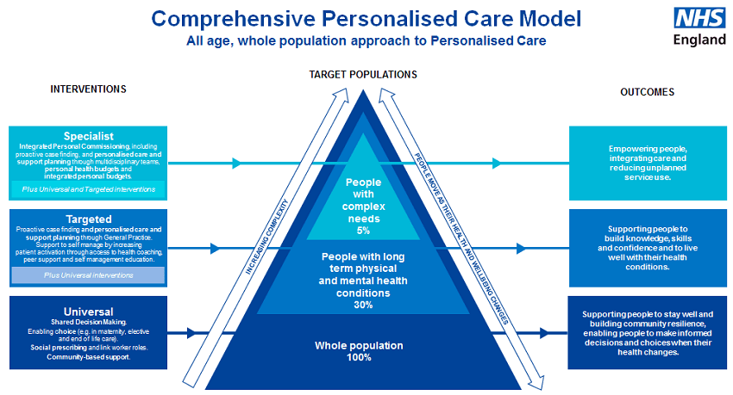

Figure 8: NHS Personalised Care Model
- In the UK, NHS Personalised Care Model is based on shared decision-making, self-management with coordinated multidisciplinary input, which are not only beneficial but also aligned with the long-term and unpredictable progression of rheumatoid arthritis (RA) (NHS UK, 2026; Barber et al., 2021).
- Patient-centred quality measurement models also facilitate the tracking of patient relevant outcomes, such as functional capability and quality of life, in addition to only biomedical outcome measures (Barber et al., 2021; Landgren et al., 2021).
- The Chronic Care Model is an internationally promoted approach that emphasizes proactive, premeditated care with the involvement of educated patients and ready medical personnel that focuses more on integrating systems at the level and monitoring chronic illnesses continuously (Conley et al., 2023).
- The integrated care models also emphasize alignment of primary and specialist care and seek to achieve fewer instances of fragmentation and enhance long-term results (Inchingolo et al., 2024).
- The advantages of these models are that they focus on multidisciplinary collaboration and patient empowerment that is essential in handling the biopsychosocial complexity of RA (Landgren et al., 2021).
- Nevertheless, the problem of implementation still exists, namely the shortage of workforce in rheumatology, the limited capacity and inconsistent adoption in different regions, potentially exacerbating inequalities (Versus Arthritis, 2024; Inchingolo et al., 2024).
- Despite policy frameworks being the drivers of holistic and person-centred methods, there are still gaps between the strategic intent and the practice on the daily practice and that which concerns constant availability of psychological and self-management support to the topic of people with RA.

7. Policy & Political Context
- The NHS Long Term Plan focuses on the better outcomes of individuals with long-term conditions achieved through the earlier diagnosis, personalised care and enhanced community-based services so that it offers a strategic framework applicable to transitioning rheumatoid arthritis (RA) management (NHS UK, 2026; Versus Arthritis, 2024).
- RA diagnosis, pharmacological treatment, and continuous monitoring are the areas provided by NICE guidance (NG100), to reduce the variability of care and achieve timely disease-modifying therapy commencement (NICE, 2018; Conley et al., 2023).
- Integrated Care Systems (ICS) aim to improve interaction between primary, secondary and community services, which theoretically allows continuing care around the inflammatory complexity (Inchingolo et al., 2024).
- Nevertheless, problems with workforce in rheumatology such as the shortage of specialist nurses and the capacity of the consultants, are the major obstacles on their way to meet the early referral targets and continued monitoring (Versus Arthritis, 2024).
- Financial ramifications of the NHS also affect commissioning of high-cost biologic and targeted therapies, which make regions more varied in the access despite national guidelines (Seyferth et al., 2022; Conley et al., 2023).
- After the policy hopes of early intervention, some areas still have a problem with rheumatology waiting times, which may complicate early diagnosis and increase long-term disability (Versus Arthritis, 2024).
- In turn, although policy frameworks support equitable and high-quality RA care, ongoing inequity of service and variation in access undermine the desirability of national standards and practice.

8. Recommendations
- Early diagnosis pathways should be strengthened by better awareness of primary care and rapid referral systems as delay in treatment is associated with worse functional outcomes and greater long-term disability (NICE, 2018; Versus Arthritis, 2024).
- Routine psychological screening should be incorporated into rheumatological services, as there is a significant rate of depression and its consequences in adherence and quality of life (Alwhaibi, 2025; Lwin et al, 2020).
- Structured self-management programmes and patient education programmes should be scaled up to preserve empowerment and sustain control over the disease (Landgren et al., 2021; Ester et al., 2025).
- Digital monitoring tools and patient-initiated follow-up models will potentially increase efficiency and responsiveness, if robust safety mechanisms are in place (Ester et al., 2025).
- Efforts to reduce regional inequalities in biologic access are necessary in order to ensure equitable implementation of EBTs (Seyferth et al., 2022; Conley et al., 2023).
- More recognition and specific management of fatigue should be an integral part of routine care pathways (Lwin et al., 2020).
- The further strengthening of coordinated multidisciplinary care within Integrated Care Systems would reduce the policy gap further to the complex biopsychosocial needs of people living with RA (Inchingolo et al., 2024).

Summary
Rheumatoid arthritis is a major UK and global public health issue, which is a leading cause of persistent morbidity, limitations in functional status, and excessive healthcare use (Black et al., 2023; Versus Arthritis, 2024). RA is a chronic autoimmune disease progressive in its formation marked by joint destruction and systemic complications and must be monitored and interventional (NIAMS, 2026; Firestein et al., 2024).
In addition to its physical appearance, RA has complicated psychological and social impacts that affect adherence, long-term and quality of life (Shlotzhauer, 2024, Alwhaibi, 2025). Despite the NICE guidelines and developed pharmacological treatment, the disparity in access and service availability has persisted as inequities related to the disease (NICE, 2018; ACR, 2025).
The next step will be to ensure that early diagnosis is enhanced, accompanied by providing mental health support and a fair access to evidence-based interventions within a person-centred and multidisciplinary setting.

References
ACR, 2025. Rheumatoid Arthritis. Available at: https://rheumatology.org/patients/rheumatoid-arthritis (Accessed: February 2026).
Alwhaibi, M., 2025. Depression, Anxiety, and Health-Related Quality of Life in Adults with Rheumatoid Arthritis: Findings from a National Survey. Journal of Clinical Medicine, 14(22), p.7940. Available at: https://www.mdpi.com/2077-0383/14/22/7940
Barber, C.E., Then, K.L., Bohm, V., Hall, M., Marshall, D.A., Rankin, J.A., Barnabe, C., Hazlewood, G.S., Li, L.C., Mosher, D. and Homik, J., 2021. Development of a patient-centered quality measurement framework for measuring, monitoring, and optimizing rheumatoid arthritis care in Canada. The Journal of Rheumatology, 48(3), pp.326-334. Available at: https://doi.org/10.3899/jrheum.200688
Black, R.J., Cross, M., Haile, L.M., Culbreth, G.T., Steinmetz, J.D., Hagins, H., Kopec, J.A., Brooks, P.M., Woolf, A.D., Ong, K.L. and Kopansky-Giles, D.R., 2023. Global, regional, and national burden of rheumatoid arthritis, 1990–2020, and projections to 2050: a systematic analysis of the Global Burden of Disease Study 2021. The Lancet Rheumatology, 5(10), pp.e594-e610. Available at: https://doi.org/10.1016/S2665-9913(23)00211-4
Castro Teixeira, S., da Rocha Castelar-Pinheiro, G. and de Carvalho Rodrigues, J., 2025. The relation between clinical characteristics and mental health in patients with rheumatoid arthritis. Scientific Reports, 15(1), p.38424. Available at: https://www.nature.com/articles/s41598-025-22155-3.pdf
Chen, C., Liu, X., Chen, C., Lu, Y., Xue, S., Wen, L. and Yang, X., 2026. Depression and Quality of Life in Patients with Rheumatoid Arthritis: The Impact of Self-Disgust. Journal of Multidisciplinary Healthcare, 19(0), p.12475806. https://www.tandfonline.com/doi/pdf/10.2147/JMDH.S578454
Conley, B., Bunzli, S., Bullen, J., O’Brien, P., Persaud, J., Gunatillake, T., Nikpour, M., Grainger, R., Barnabe, C. and Lin, I., 2023. What are the core recommendations for rheumatoid arthritis care? Systematic review of clinical practice guidelines. Clinical rheumatology, 42(9), pp.2267-2278. Available at: https://link.springer.com/content/pdf/10.1007/s10067-023-06654-0.pdf
Coyle, N., Kuit, S. and Dunne, S., 2025. Investigating the association between social support and quality of life in people with rheumatoid arthritis: A systematic review of the literature. International Journal of Rheumatic Diseases, 28(5), p.e70234. https://onlinelibrary.wiley.com/doi/pdf/10.1111/1756-185X.70234
Ester, M., White, K., Dhiman, K., Zafar, S., Subdar, S., Zimmermann, G.L., Hoens, A.M., Manske, S.L., Hazlewood, G., Lacaille, D. and Barber, M.R., 2025. A theory of change for patient-initiated follow-up care in rheumatoid arthritis. BMC rheumatology, 9(1), p.31. Available at: https://link.springer.com/content/pdf/10.1186/s41927-025-00481-3.pdf
Finckh, A., Gilbert, B., Hodkinson, B., Bae, S.C., Thomas, R., Deane, K.D., Alpizar-Rodriguez, D. and Lauper, K., 2022. Global epidemiology of rheumatoid arthritis. Nature Reviews Rheumatology, 18(10), pp.591-602. Available at: https://www.nature.com/articles/s41584-022-00827-y
Firestein, G.S., McInnes, I.B., Koretzky, G., Mikuls, T., Neogi, T. and O'Dell, J.R. eds., 2024. Firestein & Kelley's textbook of rheumatology-E-book. Elsevier Health Sciences.
Hochberg, M.C., Gravallese, E.M., Smolen, J.S., Van der Heijde, D., Weinblatt, M.E. and Weisman, M.H. eds., 2022. Rheumatology E-Book. Elsevier Health Sciences.
Inchingolo, F., Inchingolo, A.M., Fatone, M.C., Avantario, P., Del Vecchio, G., Pezzolla, C., Mancini, A., Galante, F., Palermo, A., Inchingolo, A.D. and Dipalma, G., 2024. Management of rheumatoid arthritis in primary care: a scoping review. International Journal of Environmental Research and Public Health, 21(6), p.662. Available at: https://www.mdpi.com/1660-4601/21/6/662
Ishikawa, Y. and Terao, C., 2020. The impact of cigarette smoking on risk of rheumatoid arthritis: a narrative review. Cells, 9(2), p.475. Available at: https://www.mdpi.com/2073-4409/9/2/475
Klingemann, L.E., Mikuls, T.R. and England, B.R., 2026. Epidemiology and outcomes of rheumatoid arthritis. Current Opinion in Rheumatology, 38(2), pp.69-75. Available at: https://doi.org/10.1097/BOR.0000000000001142
Landgren, E., Bremander, A., Lindqvist, E., Nylander, M. and Larsson, I., 2021. Patients’ Perceptions of Person‐Centered Care in Early Rheumatoid Arthritis: A Qualitative Study. ACR open rheumatology, 3(11), pp.788-795. Available at: https://acrjournals.onlinelibrary.wiley.com/doi/full/10.1002/acr2.11326
Lwin, M.N., Serhal, L., Holroyd, C. and Edwards, C.J., 2020. Rheumatoid arthritis: the impact of mental health on disease: a narrative review. Rheumatology and therapy, 7(3), pp.457-471. Available at: https://link.springer.com/content/pdf/10.1007/s40744-020-00217-4.pdf
Maisha, J.A., El-Gabalawy, H.S. and O’Neil, L.J., 2023. Modifiable risk factors linked to the development of rheumatoid arthritis: evidence, immunological mechanisms and prevention. Frontiers in immunology, 14, p.1221125. Available at: https://www.frontiersin.org/journals/immunology/articles/10.3389/fimmu.2023.1221125/full
NHS UK, 2026. Rheumatoid arthritis - Treatment. Available at: https://www.nhs.uk/conditions/rheumatoid-arthritis/treatment/ (Accessed: February 2026).
NIAMS, 2026. Rheumatoid Arthritis. Available at: https://www.niams.nih.gov/health-topics/rheumatoid-arthritis (Accessed: February 2026).
NICE, 2018, 2020. Rheumatoid arthritis in adults: management [NG100]. Available at: https://www.nice.org.uk/guidance/ng100 (Accessed: February 2026).
Scott, D.L., Galloway, J., Cope, A., Pratt, A. and Strand, V. eds., 2020. Oxford textbook of rheumatoid arthritis. Oxford University Press.
Seyferth, A.V., Cichocki, M.N., Wang, C.W., Huang, Y.J., Huang, Y.W., Chen, J.S., Kuo, C.F. and Chung, K.C., 2022. Factors associated with quality care among adults with rheumatoid arthritis. JAMA Network Open, 5(12), p.e2246299. Available at: https://jamanetwork.com/journals/jamanetworkopen/articlepdf/2799374/seyferth_2022_oi_221306_1672259534.17309.pdf
Shlotzhauer, T.L., 2024. Living with rheumatoid arthritis. JHU Press.
Uke, P., Maharaj, A. and Adebajo, A., 2025. A review on the epidemiology of rheumatoid arthritis: An update and trends from current literature. Best Practice & Research Clinical Rheumatology, 39(1), p.102036. Available at: https://www.sciencedirect.com/science/article/pii/S152169422500004X
Venetsanopoulou, A.I., Alamanos, Y., Voulgari, P.V. and Drosos, A.A., 2023. Epidemiology and risk factors for rheumatoid arthritis development. Mediterranean Journal of Rheumatology, 34(4), p.404. Available at: https://pmc.ncbi.nlm.nih.gov/articles/PMC10815538/pdf/MJR-34-4-404.pdf
Venetsanopoulou, A.I., Alamanos, Y., Voulgari, P.V. and Drosos, A.A., 2022. Epidemiology of rheumatoid arthritis: genetic and environmental influences. Expert review of clinical immunology, 18(9), pp.923-931. https://www.tandfonline.com/doi/abs/10.1080/1744666X.2022.2106970
Versus Arthritis, 2024. The State of Musculoskeletal Health 2024. Available at: https://www.versusarthritis.org/about-arthritis/data-and-statistics/the-state-of-musculoskeletal-health/ (Accessed: February 2026).
Xie, W., Chen, T., Xiao, S., Huang, H. and Zhang, Z., 2025. Difficult-to-treat rheumatoid arthritis (part 1): systematic review and meta-analysis on global prevalence. Annals of the Rheumatic Diseases. https://www.sciencedirect.com/science/article/abs/pii/S0003496725044383
Zeng, H., Yuan, Z., Wu, R.T. and Huang, Z., 2025. Research progress on complications of rheumatoid arthritis. Frontiers in immunology, 16, p.1561926. Available at: https://www.frontiersin.org/journals/immunology/articles/10.3389/fimmu.2025.1561926/pdf

