
Energy Crisis
[Document subtitle]

December 9, 2022
LUCIANA FLOREA
2126969

Contents
1.0 Introduction 2
2.0 Main Findings 3
2.1 Nature, Scope and Impact 3
2.2 SWOT Analysis 3
2.3 PESTLE Analysis 3
3.0 Conclusion 4
4.0 Recommendations 5
5.0 Planning, Monitoring and Reviewing the Solution 6
6.0 Appendices 7
7.0 Reference List 8

Introduction

Everything is driven by energy. It has become vital to the way we live now. Its power moves our cars and illuminates our environment. Think about the last time you went five minutes without electricity or your mobile phone; you quickly realise just how crucial it is to us daily.

There is a big hole in the national budget. There is now insufficient energy production from both native and foreign sources combined. There has been an impact on residential, commercial, and industrial users of energy due to the shortage. To find the underlying cause of the issue, the question of why such a massive deficit has been allowed to occur and what choices the government has in order to handle the crisis.

Main Findings

Nature, Scope and Impact

The Russo-Ukrainian War
Even though the war in Ukraine is not about energy, it has made an already unstable situation even worse. After the lockdown, there was more demand for energy than supply, which caused prices to go up. Changes were made to the way the energy trade worked. Even though Russia invaded Ukraine on February 24, they kept sending gas and oil through pipelines that go through Ukraine. Only in June were physical gas supplies cut off. This is because Russia will not sell gas to countries like Poland and Bulgaria that will not pay in their currency or that want to join NATO. All these times, the supplies cut supplies were easy to replace. On July 11, however, Russia shuts down the important Nord Stream 1 pipeline.
The UK is especially vulnerable to the energy crisis because it relies on gas to heat and power its homes and because its buildings are not well insulated. About 80% of homes in the UK use gas boilers to heat their homes, and about 40% of the country's electricity comes from power plants that run on gas. In the current situation, there are limits to how much higher costs can be passed on to customers, which means businesses could go out of business. After predictions that annual household bills would go up, the government said it would provide financial support for households and businesses.

SWOT Analysis
A SWOT analysis of the power industry provides a breakdown of the strengths, weaknesses, opportunities, and threats facing the industry.
Strengths
Renewable energy plays a significant role in every country of the world. The development of renewable energy sources is tied to the growth of technology and the reduction of greenhouse gas (GHG) emissions. It also helps create new jobs.
Weaknesses
A high demand for energy, a low level of development, a lack of fuel transport infrastructure, total reliance from outside sources, and obligations in the field of environmental protection, including climate protection, mean that decisive steps need to be taken to keep things from getting worse for fuel and energy consumers.
Opportunities
- International trade
- Flexible contracts
- Global market
Threats
A SWOT analysis of the threats to the power industry finds things outside of the industry that could stop it from growing. These are examples of things that are out of the industry's control. For instance, the power industry may face problems like more rules about emissions and climate change.

PESTLE Analysis
(Yüksel, 2012) says that a PESTLE analysis is a basic requirement for strategic management analysis. The PESTLE analysis will be applied to figure out how the energy sector is affected by external factors. Political, Economic, Social, Technological, Legal, and Environmental is what PESTLE stands for. It gives a big picture view of the energy sector's environment.
Political factors
- UK's main suppliers are from outside the country. Their business relationship was affected by the war and by competition from nearby countries.
- Support from the government for the switch to renewable energy
- Governmental flexibility to global trade
Economic factors
The crisis has already influenced the world's financial markets and could have an effect on how much people spend all over the world. At first glance, this seems like an overreaction, but banks all over the world have to deal with US debt.
Social factors
The economy of a country can be affected by changes in consumer demographics. The number of people who work in a country affects how much energy that country uses (Hasanov and Mikayilov, 2017).

Technological factors
In this part of the PESTLE analysis, the social external factors show that the industry environment has room for technological innovation. For example, the increase in demand caused by this external factor helps the operating segment for Renewable Energy. This external analysis also shows that the growing use of mobile technologies is a macro-environmental factor that creates business opportunities, such as in technological innovation.

Legal factors
This factor looks at the laws in a country that have a direct effect on a certain business. It could include laws about renewable energy and health and safety. When such laws are in place, investors know that there are legal systems in place to protect their investments (Agyekum, 2020).

Environmental factors
This PESTEL/PESTLE analysis shows that limited reserves are a factor in the macroenvironment. This threat forces economies to look for other ways to make money. As a result, it makes it easier for businesses to grow in the Renewable Energy segment.

3.0 Conclusion
The UK is facing its worst energy crisis in a generation, just like most of Europe.
Energy costs have reached all-time highs due to a mix of domestic and international factors. Oil and gas companies have made a lot of money because of this, but people who use energy are bracing for the hardest winter they have ever had.
Families are already having a challenging time because of inflation and the rising cost of living. This huge rise in energy prices is expected to put millions of people in poverty.
Businesses all over the country are under even more pressure because there is no price cap on commercial energy tariffs. Business owners have said that their energy costs have tripled in the past few months. Because of this, there is a lot of worry that thousands of businesses could be forced to close because they cannot keep up with the higher costs of running them.
The response of the government to the energy crisis
In response to the climate emergency, the UK became the first major economy to promise to have net-zero greenhouse gas emissions by 2050. These changes could also save a lot of money and make people more comfortable and productive. One of the main things that slows down progress toward reducing energy use is the fact that people do not understand how energy is used.

4.0 Recommendations

Benchmarking is often used to measure how well buildings use energy. Benchmarking makes people more aware of how much energy is being used and shows it to the the public. This gives people a reason to improve operational efficiency. Figuring out and recognising a building's energy efficiency makes it possible for building owners to make changes. So, benchmarking is a particularly important step in reducing the amount of energy use.

5.0 Planning, Monitoring and Reviewing the Solution
Decision implemented:

- to increase user understanding for rational use
- because energy customers are in for hard times, there is a real desire for transformational change from the public.

Monitoring the decision:
Resources:
One idea would be to stop gas prices from being tied to electricity prices. All electricity prices have gone up because of the fast rise in wholesale gas prices, even for those who get their power from renewable sources. By changing the way the energy market works, renewable energy providers would be able to offer electricity rates that are much lower than fossil fuel providers. In turn, we would expect customers to move toward companies that offer cheaper renewable energy rates. This would strengthen their market position and allow them to invest more in more renewable energy generation.

Key Indicators:
- attitudes towards and support for renewable energy
- training in development
- entrepreneurial spirit and border nature of the society

Targets:
- supporting vulnerable energy customers through the energy crisis (energy bill financial support, uprating benefits)
- improve energy efficiency (putting in place stricter minimum standards for energy efficiency for its users)

Data Sources:
The key factor is the start of new biofuel production companies, or the extension of current production lines, for the development of the biofuel industry in terms of its market size with respect to other fuels.

Reviewing the decision:
(Write here how you will evaluate/review the problem. What questions will you ask? Etc)

Energy poverty is a problem in the poorer half of the world. When people do not have access to modern energy sources for cooking and heating, they use solid fuels like firewood, dung, and crop waste. Using wood as a source of energy also hurts the environment. Lastly, people are forced to live in poverty because they cannot get energy. Without electricity, you cannot keep food cold, wash clothes or dishes, or see at night.
The second problem with energy is that those who have access to it put out too much greenhouse gas.
Even the poorest people in richer countries, where energy poverty is rare, use more energy than people in poorer countries. The source and price of energy are key to making progress on both fronts. People who live in energy poverty cannot afford enough energy, and those who have gotten out of the worst poverty depend on fossil fuels to meet their energy needs. When we look at it this way, the two problems with energy are really just two sides of one big problem. We do not have any cheap, safe, and long-lasting alternatives to fossil fuels that can be used on a large scale.

6.0 Appendices
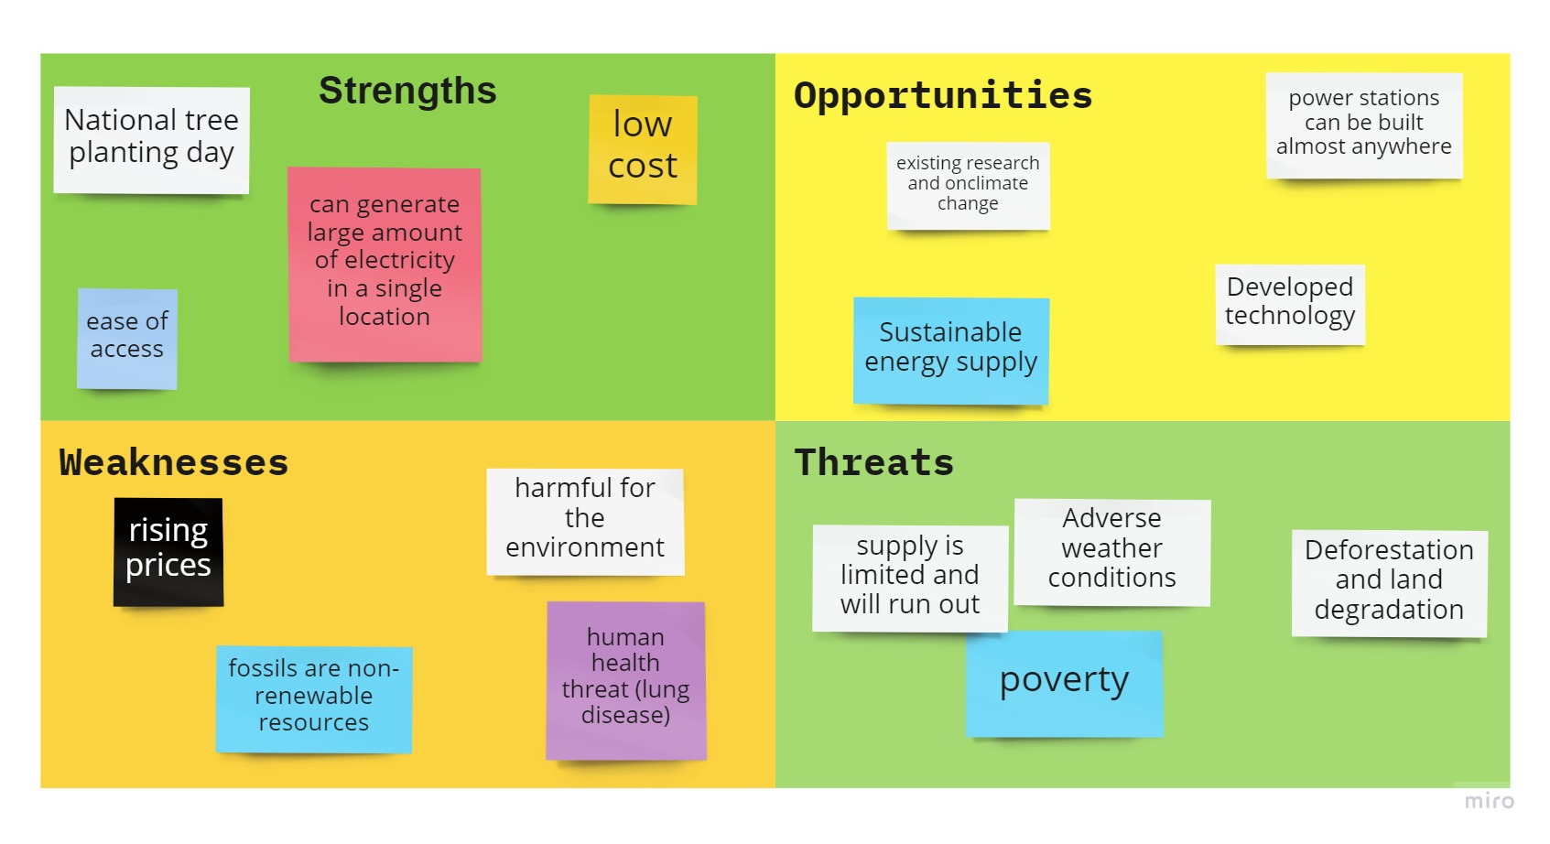

7.0 Reference List
ACHINAS, S., HORJUS, J., ACHINAS, V. and GERRIT JAN, W.E., 2019. A PESTLE Analysis of Biofuels Energy Industry in Europe. Sustainability, 11(21), pp. 5981.
Agyekum, E.B., 2020. Energy poverty in energy rich Ghana: A SWOT analytical approach for the development of Ghana’s renewable energy. Sustainable Energy Technologies and Assessments, 40, p.100760.
COYLE, E. D., & SIMMONS, R. A. (Eds.). (2014). Introduction. In Understanding the Global Energy Crisis (pp. 1–8). Purdue University Press.
Energy crisis (2022) National Energy Action (NEA). Available at: https://www.nea.org.uk/energy-crisis/ (Accessed: December 9, 2022).
Hasanov, F.J. and Mikayilov, J.I., 2017. The impact of age groups on consumption of residential electricity in Azerbaijan. Communist and Post-Communist Studies, 50(4), pp.339-351.
Kissinger, D. (2017) General Electric (GE) Pestel/Pestle Analysis & Recommendations, Panmore Institute. Available at: https://panmore.com/general-electric-ge-pestel-pestle-analysis-recommendations (Accessed: December 9, 2022).
Mohamed, S. et al. (2021) ‘The correlation of energy performance and building age in UK schools’, Journal of Building Engineering, 43, p. 103141
Morris, M.I.R. and Hicks, A.L. (2021) A human-centered review of life cycle assessments of bioplastics - the International Journal of Life Cycle Assessment, SpringerLink. Springer Berlin Heidelberg. Available at: https://link.springer.com/article/10.1007/s11367-021-02001-0 (Accessed: December 9, 2022).
The impact of the Ukraine War on Global Energy Markets (no date) Centre for European Reform. Available at: https://www.cer.eu/insights/impact-ukraine-war-global-energy-markets (Accessed: December 9, 2022).
Yüksel, I., 2012. Developing a multi-criteria decision-making model for PESTEL analysis. International Journal of Business and Management, 7(24), p.52.

