Analysing the Effectiveness of Technology on Improving Physical Health

Name: Kai Harley Strand-Regan

Module Code: ACCA5004

University of Wales Trinity Saint David – Swansea

Tutor: John Rees

Date Submitted: 14th of May 2020

Contents
Abstract 3
Background 4
Evidence 4
Field of Work 5
Justification 5
Overarching Aim 6
The Sub Goals 6
Research Objectives 6
The Approach 8
Anticipated Problems 8
The Implementation 9
Strategy 9
Design Target 9
Concepts 10
Good Practices? 11
Software Required 11
Privacy 12
Outcomes 12
What is the production Aim? 12
What will the Outcome Be? 12
What will be Demonstrated? 12
Project Plan 13
Conclusion 13
Bibliography 14

Abstract
The report introduces the project proposal, along with background research to support the project, the aim of the project and how it will be implemented.

Introduction
The project proposal will examine whether technology can be used to increase physical health. The experiment will use test subjects to see if the use of a website/app (created by the author) is able to help improve their physical health. This report will detail what the website will contain, the aim of the experiment, how this will be implemented, and what the expected outcome is.

Background
The background section of this report will look at what evidence and services are available to support the claim of the project.

Evidence
The first study [1], looks at the role in which technology has been utilized as an exercise motivation tool and what aspects should be implemented into the proposed project .
From the internet to video games, technology can provide information such as online forums, GPS tracking and gamification. “Gamification is a technique where designers insert gameplay elements in non-gaming settings so as to enhance user engagement with a product or service.” [1] Which, has been proven to increase user engagement. An estimated “50% of organisations will gamify aspects of their business by 2015” [2]. This was written in 2014 and as of 2018, the gamification market has “a global value of $6.8 billion” [3]. This can be applied to the project idea as it is clear that implementing a gamification aspect will increase the user engagement.
Examples of this can be found in exercise apps such as Strava [4] which is a GPS app that can track your running or biking progress. Additionally, they provide a statistical breakdown of a run/bike ride which can be used as a guide to help improve the exercise. They offer a basic form of gamification with their user created challenges which people can join.
Gamification and other persuasive systems are an important tool for changing people’s behaviour. The graphic below is examples of gamification and persuasive systems which have been used to increase someone’s health and wellness goals.
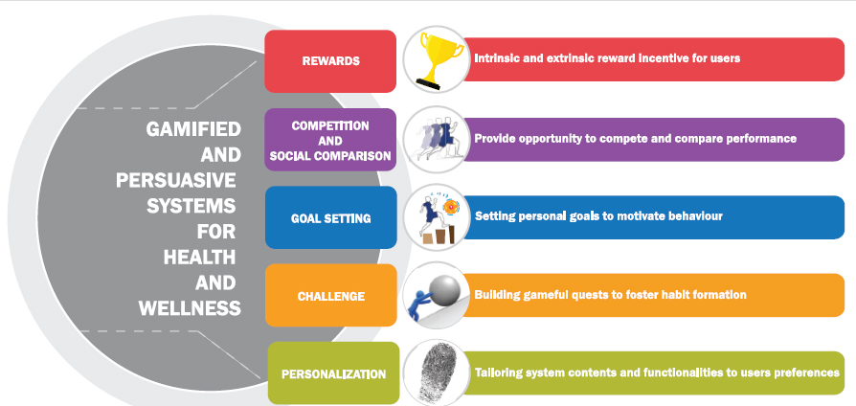
Figure 1 https://dl.acm.org/cms/attachment/d8ff11d2-4c04-4c9f-a3d7-5059b7b17b03/f1.html

The main conclusion from this study is that the decision to change is very much determined by relying on the person’s “intrinsic motivation to aspire for a better quality of life [5]”. However, these methods do show that they can “facilitate positive health behaviour and health outcomes.” [5]
Another important takeaway is that it Is possible an “over dependency” [5] on the challenges may cause the users to not push themselves outside of the set challenges which, is why it will be important to make them fresh along with focusing on self-improvement so that the users do not become reliant [5]”.
The next study titled “Measuring and Influencing Physical Activity with Smartphone Technology” was published in 2014 and concluded that one of the limitations of this experiment is that it is a “relatively new field of study” [6]. Six years later and it is still not easy to find clear studies that have been able to successfully prove the effectiveness of technology. However, from the studies found it is clear that if the accessibility is there, then the results point in a positive direction for the use of technology.

Field of Work
Physical health through technology will be the focus of this project, which will incorporate web design, statistics and physical health. It will be important that the data gathered can be presented accurately and fairly. To do this the website and therefore the contents must meet several requirements which will be detailed in the report.
Given that the website looks to provide users with all the needed tools to improve a person’s physical health, it will have to be a dynamic website, which can be accessed on both mobiles and desktops.
There will be a balanced focus between the website creation and the statistical analysis as these represent the two pillars of the project. The website must contain all the areas which the users need to make sure that it is not the quality of the software, which is holding back the impact of the technology. The website requirements will be detailed in a later section.

Justification
This section looks to explain why the chosen topic area is relevant and therefore the reason it has been chosen.
From an observational view, people on average are not reaching a healthy lifestyle which is decreasing their life span along with restricting them from important life experiences such as travelling, taking part in activities and there mental wellbeing.
First, looking at the impact on life expectancy, “the relative risk of death is approximately 20% to 35% lower in physically active and fit persons” when compared to an unfit person [7] [8]. This shows the importance of physical health from a survival point of view and proves that being healthy physically has a direct impact.

Second, the impact on being able to take part in activities, it has been shown that the “Level of physical activity was shown to be positively associated with general well-being, lower levels of anxiety and depression, and positive mood.” [9] in a secondary analysis of four surveys, it is a reasonable assumption therefore that the less healthy someone is physically could lead to them becoming depressed.
While this also applies to children as child obesity is a large issue this project will not focus on children as the storage of underage users brings too many legalities.
Third, the mental wellbeing of someone is very important therefore, taking part in social activities can help as it allows people to feel less isolated and to be healthy which as evidenced above is important.

Overarching Aim
This section looks at what the ‘bigger goal’ of the project is, along with analysing how that goal will be reached. It will be important to follow the S.M.A.R.T [10] target so that the end goal is reached using a reasonable set of tasks.
The title describes the goal of the project as “Analysing the Effectiveness of Technology on Improving Physical Health” which will need to be measured and presented.

The Sub Goals
The first step for this project is to plan what can be achieved in the time frame so that there will be enough completed that a conclusion can be drawn. The key components for the project will be as follows:
- A website with at least three core features
- At least 5 test subjects to draw a conclusion
- A good range of data methods to show a fair result
- A project conclusion
With these core aims in mind, the second step will be to have a project plan with a time frame for each sub goal. Later in the report a Gannt Chart is available to give a map of the project from start to finish. This plan is just a guide but should be followed closely where possible.

Research Objectives
The first objective will be to design and develop a website which is able to provide the user with a platform that has all the tools they need to improve their physical goals. This will begin with looking at what other applications in this field currently use and to decide which will work with the project.
These tools include the following:
- Progress diary with images and videos
- Food diary
- Diet and meal plans
- Exercise plan
- Nutrition information
- Personal trainer contacts
Harvard Medical School have a blog which discusses the importance of a food diary and cited a weight loss study [11] which found that out of the “1,700 participants those who kept daily food records lost twice as much weight” [12] compared to those who did not. Therefore, a key part of the website will have users upload their food intake each day.
Similarly, a progress diary which allows you to visibly see your body transformation can be a huge motivator. This, therefore, will be a big focus. There will be an option to keep the images or videos private, if the user wishes.
The website should improve over the duration of the project once user feedback has been provided so that the final product is up to, or above, the current standard. This will provide a great platform that allows for the critical evaluation to be as accurate as possible.
The final objective is to evaluate the user feedback and present the findings to the question, “Did the technology provided help to improve your physical health?” This question will be one of the many which will be posed using the Likert scale, which (like with the number of users) is a scale that has 5 answers. As the graphic below shows, there is a range from ‘very unsatisfied to very satisfied with less extremes towards the middle. This allows for an accurate read on the user feedback and is thought to be “more likely to yield data that are reliable and that lead to more valid interpretations.” [13]
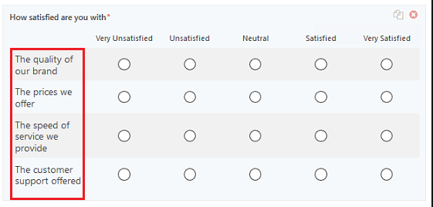

Figure 2 https://cdn.wpforms.com/wp-content/uploads/2018/07/Likert-Scale-Indicator-Question-Examples.png

The Approach
Now that the goals have been established it is important to understand the approach that will be taken to compete them.
The first challenge will be creating a website which users will use so a plan of the pages, features and design style is essential. Naturally the functionality of the website is a priority although, the importance of the layout and design will not be underestimated. “95% of customers” say that a website must be “easy to navigate” [14], and although the website will be tested on a small user base it is important that they are able to use a consistent website.
As the main aim of the project is to produce a result, then the approach to the data collection and presentation is extremely important.

Anticipated Problems
The website development is very likely to have errors in testing due to the scale of the website and the features that will be implemented. One of the main counter measures to this will be to research all the core features before implementing them to reduce the possible failures that might occur.
Another issue might be finding enough people to test the product, it will be important to contact 5-10 people who are willing to participate before going ahead with the project. The main issue that may arise from using just 5 users, is that there are different physical attributes being tested, so in this case 5 users who want to lose weight will be in a separate group to those who want to gain muscle.
Typically, 5 users are the optimal number, as anything after this results in diminishing returns. An article by Jakob Nielsen [15] shows that “as you add more users, you learn less and less” since you will keep seeing repeated results. Although 15 users might seem to be a good idea, an optimised approach would be to do 3 smaller tests with the same 5 people. This makes sure the test is more focused on the issue at hand, along with being able to cover more ground.
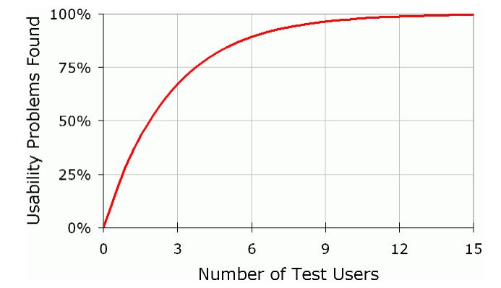

Figure 3 https://www.nngroup.com/articles/why-you-only-need-to-test-with-5-users/
Time scale is a big challenge in most projects which is why a project plan will be created, otherwise it is possible that there will not be enough time given to testing the results and too much time getting the website to be fully working.
Accessibility is an issue that might arise. As a result it might mean that the website will need to be available as a mobile app and website as not everyone has a computer available to them. The website will be designed using the “mobile first approach” [16]. This will allow the website to be converted into an app without too many complications as the sizing and content will already be decided. From the research done so far, it is clear that so long as the website has a mobile first design then the conversion will be relatively simple [17].

The Implementation
This section will look at how the project will be implemented, from the strategies that will be taken to the design target.

Strategy
The project strategy will be to use the goals that have been identified and then use those to set up the order in which each stage should be taken.
- Understanding the aim of the project
- Outlining a time scale for the project
- Design the initial concept of the website
- Find willing participants for the website
- Create the website
- Implement the first stage of testing
- Add feedback suggestions
- Deploy final design
- Analyse results
This is a basic look at the strategy for the project. The key to a successful project includes “clearly documented project milestones and deliverables” [18] which is why the planning section is so important to the success of this project.

Design Target
The design target looks at the following:
- Who the audience for the project is aimed at?
- What the design needs to be?
- How this will be accomplished?

The target audience for this project is people aged 18 or older who want/need to improve their physical health. For this project it will not be possible to support the range of different people that this includes. Many people have pre existing conditions, heart problems, dietary requirements etc. Therefore, it will not be possible to account for all of these. Instead the aim will be to focus on providing support to three categories, people who want to lose weight, people who want to gain muscle and people who are recovering from an injury.
This will then be designed in a way which splits the groups into an age category so that the correct information is available to that person.
As this website needs to be usable by all ages then the simplicity of the navigation is a key factor, as mentioned previously, this is a significant factor in a successful website. The design will look to follow a clean house style which is consistent throughout the website.

Concepts
Some concept designs have been created as a rough guide into how the website will look. These are subject to change and are to be used as a rough idea of the end website.
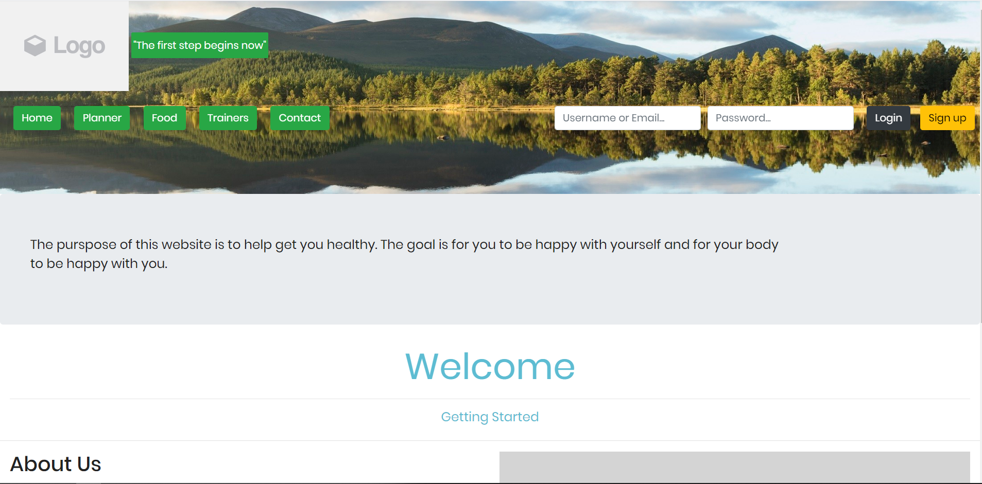
Above is an example of the home page, the design will be clean and concise so that all users are able to get to where they need to on the website.
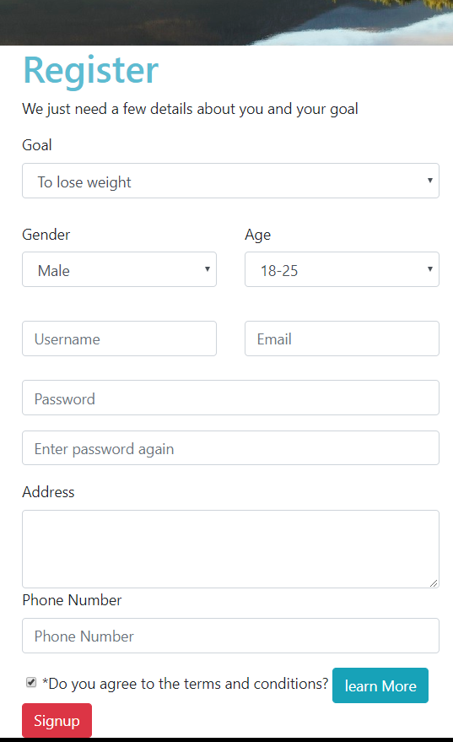
The sign-up page, see figure, will be a key part in identifying the type of user, as it will save the users details, which will decide what they will see on the body of the site. This page will be added to later, the concept is there and offers an idea into what information will be needed.
Figure sign up concept
Other pages include, planner, food, trainers and contact. These will need to be given more thought as the content will depend heavily on what goal the user has entered. The page names give a good indication as to what will be expected although there maybe some changes to these along with some possible additions.

Software Required
The software required includes the following:
- Visual Studio 2019 (VS)
- Photoshop
- Excel
- Word
- Premier Pro
The code will be designed in VS from html to php. The logo and images will be sized in Photoshop which will add a professional look. Excel will be used to produce and display the data, along with the use of Word. It is possible that there will be some instruction films that will need to be edited so Premier Pro will be required.

Privacy
Privacy will be a huge focus for this project as the details of user’s private information will need to be stored.
The Data Protection Act 1998 [19] was created to protect individuals from having their data used without permission. It was created to give people more privacy regarding their personal data. Although it does not specify privacy, it is based on not disclosing personal information. This means that a company is not allowed to disclose personal information unless given a warrant.
They are eight principles the law protects regarding personal information:
- fairly and lawfully processed
- processed for limited purposes
- adequate, relevant and not excessive
- accurate and up to date
- not kept for longer than is necessary
- processed in line with your rights
- secure
- not transferred to other countries without adequate protection.
With this in mind, the data, which will be stored, will have the option by the user to be terminated at any time. Along with data privacy, the security will also be important. This will mean that the password will use encryption to avoid any breach of data.

Outcomes

What is the production Aim?
The production aim is to give a good idea as to the effectiveness of the website/app provided regarding the improvement in the person’s physical health.

What will the Outcome Be?
The expected outcome for the project is that users will notice an increase of motivation, organisation and information, as a result of using the website, which should collectively give the users an increase to their physical ability.

What will be Demonstrated?
There will be a demonstration of the website and what the conclusions were. This will be presented in a way that gives a fair judgement of the result. If the result conflicts with the expected outcome, this will be shown. The demonstration will be a clear and fair result.

Project Plan
Gannt Chart
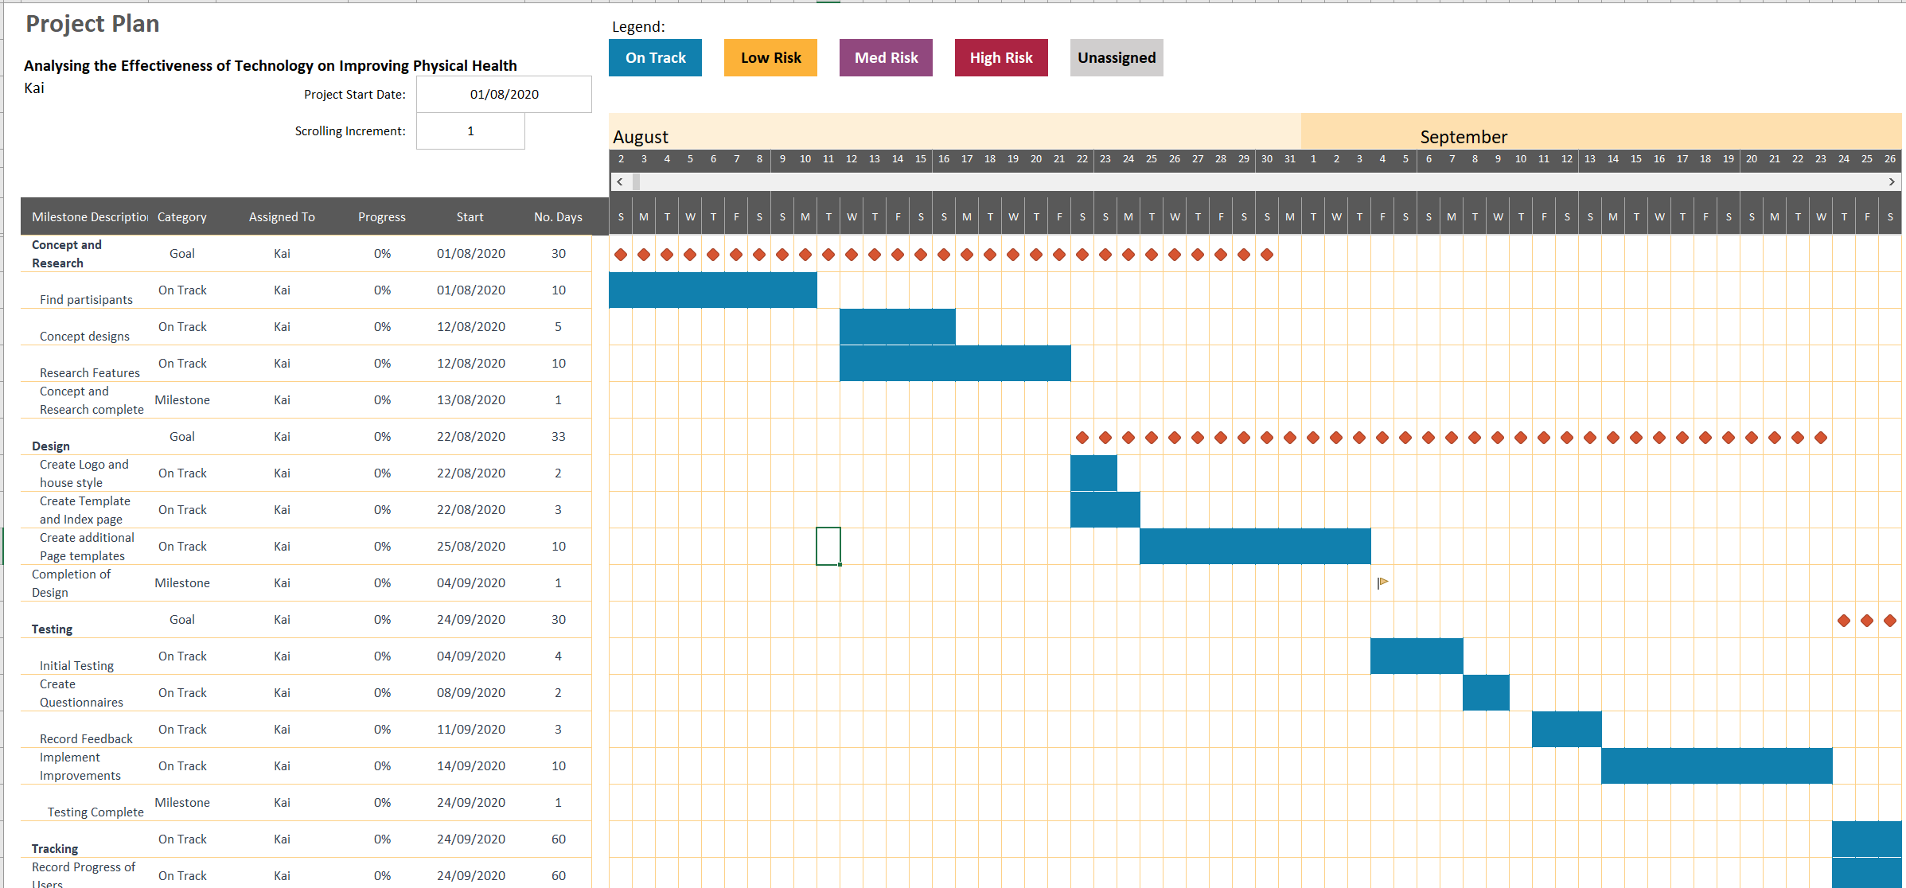
The Gantt Chart has been created to offer a project plan for the development cycle and offers a time scale for completion. The software available prevented the exclusion of weekends so this may be revised in the future.

Conclusion
This report has looked at background research which has been conducted in the field of technology and physical health, along with justifying the importance of the project. The goals and objectives have been clearly laid out along with addressing the legalities of storing private data. The plan for the project has been laid out in full.

Bibliography

[1] | c. a. E. J. L. a. C. G. V. Deborah F. Tate, “High-Tech Tools for Exercise Motivation: Use and Role of Technologies Such as the Internet, Mobile Applications, Social Media, and Video Games,” PMC, 28 Jan 2015. [Online]. Available: https://www.ncbi.nlm.nih.gov/pmc/articles/PMC4334081/. [Accessed 07 May 2020].
[2] | J. K. a. H. S. J. Hamari, “Does Gamification Work? -- A Literature Review of Empirical Studies on Gamification,” IEEE Xplore, 10 March 2014. [Online]. Available: https://ieeexplore.ieee.org/abstract/document/6758978. [Accessed 07 May 2020].
[3] | “Global Gamification Market By Solution , By Deployment , By Organization Size , By Application , By End-User Vertical , By Region, Competition, Forecast & Opportunities, 2024,” ReportLinkerauthor, ? March 2019. [Online]. Available: https://www.reportlinker.com/p05762137/Global-Gamification-Market-By-Solution-By-Deployment-By-Organization-Size-By-Application-By-End-User-Vertical-By-Region-Competition-Forecast-Opportunities.html?utm_source=PRN. [Accessed 07 May 2020].
[4] | Strava, “Strava,” Features for athletes, made by athletes, ? ? ?. [Online]. Available: https://www.strava.com/features. [Accessed 07 May 2020].
[5] | R. O. Dennis L. Kappen, “Gamified and persuasive systems as behavior change agents for health and wellness,” XRDS: Crossroads, The ACM Magazine for Students, 01 November 2017. [Online]. Available: https://dl.acm.org/doi/fullHtml/10.1145/3123750. [Accessed 12 May 2020].
[6] | “Measuring and Influencing Physical Activity with Smartphone Technology: A Systematic Review,” Springer Link, 05 02 2014. [Online]. Available: https://link.springer.com/article/10.1007/s40279-014-0142-5. [Accessed 11 May 2020].
[7] | 1. ,. G. K. 2. a. A. K. R. 3. C. D. Reimers, “Does Physical Activity Increase Life Expectancy? A Review of the Literature,” PMC, 01 July 2012. [Online]. Available: https://www.ncbi.nlm.nih.gov/pmc/articles/PMC3395188/. [Accessed 07 May 2020].
[8] | “ A summary of the evidence supporting the importance of regular physical activity for the prevention of chronic diseases and,” PMC, 14 March 2006. [Online]. Available: https://www.cmaj.ca/content/cmaj/suppl/2006/03/08/174.6.801.DC1/health-war-online_appendix_2.pdf. [Accessed 07 May 2020].
[9] | T. S. Ph.D, “Physical activity and mental health in the United States and Canada: Evidence from four population surveys,” Science Direct, ? January 1998. [Online]. Available: https://www.sciencedirect.com/science/article/pii/0091743588900709. [Accessed 07 May 2020].
[10] | Kazoo, “How to Write and Use SMART Goals at Work,” Kazoo, ? ? ?. [Online]. Available: https://www.kazoohr.com/resources/library/how-to-set-smart-goals. [Accessed 07 May 202].
[11] | A. J. P. Med., “Weight loss during the intensive intervention phase of the weight-loss maintenance trial.,” pubmed, August 2008. [Online]. Available: https://www.ncbi.nlm.nih.gov/pubmed/18617080. [Accessed 11 May 2020].
[12] | M. R. L. Katherine D. McManus, “Why keep a food diary?,” Harvard Medical School, 31 January 2019. [Online]. Available: https://www.health.harvard.edu/blog/why-keep-a-food-diary-2019013115855. [Accessed 11 May 2020].
[13] | T. &. B. D. Nemoto, “Developing Likert-Scale Questionnaires,” Temple University, Japan , NA NA 2014. [Online]. Available: https://jalt-publications.org/sites/default/files/pdf-article/jalt2013_001.pdf. [Accessed 12 mAY 2020].
[14] | M. Guta, “94% of Consumers Say Your Website Must Be Easy to Navigate,” Small Biz Trends, 01 January 2019. [Online]. Available: https://smallbiztrends.com/2019/01/easy-website-navigation-is-important.html. [Accessed 08 May 2020].
[15] | J. Nielsen, “Why You Only Need to Test with 5 Users,” NN/g, 18 March 2000. [Online]. Available: https://www.nngroup.com/articles/why-you-only-need-to-test-with-5-users/. [Accessed 12 May 2020].
[16] | UXPin, “A Hands-On Guide to Mobile-First Responsive Design,” UXPin, ? ? ?. [Online]. Available: https://www.uxpin.com/studio/blog/a-hands-on-guide-to-mobile-first-design/. [Accessed 10 May 2020].
[17] | B. Directories, “How to Turn a Website into a Mobile App,” Brilliant Directories, 21 April 2016. [Online]. Available: https://www.youtube.com/watch?v=elkJIrLJeug. [Accessed 10 05 2020].
[18] | D. Haughey, “Eight Key Factors to Ensuring Project Success,” Project Smart, ? ? 2014. [Online]. Available: https://www.projectsmart.co.uk/white-papers/eight-key-factors-to-ensuring-project-success.pdf. [Accessed 09 May 2020].
[19] | GOV.UK, “Data protection,” GOV.UK, ? ? 1998. [Online]. Available: https://www.gov.uk/data-protection. [Accessed 10 May 2020].
[20] | Personify, “Securing your site using traffic encryption,” Personify, [Online]. Available: https://gethelp.wildapricot.com/en/articles/178-securing-your-site-using-traffic-encryption. [Accessed 01 May 2020].
[21] | MOZ, “What is SEO?,” MOZ, [Online]. Available: https://moz.com/learn/seo/what-is-seo. [Accessed 01 May 2020].
[22] | C. Check, “Use Check Verification to Authorize Checks,” Cross Check, [Online]. Available: https://www.cross-check.com/products-services/check-verification. [Accessed 01 May 2020].

