Comparison of Two Methods of Manufacture Serving as Alternatives to Traditional CNC Milling

Abstract
A machining company wishes to modernize and have thus decided to test possible replacement technologies. Two of these have been selected for comparison, to be put against each other, and the original process, CNC milling. This report details the pair of processes, being Abrasive Water Jet cutting and Laser Engineered Net Shaping (LENSTM), their respective capabilities and those of the traditional CNC, comparing and contrasting their abilities, concluding with a decision on the adoption of the technologies.
Table of Contents
Abstract 2
Introduction 4
CNC Milling 5
Typical Specifications: 5
Abrasive Water Jet Cutting 6
Laser Engineered Net Shaping (LENS™) 7
Conclusion 8
References 9
Figures 9

Introduction
A company has decided that it wants to change the method of manufacturing one of the items in their catalog, specifically by adopting a “non-traditional” process. There are various ways that this part could be made, but for the purposes of this report, two techniques are to be compared. At present, the company is using a CNC mill to machine a part, hence the following assumptions:
- The part is milled from one contiguous piece of billet aluminum.
- The two holes are drilled as part of the machining on the mill.
- All other cosmetic features, that is, the ribs and the two depressed areas in the center, are also machined into the billet, and are not a result of separate processes.
These assumptions have been made to provide a concrete starting point for the comparisons of the possible processing alternatives which will be posited in this report. Additionally, the following data have been provided:
- The part is 508 x 330 x 25 mm (20 x 13 x 1 inch).
- Tolerances are to be within 0.127 mm (5 Thou).
- The part is to be heat-treated, so presumably heat damage would be unacceptable.
- Surface quality is to be improved, if possible.
Therefore, an overview of the capabilities of CNC milling will come first, followed by a pair of alternatives, in this case, abrasive water-jet cutting, and Laser Engineered Net Shaping (LENS).

CNC Milling
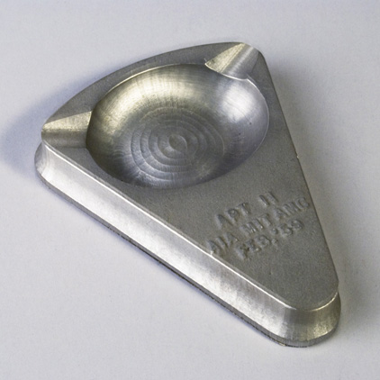
Computer Numeric Control, or CNC, is a system of automation, commonly associated with three- and five-axis mills. These mills take instructions entered into a computer, in a basic numerical code, and interpret them into the motions that make a machined part. The idea was first proposed in 1949, and within the next ten years, computers were introduced, by the Computer Applications Group of the Massachusetts Institute of Technology (Ross, 1978). Since then, CNC has become a standard process, producing products precisely, proliferated around the world, for diverse operations. As a result, most of the alternatives to milling that are available at present still rely on the CNC principles to operate, some even so far as to be built into combination machines, such as the “i-AM” range by MAZAK (Mazak Corporation, 2018).
Figure 1. One of the items released as a press-kit by MIT in 1959, created by Computer Numerical Control Milling (MIT Museum, 2011).

Typical Specifications:
A given CNC mill should be expected to conform to standards of precision and accuracy. As such, some reference values for precision, from an Indian government tender for three-axis CNC mills, follow here (Raja Ramanna Centre for Advanced Technology, 2014):
- Linear axes repeatable to ≤ 0.007mm
- Cutting feed rate ≥ 10 m/min
- Positional accuracy of linear axes ≤ 0.010 mm
- Power on the order of 15 kW
- Simultaneous maneuvering in X, Y, Z, and B axes
Thus, a replacement technology should be able to at least match these statistics, or otherwise offer a significant advantage over the CNC mill in a particular facet of the manufacturing process. Additionally, CNC mills do not cause significant heat damage, if properly stringent lubrication regimes are followed in the milling of a given part, though the tool can be adversely affected by improper cooling (DinizI, JúniorII, & Filho, 2008) which can negatively impact the ability to produce quality machining.

Abrasive Water Jet Cutting
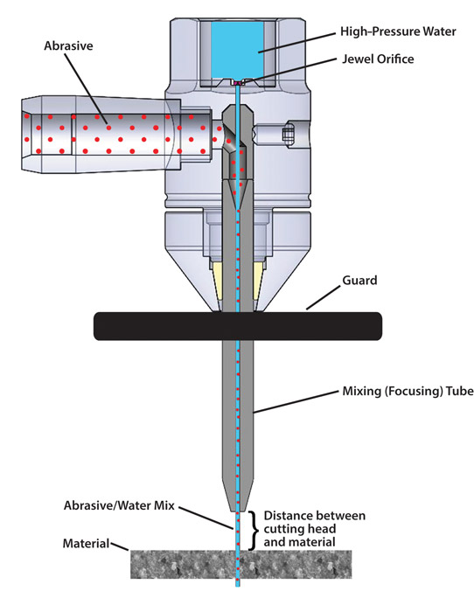
This process relies on the use of high-pressure water, in the range of 500 MPa, with a granular abrasive, typically made of garnet, shot through a nozzle with a diameter of approximately 0.5 mm (Shukla, 2013). This garnet-saturated water is propelled to speeds of around 1000 ms⁻¹ to effectively grind through the target material in a concentrated beam. This process, according to Shukla, allows for:
Figure 2. A diagram of the water jet nozzle (Nambiath, 2016).
- Very little heat, thus no thermal damage to the workpiece.
- Relatively high speed of cut.
- Very smooth cut surfaces, in most conceivable curves, little attention required after the machining.
These advantages in mind, the process is not perfect: there are also significant disadvantages (Shukla, 2013):
- Low maximum surface finish quality, because of the abrasion process. This is especially poor if the jet is used to cut troughs or blind holes, as opposed to cutting cleanly through the workpiece.
- Severe taper in the plane of the cut, caused by the drop-off in pressure over the course of the operation, limiting the precision of the machining.
- Various environmental concerns, including the contaminated water, abrasives, and the hazards posed by water and electricity co-existing in a workplace environment.
As such, this process may not be suitable as a replacement to a five-axis mill to produce the part in question, as the limitations of what operations may be conducted, in three-axes only, and with difficulty in the blind cuts, would severely hamper the ability to repeatedly produce a quality product.

Laser Engineered Net Shaping (LENS™)
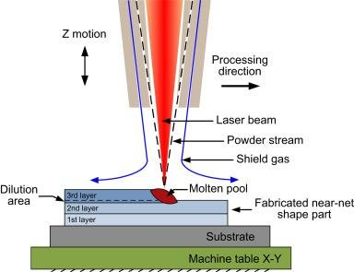
Additive Manufacture, AM, is a relatively new set of processes where material is deposited onto a substrate, producing the desired object by building it in situ, as opposed to a traditional subtractive process, where material is removed by a cutting tool, or eroded, to form the final shapes of the product.
Figure 3. Diagram of LENS process in use (Dehghanghadikolaei, Namdari, Mohammadian, & Fotovvati, 2018).
As an additive process, LENS offers some unique solutions to problems that may prove exceedingly difficult to overcome by traditional means. It adds material to a substrate, rather than removing it, thus allowing for efficiency in the use of material, by avoiding the wastage incurred by subtractive manufacture.
It can, according to the copyright holder, Sandia National Laboratories:
- Operate on a wide variety of materials
- Be used in 3- or 4-axes
- Create “fully dense” items with mechanical and metallurgical properties similar to those produced conventionally (Sandia National Laboratories, 2002).
Additionally, the process can construct complex architecture, creating intricate detail, and control of material density and porosity that would otherwise not be possible if a traditional subtractive process were to be used (Gualtieri & Bandyopadhyay, 2016). The issue with this process in the context of this report, is that these abilities are not required, and as such, the benefits of LENS over another process would not be realized, unless the company wished to expand into areas where LENS would give a cutting edge over the competition.

Conclusion
Whilst the currently used milling process is both inefficient, in time and resources, and expensive, in the same, these two alternatives would be no better in fulfilling the requirements of making the parts needed. That is to say that, while alternatives may exist out there that are better suited, neither LENS nor Abrasive Water Jet Cutting are the answer. It could be argued that, for most any process, there are advantages over the traditional method, but it can also be argued that the present process produces products of high quality, and the machinery is already paid for. Thus, the final question is whether the new process would save money in the processing compared to the old, in how long a time, compared to the old, as the two chosen processes have no other advantages over traditional milling.

References
Dehghanghadikolaei, A., Namdari, N., Mohammadian, B., & Fotovvati, B. (2018). Additive Manufacturing Methods: A Brief Overview. Journal of Scientific and Engineering Research, 127. Retrieved from https://www.researchgate.net/publication/327701079_Additive_Manufacturing_Methods_A_Brief_Overview
DinizI, A. E., JúniorII, A. B., & Filho, F. T. (2008, April/June). Tool wear damage caused by abundant emulsion in milling operation of PH stainless steel. Journal of the Brazilian Society of Mechanical Sciences and Engineering, 30(2). Retrieved from http://www.scielo.br/scielo.php?script=sci_arttext&pid=S1678-58782008000200005
Gualtieri, T., & Bandyopadhyay, A. (2016, October 28). Laser Engineering Net Shaping of Microporous Ti6Al4V Filters. (B. Koc, Ed.) Frontiers in Mechanical Engineering. Retrieved from https://www.frontiersin.org/articles/10.3389/fmech.2016.00009/full
Mazak Corporation. (2018). INTEGREX i-400AM. Retrieved from Mazak USA: https://www.mazakusa.com/machines/integrex-i-400am/
MIT Museum. (2011). Numerically Controlled Milling Machine, MIT Servomechanisms Lab, 1950s. Retrieved from MIT Museum: http://museum.mit.edu/150/86
Nambiath, P. (2016, November 29). Pressure matters in abrasive waterjet cutting. Retrieved from The Fabricator: https://www.thefabricator.com/article/waterjetcutting/pressure-matters-in-abrasive-waterjet-cutting
Raja Ramanna Centre for Advanced Technology. (2014, May 30). Technical Specification for CNC Horizontal milling machine. Indore, India. Retrieved from http://www.rrcat.gov.in/tenders/irpsu/53081_1.pdf
Ross, D. T. (1978, August). Origins of the APT Language for Automatically Programmed Tools. ACM SIGPLAN Notices, 13(8), 61-99. Retrieved from https://www.webcitation.org/5o6WeFeUk?url=http://ied.unipr.it/silve/meaz/origini-APT.pdf
Sandia National Laboratories. (2002). Laser Engineered Net Shaping. USA. Retrieved from https://www.sandia.gov/mst/pdf/LENS.pdf
Shukla, M. (2013). Abrasive Water Jet Milling. In Nontraditional Machining Processes (p. 2). Allahabad, India: Springer-Verlag London. Retrieved from https://www.researchgate.net/publication/278704656_Abrasive_Water_Jet_Milling

Figures
Figure 1. One of the items released as a press-kit by MIT in 1959, created by Computer Numerical Control Milling (MIT Museum, 2011). 5
Figure 2. A diagram of the water jet nozzle (Nambiath, 2016). 6
Figure 3. Diagram of LENS process in use (Dehghanghadikolaei, Namdari, Mohammadian, & Fotovvati, 2018). 7

