

Digital Transformation in the Health and Care Professions (BMHP6026)

Component 1: Written Report

Student name: Larry Osei Kofi
Student number: 2308809
Lecturer’s name: Laila Surani

Table of Contents
INTRODUCTION 3
IMPACT ON WORKFORCE 4
IMPACT ON SERVICE DELIVERY 5
IMPACT ON PATIENTS 7
IMPACT ON COMMUNITY 8
CONCLUSION 10
REFERENCES 11

INTRODUCTION
The NHS Apian-Wing Drone (Hummingbird V2 Autonomous Delivery Drone) is a modern healthcare technological tool introduced under the UK healthcare framework, designed through a collaboration between Wing (Alphabet Inc.), Apian Ltd., and the NHS (Guy's and St Thomas' NHS Foundation Trust) (McNabb, 2024). Launched in 2024, the drone is to be utilised for the transportation service for essential medical supplies like blood samples, diagnostics, and medicine between hospital locations around London (Guy's and St Thomas' NHS Foundation Trust, 2024). The technology functions under the power of electric vertical take-off and landing (eVTOL) capability and is completely self-propelled, with the facilitations provided through the application of AI navigation, GPS, and LiDAR sensors (Apian, 2025). Deliveries, taking around 30 minutes through the roads previously, now save less than two minutes, accelerating and improving the enhancements to patient care. Also, the drone is entirely zero-emission, aiding the mission of the NHS to achieve net-zero carbon emissions, eventually. The venture is an example that digital and autonomous technology can be applied to advance the efficiency ratio of the healthcare logistics, accelerate time lag time for treatment, and promote the ideology of sustainability to all the operations under the NHS.

IMPACT ON WORKFORCE
The use of the Apian Wing Drone project has introduced many changes to workforce practices in the UK healthcare and social care sector. In the past, the transport process of pathology samples, drugs, and healthcare equipment was carried out by ground couriers and hospital transport staff. The current trend has shown the creation of new workforce roles such as drone operators, digital logistics coordinators, and maintenance engineers due to the need to implement the use of drones in healthcare transport services (Apian, 2025). The development shows that there is an increasing need to ensure that healthcare employees are technically skilled in digital technology applications such as the use and monitoring of automated technology.
The use of drone technology has also led to inter-professional collaboration between healthcare practitioners and other stakeholders such as engineers and aviation experts from Apian (Sollof, 2024). This has promoted an interdisciplinary culture within the NHS environment. Employees are encouraged to participate in digital innovation outside of their usual medical role. The impact has been a culture that promotes continued professional development among employees.
But with these advancements come challenges too. The use of these technologies will lead to job redundancy in the sense that there may be implications on the demand for personnel in the current logistics function within the NHS. Additionally, with the emphasis on training in aviation safety and operating drones as well as data management, there is potential strain on already extended budgets within the NHS. The workforce has to be able to integrate the drones’ data management systems with those that are already in use within the healthcare environment.
Despite these concerns, the benefits to the workforce exceed the negative implications. The workforce can concentrate more on caring for patients since drones cut the time taken to transport them manually. The technology additionally complies with the organisational plans aimed at digital transformation and sustainability within the healthcare sector. In conclusion, the Apian Wing Drone contributes to various aspects aimed at improving workforce capabilities through digital transformation within the healthcare sector. When combined with change management processes and training, drones are useful in supplementing the workforce rather than replacing people in the healthcare sector to meet current demands.

IMPACT ON SERVICE DELIVERY
Until now, the Apian Wing Drone has significantly enhanced the speed, efficiency, and sustainability involved in delivering a service to the NHS (NHS Blood and Transplant, 2024).
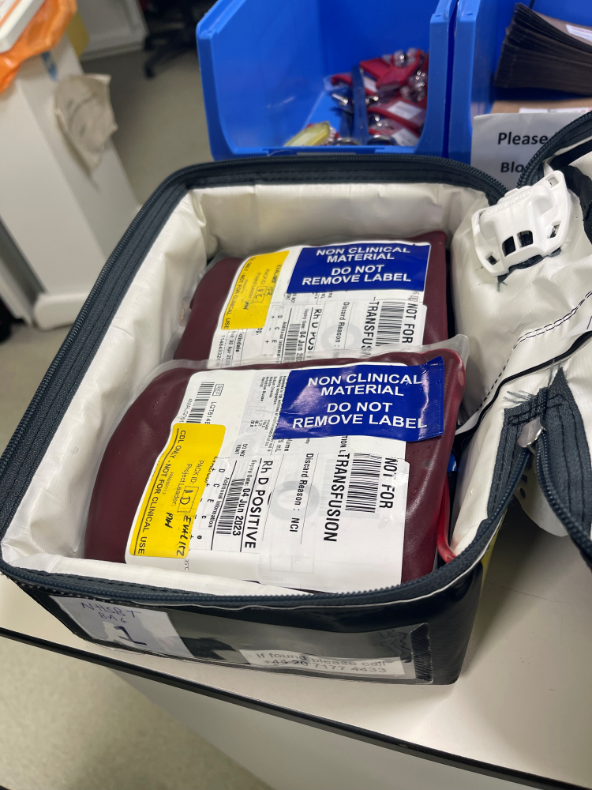
Image 1 is a blood delivery by the NHS Apian Wing drone (NHS Blood and Transplant, 2024)
Had this service not involved applying the concept of drone usage, transporting pathology, blood, or medication between a hospital and a lab could have taken a delivery time of over an hour, all being well with the roads. The trial involving the Isle of Wight identified that a drone could achieve this delivery time in under ten minutes, resulting in a substantial improvement in the turnaround times for urgent cases.
The system supports the Net Zero 2040 plan proposed by the NHS due to the reduction in carbon emissions produced by the drone. The drone operates through electric power, meaning fewer greenhouse gases are produced as opposed to other traditional cars operating on the roads with combustion engines. There are fewer congestion routes, as well as logistical jams, that could slow down the delivery of vital medical care through the drone service model, but however, the integration with the service delivery model has been a problematic endeavour. (NHS England, 2022).
Because it is a drone, there are negativities which surround the use of drones for healthcare services, which are reactions to any adverse weather conditions and enormous expenses involved with the maintenance and software handling associated with the drone technology, at least over the initial operational period (Julián Estévez, 2020). This contributes to the reasons why drone delivery service practices have not been made the primary means of transport of medical supplies in our healthcare system. Also, there could be the operational concern involving consistent communication between clinical as well as logistics involved with the operational service delivery toward reliability, security, and viability.
Nevertheless, the service delivery of the NHS Apian-Wing drone was conducted by the NHS Blood and Transplant (NHSBT), which, according to Lonsdale and Pickover (2024), involved transportation of ten identical blood bags from the Northumbria Healthcare NHS Foundation Trust's Wansbeck Hospital to the Alnwick Infirmary in Northumberland and back. Half of the blood was carried by drones, while the remaining five were transported by road; however, the researchers discovered that drone delivery had no impact on the blood's quality or duration. Dr Gail Miflin, chief medical officer of NHSBT, said, "The results of this first trial are very promising, showing no compromise to the safety of the blood." Following a carefully organised journey with the Civil Aviation Authority (CAA), the drones crossed 42 miles (68 km) of Northumberland coastline in 61 minutes. meant that the pilot was unable to observe the drone while it was in flight.
Therefore, proving that though the drones might have negative impacts on their services, the NHS Apian-Wing drone comes with an abundance of benefits, starting with greater responsiveness and also resulting in faster results, among other considerations. The Apian Wing Drone, however, does show how automation technology could enhance rather than reduce human mediation as part of the operational delivery service involved with the delivery of medical service. It has also smoothened the supply chain overhaul and modernised service delivery, allowing room to refocus other resource allocation connected with actual client service.
Furthermore, this could encompass a broader strategy between all concerned NHS trusts toward an integrated national drone service delivery umbrella, providing a boost to rapid access toward vital medical service delivery. As this crucial development concerns, the Apian Wing Drone technology represents a crucial or applicable model toward how technology could transform the operational delivery service, as well as viable targeting, toward meeting critical service delivery and innovation strategies toward customer service delivery.

IMPACT ON PATIENTS
From the perspective of the patient, the Apian Wing Drone in the NHS provides tremendous benefits with regard to accessibility and timely medical care. The quick transport service for testing samples and medicines ensures that patients receive faster diagnoses and treatments. This is particularly helpful for patients who are living in remote areas (Ioanna Lykiardopoulou, 2024). The waiting time to receive medical results is also shortened; this ensures that the patient’s anxiety is alleviated since waiting results in stress. The invention shows that the NHS is committed to improving patient outcomes through digital transformation initiatives.
Patients perceive the use of drones as evidence that the NHS has modernised and has adopted innovative techniques. This lifts the confidence of the people in the healthcare sector's willingness to adopt technology that will improve the delivery of care. The use of the Apian Wing Drone to offer same-day sample delivery and to improve the laboratory result turnaround time has a direct impact on improving patient experiences and outcomes. In emergency situations such as blood tests and biopsy analysis, faster transport offers an opportunity to save lives.
Nevertheless, the NHS Apian Wing Drone, though useful, has a number of concerns that form from the perspective of the patient. Some people within the public domain are concerned about the implications that come with the use of drones. In most cases, there are concerns about the potential malfunctioning that might lead to accidents and the possibility of taking images that might violate people's privacy (Rao, 2024). Furthermore, there is unequal distribution with regard to accessing healthcare technology; those who are in remote areas might end up with more benefits compared to those within urban areas.
In spite of these challenges, the reaction of patients has been positive. They are pleased with the dependability and immediacy that drones bring to medical services. The Apian Wing Drone ultimately leads to an enhancement in patient trust and confidence within the NHS. In due course, with the more widespread acceptance of drone delivery technology, patient safety and satisfaction are also likely to improve. The ethical questions that need to be addressed enable the more optimistic implications to be fulfilled and ensure that patient experiences are continually positive due to this innovative technology within the NHS.

IMPACT ON COMMUNITY
From the community perspective, the potential that the Apian Wing Drone offers is indeed vast, as far as the promotion of equality, sustainability, and accessibility in relation to the public health care programme is concerned. The community will indeed welcome the speedy approach and efficient manner being used in the delivery of crucial medical supplies, which will contribute considerably to the promotion of the public health programme and will save many lives, particularly during emergencies. The drone will offer a vital connection between patients and medical practitioners, given that previously, geographical locations could create a hindrance when transporting medical supplies or samples.
Moreover, the technology used by the drones will ensure that the proposed strategy towards sustainability by the NHS will lower the carbon emissions, as they offer a better approach, which is electric, as opposed to the traditional approach by vehicle (Guy's and St Thomas' NHS Foundation Trust, 2025). The Wing Apian Drone is a clear indication of innovation that makes a statement regarding the position developed by the NHS as a trusted institution by adopting an environmentally conscious approach. Nevertheless, feedback has mixed reactions among communities. As a matter of fact, some community members realise the potential that drones hold, while others are worried about safety, privacy, and noise pollution (King, 2025). Communities living around routes, which the drones pass through, may well be concerned about any potential crashes, as well as disruptions to their activities and routines. Furthermore, community perceptions, among other things, are a matter of concern, as other people may realise a negative part, having to do with something like surveillance or military uses, connected with the use of drones (Rao, 2024). The negative reactions have been addressed via public discussions between the NHS and Apian, whereby they outline their safety and environmental strategies and advantages. The innovation facilitates co-production in the medical space, whereby the community offers feedback as well as input to enhance the design of particular drone services so as to help route planning, with a lower degree of resultant disruptions, among other things. The innovation brings all the organisations, as well as their respective communities, closer so as to come together to address their various challenges, among other things. The resilience among communities is boosted, thanks to better logistics chains among institutions, as a result of a state characterised by pandemic outbreaks or natural disasters, among other things.
Overall, the Apian Wing Drone positively impacts society, as far as better approaches to medical care are concerned, as well as sustaining communities, as well as assisting public health, even if noise, privacy, and safety are concerns, as they are, even if they are resolved by regulation and open communication, among other things. Eventually, a better integration between drone technology and both community members and institutions will occur, resulting in an equitable public health service as a consequence of this innovation, as a sign, among other things, that symbolises hope and development, as far as this community at the NHS is concerned.

CONCLUSION
In conclusion, Apian Wing Drone technology reveals the impact that digital transformation can bring to the healthcare sector if carried out with sensitivity and collaboration. The Apian Wing Drone will certainly need monitoring in the future to ensure that it is still beneficial to all who depend on the care that the NHS provides. The Apian Wing Drone in the NHS has been groundbreaking in terms of digital innovation in the health and social care arena in the UK. The introduction of the Apian Wing Drone has greatly changed the way the workforce operates and has resulted in improved health outcomes. While there are still concerns about regulation and affordability, the impact on the environment is substantial.

REFERENCES
Apian (2025) Apian. Available at: https://www.apian.health (Accessed: 12 November, 2025).
Apian (2025) Securly - Geolocation Sharing. Available at: https://www.apian.health/northumbria-stage-1 (Accessed: 12 November, 2025).
Guy's and St Thomas' NHS Foundation Trust (2024) NHS Blood Samples to Be Delivered by Drones in London First. Available at: https://www.guysandstthomas.nhs.uk/news/nhs-blood-samples-be-delivered-drones-london-first
Guy's and St Thomas' NHS Foundation Trust (2025) NHS Delivery Drones Take Flight, Offering Faster and Greener Patient Care. Available at: https://www.guysandstthomas.nhs.uk/news/nhs-delivery-drones-take-flight-offering-faster-and-greener-patient-care (Accessed: 12 November, 2025).
Ioanna Lykiardopoulou (2024) Apian and Alphabet’s Wing to Fly NHS Blood Samples by Drone in London First. Available at: https://thenextweb.com/news/apian-wing-fly-nhs-blood-samples-drone-london-first (Accessed: 12 November, 2025).
Julián Estévez (2020) The Limitations of Drones for Medicine Delivery - Mapping Ignorance. Available at: https://mappingignorance.org/2020/09/09/the-limitations-of-drones-for-medicine-delivery/#note-7181-2 (Accessed: 12 November, 2025).
King, J. (2025) NHS Blood-Carrying Drones Plan Branded Crazy by Londoners. Available at: https://metro.co.uk/2025/07/08/nhs-blood-carrying-drones-plan-branded-crazy-londoners-23611263/ (Accessed: 13 November, 2025).
Lonsdale, J. and Pickover, E. (2024) Northumberland Research Finds Blood Can Be Safely Moved by Drones. Available at: https://www.bbc.co.uk/news/articles/cx2e9l07w31o (Accessed: 13 November, 2025).
McNabb, M. (2024) Wing’s Drone Deliveries Bring New Speed to NHS Blood Sample Transport in London. Available at: https://dronelife.com/2024/11/13/wings-drone-deliveries-bring-new-speed-to-nhs-blood-sample-transport-in-london/amp/ (Accessed: 13 November, 2025).
NHS Blood and Transplant (2024) Drones Successfully Fly Blood Packs in Longest-Ever Beyond Visual Line of Sight Flights in UK First. Available at: https://www.nhsbt.nhs.uk/news/drones-successfully-fly-blood-packs-in-longest-ever-beyond-visual-line-of-sight-flights-in-uk-first/ (Accessed: 13 November, 2025).
NHS England (2022) NHS England World’s First Chemo Drone Delivery Announced on NHS Birthday. Available at: https://www.england.nhs.uk/2022/07/worlds-first-chemo-drone-delivery-marks-nhs-birthday/ (Accessed: 13 November, 2025).
Rao, D. (2024) The Pros and Cons of Drone Delivery. Available at: https://theweek.com/tech/drone-delivery-pros-cons (Accessed: 13 November, 2025).
Sollof, J. (2024) Drones deliver urgent blood samples for Guy’s and St Thomas’. Available at: https://www.digitalhealth.net/2024/11/drones-deliver-urgent-blood-samples-for-guys-and-st-thomas/ (Accessed: 13 November, 2025).

