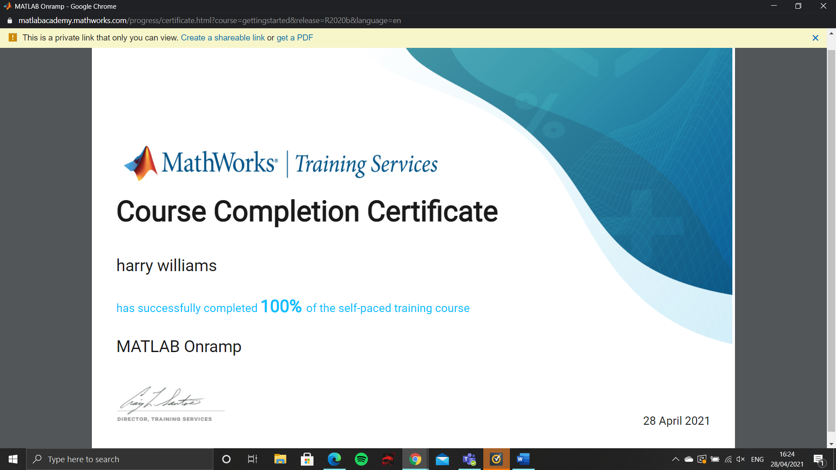here is my certificate to show that I (Harry Williams) has completed the MatLab OnRamp certificate on the 28th of April

