
PROFESSIONAL CAREER development
BMSW4005
Loraine Kristel Tabila Eleccion
1917097
HOSSEIN SHOKRI

Introduction

This report it helps me to explain and develop my future plans using the Gibbs reflective style.
That I learn from last term, it helps to describe better my thoughts and feelings, evaluating the experience, analysing and concluding changes, and the last, making a future plan based on that experience. (Andrew Grant, 2017)

Since I was young, I had difficulties of concentration and insecure of myself, for that reason I wasn’t sure what I wanted to be become when they were asking me.
The only answer I was giving to the grow ups was to become a leader and helping vulnerable people.

This module helped me to focus on my personal and professional career development.

2.Lifeline

Our first day in this assessment, our lecture Hossain explain us what a lifeline is; is a chart where we create our lines describing highs and downs during our lifetime, personal and career, just to help us to have an approach from our past and determine our goals in the future.
High one describes our achievements and the lower is our bad or inconvenience. (Ibarra, 2007)

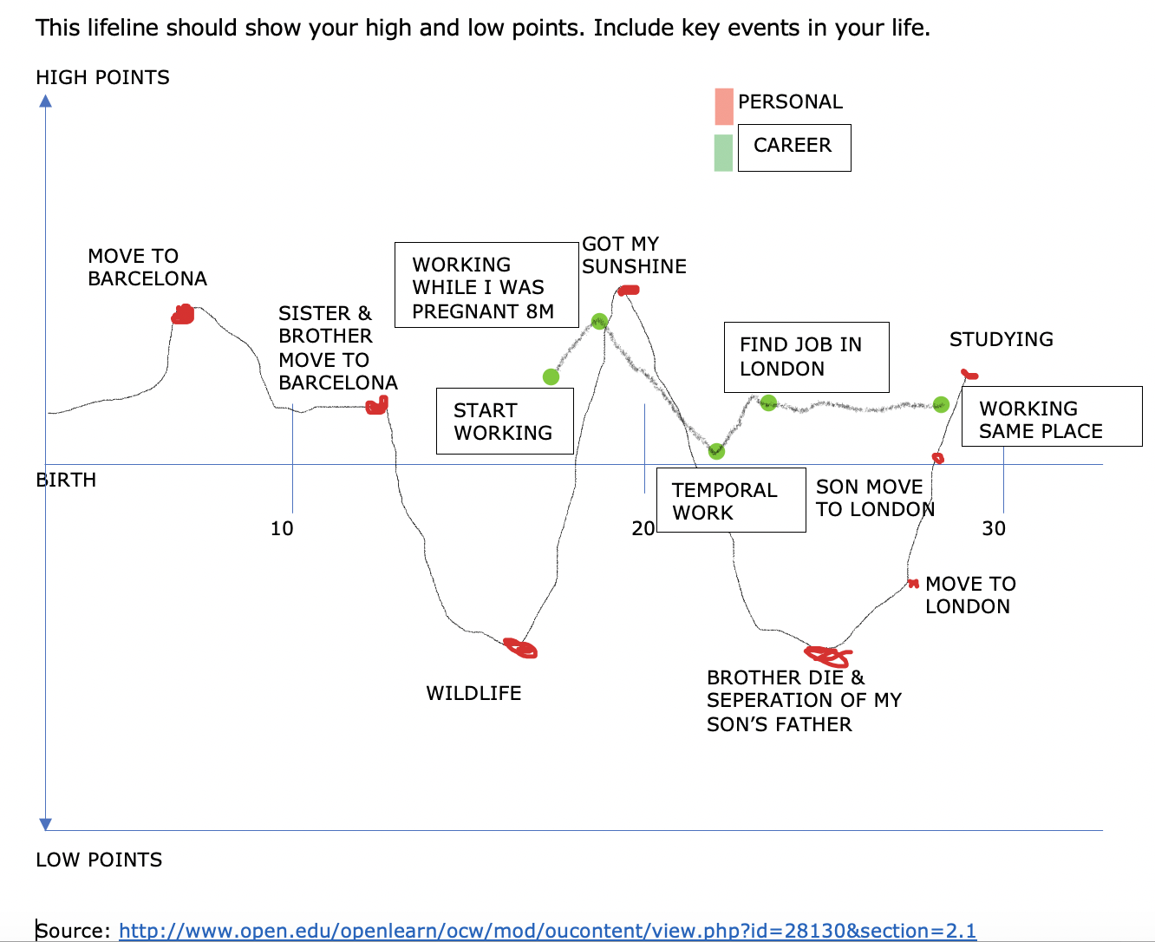

As reflect my chart red points is personal and the green the career.

While I was doing this activity in the class, I feel motivated and focused on what I have had done and achieved from my past and in this present moment, personally and in my career development.

Looking at my chart, I do like how slowly I grow emotionally.
Especially when I decided to move in London having another opportunity and taking my son with me.
And finally giving me a chance to finish my studies.
Doing this activity, I become conscious that I am stuck in my workplace, probably of lock self-confidence, and it helped me to realise that I want to develop more myself especially in my actual career development.

Choosing the right learning style will help to accomplish my professional develop plan.
Interpreting better my SWOT analysis, empowering my weakness into straight.
And focusing my SMART goals with clarity and self-commitment, with it, I can take an action and achieve my goal of personal development plan.

3. Role play

The first task of this assignment was by pair that our lecturer Hossain gave us, doing a role play linked with our personal goal.
The role play consists in, one student play as an interviewer and the other student as an interviewee and after, we change the role.
The interviewer needs to asked relating questions about the requirements, skills and experience that the interviewee applied for it.

On the beginning was hard for me what career I wanted to apply for, I always wanted to work in HR, but Human resources is a big department.
While I was deciding what career, I wanted to apply I realise that in my department have many skills that they require.

How I explain to other module in problem solving, most of the managers they don’t have the skills.
Personally, I can grow in Housekeeping department as require team management and organization, this one of the skills HR needs.
Having this opportunity to grow in the same organization where I am working.

The assignment helped me to analyse better the skills and to practice in the future for an interview, as our lecturer Hossain gave us his feedback.
And do a better research for each career and with that gain more knowledge.

That is the reason to know which learning model is good for us that it can guide us for our personal development plan.

4. Learning styles VAK

During the class, we have done an exercise related with our style of learning, there was a questionnaire with three different types such as: visual, auditory and kinaesthetic we had to identify which style was the best for us related with our own experience, I had a relevant score, in comparison with the rest of the styles the heights percentage was seventeen.

From my own experience it was very interesting dynamic, I realised that the answer of the questionnaire it was accurate, this concept was new for me but in practise was perfect definition, especially because I identify myself with the visual learning style, was very assertive given me the right tools to follow the style.
I respond faster to that kind of visual materials.

The benefit of visual learning style giving me better approach to develop my capabilities using this tool such us: videos, helping me to retain the information, virtual learning it a great support with graphs, images, visual images connect me more with my emotions, internet has a perfect opportunity for me to acknowledge my advantages and disadvantages to improve on my practical life



5.Analysis

SWOT analysis

Is a technique that it applies personal or and, in the companies, identifying strengths, weakness, opportunities and treats. (Parsons, 2018)

As I see in my chart and analysing myself, I can see there is a balance between my weakness, threats and opportunities.

With my weakness will helped me to turn it in opportunity specially my time management and organization.

Johari Window

Is a model created in 1955 by Joseph Luft and Harry Ingham. This tool it help the people to categories information about ourselves and what others they know or may think about us.
Is categories by four part known to self, unknown to self, known to others and unknown to other. Arena, blindspot, facade and unknown.

Arena: What others see from us, good or bad.
Facade: Hidden personality that we hide to different people.
Blindspot: Is the skills that everyone has but not everyone is aware from it.
Unknow: Is un exploring skill. (Morgan, 2017)

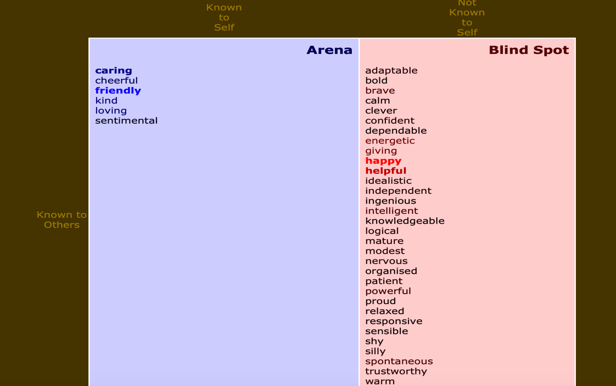

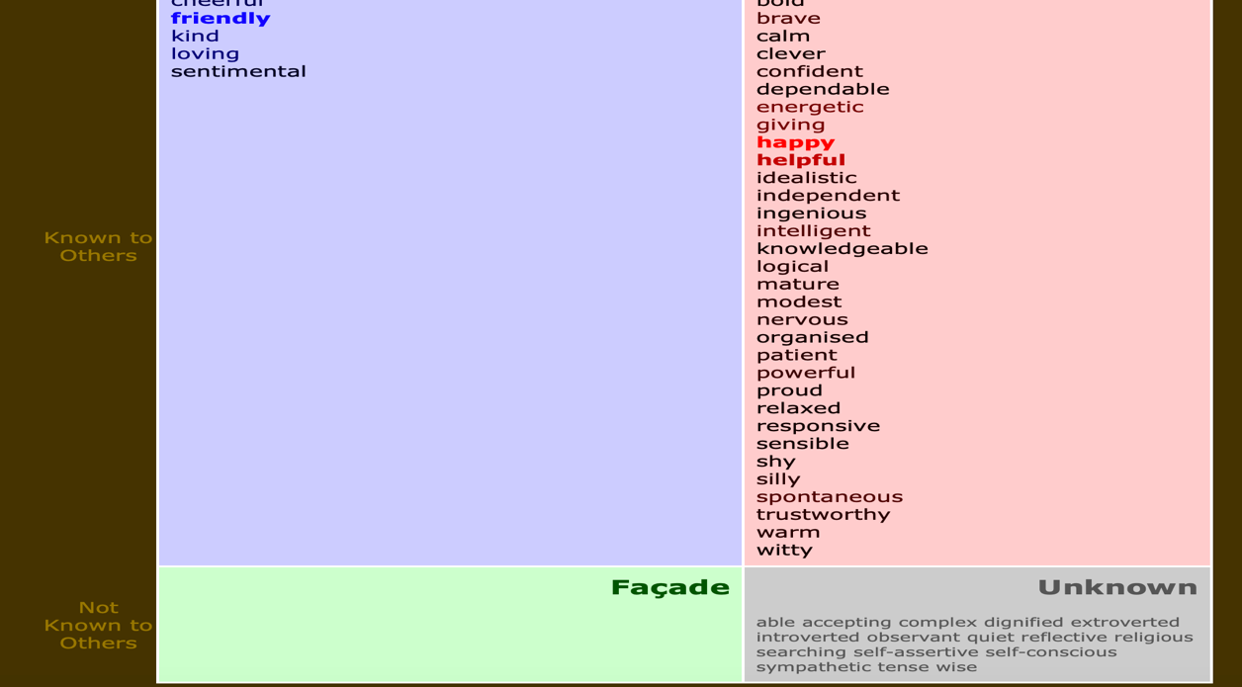

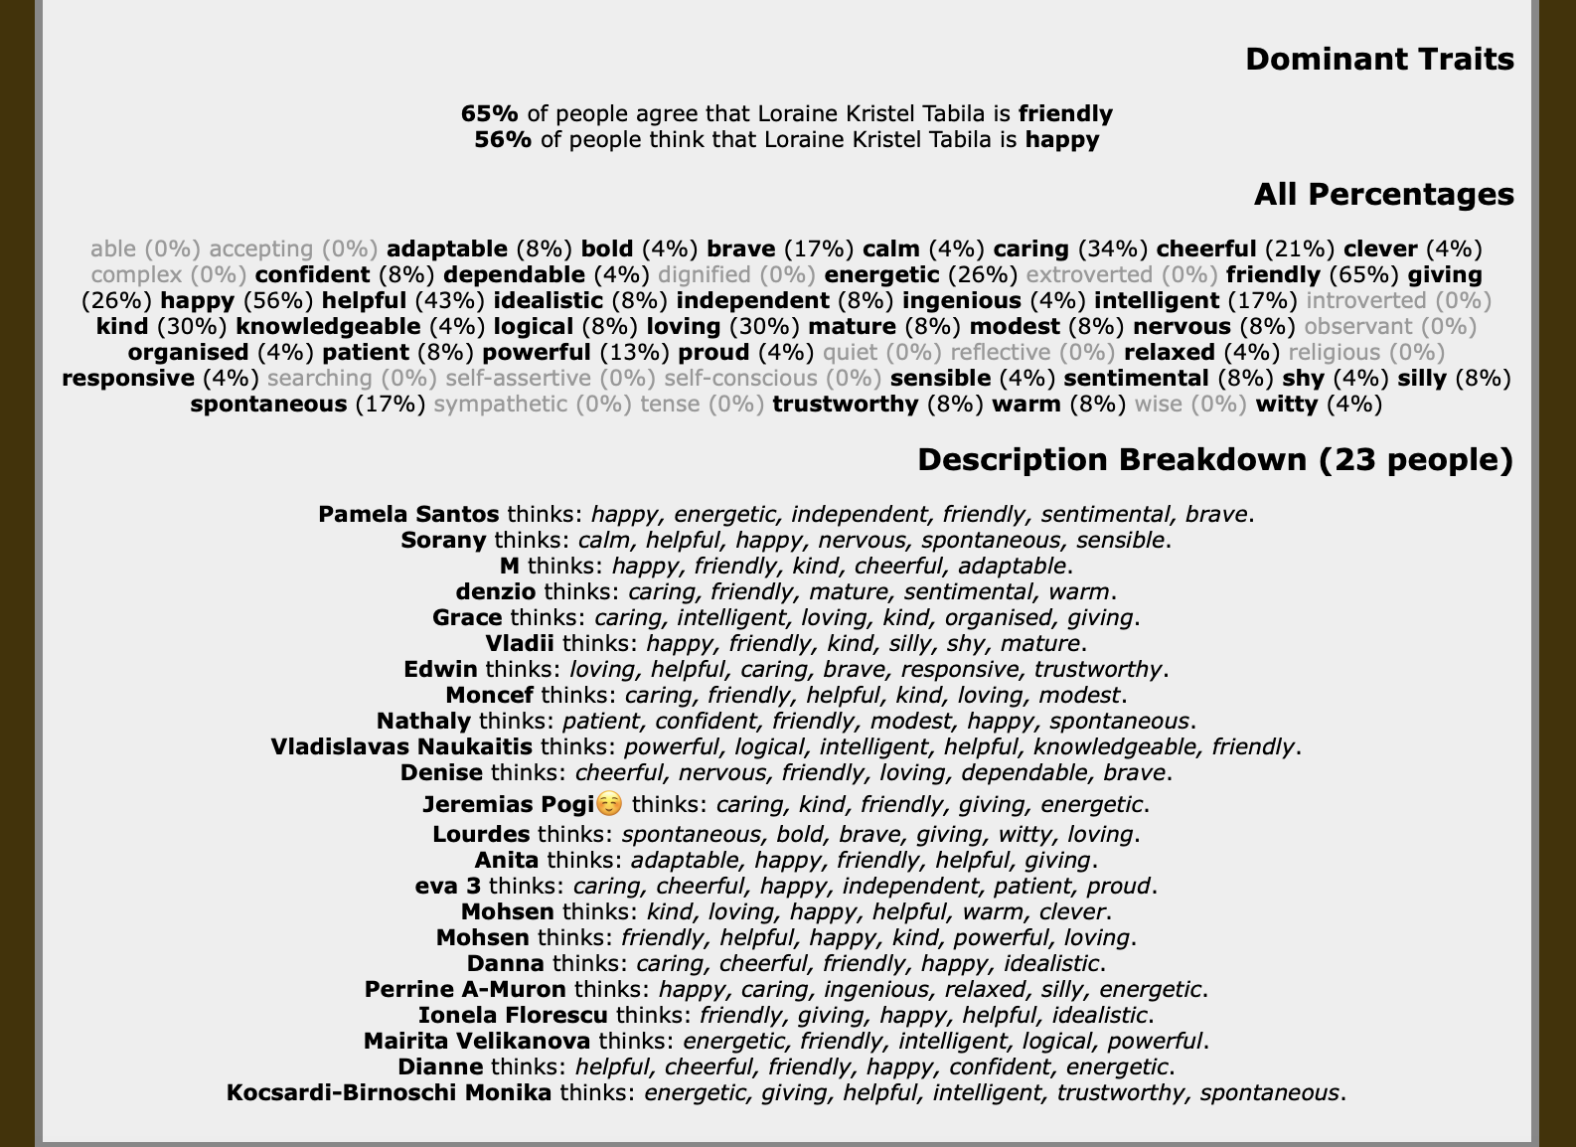

Doing this model, I can see that I am not hiding any another personality. And I have a long list of blind.
And most of their answer reflect that I am a friendly and happy.

6.Personal development plan

The personal development plan is the process that follows specific steps to identify our goals, to achieve them using a structure to reflect in a particular sequence.
It is crucial to recognize our weaknesses and skills that we can use in the future; this method permits us to measure our goals to be successful. (Spacey, 2018)

 | Next to three to six months | Next six months to  Two years | Next to three years
Goal | Pass the certificate of higher education: skills for the workplace student yearbook  To be calm and enjoy my time with son during this pandemic | Year 5 of BA (Hons) Leadership and management  And gate my driving license | Accomplish year 6 of BA (Hons) Leadership and management
Skill to developed and to be learned | Learn more  Develop my skills  To be more calm and practising yoga | Developing my skills and focusing | Developing my skills
Next steps | Focussing  Enjoying and being positive this hard time | Using my fiancé motorbike | Next plan development plan
Resources | Books, Moodle, internet  Toys | Books, Moodle, internet  Practise and learning about street and signal | Books, Moodle, internet
Time schedule | All day | School time and  spare time | School time and spare time

Following the structure of a personal development plan allows me to analyse my professional and personal life objectives, using critical thinking about my abilities and how I can improve to achieve my goal effectively.

7.Conclusion

I always over dream and think that I will accomplish my goals being positive, but now that I grow up, I had realised that being organised and developing better my skills I can accomplish my goals.

And this course it helps me to develop and gain better my skills than before I never thought I had.

It helps me how to research better other career and gain more knowledge, specially, to write and think more in future and not “living with a flow”.

8 Appendix

8.1 Appendix Role play interview

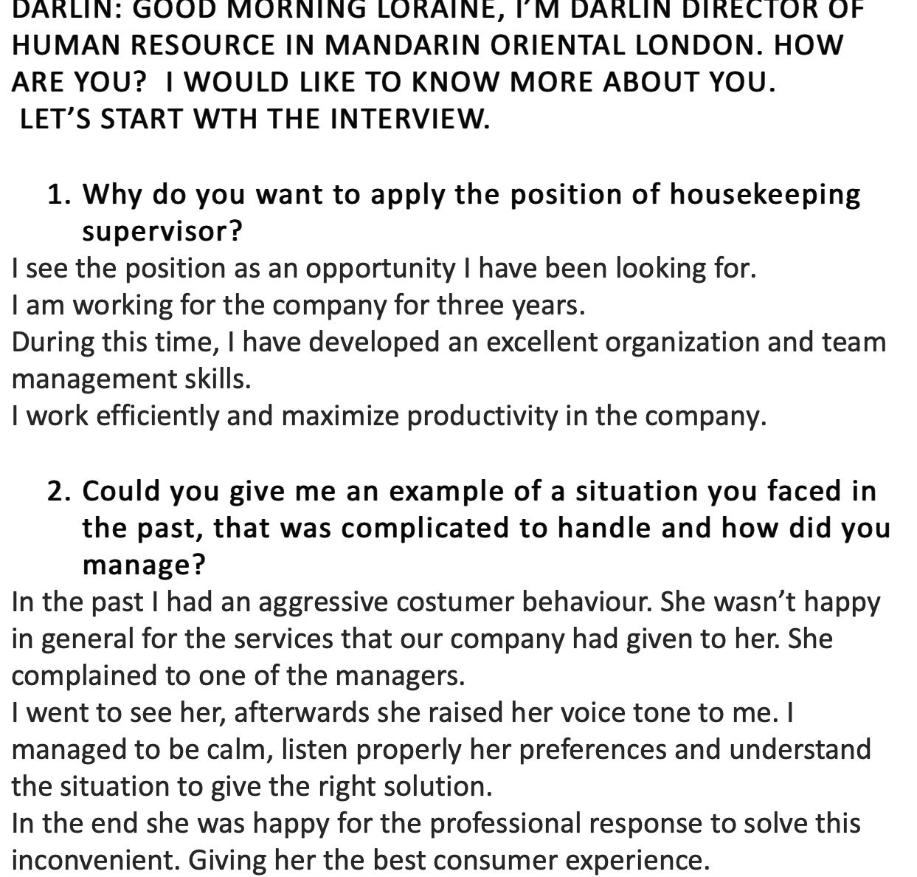
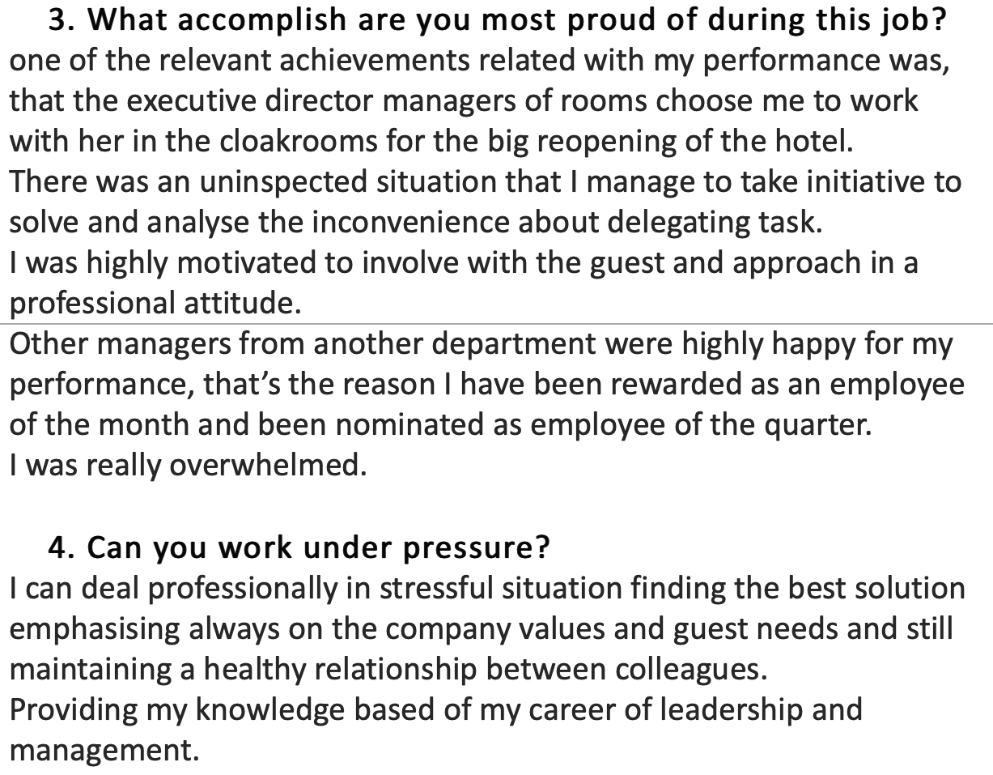
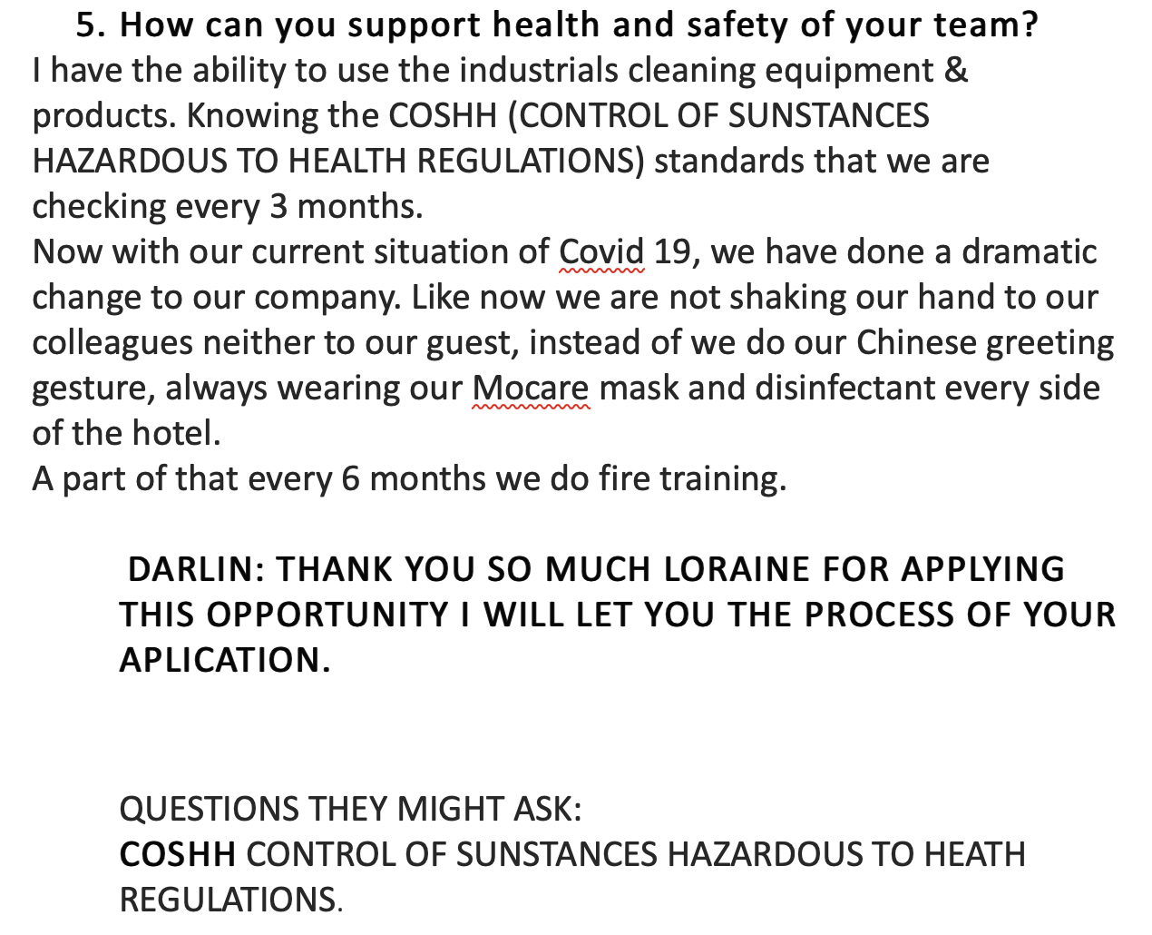

8.2 Appendix self-motivation
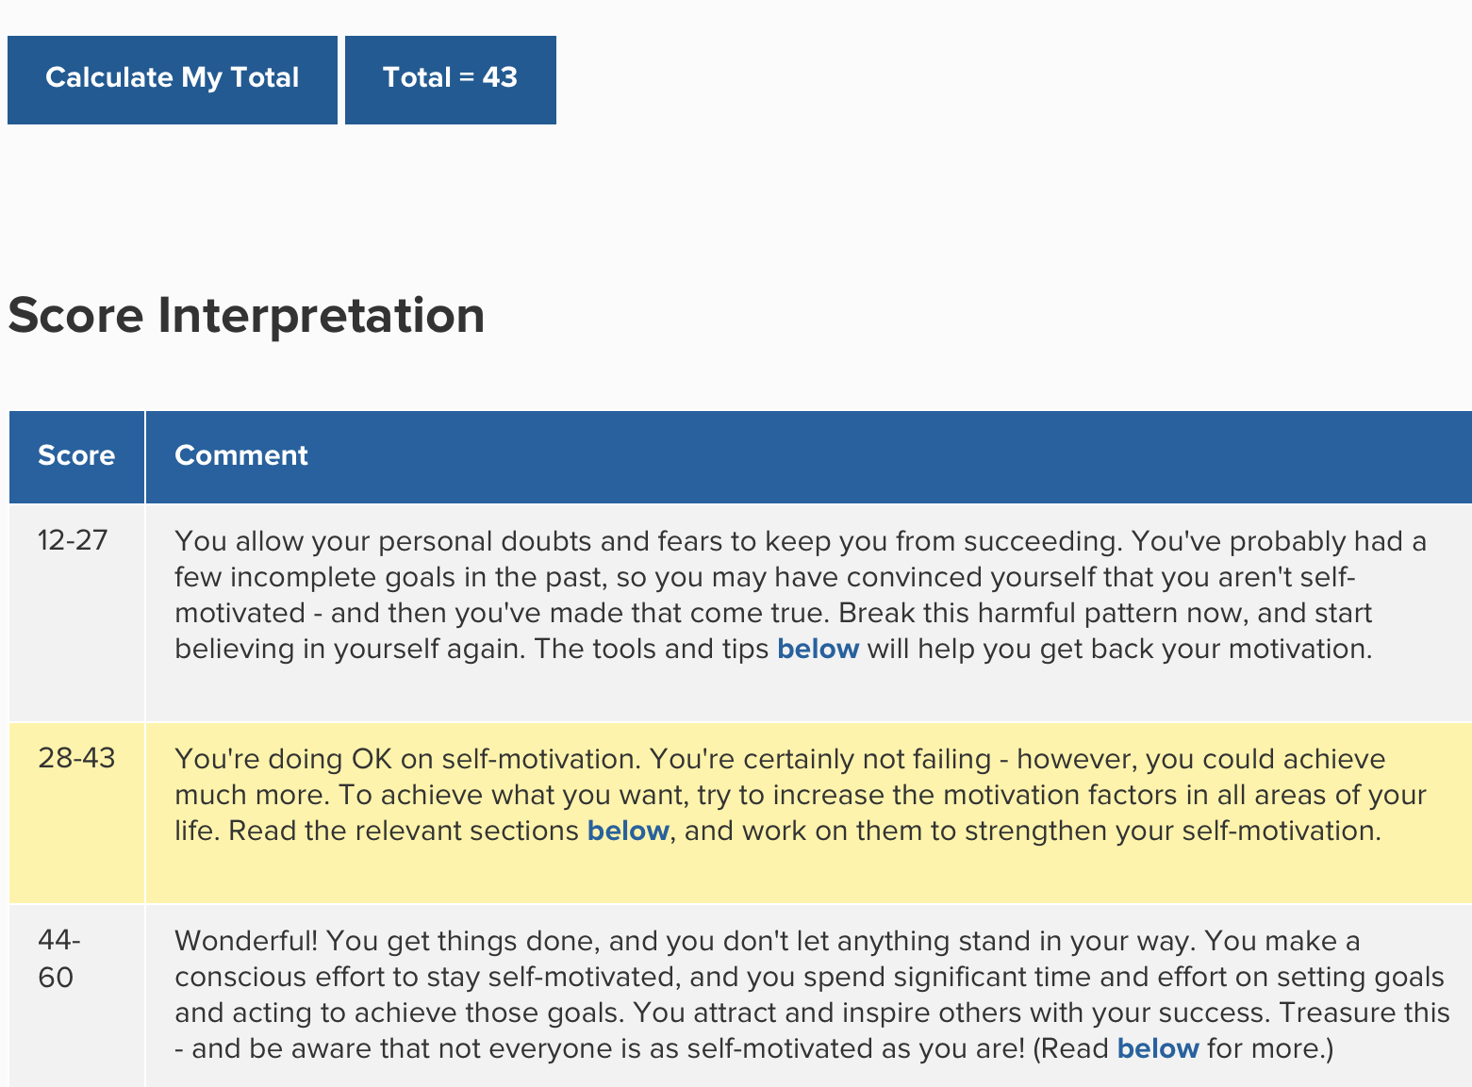

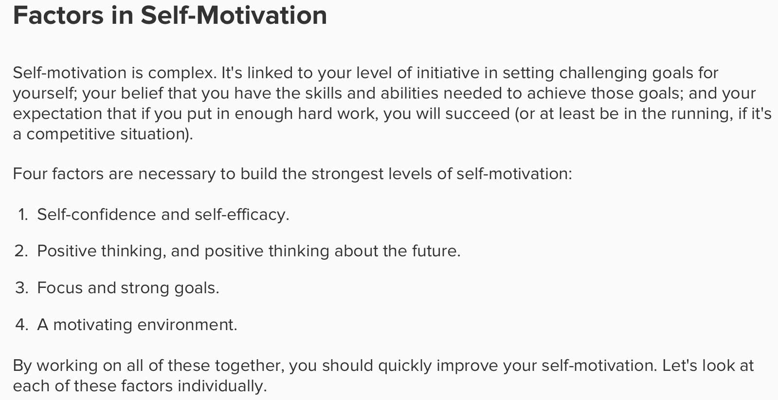

8.3 Appendix VAK questionnaire

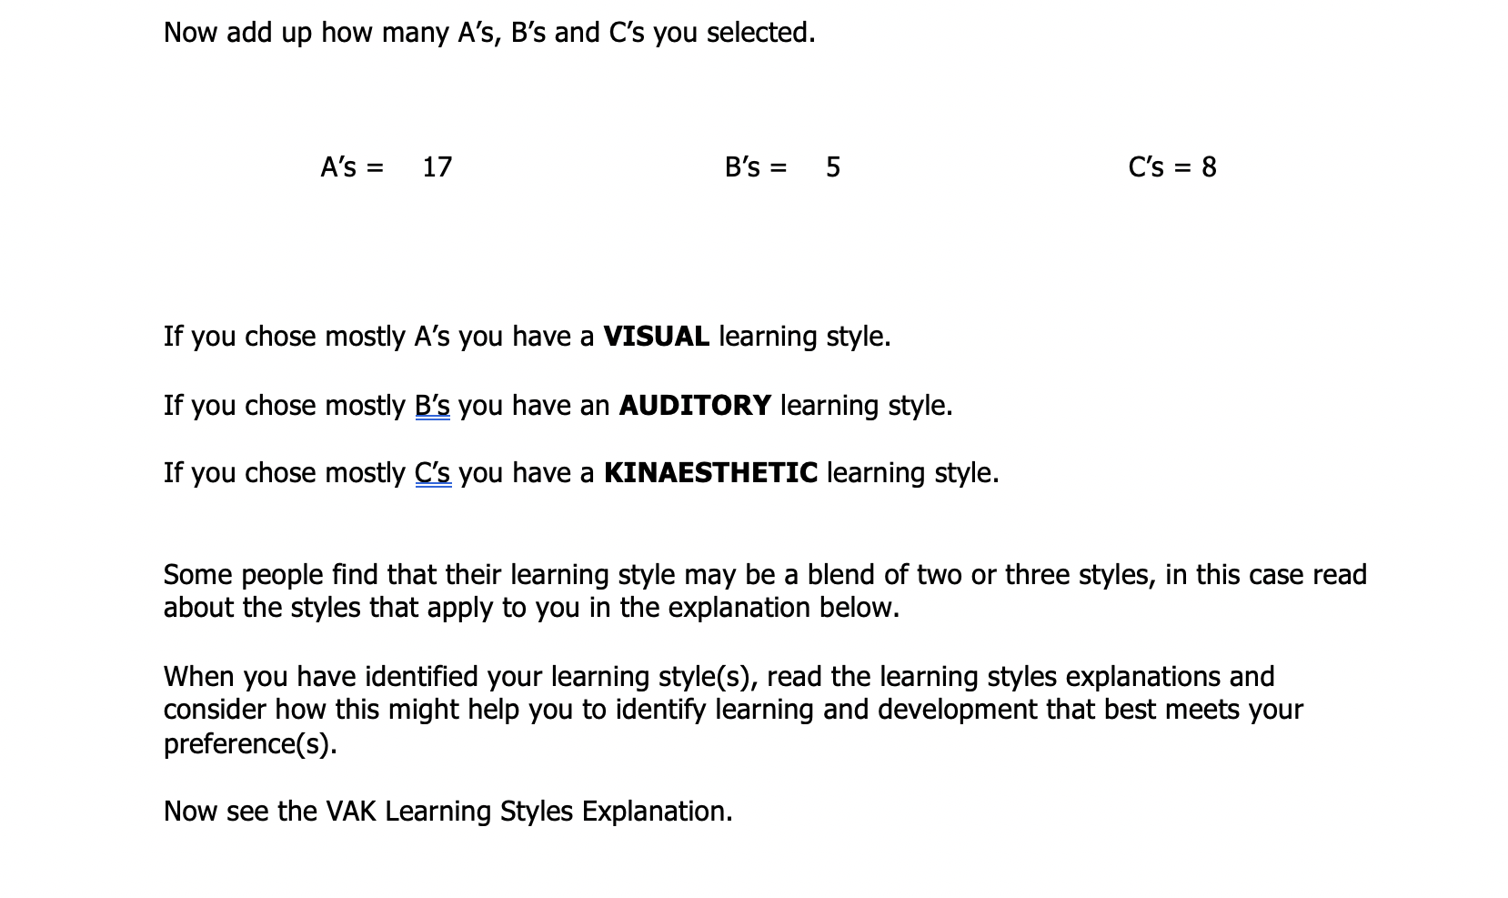
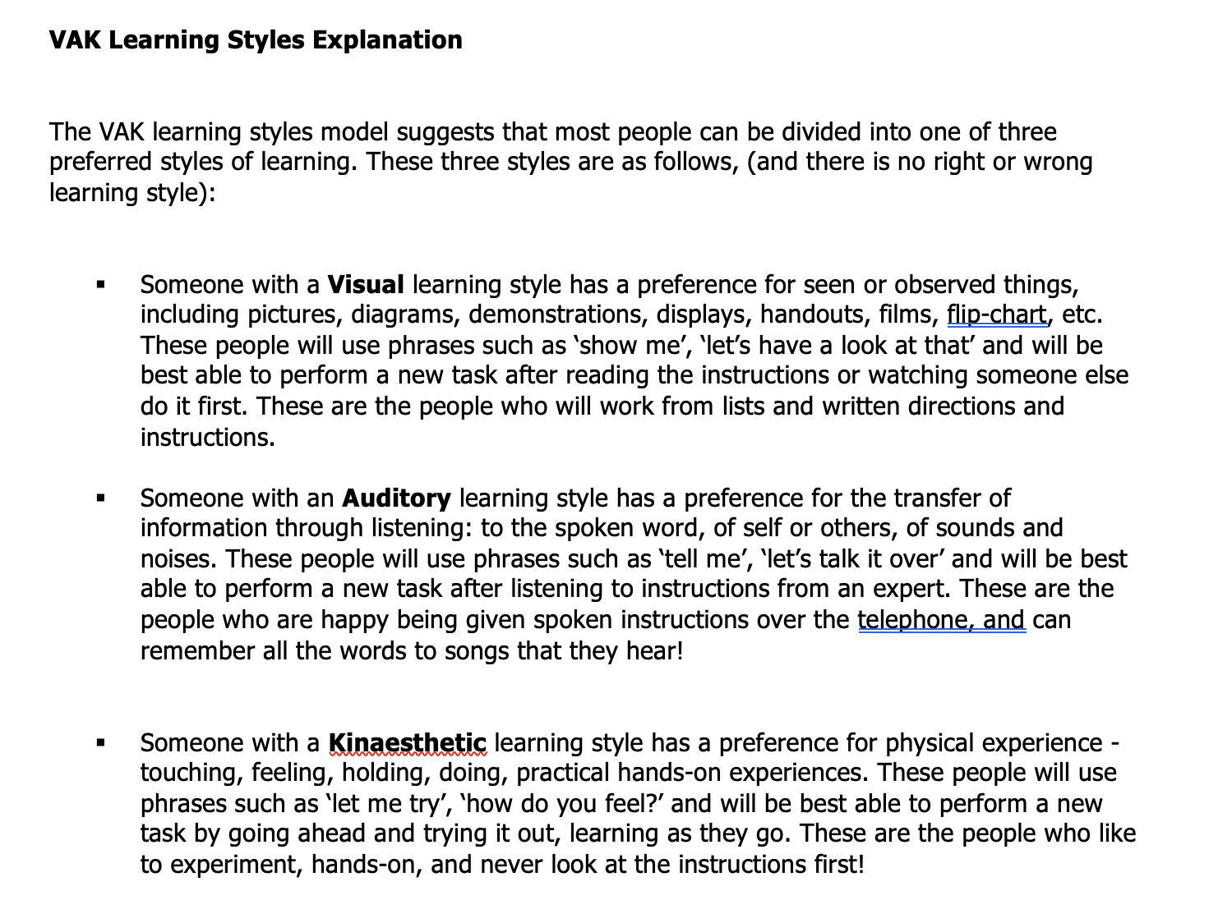

8.4 Appendix Development of personal/ career Vision.

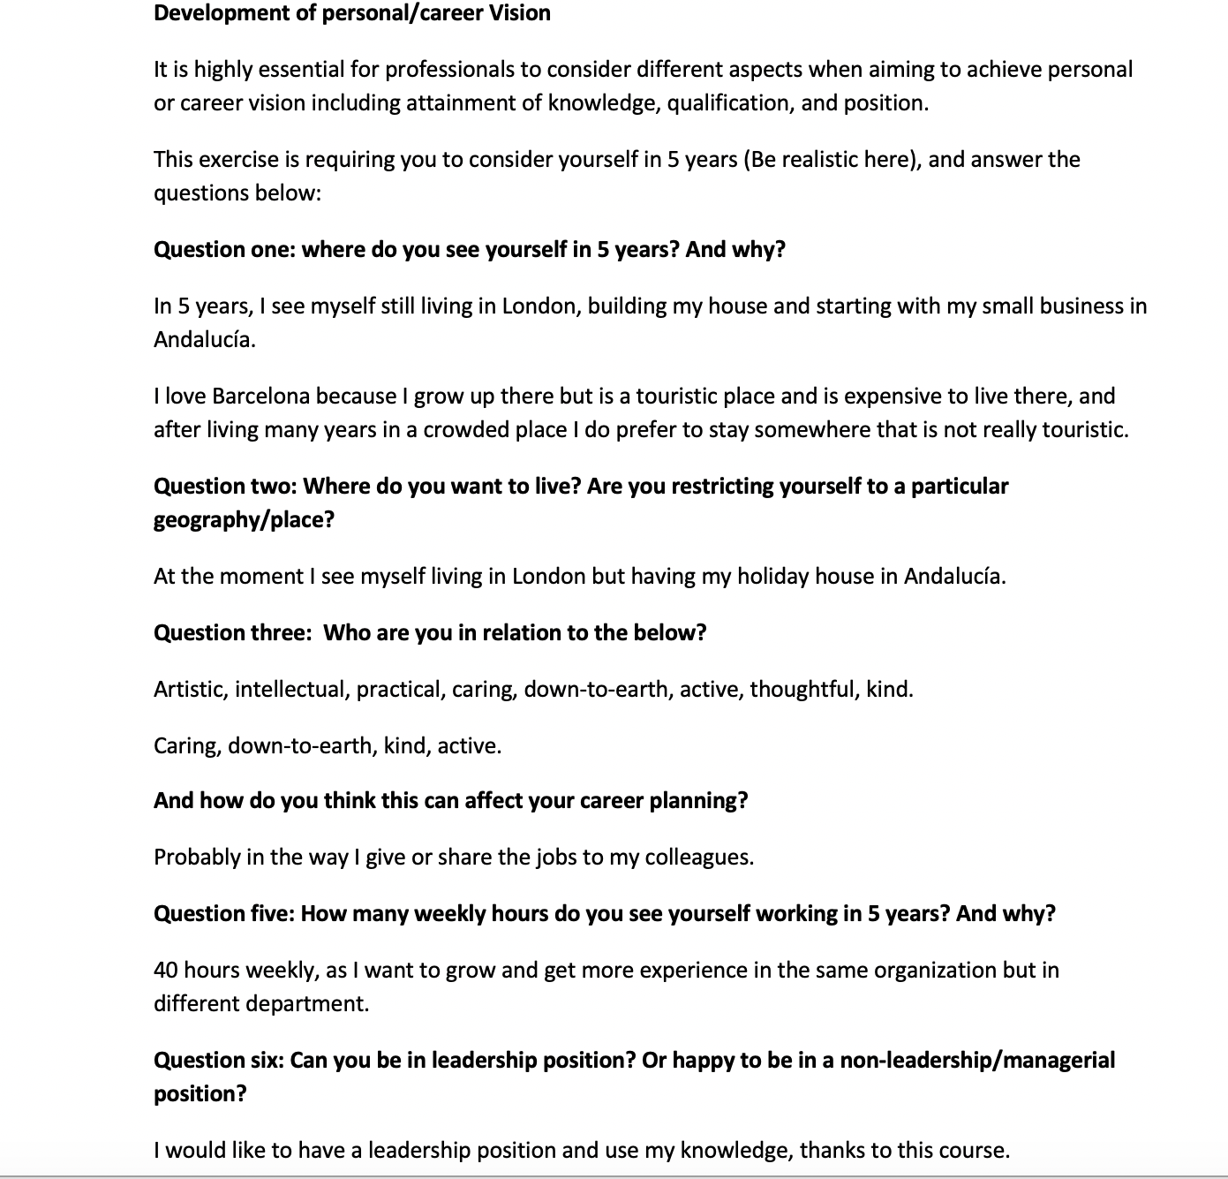
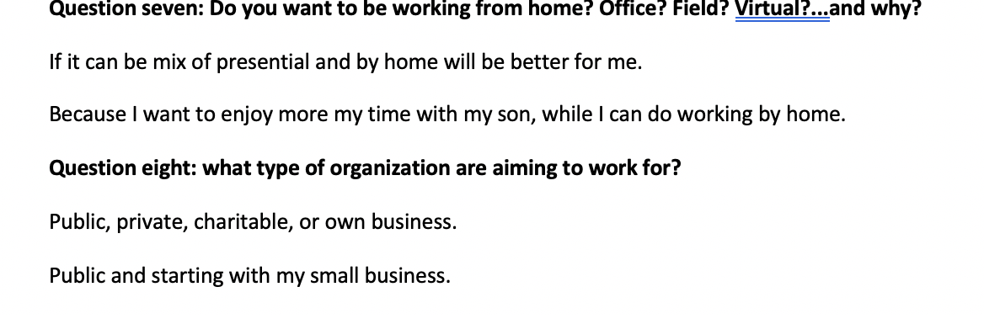

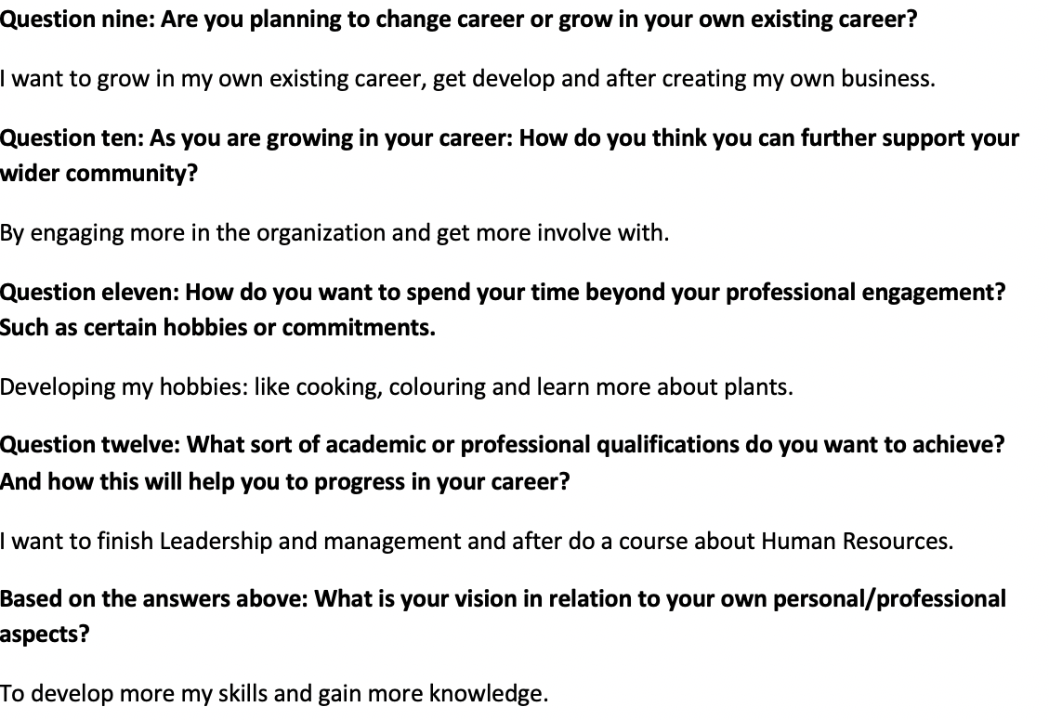

9. References

Bibliography
Andrew Grant, J. M. F. M., 2017. Frameworks for reflection. In: W. Blackwell, ed. Developing Reflective Practice. London: John Willey & Sons Ltd, pp. 28-31.

Ibarra, H., 2007. Identity transitions. Possible selves, liminality and the dynamics of voluntary career change, 24 April, pp. 16-18.

Morgan, P., 2017. Personal Development and learning . In: Sage, ed. The business student guide to study and employability. London: Sage, pp. 29-30.

Parsons, N., 2018. Live plan. [Online]
Available at: https://www.liveplan.com/blog/what-is-a-swot-analysis-and-how-to-do-it-right-with-examples/
[Accessed 4 January 2020].
Spacey, J., 2018. Simplicable. [Online]
Available at: https://simplicable.com/new/personal-development-plan
[Accessed 4 January 2020].

