

Programme Name: Master of Business Administration
Module Code: LCMB7003
Title: Strategic Management
Lecturer Name: Zulfiqar Khan
Student Name: Hafez Hossen Bishal
Student ID: 2439638
Word Count: 5052
Submission Date: 1st April, 2026

Contents
1. Organisational Context and Overview 3
1.1 Overview of Zappos 3
1.2 Industry, Competitors, and Market Position 3
2. External and Internal Environment Analysis 4
2.1 External environment analysis using PESTEL 4
2.2 Critical success factors and strategic challenges in the external environment 7
2.3 Internal environment: resources, capabilities, and core competencies 8
2.4 VRIO analysis of Zappos’ strategic capabilities 9
2.5 How internal strengths contribute to competitive advantage 10
3. CSR and Sustainability Objectives 11
4. Comprehensive and Holistic View of the Organisation 12
4.1 Financial perspective 12
4.2 Customer perspective 12
4.3 Internal business processes perspective 13
4.4 Learning and growth perspective 13
5. Strategic Choices and Implementation 14
6. Strategic Evaluation and Recommendations 16
6.1 Strategic Evaluation of Zappos’ Current Strategy 16
6.1.1 Ansoff’s Matrix Strategy 16
6.2 Recommendations for Improving Competitive Advantage 17
7. Reflective Account 19
7.1 Description 19
7.2 Feelings 19
7.3 Evaluation 19
7.4 Analysis 20
7.5 Conclusion 21
7.6 Action Plan 21
8. References 22

1. Organisational Context and Overview

1.1 Overview of Zappos
Zappos has been a very prominent business in the United States of America. The company has developed a very good brand image in perspective of retail industry. The company has started its business in 1999. The company operates its business an online retail company. Initially, Mr. Nick Swinmurn continued the business as ShoeSite.com. After that, he named the business Zappos.com. This business genuinely focused on retailing footwear at its very beginning, and then the business started growing towards clothing, handbags, accessories, and other products. The company has ensured a very secure image in the mind of customers that customers found reliable. In some years, the company has become a billion-dollar company in 2008 and employed seven hundred people.
When observing the company from a very strategic perspective, it becomes very obvious that the top management of the company has focused on service, culture, and customer experience. This is how the company has built a strong brand identity.

1.2 Industry, Competitors, and Market Position
Zappos has been operating its core business in the online footwear and apparel retail industry. This industry has become more popular among people in the late 2000s. Due to rapid growth in the industry, many business organizations wanted to enter the industry with full rhythm. Some notable companies of those are Nordstrom and Piperlime. These were backed by some notable companies, such as Gap and Amazon-owned Endless.com. For this, the market of the industry has been very competitive. These rivalries have brought financial support, technological advancements, and other resource supports. On the other hand, this rivalry brought some disadvantages to Zappos also. For example, the company must maintain a cost-leadership strategy, extensive counter attack to the actions of competitors, and creating loyal customer segments.

2. External and Internal Environment Analysis

2.1 External environment analysis using PESTEL
PESTEL analysis is now a very common and effective method to evaluate and analyze a business’s or any other organization’s qualitative and quantitative situation. This analysis includes six different factors to better define the market situation of any kind of organization. Those six factors are political, economic, social, technological, environmental, and legal. These six factors create camouflage about the scenario dynamics of any organization’s operating region, while focusing on trust of customers and differentiation (Mursalim Nohong et al., 2025).
- Politics is what runs any country. Without standard politics, no country can thrive towards neither development nor excellence. To ensure these two things, country should ensure that it has a good defined political systems and standards that all the political parties obey respectfully. Here, America is a very liberal country. This country’s political system highly depends on the democracy and all other elements of the country highly encourages this system. In addition to this, political element of any country also represents the relationship of the country with other countries, impacting trade and business of the country. For this, along with people, all other stakeholder parties remain calm and peaceful. This creates a good environment for businesses. All of these elements of politics directly and indirectly support Zappos to do business smoothly. For example, the company does not face trouble from political movements regularly, so the company does not have to worry much about logistic system (Dess et al., 2024).
- The economic element of any country results the very prominent influence in the whole business cycle running within the country. It represents very optimal result issue while navigating all the financial issues in the country. In essence, the economic element of any country in which the firm or business runs, includes financial factors; such as wages rate of workers, cost of production, inflation, deflation, tariff rate, vat, tax, SD, interest rates, and many other things. For Zappos in America, it becomes more soothing. How? In America, the online footwear retail market had a rapid growth in 2006 to 2008. For this an intensive competition between Zappos, Piperlime, and endless.com (owned by Amazon) arose. Some problems that Zappos faced are high shipping cost that reached to 17% of sales of the company and high staffing costs. In addition to this and more importantly, 35% of sales got returned, which created the most challenging camouflage for the company (Deirmentzoglou, Georgios A et al., 2026).
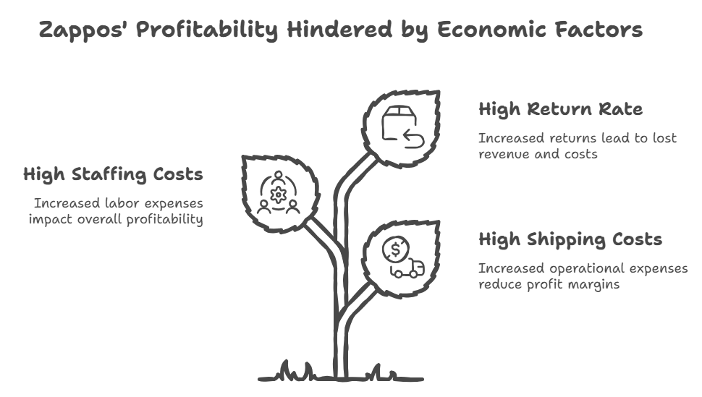
Figure 1: Zappos' Economic Factors
- The social elements of a country in which a firm or organization runs it business have good influence over the overall wellbeing of the organization’s operation. Social elements include values, culture, societal norms, attitudes, and feeling about a thing. The American society is normally more liberal, promotes freedom, self-service, prioritizes convenience, and wants to have emotional boning. Here, Zappos plays a vital role by providing them a good service. How? The company provides products at the home of customers, ensures quality, offers the opportunities to return products if products does not seem as they are on website, thinks of the comfort of customers, and the company always concerns about the convenience of customers in an effective way. These qualities of the company have brought the company in a supreme place in the mind of customers (O’Brien et al., 2019).
- The technological elements of the environment in which any business runs impact the operational excellence efficiently and effectively. Technological advancements have been the most common feature in the case of more diverse business. Because technologies decrease time to accomplish tasks efficiently and maintaining good qualities. Even sometimes technologies help business to complete tasks that human cannot perform. For Zappos in America, the company uses very advanced technologies to grab vast customer base of the country. How? Zappos has focused on developing a very sophisticated website that enable customers to brows very smoothly, offers customers-friendly interface to understand the dynamics, analyzing stock of the business instantly (real-time), and the most sophisticated delivery system that others do not have. This is how the company has developed a good culture of innovation (Islam, 2026).
- The whole world is now going towards sustainability. People now do not only become happy when they have their desired products. They want sustainable products to consume. Sustainability means consuming environment and materials of environment without harming; rather keeping the environment safe for the next generations. So, sustainability becomes a very concerning element. Here, Zappos in America always focuses on the ways to reduce the environmental harming footprint. How? The company highly prioritizes to lower the wastage in the environment, reducing the use of polythene, and efficient transportation that minimizes fuel consumption.
- The legal perspective of America also supports Zappos. The legal system of any country includes rules and regulations imposed by the government of the country. Here, for a company, some notable legal rules and regulations include trade policy, return policy, consumer rights, labor rules, competition law, contract law, negotiable instruments law, service law, shipping law, and so many other laws. For Zappos, these legal issues highly concentrated on the well-being of the company. Because Zappos offers free shipping, free returns, and high service standards. Later, due to these service excellences and the brand image of Zappos, Amazon acquired the company in 2009.

2.2 Critical success factors and strategic challenges in the external environment
Some elements of the environment are controllable. These controllable elements are known as the internal elements of business organization. On the other hand, business organizations alone cannot change some factors, such as natural disasters, inflation, deflation, ban on some specific countries, and so on; these elements are known as external elements. For a better understanding, the report will go through a sophisticated description:
- To be effective in this market, the business must ensure that it is trusted and it provides consistent service quality. If any organization cannot ensure these two true success factors, the company suffers a bad reputation developed over time. For this, Zappos always tried to maintain a standard of service quality. The company includes timeliness, convenience, and completeness, while navigating accuracy of quality service to be relevant in the job market. Here, the company has been going through some notable initiatives to ensure that the company is dedicated to these. Those factors are ensuring 24/7 service, convenience while ordering in the website, providing unique color design, and new products layout.
- Creating customer loyalty is another good point. Zappos has done its business quite well in this sense. How? Because the company receives its 75% of orders from its older customers (YAZID, 2020).
Despite these facilities being ensured by the dynamics, Zappos has some strategic challenges to deal with proper caution. Those strategic challenges extensively impact the well-being of the company in both short-term and long-term perspectives.
- The fear of being copied is one of the notable fears of the company. The company developed a very structured and sophisticated interface and website combo. But this can be copied by competitors easily. In addition to this, website design, shipping policies, and assortment are also very vulnerable elements to be kept confidential. This problem is known as the imitation problem (Tekir, 2022).
- In addition to this, the company also faced crisis in dealing the scaling of the company with new and old culture. Because there is fear that the company minimizes the culture that made the company special in America. This fear was not trivial because there were competitors; such as Amazon and Piplime. They had the resources and facilities to overcome Zappos in some categories.

2.3 Internal environment: resources, capabilities, and core competencies
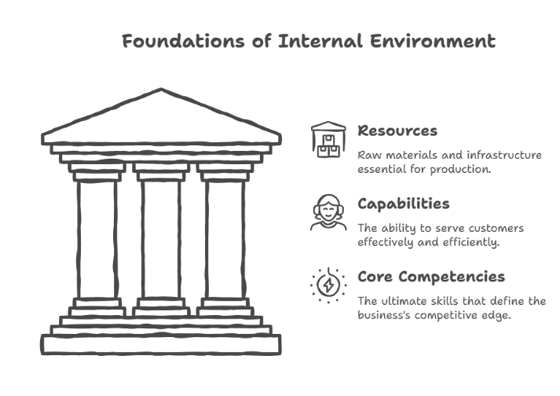
Internal environment refers to the surroundings of the business that belong to the business itself. Business has had the control over the elements of internal environment. This includes productivity, efficiency, input, financial excellence, organizational structure, and intangible resources. Here, some important factors play vital role:
Figure 2: Internal Environment Dynamics
- Resources: Resource is the most important thing in production of the main product. Here, production requires raw materials. Without good quality raw materials, good products cannot be produced. To ensure regular supply of good raw materials, the company must have good agreements with good suppliers who will supply product on time. In addition to this, the company also needs to ensure good logistics systems while navigating real-time stock checking systems. Without raw materials, there some infrastructural developments are needed. For instance, we can talk about dynamic website, delivery system, order processing technologies, ERP systems, and many others (Zeller, 2023).

- Capabilities: Capabilities refer to the ability of business to serve its customers effectively and efficiently. Zappos always focused on this in a very prominent action; such as the company does not consider customer service as a support system; rather the company offers this as a value proposition with its products. The company encourages its employees to react with the customers in this way so that customers feel connected with the company and own the company as their own.
- Core competencies: Core competencies refer to the ultimate skill of any business organization. Here, Zappos has established itself as a relentless customer service providing-company as its core competencies.

2.4 VRIO analysis of Zappos’ strategic capabilities
In this report, a VRIO analysis has been done with thorough care. From the analysis, it has been very much obvious that Zappos has developed a good culture of service-providing system.
- Value: This virtue of the company is very crucial for retail industry business since this quality of the business attract customers, while navigating their trust, convenience, and emotional connection (Wirtz, 2024).
- Rarity: the service the company has developed was very strong and absence in the service of its competitors; including endless.com owned by Amazon and Piplime.
- Imitability: To establish those qualities in service, business has to cost significant amount of financing resources. Because establishing those qualities require a new culture where innovation is encouraged. Also, ambiguous cause, and social complexity have good stake that minimizes the risks to be copied by others in the market (Taran, Boer and Nielsen, 2021).
- Organization: In this section, the report clears and focuses on the issues of the company that it has developed those qualities in its products through constant training, hiring, and customer-service processes. These are highly dependent on leadership systems of the company (Pablo, Javidan and Staff, 2009).
Combining all the factors, it becomes more easier to conclude that the culture the company developed is not only the strength of the company; rather it is the source of the company to be competitive in the market while navigating challenges created by the competitors.

2.5 How internal strengths contribute to competitive advantage
Internal strengths of any business make the business very efficient compared to others. It works like core competencies. In the case of Zappos, it is more relevant when analyzing its core competencies. The company has differentiated itself as the best service-providing company. This is how Zappos has reduced its return rate, while attracting repeat customers. For this, the company has developed a good number of good employees who work on design innovation and quality upgradation in different factors. This has increased the number of loyal customers who consider the brand as their own (Djennas, 2016).

3. CSR and Sustainability Objectives
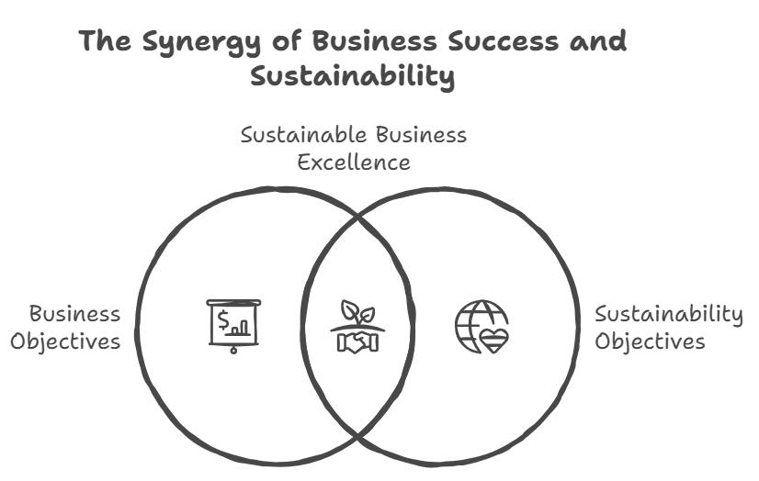
Sustainability is now a good concept in terms of different developed countries. America is a very liberal country promoting sustainability culture. The country’s people now do not want only the products they desire, they want their desired products in a way that do not harm the future consumption of the next generations. For this, working on people, ethics, social developments, and wellbeing of mankind have been very crucial for business organizations to survive, so is for Zappos (Pyka and Nocoń, 2021).
Figure 3: Sustainability and Business
Zappos markets products that do not harm the health. In addition to this, the company focuses on employee well-being, customer satisfaction, and a value-driven culture. The company has arranged a system to know the opinion of its customers. More importantly, the company aims to reduce the wastage (Clay, 2015).

4. Comprehensive and Holistic View of the Organisation
In this report, above it shows that the company does not operates its business maintain cost leadership approach; rather the company runs its business focusing on providing excellent quality service. In this service-oriented business, the company has developed a very sophisticated culture where employees are highly encouraged to be very frank and jolly with customers. Because the company considers customer satisfaction as the sole way to make profit and survive. For this, a balanced scorecard is hugely important for the company (Sanders and Carpenter, 2024).

4.1 Financial perspective
All business organizations want to make profit and Zappos is no different company in this perspective. But the company sets its primary vision to make profit by ensuring sustainability in the society since the world is experiencing an intensified need for sustainability. In the case, it has been very obvious that the company has been a billion-dollar company in 2008. It represents that the company has been very revenue-generating from the very beginning though the company faced significant service costs. The reasons behind the problem are high shipping costs and returns of the products. At the very beginning the company has suffered 17% of shipping cost of overall sales. Over time, the company has advanced its strategies. The company has been efficient in shipping and lowered the costs of shipping; resulting in profit without sacrificing the quality of service. in addition to this, at the very beginning the company suffered 35% of sales return; hampering the profit margin. The company has taken initiatives. The most orders are now from repeat customers. For this, ratio of return has been drastically decreased. This is how the profitability of the company has been increased (Boone and Kurtz, 2013).

4.2 Customer perspective
The customer perspective is one of the most concerning issues, specially in the retail industry business. It is important that what customers think about the business organization. The company has specialized its strategies to train its employees in an effective way so that the behave customers gently and in jolly way with providing them good insights. In addition to this, 24/7 support, regular helpline, and other customer-friendly policies have resulted in Zappos’ customer loyalty. For this, survey says that 75% of orders of the products come from its old customers (Martin and Osterling, 2013).

4.3 Internal business processes perspective
Internal business process holds the most strategic position. If the business’ production cycle is very efficient, the business can offer cost-leadership price, fast delivery, discounts, and many other facilities to customers that competitors cannot provide. Here, Zappos holds that kind of advantage. How? The company has designed good website that allows customers to order products smoothly and it has ERP system that enables the company forecast, navigating demand factors, and many other facilities. In addition to this, the company has developed a good return cycle time, and first-contact problem resolution (Pucelj, Bohinc and Hrast, 2025).

4.4 Learning and growth perspective
Learning and growth perspectives are always prioritized in Zappos. The company highly emphasizes on the culture. The company considers its culture more than just a strength. The company considers the culture as the source of the brand image in the society. For this, the brand highly encourages its employees to learn and grow in ways that how to convince and attract customers. It resulted the company expense significant amounts of resources while giving training to its employees. For a better understanding, we can talk about 225 hours in its pipeline, and had call-centre turnover of only 7%. This ratio is very lower than others (Johnson, 2020).

5. Strategic Choices and Implementation
Strategic choices and implementation are very close and always an ambivalence remains between these two factors. How? Let’s talk about Zappos the American retail industry leader. The company at its business level strategy has several strategic options. Let’s talk about them:
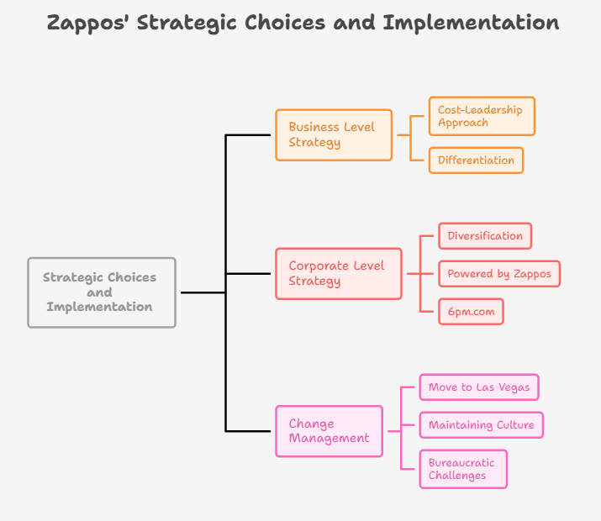
- Cost-leadership approach: Cost-leadership approach refers to the company’s strategy where the company provides products at the lower price compared to its competitors. Here, business organizations achieve productivity and efficiency in its operations to be able to provide products at lower price. Here, Zappos has achieved also the productivity and efficiency. But the company does not comply with cost-leadership theory; rather the company focuses on delivering value-driven services to its customer base (Ringler, Jones and Stevens, 2022).
Figure 4: Strategic Choices of Zappos
- Differentiation: Differentiation refers to defining its customers base in an effective way so that business can better serve that customers segment/s selected by the company itself. Here, in America, Zappos has done also this thing in an efficient strategic method. Here, Zappos offers its customer base a vast scope of choice, free shipping facilities, free returns, structured products use directions, and good customer support service. Here, the company highly prioritizes the internal culture of the company. The company and its top management highly believe in that physical infrastructure might be copied by others but good culture within the company cannot be copied (Diler, 2018).

The company do not comply with both strategies because the company considers these strategies as stuck in the middle factors. Since with the low costs, it becomes tough to offer innovative product design and good quality products cannot be produced. On the other hand, at corporate level strategy, the diversification strategies arise while navigating different challenges in the external environment of the business. For instance, we observe that the company has expanded its business from only shoe retail business to clothing, handbags, and accessories. In addition to these, there some other initiatives at the corporate level strategy taken by the company. The company has founded Powered by Zappos and the company has also taken over 6pm.com. It is true that the company had potential to also cover the international market since the company sells its products over online and it is easier for the business to sell products in international markets and does not require any other facilities except good delivery method that already has been developed by the company. Since the company considers its culture of good customer service, the company does not want to rapid expansion as this may hamper the good culture which is the foundation of the company (Kruti Lavingia et al., 2024).
Change management is also a very important factor while navigating changes within the company. Zappos did good changes in terms of the expansion, adopting new strategies, and others. But the company could not perform the changes without tensions. For example, the company considers its move to Las Vegas as the biggest change, and yet that time the company never compromised with the productivity, efficiency, lower labour costs, and 24/7 customer support. More importantly, the company highly took pressure to maintain the good values, culture, training, and innovative leadership while the changes occurred though the bigger the company became, the more bureacratic it appeared (Fischer and Praxmarer-Carus, 2021).

6. Strategic Evaluation and Recommendations

6.1 Strategic Evaluation of Zappos’ Current Strategy
Zappos has been thriving towards the market leadership in the online retail business for a long period. The company has been the billion-dollar company in 2008. The company has developed some qualities to counterattack the initiatives taken by its competitors. One notable strategy of those qualities is the differentiation strategy. Here, in the differentiation strategy, Zappos heavily focuses on specialized customer support while ensuring good company culture and customer loyalty. Low-price offering companies could not replace these qualities with their low-priced products (Grigoriou and Rothaermel, 2016).
While using SWOT analysis, the report shows that the company has several strengths, namely, strong customer relationship management, 24/7 customer support ability, brand identity, trust in brand, and strong physical infrastructure, including a good website, easy user interface, easy order process, and so on. These elements create the customers’ ownership of the brand. The brand has some weaknesses also, including vulnerability in websites while making orders due to server problems and the banking channel. While talking about opportunities of the company, the company has some new opportunities, including international expansion, grabbing new segments of customers, and adding new categories of business. The company has some threats also, including the threat of competitors and new entrants, while the country is at war with Iran and in a cold war with some other countries. Here, tariffs and the blocking of roads play a vital role (Heath et al., 2012).

6.1.1 Ansoff’s Matrix Strategy
Ansoff’s Matrix Strategy | Strategy Overview | Strategic Implications
Market Penetration | The company has created trust. It has been possible by providing a very consistent customer service to the customers. This built customer loyalty. | To increase the market share, the company consistently kept its quality and attracted new customers, and more importantly the implications of this strategy resulted in satisfied customers who repeatedly purchase products.
Product Development | Zappos now not only sells shoes, but the company has also developed products in several categories, including clothing, handbags, and accessories. | Due to offering similar types of products of the company, the company has also been relevant in the market, while ensuring some new categories of profit margin.
Diversification | Zappos focuses on diversification, it is true. But the company, at the same time, focuses on the avoidance of unnecessary expansion. For instance, to save its culture, the company did not enter the international market. | This is how the company has minimized the unnecessary uncertainties while expanding and doing business effectively and efficiently in the market. More importantly, it has created scopes for the company to more expertise its core competencies.
Competitive Pressure | Zappos’ journey is not quite very soothing. The company has to face endless.com, owned by Amazon, and a giant company like Piplime. | These competitive pressures of the external environment have supported the company to do innovation, establish a good culture, create customer relationship and provide good service.
Figure 5: Ansoff’s Matrix Strategy

6.2 Recommendations for Improving Competitive Advantage
To do well in this market, Zappos should take some more initiatives to be more relevant and to survive the upcoming pressure from different types of dynamics. Some of those potentials have been described in well-mannered scenarios.
- The company should focus more on its differentiation strategy to be more efficient
- Zappos should increase the amount of investment in hard-to-imitate intangible assets. Because physical infrastructure might be copied. This is how the company will keep the core competencies intact and the infrastructural development will support its operations.
- While going for expansion, the company should analyze whether this expansion is related and whether the company has the ability to serve that new segment.
- Since there is increasing awareness about sustainability and social responsibilities among consumers, Zappos must comply with the pulse of the customers.

7. Reflective Account

7.1 Description
From the very beginning of the report, I have created a draft of this report about Zappos. I analyzed the historical data of Zappos to better know the company. For this, I have focused on many dynamics of the company. For instance, we can talk about the external environment, internal scenarios, and the strategic choices of the company to choose. In addition to these points, there were other points, such as implementation and recommendations of the strategic innovation and systems. In this description stage, I have been benefited by increasing my capabilities to understand complex scenarios, where data are not organized properly; rather scattered in different sources.

7.2 Feelings
Once I had understood the scenarios, I felt the need for some tools to analyze the scattered data. While analyzing the data, it increased my critical thinking to use relevant tools to get the proper analysis. This made me a little nervous since this is not quite a descriptive assignment; here, I needed to do more than explain theories and policies. I had to relate them to real-time data. For this, I finally reached my decision that I need to use tools such as SWOT, PESTEL, VRIO, and Ansoff’s Matrix Strategy. At this post-graduate level assignment, it has been very easy for me to conclude my decision by taking all other issues into consideration. Though I worried about whether I would be able to conclude and describe all those factors effectively, I was confident due to my previous consistent experiences of analysis, and when I started working on Zappos, I really felt very comfortable. Because the company is very clear to its audience. For instance, the company has pushed a very common thing, which is its culture. The company has developed the finest culture to lead the market, and the company adheres to all its other factors to keep the culture intact.

7.3 Evaluation
In the evaluation stage, I am very confident and happy with the factors associated with the common features in the markets. Before starting to write the report, I focused on the brief given by the teacher. I tried to understand what the teacher wanted me to learn, and I focused on the learning objectives mentioned in the brief. Then I created a draft of the paragraphs I need to include in this report. Then I chose Zappos as the selected company that was a blessing for me. After that, I started writing, approaching each of the strengths and weaknesses of the company. In the company, I got to know the good culture, the process of serving customers, differentiation, cost-leadership approach avoidance, diversification, customer support, 24/7 service providing capabilities, and value-driven business policies. I also learned how the company deals with challenging scenarios, including situations when operating costs increase, the cost of delivery increases, the availability of labor decreases, the logistics system falls into instability, and supply chain problems.

7.4 Analysis
At the analysis stage of the report, I have gone through a diverse range of critical thinking ability learning. The analysis stage has enabled me to directly bring all the data into tools and process the raw data in an organized way to better make decisions. In this stage of the report, I have learned that strategic management is not only about choosing a strategy. It is about ensuring that the company complies with the implementation of the chosen strategies. For instance, in this report, in the case of Zappos, we observed that the company highly prioritizes good company culture. To perform this, the company adopted other strategies in a standard way so that it would not harm the culture of the company.
In this part of the report, I have also learned about the internal and external environment elements in the case of the control mechanism. When structuring the draft, I made a mistake about keeping them into a same section. But I understood my mistake while writing the report that the internal strengths of the company highly matter because they are the real reasons to answer the external elements of the company. For instance, let’s clear the problem with an example; when ordering shoes from the website, customers do not understand whether the shoes will fit or not. For this, the company has arrangements, such as returns, strong services, and customer support.

7.5 Conclusion
To be more specific about the report, the report has been a very crucial learning point for my early career. The report has provided me with many valuable insights about the dynamics of career and learning, including the ability to observe raw data, making them organized, and then analyze it. More importantly, the report has enabled me to make a decision about what strategy should be adopted under what circumstances. For example, Zappos did not choose international expansion to keep its culture secure from any damage. Because the company believes that the culture it has developed is more important than the drastic market expansion. In addition to this, the company has increased the categories of business to keep a good margin of profit in terms of the market share.

7.6 Action Plan
As an action plans, I have thought of many initiatives to make my future career smooth from this experience of the report. To be specific, I found several factors to improve.
Firstly, I will work on how to manage more time in planning. Because planning is the most important thing, it has been clear in this assignment. So, I will seek some more ways to do thorough planning before starting any new task. Secondly, my core focus will be on my weaknesses and threats to perform the assigned tasks. These will help me to know what skills should I have to perform. Then I will focus on ways to manage my time effectively, since managing time will improve the ability to ensure the quality of work.

8. References
Boone, L.E. and Kurtz, D.L. (2013). Essentials of Contemporary Business. Wiley Global Education.
Clay, B. (2015). Search Engine Optimization All-in-One For Dummies. John Wiley & Sons.
Deirmentzoglou, Georgios A, Anastasopoulou, E.E., Geldres-Weiss, Valeska V, Jovanovski, B. and Masouras, A. (2026). Entrepreneurial Resilience in Turbulent Globalized Economies. IGI Global.
Dess, G.G., Mcnamara, G., Eisner, A.B. and Sauerwald, S. (2024). Strategic management text and cases. 11th ed. New York, NY McGraw-Hill Education.
Diler, Dr.U. (2018). Formation of Defining Ideology that Althusser Refers: Its Influences of Feminism. International Journal of Humanities and Social Science, 8(12). doi:https://doi.org/10.30845/ijhss.v8n12p6.
Djennas, M. (2016). Business cycle volatility, growth and financial openness: Does Islamic finance make any difference? Borsa Istanbul Review, 16(3), pp.121–145. doi:https://doi.org/10.1016/j.bir.2016.06.003.
Fischer, D. and Praxmarer-Carus, S. (2021). What Consumer Responses Make a Brand Experience Create Brand Attachment? Marketing ZFP, 43(3), pp.35–48. doi:https://doi.org/10.15358/0344-1369-2021-3-35.
Grigoriou, K. and Rothaermel, F.T. (2016). Organizing for knowledge generation: internal knowledge networks and the contingent effect of external knowledge sourcing. Strategic Management Journal, 38(2), pp.395–414. doi:https://doi.org/10.1002/smj.2489.
Hartanto, P. (2023). Proceedings of the International Conference on Economics, Management, and Accounting (ICEMAC 2022). Springer Nature.
Heath, S., McMahon, K., Nickels, L., Angwin, A., MacDonald, A., van Hees, S., Johnson, K. and Copland, D. (2012). The neural correlates of picture naming facilitated by auditory repetition. BMC Neuroscience, 13(1). doi:https://doi.org/10.1186/1471-2202-13-21.
Islam, R. (2026). Building High Performance Culture: Zappos - 940 Words | Case Study Example. [online] Free Essays. Available at: https://ivypanda.com/essays/zappos-case-study-project/ [Accessed 22 Dec. 2022].
Johnson, G. (2020). Exploring Strategy, Text and Cases, 12th Edition. 12th ed. Pearson UK.
Kruti Lavingia, Patel, R., Patel, V. and Lavingia, A. (2024). Software Effort Estimation using Machine Learning Algorithms. Scalable Computing. Practice and Experience, 25(2), pp.1276–1285. doi:https://doi.org/10.12694/scpe.v25i2.2213.
Martin, K. and Osterling, M. (2013). Metrics-based process mapping : identifying and eliminating waste in office and service processes. Boca Raton, Fla.: Crc Press.
Mursalim Nohong, Fitra Roman Cahaya, Tuan, P.M., Mannan, A., Anwar, A.I., Rianda, Prima, N., Andi Tenri Harahap, Muhammad Try Dharsana and Fakhrul Indra Hermansyah (2025). Proceedings of the 9th International Conference on Accounting, Management, and Economics 2024 (ICAME 2024). Springer Nature.
O’Brien, D., Parent, M.M., Ferkins, L. and Gowthorp, L. (2019). Strategic Management in Sport. Routledge.
Pablo, A.L., Javidan, M. and Staff, S.M.S. (2009). Mergers and Acquisitions : Creating Integrative Knowledge. Williston: Wiley.
Pucelj, M., Bohinc, R. and Hrast, A. (2025). Investigating Directors’ Accountability in Promoting Corporate Social Responsibility. IGI Global.
Pyka, I. and Nocoń, A. (2021). Banks’ Capital Requirements in Terms of Implementation of the Concept of Sustainable Finance. Sustainability, 13(6), p.3499. doi:https://doi.org/10.3390/su13063499.
Ringler, C., Jones, C.L.E. and Stevens, J.L. (2022). The Ostrich effect: Feeling hidden amidst the ambient sound of human voices. Journal of Retailing, 23(12). doi:https://doi.org/10.1016/j.jretai.2022.02.001.
Sanders, T. and Carpenter, A.M. (2024). Fieldwork Educators’ Perceptions of the Revised Fieldwork Performance Evaluation. Journal of Occupational Therapy Education, 8(1). doi:https://doi.org/10.26681/jote.2024.080110.
Taran, Y., Boer, H. and Nielsen, C. (2021). The Business Model Innovation Process. Routledge.
Tekir, Ö. (2022). The relationship between fear of COVID-19, psychological well-being and life satisfaction in nursing students: A cross-sectional study. PLOS ONE, 17(3), p.e0264970. doi:https://doi.org/10.1371/journal.pone.0264970.
Wirtz, B.W. (2024). Digital Business and Electronic Commerce. Springer Nature.
YAZID, A.S. (2020). Does Corporate Social Responsibility Activities Have a Role in Creating Customer Satisfaction and Customer Loyalty? Journal of Research on the Lepidoptera, 51(2), pp.106–123. doi:https://doi.org/10.36872/lepi/v51i2/301082.
Zeller, T.A. (2023). The Most Important Thing. Family Medicine, 55(10), pp.691–691. doi:https://doi.org/10.22454/fammed.2023.616016.

