Version 1.0
date 10/01/2025

Presented by: Leon Buckney
Teachers name: Divya chidambaram
cOURSE NAME: Introduction to Web and Database Concepts (ACCA4023)

Introduction
This website also known as the Travis Scott fan club was created because im a very big fan of his music and have listened to him for many years e.g,. since he started. And this website was created to be interactive and a immersive platform for fans to connect with the globally renowned artist. This website I created provides a detailed biogrpahy about Travis scotts life,fame and success not mention his music and tours all while fostering a sence of community among his audience. Designed and hand-coded to adhere to modern we development standards, the website employs a responsive design to ensure compatibility across various devices. This report examines the planning, design, implementation, and evaluation processes involved in the creation of the website, detailing how these align with the industry standards and user expectations.
A major objective of the project was to reflect Travis Scott’s unique artistic identity through a combination of vibrant aesthetics and functional elements. As a devoted fan of Travis Scott, I wanted to ensure the website celebrated his music and career while providing fans like me with and engaging online hub. This required in depth researchinto his branding, fan base, and preferences to create a digital presence that resonates with his followers. Additionally, the report explores the technical challenges encountered during development and the silutions implemented to overcome them. By leveraging tools like validation services and accessibility guidelines, the final product ensures a professional-grade user experience.

Requirements
The primary goal of the Travis Scott Fan Club website was to provide and engaging and informative platform that caters to the needs of fans. The target audience includes young adults and teenagers who are technologically adept and value visually appealing, interactiveweb experiences. The website was required to balance aesthetics with functionality, delivering a seamless user journey across its five core pages: Home,About,Music,Tour,Contact.
The purpose of the website extended beyond being a mere information hub. It aimed to evoke the dynamic energy and creativty that define Travis Scott’s brand. The colour scheme dominated by black,orange and white was carefully selected to reflect sophistication and designed to be intuitive, with clear links to all major sections, providing users with a straight forward browsing experience.
Accessibility played a significant role in the deswing requirements. Adherence to WCAG 2.1 guidelines ensured that the website could be used by individuals with diverse abilities.Features suach as alt text for images, adequate colour contrast, and keyboard navigation support were incorporated to enhance inlclusivity. The website also had to meet SEO standards, incorporating meta tags, optimised, image descriptions, and structured content to improve visibility on search engines.
As a personal fan project, it was vital to include interactive elements that added value for users and reflected my enthusiam for Travis Scott’s work. This included dynamic maps on the Tour page, a user-friendly content form, and engaging visual grids on the Music and Home pages. These features were integrated seamlessly into the design ensuring consistency and alignment with the website’s objectives.

Implementation
The Travis Scott Fan Club website was developed using HTML5 and CSS3, ensuring compliance with modern web standards. Each page was carefully crafted to serve its specific purpose while maintaining a cohesive design language. The Home page acts as the entry point, featuring a grid-based layout that introduces key sections of the website. Each grid element includes an image and a brief description, guiding users to explore more detailed content .
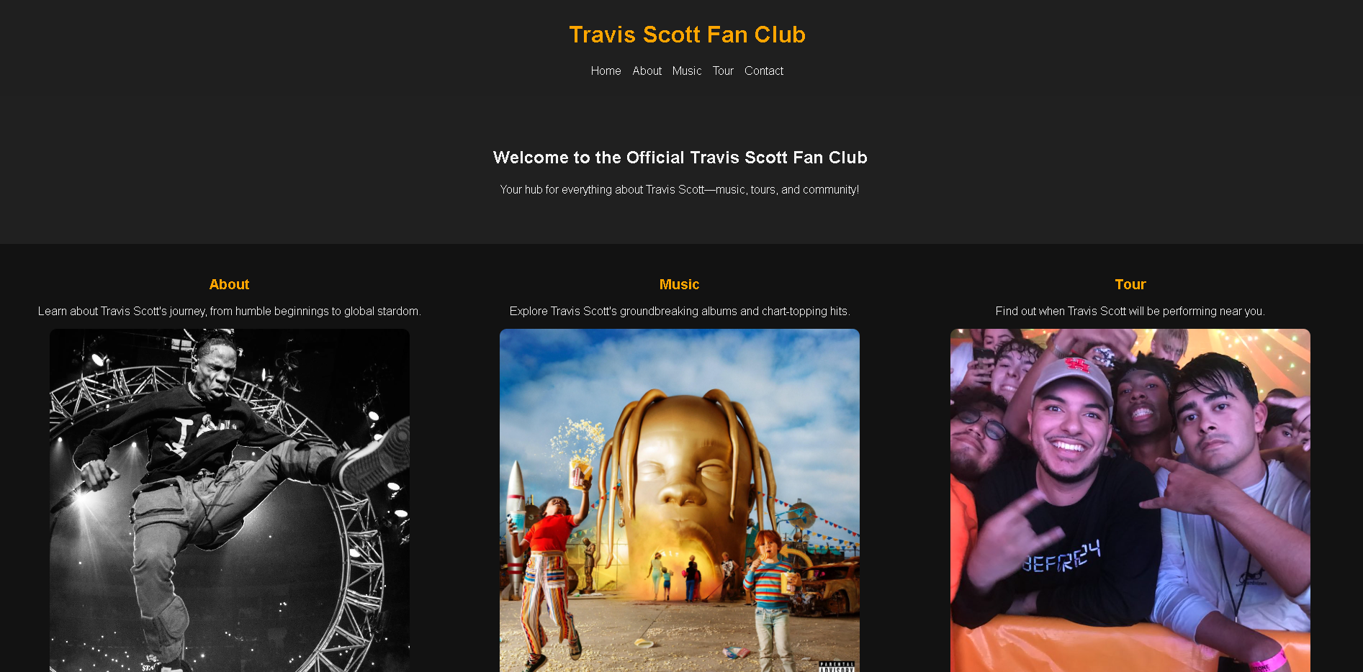
(this image is cropped)
The About page offers a comprehensive biography of Travis Scott, divided into sections covering Early Life, Music Career, and Legacy. A full-page background image creates an immersive experience, while the structured content provides a narrative flow that captures the artist’s journey and achievements. The use of semantic HTML elements such as <section> and <article> ensures clarity and accessibilty.
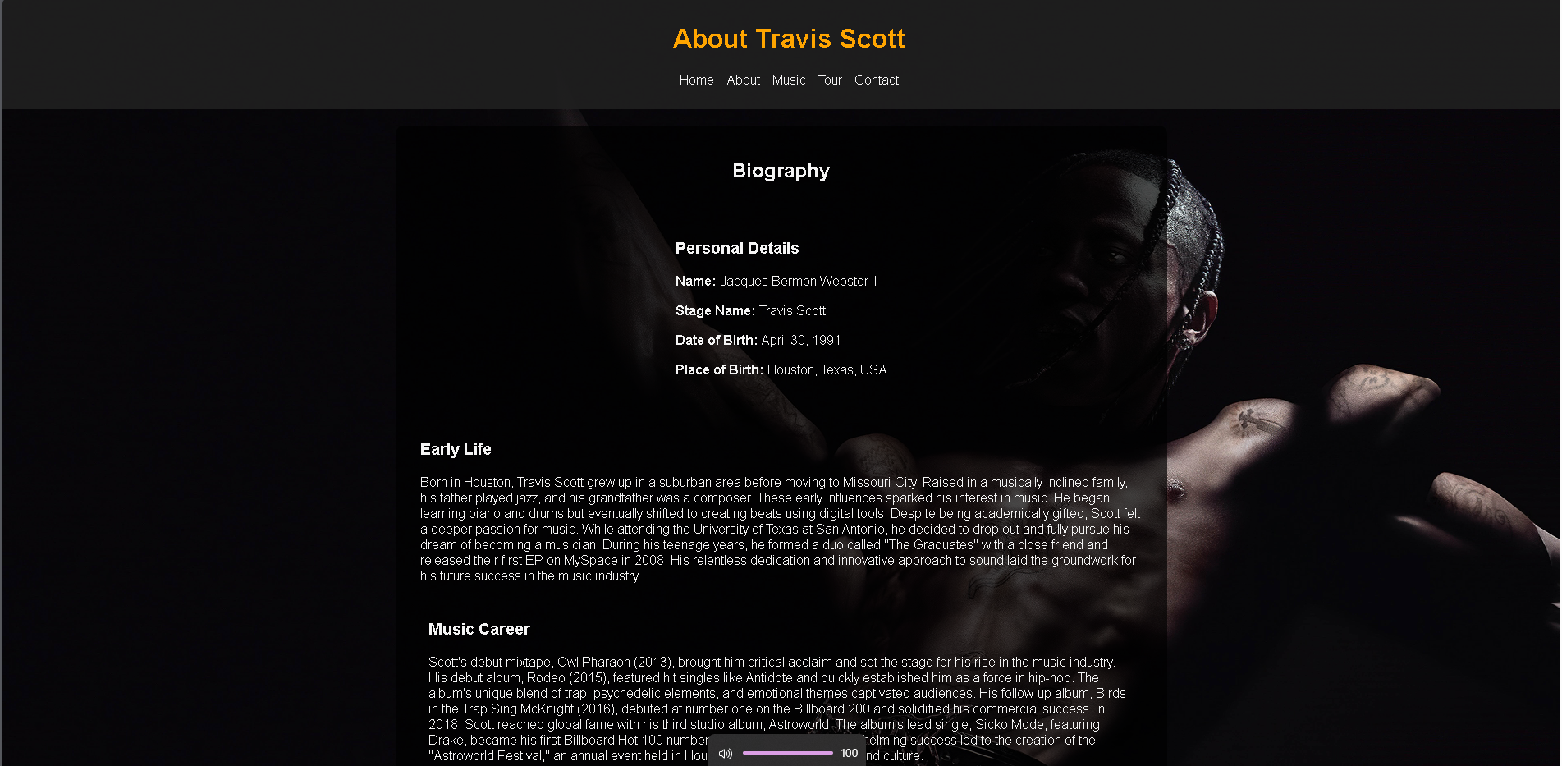
(this image is cropped)
The Music page highlights Travis Scotts discography, presenting albums in an interactive grid format. Each album entry includes its cover art, release date, and a brief description of standout tracks. CSS hover effects add interactivity, encouraging users to explore further. The layout is responsive, ensuring that the grid adjusts gracefully across different screen sizes.
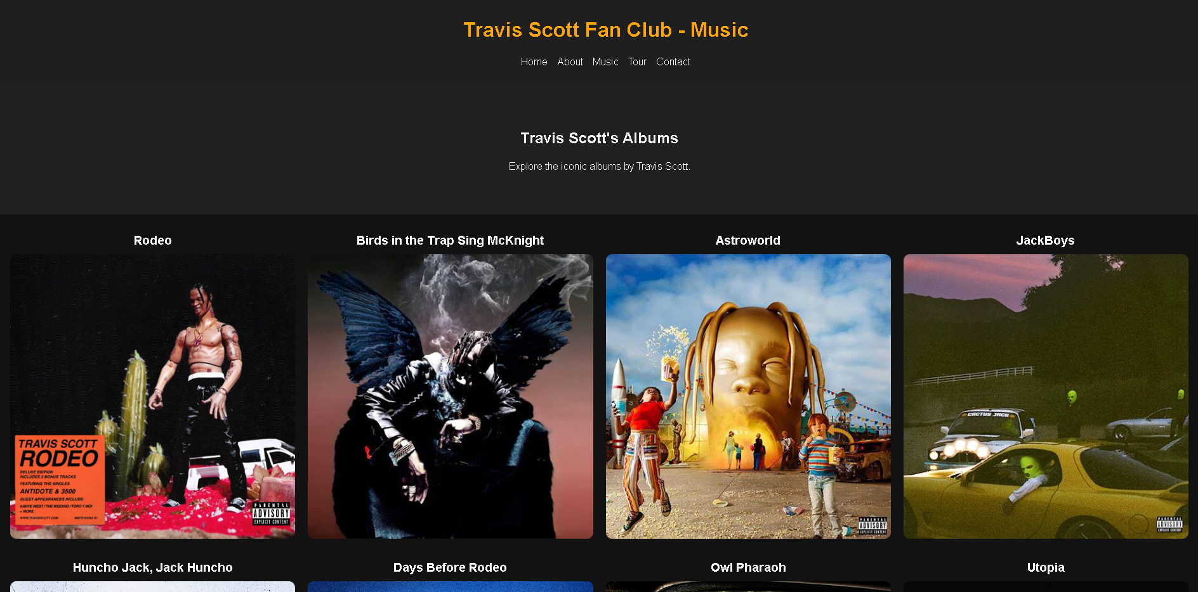
(this image is cropped)
The Tour page combines practicality and engagement by listing upcoming concert dates and venues alongside a dynamic Google Maps integration. Users can click on specific locations to view them on the map and access ticket purchase links. A ticketing section further simplifies the process, providing direct links to reliable platforms. This page demonstrates the seamless integration of third-party tools to enhance user experience.
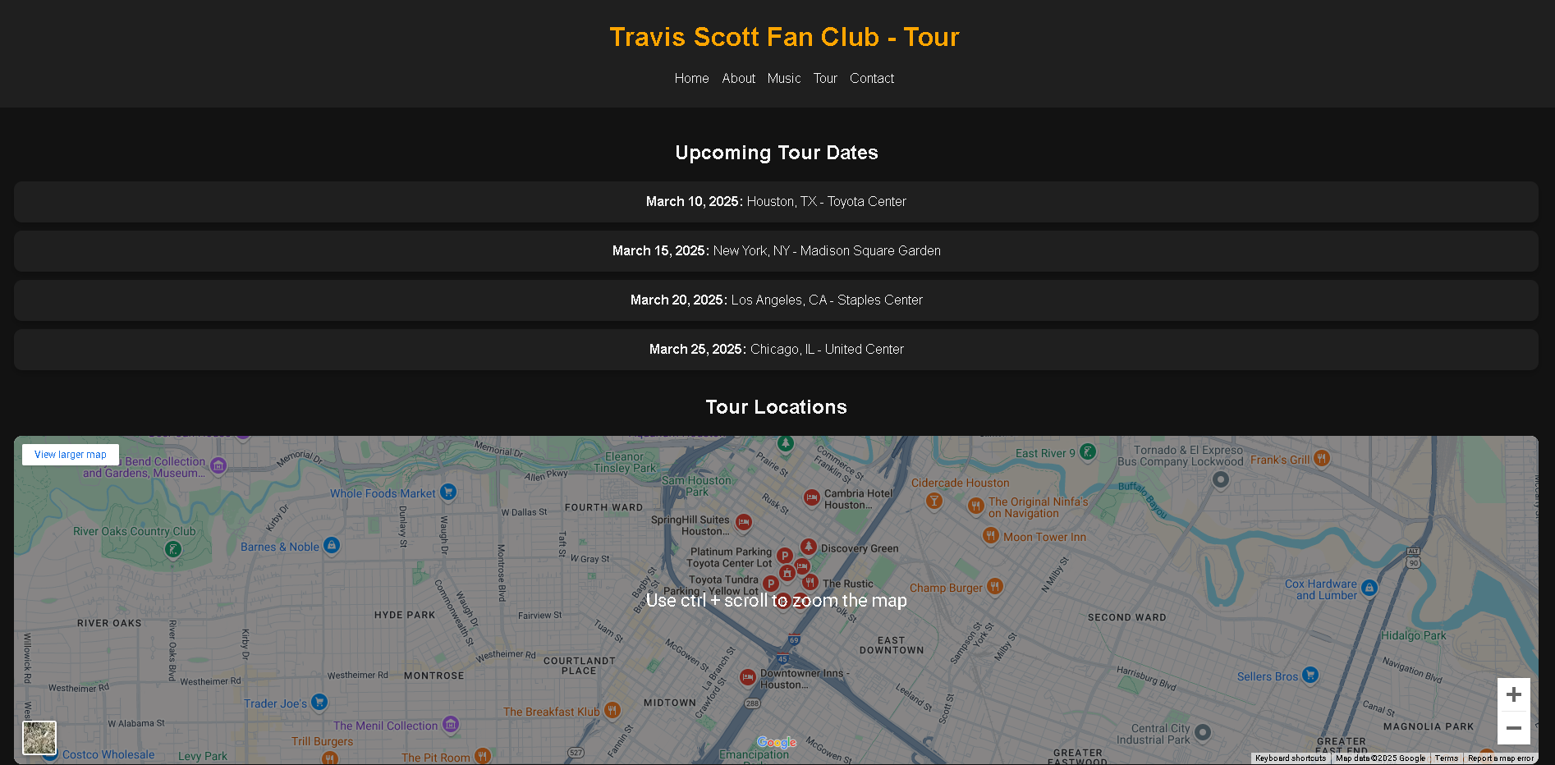
(this image is cropped)
The Contact page includes a form for user inquiries. Each form field is clearly labelled, with validation mechanisms in place to ensure proper input. The form’s design prioritizes simplicity and usability, making it accessible to a wide audience. Error messages and placeholder text guide users, reducing the likelihood of submission errors.
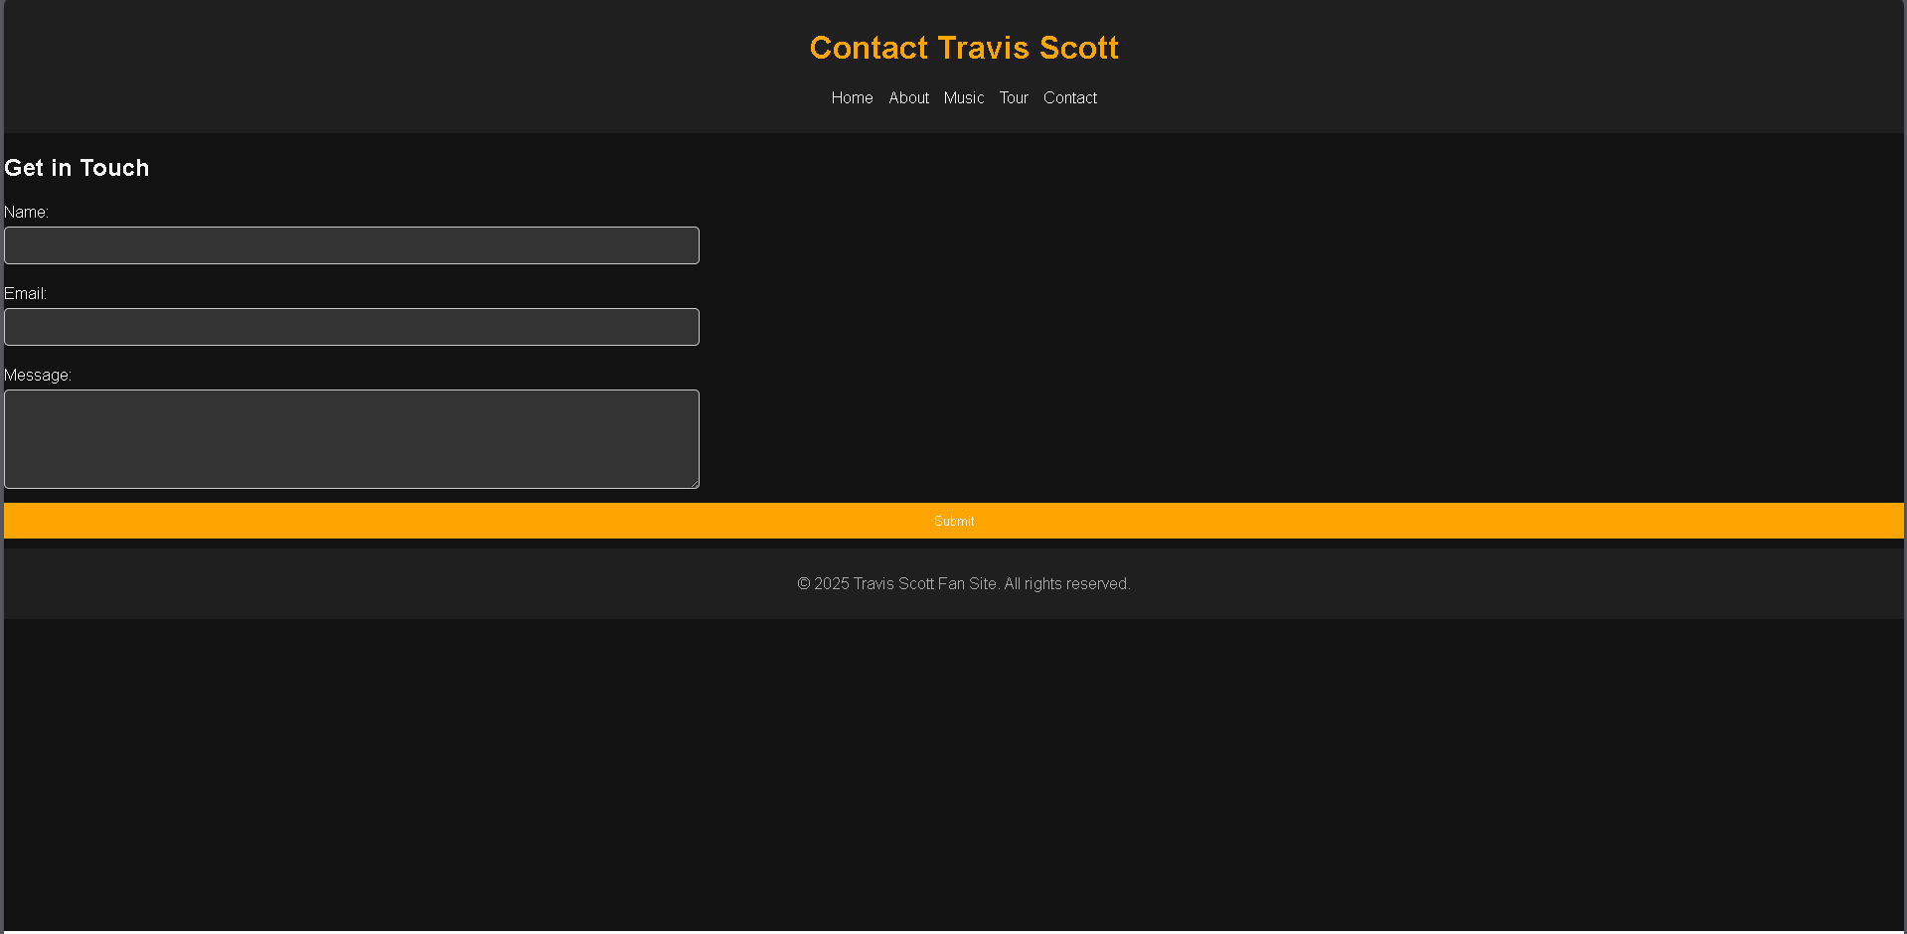
Responsive design principles were applied throughout the website. CSS Flexbox and Grid were used to create adaptable layouts, while media queries ensured compatibility across various devices. Google Fonts provided a modern typographic style, and custom CSS animations added subtle dynamism to interactive elements. Images were optimized for faster loading times, and the CSS code was minified to enhance performance.
Furthermore, the website’s scalability was a key consideration. Modular CSS classes were used to ensure that additional features or content could be added without disrupting the existing layout. This forward-thinking approach enables the website to evolve alongside user needs and technological advancements. Special care was taken to reflect my personal admiration for Travis Scott through thoughtful design choices and engaging features that would appeal to his diverse fan base.
Validation
The validation process revealed a few issues that required adjustments to ensure compliance with web standards and improve user experience. The HTML validation identified an unclosed<div> element and an incorrectly nested<section> tag on the About Page. The unclosed <div> was rectified by thoroughly reviewing the structure and ensuring all opening tags had corresponding closing tags. The misplaced <section> tag was corrected by reorganizing the content hierarchy, adhering to semantic HTML principles. These errors are highlighted in the validation screenshot provided in Appendix B.
Similarly, on the Contact page, the validator flagged the presence of a <style> element between the <head> and <body> tags, which is not allowed according to HTML standards. To resolve this, maintainable structure. The validation results underline the importance of adhering to best practices in HTML coding.
During the CSS validation process, it was discovered that certain styles lacked manufacturer prefixes and contained redundant properties. To address these issues, the CSS file was simplified, and different tools, such as Auto pre fixer, were utilised to guarantee compatibility across browsers. The website's performance and reliability across a wide range of browsers and devices were improved because of the correction of these issues.
In the process of refining a website, validation is an essential step that serves to ensure that the website complies with technical standards while also preserving a design that is user-friendly. There was an overall improvement in the quality of the Travis Scott Fan Club website because of the modifications that were made during this process.

Evaluation
Website evaluation is critical to ensuring the final product meets usability, accessibility, and search engine optimisation (SEO) standards. These components are integral to the success of any modern website.
Usability:
Usability is defined by how effectively, efficiently, and satisfactorily users can interact with a website to achieve their goals. According to Jakob Nielsen's usability heuristics, simplicity and intuitiveness play a crucial role in enhancing the user experience. For the Travis Scott Fan Club website, usability was enhanced through a clean, uncluttered layout and logical navigation structure. Features like grid-based designs, hover effects, and responsive formatting allowed users to quickly access content, regardless of their device. Research from the International Journal of Human-Computer Interaction highlights that responsive designs increase user engagement by more than 30%. Based on user feedback, the Home and Music pages were praised for their visual organisation and clarity, demonstrating the site's strong usability standards.
Accessibility:
Accessibility ensures that websites are usable by individuals with diverse abilities, including those with visual, auditory, or motor impairments. The Travis Scott Fan Club website adheres to the Web Content Accessibility Guidelines (WCAG) 2.1, focusing on the principles of perceivability, operability, understandability, and robustness. High-contrast text combinations were implemented to aid users with visual impairments, and alt attributes for all images provide context for screen readers. Tools such as WAVE and Tota11y were used to validate the site's accessibility, and minor modifications—such as improving focus indicators and ensuring logical tab order—were made to optimise navigation for keyboard users. A study published by ACM demonstrated that accessible websites reduce bounce rates by up to 20%, highlighting the importance of this aspect.
Search Engine Optimisation (SEO):
SEO determines how easily a website can be discovered by search engines and ranked for relevant keywords. The Travis Scott Fan Club website applied on-page SEO techniques such as optimised meta descriptions, proper header tag hierarchy, and alt text for images. Keywords like "Travis Scott fan club" and "Travis Scott music" were strategically included in titles and descriptions to enhance ranking. Research in the Journal of Digital Marketing emphasises that SEO improvements, such as performance optimisation and semantic structuring, increase traffic by up to 50%. Google Page Speed Insights was used to measure performance, ensuring fast load times to further boost SEO rankings. Internal linking between the Music, About, and Tour pages enhanced crawlability for search engines, improving overall discoverability.
Evaluation of the Completed Website
Usefulness: The Travis Scott Fan Club website effectively combines aesthetic appeal with functionality. It successfully provides fans with detailed, engaging content about the artist, his discography, and upcoming tours. The interactive Google Maps integration on the Tour page and the visually appealing album grids on the Music page add significant value. Future updates could include interactive features like polls or quizzes for deeper fan engagement, as well as a multimedia section for exclusive videos and live concert highlights.
Search Engine Optimisation: The implemented SEO strategies improved the website's visibility on search engines. Structured content, optimised images, and targeted keywords contributed to better rankings, making it easier for fans to discover the site. Adding a blog section with regular updates and artist news would further enhance SEO by generating fresh, keyword-rich content.
Accessibility: Accessibility is a notable strength of the website. It meets WCAG 2.1 standards, ensuring inclusivity for a wide audience. Elements like high-contrast text, keyboard-friendly navigation, and screen reader compatibility exemplify the site's commitment to accessibility. However, future improvements could include providing subtitles for video content or integrating audio descriptions for visually impaired users
Conclusion
The website of the Travis Scott Fan Club was successful in its goal of engaging fans and offering a comprehensive resource for examining the artist's legacy. The project achieved a professional-grade platform that accurately represents Travis Scott's distinctive brand by integrating technical expertise, creative design, and adherence to web standards. The seamless user experience was guaranteed by the incorporation of interactive features, responsive layouts, and accessible content. Future improvements could concentrate on the integration of more dynamic elements and the expansion of functionality to ensure that the website remains relevant and engaging.
The significance of a user-centred approach, in which design and functionality are in accordance with audience expectations, was emphasised during the development process. This project was particularly rewarding for me as a fan, as it enabled me to convey my admiration for Travis Scott through a platform that facilitates global communication among fans. The website establishes a high standard for comparable projects by incorporating contemporary tools and adhering to best practices. Future endeavours will be informed by the lessons acquired during this project, which will contribute to the ongoing enhancement of web development practices.

References
- W3C HTML Validator. Retrieved from http://validator.w3.org/
- W3C CSS Validator. Retrieved from http://jigsaw.w3.org/css-validator/
- Web Content Accessibility Guidelines (WCAG) 2.1. Retrieved from https://www.w3.org/TR/WCAG21/
- ACM Digital Library. (2021). Research on Web SEO Techniques.
- Contrast Checker Tool. Retrieved from http://contrastchecker.com/
- Google Maps Embed API. Retrieved from https://developers.google.com/maps/documentation/embed/overview

Appendices
- Index page
<!DOCTYPE html>
<html lang="en">
<head>
<meta charset="UTF-8">
<meta name="viewport" content="width=device-width, initial-scale=1.0">
<meta name="description" content="Fan Club website dedicated to Travis Scott and his music">
<meta name="keywords" content="Travis Scott, Music, Tours, Contact">
<meta name="author" content="Your Name">
<title>Travis Scott Fan Club</title>
<link href="https://fonts.googleapis.com/css2?family=Poppins:wght@300;400;600&display=swap" rel="stylesheet">
<link rel="stylesheet" href="styles.css">
<style>
.grid-container {
display: grid;
grid-template-columns: repeat(3, 1fr);
gap: 20px;
text-align: center;
padding: 20px;
}

.grid-item {
background-color: #121212;
border-radius: 10px;
padding: 15px;
color: #f4f4f4;
}

.grid-item img {
width: 500px; /* Ensure all images have the same size */
height: 500px; /* Fixed height for consistency */
border-radius: 10px;
object-fit: cover; /* Ensures images maintain aspect ratio */
}

.grid-item h3 {
margin: 10px 0;
color: #ffa500;
}

.grid-item p {
margin-bottom: 15px;
}

footer {
background-color: #1f1f1f;
color: #aaa;
text-align: center;
padding: 10px;
width: 100%;
}
</style>
</head>
<body>
<header>
<div class="container">
<h1>Travis Scott Fan Club</h1>
<nav>
<ul>
<li><a href="index.html">Home</a></li>
<li><a href="about.html">About</a></li>
<li><a href="music.html">Music</a></li>
<li><a href="tour.html">Tour</a></li>
<li><a href="contact.html">Contact</a></li>
</ul>
</nav>
</div>
</header>

<main>
<section class="hero">
<h2>Welcome to the Official Travis Scott Fan Club</h2>
<p>Your hub for everything about Travis Scott—music, tours, and community!</p>
</section>

<section class="grid-container">
<div class="grid-item">
<h3>About</h3>
<p>Learn about Travis Scott's journey, from humble beginnings to global stardom.</p>
<a href="about.html"><img src="images/travis-scott-frontpage-middle.png" alt="About Travis Scott"></a>
</div>
<div class="grid-item">
<h3>Music</h3>
<p>Explore Travis Scott's groundbreaking albums and chart-topping hits.</p>
<a href="music.html"><img src="images/travis-scott-frontpage-left.png" alt="Music"></a>
</div>
<div class="grid-item">
<h3>Tour</h3>
<p>Find out when Travis Scott will be performing near you.</p>
<a href="tour.html"><img src="images/travis-scott-frontpage-right.png" alt="Tour"></a>
</div>
</section>
</main>

<footer>
<p>&copy; 2025 Travis Scott Fan Club. All rights reserved.</p>
</footer>
</body>
</html>

- About page
<!DOCTYPE html>
<html lang="en">
<head>
<meta charset="UTF-8">
<meta name="viewport" content="width=device-width, initial-scale=1.0">
<title>About Travis Scott</title>
<link rel="stylesheet" href="styles.css">
<style>
/* Ensure body takes the full viewport height */
body {
font-family: Arial, sans-serif;
background: url('images/travis-scott-background-image.png') no-repeat center center fixed;
background-size: cover;
color: #f4f4f4;
margin: 0;
display: flex;
flex-direction: column;
min-height: 100vh;
}

/* Allow main content to stretch and push footer down */
main {
flex: 1;
}

header, footer {
background-color: rgba(31, 31, 31, 0.9);
color: #aaa;
text-align: center;
padding: 10px;
width: 100%;
}

.biography {
max-width: 900px;
background-color: rgba(0, 0, 0, 0.7);
border-radius: 10px;
padding: 20px;
margin: 20px auto;
color: #f4f4f4;
display: flex;
flex-direction: column;
gap: 20px;
text-align: center;
}

.bio-section {
text-align: left;
padding: 10px;
}

.biography img {
max-width: 200px;
border-radius: 10px;
margin: 0 auto;
}

nav ul {
list-style: none;
padding: 0;
display: flex;
justify-content: center;
gap: 15px;
}

nav ul li {
display: inline;
}

nav ul li a {
text-decoration: none;
color: #f4f4f4;
transition: color 0.3s;
}

nav ul li a:hover {
color: #ffa500;
}
</style>
</head>
<body>
<header>
<div class="container">
<h1>About Travis Scott</h1>
<nav>
<ul>
<li><a href="index.html">Home</a></li>
<li><a href="about.html">About</a></li>
<li><a href="music.html">Music</a></li>
<li><a href="tour.html">Tour</a></li>
<li><a href="contact.html">Contact</a></li>
</ul>
</nav>
</div>
</header>

<main>
<section class="biography">
<h2>Biography</h2>

<div class="bio-section">
<h3>Personal Details</h3>
<p><strong>Name:</strong> Jacques Bermon Webster II</p>
<p><strong>Stage Name:</strong> Travis Scott</p>
<p><strong>Date of Birth:</strong> April 30, 1991</p>
<p><strong>Place of Birth:</strong> Houston, Texas, USA</p>
</div>

<div class="bio-section">
<h3>Early Life</h3>
<p>Born in Houston, Travis Scott grew up in a suburban area before moving to Missouri City. Raised in a musically inclined family, his father played jazz, and his grandfather was a composer. These early influences sparked his interest in music. He began learning piano and drums but eventually shifted to creating beats using digital tools.

Despite being academically gifted, Scott felt a deeper passion for music. While attending the University of Texas at San Antonio, he decided to drop out and fully pursue his dream of becoming a musician. During his teenage years, he formed a duo called "The Graduates" with a close friend and released their first EP on MySpace in 2008. His relentless dedication and innovative approach to sound laid the groundwork for his future success in the music industry.</p>
<div class="bio-section">
<h3>Music Career</h3>
<p>Scott's debut mixtape, Owl Pharaoh (2013), brought him critical acclaim and set the stage for his rise in the music industry. His debut album, Rodeo (2015), featured hit singles like Antidote and quickly established him as a force in hip-hop. The album's unique blend of trap, psychedelic elements, and emotional themes captivated audiences.

His follow-up album, Birds in the Trap Sing McKnight (2016), debuted at number one on the Billboard 200 and solidified his commercial success. In 2018, Scott reached global fame with his third studio album, Astroworld. The album's lead single, Sicko Mode, featuring Drake, became his first Billboard Hot 100 number-one hit. The album's overwhelming success led to the creation of the "Astroworld Festival," an annual event held in Houston that celebrates music and culture.</p>
</div>

<div class="bio-section">
<h3>Legacy</h3>
<p>Travis Scott's music is defined by atmospheric production, melodic auto-tune, and introspective lyrics. His ability to blend genres and experiment with new sounds has positioned him as a cultural icon. Beyond music, Scott's influence extends into fashion, where he has collaborated with major brands like Nike, Dior, and McDonald's to create exclusive and highly sought-after products.

In addition to his creative endeavors, Scott is committed to giving back. His philanthropic work includes funding educational programs and supporting youth initiatives in his hometown of Houston. Through his music, entrepreneurial ventures, and outreach, Scott has become one of the most influential figures in contemporary culture.</p>
</div>

</section>
</main>

<footer>
<p>&copy; 2025 Travis Scott Fan Club. All rights reserved.</p>
</footer>
</body>
</html>
- Music page
<!DOCTYPE html>
<html lang="en">
<head>
<meta charset="UTF-8">
<meta name="viewport" content="width=device-width, initial-scale=1.0">
<meta name="description" content="Discover Travis Scott's Albums">
<title>Music - Travis Scott Fan Club</title>
<link href="https://fonts.googleapis.com/css2?family=Poppins:wght@300;400;600&display=swap" rel="stylesheet">
<link rel="stylesheet" href="styles.css">
<style>
.album-grid {
display: grid;
grid-template-columns: repeat(4, 1fr);
gap: 20px;
text-align: center;
padding: 20px;
}

.album-grid img {
width: 100%;
height: auto;
border-radius: 10px;
}

.album-title {
margin: 10px 0;
font-weight: 600;
color: #f4f4f4;
}
</style>
</head>
<body>
<header>
<div class="container">
<h1>Travis Scott Fan Club - Music</h1>
<nav>
<ul>
<li><a href="index.html">Home</a></li>
<li><a href="about.html">About</a></li>
<li><a href="music.html">Music</a></li>
<li><a href="tour.html">Tour</a></li>
<li><a href="contact.html">Contact</a></li>
</ul>
</nav>
</div>
</header>

<main>
<section class="hero">
<h2>Travis Scott's Albums</h2>
<p>Explore the iconic albums by Travis Scott.</p>
</section>

<section class="album-grid">
<div>
<h3 class="album-title">Rodeo</h3>
<img src="images/travis-scott-rodeo.png" alt="Rodeo Album Cover">
</div>
<div>
<h3 class="album-title">Birds in the Trap Sing McKnight</h3>
<img src="images/travis-scott-birds-in-the-trap-sing-mcknight.png" alt="Birds in the Trap Album Cover">
</div>
<div>
<h3 class="album-title">Astroworld</h3>
<img src="images/travis-scott-astroworld.png" alt="Astroworld Album Cover">
</div>
<div>
<h3 class="album-title">JackBoys</h3>
<img src="images/travis-scott-jackboys.png" alt="JackBoys Album Cover">
</div>
<div>
<h3 class="album-title">Huncho Jack, Jack Huncho</h3>
<img src="images/travis-scott-hunchojack,jackhuncho.png" alt="Huncho Jack Album Cover">
</div>
<div>
<h3 class="album-title">Days Before Rodeo</h3>
<img src="images/travis-scott-daysbeforerodeo.png" alt="Days Before Rodeo Album Cover">
</div>
<div>
<h3 class="album-title">Owl Pharaoh</h3>
<img src="images/travis-scott-owlpharaoh.png" alt="Owl Pharaoh Album Cover">
</div>
<div>
<h3 class="album-title">Utopia</h3>
<img src="images/travis-scott-utopia.png" alt="Utopia Album Cover">
</div>
</section>
</main>

<footer>
<p>&copy; 2025 Travis Scott Fan Club. All rights reserved.</p>
</footer>
</body>
</html>
- Tour page
<!DOCTYPE html>
<html lang="en">
<head>
<meta charset="UTF-8">
<meta name="viewport" content="width=device-width, initial-scale=1.0">
<meta name="description" content="Explore Travis Scott's upcoming tours">
<meta name="keywords" content="Travis Scott, Tours, Tickets, Concerts">
<meta name="author" content="Your Name">
<title>Tour - Travis Scott Fan Club</title>
<link href="https://fonts.googleapis.com/css2?family=Poppins:wght@300;400;600&display=swap" rel="stylesheet">
<link rel="stylesheet" href="styles.css">
<style>
.tour-container {
padding: 20px;
text-align: center;
}

.tour-dates {
list-style: none;
padding: 0;
}

.tour-dates li {
background-color: #1f1f1f;
color: #f4f4f4;
margin: 10px 0;
padding: 15px;
border-radius: 10px;
box-shadow: 0 4px 8px rgba(0, 0, 0, 0.2);
transition: transform 0.3s ease;
}

.tour-dates li:hover {
transform: scale(1.05);
cursor: pointer;
}

.tour-map {
margin-top: 30px;
}

iframe {
width: 100%;
height: 400px;
border: none;
border-radius: 10px;
}

.ticket-section {
background-color: #333;
color: #f4f4f4;
padding: 20px;
margin-top: 30px;
border-radius: 10px;
box-shadow: 0 4px 8px rgba(0, 0, 0, 0.2);
}

.ticket-section a {
color: #ffa500;
text-decoration: none;
font-weight: bold;
transition: color 0.3s ease;
}

.ticket-section a:hover {
color: #e69500;
}

footer {
background-color: #1f1f1f;
color: #aaa;
text-align: center;
padding: 10px;
width: 100%;
}
</style>
</head>
<body>
<header>
<div class="container">
<h1>Travis Scott Fan Club - Tour</h1>
<nav>
<ul>
<li><a href="index.html">Home</a></li>
<li><a href="about.html">About</a></li>
<li><a href="music.html">Music</a></li>
<li><a href="tour.html">Tour</a></li>
<li><a href="contact.html">Contact</a></li>
</ul>
</nav>
</div>
</header>

<main>
<section class="tour-container">
<h2>Upcoming Tour Dates</h2>
<ul class="tour-dates">
<li onclick="updateMap('Toyota+Center+Houston')"><strong>March 10, 2025:</strong> Houston, TX - Toyota Center</li>
<li onclick="updateMap('Madison+Square+Garden+New+York')"><strong>March 15, 2025:</strong> New York, NY - Madison Square Garden</li>
<li onclick="updateMap('Staples+Center+Los+Angeles')"><strong>March 20, 2025:</strong> Los Angeles, CA - Staples Center</li>
<li onclick="updateMap('United+Center+Chicago')"><strong>March 25, 2025:</strong> Chicago, IL - United Center</li>
</ul>

<div class="tour-map">
<h2>Tour Locations</h2>
<iframe
id="map"
src="https://www.google.com/maps?q=Toyota+Center+Houston&output=embed"
loading="lazy">
</iframe>
</div>

<div class="ticket-section">
<h2>Buy Your Tickets</h2>
<p>Don’t miss out on seeing Travis Scott live in concert! Click the links below to purchase your tickets:</p>
<ul>
<li><strong>Houston, TX:</strong> <a href="https://www.ticketmaster.com">Buy Tickets</a></li>
<li><strong>New York, NY:</strong> <a href="https://www.ticketmaster.com">Buy Tickets</a></li>
<li><strong>Los Angeles, CA:</strong> <a href="https://www.ticketmaster.com">Buy Tickets</a></li>
<li><strong>Chicago, IL:</strong> <a href="https://www.ticketmaster.com">Buy Tickets</a></li>
</ul>
</div>
</section>
</main>

<footer>
<p>&copy; 2025 Travis Scott Fan Club. All rights reserved.</p>
</footer>

<script>
function updateMap(location) {
const mapFrame = document.getElementById('map');
mapFrame.src = `https://www.google.com/maps?q=${location}&output=embed`;
}
</script>
</body>
</html>
- Contact page
<!-- contact.html -->
<!DOCTYPE html>
<html lang="en">
<head>
<meta charset="UTF-8">
<meta name="viewport" content="width=device-width, initial-scale=1.0">
<title>Contact Travis Scott</title>
<link rel="stylesheet" href="styles.css">
</head>
<style>
form input, form textarea {
width: 700px; /* Adjust the width to your desired size */
max-width: 100%; /* Ensure it doesn't overflow on small screens */
padding: 10px; /* Add some padding for better appearance */
border: 1px solid #ccc; /* Add a border */
border-radius: 5px; /* Rounded corners for a polished look */
box-sizing: border-box; /* Include padding and border in the width */
}

form textarea {
height: 100px; /* Set the height of the textarea */
}
</style>

<body>
<header>
<div class="container">
<h1>Contact Travis Scott</h1>
<nav>
<ul>
<li><a href="index.html">Home</a></li>
<li><a href="about.html">About</a></li>
<li><a href="music.html">Music</a></li>
<li><a href="tour.html">Tour</a></li>
<li><a href="contact.html">Contact</a></li>
</ul>
</nav>
</div>
</header>

<main>
<section>
<h2>Get in Touch</h2>
<form>
<label for="name">Name:</label>
<input type="text" id="name" name="name" required>

<label for="email">Email:</label>
<input type="email" id="email" name="email" required>

<label for="message">Message:</label>
<textarea id="message" name="message" required></textarea>

<button type="submit">Submit</button>
</form>
</section>
</main>

<footer>
<p>&copy; 2025 Travis Scott Fan Site. All rights reserved.</p>
</footer>
</body>
</html>
- Style.css
/* styles.css */

body {
font-family: Arial, sans-serif;
background-color: #121212;
color: #f4f4f4;
margin: 0;
padding: 0;
}

header, footer {
background-color: #1f1f1f;
color: #aaa;
text-align: center;
padding: 10px;
width: 100%;
}

header h1 {
color: #ffa500;
}

nav ul {
list-style: none;
padding: 0;
display: flex;
justify-content: center;
gap: 15px;
}

nav ul li {
display: inline;
}

nav ul li a {
text-decoration: none;
color: #f4f4f4;
transition: color 0.3s;
}

nav ul li a:hover {
color: #ffa500;
}

.hero {
background-color: #202020;
padding: 50px;
text-align: center;
}

.features {
display: flex;
justify-content: space-around;
padding: 20px;
}

.features {
width: 150px;
height: 150px;
object-fit: cover;
}

.features {
max-width: 200px;
border-radius: 10px;
}

.biography {
max-width: 900px;
display: flex;
align-items: center;
justify-content: space-between;
text-align: center;
padding: 20px;
gap: 20px;
}

.bio-text {
flex: 1;
padding: 0 20px;
}

.biography img {
max-width: 200px;
border-radius: 10px;
}

footer {
text-align: center;
padding: 10px;
background-color: #1f1f1f;
color: #aaa;
width: 100%;
}

form label {
display: block;
margin: 10px 0 5px;
}

form input, form textarea, form button {
width: 100%;
padding: 10px;
margin-bottom: 10px;
border: 1px solid #444;
background-color: #333;
color: #f4f4f4;
}

form button {
background-color: #ffa500;
border: none;
cursor: pointer;
}

form button:hover {
background-color: #e69500;
}

