

Social Media for Reaching New Customers

MODULE NAME: DIGITAL SKILLS
MODULE CODE: LCLM 4002
STUDENT’S NAME: Catia Ferreira
STUDENT’S ID: 2331409
GROUP: 2
LECTURER’S NAME: Dr. Hoang Dang Nguyen
UNIVERSITY OF WALES TRINITY SAINT DAVID (LONDON CAMPUS)

Table of Contents

Social media for reaching new costumers:
Introduction 1
Main Body 2
Overview of social media: Its Use and Development in Recent Years 2
What is Marketing? Traditional vs. Modern Methods 2
How Social Media Can Be Used for Marketing and Reaching New Customers 3
Advantages of Using Social Media as a Tool for Reaching New Customers 3
Disadvantages of Using Social Media as a Tool for Reaching New Customers 4
Conclusion 5
References 6

Introduction
In the digital era, social media is essential for companies seeking to reach new customers. With billions of users engaging daily across platforms such as Facebook, Instagram, TikTok, and LinkedIn, there are exceptional opportunities to boost brand visibility and build customer relationships. This report examines the transformation of social media, its significant role in modern marketing, and the benefits and challenges it presents to businesses. By gaining insights into these elements, organisations can more effectively utilise social media to connect with their target audiences and drive growth in a competitive marketplace.

Main Body:
  - Overview of Social Media: Its Use and Development in Recent Years:
Social media has grown from simple communication tools into key platforms for business marketing and customer engagement. Recently, apps like Facebook, Instagram, Twitter, TikTok, and LinkedIn have become vital for businesses to reach new customers. By 2023, there were 4.9 billion social media users worldwide, a sharp rise from previous years (Statista, 2023). This growth is due to better mobile technology and easier internet access, allowing people to interact with content daily. Features like live streaming, augmented reality (AR), and social commerce have also boosted how businesses connect with their audiences.
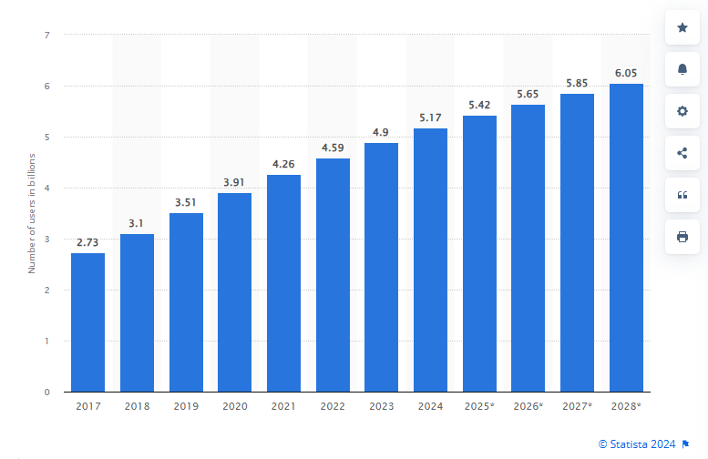
Figure 1. Number of global social network users between 2017-2028.

  - What is Marketing? Traditional vs. Modern Methods:
Marketing involves promoting products or services to specific customers. Traditionally, this was done through TV, radio, print ads, and billboards, which focused on reaching a wide audience but couldn't target specific groups or offer much interaction. Now, marketing has moved to digital channels, with social media being key. Digital marketing includes email campaigns, SEO, content marketing, and social media ads. Social media allows businesses to target and personalise their messages, reaching specific audiences based on interests and behaviours. Platforms like Facebook and Instagram provide detailed targeting options, making marketing more effective.

  - How Social Media Can Be Used for Marketing and Reaching New Customers:

Social media is a powerful marketing tool for attracting new customers through content creation, targeted ads, and influencer partnerships. Content, such as videos and blog posts, is crucial for engaging with the target audience. Choosing the right platform is key to a successful social media strategy.
Figure 2. Social media engagement.
- Facebook is highly popular for increasing brand awareness, generating leads, and driving sales but is also highly competitive.
- Instagram is ideal for visually appealing businesses, offering features like stories, reels, and live streams.
- Twitter is useful for short, impactful messages, customer service, and industry news.
- YouTube, the second-largest search engine, is essential for brands with strong video content, helping to explain products and showcase features.
- Pinterest excels at visual discovery, making it perfect for brands that inspire personal projects, like home renovations.
- LinkedIn is the go-to for B2B businesses, focusing on professional networking and lead generation.
- TikTok is popular among younger audiences, offering short-form video content that can be discovered through hashtags (Forbes, 2024).
A 2022 Hootsuite report found targeted social media ads have a conversion rate of 14.3%, and a 2023 study showed 61% of consumers trust influencer recommendations, highlighting the effectiveness of these strategies (Influencer Marketing Hub, 2023).

  - Advantages of Using Social Media as a Tool for Reaching New Customers:
One of the key benefits of using social media for marketing is its affordability. Unlike traditional media, social media campaigns can be run on modest budgets, making them suitable for businesses of all sizes. The return on investment (ROI) is often higher because you can track performance in real-time and adjust your approach as needed.
Social media also offers extensive reach and engagement opportunities. With billions of active users, businesses can connect with customers globally. The interactive nature of social media allows for instant communication, helping businesses build strong relationships and increase brand loyalty. Additionally, content can go viral, quickly increasing a brand’s visibility. For example, TikTok’s algorithm favours highly engaging content, allowing even small brands to gain widespread attention rapidly (Boyd & Ellison, 2022).
Another advantage is the ability to gather valuable data. Social media platforms offer detailed insights into user behaviour, engagement, and demographics, helping businesses refine their marketing strategies and better understand their audiences.

  - Disadvantages of Using Social Media as a Tool for Reaching New Customers:
However, there are challenges associated with social media marketing. One significant disadvantage is the need for continuous content creation. Social media platforms thrive on fresh, engaging content, which requires businesses to invest time and resources into regularly producing and curating material. This can be particularly demanding for small businesses with limited marketing budgets.
Another challenge is managing negative feedback. Social media provides a public forum for customers to voice their opinions, and negative comments or reviews can quickly damage a brand's reputation if not handled properly. Businesses must be prepared to respond to criticism and engage with dissatisfied customers to mitigate potential harm.
Additionally, social media algorithms are constantly changing, which can impact the visibility of a business’s content. For example, changes to Facebook’s algorithm have made it more challenging for brands to reach their audience organically, often necessitating paid advertising to maintain visibility.
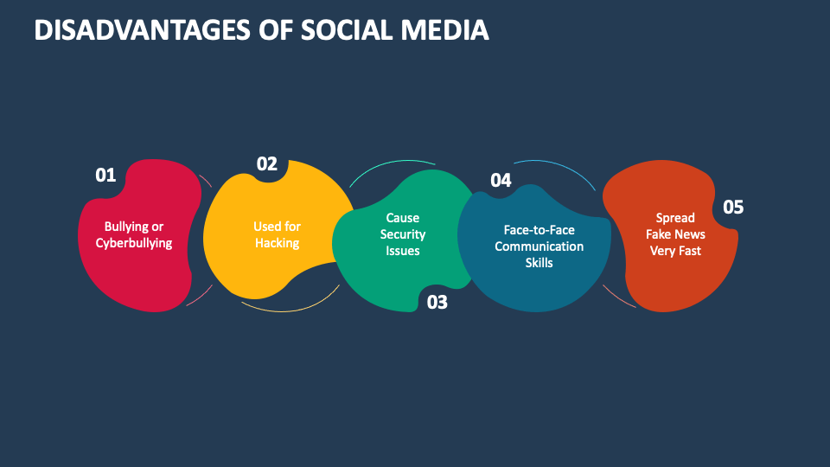
Figure 3. Disadvantages of Social Media.

Conclusion
Social media has become an indispensable tool for businesses looking to reach new customers. While it offers numerous advantages, such as cost-effectiveness, global reach, and real-time engagement, it also requires significant time and effort, managing multiple platforms, responding to customer inquiries, and staying updated on trends, which can be overwhelming, especially for smaller businesses with limited resources. Challenges that businesses must navigate carefully. By understanding both the benefits and drawbacks, companies can effectively leverage social media to expand their customer base and achieve their marketing objectives.

References
- Statista. (2023). Number of social media users worldwide from 2018 to 2023. [online] Available at: https://www.statista.com/statistics/278414/number-of-social-media-users-worldwide / [Accessed 24 August 2024].
- Chaffey, D. and Ellis-Chadwick, F. (2012). Digital Marketing: Strategy, Implementation, and Practice. 5th ed. Pearson Education.
- Hootsuite. (2022). Social Media Marketing Trends 2022. [online] Available at: https://www.hootsuite.com/resources/social-media-marketing-trends-2022 [Accessed 24 August 2024].
- Influencer Marketing Hub. (2023). Influencer Marketing Benchmark Report 2023. [online] Available at: https://www.influencermarketinghub.com/influencer-marketing-benchmark-report-2023 [Accessed 26 August 2024].
- Forbes. (2024). Key components of a good social media marketing strategy. [online] Forbes. Available at: https://www.forbes.com/advisor/business/social-media-marketing/#key_components_of_a_good_social_media_marketing_strategy_section [Accessed 26 August 2024].
- Boyd, D. M. and Ellison, N. B. (2022). ‘Social Network Sites: Definition, History, and Scholarship’, Journal of Computer-Mediated Communication, 13(1), pp. 210-230.
- Collidu. (2024). Disadvantages of Social Media. Available at: https://www.collidu.com/presentation-disadvantages-of-social-media [Accessed 27 Aug. 2024].

