BA (Hons) Leadership and Management Skills for the Workplace

Project Management Plan

Project A – Project management plan for launching a new product

Adolfo Heras
Student Number: 1915415

Module code: BMSW5104 _BIRM
Managing Projects in the Organisation
Lecture: Daminabo Pokubo
Executive Summary
The project has been prepared to introduce a new product line (multi-vitamin) of Crookes Healthcare Ltd. in the UK market. It has been observed from the project that the company has attempted new product launch but failed due to inadequate planning. Currently, after the outbreak of COVID-19 pandemic, the people of the UK are showing interest in consuming the multi-vitamins. Therefore, considering the market demand, the project has considered the in-depth analysis of the stakeholders, risks, available resources, etc. to achieve project aim. The utilisation of the project management tools like Stakeholder analysis, Work-Break Down structure, Gantt chart, risk assessment and cost structure has been used to achieve the project success.

Table of Contents
Executive Summary 2
1.0 Introduction 4
1.1 Project Description 4
1.2 Project Outline 4
1.3 Project Scope 5
2.0 Stakeholder Analysis 5
2.1 Stakeholder Analysis: Concept 5
2.2 Stakeholder Analysis applied to Crookes Healthcare 6
2.3 Stakeholder’s Engagement plan 8
3.0 Work Break Down Structure (WBS) 9
3.1 Work Break Down Structure (WBS): Concept 9
3.2 Work Break Down Structure (WBS) of Crookes Healthcare 10
4.0 Project Cost/Resources 12
5.0 Project Schedule 13
5.1 Importance of project schedule 13
5.2 Gantt Chart of Crookes Healthcare Ltd. 13
6.0 Risk Assessment 14
6.1 Risk Assessment: Concept 14
6.2 Risk Assessment of Crookes Healthcare Ltd. 15
7.0 Conclusion 16
References 17

1.0 Introduction

1.1 Project Description
Project underlines the series of tasks that needs to be undertaken and completed to reach to a specific project outcome (Ibbs, 2016). The current project is to devise a ‘project management plan for the new product of a pharmaceutical company’. The proposed product is the ‘multivitamin’ that will be introduced by Crookes Healthcare ltd. in the UK market. Previously, the company has attempted new product launch but failed due to inadequate planning. After the outbreak of COVID-19 pandemic, the people of the UK are showing interest in consuming the multi-vitamins. As per the market analyst report, the market of the multi-vitamin is expected to reach £559 million by 2025. Moreover, the report has predicted that the market of the multi-vitamin will increase by 13%. The consumers are worried about their health after the outbreak of COVID-19 pandemic. The preventive measures like intaking vitamins and supplements are commonly observed across the globe. Therefore, introducing a product that can create value to the customers can improve the existing business situation.
Project Success underlines the level of efficiency that the project needs to achieve in reaching the project objectives (Buysse, 2018). Moreover, the efficiency is interrelated to the aspect that the project manages its limited resources while meeting the project goals and building good relationships with the stakeholders. As per Kerzner (2018), project success underlines the project outcomes that the project is acceptable to the end user, stakeholders and customers.

1.2 Project Outline
The aim of the project is to introduce a new product line (multi-vitamin) of Crookes Healthcare ltd. in the UK market. Crookes Healthcare is the UK based health care manufacturer and a subsidiary of Reckitt is planning to expand its product line of the multi-vitamin category in the UK market. However, previously, the company has failed to launch a new product due to the inadequate project management plan.
In the context of present UK health market scenario, the demand of the multi-vitamin is high due to the rise in the health consciousness people. Moreover, after the outbreak of COVID-19 pandemic, the people are undertaking preventive measures like intaking multivitamins and supplements in their diets. The application of the Project Management tools is important to drive the project success and to achieve the project deliverables. Project Management signifies the utilisation of the specific knowledge, skills tools, and techniques in delivering value to the end users. Each project is different and requires effective planning. Therefore, considering the market demand, the project will require in-depth analysis of the stakeholders, risks, available resources, etc.

1.3 Project Scope
Project Scope is a key part of the project planning that helps in documenting and determining the project goals, tasks, deliverables, cost and deadline (Kerzner, 2018). The included scopes of the current project are as follows:
- Introduction of the new product line (multi-vitamin) of Crookes Healthcare.
- The utilisation of the project management tools Stakeholder analysis, Work-Break Down structure, Gantt chart, risk assessment and cost structure.
- The competition of the project within the stipulated deadline.
- The influence and prioritisation of the stakeholders towards the project will be estimated.

2.0 Stakeholder Analysis

2.1 Stakeholder Analysis: Concept
The stakeholders are the individual or groups having a specific role and interest on the project. A stakeholder analysis underlines the process of evaluating the system and potential changes by identifying and assessing the relevant parties associated with the project (Buysse, 2018). The objective of the stakeholder analysis is to collect and analyse the qualitative information in a systematic way for determining the interest of the party(s) during the formulation of the organisational policy and program. The stakeholder analysis is a pivotal part of the project management that helps to understand the influence of the stakeholders to the project and also to execute the project effectively. Moreover, the stakeholder analysis is beneficial in gaining more support in the project and also to enhance the project visibility (Meredith, 2018). Therefore, using the stakeholder analysis in the project management can increases the probability of the project success by focusing on the concepts, planning and execution as a part of the project assessment process throughout the project life cycle.

2.2 Stakeholder Analysis applied to Crookes Healthcare
The following table will help to analyse the influence and impact of the stakeholders in the current project.
Table 1
Stakeholders | Description | Contribution of the Stakeholder to the project | Influence | Impact
Founder/owner | The founder of Crookes Healthcare used to secure the funding, bringing the resources and marketing the brand. Moreover, the founder of the company is responsible to set the vision of the company by ensuing superior value proposition to the customers. | The founder used to provide approval to the project in the context of funding, resources, deadline extension and existing business information related to the target market. | High | High
CEO of the company | The CEO is responsible to manage the overall operation of the organisation. More specifically, the delegation, setting the agendas and driving profitability of the business are the key responsibilities of the CEO | The CEO is the primary advisor of the project and provides approval to the project cost anticipated by the project manager. | High | High
Project Manager | The Project Manager plays a leading role I undertaking a project by considering the functions like planning, executing, monitoring, controlling, and closing out projects. | Project Manager used to monitor and tracking the progress of the project with an aim to achieve the project milestone. | High | High
Project Management team | The project management team ensure the application of the project action plan formulated by the Project manager. | The execution of the project tasks as per the direction of the Project manager can be observed from the Project management team. | High | High
Marketing Team | The marketing team of the company is responsible to introduce the proposed product in the market. The responses of the proposed product need to be gathered for amending the project if required. | The market team of the company has to share valuable insight to the Project Manager regarding the product sales, shelf life of the product, primary target market and effective promotional campaigns. | High | High
Customers | The customers are the fundamental revenue driver of the organisation and influences the project outcomes by their acceptance and responses. | In the Project implementation phase, the feedback of the customers is fetched to modify the project action plan if required. | High | High

2.3 Stakeholder’s Engagement plan
Stakeholders in the project plays an important role in completing the project on the stipulated deadline (Buysse, 2018). The stakeholder’s engagement plan supports the researcher to implement a systematic approach to deliver the expectations, decisions, risk/issues and project progress to the right person and also at the right time (Olander, 2020). The purpose of the stakeholder’s engagement strategy is to outline the communication plan with the stakeholders to accomplish the project deliverables. Moreover, the stakeholder engagement plan can reduce the probability of the misunderstanding and future conflicts (Roloff, 2019).
Table 2
Stakeholders | Engagement strategy
Owner/Founder of Crookes Healthcare | The formal communication in the form of e-mail and written reports will be shared in frequent intervals to monitor the progress of the project. Furthermore, the update from the owner will be implemented on real-time basis on the project.
CEO of the company | The CEO can access the project progression through the integrated software that will be used in undertaking the concerned project. Moreover, the accessibility will be shared with the CEO of the company to make sure the project is moving to the right direction.
Project manager | The Project manager will have a direct communication with all the stakeholders of the project to reduce the chances of errors.
Project Team | The integrated software and applications will be used to access the real-time information. The team members can share insight to their colleagues for restricting the deviation of the project. Moreover, team meetings will be organised in different intervals to track and monitor the progress the project.
Customers | The web-based questionnaire survey will be distributed in the social media platforms to gain maximum responses from the target market. Furthermore, customer feedbacks will be taken with the help of the face-to-face communication from the retail points regarding the proposed product of Crookes Healthcare.
Marketing Team | The face-to-face communication with the marketing team will be emphasised to fetch valuable insights regarding the existing product line and distribution strategy. Furthermore, official e-mail will be sent to the marketing team for the sake of documentation of the sales report and product turnover data.

3.0 Work Break Down Structure (WBS)

3.1 Work Break Down Structure (WBS): Concept
Work Break Down Structure (WBS) is a project management tool that helps to outline the tasks of the project in a logical visual form (Crawford, 2017). The purpose of the WBS is to break the critical components of the project into the manageable deliverables. Moreover, each deliverable can be segregated into the subtasks that ensure the meeting of the needs of the project with the WBS. The WBS is used in the project to organise the discrete work elements in an organised way to achieve the project outcomes (Munns, 2017). Therefore, segmenting the project into smaller components will help to integrate the scope, cost and deliverables of the project. The WBS has been used in the current project for the following reasons:
- Reason 1: organising the project scope more precisely to achieve the project outcomes.
- Reason 2: Efficient allocation of the roles, responsibilities, distribution of the resources and management of the project.
- Reason 3: Accurate estimation of the project risks, costs, and time.

3.2 Work Break Down Structure (WBS) of Crookes Healthcare
Table 3
Work Breakdown Structure (WBS)
Project Aim: The aim of the project is to introduce a new product line (multi-vitamin) of Crookes Healthcare Ltd. in the UK market.
WBS Id | Level | Name of Element | Work Description | Budget $ | Resources | Deliverable
PA_0.1  PA_0.2  PA_0.3  PA_0.4 | 1  2  3  4 | Initiation  planning  execution and controlling  Closure | Background study, secondary data collection, project aim and objectives  Project planning phase will include determination of the scope of the project, formulation of the project team, setting up the budget, project approval from the concerned authority and delivery of the project plan  Monitoring the project progression, moving as per the action plan, team meetings, primary data collection, risk management and data analysis  Market testing, developing training strategy, anticipation of the growth factors in the upcoming period |  | RESEARCH JOURNALS and Books  project management concepts and tools  Data analysis and research methodology concepts  presentation of the project | background Analysis  project Management plan  project implementation  drawing a valid conclusion of the project based on the project findings

4.0 Project Cost/Resources
Project Cost underlines the total fund that is needed to undertake a project that includes direct and indirect cost (Rickards, 2019). The monetary obligation that is incurred to complete the concerned project can be observed under the Project cost. Moreover, the purpose of the Project cost management is to estimate, anticipate and control the costs with an objective to keep the expenditures within the approved budget. The current project cost as been approved by the CEO of the company in consultation with the founder/owner of the company.
Table 4
Cash Budget for Crookes Healthcare Ltd. For New Multivitamin Product for First 3 Months.
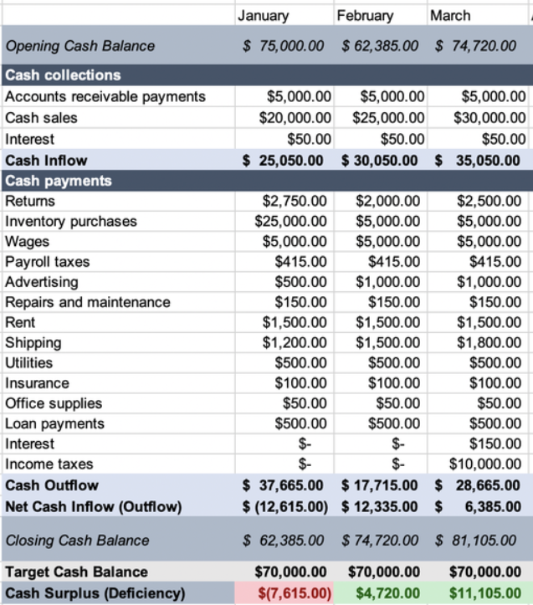

5.0 Project Schedule

5.1 Importance of project schedule
Project Schedule is a pivotal to the project management plan that determines the specific activities, resources required and stipulated time period of the project (Crawford, 2017). The time table helps to outline the starting and ending day of the project by outlining the milestone. The purpose of the project schedule is to list the key activities, deliverables and milestones within the concerned project. The project schedule helps the project team and manager to complete the project on the concerned deadline. With the help of the project schedule, the project team can efficiently optimise the resources by emphasising on the cost savings.

5.2 Gantt Chart of Crookes Healthcare Ltd.
A Gantt chart underlines the visualisation that assist in scheduling, monitoring and managing the specific tasks and resources in the project (Kerzner, 2018). The progress of the project tasks can be tracked with the help of the Gantt chart. As per Munns (2017), Gantt chart helps to organise the project by improving the visibility and supports the tracking process. Furthermore, the project manager can encourage collaboration among the project team members by monitoring the progress of the project from the Gantt chart.

Table 5
Project Phases | Activities | Start Date | End Date
Initiation | Background analysis, secondary data collection | 31st January 22’ | 6th February 22’
Initiation | Formulation of the project aim and objectives | 7th February 22’ | 13th February 22’
Planning | Determination of the scope and formulation of the project team | 14th February 22’ | 20th February 22’
Planning | Setting up the budget and project approval from the concerned authority | 21st February 22’ | 27th February 22’
Execution | Monitoring the project progression | 28th February 22’ | 6th March 22’
Execution | Primary data collection and risk management and Data Analysis | 7th March 22’ | 13th March 22’
Closure | Market Testing and Developing of the training strategy | 14th March 22’ | 20th March 22’
Closure | Drawing a valid conclusion of the study | 21st March 22’ | 27th March 22’

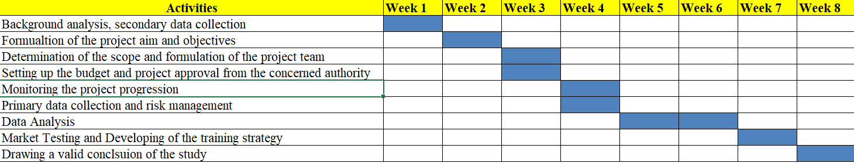
Gant chart, Source: Author

6.0 Risk Assessment

6.1 Risk Assessment: Concept
Risk Assessment underlines the process of determining the quantitative or qualitative value of the risks associated with the concerned project. Moreover, the risk assessment involves the measurement of the probability of the risk that can influence the project outcomes. The negative events that have an impact on the project success and can interrupt the project activities are required to be analysed under the Risk Assessment framework. The possible risks that are identified proactively during the project planning phase can help to achieve the project outcomes. The purpose of the Risk Assessment is to sort out the probable risks and their impact on the project outcomes. Furthermore, the measures to control the risks associated with the project can be done with the help of the Risk Assessment framework.

6.2 Risk Assessment of Crookes Healthcare Ltd.
Risk Assessment framework of Crookes Healthcare Ltd. will help to identify the possible risks, impact and measures to eliminate the risks from the project are plotted in the following way:
Table 6
Key Risks | Impact | Measures to reduce the risks
Incorrect Market Assessment | High | The actual insight of the market will be collected by conducting the extensive market research will be focused. The utilisation of the Marketing Intelligence information will be emphasised to collect relevant information about the project outcomes.
Misleading data from the target market | High | The in-depth analysis needs to be performed in comparing the correct and irrelevant data collected from the sample population.
Miscommunication within the Project team | Moderate | The integrated working approaches can sort out the miscommunication issues in the project. Moreover, organising the team meetings in frequent intervals can reduce the miscommunication between the team members. Furthermore, collaborative working approaches will be focused to ensure the project success.
Financial constraints | High | The shortages of the fund can be managed by consulting with the CEO and owner of the company by briefing them about the rationale of the project. Moreover, expected project cost with justification will be presented to the CEO of the company to make sure that there are no shortages of the fund.
Time Constraints | Moderate | The constant monitoring of the project by tracking the progression will be focused to overcome the time constraints. Furthermore, the collaborative working practices can support the project delivery on stipulated time period.

7.0 Conclusion
To conclude, the project has been prepared to introduce a new product line (multi-vitamin) of Crookes Healthcare Ltd. in the UK market. It has been observed from the project that the company has attempted new product launch but failed due to inadequate planning. Currently, after the outbreak of COVID-19 pandemic, the people of the UK are showing interest in consuming the multi-vitamins. Therefore, considering the market demand, the project has considered the in-depth analysis of the stakeholders, risks, available resources, etc. to achieve project aim. The utilisation of the project management tools like Stakeholder analysis, Work-Break Down structure, Gantt chart, risk assessment and cost structure has been used to achieve the project success.

References
Buysse, K. a. V. A., 2018. Proactive environmental strategies: A stakeholder management perspective. Strategic management journal, 24(6), pp. 453-470.
Crawford, L., 2017. Senior management perceptions of project management competence. International journal of project management, 33(6), pp. 7-16.
Ibbs, C. a. K. Y., 2016. Assessing project management maturity. Project management journal, 34(5), pp. 32-43.
Kerzner, H., 2018. Project management: a systems approach to planning, scheduling, and controlling. London: John Wiley & Sons.
Meredith, J. S. S. a. M. J. S., 2018. Project Management: A Strategic Managerial Approach. London: John Wiley & Sons.
Munns, A., 2017. The role of project management in achieving project success. International journal of project management, 14(5), pp. 81-87.
Olander, S., 2020. Stakeholder impact analysis in construction project. Construction management and economics, 25(3), p. 277–287.
Rickards, T. a. M. S., 2019. Creative leadership processes in project team development: an alternative to Tuckman's stage model. British journal of Management, 11(6), pp. 273-283.
Roloff, J., 2019. Learning from multi-stakeholder networks: Issue-focussed stakeholder management. Journal of business ethics, 83(2), pp. 233-250.

