BSc/HND COMPUTING PORTFOLIO — LEVEL 5
ACCB5030 Software Engineering Principles and Testing
Software Engineering
Design & Testing
Battleships Web Application

Module | Software Engineering Principles and Testing
Module Code | ACCB5030
Assignment | Software Engineering Design & Testing
Lecturer | Mark Huntly
Internal Verifier | Nathan Morgan
Student Name | Tonio George
Student ID | 2312861
Team | SEPT2026-Team4 (Group 4)
Submission | 5th May 2026
Word Count | ~5000 words equivalent

Student Name | Student ID
Tonio George | 2312861

Abstract
This report is an individual written evaluation of collaborative design and testing work carried out by SEPT2026-Team4 (Group 4) for the ACCB5030 Software Engineering Principles and Testing module. The team worked together on a shared Miro board to produce a user story map, CRC cards through two iterations, a sequence diagram, and class diagrams for a web-based Battleships game. This document presents my personal reflection on that process, evaluates the artefacts produced, distinguishes between black-box and white-box testing methodologies, and presents eight structured test cases derived from the application design. Unit testing principles and their application to the Battleships design are also investigated.

Table of Contents
1. Introduction 1
2. Evaluation of the Design Process 1
2.1 How the Team Approached Design 1
2.2 What Worked Well 1
2.3 What Could Have Been Better 1
2.4 The Iterative Refinement Process 1
2.5 Lessons for Future Projects 1
3. User Stories and User Story Map 1
3.1 What User Stories Are and Why They Matter 1
3.2 The Team's Story Map 1
3.3 Selected User Stories 1
3.4 Discussing the Benefit Element 1
3.5 Evaluating the Stories Against INVEST 1
3.6 MoSCoW Prioritisation 1
4. CRC Cards 1
4.1 The CRC Card Technique 1
4.2 The Team's First Iteration 1
4.3 Critique and the Second Iteration 1
4.4 The Refined CRC Cards 1
4.5 Are the Cards Good Enough for Implementation and Testing? 1
4.6 Class Diagrams 1
5. Software Testing Evaluation 1
5.1 Why Testing Matters 1
5.2 Black-Box Testing 1
5.2.1 What It Is 1
5.2.2 Why It Suits This Project 1
5.3 White-Box Testing 1
5.3.1 What It Is 1
5.3.2 Why It Complements Black-Box Testing 1
5.4 Comparing the Two Approaches 1
5.5 Testable Code 1
6. Application Tests and Unit Testing Investigation 1
6.1 Unit Testing Principles 1
6.2 Testing Frameworks 1
6.3 Test Cases 1
6.4 How the Design Supports Testability 1
6.5 Limitations of Unit Testing 1
7. Conclusion 1
Appendix A — User Story Map: Written Reference 1
A.1 User Activities (Backbone) 1
A.2 User Tasks (Steps) 1
A.3 User Stories — Increment 1 (Must Have) 1
A.4 User Stories — Increment 2 (Should Have) 1
A.5 User Stories — Increment 3 (Could Have) 1
References 1

1. Introduction
This report covers the design and testing work I carried out as part of the ACCB5030 Software Engineering Principles and Testing module. The focus of the coursework is a web-based Battleships game — a two-player application played on a 10×10 grid. The game follows the standard rules with two additions introduced in the specification: a drop bomb that destroys an entire ship in one move, and a counter-manoeuvre that lets a player shift one of their ships a single square to dodge an incoming attack [1].
The design artefacts presented in this report were produced collaboratively as part of SEPT2026-Team4 (Group 4). My team worked together on a shared Miro board, collectively producing a user story map, two iterations of CRC cards, a sequence diagram, and class diagrams. While the design work was a group effort, this report is my own individual written evaluation of that process — reflecting on the artefacts from my personal perspective, as required by the assignment specification.
The report is structured to match the marking scheme. Section 2 reflects on the design process from my perspective. Section 3 presents and discusses the user stories and story map my team produced. Section 4 evaluates the CRC cards and class diagrams. Section 5 evaluates the importance of software testing and compares black-box and white-box approaches. Section 6 presents test cases I would apply to the application and investigates unit testing. Appendix A contains the full written user story reference.

2. Evaluation of the Design Process

2.1 How the Team Approached Design
From the start, my team agreed to work iteratively rather than trying to get everything right in one go. Our sessions on the Miro board began with open discussion about the problem before anyone started drawing or writing. The first step was always to agree on what we were trying to design, which meant talking through the game rules and the scenarios players would encounter. Once there was a shared understanding, we moved to producing artefacts — user stories first, then CRC cards, and finally the sequence and class diagrams.
This approach is broadly consistent with Agile principles, which emphasise working together and responding to feedback over sticking rigidly to a plan [2]. The Miro board worked well as a shared workspace because every team member could see and contribute to the same artefacts simultaneously, rather than one person driving while others watched.

2.2 What Worked Well
The biggest strength of my team's approach was the willingness to critique work openly. After the first round of CRC cards was produced, one of my teammates pointed out that several of the 'classes' — Place Ship, Rotate Ship, Move Ship, Hit, Miss, Destroy Ship — were really just operations on a ship or board rather than classes with their own identity and state. This kind of honest peer review is exactly what Beck and Cunningham [3] had in mind when they designed the CRC card technique as a discussion tool rather than a documentation tool. That feedback led directly to a much cleaner second iteration.
The sequence diagram was another highlight. Laying out the full message flow between Player, Game, Board, Ship, and Action in a single diagram gave us a way to check whether all the CRC card responsibilities were actually accounted for. Where the sequence diagram called for a message that no CRC card handled, we knew a responsibility was missing. Sommerville [4] describes exactly this kind of cross-artefact validation as one of the most effective ways to catch design gaps early.

2.3 What Could Have Been Better
The first CRC card iteration produced twelve classes, several of which turned out to be methods rather than classes. Some of that time could have been saved by starting with a noun-identification exercise on the user stories before writing any cards. Cockburn [5] recommends this as a warm-up step precisely because it sets everyone's mental model straight before detailed design begins.
The class diagrams were also initially missing visibility markers, multiplicity notation, and constructors — gaps noted by a team member in a Miro comment. UML notation is something worth agreeing on as a team at the beginning of the design phase, rather than discovering inconsistencies partway through.

2.4 The Iterative Refinement Process
Having two iterations of the CRC cards turned out to be one of the most valuable parts of our process. The first iteration was rough, but it generated a shared vocabulary and a set of domain concepts to argue about. The second iteration was cleaner precisely because the first one had surfaced the things that needed fixing. This matches what Cockburn [5] calls the 'walking skeleton' pattern: build the smallest version you can, then add meat to the bones. The same pattern applied to the class diagrams — the first pass identified what attributes and methods were needed, and feedback on the board guided the next version.

2.5 Lessons for Future Projects
The main takeaways are: do a noun-identification exercise before CRC cards; agree on UML notation before class diagrams; and use the sequence diagram as a validation tool against the CRC cards. A brief structured review checkpoint after producing each artefact type would also help catch issues before they compound.

3. User Stories and User Story Map

3.1 What User Stories Are and Why They Matter
A user story is a short, informal description of a feature told from the perspective of the person who will use it. Cohn [6] defines the standard format as: 'As a [role], I want [something] so that [some reason].' The format is deliberately simple — the goal is not to write a full specification but to capture enough to start a conversation. The 'so that' part, which describes the benefit to the user, is often the most revealing piece because it forces the team to justify why a feature should exist at all.
A user story map, as Patton [7] describes it, takes individual stories and arranges them in two dimensions: a horizontal backbone of user activities running left to right, with tasks beneath each activity, and stories organised into delivery increments going top to bottom. This makes it possible to see the whole product at once, understand what the MVP looks like, and plan releases without losing sight of the bigger picture.

3.2 The Team's Story Map
Figure 1 shows the user story map my team produced on the Miro board. The backbone runs across the top with three activities: Manage Ships, Manage Placements, and Manage Game. The task steps beneath these are Place, Rotate, Move (under Manage Ships); Strike, Drop Bomb, Countermanoeuvre, Miss, Destroy (under Manage Placements); and Time, End, Turns, Results, Restart, Movements, Game (under Manage Game). Stories are distributed across three MoSCoW increments — Must Have, Should Have, and Could Have.

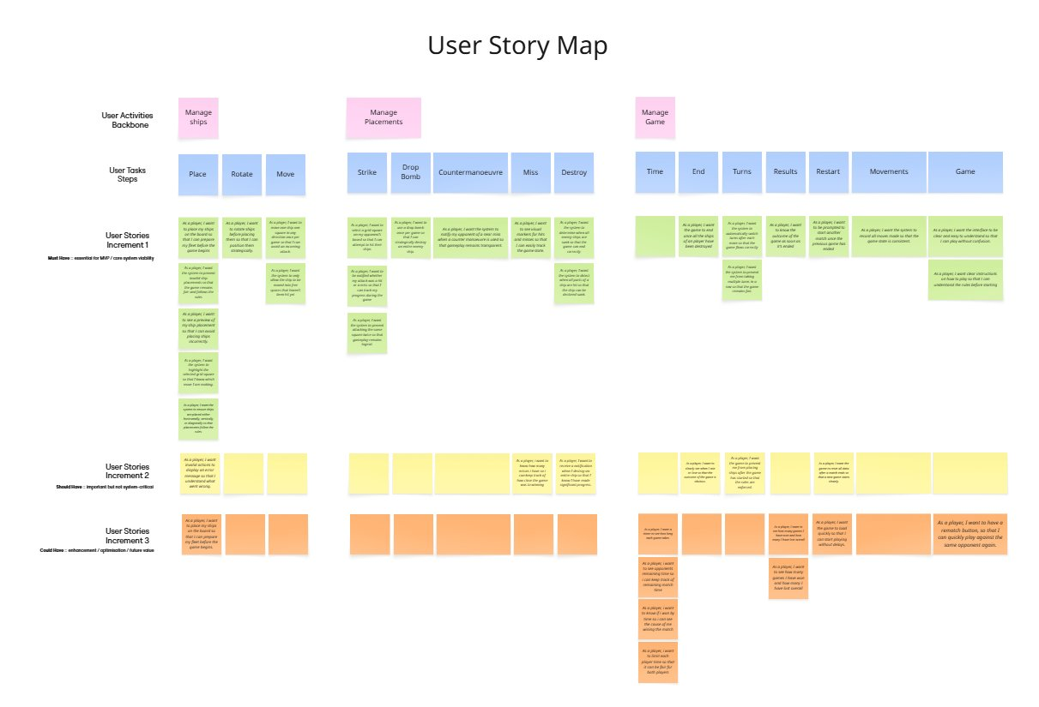
Figure 1. User Story Map — Miro Board SEPT2026-Team4 (produced collaboratively)

Increment 1 (green) contains the stories that are essential for a playable game — placing ships, taking turns, recording hits and misses, and ending the game when all ships are sunk. Increment 2 (yellow) adds error handling, miss counts, and clearer win/lose displays. Increment 3 (orange) covers optional enhancements like timers, win/loss history, and a rematch button.

3.3 Selected User Stories
Six stories from my team's set are shown below. These were chosen to represent the range of functionality — from core mechanics to the two rule amendments in the specification.

User Story US-01
As a...: player
I want to...: place my ships on the board before the game begins
So that...: I can prepare a strategic fleet position, which directly shapes my chances of winning and makes me feel invested in the game from the very start.
Acceptance Criteria: Ships can be placed horizontally, vertically, or diagonally. Overlapping placements are rejected. A preview shows the position before it is confirmed.

User Story US-02
As a...: player
I want to...: rotate a ship before placing it
So that...: I can choose the orientation that best fits my strategy, rather than being forced into a single direction.
Acceptance Criteria: Rotation updates the ship preview in real time. All placement rules apply to rotated ships equally.

User Story US-03
As a...: player
I want to...: select a grid square on my opponent's board to attack
So that...: I can try to find and sink the opponent's ships, with clear feedback on each move so I know whether I hit or missed.
Acceptance Criteria: The system returns hit, miss, or destroy. A cell that has already been attacked cannot be selected again. The board updates immediately with the correct marker.

User Story US-04
As a...: player
I want to...: use a drop bomb once during the game
So that...: I have a powerful one-time option that can sink a whole ship instantly, which adds a strategic dimension beyond the normal turn-by-turn play.
Acceptance Criteria: The drop bomb can only be used once per player. If it lands on any cell of a ship, the entire ship is destroyed and the opponent is notified. The used status persists for the rest of the game.

User Story US-05
As a...: player
I want to...: move one of my ships one square in any direction during the game
So that...: I can respond to an attack I anticipate, which adds a defensive element that makes the game more than just guessing coordinates.
Acceptance Criteria: The counter-manoeuvre can only be used once. The ship must move to a free, unattacked square. The opponent is notified of a near miss. The ship leaves its old cells and occupies the new ones.

User Story US-06
As a...: player
I want to...: see clear visual markers for hits and misses on both boards throughout the game
So that...: I can track the state of play accurately without relying on memory, which keeps the game fair and reduces the chance of mistakes.
Acceptance Criteria: Hits are marked with ✕ and misses with ○. Markers appear on the correct board immediately and stay for the full game.

3.4 Discussing the Benefit Element
The benefit clause is often treated as optional, but it is actually the most useful part of the story. Cohn [6] argues that if you cannot write a meaningful benefit, it is a sign the feature might not be worth building. In practice, writing the benefit forces a conversation about what the player actually gains.
For the drop bomb story (US-04), the benefit — 'a strategic dimension beyond normal turn-by-turn play' — immediately raised a design question: if the move is powerful and irreversible, the player needs a way to confirm before using it to avoid accidents. That requirement would never have appeared from a technical description alone. Similarly, for US-05, framing the counter-manoeuvre as 'a defensive element' made clear that the near-miss notification needs to feel meaningful to the opponent, not just a system message. Patton [7] makes exactly this point: the benefit clause reliably surfaces hidden acceptance criteria that pure functional descriptions miss.

3.5 Evaluating the Stories Against INVEST
Wake [8] proposed the INVEST criteria as a quality check for user stories: Independent, Negotiable, Valuable, Estimable, Small, Testable. The team's Increment 1 stories hold up well against most of these. They are small enough to be completed in a short sprint, clearly valuable to the player, and testable against the acceptance criteria listed on each card. The drop bomb story (US-04) is the weakest on independence because it depends on the hit-detection logic from the Strike story — a dependency that was flagged and managed by scheduling the Strike story first.

3.6 MoSCoW Prioritisation
My team's three-increment structure reflects sound MoSCoW thinking. Increment 1 is the walking skeleton — the smallest version of the game that is actually playable. Increments 2 and 3 layer on progressively less critical features. This meant we always had a shippable product, even if the project ran over time, which aligns with the core Agile principle of delivering working software frequently [2].

4. CRC Cards

4.1 The CRC Card Technique
CRC stands for Class-Responsibility-Collaborator. Beck and Cunningham [3] introduced the technique as a way for teams to reason about object-oriented design without getting bogged down in notation. Each card represents one class and captures two things: what it is responsible for doing, and which other classes it needs to work with. The point of writing them on cards — physical or digital — is that they can be moved around, crossed out, and rewritten quickly during a discussion. Ambler [9] notes that CRC cards are most effective in early design precisely because they lower the cost of changing your mind.

4.2 The Team's First Iteration
Figure 2 shows the first iteration of CRC cards my team produced during the in-class design session. Twelve classes were created: Start Game, Miss, Rules, End Game, Drop Bomb, Board, Place Ship, Hit, Results, Rotate Ship, Countermanoeuvre, Restart, Move Ship, and Destroy Ship.

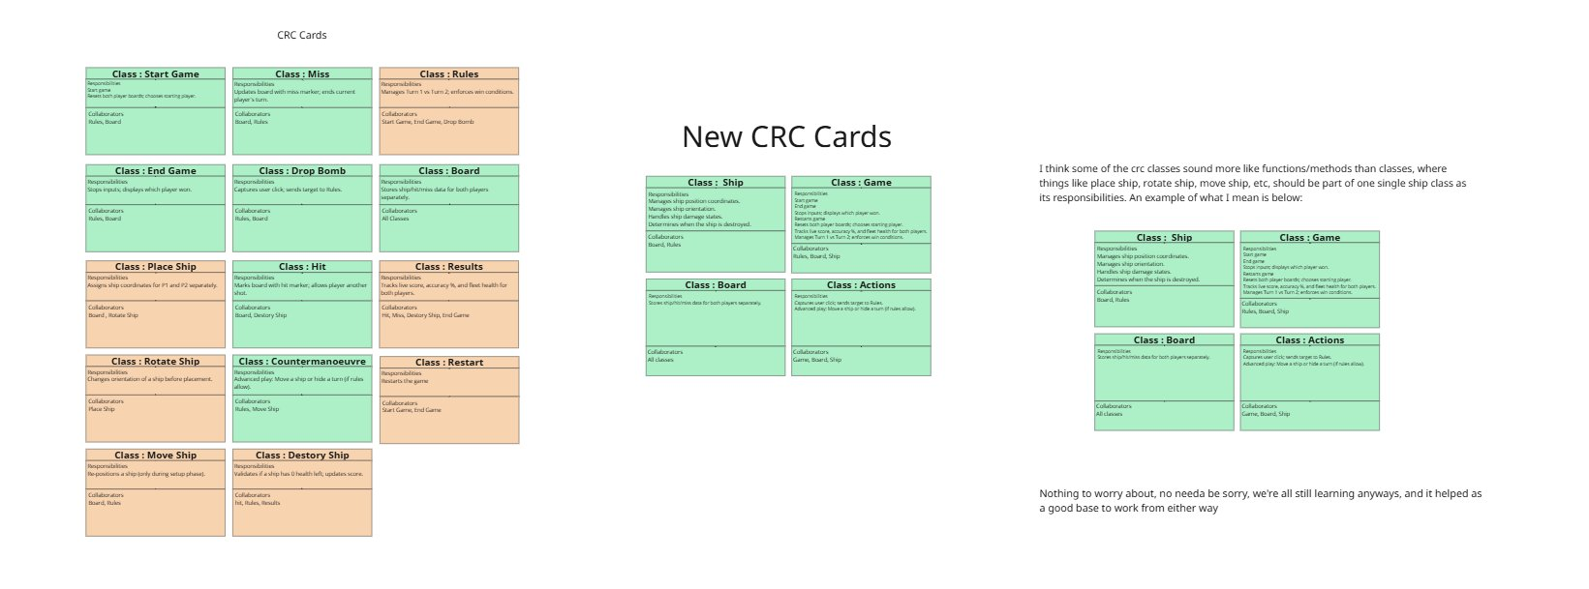
Figure 2. First Iteration CRC Cards, Refined Cards, and Team Feedback — Miro Board

4.3 Critique and the Second Iteration
A team member's comment on the Miro board pointed out that several of the twelve classes were really operations rather than classes: Place Ship, Rotate Ship, Move Ship, Hit, Miss, and Destroy Ship are all things you do to a ship or a board, not independent entities with their own state and behaviour. This is one of the most common mistakes in early object-oriented design, and Ambler [9] specifically warns against it. The feedback prompted a noun-identification exercise, using the user stories to separate things that exist in the domain (nouns like Ship, Board, Game) from things that happen (verbs like place, rotate, hit).
The result was a refined set of four classes: Ship, Game, Board, and Actions. This second iteration is shown in Figure 2 alongside the first. The reduction from twelve to four is significant — it means each class has a clear, well-bounded purpose, which makes both implementation and testing considerably more straightforward.
I thought it was worth noting how the feedback was received. The response on the board was: 'Nothing to worry about, no need to be sorry, we're all still learning anyway, and it helped as a good base to work from either way.' That kind of psychological safety — where critique is offered and received constructively — is what made our collaborative design work well. Cockburn [5] identifies team trust as one of the most important factors in the success of any design process.

4.4 The Refined CRC Cards
The four refined cards are reproduced below in a structured format for clarity.

Class: Ship
Responsibilities | Collaborators
Manages ship position and coordinates | Board
Manages ship orientation (H/V/diagonal) | Rules
Handles ship damage states
Determines when the ship is fully destroyed

Class: Game
Responsibilities | Collaborators
Starts and ends the game | Rules
Displays which player has won | Board
Resets the game state for a new match | Ship
Tracks live score, accuracy %, and fleet health for both players
Manages Turn 1 vs Turn 2 and enforces win conditions

Class: Board
Responsibilities | Collaborators
Stores ship/hit/miss data for both players separately | All classes
Updates cell state for both players in a consistent way

Class: Actions
Responsibilities | Collaborators
Captures user clicks and sends the target to Rules | Game
Handles advanced play: activates Drop Bomb or triggers the counter-manoeuvre if rules allow | Board
 | Ship

4.5 Are the Cards Good Enough for Implementation and Testing?
The refined four-class design is solid. The responsibilities are specific enough that a developer could translate them directly into method signatures, and the collaborator lists define the interfaces between classes. The Board class in particular is well designed for testability: its single responsibility — storing and updating cell state — means it can be tested completely independently of the other classes.
There are two things worth flagging for a real project. First, the cards do not specify data attributes, which means developers would need to infer or add these when writing code. The class diagrams discussed in Section 4.6 address this partly, but a future iteration of the CRC cards would benefit from including key attributes. Second, the cards do not explicitly link responsibilities to user story acceptance criteria. Adding a story ID annotation to each responsibility would make the traceability explicit and reduce the risk of missing a test.

4.6 Class Diagrams
Following the CRC card review, my team produced class diagrams with attributes, methods, and relationships. Figure 3 shows the Ship class diagram in detail, along with a UML notation guide we worked from. The Ship class includes attributes such as shipID, isSunk, shipType, coordinates, orientation, oldCoords, newCoords, missMarker, splashEffect, damageValue, and hitEffect, with methods including removeShip(), notifyFleetUpdate(), setShipPosition(), isValidPlacement(), toggleRotation(), getBounds(), shiftShip(), checkOverlap(), triggerSplash(), endTurn(), triggerExplosion(), and applyDamage().

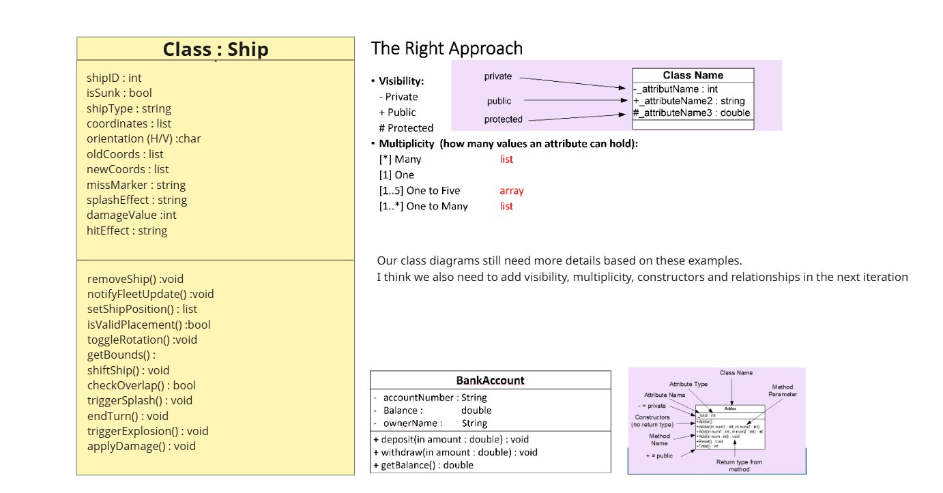
Figure 3. Ship Class Diagram and UML Notation Reference — Miro Board

The relationships between classes are: one Game to one Board; one Game to many Ships; one Board to many Actions; Actions depend on Board and Ship. These multiplicities confirm the design is consistent with the CRC collaborator lists. One of my teammates noted on the board that the diagrams still needed visibility markers, multiplicity annotations, and constructors adding in the next iteration — a sign of healthy self-reflection during the design process.

5. Software Testing Evaluation

5.1 Why Testing Matters
Testing is how we build confidence that software actually does what it is supposed to do. Myers et al. [10] define it bluntly: testing is the process of running a program with the intent of finding errors. That framing — finding errors rather than confirming correctness — is important because it pushes testers to think adversarially, to ask where the code might break rather than where it is likely to work.
The consequences of insufficient testing can be severe. The Ariane 5 rocket failure in 1996 was caused by an unhandled integer overflow in software that had been reused from the Ariane 4 without being retested in the new context [11]. The Therac-25 radiation therapy machine delivered lethal overdoses to patients as a result of race conditions in the control software that were not caught by the testing process [12]. While a Battleships web application carries no comparable safety risk, these examples make clear why testing cannot be treated as optional or bolted on at the end.
Testing also has a design benefit. Beck [13] argues that writing tests before or alongside code forces developers to think clearly about what a method should do and how it should be called before they write a single line of implementation. This almost always produces cleaner, more modular code.

5.2 Black-Box Testing

5.2.1 What It Is
Black-box testing derives test cases from the specification or requirements without any knowledge of how the code is implemented internally [10]. The tester treats the system as a black box: give it an input, observe the output, check whether it matches what was expected. The main techniques are equivalence partitioning (dividing inputs into groups expected to behave the same way), boundary value analysis (testing at the edges of valid and invalid ranges), and decision table testing (systematically covering combinations of conditions).
For Battleships, equivalence partitioning applies clearly to grid coordinates: valid inputs (row and column both 0–9), out-of-range inputs (negative values or values above 9), and repeat inputs (a coordinate that has already been attacked) each form a distinct partition, and at least one test case per partition is needed.

5.2.2 Why It Suits This Project
The strength of black-box testing is that tests are tied to the requirements rather than the implementation. If the Board class is refactored — changing how it stores cell state internally — the black-box tests should still pass, because they only care about the observable output. For an iterative project like ours where the internal structure is likely to change, this robustness is valuable.

5.3 White-Box Testing

5.3.1 What It Is
White-box testing uses knowledge of the internal code structure to design tests that exercise specific paths, branches, and conditions [14]. Unlike black-box testing, white-box tests are written by looking at the code. Common coverage criteria include statement coverage (every line executed at least once), branch coverage (every conditional branch taken in both directions), and path coverage (every unique execution path tested).
For Battleships, branch coverage is the most relevant criterion. The logic for handling a strike contains multiple branches: is the cell already attacked? is it a hit or a miss? if it is a hit, does it sink the ship? if it sinks the ship, does it end the game? Each of these branches needs a test case that takes it in both the true and false direction.

5.3.2 Why It Complements Black-Box Testing
White-box testing catches bugs that are invisible at the interface level. For example, the drop bomb method in the Actions class has an internal check: if the ability has already been used, it should return an error. A black-box test might cover this scenario, but only if the tester thought to include it. A white-box tester looks at the code, sees the branch, and writes a test for it as a matter of course.

5.4 Comparing the Two Approaches
Dimension | Black-Box | White-Box
Knowledge needed | Specification / requirements only | Internal code structure
Tests derived from | User stories, acceptance criteria | Code paths, branches, conditions
Coupled to implementation? | No — survives refactoring | Yes — may break after refactoring
Typical use | Acceptance testing, regression | Unit testing, coverage analysis
Main strength | Traces back to requirements; no implementation bias | Finds logic bugs invisible at the interface
Main limitation | Can miss internal errors | Does not verify correctness against requirements
Figure 4. Comparison of Black-Box and White-Box Testing

5.5 Testable Code
Testable code is code that has been written in a way that makes it straightforward to test. Meszaros [15] identifies four key properties: single responsibility (each unit does one clearly defined thing), dependency injection (objects receive their dependencies from outside rather than creating them internally, which makes it easy to substitute mock objects in tests), absence of global state (hidden shared state is the enemy of independent tests), and determinism (the same inputs always produce the same outputs).
In our Battleships design, the decision to separate Actions from both Game and Board is a testability decision, even if my team did not explicitly frame it that way. Because Actions receives Board and Ship as inputs rather than creating them internally, a test can pass in mock objects that record what methods were called without executing any real game logic. This means the Actions class can be tested completely in isolation. Sommerville [4] argues that testability should be treated as a first-class design requirement from the start of a project, not something considered after implementation. My team's class design, particularly the separation of concerns across the four classes, reflects this principle in practice.

6. Application Tests and Unit Testing Investigation

6.1 Unit Testing Principles
Unit testing means testing individual methods or functions in isolation — one unit at a time, with everything else either stubbed out or mocked. Beck [13] describes the F.I.R.S.T. properties that good unit tests should have: Fast (they run in milliseconds, not seconds), Independent (no test depends on the outcome of another), Repeatable (the same result every time, on any machine), Self-validating (they pass or fail automatically, without manual inspection), and Timely (written at the same time as the code, not months later).
Cohn [16] places unit tests at the base of the testing pyramid: a large number of fast, isolated unit tests, supporting a smaller set of integration tests, topped by a small number of slow end-to-end tests. The pyramid shape reflects cost — unit tests are cheap to write and run, integration tests are more expensive, and end-to-end tests are the most expensive of all. For the Battleships application, unit tests would target individual class methods such as Board.updateCell(), Ship.isValidPlacement(), and Actions.activateSpecial(). Integration tests would verify that a full turn sequence — placement, attack, turn switch, win check — works correctly across the class boundaries.

6.2 Testing Frameworks
For a JavaScript web application, Jest is the standard choice [17]. It provides built-in assertion functions, mocking support, and automatic code coverage reporting. Tests in Jest follow the Arrange-Act-Assert pattern: set up the state needed for the test (Arrange), call the method under test (Act), and verify that the result is what was expected (Assert). This pattern maps directly to the pre-conditions, inputs, and expected outputs specified in the test cases below.

6.3 Test Cases
Eight test cases are presented below, covering both black-box and white-box approaches. Each is derived from my team's user stories and class design.

Test ID | TC-01
Type | Black-Box — Functional
Description | Valid ship placement on empty board
Pre-conditions | A new Board has been created with an empty grid. No ships have been placed yet.
Inputs | Ship type: Carrier (size 5); starting cell: (0,0); orientation: horizontal
Expected Output | isValidPlacement() returns true. Cells (0,0) through (0,4) are marked as occupied. No error is thrown.
What it elicits | Tests the happy path for ship placement (US-01). Checks that the coordinate assignment logic is working correctly. A common off-by-one error would result in only four cells being assigned instead of five.

Test ID | TC-02
Type | Black-Box — Boundary
Description | Ship placement extending past the board edge
Pre-conditions | A new Board has been created. No ships have been placed.
Inputs | Ship type: Carrier (size 5); starting cell: (0,7); orientation: horizontal (would need cells (0,7) through (0,11))
Expected Output | isValidPlacement() returns false. Board state is unchanged. An error is returned.
What it elicits | Boundary value analysis: column 11 does not exist on a 10-column grid. Tests that the placement validation catches this before trying to write to an invalid array index. Without this check, the application would likely crash.

Test ID | TC-03
Type | Black-Box — Functional
Description | Attacking an empty cell returns a miss
Pre-conditions | A Board has been set up with a Destroyer at cells (3,3) and (3,4). No attacks have been made yet.
Inputs | Attack target: (5,5) passed to Actions.findShot()
Expected Output | Returns 'miss'. Cell (5,5) is marked as attacked on the board. No ship is reported as sunk.
What it elicits | Tests the miss path of the strike logic (US-03). Confirms that the board records the attack correctly and that the 'miss' notification is returned. Derives directly from the acceptance criterion 'the system returns hit or miss'.

Test ID | TC-04
Type | Black-Box — Functional
Description | Hitting the last cell of a ship triggers a destroy notification
Pre-conditions | A Board has a Destroyer at (3,3) and (3,4). Cell (3,3) has already been hit and recorded on the Ship.
Inputs | Attack target: (3,4) passed to Actions.findShot()
Expected Output | Returns 'destroy'. Both cells are recorded as hit. Ship.isSunk() returns true. 'Destroy' notification is raised.
What it elicits | Tests the ship-sinking detection logic across Actions, Ship, and Board (US-03). Verifies that hitting all cells of a ship correctly triggers the 'destroy' notification rather than a simple 'hit'. This acceptance criterion is explicitly stated in the user story.

Test ID | TC-05
Type | Black-Box — Functional
Description | The drop bomb can only be used once
Pre-conditions | Actions has been instantiated. The game state confirms the drop bomb has not yet been used. A Board with a Cruiser is set up.
Inputs | Player calls Actions.activateSpecial('dropBomb') twice in a row.
Expected Output | First call: the Cruiser is fully destroyed, 'destroy' is returned, and the drop bomb is marked as used. Second call: rejected with an error. Board state does not change.
What it elicits | Tests the single-use constraint on the drop bomb (US-04). Any missing guard clause that fails to check the used flag would allow the bomb to be used multiple times, breaking the game rules.

Test ID | TC-06
Type | Black-Box — Functional
Description | Counter-manoeuvre moves the ship and notifies the opponent
Pre-conditions | A Cruiser is positioned at (2,2), (2,3), and (2,4). The counter-manoeuvre has not yet been used. The opponent has just attacked (2,2).
Inputs | Player triggers Actions.activateSpecial('evadeAttacks'), moving the ship one square to the right: new position (2,3), (2,4), (2,5).
Expected Output | 'Near miss' notification is returned. Ship coordinates are updated to the new cells. The old cells are cleared on the Board. The counter-manoeuvre is marked as used.
What it elicits | Tests the complete counter-manoeuvre flow end-to-end (US-05): coordinate update, board state change, and notification. A bug in the cell-clearing logic would leave the ship occupying both old and new cells simultaneously.

Test ID | TC-07
Type | White-Box — Branch Coverage
Description | The game blocks a player from acting out of turn
Pre-conditions | Game has been instantiated. currentPlayerID is set to 1. A Player 2 object is available.
Inputs | Player 2 attempts to trigger an action while currentPlayerID is 1.
Expected Output | The action is blocked. An error or false is returned. Game state is unchanged. currentPlayerID remains 1.
What it elicits | Targets the internal guard clause in Game's turn management: 'if actor !== currentPlayerID, reject.' This test requires knowing that the currentPlayerID attribute exists, which is why it is a white-box test. It covers the error branch that would be triggered by a race condition or a direct API call bypassing the UI.

Test ID | TC-08
Type | White-Box — Statement Coverage
Description | isSunk() returns false when only part of the ship has been hit
Pre-conditions | A Battleship (size 4) has been created. The internal hit record shows one cell hit and three not hit.
Inputs | Call the method responsible for checking whether the ship is sunk (derived from the 'determines when the ship is fully destroyed' responsibility).
Expected Output | Returns false.
What it elicits | Confirms that the sunk-detection logic checks all cells, not just the first one. If the method returned true after any hit, it would trigger a false 'destroy' notification. This white-box test accesses the internal hit array directly in the Arrange step, which is only possible with knowledge of the implementation.

6.4 How the Design Supports Testability
Looking back at the test cases, it is clear how much the class design decisions affect how easy the tests are to write. TC-05 and TC-06 are straightforward because the ability-used flags are stored as instance-level state in the Actions or Game class, which means a test can set them directly in the Arrange step without having to simulate a full game sequence. TC-07 works cleanly because currentPlayerID is an explicit attribute on the Game class, visible in the class diagram.
The separation of Board into its own class with a simple updateCell / getCellStatus interface is particularly important. It means TC-03, TC-04, and TC-06 can all verify board state changes without depending on any Ship or Actions logic. Each test is testing exactly one thing, which is what makes them fast and independent — the F.I.R.S.T. properties in action [13].

6.5 Limitations of Unit Testing
Unit tests are not enough on their own. By definition, they test components in isolation, which means they cannot catch bugs that only appear when components interact. For Battleships, an integration test would be needed to verify that a full turn sequence — ship placement, attack, turn switch, win detection — works correctly when the classes are all running together. Myers et al. [10] make the point that testing can only show the presence of defects, never their absence. A thorough combination of black-box tests derived from the user stories and white-box tests targeting the complex internal branches in the class design gives the broadest practical coverage, while acknowledging that complete certainty is never achievable.

7. Conclusion
This report has evaluated the software engineering design and testing process I was part of in developing the Battleships web application. Working collaboratively on a shared Miro board, my team produced a user story map with three MoSCoW increments, two iterations of CRC cards, a sequence diagram, and class diagrams with attributes, methods, and relationships.
The two-iteration CRC card process was the most valuable part of our design work. The first iteration gave us a shared domain vocabulary; the second, prompted by honest peer critique, produced a clean four-class design — Ship, Game, Board, and Actions — that is coherent with both the sequence diagram and the class diagrams. The user story map provides a clear MVP scope and demonstrates that my team understood the walking skeleton principle.
The testing sections show that black-box and white-box approaches complement each other: black-box tests trace directly back to user story acceptance criteria, while white-box tests target the internal branches that specification-level testing would likely miss. The eight test cases presented demonstrate this traceability from requirement through design to test. The unit testing investigation confirms that the class design's separation of concerns directly enables effective isolated testing in a framework like Jest.
Overall, this process taught me a lot about how collaborative software design actually works in practice. The main lessons — start with noun identification before CRC cards, agree on UML notation early, use the sequence diagram as a cross-check against the CRC cards — are things I would apply from the start of any future project.

Appendix A — User Story Map: Written Reference
This appendix provides a full written breakdown of all user stories produced by my team, organised by activity, task, and delivery increment. It accompanies Figure 1 in Section 3.

A.1 User Activities (Backbone)
- Manage Ships
- Manage Placements
- Manage Game

A.2 User Tasks (Steps)
- Manage Ships: Place, Rotate, Move
- Manage Placements: Strike, Drop Bomb, Countermanoeuvre, Miss, Destroy
- Manage Game: Time, End, Turns, Results, Restart, Movements, Game

A.3 User Stories — Increment 1 (Must Have)
Manage Ships
Place
- Place ships on the board to prepare the fleet before the game begins.
- Prevent invalid ship placements to keep rules fair.
- Preview ship placement to avoid incorrect positions.
- Highlight selected grid square to confirm the move.
- Ensure ships can be placed horizontally, vertically, or diagonally per rules.
Rotate
- Rotate ships before placing to position them strategically.
Move
- Move one ship one square in any direction once per game to avoid an incoming attack.
- Only allow moving into free, not-yet-hit spaces.

Manage Placements
Strike
- Select a grid square on the opponent's board to attempt a hit.
- Notify if an attack is a hit or miss to track progress.
- Prevent attacking the same square twice.
Drop Bomb
- Use a drop bomb once per game to destroy an entire enemy ship.
Countermanoeuvre
- Notify opponent of a near miss when a counter manoeuvre is used.
Miss
- Show visual markers for hits and misses to track state.
Destroy
- Detect when all parts of a ship are hit to declare it sunk.
- Determine when all enemy ships are sunk so the game can end.

Manage Game
End
- End the game once all ships of a player are destroyed.
Turns
- Automatically switch turns after each move.
- Prevent taking multiple turns in a row.
Results
- Show the outcome immediately after the game ends.
Restart
- Prompt to start another match after a game ends.
Movements
- Record all moves so game state is consistent.
Game
- Provide a clear, easy-to-understand interface.
- Provide clear instructions before starting.

A.4 User Stories — Increment 2 (Should Have)
- Manage Ships: Show error message for invalid actions.
- Manage Placements: Show count of misses; notify when an entire ship is destroyed.
- Manage Game: Clearly show win/lose; prevent placing ships after the game starts; reset all data after a match.

A.5 User Stories — Increment 3 (Could Have)
Manage Game
- Time: Show game timer; show opponent's remaining time; indicate wins by time; limit each player's time.
- Results: Show total wins and losses.
- Restart: Load the game quickly.
- Game: Provide a rematch button to replay the same opponent.

References
[1] Mark Huntly, "ACCB5030 Semester 2 Coursework Specification - Software Engineering Design & Testing," Swansea College of Art & Technology, 2026.
[2] K. Beck et al., "Manifesto for Agile Software Development," 2001. [Online]. Available: https://agilemanifesto.org. [Accessed: 3 May 2026].
[3] K. Beck and W. Cunningham, "A laboratory for teaching object-oriented thinking," ACM SIGPLAN Notices, vol. 24, no. 10, pp. 1-6, Oct. 1989.
[4] I. Sommerville, Software Engineering, 10th ed. Harlow: Pearson, 2016.
[5] A. Cockburn, Crystal Clear: A Human-Powered Methodology for Small Teams. Boston, MA: Addison-Wesley, 2004.
[6] M. Cohn, User Stories Applied: For Agile Software Development. Boston, MA: Addison-Wesley, 2004.
[7] J. Patton, User Story Mapping: Discover the Whole Story, Build the Right Product. Sebastopol, CA: O'Reilly Media, 2014.
[8] B. Wake, "INVEST in Good Stories, and SMART Tasks," 2003. [Online]. Available: https://xp123.com/invest-in-good-stories-and-smart-tasks. [Accessed: 3 May 2026].
[9] S. W. Ambler, Agile Modeling: Effective Practices for Extreme Programming and the Unified Process. New York, NY: John Wiley & Sons, 2002.
[10] G. J. Myers, C. Sandler, and T. Badgett, The Art of Software Testing, 3rd ed. Hoboken, NJ: John Wiley & Sons, 2011.
[11] J. L. Lions, "ARIANE 5 Flight 501 Failure: Report by the Inquiry Board," ESA/CNES, Paris, France, 1996.
[12] N. G. Leveson and C. S. Turner, "An investigation of the Therac-25 accidents," Computer, vol. 26, no. 7, pp. 18-41, Jul. 1993.
[13] K. Beck, Test Driven Development: By Example. Boston, MA: Addison-Wesley, 2003.
[14] B. Beizer, Black-Box Testing: Techniques for Functional Testing of Software and Systems. New York, NY: John Wiley & Sons, 1995.
[15] G. Meszaros, xUnit Test Patterns: Refactoring Test Code. Upper Saddle River, NJ: Addison-Wesley, 2007.
[16] M. Cohn, Succeeding with Agile: Software Development Using Scrum. Upper Saddle River, NJ: Addison-Wesley, 2009.
[17] Meta Platforms, "Jest: Delightful JavaScript Testing," 2023. [Online]. Available: https://jestjs.io. [Accessed: 3 May 2026].

