

ASSIGNMENT DETAILS AND FEEDBACK
SOUTH WEST WALES CENTRE FOR TEACHER EDUCATION
Sections marked with * should be completed by module lead
Student name: | Hannah Rees | Student P number: | 1301065
Programme: * | PGCE Primary
Module: * | The Enquiring Teacher | Module Level (6 or 7):* | 7
Module code: * | M7X2152 | Contribution to Overall  Module Assessment (%): * | 100%
Module Lead:* | Catherine Morgan
Assignment Title:* | Write a critical and analytical essay that discusses your practitioner research ‘lesson study’ in relation to a chosen field. | Assignment No (x of x):* | 1/1
Start date:* | 09/01/18 | Submission deadline:* | 16/04/18
Return date of provisional marks & written feedback:*

Referencing: | In the main body of your submission you must give credit to authors on whose research your work is based. Append to your submission a reference list that indicates the books, articles, etc. that you have read or quoted in order to complete this assignment (e.g. for books: surname of author and initials, year of publication, title of book, edition, publisher: place of publication).
Submission: | All assignments must be submitted to Turnitin unless otherwise instructed by the Lecturer.  Note: the Turnitin version is the primary submission and acts as a receipt for the student. Late submission of the electronic version of the assignment will result in a late penalty. Penalties for late submission: Up to one week late, maximum grade D. Over one week late, Refer. Only the Extenuating Circumstances Panel may grant an extension. | Date: | 16/04/18

Module lead to tick to indicate if a hard copy version of the assignment must be submitted.* | YES
 | NO

marking criteria and Student FEEDBACK

This section details the assessment criteria. The extent to which these are demonstrated by you determines your mark. The marks available for each criterion are shown. Lecturers will use the space provided to comment on the achievement of the task(s), including those areas in which you have performed well and areas that would benefit from development/improvement.

Common Assessment Criteria Applied | Grade  awarded
1. Subject Knowledge and Understanding (which includes using research-informed literature and knowledge and understanding of the subject)
Extent of research and/or own reading, selection of credible sources, application of appropriate referencing conventions. Extent of knowledge and understanding of concepts and underlying principles associated with the discipline.
2. Intellectual Skills (Analysis)
Analysis, evaluation and synthesis; logic, argument and judgement; analytical reflection; organisation of ideas and evidence
3. Pedagogic and Professional Applications (Practical Application and Deployment)
Deployment of pedagogic methods, materials, tools and techniques; application of concepts; formulation of innovative and creative solutions to solve problems. Attributes in professional practice: individual and collaborative working
4.Key Transferable Skills
Deployment of appropriate media; presentation and organisation.

Assignment Grade (Assessment grades are subject to ratification at the Exam Board. These comments and marks are to give feedback on module work and are for guidance only until they are confirmed. ) | Late Submission Penalties (tick if appropriate)
 | Up to 1 week late | D Max
 | Over 1 week late | Fail

Level 7 | Assessment Criteria Descriptors for Primary PGCE with QTS  This format emphasizes the holistic nature of judgements to be made by markers. Equal weighting is given to each section. Plagiarism or non-submission will result in F (0%) grading.
Assessment Criteria | Fail - grade E | Weak pass– grade D | Pass – grade C | Pass – grade B | Pass – grade A
Assessment Criteria | Poor | Weak Pass | Satisfactory | Good | Excellent
Overall judgement | Poor understanding, unsystematic, incomplete and/or inaccurate | Understanding of main issues demonstrated | Satisfactory understanding demonstrated with satisfactory analysis | Good understanding of basic principles and relevant evidence, with a coherent and logical argument | Highly thoughtful answer informed by wider reading, showing clarity of thought, personal insight and some originality
Subject Knowledge and Understanding  (Conceptual)  (Reading) | Basic misunderstanding, misconceptions, or misinterpretations - Some superficial knowledge in places | Main concepts understood with limited evidence of critical insight | Sound understanding of concepts and critical engagement with ideas | Good understanding of key concepts; knowledge of wider implications; critical engagement | Engaged critically and systematically with the main concepts and theories: excellent engagement
Subject Knowledge and Understanding  (Conceptual)  (Reading) | Poor and/or inappropriate literature, lacking accuracy, unsound, limited/dated range of sources | Satisfactory range of reading overall although this may be limited in some way | Satisfactory range of reading drawn from the recommended list and other sources | Good range of relevant literature from a variety of sources beyond recommended list | Clear evidence of independent thinking informed by a selective range of reading from a variety of sources
Intellectual skills  (argument)  ( professional data collection: research design/data collection )  (presentation of findings/analysis)  (critical /reflective evaluation) | Little sense of an argument lacks coherence.  Generally descriptive or anecdotal | Argument is balanced with some differing viewpoints presented. Some questioning of assumptions | Argument presented shows satisfactory evidence of critical and analytical reflection. | Strong argument developed. Good evidence of critical and analytical reflection | A well-structured critical argument is presented with evidence of synthesis of viewpoints
 | Professional data collection is inappropriate/ flawed /not discussed | Professional data collection is mainly suited to purposed; beginnings of critical considerations | Professional data collection is suited to purpose and considered critically. | Professional data collection well suited to purpose, justified with clear identified focus | Professional data collection logical and sophisticated; comprehensive understanding of appropriate techniques
 | Findings presented with little or no framework or discussion; or discussion of findings is descriptive. Few conclusions are drawn or conclusions drawn are inappropriate. | Findings are presented with basic analysis and some limited but appropriate conclusions | Findings presented with some analysis and criticality with justified conclusions | Findings presented in a critical and analytical framework. Thoughtful conclusions, firmly based upon the evidence presented | Findings presented in a critical and analytical framework. Insightful conclusions, firmly based upon the evidence presented
 | Little or no evaluation attempted; no or limited reflection | Evaluation and reflection is present but may be limited | Satisfactory critical evaluation of study; satisfactory reflection | Good critical evaluation of study; good reflection | Critically reflective evaluation of work informed by excellent reflection.
Pedagogic and Professional applications  (linking theory to practice)  (professional reflection)  (working in a group)  (ethical conduct where appropriate) | Little or no evidence of engagement or superficial engagement and understanding with respect to the pedagogic and professional context(s) | Some engagement and understanding with respect to the pedagogic and professional context(s) | Sound engagement and understanding with respect to the pedagogic and professional context(s) | Good evidence of integration of theory and practice with respect to the pedagogic and professional context(s) | Excellent integration of theory and practice with respect to the pedagogic and professional context(s)
 | No evidence of reflection | Some evidence of reflection whilst beginning to make links with own practice and thinking | Satisfactory evidence of critical reflection whilst beginning to make links with own practice and thinking | Good evidence of critical reflection whilst making links with own practice and thinking | Demonstrates an excellent level of understanding of critical reflection as a learning process
 | Inability to work with others or works within a group but lacks self direction or group responsibility | Responsibility for planning and developing courses of action; shows awareness of group responsibility | Initiates and occasionally leads tasks/processes for won work and where appropriate for others. | Chooses goals and can self-direct; able to co-operate within a group and can take the lead | Accepts accountability for determining and achieving personal and/or group outcomes
 | Ethical issues not or superficially considered | Some awareness of ethical issues | Appropriate ethical issues raised and discussed; bias/prejudice not noted | Good, clear understanding of ethical issues; awareness of bias and prejudice | Ethical issues have been addressed effectively; bias/ prejudice discussion includes attempts to nullify this
Key/Transferable Skills  (presentation)  (spelling, punctuation and grammar)  (structure)  (referencing techniques) | Poor presentation of written work | Presentation of written work is weak | Satisfactory presentation of written work | Good presentation of written work | Excellent presentation of written work
 | Significant errors in spelling, punctuation or grammar | Some errors in spelling, punctuation or grammar | Spelling, punctuation and grammar are satisfactory; few errors in written language | Spelling, grammar and punctuation are good; very few errors in written language | Excellent standard of written language. No or very minor errors in written language
 | Poor structure with unclear writing style | Structure is present but may be underdeveloped, writing style is mostly coherent | Satisfactory structure with coherent writing style | Good structure with a coherent writing style | Effective structure and highly coherent writing style which fully engages the reader
 | No use or limited use of protocols and conventions including Harvard referencing | Some following of protocol and conventions of Harvard referencing | Satisfactory use of Harvard referencing protocols and conventions | Good use of Harvard referencing protocols and conventions | Harvard system used accurately, consistently and effectively with all sources

Student Self Evaluation Form

This section repeats in brief the common assessment criteria detailed on previous pages. The extent to which these are demonstrated by you determines your mark. Using these criteria, tick the box that best indicates the level of achievement you feel you have achieved with regard to each of them.
Common Assessment Criteria Applied
Common Assessment Criteria Applied | REFER |  | D |  | C |  | B | A
 | OUTRIGHT FAIL | UNSATISFACTORY | SATISFACTORY | GOOD |  | VERY GOOD |  | EXCELLENT
1. Subject Knowledge and Understanding (which includes using research-informed literature and knowledge and understanding of the subject)
 |  |  |  | x
2. Intellectual Skills (Analysis)
2. Intellectual Skills (Analysis) |  |  |  | x
3. Pedagogic and Professional Applications (Practical Application and Deployment)
 |  |  |  | x
4. Key Transferable Skills
4. Key Transferable Skills |  |  |  |  |  | x

PLEASE COMMENT ON AREAS IN WHICH YOU FEEL THAT YOU HAVE PERFORMED WELL | PLEASE COMMENT ON AREAS you feel that you need TO DEVELOP
I feel that I have performed well on the research, I was able to apply my knowledge to the research. I was able to make links between the research, and distinguish between reliable sources and outdated sources. I believe that I was able to consider the ethics of the study, as I have an A-Level in Psychology which has helped mein this essay. | I need to consider the practical applications to my research. How it would effect wider society and its real world applications.

Student’s Name | Hannah Rees | Date | 15/4/18
Student’s Signature | H Rees

Write a critical and analytical essay that discusses your practitioner research ‘lesson study in relation to a chosen field (6640 words)

Introduction
This assignment will discuss a piece of research that was carried out, in a local primary school. The issue that captured my interest me was peer assessment, and whether it encouraged involvement in a lesson. This was of a personal interest to me because during my time teaching in a local primary school, I used various assessment techniques within my lessons. Unfortunately, I never got the opportunity to ask the students what they thought and what would help them to develop their learning further. At the beginning of my training, I found that many of my students were engaged in the main aspect of the lesson but lost interest during the plenary. I wanted to conduct research that solved both of the issues. As part of my teaching experience, I wanted to experiment with different types of assessment techniques and find out which worked the most. Having completed that experience I found that I wasn’t closer to getting the answer, I needed to find a peer assessment technique that encouraged students’ participation and high level of achievement. This research paper has helped to clarify these aspects to education.
Research context
There are many different things that influenced my decision to undertake this research. During my observations of good teaching practice, I found that there was often, only one type of assessment carried out in the classroom. This was teacher marking. Without conducting any previous research, I was aware that teacher marking was outdated and irrelevant. I wanted to change this, I decided to implement different assessment strategies such as individual and peer-assessment.
I discussed this with a partner that found the same issues, and we decided to focus on a key assessment strategy which is peer assessment. When my teacher would mark my work as a child, if would check to see what I had gotten right or wrong but I never questioned it. I never wondered ‘How can I improve?’. Hence the decision to undertake this research. We wanted to find out if peer assessment would help pupils to be more active in their learning, and if it would encourage them to create their own targets for the future. Together our research question is ‘How can we improve student involvement in short story writing through the use of a feedback sandwich?’. For my class, this means that if the research question provides us with a solution, I will be able to use this in my next teaching practice and encourage students to exceed their expectations.

Short overview of relevant literature (770-800)
Before undertaking the research study, I wanted to ensure that I was fully prepared and able to narrow down the research study into an extremely specific area of learning. From my teaching experience, my class (as previously mentioned) were frequently using teacher assessment as a marking strategy. Occasionally, they would use peer-assessment but only when marking a maths piece of work (the answer is either right or wrong). When trialling peer-assessment in a subject other than mathematics, the pupils understood the concept of marking the work, but were unsure of how to give feedback. It was either marked right or wrong, and that was the end of it. Before designing the research I looked into relevant research, to help me gain a better understanding of what I could do for my own class to improve their learning.
As educational specialists, we frequently keep up to date with the latest methods in which to better enhance the learning of our students. As we all are aware, assessment is one of the most important ways in which to accomplish this. Peer assessment is described as “an arrangement for peers to consider the level, value, worth, quality or successfulness of the products or outcomes of learning of others of similar status'.” (Topping, 1998, cited in Leenknecht, 2017, p. 102).
Many positive qualities can be obtained through interaction with peer assessment. Throughout many research studies, it has been found that the use of peer assessment provides skills such as “lesson participation; increasing concentration on learning; providing feedback to other students; increasing attendance and responsibility’ (Yurdabakan, 2011, p.157). These are essential qualities that I want students to possess, the teacher can only teach so much but an eager student possesses no limits.
Furthermore, Searby and Ewers (1997, cited in Yurdabakan, 2011) supports Yurdabakan, building upon the work and stating that participation in peer assessment provides students with a key skill, which is critical thinking. Critical thinking and problem solving learning are as extremely favoured by the Welsh Assembly Goverment (2010), who argue that-
Developing thinking enables learners to gain a deeper understanding of topics, to be more critical about evidence, to think flexibly and to make reasoned judgements and decisions rather than jumping to conclusions. These qualities in thinking are needed both in school and in the wider world. (WAG, 2010, P.4).
One of the issues that arises from peer assessment, is the lack of ability and knowledge required in order to assess (Prins, 2006, cited in Leenknecht, 2017). Prins (2006) believes that when students peer-assess each other, the quality of the feedback received is low as pupils are not trained enough to assess. In addition to this, it can stem from a students' lack of self-esteem (Prins, 2006). Falchikov et al (1995, cited in Leenknecht) are in favour of this, and further argue that students feel ‘unqualified' to mark their peers’ work. It is possible to argue here that blame falls at the feet of the teacher.
Bloxham and West (2007) in their research have discovered that students find it difficult to understand what they are looking for. Similarly, Boon et al (2015) suggest that to get the best out of peer assessment, students need to be shown examples of successful work. This helps students in their understanding, as they have a model in which to help them progress. Moreover, Min (2005, cited in Boon, 2015) looked at teachers who discussed examples of successful work, and explained what they were looking for. They found that students were no longer only marking correct or incorrect for smaller errors such as spelling mistakes, but they were more focused on the meaning and structure of the work that they were given. This is a crucial element as it is encouraging students to look beyond the trivial, and focus more on the meaning and the flow of their work. Likewise, findings concluded from a research study into peer assessment with secondary school children, found that some of the better attaining schools used peer assessment and explanation. By this it is meant that, pupils gave reasons for their marking and suggested how the student could improve their work, if they were to repeat (Boon, 2015). This is one of the key findings, that influenced my decision to undertake this particular research. All of this research shows us that in order to encourage high order assessment skills, students need to be shown success criteria and discuss what a good piece of work looks like. Many schools nowadays, use success criteria in order for students to follow. However, teachers need to properly explain these and encourage taking risks and not just playing it safe. Many schools are ‘Teaching to the test, and should encourage students to think for themselves. We teach children to obey the rules and not to be experimenters, and try out different ways of completing the work set.
These pieces of research have helped to formulate our research question, which is ‘How can we improve involvement in short story writing through the use of a feedback sandwich?’. We decided upon this area because after looking at relevant research, a lot of it (as mentioned here) discussed how students needed a foundation of knowledge to be able to peer assess effectively. They needed to be trained to do so, and to do this they needed to know how to effectively assess. Hence, the decision of the feedback sandwich which is a popular assessment technique amongst primary school-aged children. It teaches children to look deeper at the meaning and structure of a piece of work, highlight its good points, it’s weaknesses and potential improvements. It encourages deeper thinking, problem solving and critical thinking. A structure of the feedback sandwich is available in appendix one.
Explanation of your lesson study design (1100-1200)
Before conducting the research, my research partner and I needed to consider the method in which we were going to carry out the study. We needed to consider the most ethically-valid approach which we could use to carry out our investigation. There were going to be two different age classes involved in the study, a year 6 and a year 5 class. Both worked in exactly the same conditions, with the aim of finding common observations and interviews to help us to answer our research question.
To begin the study, we needed to debrief the students about the nature of the study, and their rights as valued participants. We had decided that the best way to do this was to read a statement of intent (see appendix three), this allowed us to be able to ease any worry and answer questions before the study had even begun. Assent forms were then given out to all of the students, these were based on the statement that was read out. All of the students were either permitted to sign if they agreed to take part, or left blank if they do not want to participate and this was explained to them. Regardless if students sign or not, all participants are to take part in the lesson. Those who do not sign and therefore do not wish to participate, will be eliminated from the observations and interviews (refer to ethics form).
The lesson is a short-story writing lesson, and the researcher wrote a sentence on the board which is to be continued by the students. Beforehand, the researcher discussed the success criteria and describe how students will peer assess each other (based upon research proposed by Boon, Bloxham, and Min). The peer assessment technique that we used was known as the ‘feedback sandwich’, which consists of a layered approach to peer assessment, (available in appendix 1). Students were observed in the story-writing and assessment aspects of the lesson.
To track the pupil, the observer was given the assent forms and chose 10 pupils at random to write notes about. The researcher was therefore not aware of what pupils were chosen. The purpose of this was to eliminate the risk of researcher bias, the researcher therefore would not treat the pupils any differently as they were unsure of which pupils were being observed. 10 children were chosen due to the risk that not enough valuable information will be gathered if more than 10 children are chosen to be observed.
The ratings that were made, followed the form of the Leuven scale of involvement (see appendix five). This scale worked with purely quantitative data, which made it easy to analyse and gain representative data. The students were scored on their involvement in the beginning, middle and plenary proportions of the lesson. The questions that the observer answered are available in appendix 5. The observer then wrote comments about the behaviour and involvement in the peer assessment portion of the lesson. These were qualitative comments, and gave us valuable information to back up the scorings. In order to avoid interpreter bias, teacher B observed in lesson study one and then conducted the interview while teacher A made notes. In lesson study two, these roles were reversed. Therefore, in each lesson study both researchers made notes and the information was not misunderstood.
Once the lesson had finished, three students were chosen by the observer to participate in a focus group, semi-structured interview. The reason for choosing a semi-structured interview was because the interviewer is able to explore and find reasons for things that have been observed in the lesson (Cohen et al, 2000). In light of this, Cohen et al (2000, p.46) further argue that semi-structured interviews provide “honesty; depth of response; richness of response; and commitment of the interviewee”. The interview gave participants the opportunity to express their feelings regarding peer-assessment, compared to other forms of marking. A number of questions were agreed ready for the interview, but the conversation is able to flow freely in-between these questions. The questions can be found in appendix two.
The note taking throughout the entire process was acceptable, and as researchers, we believed it to be the most sensitive and ethically-sound form of recording. When deciding upon the best method of recording, we consider several methods of recording. We arrived at the conclusion that note--taking would be the best method, we could write down everything in the moment and not disturb participants with recording equipment. By using video or audio recording, it could have been more reliable in the sense that neither of us would have misinterpreted the information recorded. However, we believed that having an electronic form of equipment to capture the things being said may have encouraged the participants to behave in a certain way causing experimenter influence. Writing notes and working with the Leuven scale of involvement seemed to be the most effective way of capturing information and data. The participants were less likely to notice a person writing things at the back of the classroom, compared with a researcher that was recording them digitally. The interviews were recorded in a similar style, for the same reason.
The focus group were chosen as a random sample by the observer in each lesson. There were on average, 30 children in each class. Out of that sample, three pupils were chosen out of the assent forms that we had received. We ensured that we had a mixture of boys and girls, and who didn’t sit by each other during the initial teaching episode (eliminating friendship groups, and therefore similar answers). The information gathered in the focus-group interview was purely qualitative data, ensuring that we could build upon the information gathered in the teaching episode.
With every research study, the researcher needs to reflect upon the research procedure. The reflections were captured using Gibbs (1988) ‘reflective cycle’, which consisted of 6 stages of reflection. The stages are as follows-
- Description- What happened?
- Feelings- What were you thinking and feeling?
- Evaluation- What was good and bad about the experience?
- Analysis- What sense can you make of the situation?
- Conclusion- What else could you have done?
- Action plan- If it arose again, what would you do?
These stages helped us look at the research in various different ways, and consider possible outcomes. It helped us to analyse the information, and use it to apply to different areas. It helped us to look at the research and evaluate what aspects of the study were weaker and what we needed to change in order to continue the research and gain stronger results.
Ethical considerations (250-300)
There are many considerations to take into account when conducting research in a classroom, the most important being ethics. To begin with, I read guidelines set by the university, British Educational Research Association (2011) and the Education Workforce Council (EWC). This helped to make things clear, and helped us to work out the logistics of our investigation. Sharp (2012) has helped to highlight the key issues in ethics, and provided a wealth of information. It brought to light the various different aspects to consider, confidentiality and anonymity being one of the key aspects. To ensure that we abided to the rules, all participants were debriefed before the study began (as previously stated). We highlighted the key concepts that we were going to make sure were in place, these were- anonymity, confidentiality and informed consent.
As previously stated, students were read a statement (which is available in appendix 3), and given an assent form (see appendix four). During this part of the research study, the teacher walked around the classroom in case any pupils didn’t understand any of the information presented to them. To ensure confidentiality, none of the participants were named at any point during the research. The data obtained during the study was kept on a password protected online cloud, which was deleted a week after the paper was submitted. It was kept purely for reflection and referral purposes. This information was submitted to the University of South Wales, Trinity Saint David and this was only available to one tutor for marking purposes. All information and data was treated with extreme care and caution, at no point during the research were any rules broken by either researcher (Refer to ethics approval form of more information).
Lesson 1 study and analysis (1000 for each analysis)
The children worked well during the initial first lesson, and understood the success criteria. During the introduction to the lesson, the researcher introduced the lesson really well and plenty of time was allocated in order for the students to establish understanding. To understand whether the students achieved the learning goals, pupils assessed each other comparing it to the success criteria (discussed in the introduction). The success criteria was written clearly on the board, and the researcher discussed it thoroughly to ensure that it was understood. The success criteria was a list of 5 things, and students would mark the work according to the five elements of success (mark out of five). The next step in the process was to introduce the feedback sandwich (which was done in the introduction), and encourage students to look at what they are marking in a number of different ways.
All participants were able to reflect on the piece of work, and verbally feedback to their partner. During this part of the lesson, there was a lot of noise in the classroom but it was all related to the work set. There is a pupil in this class that normally has behavioural issues and causes a lot of disruption to the class, and this pupil to our surprise worked really well (named to pupil 1). Pupil 1 worked really well during the feedback proportion of the lesson, as he was able to communicate with his partner. He communicated his findings well and listened to his partners feedback, and he enjoyed the actual lesson and managed to write a really descriptive story. He embraced the opportunity and repeated excitedly that he was excited to show his work to his friend. Therefore from this, it can be concluded that children made more of an effort with their work when they knew that a friend was assessing the piece.
The observer made several notes during the lesson, never naming any of the pupils. The notes consisted of the behaviour of the participants, reactions to things said and the attention paid. Referring to appendix 5, this provides us with various pieces of data to describe the findings of involvement. The data well and truly speaks for itself, on average the students were engaged with the activity. The most important finding that has arisen from the data was that in the majority of cases, pupils had a low level of motivation in the introduction to the lesson. However, by referring to appendix 5 it can be concluded that the level of engagement in the introduction raised throughout the lesson. From this data, we can arrive at the conclusion that implementation of the feedback sandwich had a positive effect on the level of engagement in a writing lesson. Referring back to the literature review, WAG (2010) the feedback sandwich encourages deeper thinking, and the thinking in turn encourages better higher order thinking skills. These are skills that high performing schools in PISA tests are using.
Reflecting on the interview proportion of the lesson (appendix 6), it is clear that there were mixed reviews about the questions asked (see Appendix two). In general, pupils enjoyed the lesson and found the implementation of the feedback sandwich to be useful. Some comments were made however, which hinted at the feedback sandwich not being as helpful as we first predicted. When we asked the third question (see appendix two), we found that we were correct in thinking that self marking isn’t a preferred way of marking. All students stated that it was their least preferred method of assessment, due to the temptation to cheat and change their answers. Teacher marking remained to be one of the most preferred methods of assessment, as students knew that what the teacher said or wrote was always going to be correct. However, all three students that were interviewed stated how they rarely read the teachers comment, they only checked to see whether the answers were correct or not. On the other hand, students A and B stated that they liked the concept of the feedback sandwich, as it was layered and it encouraged students to analyse the work from different perspectives (positive, negative, improvement). Referring to the literature section of this report, Prins (2006) who argues that peer-assessment is an excellent method of assessment, however as students are untrained in what they are looking for the feedback quality is low. As the success criteria was discussed at length during the introduction to lesson study one, teacher B observed that the quality of the verbal feedback between partners was extremely high. They backed up their opinions with pieces of text, and work that They had previously completed. They offered potential improvements and compared the piece of work that they had marked to their own. The conversations observed, were of a high quality.
In order to improve this research study for the next class, we needed to revise the timings of the class. There was a good amount of time allocated to the introduction and main parts of the lesson, however the observer noted that more time designated to the explanation of the feedback sandwich could have been more effective. As previously mentioned in the findings, students liked the concept of the feedback sandwich because it was layered. From the observations, we can determine that the feedback sandwich definitely helped improve the level of engagement within the activity. It can be argued however, that more practice with the concept of the feedback sandwich is necessary. In the introduction to the lesson, pupils were explained the process of the sandwich and they seemed to understand what was expected. Contrary to this, in the interview students spoke about how they understood how to assess (via the feedback sandwich) but needed help remembering exactly how to do it. Therefore, in the future a practice lesson could be implemented and examples of how to assess via this method, could be extremely helpful.
On the whole, there seemed to be mixed reviews on the feedback sandwich method of assessment. From the observations conducted in the classroom and the comments made in the interview, we can conclude that students on the whole, liked the feedback sandwich. They preferred teacher marking as they believed the teacher was always right, and their peer might miss mistakes (this has been highlighted in the previous paragraph). Students wanted more practice with the feedback sandwich, but would like a mix of teacher assessment and the feedback sandwich. They also stated how they didn’t want to self assess, as they could change the answers and that was no help to anyone. I believe that in order to further investigate this, we needed more time and to change conditions. I believe that more time is needed in the introduction of the lesson, in order to explain the sandwich in more detail and to possibly provide examples of how to do each section.
Lesson 2 study and analysis
During the first lesson study we found that students on the whole, liked the concept of the feedback sandwich. Teacher B also noted that it helped to encourage involvement. The class in the second study, were a year 5 class and obviously, worked at a lower level than the other class. However, both classes were old enough to understand what is expected of them and their behaviour. The second class didn’t abide to these rules, and acted up a lot during the initial introduction, causing an extreme amount of disruption. Teacher B tried to control this, and managed to get through the introduction and explain the feedback sandwich. From the first lesson study, it was concluded and agreed that more time needed to be put into the introduction to better explain the notion of the feedback sandwich. In the second lesson study, this unfortunately didn’t happen due to the behaviour issues that were experienced. Various questions were asked during the introduction and pupils stated that they had understood what was expected of them. Despite the behavioural issues, teacher B was able to discuss the success criteria and the feedback sandwich. The notes made during the introduction by teacher A, show that on average the level of enthusiasm and involvement with the activity seemed to be moderate.
Much like lesson study one, teacher A had chosen ten pupils at random to observe during the lesson and monitored their level of involvement (using the Leuven scale as reference). In the majority of cases (referring to appendix seven), the level of pupils’ engagement during the main portion of the lesson suggests that there was a mix of engagement. Several scores in the observation were rated as a one, TES (2013) provided a description of each level of scoring. A rating of one was described as “The child seems absent and displays no energy. They may stare into space or look around to see what others are doing” (TES, 2013). In addition to this, teacher A wrote several notes on the 10 pupils during the initial lesson. Referring to the notes made during the lesson, we can see that out of the 10 pupils observed, 4 had low level scores of engagement. These four students were not sitting anywhere near each other, but attempted to distract others (This could just be an anomaly). Amongst the low level scores, there was additionally a mix of high level scoring. This was therefore difficult to determine whether students had engaged with the main portion of the learning experience, as there was a mix of scores. There were a lot of students who were continuously messing around, and an equal amount who were fully engaged in the learning process.
By referring to appendix seven, it is evident that in the majority of cases, the pupils’ level of engagement increased throughout the lesson. There were one or two anomalies within the data however, one or two students’ engagement level decreased throughout the lesson. Focusing on the information gathered in the first lesson, we determined that more time needed to be given to the introduction in order to better explain the feedback sandwich and provide examples of work assessed through the means of a feedback sandwich. This variable was changed in the second lesson, for the purpose of seeing whether it would have any effect on the results. In addition to this, the plenary of the lesson was made longer to allow pupils more time to assess each other and discuss what they had found. After the first teaching episode, we had predicted that this would have a positive effect on the level of students’ engagement. Unfortunately, evidence proved this not to be the case. Increasing time in the introduction and plenary of the lesson had in fact decreased the level of students engagement as there was an equal amount of students misbehaving and students behaving (In the first lesson study this didn’t happen).
Much like lesson A, three pupils were chosen to participate in a semi-structured interview. Teacher A chose these pupils at random, and wanted to ensure that they were from different friendship groups to ensure that there was a variety amongst the answers. The interview allowed a much needed explanation of the thoughts and feelings about the feedback sandwich. Reflecting upon the lesson, not many pupils seemed to be engaged in the peer-assessment. The interview allowed us to gather more valuable information on the experience. When all three students were asked to rank several assessment strategies in order of preference (lowest to highest), all students ranked the feedback sandwich as quite low in their list. All three pupils stated they liked the structure of the sandwich, as it encouraged them to look at work of others from different angles. Nonetheless, students preferred self-assessment to the feedback sandwich and teacher assessment. This wasn’t found in lesson study one, all pupils in lesson study one had stated how they didn’t like self-assessment due to the temptation to change their answers. Pupils in lesson study two, stated that they preferred self-assessment because they didn’t want others to read their work. Perhaps this is because they are at a younger age than pupils in lesson study one.
Question 8 asked the pupils “What would you change if you were to teach the lesson?”. A range of answers came from this, pupils stated how they liked the sentence starter as it captured their interest immediately. Pupil D stated how they would have liked more explanation of the feedback sandwich. However, if we refer back we can see that one of the variables that we changed was the amount of time dedicated to the introduction and plenary of the lesson. This was done to ensure that there was a good amount of time to explain the feedback sandwich. Teacher B dedicated a lot of time to explaining this (due to the feedback received in lesson study one), and during this time pupils began to lose interest as the introduction and plenary were quite time-consuming. Overall, a lot of conclusions can be drawn from both lesson study one and two and it will help to inform our practice in the future.
Discussion of research findings (575-600)
Combining the two research studies, I found out that the feedback sandwich was favoured amongst the majority of students. They liked the concept of it, and how it encouraged them to look at a piece of work. The feedback sandwich overall, seemed to encourage involvement in short-story writing, therefore deeming this a positive piece of research. For my class, this means that I will be able to implement different peer assessment strategies effectively in my teaching such as the feedback sandwich. This will mean that I can make the assessment process more variable for the students. A significant amount of pupils stated (in the interview), how they disliked self-assessment and that teacher assessment meant nothing to them. By changing the way in which assessment strategies are implemented, students are likely to be more engaged in their work as their friends are assessing them.
In order to have a more reliable study, I need to change the variables. The first thing that I would change is having a larger scale study. I would take samples from different schools across the country, and different age groups would be included in the sample. Therefore by doing this, the results are more reliable and can be generalised as the sample is including lots of different people. Currently, I believe that the results aren’t generalizable to the wider society as the sample is quite small. In order to better generalise to the findings, the study would need to take place in different age settings and from different cultural backgrounds, hence the need to expand the research database. I would change the researchers, only so the researchers are not known to the participants. This would eliminate the risk of experimenter influence and bias, and the results would be deemed to be more valid.
As Yurdabakan (2011, p.157) states previously in this essay, peer assessment provides a number of characteristics such as “lesson participation, increases concentration on learning, provides feedback to the students, increases attendance and teaches responsibility”. We can see here that the implementation of a famous peer assessment strategy such as the feedback sandwich, proved to be able to encourage all of these aspects. The interview notes and observation scores prove all of these things to have appeared in the lesson, at a higher rate. Prins (2006) argues that the quality of feedback given in peer assessment is low, as the pupils’ level of knowledge is limited. This will be used to inform my future practice. Before the lesson, I kept this in mind when designing the lesson structure. I ensured that I allocated plenty of time to discuss the success criteria, to ensure that the pupils in the lesson were fully knowledgeable and could appropriately assess eachother. The knowledge that was gained through the introduction would be applied in the form of the feedback sandwich.
As previously discussed, the research methods used in this study were carefully decided upon by weighing up the advantages and disadvantages. By deciding to conduct an observation in the participants‘ natural environment, we didn’t put participants any extra unnecessary stress. Students were not exposed to stress and everything was kept as natural and stress free as possible. With regards to the semi-structured interview, this would give us the most detailed feedback without the students feel too pressured. If we had chosen a structured interview, it would consist of mainly closed questions and no expanding on answers given. If we had decided upon an unstructured interview, as the participants were students there would be a high chance that the natural conversation would flow to an alternate topic.

Conclusion (775-800)
To conclude, I believe that this study was a positive experience for all involved. Students and researchers were not put under any unnecessary distress or harm, and the procedure was extremely straight forward. The methods that were used provided us with a further belief that peer assessment strategies encourage participation, increased attention and a general enthusiasm to learning. However, in order to explore this matter further and distinguish between other characteristics observed amongst students, we need to expand the research base. In order to do this, as previously mentioned, we need to increase the amount of students participating in this study. Due to the fact that the lesson study was on such a small scale, it is difficult to argue that the findings are reliable as there is a lot of other factors that could change these results. Joppe (2000, cited in Golafshani, 2000, p.598) defines reliability as “The extent to which results are consistent over time and an accurate representation of the total population under study is referred to as reliability and if the results of a study can be reproduced under a similar methodology, then the research instrument is considered to be reliable”. These factors could be things like cultural factors, different age groups, or physical settings such as the environment in which the research was conducted. In the future, I would like to repeat this study in different schools and in different age groups, to ensure reliability. The results that are generated from that meta-analysis could then be analysed and published as a research paper, discussing differences in opinions that occur across different cultures. The results generated from this study, are helpful if changing procedures in the one school. However, if this paper is to make recommendations for changes in the wider society, the results need to be generalizable.
There are various strategies that can be implemented to improve the validity and reliability of research. This method is known as ‘triangulation’, Cohen (2000, p.112) defines triangulation as “the use of two or more methods of data collection in the study of some aspect of human behaviour”. It is the combination of different methods of data collection, by doing this the reliability and validity of study is tested. If the results remain identical or similar, we can argue that the study is both valid and reliable. This is something that I will implement in my next study, the study will be an analysis of different studies in different cultural backgrounds. There will be a method of triangulation implemented into the lesson study, the method that will be used will be ‘Methodological Triangulation' (Cohen, 2000). Methodological triangulation refers to using different methods on the same subject of study (Cohen, 2000). There will be various different methods of data collection and lesson studies, in order to generate findings that can be generalised to the wider society.
If I did this lesson again, I would use methodological triangulation and repeat the study in various schools that are not geographically close to each other. Something else that I would change is by including a researcher and observer that is not known to the participants, as previously stated. This is deemed to be necessary as it will eliminate the risk of experimenter influence. Students in the study knew their researcher, as we were their teachers on teaching practice. Therefore, the students knew our personalities and what we expected of them. Without realising it therefore, the participants may have been behaving in a way that they believed that we wanted them to. This would certainly pose a threat to the validity of the study.
In my next school experience, I will implement various peer assessment strategies as the study has proven this to be vital. Results generated from the study have shown us that the implementation of a peer assessment strategy has a positive effect on the attainment and involvement of students in the learning process. Students have shown a strong distaste for self-assessment as it provides no real assessment opportunities, as pupils have stated that there is a strong temptation to change their own answers. Teaching marking has also been proven to lack any encouraging comments or improvements for the future. During the interview, students stated how they would only reflect upon the teacher's comment to see if they did well or not, even if they didn’t they would just move onto the next piece of work, hoping to improve but not knowing how. A mix of assessment strategies will be employed in my classroom, but these will mainly be peer assessment techniques as they have had a proven effect on the involvement of students.
Recommendations (250-300)
Peer assessment works effectively when implemented into a “supportive, non-threatening environment where it is safe to share thoughts without the worry that any demoralizing, destructive comments will be will be allowed. It's important that children feel secure in this or you won't reap the benefits” (Dunn, 2012, p.40). If teachers are to use the information provided in this research article, they must first create a safe, friendly environment that encourage pupils in their care to assess without the fear of being laughed at. Dunn (2012) further provides a way in which to do this, by creating language posters which demonstrate the vocabulary that assessment encourages. Practice makes perfect as we all know, students need practice with peer assessment techniques such as the feedback sandwich and to know what the success criteria are. Only then, will they truly flourish in a carefree environment.
This paper aimed to give student teachers and other professionals an insight into the opinions of students about peer-assessment. Results did support the research title ‘How can we improve pupil involvement in short-story writing through the use of a feedback sandwich?’. Results did show that peer-assessment had a positive impact upon pupil engagement, on the whole. The nature of a semi-structured interview allowed us to gain more insight into other relevant assessment techniques and we could see the effect that these had on pupils. Encouraging pupils to be self-sufficient learners, will help them as they progress through the education system to the wider society. As teachers, we have the responsibility for helping to mould the personalities of students, and that is a truly incredible responsibility. If we can encourage to be self-sufficient, independent, creative and knowledgeable then I well and truly believe that we are creating a better future for us all.

References
- Boon, S. (2015) ‘The role of training in improving peer assessment skills amongst year six pupils in primary school writing: An action research enquiry’, International Journey of Primary, Elementary and Early Years Education, 43, no. 6, pp. 664-680 [Online] Available at: https://www-tandfonline-com.ezproxy.uwtsd.ac.uk/doi/pdf/10.1080/03004279.2013.856930 (Accessed: 08/04/18)
- Cohen, L., Manion, L. and Morrison, K. (2000) Research Methods in Education, 5th edn. London: Routledge Falmer.
- Dunn, D. (2012) How to be an outstanding primary school teacher. London: Bloomsbury Publishing Plc.
- Golafshani, N. (2000) ‘Understanding Reliability and Validity in Qualitative Research’, The Qualitative Report, vol 8, no 4, pp. 597-607. [Online] Available at: https://nsuworks.nova.edu/cgi/viewcontent.cgi?article=1870&context=tqr (Accessed: 14/4/18)
- Leenknecht, M. And Frans, J. (2017) ‘Formative assessment in primary schools: The effects of involving pupils in setting assessment criteria on their appraisal and feedback style’, European Journal of Educational Psychology, 33, pp. 101-116 [Online] Available at: https://link-springer-com.ezproxy.uwtsd.ac.uk/article/10.1007%2Fs10212-017-0340-2 (Accessed: 6/4/18)
- Sharp, J. (2012) Success with your research education project, 2nd edn, London: SAGE Publications.
- TES, (2013) ‘Well-being and involvement- Leuven scale‘ Available at: https://www.tes.com/teaching-resource/well-being-and-involvement-leuven-scale-6340990 [Accessed: 13/4/18]
- Wales: Young Wales (2010) Why develop thinking and assessment for learning in the classroom?, Cardiff: Welsh Assembly Government [Online] Available at: https://www.google.com/url?sa=t&source=web&rct=j&url=http://learning.gov.wales/docs/learningwales/publications/130426-why-develop-en.pdf&ved=2ahUKEwiui7ea-LzaAhWBCsAKHcywBjQQFjABegQIBxAB&usg=AOvVaw1DkFQxc3m2GYKpEhcwoUdB (Accessed: 15/4/18)
- Yurdabakan, I. (2011) ‘The Investigation of Peer Assessment in Primary School Cooperative Learning Groups with Respect Gender’, Department of Educational Sciences, Vol. 39, No.2, pp. 153-169. [Online] Available at: https://www-tandfonline-com.ezproxy.uwtsd.ac.uk/doi/pdf/10.1080/03004270903313608 (accessed: 08/04/18)

Appendices

Appendix one
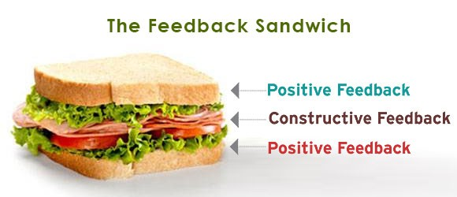

Appendix two
- What strategy did the teacher use to assess?
- What do you understand of the feedback sandwich?
- Which of these strategies do you like best? Rank in order. (laminated words)
- How interested were you in the lesson at the beginning?
- Did the feedback sandwich make you more or less interested in the lesson at the end?
- How did you react to the comments made by your partner?
- What did you think of your partners work?
- What would you change if you were to teach the lesson?
Appendix three -Statement of intent
Today, we will be looking at your involvement in a lesson that is assessed using a peer assessment strategy called the feedback sandwich. The feedback sandwich is a way in which you look at your friend’s work, and give them a positive, something that they could have done better and a target for the future (positive).
You do not have to worry about anything, all you are going to do is write a short story about WW2/Space, and assess your friend’s work using the feedback sandwich. If you’re struggling at any point or do not understand something, please ask me. I’m here to help!
You will be given a sheet to sign, which talks about the rules that we follow. You can sign it if you are happy to be a part of this research. If you don’t want to take part in the research that’s okay, just don’t sign it. You do need to take part in the lesson therefore, but we will not write anything about you.
Whatever you write or say is confidential, meaning that we won’t say that you said it. If you decide not to take part in the research, you will not be treated any differently and you will not get into any trouble. All that will happen is that we won’t take what you say into account.
After the lesson, we will choose 3 of you to come with us for a little chat about the lesson. The same rules apply to this, and we won’t write your name at any point. The questions that we will ask are not difficult, it’s just to get your opinion on things so don’t worry.
Just be yourself!

Appendix four- Assent form
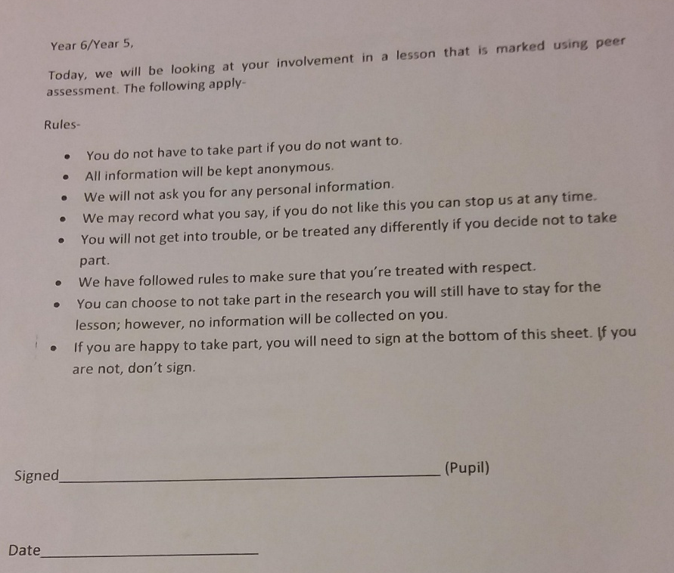

Appendix five- Yr 6 Leuven scale grading

 | How involved and engaged are students at the start of the lesson? | What is the level of engagement when the students are working independently? | How do pupils react during the feedback sandwich proportion of the lesson? | What are the students reactions to the plenary?
Pupil one | 3 | 4 | 3 | 5
Pupil two | 4 | 4 | 4 | 4
Pupil three | 3 | 4 | 5 | 4
Pupil four | 3 | 3 | 4 | 4
Pupil five | 4 | 3 | 4 | 3
Pupil six | 3 | 3 | 4 | 4
Pupil seven | 3 | 4 | 4 | 3
Pupil eight | 2 | 3 | 3 | 3
Pupil nine | 5 | 4 | 5 | 5
Pupil ten | 3 | 4 | 3 | 3

Appendix six- Interview notes year 6

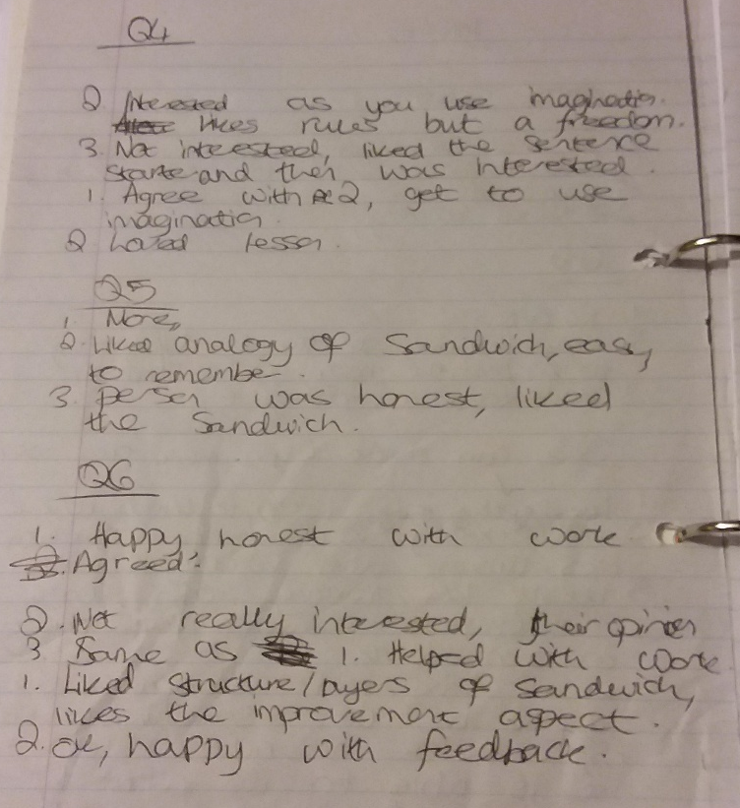
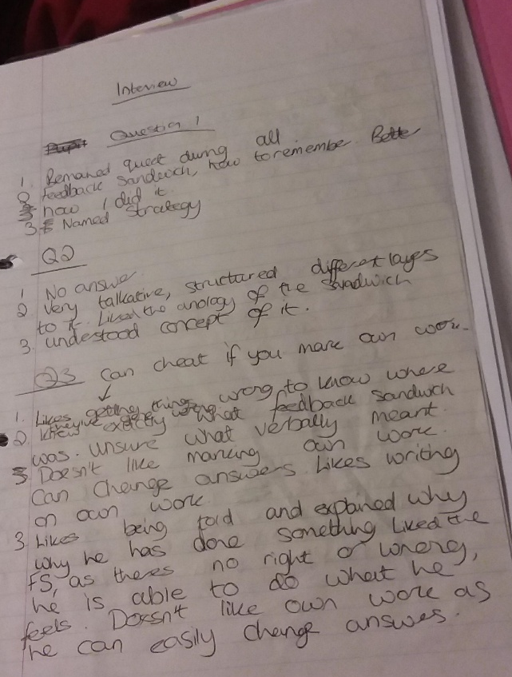

Appendix seven- Year 5 Leuven scale grading

 | How involved and engaged are students at the start of the lesson? | What is the level of engagement when the students are working independently? | How do pupils react during the feedback sandwich proportion of the lesson? | What are the students reactions to the plenary?
Pupil one | 2 | 1 | 1 | 2
Pupil two | 5 | 1 | 3 | 2
Pupil three | 5 | 1 | 4 | 3
Pupil four | 3 | 1 | 5 | 3
Pupil five | 5 | 3 | 5 | 5
Pupil six | 3 | 2 | 2 | 2
Pupil seven | 3 | 5 | 5 | 5
Pupil eight | 3 | 5 | 5 | 5
Pupil nine | 4 | 5 | 3 | 2
Pupil ten | 3 | 4 | 2 | 1

