Personal development plan – Part 2
Placement hours
Worldskills – 9:00am – 14:00pm
25.11.25 – 8:45am – 14:00pm
26.11.25 – 17:10pm – 19:30pm
9/12/25 – 13:00pm – 16:30pm
13/01/26 – 17:45pm – 20:00pm

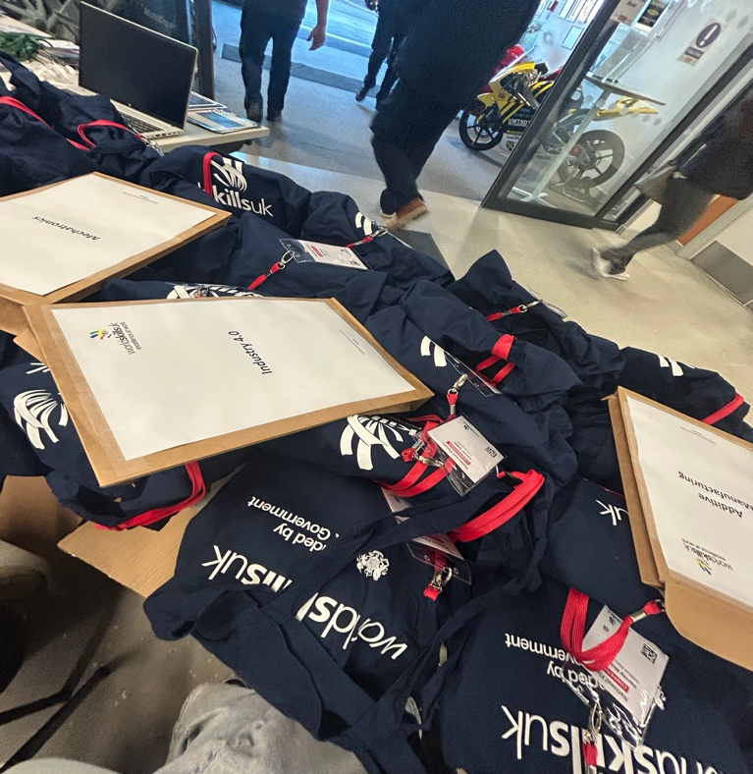
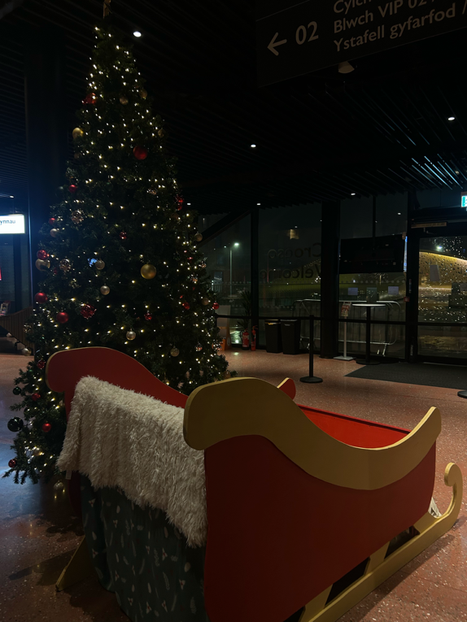
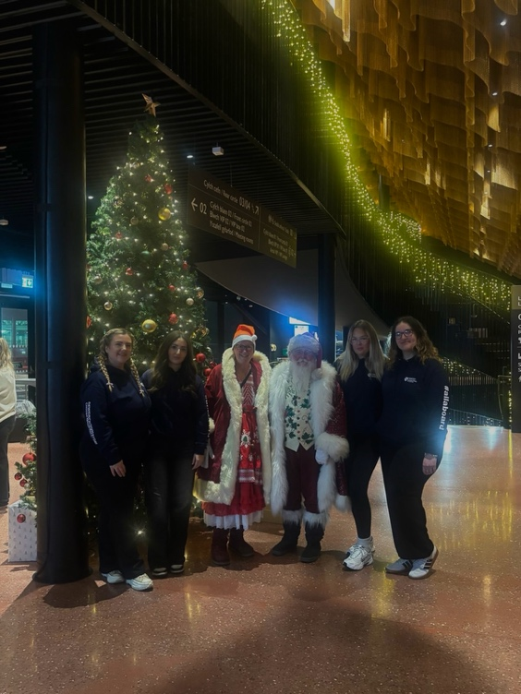
Evidence


