Assessment 1, Field Journal, Llyr 24.

From the 15th of April to the 1st of May 2024, the archaeological department at UWTSD Lampeter was engaged in an excavation at the Mesolithic site of Llanllyr, in the Aeron valley of Ceredigion. The ground at the present day is a marshy wetland, however at the time it is believed by site director Martin Bates, to have been a lake. The aim of the project was to investigate the nature and distribution of archaeological material from the beginning of the early Holocene to the end of the Neolithic, to better understand changes associated with marine inundation, resource distribution and changing human impact on the landscape. This document is a field journal, primarily made from the perspective of myself, level 4 Archaeology student, Caradoc Ewing.

On the 11th of April, a lecture giving a rundown of the site and some of the previous desktop analysis was given by site director, and Mesolithic archaeologist, Martin Bates. This lecture focused on the premise of excavation, why we excavate and when we excavate. Archaeology is fundamentally a destructive science. This means that whatever is excavated from the ground, can never be re-excavated. The context in which finds are discovered, their placing, their positioning, can only be discovered once. If they are incorrectly recorded, then there is no way to regain this data. Likewise, once the ground is disturbed by an archaeological trench, any later attempt to collect stratigraphy from that exact location will also be in vain. For this reason, before any excavation can be begun, all other avenues of research must be completed. Unless the archaeologists record is scientifically complete, he has defrauded science, and had better not have dug at all. Good desktop analysis will mean an excavation will not be digging blind. An assessment of the landscape through aerial photography and geophysics, as well as exhausting historical avenues reading references to the site, will allow the dig to begin with a better formed understanding of where to look and how to interpret the landscape.

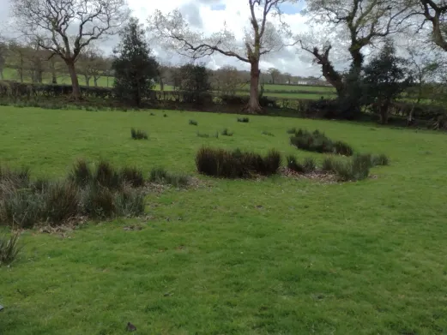
The first day of excavation began on the 15th of April, and the first task after a brief site tour, was to assess where to dig. As Professor Charles Thomas once said, to be an archaeologist, all you need is a “countryman’s eye and a good pair of boots.” Splitting into a group with myself and four peers, two sites for excavation became apparent to me. Firstly, I saw a very light circular ridge roughly 60 meters south of mound 2. It was difficult to photograph, but also was far from the reeds that I believed roughly indicated the lake boundaries. The impression made on the earth was very light, and foolishly (as I would later find Ros and Martin had also noticed this feature) I discarded this idea. The site that appeared the most promising to my group was a dried-up stream feature mentioned in Martins initial tour of the site (fig. 1.), most flint finds on the site had been found on the edge of the water, this made the stream a likely site for more flint to be discovered. The feature was picked up on the geophysical images shown to us by Martin on Thursday (fig. 2.).
Figure 1. David Hinsull (2024) strem feature at south end of field 2.
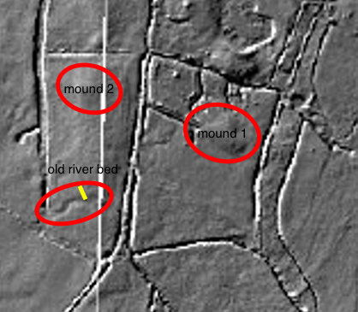
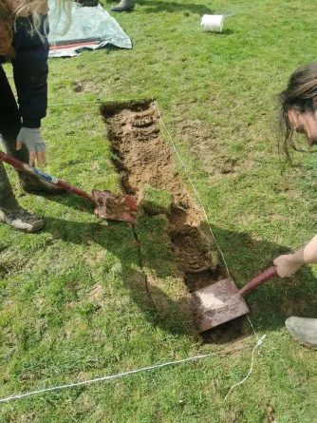
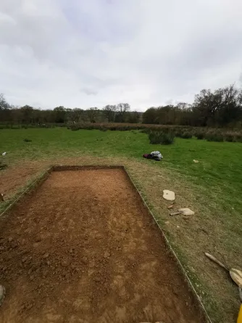
The first step of excavation was to create an accurate rectangular area for the trench to be dug. The right angles were measured with Pythagorean theorem, and the outline was finalised in string. The trench would be 2 meters by 6 meters and would run roughly perpendicular, intersecting the river bed on its northern side. The decided area was de-turfed carefully (fig. 3.), it was important to take away the turf disturbing as little of the soil as possible due to the shallow contexts of most other finds. The turf was then placed around the edges of the spoil’s tarpaulin, ‘grass to grass,’ to protect them as best as possible for re-placing. Despite being done carefully, the de-turfing left an uneven surface. This was lowered to a more level surface by use of the mattock and refined further with the trowel until the trench was even. All soil we removed was sieved, this was an important step. Especially with prehistoric excavations, much of the earth will be sifted because the sites themselves are limited in size, and the finds are very small. At Llanllyr, much of the finds were smaller than the mesh of the sieves, this makes them easy to miss while excavating and sieving was especially crucial in early mattock stages. If a find is found through sifting it is unfortunately removed from its context, therefore if anything is found, it is of great importance to stop using the mattock and revert to the trowel so any further finds can be recorded correctly. After trowelling to create an even floor to the trench (fig. 4.), we continued centimetre by centimetre. This slow process is important because any finds will be revealed in situ, not only their mapping in the trench but their rotation and position in the ground can be recorded.
Figure 2. Martin Bates [accessed 2024] edited. Caradoc Ewing (2024). Showing rough positioning of trench 14.
Figure 3. Evan Davies (2024)
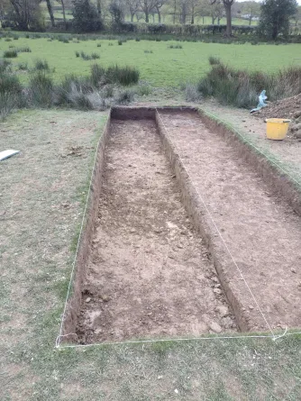
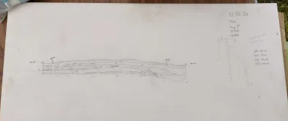
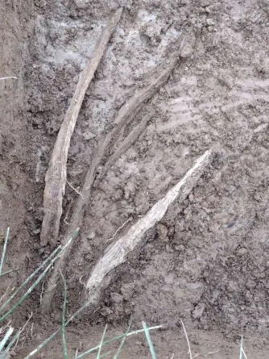
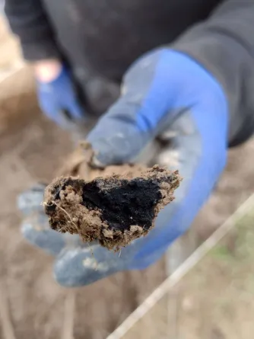
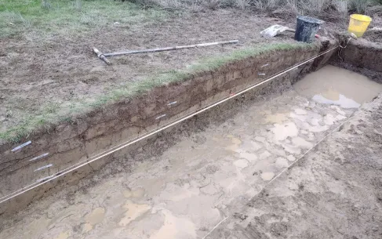
As the days passed it became apparent that we were not finding anything; In fact, the stratigraphy still looked much the same despite the depth of the trench. Martin asked us to dig deeper with the trowel, we did this however after still finding nothing, we decided to lightly mattock the remaining layer. Our aim was to reach the yellow clay horizon that other trenches had found artefacts atop, however after trowelling again without luck, it became apparent that the question was now linked to the stratigraphy of the site rather than flint finds. The decision was made by Martin to section the trench in half using string so the context could be displayed. We used mattocks and shovels to dig deeper (fig. 6.). Mattocks are a much faster way to excavate, however it is more difficult to discover finds, especially without disturbing them. mattocks are useful when digging out rapidly those deposits that have been tested and found to be archaeologically uninformative. The initial thought was to mattock until something was found and then to bring the other side of the trench down to the same layer, however although no flint finds presented themselves, as we reached the grey clay layer an impressive stratigraphy revealed itself (fig. 6.). This will be elaborated on further in a latter portion of the journal. The southern side of the trench had been deliberately cut into the old river bed, and the ground there was noticeably darker and moister, throughout the excavation. We hit the water-table here first, and striking with my mattock, I discovered a large piece of waterlogged wood (fig. 7.). Up until this point we had found scattered charcoal across the trench and a concentration of organic matter in the contexts surrounding the wood, however this was by far the largest piece found, and there were many more visible in the ground. The wood was stained black (fig. 8.), initially appearing to be charcoal. We excavated down further in case the wood was there by human means, but it was decided they were likely more modern tree roots. The roots were removed when possible but now the focus was entirely on the stratigraphy of the trench. Although in places difficult to discern (fig. 9.), trench 14 boasted 17 separate contexts including one cut. In a lecture on Soils and Sediments by Martin Bates, we learned how each of these contexts represented a geological event, the trench section (fig. 6.) showed a history of flooding and more stagnant water, while also displaying an impressively deep yet natural cut made by the river. We measured the stratigraphy using a string as a baseline and then measuring points. This diagram is important to get right as once backfilled, it is not possible to find this data again, the section is a geological record of the landscape. Monoliths were also taken at both ends of the trench around particularly useful areas of stratigraphy, Mo2 focusing on the thin organic layer of context 140013, there was also a bulk sample taken from this area. Taking samples allows for lab analysis, and it is possible to carbon date the organic areas. Digging without documentation is nearly worthless, and therefore we recorded all of this on separate context sheets along with the section drawing. Keeping a clean record of the data allows for it to be analysed fully post dig. The site was then backfilled, and the dig ended on May day 2024.
Figure 2. Evan Davies (2024)
Figure 6. David Hinsull (2024)
Figure 5. David Hinsull (2024)
Figure 8. David Hinsull (2024).
Figure7. David Hinsull (2024).
Figure 9. David Hinsull (2024).

Samantha Brummage, Martin Bates, Wendy Carruthers, Astrid Caseldine, Ros Coard, Tudur Davies, Quentin Drew, Mesolithic-Neolithic landscapes in Ceredigion: a new site at Llanllyr (Unpublished 2024) p. 1.
Eric L. Welch, ‘How are Measurements Taken and Why?’, in The 5 Minute Archaeologist in the Southern Levant, ed. by Cynthia Shafer-Elliott (Sheffield: Equinox Publishing, 2016) p.51.
Leonard Woolley, Digging up the past, 2nd ed. (London: Book Club Associates, 1973). p. 40-41.
Joe Uziel, ‘Why Sift and How Often’, in The 5 Minute Archaeologist in the Southern Levant, ed. by Cynthia Shafer-Elliott (Sheffield: Equinox Publishing, 2016) p. 56.
Jane McIntosh, The Practical Archaeologist: How We Know What We Know About the Past (London: Thames & Hudson, 1999) p. 76.
David M. Jones, Historic England, Waterlogged Wood (English Heritage Publishing, 2010) https://historicengland.org.uk/images-books/publications/waterlogged-wood/waterlogged-wood/ [accessed, 7th of May, 2024].
Eric L. Welch, ‘What is a Phase and Stratum’, in The 5 Minute Archaeologist in the Southern Levant, ed. by Cynthia Shafer-Elliott (Sheffield: Equinox Publishing, 2016) p. 47.

