

INTERNATIONAL BUSINESS COMMUNICATIONS

Assessment 1

Module: International business communications
Code: LCBB6001
Lecturer: Dr Laila Maazouz
Name: Simona Vitelaru
Student ID: 2133624

Table of Contents

1. Introduction to British Business Communications 3
2. Introduction to Greggs PLC 3
3. Evaluation of Portugal as a Potential Market 5
3.1. Cultural and Social Contexts 5
3.2. Language and Communication Considerations 5
3.3. Economic and Market Risks 6
3.4. Labour Market Analysis 6
3.5. Communication Barriers for Greggs in Portugal. 6
4. Evaluation of Estonia as a Potential Market 7
4.1. Cultural and Social Contexts 7
4.2. Language and Communication Considerations 7
4.3. Economic and Market Risks 8
4.4. Labour Market Analysis 8
4.5. Communication Barriers for Greggs in Estonia 9
5. Recommendation and Strategy for Expansion 9
5.1. Comparative Analysis of Cultural Factors 10
5.2. Comparative Analysis of Economic and Market Conditions 10
5.3. Strategic Recommendations for Greggs' Entry 11
5.4. Strategies to Overcome Communication Challenges 12
Conclusion 13
References 14

Introduction to British Business Communications

The cultural and historical background has significantly impacted British business communication strategies. British corporate communication is formal, yet informal, civil, diplomatic and hierarchical, an illustration of influence. Sophisticated, accurate, concise and nuanced communication suits a business culture that values efficiency and effectiveness, (Jones and George, 2020). British like emails and formal reports to communicate because they enhance responsibility and rational decision-making.
Effective communication is the key to any international business. With the ever-growing global marketplaces, British companies have to handle various cultures. In order to be triumphant in this diverse market, one needs cross-border knowledge of communication: language skills, cultural norms, expectations, and business etiquette. British corporations seem very conservative and risk-averse but always find it very hard to adjust their very formal means of communication to a host country's less formal and relaxed modes (Driskill and Brenton, 2019). This is the balance British companies need to achieve in order that they remain competitive in a world whose market is changing very fast.
There are many plus factors in British corporate communication, but the going may not be all that smooth in so far as global interactions are concerned. British conservatism and formality may be perceived as coldness or aloofness by overseas partners, thus becoming a basis for misunderstanding. British tendencies to use euphemisms and avoid confrontation may be misconstrued in cultures where forthrightness is perceived as an indication of transparency and assertiveness (Jones and George, 2020).

Introduction to Greggs PLC

Originally a little bakery in 1939, British background Greggs PLC has evolved into a food-on-demand monster. Starting in Newcastle upon Tyne, Greggs now claims more than 2,000 UK outlets.

(Greggs, 2023)

The company advertises moderately priced, superior baked items including sausage rolls, sandwiches and sweets (Fernie and Sparks, 2019) even as it provides fast, customer-oriented service. The reason Greggs is successful is that it can adapt to British tastes by juggling new nutritional trends like vegan replacements with classic favourites.
Many times, retail strategy is based on Greggs' situation in the UK. Constant product and operational innovation lead to its growth. Funding digital technologies and including click-and-collect and delivery systems (Cumming, 2016) Greggs has addressed modern retail difficulties. Greggs has maintained its market leadership in the face of greater competition from new fast-food restaurants and conventional bakeries by virtue of its strategic flexibility. Maintaining market leadership has meant the corporation has to keep competitive prices while improving the quality of its goods.
Greggs's continuous performance in the UK has inspired it to seek international expansion. While Greggs has focused on domestic development, the crowded UK market suggests considering overseas opportunities. Entering new markets, Greggs might use operational capacity and brand strength to meet global demand for fast, premium food goods (Fernie and Sparks, 2019). An expansion would enable the company to diversify its revenue and reduce dependency on the UK market. Greggs might expand globally by copying its successful business plan.

Evaluation of Portugal as a Potential Market

Cultural and Social Contexts

Portugal's social and cultural landscape presents both opportunities and challenges for Greggs. The nation's rich maritime heritage has fostered a deep sense of community, tradition, and kinship. In Portuguese business culture, trust and long-term relationships are highly valued. According to Almeida (2021), Portuguese consumers have a strong preference for locally sourced and fresh goods, which can be attributed to their rich culinary heritage. Greggs may use Portuguese ingredients or recipes to highlight the local emphasis on quality and heritage.
Portugal and Porto are socially modernising as the middle class becomes wealthier and more open to foreign products. Palma and Reis (2019) found considerable urban-rural consumption differences. To succeed in Portugal, Greggs must adapt to these cultural differences. Greggs may attract urban clients by appearing modern and high-quality. Greggs may face hostility in rural communities that value tradition and local products unless it targets rural customers. Greggs' success in Portugal is due to their geographical knowledge.

Language and Communication Considerations

In Portugal, effective communication and language use are essential for economic success. Speaking Portuguese is the norm, as it is the official language. Foreign businesses must invest in Portuguese language proficiency to communicate effectively and build relationships with local stakeholders, even while English proficiency is increasing, particularly among younger generations and in metropolitan regions (Almeida, 2021). Speaking the language well is both a sign of deference and a tactical advantage while navigating regional business procedures and customer preferences.
Portuguese people communicate informally and formally, valuing politeness and avoiding confrontation. Comprehending these nuances is crucial for managing company conversations and guaranteeing that messages are comprehended, diminishing the possibility of misunderstandings that may impede market entry (Hofstede, 2001). Any business looking to get into the Portuguese market has to adjust to these communication and linguistic barriers.

Economic and Market Risks

Future market entrants should study Portugal's complex economy. Tourism and exports expose the Portuguese economy to external shocks notwithstanding its post-crisis recovery (Palma and Reis, 2019). Since consumer spending and market demand are dependent on global economic downturns and geopolitical instability, uncertainty might harm them.
Portugal is small compared to other European economies, which may limit new entrants' scalability and revenue. Specialist product distribution and marketing are needed due to urban-rural economic differences (Almeida, 2021). Though mostly aligned with EU standards, the regulatory climate can be challenging for enterprises unfamiliar with local requirements. Risk management is needed to minimise setbacks and maintain market penetration due to economic and market issues.

Labour Market Analysis

Companies operating into Portugal face job market opportunities and challenges. In Lisbon and Porto, educated individuals are desired. These institutions develop young professionals who are fluent in multiple languages and technologies. The government's initiatives to expand higher education and vocational training to meet market demands have altered the population (Almeida, 2021).
Business distinctions between areas are important. Rural unemployment and a skilled labour scarcity are challenges for business owners trying to grow nationwide. These locales may require specific hiring and retention strategies.
Portugal pays lower wages than many Western European countries, yet strict restrictions make it difficult to get job. HR managers must exercise caution since these limits can complicate contract negotiations and worker protection. Companies doing business in Portugal must comply with labour rules and plan to recruit and retain employees in a competitive job market (Palma and Reis, 2019). To thrive in Portugal, businesses must strike the right balance between these variables.
3.5. Communication Barriers for Greggs in Portugal.

Greggs may have communication challenges as it enters the Portuguese market. Cultural differences make business communication between the United Kingdom and Portugal difficult. Portuguese culture encourages indirect communication and high-context tactics, with most information contextualised (Hofstede, 2001). Unlike UK communication, which is direct and low-context, this may lead to miscommunication in negotiations or daily interactions.
Although English is increasingly used in business, language remains a hurdle. Portuguese is required for marketing, branding, and communicating with locals, consumers, and stakeholders (Almeida, 2021). Regional accents and communication methods may make it difficult for Greggs to establish a nationwide brand (Palma and Reis, 2019). To solve these challenges, Greggs must teach critical staff culturally sensitive communication and language skills.

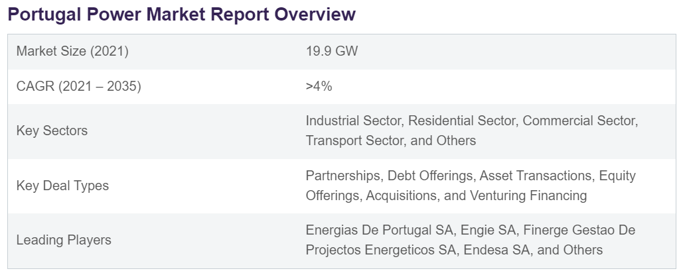
(GlobalData, 2023)

Evaluation of Estonia as a Potential Market

4.1. Cultural and Social Contexts

Greggs may find Estonia's cultural and social mix of traditional traditions and cutting-edge digital innovation appealing. Estonian society values efficiency, individualism, and progressivism, especially in metropolitan regions with high digital literacy (Ibrus, Tamm and Tiidenberg, 2022).
The nation's devotion to e-governance and digital culture reflects its transparent and tech-savvy society.
History has also shaped the cultural landscape, which values directness and pragmatism in communication (Mockaitis, 2005). Young return migrants enrich Estonia's culture (Tverdostup and Masso, 2016). Greggs must understand these factors to succeed in Estonia.

4.2. Language and Communication Considerations

Growth-oriented businesses must consider Estonian language and communication. Despite Estonian being the official language, many city and entrepreneurs know English. Since digital innovation and trade are important, most Estonians speak English (Ibrus, Tamm, and Tiidenberg, 2022). Bilingualism can help multinational organisations operate more efficiently, but speaking and writing Estonian helps integrate into new markets and comprehend different cultures.
Estonian enterprises value speed and clarity, therefore conversation is brief (Mockaitis, 2005). Businesses must adapt to this requirement for straightforward communication, unlike other European markets that use more convoluted methods.
Returning Estonians introduced several languages and cultures to Estonian. Languages and cultures have increased, making corporate communication harder (Tverdostup and Masso, 2016). Companies can penetrate the Estonian market by understanding and leveraging this multicultural feature while respecting Estonians' quickness and clarity.

4.3. Economic and Market Risks

Market entrants face possibilities and hazards in Estonia's economy. The country has a strong digital economy and a business-friendly climate, but its limited market is a concern. Estonia's domestic demand may hinder consumer-oriented business growth with 1.3 million people (Ibrus, Tamm and Tiidenberg, 2022). Estonia is subject to regional economic volatility because its economy is strongly related to its Baltic neighbours and the EU.
Rapid technical improvements in Estonia could lead to market saturation in digital and tech-driven enterprises. To compete in this fast-changing environment, businesses must be nimble and innovative (Tverdostup and Masso, 2016). Companies unfamiliar with Estonia's direct business procedures may also struggle with the culture's emphasis on efficiency and pragmatism (Mockaitis, 2005).

4.4. Labour Market Analysis

Estonia's educated and tech-savvy workforce shows its commitment to innovation. Information technology and other knowledge-intensive industries dominate Tallinn. Rapidly expanding firms may suffer in Estonia's restrictive employment market.
Young migrants have returned to Estonia to work, bringing their skills and global experience (Tverdostup and Masso, 2016). Despite these returning professionals adding skills, new organisations struggle to hire and retain top people. Tech companies must offer attractive incentives and growth opportunities to recruit top talent due to severe competition.
Due to Estonian executives' simplicity and efficiency, foreign companies may need to adapt their management and communication styles (Mockaitis, 2005). Firms must respect cultural norms in Estonia's competitive labour market.

4.5. Communication Barriers for Greggs in Estonia

When Greggs enters Estonia, communication may be an issue. Unlike British business approaches, Estonians value clear, concise, and effective communication (Mockaitis, 2005). Because of this cultural gap, Greggs must adapt its communication style to local standards to avoid miscommunication and conflict.
Despite English being the business language, Estonian is necessary for connecting with local stakeholders and customers (Ibrus, Tamm, and Tiidenberg, 2022). Understanding Estonian could help Greggs build trust and loyalty with its customers.
Due to Estonia's digitalisation, effective communication requires strong online and digital connection. Greggs may need to adapt their marketing and operations to Estonia's tech-savvy culture to reach Estonian consumers online (Tverdostup and Masso, 2016). Greggs must adapt to Estonian communication practices to succeed.
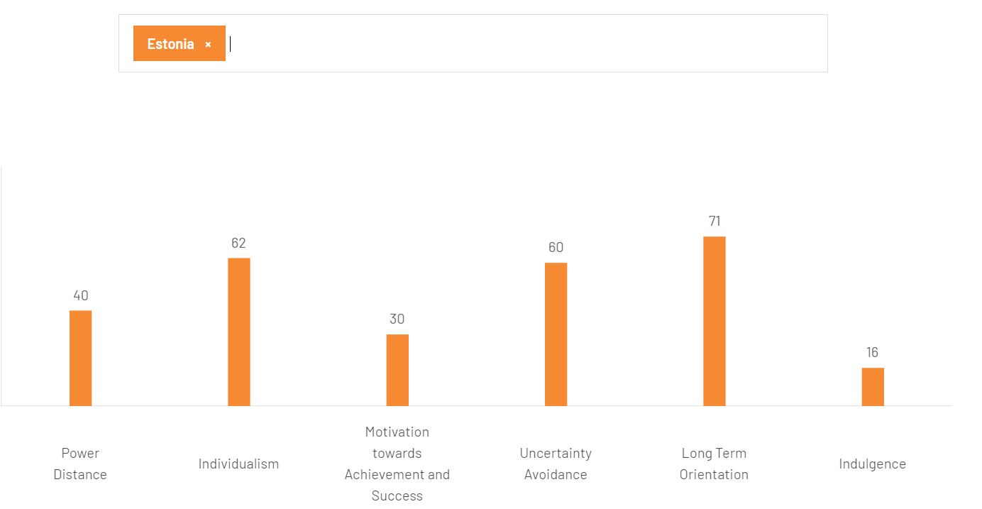

(Hofstede Insights, 2024)

\\

\\\

Recommendation and Strategy for Expansion

Comparative Analysis of Cultural Factors

Greggs' expansion approach will be influenced by the contrasting cultures of Portugal and Estonia. The corporate culture in Portugal places a strong emphasis on building trust and relies on indirect communication, which is a reflection of its collectivist tendencies (Trompenaars and Hampden-Turner, 2020). Estonia's culture is known for its focus on efficiency, directness, and individualism, as highlighted by Lewis (2018). In order to adapt to the cultural dynamics, Greggs should focus on building lasting relationships and trust in Portugal, while also streamlining operations and embracing digital solutions in Estonia. In order to thrive in diverse settings, leaders must possess the ability to adapt and demonstrate cultural sensitivity (Marques and Dhiman, 2019).

Comparative Analysis of Economic and Market Conditions

The economic and market realities in Portugal and Estonia present Greggs with both opportunities and obstacles in its expansion goals. Portugal has a larger, more mature market with established consumer habits, making business stable. However, this makes the market competitive and may hinder adoption of new products or services due to established preferences (Trompenaars and Hampden-Turner, 2020).
Estonia, a smaller but highly digital market, has substantial growth potential, especially in metropolitan regions where tech-savvy consumers are more open to innovative products (Lewis, 2018). Estonia's market may be more innovative and quick to absorb new trends, but its smaller size may constrain operations.
Greggs must reconcile the stability and scale of the Portuguese market with Estonia's quick expansion and lower entry hurdles (Marques and Dhiman, 2019). Expanding into both countries may require a dual strategy that adapts to each market. This may require a more traditional approach in Portugal to create brand loyalty in a competitive market, and a more inventive, digital strategy in Estonia to attract its forward-thinking consumers.
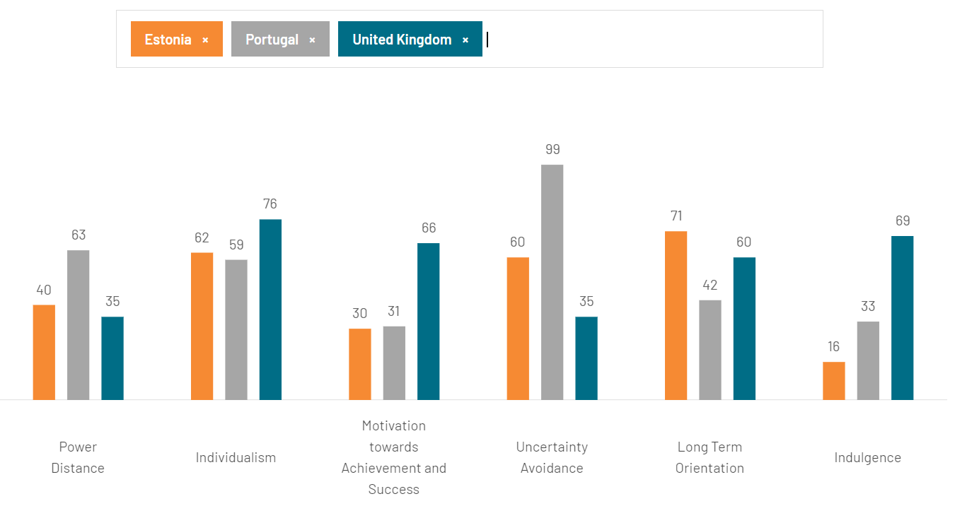
(Hofstede Insights, 2024)

Strategic Recommendations for Greggs' Entry

Greggs should adapt to Portugal and Estonia's cultures and economies to succeed. Greggs should create relationships and adapt to fulfil Portuguese demand for traditional, high-quality meals. Use local suppliers and showcase Portuguese culture and cuisine (Trompenaars and Hampden-Turner, 2020). Greggs might attract locals by emphasising local produce and Portuguese tastes.
Greggs could leverage digital reward programs, mobile ordering, and other tech to engage clients in Estonia, where technology is advanced. This strategy suits Estonian society, which values efficiency and clarity (Lewis, 2018). By being transparent and easy to use online, Greggs can attract tech-savvy Estonians.
Leaders should emphasise adaptation and cultural intelligence in both domains to handle varied business conditions (Marques and Dhiman, 2019). Greggs must adjust its business processes and management approaches to fit local needs to grow into these new markets.

Strategies to Overcome Communication Challenges

Greggs should use market-specific communication methods to overcome communication difficulties in Portugal and Estonia. Greggs should prioritise personalised, context-aware interactions in Portugal, where indirect communication and relationship-building are crucial. More nuanced and diplomatic communication may be used to create trust and long-term connections with clients and business partners (Trompenaars and Hampden-Turner, 2020).
Greggs should prioritise clear, simple message, especially online, in Estonia, where communication is straightforward and efficiency-driven. In Estonia's advanced technical environment, digital channels for simple and effective communication are essential (Lewis, 2018).
Greggs should train its leadership and staff in cultural knowledge and communication to succeed in both markets. These programmes would bridge cultural gaps and ensure market-appropriate communication (Marques and Dhiman, 2019). Greggs can negotiate cultural differences and

Conclusion

Greggs' thorough examination of Portugal and Estonia as possible markets will shape its future approach. Portugal has a strong market based on traditional values and relationship-based business. Greggs must emphasise high-quality, locally obtained ingredients to appeal to Portuguese consumers' desire for authenticity and tradition. The cultural emphasis on trust and long-term relationships highlights the necessity for a localised communication and branding strategy to build strong customer and stakeholder ties.
In contrast, Estonia offers a unique growth opportunity in a smaller but highly digitalised and inventive market. Greggs must use its digital capabilities to reach tech-savvy customers in Estonia, where direct communication and technical integration are valued. Estonia's pragmatic, efficiency-driven culture says Greggs should prioritise operational excellence and simple marketing methods to compete in this market.
Greggs' final suggestion considers Portugal and Estonia's cultural and economic differences. The plan should improve local involvement, customise product offers, and establish strong ties with local stakeholders to integrate the brand into the Portuguese culture. Greggs should prioritise digital innovation, operational efficiency, and straightforward communication in Estonia to line with its superior technology and direct business culture. With these varied strategies, Greggs can maximise its prospects of market entry and sustainable growth in Portugal and Estonia, managing each region's specific difficulties and opportunities.

References

- Almeida, F. (2021) Open-Innovation Practices: Diversity in Portuguese SMEs. Journal of Open Innovation: Technology, Market, and Complexity, 7(3), p.169. doi:https://doi.org/10.3390/joitmc7030169.
- Cumming, E. (2016) How Greggs conquered Britain: ‘Nobody can quite believe how well it has done’. [online] the Guardian. Available at: https://www.theguardian.com/global/2016/mar/05/greggs-conquered-britain-bakery-profit-sausage-rolls.
- Driskill, G.W. and Brenton, A.L. (2019) Organizational culture in action : a cultural analysis workbook. New York, Ny: Routledge.
- Fernie, J. and Sparks, L. (2019) Logistics and retail management : emerging issues and new challenges in the retail supply chain. 5th ed. London: Koganpage.
- GlobalData (2023) Portugal Power Market Size and Trends by Installed Capacity, Generation, Transmission, Distribution, and Technology, Regulations, Key Players and Forecast, 2022-2035. [online] Market Research Reports & Consulting | GlobalData UK Ltd. Available at: https://www.globaldata.com/store/report/portugal-power-market-analysis/ [Accessed 22 Aug. 2024].
- Greggs (2023) Greggs Corporate | Our History. [online] corporate.greggs.co.uk. Available at: https://corporate.greggs.co.uk/about-us/our-history.
- Hofstede Insights (2024) Country Comparison Tool. [online] Hofstede Insights. Available at: https://www.hofstede-insights.com/country-comparison-tool.
- Hofstede, G., (2001) Culture's Consequences: Comparing Values, Behaviors, Institutions, and Organizations Across Nations. 3rd ed. Thousand Oaks: SAGE Publications.
- Ibrus, I., Tamm, M. and Tiidenberg, K. (2022) Estonia’s Digital Culture Manifesto. SSRN Electronic Journal. doi:https://doi.org/10.2139/ssrn.4000959.
- Jones, G.R. and George, J.M., (2020) Essentials of Contemporary Management. 9th ed. New York: McGraw-Hill Education.
- Lewis, R.D., (2018) When Cultures Collide: Leading Across Cultures. 4th ed. Boston: Nicholas Brealey Publishing.
- Marques, J.F. and Dhiman, S., (2019) Leadership Today: Practices for Personal and Professional Performance. Cham: Springer.
- Mockaitis, A.I., (2005) A cross-cultural study of leadership attitudes in three Baltic Sea region countries. International Journal of Leadership Studies, 1(1), pp.44-63.
- Palma, N. and Reis, J. (2019) From Convergence to Divergence: Portuguese Economic Growth, 1527–1850. The Journal of Economic History, 79(2), pp.477–506. doi:https://doi.org/10.1017/s0022050719000056.
- Trompenaars, F. and Hampden-Turner, C., (2020) Riding the Waves of Culture: Understanding Diversity in Global Business. 4th ed. New York: McGraw-Hill Education.
- Tverdostup, M. and Masso, J. (2016) The labour market performance of young return migrants after the crisis in CEE countries: the case of Estonia. Baltic Journal of Economics, 16(2), pp.192–220. doi:https://doi.org/10.1080/1406099x.2016.1233729.

