Project Management (M2X9396)

PD05 A1 Assignment
Prepare a report seeking authority to undertake a project within a setting with which you are familiar such as your place of work.
1,500 words (+- 10%)

Word Count - 1647

Student Number: 1708503
1.0 Introduction
The following report aims to outline the requirement for a project to achieve necessary business change at Biotage GB Ltd. The report will outline the desired outcome of the project and its context within the organisation and its relevant stakeholders. Furthermore, the report will define the project team structure by considering a suitable methodology and the roles and related skills required for effective project fulfilment.
Biotage is a global manufacturer of analytical chemistry products, with key customers including pharmaceutical manufacturers, academic institutes, beverage manufacturers and health service providers. The company currently employees 330 people, manufacturing its products in Wales and operating sales and distribution hubs in Sweden, Asia and the USA (Biotage, 2019).

2.0 Biotage’s project requirement
In order to achieve accurate and resource-efficient make-to-order production and supply chain operations, Biotage utilises an ERP system; Microsoft Dynamics AX2009. However, following 5 years of sustained growth (Biotage, 2019), the organisation has identified the requirement to upgrade its system to the latest iteration; AX365. A primary driver for change relates to the discontinuation of software support for AX2009, restricting access to innovative new ERP features and an increased cyber security vulnerability (Correa, 2017). Biotage’s ERP system is a business-critical tool and therefore the associated level of risk is deemed unacceptable by senior management. Furthermore, as part of the organisation’s continuous improvement strategy, AX 2009 provides several obstacles; including a lack of support for lean process innovations such as barcode/QR scanners and mobile/tablet functionality. To overcome these obstacles, Biotage’s COO and CEO communicated that a project should be initiated to upgrade Biotage’s ERP system from AX2009 to AX365. As a result, this report aims to propose an appropriate structure to achieve these aims.

3.0 Biotage’s project stakeholders
The Association for Project Management (2019), defines stakeholders as ‘individuals or groups with an interest in the project, programme or portfolio because they are involved in the work or affected by the outcomes’. Continuing, The APM (2019) proposes that stakeholders can sometimes have different or even conflicting interests in the delivery of a project, which therefore requires careful management. One framework for identifying key stakeholders is through the Stakeholder Salience theory proposed by Mitchell et al (1997), who suggest that all stakeholders consist of three variables:
- Power – to influence the organisation
- Legitimacy – of the entity’s relationship with the firm
- Urgency – of the entity’s project expectations
Based on these variables, Mitchell et al (1997) suggest that stakeholders who posses all three attributes should be considered as ‘definitive’ (key stakeholders) and those with two should also have their expectations closely managed.

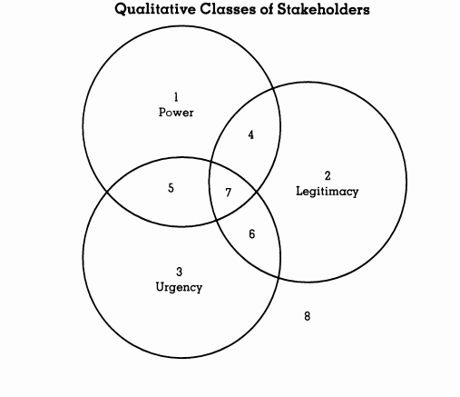

Figure 1 – Stakeholder Salience – sourced from Mitchel et al (1997)
Whilst the level of power and legitimacy of stakeholders can be easily identified through means such as organisation charts (internal) and business reporting (external such as customers and suppliers), Biotage recognises that stakeholder urgency can vary depending on the impacts (and resulting level of interest) in an individual project. One method of identifying and assessing the level of such impacts is through stakeholder impact analysis (see figure 2). Through this method, Biotage can establish the impact (and therefore level of concern) of project related factors on internal and external entities (Lock, 2007). Based on a scoring system of 1 to 5, 5 represents the highest level of impact and therefore the greatest level of urgency.

Impact Number | Description of Impact | End Users – Operational staff | Customers | Suppliers | Competitors | Directors | Government | Community
1 | Increased rate of ERP errors resulting in supply chain disruption | 5 | 3 | 3 | 1 | 3 | 1 | 1
2 | Cyber security threat to data integrity and functionality of supply chain systems | 5 | 5 | 4 | 1 | 5 | 3 | 1
3 | Lack of innovative ERP technologies leading to missed efficiency opportunities and loss of competitive advantage | 4 | 2 | 1 | 5 | 5 | 1 | 1
4 | Increased operational costs associated with the realisation of above impacts | 3 | 2 | 2 | 1 | 4 | 1 | 1
 | Total | 17 | 12 | 10 | 8 | 17 | 6 | 4

Figure 2 represents Biotage’s impact analysis of continuing to operate Microsoft AX2009, without upgrading. It can be suggested that the greatest impact of such a decision concerns the everyday end-users of the system, most notably operational staff throughout the business, with departments including Finance, Production, Materials (purchasing, planning and warehousing), Sales and IT. The second highest impact concerns Biotage’s directors, who are responsible for company performance and the implementation of operational strategy for which Biotage’s ERP system supports. Therefore, this report proposes that the end-users and directors are managed as primary stakeholders throughout the project, with their expectations closely managed. However, the analysis also illustrates that customers and suppliers are subject to impact from Biotage’s ERP system, particularly data security and accurate ERP transactions (submission of purchase orders and fulfilment of sales orders). Therefore, this report proposes that Biotage also manages their expectations as secondary level stakeholders.

4.0 Project structure
In allocating a structure to the ERP system re-engineering project, Biotage will utilise the Prince2 (PRojects IN Controlled Environments) methodology. Prince2 is a standardised, process-based framework for project management and is the defacto standard implemented by UK Government (Prince2.com, 2019). Utilised across multiple industries, the method provides organisations with a standardised format project format, mitigating against 7 key factors:
- Ensuring business justification
- Recording lessons learnt
- Defined roles and responsibilities
- Managing by defined stages
- Managing by exception (issues and problem management)
- Managing products (work outputs)
- Tailoring Prince2 to the relevant project environment
(adapted from Prince2.com, 2019).
As a result, Gomez and Jimenez (2019) identify Prince2 as being a highly adaptable method of project management, applicable to projects of varying risk, complexity, type and size.
In adopting the Prince2 methodology for its internal projects, Biotage management has acknowledged the importance of staff training in order to ensure its effective implementation. Therefore, all director, senior and junior managers (who are actively involved in the delivery of Biotage projects) have undertaken Prince2 Practitioner training (AXELOS, 2019). Supporting this, Mullins (2016) suggests that training not only ensures process familiarity and competence to achieve sustained performance improvements, but also provides secondary advantages beneficial to project success; including increased motivation and sense of responsibility in the implementation of work.

5.0 Team structure and related project tasks
Whilst the Prince2 methodology provides a clear governance and flow structure (Prince2,2012), the ERP project cannot be successful without ensuring that human resources with suitable skills are recruited in order to ensure the execution of effective project work. Given the cross functional nature of ERP software, encompassing sales, warehousing, production and finance, this report proposes a cross-functional project team with skills and expertise from each area. In addition, end users have been identified as key stakeholders of the ERP project and Furthermore and this report identifies cross functional representation in the project team as an effective means of managed influence and management of expectations. With regards to the position of Project Manager, this has been assigned to the Global IT Architecture Manager, who demonstrates suitability through possessing significant prior IT project management experience and is responsible for overseeing the business as usual (BAU) operation of Biotage’s current ERP system.
From, this report suggests that the following Prince2 aligned (see figure 3) AX365 re-engineering project team be implemented:

Project Role | Allocated Person(s)
Project Board | IT Director, Operations Director, UK (country) director
Project Manager | Global IT Architecture Manager
Project Team / Work Delivery Managers | UK Finance Manager (and supporting staff)  UK Production Manager (and supporting staff)  UK Materials Manager (and supporting staff)  UK Customer Service Manager (and supporting staff)  UK IT Manager

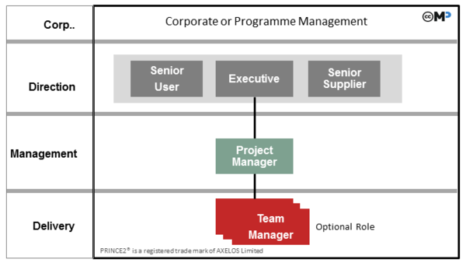

Figure 3 –Typical Prince2 organisational structure – sourced from (AXELOS cited by Rad (2019)

The Prince2 methodology underlines the output of ‘products’ in the execution of a projects (Prince2, 2012). Based on this, in conjunction with Biotage’s Project Manager and considering the functional skill sets and resource availability of the project team, this report proposes several key product requirements to be included in an approved project plan:
Project team member(s) | Required products
UK Finance Manager  + 3 reporting finance officers | Legitimate/precise financial data for migration  Design of financial management AX365 workflows  Support staff training for new AX365 workflows, relevant hardware and software
UK Production Manager  + 3 reporting supervisors | Legitimate/precise production data for migration  Design of production AX365 workflows  Support staff training for new AX365 workflows, relevant hardware and software
UK Materials Manager  + 1 reporting procurement officer and 1 planner | Legitimate/precise supply chain data for migration  Design of supply chain (production, warehouse, dispatch) AX365 workflows  Support staff training for new AX365 workflows, relevant hardware and software
UK Customer Service Manager  +2 reporting customer service officers | Legitimate/precise sales data for migration  Design of customer service AX365 workflows  Support staff training for new AX365 workflows, relevant hardware and software
UK IT Manager  + 1 IT assistant | New hardware/software infrastructure in preparation for AX365 migration  Support staff training for new AX365 workflows, relevant hardware and software  Migration of operational data to AX365 system

Conclusion
To conclude, a robust project proposal has been submitted to management to proceed with upgrading Biotage’s ERP system from AX2009 to AX365. A primary reason for implementation identified by this report is the enablement of future opportunities for improvement to supply chain processes through improved AI and the accommodation of innovative technologies (such as barcode scanners). However, several detrimental impacts to Biotage operations (and its key stakeholders) have also been identified and could threaten the integrity of operations should the organisation choose not to proceed with the project.
Furthermore, this report has outlined an appropriate cross functional team who possess the operational knowledge, skills and expertise to ensure effective project execution. Additionally, to maximise the project’s chance of success, Biotage already possess a track record of successful projects delivered through a standard methodology via Prince2 - a framework which has been further reinforced by the organisations initiative to train its relevant staff to practitioner level. As a result, this report re-iterates the validity of the business case and the necessary resources for effective project delivery.

References:
Stakeholder Management, The Association of Project Management (APM), retrieved from https://www.apm.org.uk/body-of-knowledge/delivery/integrative-management/stakeholder-management/ on 17 May 2009 at 09:35
What is Prince2?, Prince2.com, retrieved from https://www.prince2.com/uk/what-is-prince2 on 15 May 2019 at 14:30
Rad N.K. (2019), Organization – Project Team Structure, Prince2 Wiki, available at: http://prince2.wiki/Organization
Correa D., (2017), Outdated software exposes millions of PC users to cyber-risks, SC Media UK, retrieved from https://www.scmagazineuk.com/outdated-software-exposes-millions-pc-users-cyber-risks/article/1474977 on 16th May 2019 at 09:25
Biotage GB Ltd, About Biotage, retrieved from http://www.biotage.com/page/about-biotage on 15 May 2019 at 13:10
Gomez D., Jimenez L.A, Use of PRINCE2 as a Project Management Approach for Spatial Audio Developments, Conference Paper, 47th International Congress and Exposition on Noise Control Engineering
Lock D. (2007), Project Management, Ninth Edition, Gower
Mitchell R., Bradley R., Wood D. (1997), Toward a Theory of Stakeholder Identification and Salience: Defining the Principle of Who and What Really Counts, The Academy of Management Review, Vol. 22, No. 4 October 97, pp. 853-886
Biotage GB Ltd, Annual Reports, retrieved from https://biotage.com/literature/search?page=1&rpp=20&order-by=issued_year+desc&q=&advanced=1&display_type=1&keywords%5B4%5D%5B%5D=537&keywords%5B14%5D%5B%5D=528&keywords%5B13%5D%5B%5D=0 on 15 May 2019 at 13:15
Mullins L., (2016), Management and Organisational Behaviour 11th Edition, Pearson
Prince2 (2012) Managing successful projects with Prince 2, 2009 Edition (2012 impression), The Stationary Office - London
PRINCE2® 2017 Project Management Certifications, AXELOS, retrieved from https://www.axelos.com/certifications/prince2 on 19th May 2019 at 10:20

