Samuel Digby (1901067)

Conrod Dynamic Forces Report (M4X02193)

Abstract
The aims of this report were to find out the velocity, acceleration and tensile force acting on the connecting rod at different engine speeds.
The primary findings were that the velocity, acceleration and tensile force would increase with the increase of engine speed. Also, that the acceleration and tensile force would follow a similar pattern to each other.
Some recommendations to this report would be to use a smaller time interval for the tests and use a more common engine.

Contents
List of Figures 2
Introduction 3
Methodology 3
Research 4
Conrod research 4
Engine research 5
Calculations 6
Analysis of Data 7
1000RPM 7
2000RPM 8
3000RPM 9
4000RPM 10
5000RPM 11
6000RPM 12
Conclusion 13
Recommendations 13
References 14

List of Figures
Figure 1- Conrod schematic diagram 3
Figure 2- An example of an I-beam connecting rod 4
Figure 3- An example of a H-beam connecting rod. 4
Figure 4-The engine used in the Dodge viper GTS-R. 5
Figure 5- An example of the Dodge Viper GTS-R. 5
Figure 6-Velocity Graph at 1000RPM 6
Figure 7-Acceleration and Force graph at 1000RPM 6
Figure 8-Velocity graph at 2000RPM 7
Figure 9-Acceleration and Force graph at 2000RPM 7
Figure 10-Velocity graph at 3000RPM 8
Figure 11-Acceleration and Force graph at 3000RPM 8
Figure 12-Velocity graph at 4000RPM 9
Figure 13-Acceleration and Force graph at 4000RPM 9
Figure 14-Velocity graph at 5000RPM 10
Figure 15-Acceleration and Force at 5000RPM 10
Figure 16-Velocity graph at 6000RPM 11
Figure 17-Acceleration and Force graph at 6000RPM 11

Introduction
In this report, a piston type engine will have some theoretical testing performed to it to measure the velocity, acceleration and force the connecting rod (otherwise known as a conrod) is experiencing. How this will be performed is that the following set of data will be recorded from the engine:
- Crank radius
- Connecting rod length
- The engine’s revolutions per minute (RPM)
- The mass of the piston including its gudgeon pin
This data will be used in an excel spreadsheet that will calculate the force, velocity, height and acceleration of the connecting rod. The excel spreadsheet is set up to take readings at 0.02 second intervals. From here, the excel spreadsheet will generate graphs showing various sets of data that it has calculated from the data that has being programmed into the spreadsheet. These graphs will then be analysed and compared to each other where comparisons can be drawn.
Once this has being performed, changes to the data will be performed to see how changing said data affects the graphs. These graphs will also be documented in this report.

Methodology
The theoretical test shall be undertaken by inserting the numbers that were researched into the spreadsheet that will be submitted with this report. The spreadsheet is on Microsoft Excel. The aim of this report is to complete an analysis on the velocity, acceleration and force of the conrod as the engine increases speed up to its limit.
Using Microsoft Excel, the data that is acquired can be used to create graphs that show the data in an easy to view format. Putting the data in graph form allows the reader identify any anomalies in the data easier and quicker than if the data was still in number form.

Research

Conrod research
The conrod, otherwise known as the connecting rod, connects the piston head to the crankshaft. This allows the vertical forces that are acting on the piston head to be transmitted to the crankshaft where the vertical motion of the piston is turned to rotational motion at the crank shaft.

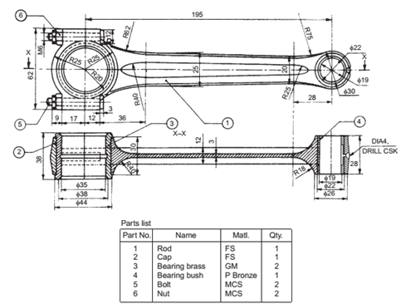
Figure 1- Conrod schematic diagram
The connecting rod (Fig 1) contains two ends. The smaller of the two is called the small end. This is where the piston head is located and secured using a gudgeon pin. The other end of the connecting rod is called the big end. This is where the connecting rod is fitted the crank pin. At the big end, the connecting rod is either cut or sheared to allow the connecting rod to fit onto the crank pin.
The construction of the connecting rod varies from application to application. In terms of material, connecting rods are normally constructed from either steel, aluminium or an alloy. (Heywood, 2018)

In terms of shape the are two common shapes for a connecting rod:
- I-beam rods (Fig 2)
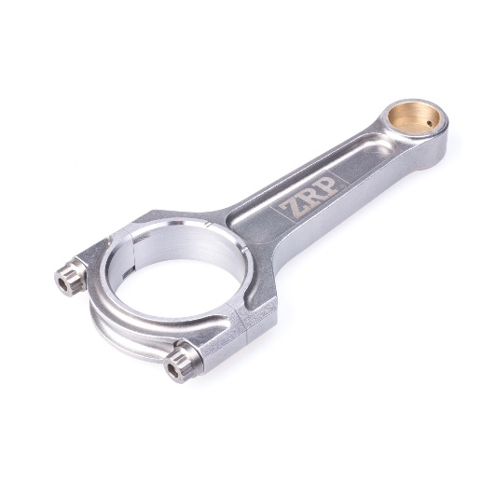
- H-beam rods (Fig 3)
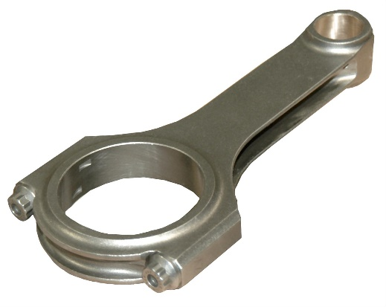

Figure 2- An example of an I-beam connecting rod
Figure 3- An example of a H-beam connecting rod.

These construction methods are the two basic types on connecting rod construction. However, the H-Beam construction is more prevalent in engines that produce high levels of torque and maximum engine power at lower engine speeds. This is because H-beam connecting rods are more capable at handling the high compressive loads that these types of engines put on to the connecting rod when compared to I-beam connecting rods. This also comes with the H-beam construction being lighter than I-beam connecting rods. (Carley, 2008)

Engine research
The vehicle engine that will be used in this theoretical test is the 8.0 litre V10 “Copperhead” engine that was used originally being developed for 1994 range of Dodge trucks. This engine went under numerous modifications to turn it to an engine capable of being placed into a sports vehicle. This engine was placed into a sports vehicle released to the public in 1992. This vehicle was called the Dodge Viper RT/10. (Stone, 2003).
This engine since its introduction in 1992 has gone under more modifications as new models of the Dodge viper was realised with the 2013 SRT Viper producing 640 horsepower out of an 8.4 litre V10 engine. (Korzeniewski, 2012)
The specific model of Viper that will be used in this theoretical test will be the 1996 Dodge Viper GTS-R. The engine of this vehicle is shown in Fig 4. This is the race modified version of the 1996 Dodge Viper GTS that first raced in the 1996 Rolex 24 hours of Daytona. (Stone, 2003). In the following years the Viper would be further developed and by the end of its service life in 2003, the Dodge Viper had gathered 163 wins out of 262 starts. Fig 5 shows an example of the Dodge Viper GTS-R.
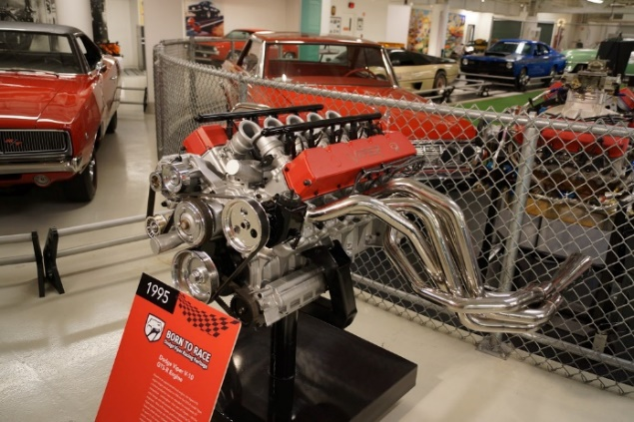
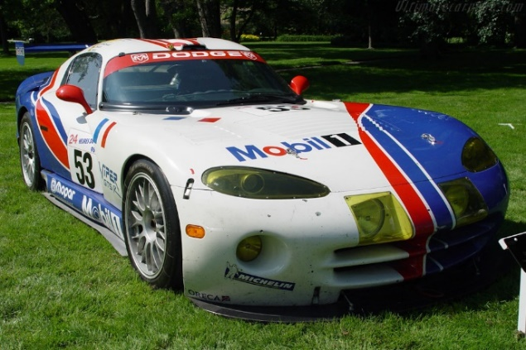
Figure 4-The engine used in the Dodge viper GTS-R.
Figure 5- An example of the Dodge Viper GTS-R.

The information required for the theoretical test is stated below:
- Crank radius = 49.276mm (1,94 inches)
- Connecting rod length = 147.828mm (5.82 inches)
- The engines RPM = Redline at 6000RPM (Stone, 2003)
- The mass of the piston including its gudgeon pin = 490 grams (0.49kg)

Calculations
The information required to calculate these numbers are as follows:
- Engine bore: 4.00 inches
- Engine stroke: 3.88 inches
(Stone, 2003)
Note: the following calculations are approximate calculations and may not be 100% correct.
The crank radius is calculated by the following calculation:
$$\frac{Stroke}{2}=Crank radius$$
When the appropriate numbers are put into the above equation the result is as follows:
$$\frac{3.88}{2}=1.94in$$
To convert this figure into metric units, for this case millimetres, the following is performed:
$$1.94×25.4=49.276mm$$
The connecting rod length was calculated by the following calculation:
$$Stroke+Crank radius=Connecting rod length$$
When the appropriate numbers are put into the equation the result is as follows:
$$3.88+1.94=5.82in$$
To convert this figure into metric units, for the case of the spreadsheet, millimetres, the following is performed:
$$5.82×25.4=147.828mm$$

Analysis of Data

1000RPM
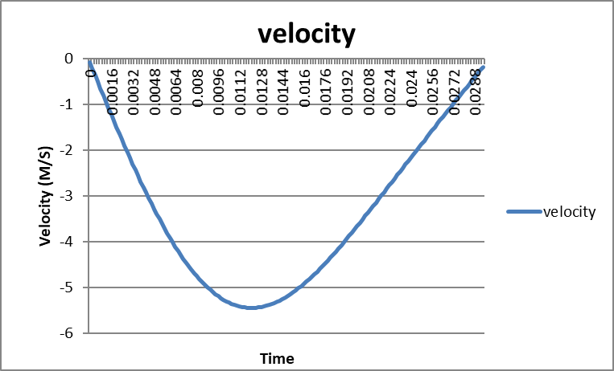
Figure 6-Velocity Graph at 1000RPM
The velocity of the connecting rod at 1000RPM (Fig 6) is slow. The connecting rod is only able to complete 2 strokes of the Otto cycle, induction and compression within the set time interval.
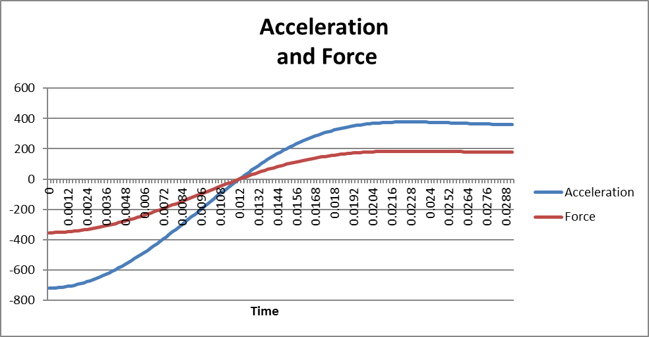
Figure 7-Acceleration and Force graph at 1000RPM
The acceleration of the connecting rod is also low due to the low engine speed. this also means that the force acting on the connecting rod is also low as shown in Fig 7. The maximum tensile force that is acting on the connecting rod is 352.892N.
Overall, the connecting rod is not under massive forces at 1000RPM. This means that the engine is working slowly and the chances of failure is very low at this engine speed. These forces are expected to increase as the engine speed is increased.

2000RPM
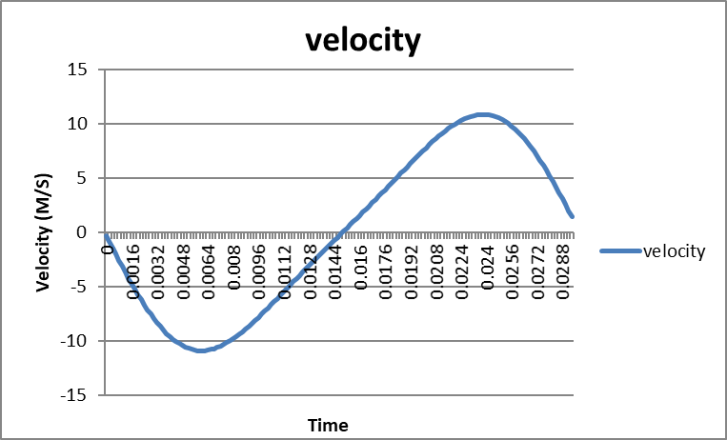
Figure 8-Velocity graph at 2000RPM
At 2000RPM, the connecting rod is able to go through a full revolution within the time allocated for the test as shown in Fig 8. The velocity has increased approximately by 2. This is expected has the engine speed has been increased by 1000RPM
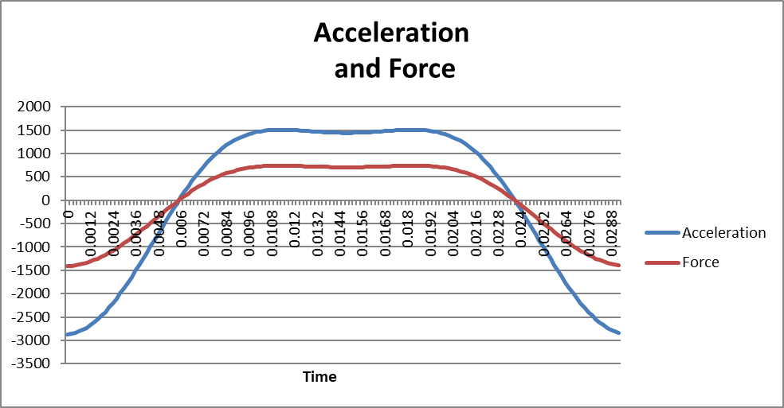
Figure 9-Acceleration and Force graph at 2000RPM
The acceleration of the connecting rod is increased dramatically with the change in engine speed as shown in Fig 9. The acceleration is increased by a different number when compared to the velocity because acceleration is defined in this case as meters per second squared (M/S²)
The force seems to follow a similar trend as the acceleration although not as dramatic with the most force being produced at the beginning and end of the graph (The maximum tensile force on the connecting rod is 1409.76N). This is because the connecting rod is enduring the forces of the controlled burn created under the power stroke. This trend is expected to continue but is to happen more frequently as the engine speed is increased.

3000RPM
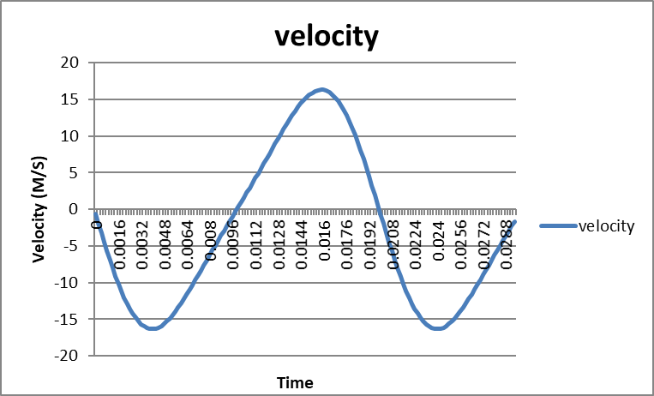
Figure 10-Velocity graph at 3000RPM
Fig 10 shows the velocity of the connecting rod at 300RPM. The trend of the RPM increasing by 5M/S seems to persist. This is expected as the engine speed is increased by 1000RPM. Also, the connecting rod goes through 1 and a ½ revolutions. This trend is also expected persist through out the test.
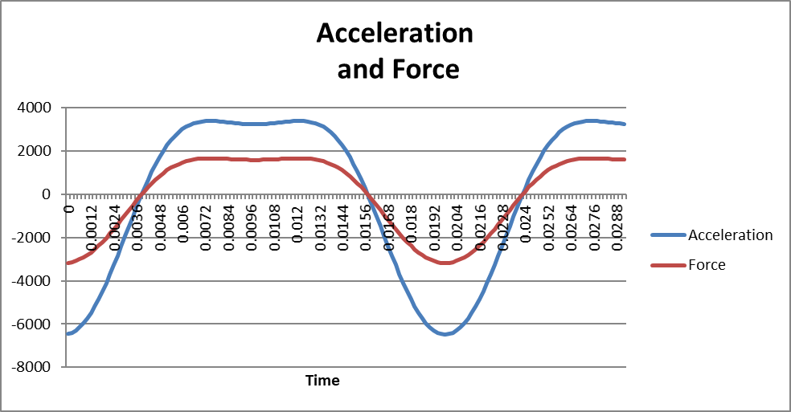
Figure 11-Acceleration and Force graph at 3000RPM
The acceleration and force have increased as shown in Fig 11. An observation that has not been seen clearly in lower engine speeds is the decrease of force and acceleration during the end of the compression stage. This observation will be noted in the following tests to see if it changes in any way or form. The maximum tensile force on connecting rod has increased to 3175.64N.

4000RPM
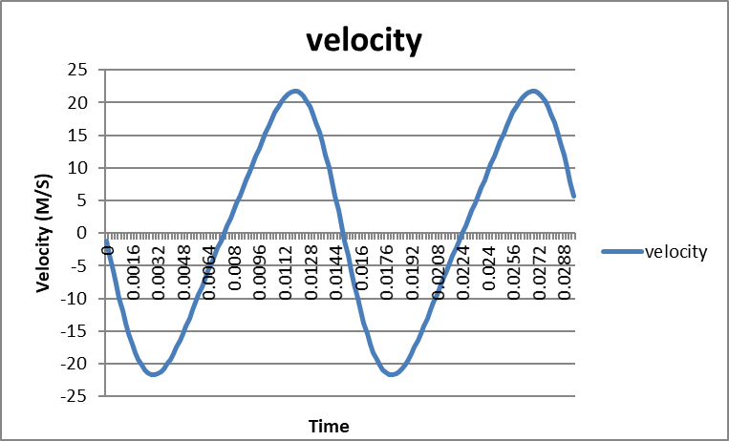
Figure 12-Velocity graph at 4000RPM
As expected, Fig 12 shows that the connecting rod has gone through 2 revolutions and the velocity has increased as well.
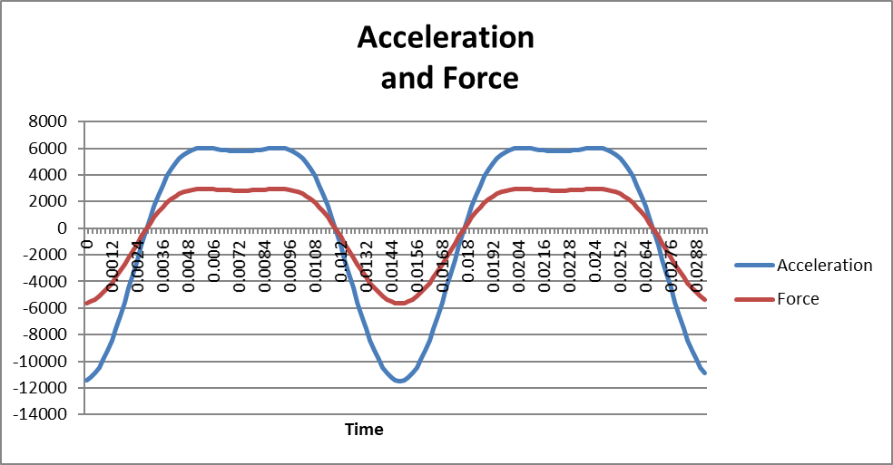
Figure 13-Acceleration and Force graph at 4000RPM
As expected, the acceleration and force have increased with engine speed in a non-linear fashion, as shown in Fig 13. With the dip in acceleration and force during the end of the compression stroke still present. The maximum tensile force on connecting rod at 4000RPM is 5643.18N, this again seems to be a non-linear increase.

5000RPM
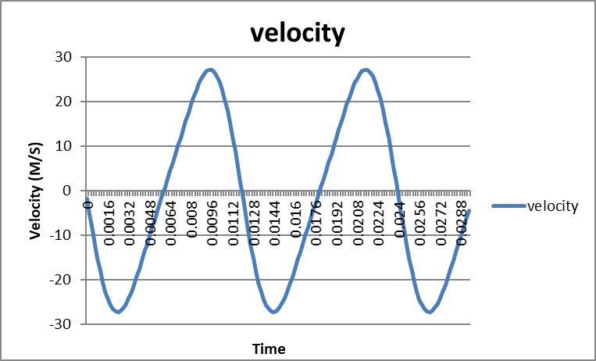
Figure 14-Velocity graph at 5000RPM
Again, at 5000RPM the velocity of the connecting rod is increased as shown in Fig 14. With the connecting rod completing 2 and a ½ revolutions.
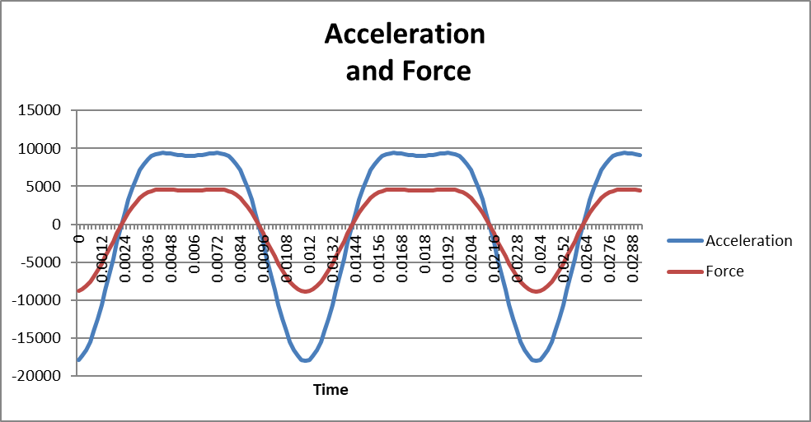
Figure 15-Acceleration and Force at 5000RPM
As shown in Fig 15, The trend of the acceleration and force increasing and following a similar pattern is still present. So is the dip in both acceleration and force at the end of the compression stroke. The maximum tensile force on connecting rod at 5000RPM is 8812.64N.

6000RPM
This is the “redline” for this specific engine. This engine is limited to 6000RPM as there would be no performance related benefits to increasing the RPM beyond this point.

Figure 16-Velocity graph at 6000RPM
As shown in Fig 16, the connecting rod as gone through 3 revolutions as expected. The velocity has increased in a similar pattern that was previously stated. (See Fig 18)
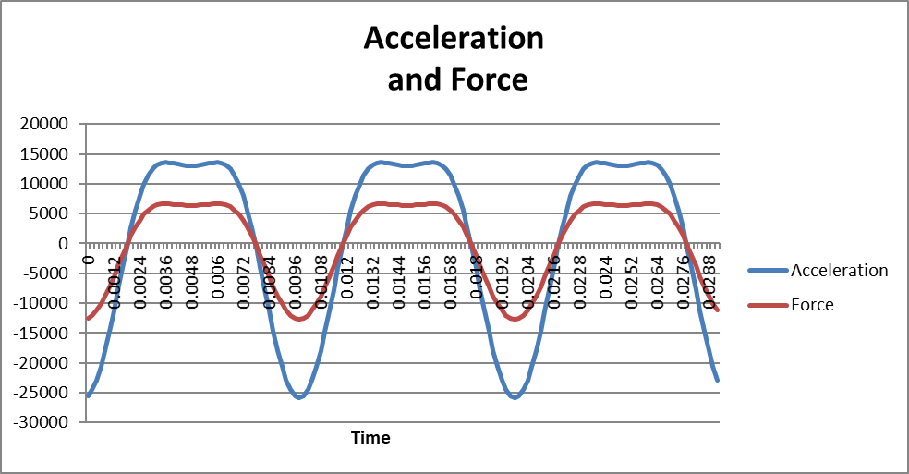
Figure 17-Acceleration and Force graph at 6000RPM
The acceleration and force have increased in the same way it has before (See fig 17). The dip at the end of compression is still present. The maximum tensile force on connecting rod is 12681.7N

Conclusion
In conclusion, this test has found out what forces are being placed on a connecting rod of a 1996 Dodge Viper GTS-R, with a piston weight 0f 0.49kg.
As for test findings, the theoretical tests have reported the findings of the speed, acceleration and tensile forces of the engine used in the Dodge Viper GTS-R. There were some unexpected results as with the dip in acceleration and force at the end of the compression stroke, but most results were as expected. The velocity, acceleration and tensile force increase with RPM. Interestingly, acceleration and tensile force have a relation that was replicated through out the tests.

Recommendations
If this investigation were to be repeated, some recommendations would be given to either improve accuracy of the data acquired or to more easily obtain the data.
The first recommendation that would be recommended is to take the graphs at smaller RPM intervals. This would provide more vital data. This is because the engine in this investigation was used in racing situations, where the engine is constantly varying in RPM. The variations in RPM would theoretically take place within peak torque, which occurs at 3600RPM and peak power, which occurs at 5200RPM (Stone,2003). With RPM intervals of 1000RPM, only four graphs show the velocity, acceleration and force of the conrod at the normal operating range of 3600RPM and 5200RPM. Although the piston needs to be able to cope with the force at 6000RPM, it will rarely go that high. The data captured at 1000RPM and 2000RPM is also vital as the engine does rev at that range but rarely as this is where the engine is either on idle or close to and during a race the engine will only rev that low during the start procedure, pitstops and safety cat periods. Using smaller intervals, the analysis will be able to analyse more appropriate data for this specific engine.
Another recommendation to make if this investigation was to be exercised again is to use a different engine. The reasoning behind this is the fact of acquiring the appropriate data. Considering the engine used in the investigation is over 20 years old, the information on it is hard to come by because of it being a race engine. These engines are built in house away from the general public and the companies that make the engines do not realise publications of the engines to the general public. Publications on these types of engines are normally made years after the engine has been raced and retired and normally go over the history of the creation of the engine. Even in this case where the engine is simply a modified version of the engine that is used in road legal Vipers, the vehicle in question is not a common vehicle.
If a more common engine was selected, the data would be easier to come by because there will be more documentation available to the general public and more people would be able to strip the engine down and take measurements of the engine components.
If these tests were to be performed again, another recommendation is to look at the data more carefully. As mentioned in the analysis, there is a dip in acceleration and tensile force. A further investigation into this can show the reasoning behind it and to see if it could be used to benefit the performance of the engine.

References
Carley, L (2008) Connecting Rods: So Many Choices, Available at: https://www.enginebuildermag.com/2008/09/connecting-rods-so-many-choices/ (Accessed: 20th November 2019).
Heywood, J.B (2018) Internal Combustion Engine Fundamentals , 2nd edn., New York: McGraw-Hill Education .
Korzeniewski, J (2012) 2013 SRT Viper Bites Back with 640 HP, Returns to Racing [w/video], Available at: https://www.autoblog.com/2012/04/04/2013-srt-viper-bites-back-with-640-hp-returns-to-racing-w-vide/?guce_referrer=aHR0cHM6Ly9lbi53aWtpcGVkaWEub3JnLw&guce_referrer_sig=AQAAAIp676Sueh3xIaWDFO61YV_aoKbNNgY4R7sDNAlzzRqgJYcs2r6G96BuIdzwKMSGmE8D7Te4EmyQPaVstLOAzm_d2klVlGv6MaiL_EkbTfPH8QiwS4_1xARPs3zzeCLT7TgNPVyCrMd9qx-zCJeZ_jiJkCo0WXmeZh21beYJv9o-&_guc_consent_skip=1574512494 (Accessed: 20th November 2019).
Stone, M (2003) The Viper, St. Paul: MBI Publishing Company.

