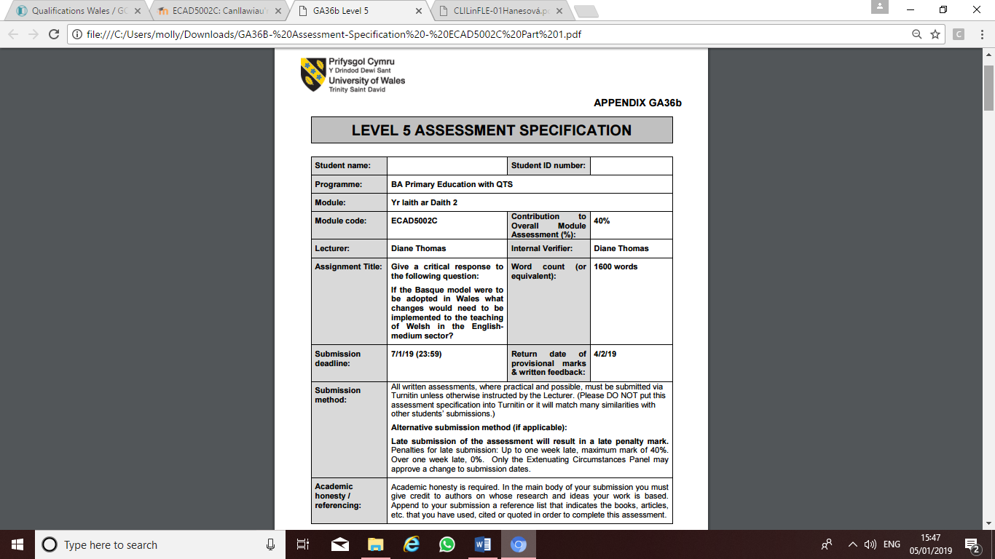
1701043
Molly Green
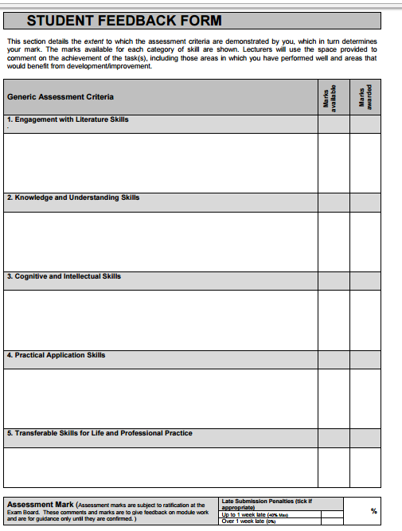

Give a critical response to the following question:
If the Basque model were to be adopted in Wales what changes would need to be implemented to the teaching of Welsh in the English-medium sector?
This assignment will critically analyse both positive and negative points of adopting the Basque model in Wales through a comparison of our current system and an anonymous community in Spain. Many points will be considered such as, how the education system in Wales is already similar to the Basque model and how it would need to change, but also how other elements of the system are very different, if it would be possible to alter them and what would need to be considered. Some of the points to be considered are how the school systems are categorised in both countries, types of examinations that are available and how the we could use the Basque model to raise standards of Welsh throughout the workforces.
The first point of discussion will be how schools in both Wales and the anonymous community in Spain are categorised. The Basque model says that schools in Spain are categorised as A-Model, B-Model and D-Model, with Wales currently having a similar structure, where children have the option of English or a Welsh-Medium school. Each school/model will assign different amounts of language contact hours which will have an effect on the standard of the language. Education in D-model schools is taught through the medium of Basque with Spanish as a topic subject, similarly in Welsh-medium schools’ instructions are given in Welsh and English is taught as a topic subject. These schools will allocate a significant amount of contact time for their languages. In English-medium Primary schools in Wales, 70% of teaching is through the medium of Welsh. The Basque model states that A-model schools give instructions through the medium of Spanish where Basque is taught for 3 hours a week. Likewise, in Wales, English-medium schools teach Welsh as a topic and give instructions in English. The research briefing of Welsh-medium education and Welsh as a subject defines English-Medium education as a setting where only “some Welsh is used to communicate with pupils with the aim of improving their capacity to use every day Welsh” (National Assembly for Wales, 2016, p.2). Research into Welsh-Medium schools conducted by Megan Jones suggests that in Wales, just 16% of pupils attend Welsh-medium education and an online document released by the Welsh Government based on studies of the Welsh language, suggests that only 19% of the Welsh population can speak the language. These statistics suggest that majority of Welsh speakers have come from the Welsh-medium schools despite Welsh being taught as a topic in English-medium schools. Content and language integrated learning (CLIL) is a term created by David marsh, which refers to situations where “subjects or parts of subjects are taught through a foreign language” (D. Marsh, 1994). CLIL has many educational benefits such improving overall and specific language competence and diversifying methods of teaching and learning. A CLIL project has already been put in place in Ikastola D-model schools where they use a “carefully planned system with timetabling training and classroom resource implications” (Section 5. The Basque Country, 2018, p.27). They also employ a full team of dedicated educationalists who specialise in the area. Using a CLIL pedagogy in English medium schools aim to improve Welsh second language. However, funding to employ specialist teachers in each school to promote this approach and for resources have to be considered.
If the Basque model were to be adopted in Wales with just models A and D, massive changes would not have to be made. However, schools in the anonymous community are also categorised into a third section, the B-model. The curriculum in B-Model schools is taught between 30% to 40% in Basque as well as receiving it as a subject. This represents a bilingual or dual stream school where two languages are learnt simultaneously side by side. Figures from the the Research Briefing of Welsh-medium education and Welsh as a subject, found that in 2014/2015 there were 391 Welsh-Medium primary schools, 862 English Medium primary schools, and just 39 dual stream primary schools (M. Jones, 2016, p.3). This figure is considerably lower in comparison to English and Welsh-medium primary schools, if the Basque Model were to be adopted in Wales the lack of dual stream schools would need to increase. Fortunately, the National Action Plan for a Bilingual Wales plan says that the government is “looking to achieve progressive increase in the proportion of children within Welsh-medium or bilingual setting” (WAG 2003, p.39). Their long-term goal for early years provision is to provide a £35,00 grant to increase bilingual and Welsh-medium nursey groups to open across Wales, exposing under 5’s to higher Welsh settings allowing them to have an option to go to Welsh-medium or Bilingual-schools. Based on these findings, the writer believes that the way schools are categorised in Wales would only require minor changes if we were to implement the Basque Model. These minor changes are already being put in place with funding being used to promote bilingual and Welsh-medium education.
The next point to be discussed is how if the Basque model were to be adopted in Wales changes would have to be made regarding options for pupils in Key stage 4. It is compulsory in both countries for all children under the age of 16 to learn Basque/Welsh in each education system. The Basque model also states that it is the responsibility of schools “in the compulsory education system to teach Basque to under 16-year olds” (Section 5. The Basque Country, 2018, p.27). The education system in Wales teaches Welsh as a compulsory subject from foundation phase level up to Key stage 4, after this it becomes an optional subject. At key stage 4 pupils also have the option to study Welsh second language full or short course. The One Language for all document written by the Welsh Assembly Government suggests that “No door is shut to you if you can speak Welsh and if you can speak Welsh, there are more job opportunities” (WAG, 2013, p.20). Despite this, the document also says that there continues to be more candidates entered for GCSE Welsh Second Language short course opposed to full course. There could be several reasons to explain why this happens, it may be due to lack of interest or that it is not a requirement for most employers. The Welsh Language Commissioner has reported in the review of the current curriculum in Wales; Successful Futures, that there is a shortage of people who are able to communicate in both English and Welsh throughout workforces. She recommended that employers should not look for just those with advanced qualifications in Welsh Second Language but those who can hold everyday conversation with patients and clients. Unlike Wales, the Basque Model has just one examination; the Euskerra Gaitasuna Aguira (EGA) and is offered to all Basque citizens. This qualification is recognised by many employers and is essential for any professional work at ‘functionary’ level. According to the Welsh Language Survey Report (2013-2014) despite 71% of employers in Wales stating that bilingual skills are desirable for jobs in their companies, just 22% of the population use a “fair amount” of Welsh in their day to day lives (WAG 2013-2014). By adopting the Basque Model in Wales would help to improve this figure, as just one qualification for pupils would make a fair assessment for everyone and allocate more language contact time. The Qualifications Wales website discusses how the government is already trying to implement this plan by replacing Welsh second language short and full course option with a new GCSE Welsh full course which has been put in place before the new Welsh Curriculum in 2020. This qualification aims to remove the distinction between Welsh first and second language and achieve one language for all.
The final point of discussion is based on the improvement of teaching standards and use of Welsh for those who are aged 16 years and over if we were to adopt the Basque Model in Wales. Section 5. The Basque Country states that “over 16’s and adults can access Basque language tuition through the government’s Basque language schools” (2018, p.26). For citizens in Wales, the National Centre for Learning Welsh provides Welsh for adult’s programmes however dates and spaces are limited. With the new GCSE Welsh second language full course being implemented teaching standards in Wales must be considered if free tuition is not available for everyone. Teaching tomorrow’s teachers by John Furlong suggests that there will be “major implications as a result of the increased focus on…the Welsh language” for future teachers to have sound understanding of the language. Improving courses for adults wanting to learn Welsh for their employment such as teachers, doctors, and policemen will be essential if the Basque Model was adopted in Wales due to Basque being an essential part of employment. However, cost of courses and examinations for all citizens wanting to learn the Welsh would have to be considered. Particularly with learning a language having so many different elements e.g. writing, reading etc. Compromises would have to be made by the government to support funding, courses might only be available for adults working in the civil service sector. Currently, Sabbatical schemes are available for teachers to develop their Welsh language skills. This can be up to 5-12 weeks long where cover would have to be paid for.
To conclude, the writer believes that by adopting the Basque Model throughout schools in Wales would increase use of Welsh and remove the distinction between Bilingual and English-medium schools until standards are equal and English-medium Schools are no longer required. Overall, enabling to reach their goal of 1 million Welsh speakers by 2050 and improving the Welsh language for future generations.

Reference List
Donaldson, G. (2015) Successful Futures.
Dana Hanesová (2015) 1 History of CLIL - D. Marsh, University of Jyväskylä, Finland (1994).
Furlong, J. (2015) Teaching Tomorrow’s Teachers - Options for the future of initial teacher education in Wales.
M. Jones (2016) National Assembly for Wales. Research Briefing: Welsh-medium education and Welsh as a subject.
Qualifacations Wales (2019) GCSE Welsh Second Language - Available at: https://www.qualificationswales.org/english/qualifications/gcses-and-a-levels/gcses/gcse-welsh-second-language/
SECTION 5. THE BASQUE COUNTRY (2018).
Welsh Assembly Government (2003) A National Action Plan for a Bilingual Wales.
Welsh Assembly Government (2013) One language for all, Review of the Welsh Second Language at key stages 3 and 4.
Welsh Assembly Government (2013-2014) Welsh Language Survey.
Welsh Assembly Government (2019) Welsh Language - Cymreag - Available at: https://wales.com/language

