Amplifiers
Creating an Amplifier using a BC109 Transistors

Gower College Swansea
Electrical and Electronic Engineering HNC

Table of Contents
Investigating Different Types of Transistors 2
Bipolar Junction Transistors (BJT) 2
Data Sheet 3
Calculations 4
Circuit Design 5
Circuit Simulation 6
Determining Input and Output Impedance 7
7
Addition of a Capacitor 7
Two-Stage Amplifier 9
Practical Work 10
Setting Up My Practical 11
Taking Measurements 12
References 14
Bibliography 15

Investigating Different Types of Transistors
Transistors are classified into two main categories: Bipolar Junction Transistors and Field Effect Transistors. There are many similarities between these two classifications of transistors such as they can both be used as amplifiers and switches. The main difference separating these two types is that in a Field Effect Transistor only the majority charge can flow whereas in a Bipolar Junction Transistor both the minority and majority charge are able to flow. Another difference between the two is that Field Effect transistors are voltage controlled whilst Bipolar Junction Transistors are current controlled. (Williams, 1996)

Bipolar Junction Transistors (BJT)
BJTs can be further classified into NPN and PNP transistors, this is determined by the structure of the transistor and more specifically, the diodes inside. If the transistor is NPN then the ‘negative’ side of the diode is on pins 1 and 3, with the ‘positive’ ends of the diodes towards pin 2. However, with a PNP transistor this is revered so the ‘negative’ is in the middle, hence the name NPN and PNP.
For my circuit I will be using a Bipolar Junction Transistor, I am using a Bipolar Junction Transistor because these transistors have a high gain whereas. This is suitable for the circuit I am building because I want to use my transistor as part of an amplifier so a large gain will be necessary.
The Bipolar Junction Transistor that I will use will be an NPN transistor because these turn on when there is current flowing through the base of the transistor. The reason I have opted for this rather than PNP is because PNP transistors come on when there is no current at the base of the transistor.
BJTs also have smaller input impedance meaning they draw more current from the circuit which can cause loading.
The value for Beta of most NPN transistors generally are between 50-200 however more specific values can usually be found on a datasheet. These types of transistors usually take 0.7V to operate, this figure rarely changes much, normally being between 0.6V and 0.7V. (Admin, 2019)

Data Sheet
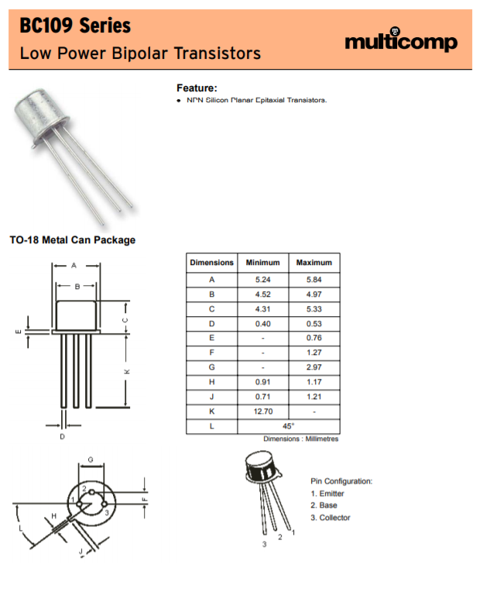

(Multicomp, 2006)
I have found a datasheet for the transistor specified in the assignment brief. This is a comprehensive datasheet which shows everything needed including voltages, power output and current.

Calculations

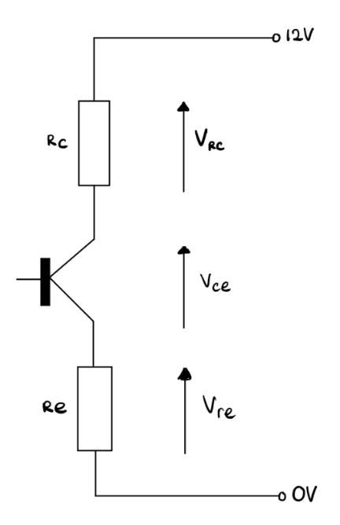
Ic = 1mA, supply = 12V
Let Vce = supply/2 = 6V
Let us split the remaining 6V as follows:
Vre = 0.86V, Vrc = 5.14V
Then Re = Vre/1mA = 0.86k ohms
And Rc = Vrc/1mA = 5.14k ohms

Next, we must select suitable values for the base resistors R1 & R2.

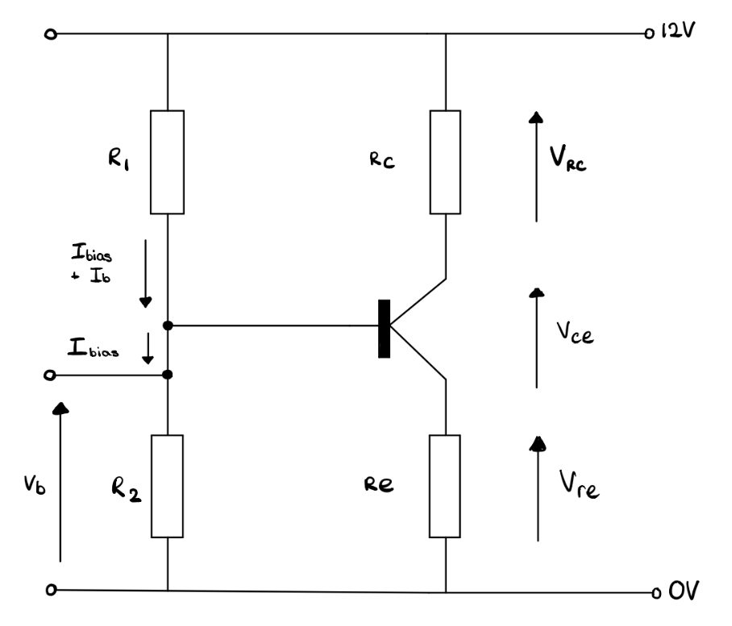
Vb = Vre + Vbe = 0.86 + 0.7 = 1.56V
Ib = Ic/hFE = 1mA/200 = 5uA
Choose Ibias = 20*Ib = 100uA
R2 = Vb/Ibias
R2 = 1.56/100uA = 15.6k ohms
R1 = (12V – Vb)/ (Ibias + Ib)
R1 = 10.44/105uA = 99.4k ohms

(Davies, 2019)

Circuit Design

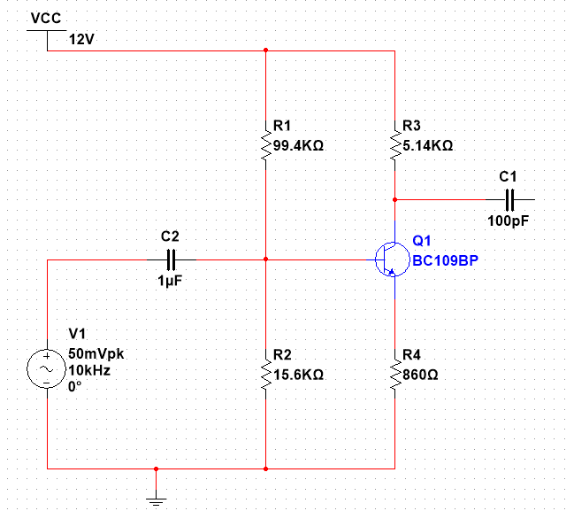

After calculating the correct values of all my resistors, I have created a circuit design using the BC109BP transistor on Multisim. I have calculated my resistors so that they give a value of gain 6 and the supply voltage being 12V. I have chosen a 1uF and a 100pF capacitor as I think these are suitable values.

Circuit Simulation
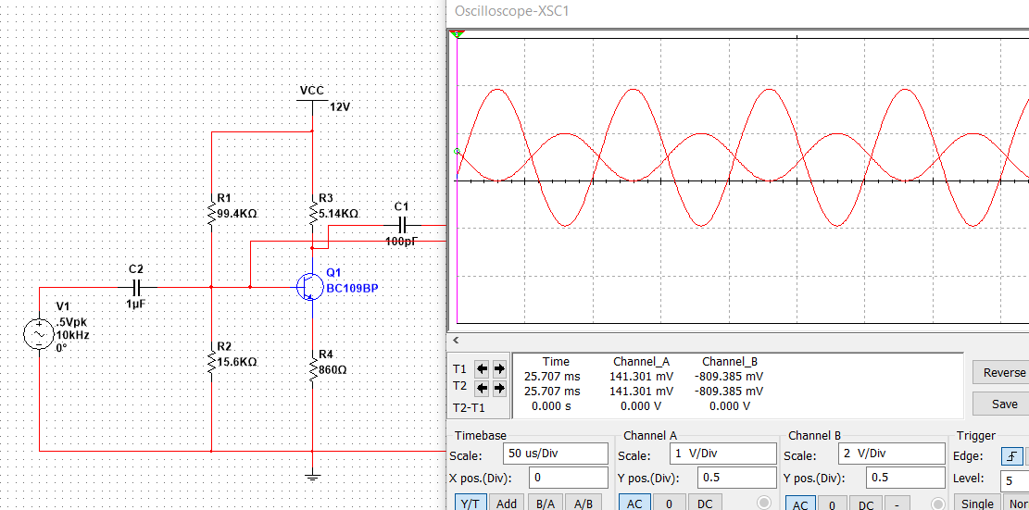

I have put a sign wave of 50mV peak to peak of 10kHz into the input and attached an oscilloscope to both the input and output so I can compare the two. From the oscilloscope I can see that the values of my resistors are correct and therefore my calculations, I have successfully achieved a gain of six which is represented by the waves produced, the input is one division where the scale is 100mV per division and the output is three divisions where the scale is 200mV per division. This means that there is 100mV at the input which is amplified to 600mV at the output thus a gain of six.
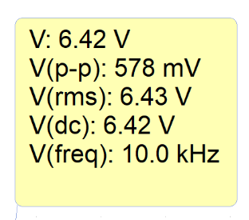
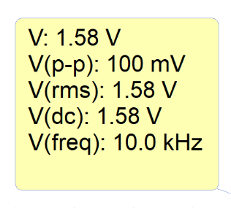

Readings at Collector
Readings at Base

I have also taken readings of voltages at the base and the collector of the transistor, from this I can see that the voltages has increased by four times and the peak to peak voltage is roughly six times larger on the collector than base.

Determining Input and Output Impedance
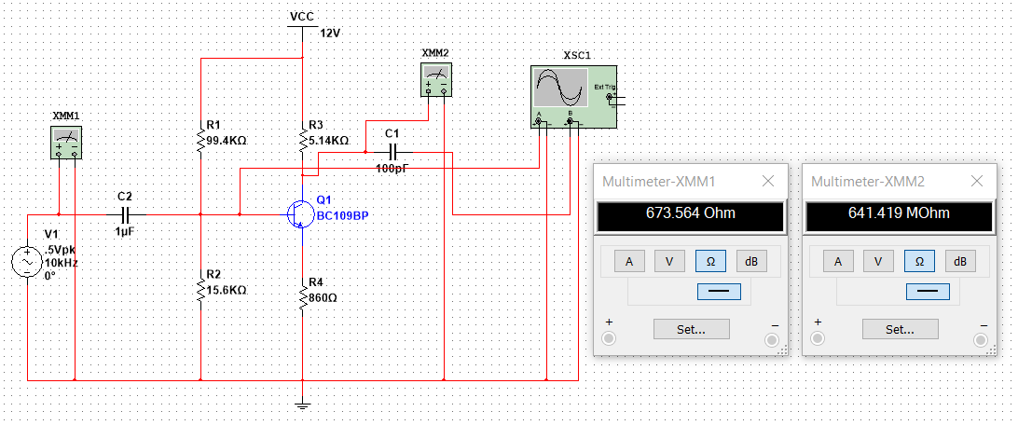

Using the Input Impedance equation
1/Zin = 1/R1 + 1/R2 + 1/hfe(re)
1/Zin = 1/99.4k + 1/15.6k + 1/200(860)
Zin = 12.5khoms is the input impedance of my circuit.
The output impedance is the value of Rc therefore it is 5.14kohms.

Addition of a Capacitor
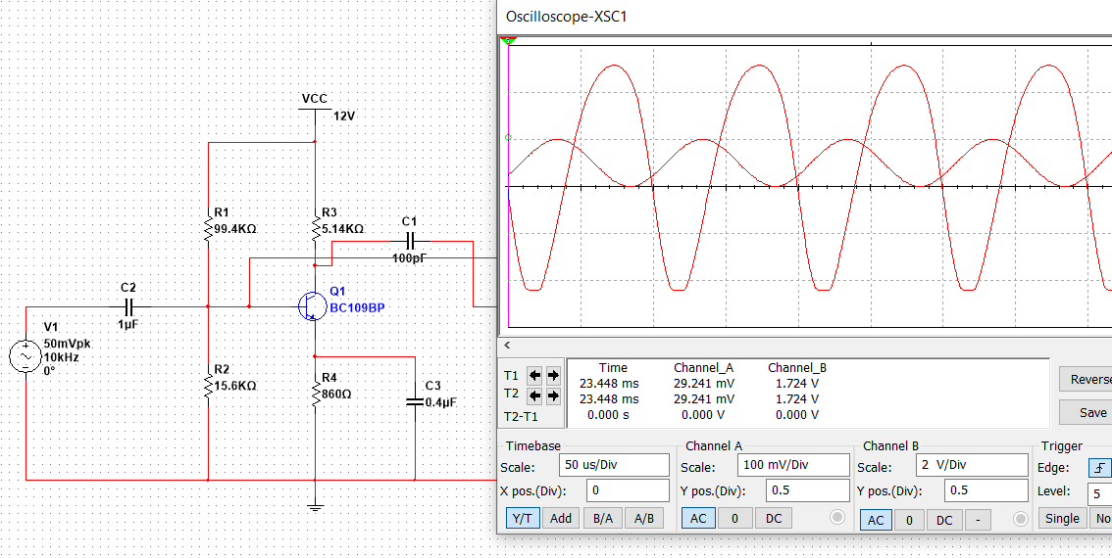

I have added a capacitor at the emitter of the transistor, I have then measured the results to see what effect this has had on the overall gain of the circuit. From the measurements shown and the waveforms produced I can see that the gain is significantly larger after the addition of the extra capacitor. The gain of the circuit has now become 95 rather than 6, as it was initially.
The reason that there is such a vast increase in gain is because this capacitor is effectively working as a bypass capacitor. It is allowing the current to flow from the emitter to ground without encountering the resistance of the 860ohm resistor.
“But the device of discussion is the Bypass Capacitor CE. The magnitude of the emitter current is large due to amplification of the ac signal. If there is no bypass capacitor, the large ac emitter current flows through the emitter resistor RE with a large ac voltage drop across RE.”
(Electronics Hub, 2019)

Two-Stage Amplifier
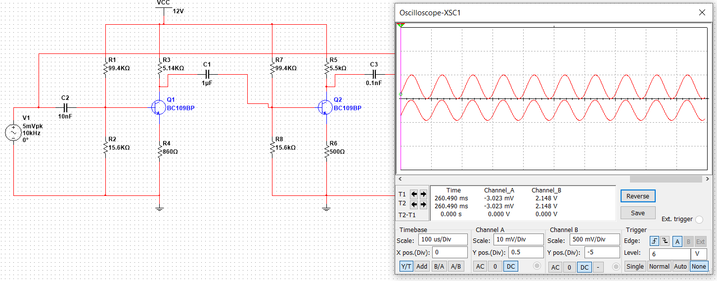

I have designed a two-stage amplifier circuit to achieve an overall gain of 50. I have done this by using my previous circuit and adding a circuit with a gain of 8.3 to the output. The reason I have chosen 8.3 is because my first gain was 6 therefore when 6 is multiplied by 8.3 an overall gain of 50 is achieved.
The second circuit I have added to create one larger circuit is a very similar amplifier circuit which uses the same transistor. It also has the same biasing resistors so the voltage going into the transistor is unaffected. The resistors that I have changed are the resistors at the collector and the emitter, I have changed the values of these slightly to adjust the gain.
From the findings I have with the oscilloscope I can see that there 10mV at the input and 500mV at the output. This shows there is a gain of 50.

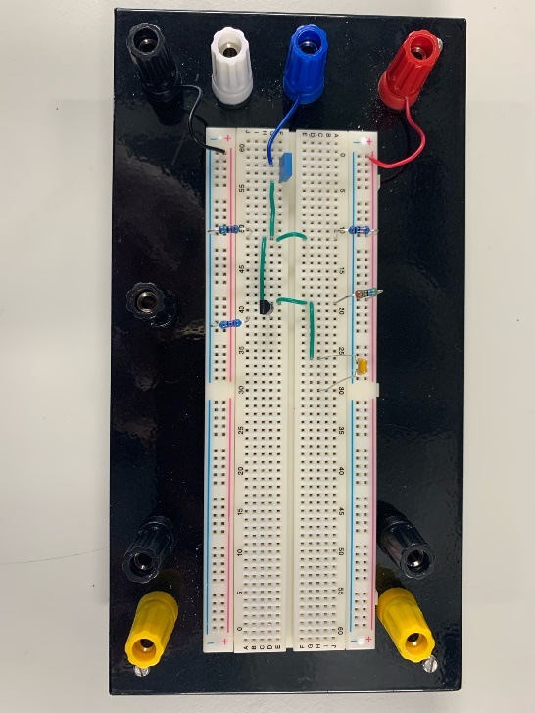
Practical Work
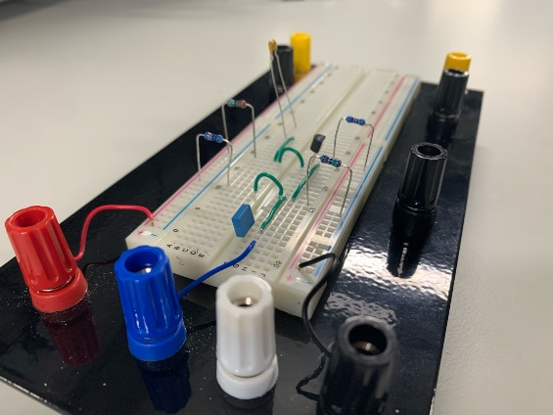

I have built my circuit on a breadboard however I have had to improvise with certain components such as the transistor. I have had to use a BC547 rather than a BC109 because the desired transistor was not available to me at the time. I chose the BC547 as an acceptable alternative because it has a similar hfe and draws around the same voltage for operation.
I have also had to slightly adjust the values of my resistors as the specific resistor values which I used in my simulation are not in the E24 Standard series of resistors. I had to choose the closest resistors to the values I wanted in order to get them as accurate as possible, for the 5.14k resistor I used a 5.1k, for the 860ohm I used an 820ohm, for the 15.6k I used a 16k and for the 99.4k I used a 100k resistor. I thought this was sufficiently accurate as I still achieved valid results however in future if I wanted to be even closer to the values in my simulation I could have used combinations of resistors in series or parallel to achieve more specific values.

Setting Up My Practical
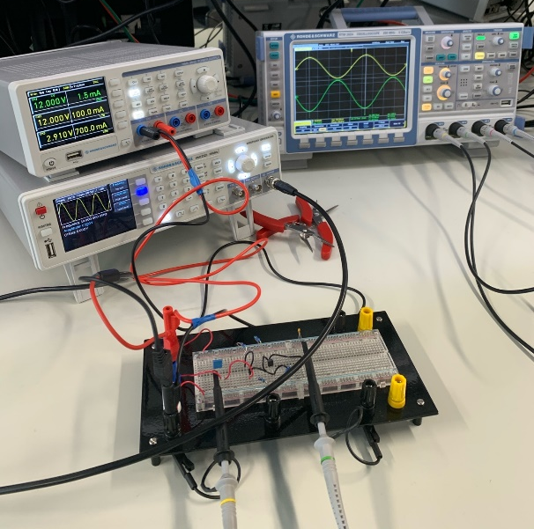
I have connected my circuit I have built on breadboard to a power supply, oscilloscope and function generator. I have set the power supply to give my circuit a VCC of 12V, and I have set the current draw limit to 100mA.
I have also used the function generator to input the same signal as my simulation which was 50mV peak to peak with a frequency of 10kHz. I have then connected this to the input of my circuit.
I have also connected an oscilloscope using two channels and connected channel one to the input and channel two to the output. I have also set up the oscilloscope so that it displays the frequency, the voltage peak to peak of both the input and the output and the phase of the two.
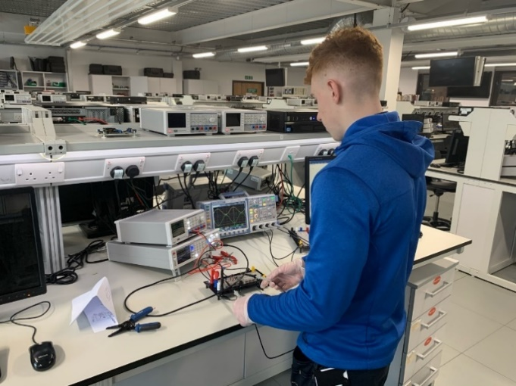

Taking Measurements
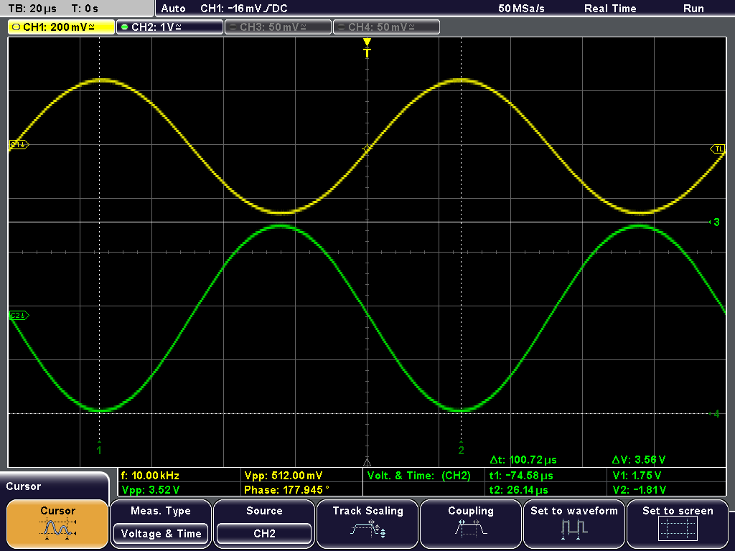

Above are the measurements I have gained with my practical circuit using the oscilloscope. As shown in the top left corner, I have set Channel 1 to 200mV per division, Channel two to 1V per division and the time base to 20us.
I can also see that the phase is measured at 177.945 degrees, this shows that they are almost perfectly out of phase with each other which is what I expected to see as this value is very close to 180 degrees.
Visually we can see that channel 1 is roughly 2.5 divisions peak to peak and channel two is 3.5 divisions peak to peak. I have set the oscilloscope up to measure this accurately which shows the peak to peak voltage of the input is 512mV and the peak to peak voltage of the output is 3.52V. This shows there is a gain of 6.875, this is slightly too large because I was hoping for a gain of 6 however this change in result is expected.
The reason why some of my results I have obtained from my practical work is not as my simulation is because in the simulation everything works perfectly. One of the reasons I must consider with my practical is that some of the resistor values I used were not accurate enough to achieve accurate results. Even if my resistors were the correct value, in a simulation there are no tolerances whereas with the resistors I used with my practical experiment had a tolerance of 5% each side. This is another factor that makes the results extremely hard to predict. Another difference between the simulation and the real circuit is that the transistor might take a slightly different voltage to turn on which could affect results.
There are also many more factors to consider when using the circuit in real life such as how noise may affect the signal or even how connections are being made, the breadboard I used was brand new to reduce any mechanical faults however there is still an uncertainty that all physical connections were made properly which could alter resistances and other parts of the circuit.

References
Admin. (2019, October 5). Difference Betten BJT and FET. Retrieved from Physics About: https://physicsabout.com/difference-between-bjt-and-fet/
Davies, D. T. (2019). EG-223 Bipolar Transistors. Swansea: Swansea University.
Electronics Hub. (2019, April 15). Bypass Capacitor. Retrieved from Electronics Hub: https://www.electronicshub.org/bypass-capacitor-tutorial/
Multicomp. (2006, April 8th). BC109 Series Datasheet. Retrieved from Farnell: http://www.farnell.com/datasheets/296634.pdf
Williams, G. E. (1996). Multistage and Power Amplifiers. In G. E. Williams, Analog Electronics (pp. 313-384). St Paul: West Publishing Company. Retrieved from https://www.elprocus.com/difference-between-bjt-and-fet/

Bibliography
Admin. (2019, October 5). Difference Betten BJT and FET. Retrieved from Physics About: https://physicsabout.com/difference-between-bjt-and-fet/
Davies, D. T. (2019). EG-223 Bipolar Transistors. Swansea: Swansea University.
Electronics Hub. (2019, April 15). Bypass Capacitor. Retrieved from Electronics Hub: https://www.electronicshub.org/bypass-capacitor-tutorial/
Multicomp. (2006, April 8th). BC109 Series Datasheet. Retrieved from Farnell: http://www.farnell.com/datasheets/296634.pdf
Williams, G. E. (1996). Multistage and Power Amplifiers. In G. E. Williams, Analog Electronics (pp. 313-384). St Paul: West Publishing Company. Retrieved from https://www.elprocus.com/difference-between-bjt-and-fet/

