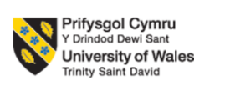


Name of Report: Ramee International Hotel, Administration Department
Module: Organisational Consultancy (BMIH6005)
Student Name & ID: Ionut Kostyal 2125398
Name of company: AZ Business Consultant
Report Delivery Date: 31.05.2024
Executive Summary
The sustainability of any business is influenced by content upgradation and ensuring high customer retention. Tourism industry growth has elevated the market expansion of the hospitality industry as well. Although development and evolution within market needs have created a tough situation for the business to achieve a healthy flow of revenue without any further developmental strategy implication (Burnes, 2014). Post-pandemic period awareness of the customer has enhanced at a noticeable rate. Reviews delivered within varied social media platforms related to the performance of the hotel influence the buying behaviour of the customers adversely. Ramee International Hotel in Deira has been identified with issues with several negative comments posted on social media sites that have resulted into a fall in customer trust and market reputation (Noordzife, 2014). Following that, the AZ Business Consultant created a report for their client, the Ramee International Hotel in Deira. The hotel in question is a member of the Ramee International Hotel Group, which operates 42 hotels across the globe. The organisation has implemented its business expansion strategy in India, Bahrain, and the United Arab Emirates as strategic locations. The Deira property has been concentrating on creating reports and taking care of the main problems the hotel is facing. A thorough examination of customer feedback and market reviews across a range of social media channels has revealed that the hotel's primary concerns are administration and upkeep of the accommodations (Kipping and Clark, 2012). Due to the executive's unprofessional and unfriendly behaviour, room service has not been able to satisfy its customers. The lack of front desk supervision and strict restrictions and regulations within the hotel have disrupted guests' ability to stay together. The top complaints from consumers include poor food quality, dirty lodgings, and loud noises. The competitive market has witnessed a significant decline in brand reputation due to the unrest over ethical practices. The hotel has suffered losses as a result of the identified difficulties that have affected the decline in revenue margin. The concerns that have been resolved have also hurt the client retention rate (Kotter, 2012). Employee unhappiness stemming from poor employee empowerment and a lack of leadership within the organisation has led to a shortage of talented workers being retained. The organisation is facing challenges in implementing innovation due to restricted cash flow caused by a lack of income. Analysis of real-time data has reflected the prime causes of the emerging issues within the hotel. 30% of the customers desire to stay at hotels with proper locations and high-technology amenities available. Smart management of the front desk will reduce the waiting time of the guests. 93% of the businesses have faced ethical issues due to mishandling of the data which affects the customer trust and security aspects. JW Marriot and Gevora Hotel have been the two prime hotels that have given huge competition to Ramee International Hotel, Diera. Lack of proper concern for employee management and talent pool has degraded the hospitality management within the organisation and failed to handle the tough competition (Subramaniam et al., 2011). A 15% increase in corporate taxation has severely impacted the profit margin for the Ramee International Hotel in Deira, according to a PESTLE analysis. One of the main causes of the increase in production costs that have affected the organisational performance of Ramee International Hotel is the 3.3% inflation rate. Brand visibility and a better work environment have been addressed through SWOT analysis and low employee retention is a major threat for Ramee International Hotel, Diera. The organisation's main strength, as shown by the TOWS analysis, is its diversified staff and strong global market position (Newton, 2010). The regulatory compliance and competition issues can be mitigated by improving the financial condition of the business. Therefore, the company can leverage finance from foreign investors to improve its financial condition has been addressed as a weakness of opportunity for the organisation. Inadequate employee satisfaction and unstable finances have been acknowledged as the company's shortcomings. The investigation has led to suggestions for change management and has been made to the Ramee International Hotel in Deira. It has been advised to enhance administration, integrate technology for improved room service, diversify offerings with a focus on the needs of the consumer, and promote ethics. Enhancing hotel administration to provide better customer service and gain a competitive edge in today's cutthroat industry will be the organization's main strategy. The organisation will efficiently centralise the Hotel management system by implementing cloud-based HMS to focus on strategic initiatives while empowering the management team. The success of the administrative change in the organisation, Ramee International Hotel must maintain an appropriate change management procedure. Transparency among staff members can help establish clear and consistent communication by enabling a multi-channel communication process. They must train their employees on how to use these channels while also collecting daily and ongoing input to comprehend the problems and challenges they are facing (Brierley, 2006). The establishment of an intuitive mobile application can facilitate direct reservation booking, enable digital keys for check-in and check-out, facilitate easy exploration of hotel services, and facilitate direct communication between guests and hotel staff to obtain assistance (Baron and Armstrong, 2007). Every recommendation's improvement and change management strategy has been thoroughly examined. Cost management, market reachability, and positive reviews can be experienced as core benefits through the implication of addressed recommendations and change management. The main tasks, including employee empowerment and training, technology integration, customer relationship management, and improved accommodations within a given time frame, are outlined in a tabular form that serves as an action plan. The action plan has specified how much money is needed for each job. The study offered a thorough examination of the Ramee International Hotel in Deira and made appropriate suggestions for further advancements.

Table of Contents
Introduction 6
Analysis 9
Evaluation of the issues identified in the hotel 9
Impact and causes of these issues 10
PESTLE analysis 15
SWOT analysis 17
TOWS analysis 18
Recommendations 19
Benefits of implementing recommended strategies 25
Costs associated with the recommendations 26
Action plan 27
Conclusion 30
References 32

Introduction
The hotel industry is the most growing and highly competitive market at present. The growth of tourism has enabled the entrepreneur to invest in the hospitality industry and expand their revenue generation scope. The growing market has delivered several options to customers that have elevated their taste and chosen them. Customer buying behaviour within the hospitality industry primarily depends upon the quality of service and strategy of customer engagement. The majority of the hotels face issues of sustainability due to customer engagement and adoption upgrade issues. Therefore a consultancy report will be formulated to address the key issues experienced by a hotel and analyse its impacts on the organisational operation. An external and internal environment that impacts organisational operations will be analysed utilising the framework of PESTLE and SWOT analysis. TOWS analysis will also be conducted to assimilate the available impacts on the organisational functioning. Based on the findings of the issues and their impact on the organisation change management and recommendations will be delivered. The impact of the change management and the key benefits the hotel can address incorporating the change will be explained in depth. Associated costs that need to be borne by the organisation to bring positive change will be highlighted. A tabular presentation will be placed within the report to present an action plan identifying the resources and timeline required for the project. The report will be developed based on the case study of Ramee International Hotel and Deira. Development and resilience within the business can be ensured through proper market research and expert advice to take the necessary business strategy. Therefore, a consultancy report will be developed by the AZ Business Consultant. The organisation promises to identify the core issues of the organisation and perform a critical evaluation to address the impacts of them on business some of the main issues are channels has revealed that the hotel's primary concerns are administration and upkeep of the accommodations. Utilising expertise workforce and the latest market assessment tool and framework market data and research will be conducted. Based on the findings adequate recommendations and change management strategies will be designed for Ramee International Hotel, Deira. Consultancy firms are dedicated to showing appropriate business pathways to achieve competitive advantage and elevate their customer retention rate within the tourist market situation.
Company Background
Ramee International Hotel Group was founded in 1985 and gradually the business has expanded its market within India, Bahrain, and UAE (Rmeehotels, 2024). expanding the business globally has elevated the scope of the organisation to achieve a wide scale of customers and strong recognition within the global market. The key services provided by the organisation include hospitality services, quality accommodation, leisure facilities, arranging meetings and events, and many more. The group of hotels operates around 42 locations within the international boundary. Mid-market segment has been prioritised by the hotel group for their resorts, apartments, and hotels. Approximately more than 10000 global employees are associated with the organisation (Zoominfo, 2024). Within the Ramee International Hotel Group, the property located at Deira will be focused on within the report. Accommodation capacity within the Ramee Internation Hotel, Deira is more than 100 with a room size ranging from 35m² to 54m². All the rooms are well-decorated and stuffed with modern amenities. Bar and lounge facilities are provided along with a business center for official purposes. The hotel is close to Dubai Abra Dock and transportation facilities are available (Tripadvisor, 2024). On-site restaurants are available within the hotel location that enables the guest to enjoy tier cuisine. Notable tourist places are near the hotel like Dream Journey, Grand Mosque, and many more. The hotel has a ranking of 239 among all the hotels available within the Dubai market. The net worth of revenue generation has escalated to 5.94% and the debt ratio is 0.13 for the company (Tofler, 2024).

AZ Bussines Consultant
Primarily focused on hotels AZ Business Consultant is a top-tier consulting company with headquarters in London UK. It specializes in offering customized solutions for the hospitality sector. AZ Business Consultant was founded in 2010 and has since gained a reputation for providing strategic insights operational enhancements and creative solutions that boost hotel clients profitability and improve their guests experiences. Customers range from boutique properties to major international chains AZ Business Consultant spans the UK and Europe serving a wide spectrum of hotel clients. The company has a group of seasoned experts with a wealth of hospitality industry experience. They ensure a comprehensive approach to problem-solving and strategy development with their consultants diverse backgrounds in hotel management marketing finance and operations. With the completion of multiple projects over the years AZ Business Consultant has helped their clients achieve notable gains in performance. Some noteworthy accomplishments are:. boosting a mid-sized hotel chains average occupancy rates by 15% in less than a year. utilizing process reengineering to cut operational costs for a boutique hotel by twenty percent. by using focused digital marketing efforts increasing online visibility and booking rates by thirty percent. Our goal is to equip lodging facilities with cutting-edge tactics and workable solutions that raise revenue guest satisfaction and operating efficiency. As the top consulting company in the hospitality sector we aim to be known for our sustainable practices client-focused methodology and dedication to quality.

Analysis

Evaluation of the issues identified in the hotel
Ramee International Hotel is one of the high-end hotels situated in Deira, Dubai. The hotel has offered high customer service and stylish and modern facilities to their guests, however, there are some issues that have been identified that have not only lowered the customer satisfaction but also the reputation of the company. According to several customer reviews, the company has poor room service and improper front desk management which has reduced the number of repetitive customers within the business. The employees at the front desk have been found less knowledgeable and have rude behaviour which has lowered their customer service rate (Whittington et al., 2020). Additionally, the hotel has been found in a poor state of Construction as it has been described as needing renovation and demolition. The rooms are not clean, and they are in need of industrial cleaning making it impossible to stay comfortably in the hotel. The bathroom facilities are poor as well as the electrical sockets are in poor condition. The overall condition of the hotel and their services is nothing but poor, creating a bad reputation in front of the customers. Along with that, the food quality is average with many options and the hotel has no recreation facilities (Arapou and Kapiki, 2023). Lack of innovation, poor management, and low customer service are the internal issues that have been identified as the factors that have been ruining the business growth. External factors such as economic fluctuations and supply chain disruption have also affected the business immensely. Further, low sustainable policies and a lack of strategic management have affected the business growth.

Impact and causes of these issues
Issue 1 Changing market trends
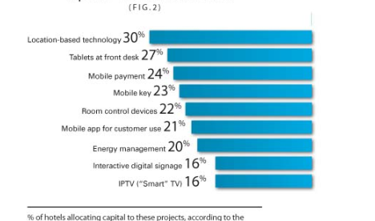
Figure: Latest market trends
Source: (bbc, 2024)
Analysis
According to recent data, it has been found that changing market trends has become a challenging issue for businesses. Due to the advancement of different technologies, mobile technology, sustainability factors, digital tools, and other different factors have affected business development. As per the above chart, it has been found that location-based technology, mobile booking, room control services, and interactive digital signage are some of the most innovative market trends that must be followed by businesses (bbc, 2024). The hotel had found it hard to incorporate these new market trends resulting in low customer satisfaction and poor management is also responsible for this.
Issue 2 Regulatory compliances
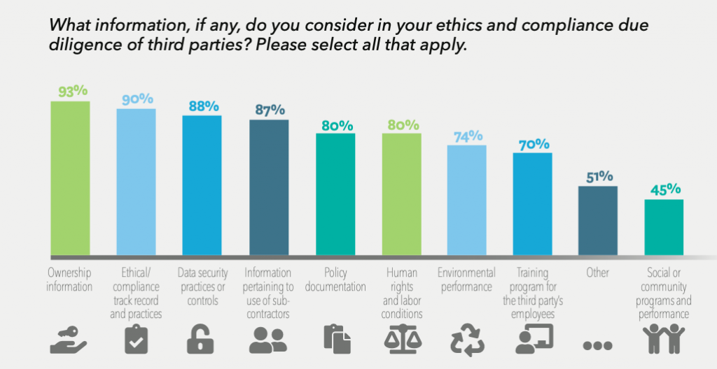
Figure: Business ethics and compliance
Source: (Nilsson, 2023)
Analysis
Business ethics and regulatory compliance are necessary for a business. According to the above data, it has been noted that ethical practices, data security, environmental performance, policy documentation, and other different factors need to be maintained by hotels. The hotel has found it hard to comply with the regulations due to the poor construction of the building as well as risky electronic devices which are poor in conduction (Nilsson, 2023). Additionally, the lack of sustainability measures and poor infrastructures have restricted them from complying with regulatory measures. Therefore, the hotel has found itself on the verge of failure and lawsuits by the government.

Issue 3 High competition
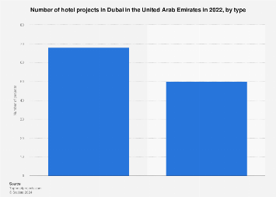
Figure: Number of hotels in Dubai
Source: (statista, 2023)
Analysis
The above graphical representation has shown the number of hotels in Dubai will be nearly 610 in 2022 which has increased throughout the years. The Gevora Hotel, JW Marriot Marquis, Four Points, and other various hotels present in the market have created high competition within Dubai. Not only that, the exquisite services and management process of these hotels have attracted them hotels highly (statista, 2023). However, Ramee International Hotel has failed to provide proper customer service and facilities to their customers which has led to slow development and low customer satisfaction. The high competition is one of the reasons behind the low customer base of the hotel. However, the poor management system and infrastructure are the main reasons behind the hotel's poor reputation and customers have chosen better options for their stay which they found due to high competition in Dubai.

Issue 4 Poor talent management
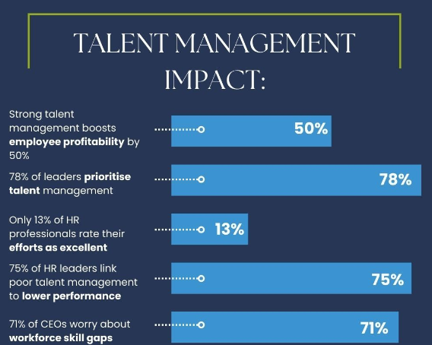
Figure: Impact of talent management
Source: (forbes, 2022)
Analysis
Talent management is one of the crucial aspects of any business. However, it plays a vital role in the hotel industry as hotels have to interact with their customers on a regular basis. Talent management helps hotels find the perfect candidate for their hotel operational process by which they can satisfy their customers. However, Ramee International Hotel has been unable to incorporate talent management properly due to their customer service being of low quality which is the reason for their low performance (forbes, 2022). According to the above carts. 75% of human resource professionals have wielded the way poor talent management is the reason behind poor performance and business failure. The employees of Ramee International Hotel have failed to deliver proper customer service and performance to the business which has resulted in a low brand reputation and customer base.
Issue 5 Lack of customer retention
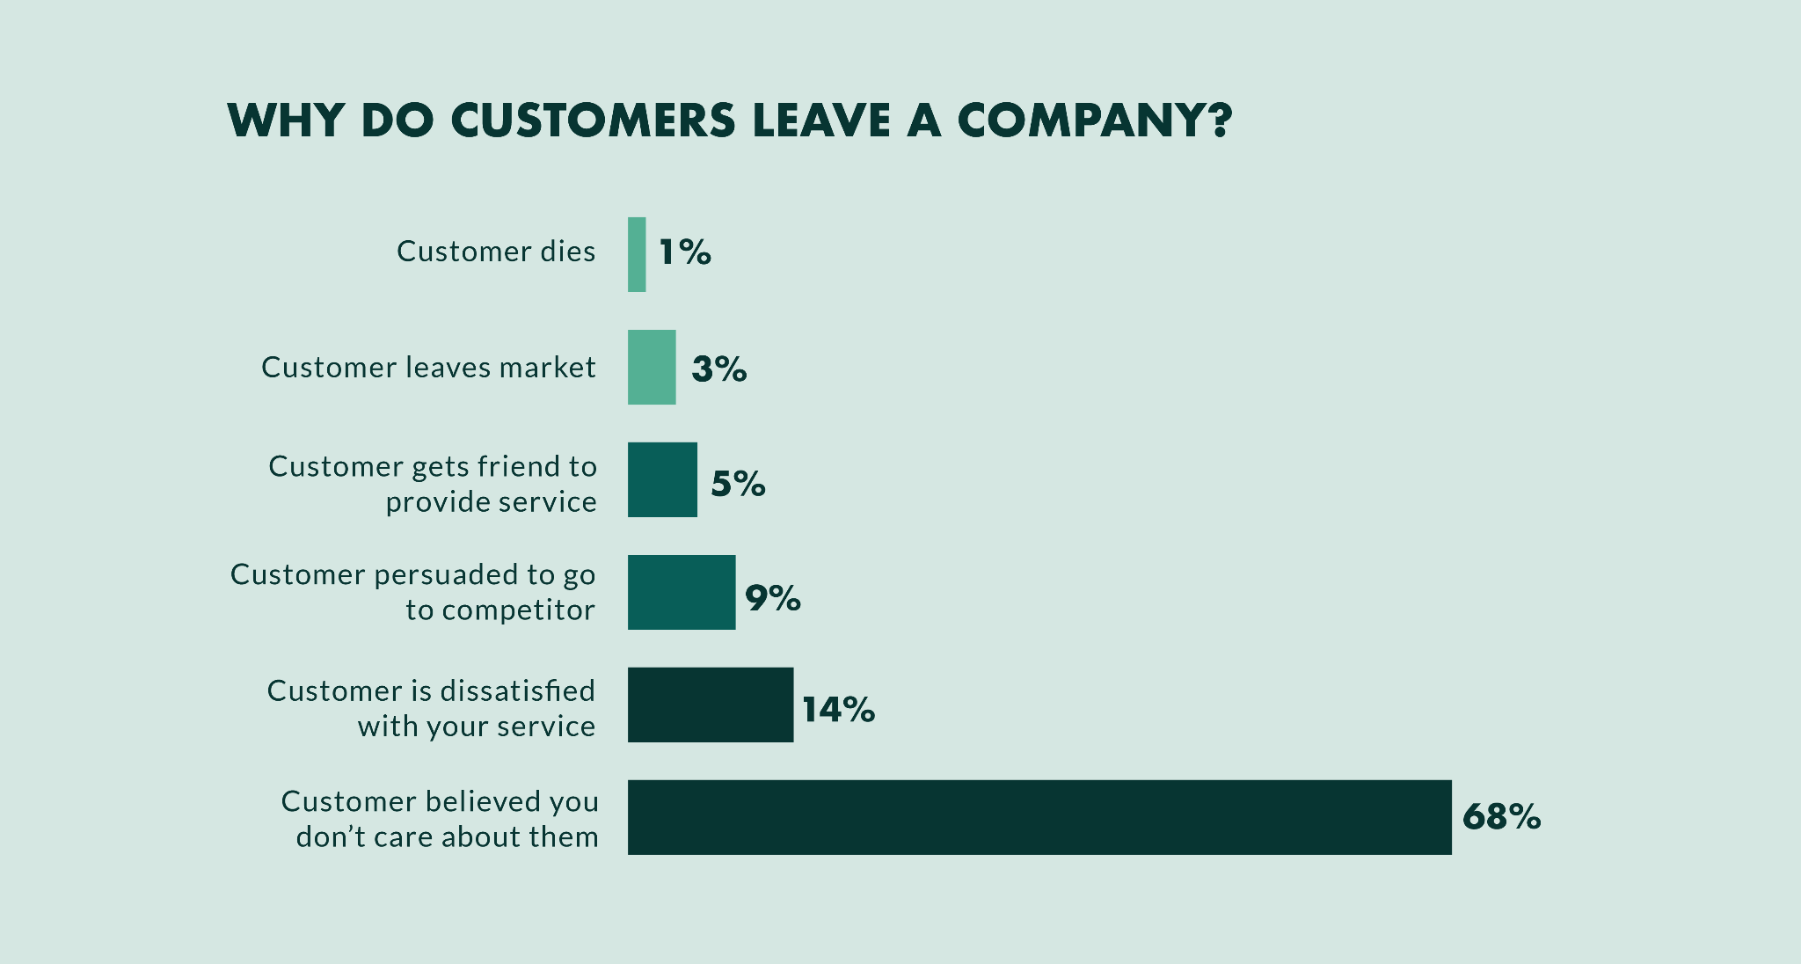
Figure: percentage of the time when customers leave a business
Source: (Hyken, 2022)
Analysis
Customer retention is an important factor for any business. Hotels generally have some regular customers who are responsible for their consistent profit generation. However, Ramee International Hotel has failed to retain its customers in their hotels. 68% of the time customers do not visit a place a second time when they think the hotel does not care about them. In this case, the poor front desk management, low-quality customer service, and lack of proper facilities, recreation, and food arrangements have made it clear to the customers that the hotel does not care about their guests' satisfaction (Hyken, 2022). Therefore, Ramee International Hotel has suffered low customer retention in its business due to the poor management of the hotel.
Issue 6 Low cash flow and innovation management
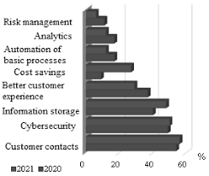
Figure: Different innovations in the hospitality sector
Source: (Berman, 2023)
Analysis
According to the above graphical representation, it has been found that innovation within the hospitality sector can ensure profit and smooth cash flow within the business. Risk management analytics, automation of business operations, cost savings through digital tools, cyber security, information storage, and personalised customer data can help the innovation process (Berman, 2023). However, Ramee International Hotel has failed to adopt these latest innovations within the hospitality sector which has led them to have poor cash flow within the business as well as low customer satisfaction.

PESTLE analysis
Political factors
Ramee International Hotel is situated in Dubai, UAE. The political conflicts about the ownership of lands can cause problems for the hotel. However, the individual government organisation of Dubai as a part of the UAE has ensured flexible management creating a smooth business environment for the business (Longart, 2020).
Economic factors
Dubai has a very strong GDP and low employment rate within the country indicating the economic stability of the business. The 3.3% inflation rate has increased the purchasing behavior of the people ensuring a better environment for tourists (Michael and Fotiadis, 2022). UAE along with Dubai has a high amount of foreign direct investment in their region creating a better business opportunity for the hotel.
Social factors
The hospitality sector of the country has faced a drastic change in its business operations and customer behavior. The rise of the digital environment has made customers more inclined to online facilities such as booking, searching, and transactions. However, customer preferences have included internet access, modern room facilities, and recreation activities (Mavridopoulou & O’Mahoney, 2020).
Technological factors
The population of Dubai is very tech-savvy and the advancement of different technologies such as AI, cloud computing, IoT, and others has affected the hospitality sector immensely. Ramee International Hotel has to implement new technological equipment in order to develop its business (Berman, 2023).
Legal factors
The hotel has to pay a corporate tax rate of 15% to their country to ensure better legal compliance. Ramee International Hotel also needs to follow the labour law of the UAE for regulatory compliance.

Environmental factors
The crystal clear beaches, modern facilities, and skyscrapers have attracted many tourists making it one of the most visited tourist places. As the concern about environmental pollution has risen, the government has focused on renewable energy sources. Therefore, Ramee International Hotel also has to incorporate these energy sources to comply with the government (de Grosbois and Fennell, 2022).

SWOT analysis
Strengths | Weaknesses
Strong global presence  Ramee International Hotel has a strong global presence that has increased through its brand expansion (Birch-Jensen et al., 2020).  Diverse workforce  The hotel has employed workers from all types of backgrounds to make a diverse workforce. | Lack of employee well-being  The hotel has not implemented employee empowerment and wellbeing strategies with their business affecting the hotel negatively.  Lack of financial stability  The low cash flow and lack of finance within the hotel are the result of poor management and infrastructure.
Opportunities | Threats
Brand visibility  The hotel has increased its brand visibility through its high global presence.  Inclusive work environment  The hotel is able to retain diverse talents boosting their productivity while gaining competitive advantage (Michael et al., 2023). | Lack of employee retention  The lack of employee well-being policies has restricted the hotel from retaining its employees (Dachner et al., 2021).  Poor hotel facilities and services  The company has been unable to offer advanced hotel facilities and policies to its customers due to poor financial stability.

TOWS analysis

 | Strengths | Weakness
Opportunities | Ramee International Hotel can leverage its strong global presence to mitigate the issue of low customer retention and talent management issues (Michael and Fotiadis, 2022). Further, the hotel can use its diverse workforce to train employees by cultivating individual talents to mitigate poor room service and improper front desk management issues. | The regulatory compliance and competition issues can be mitigated by improving the financial condition of the business. Therefore, the company can leverage finance from foreign investors to improve their financial condition.
Threats | The hotel can use its brand visibility and inclusive work environment to mitigate the issue of supply chain disruption issues and the low customer base can be improved through proper customer service and demolition of the hotel. | Implementing employee welfare policies and development strategies can help hotels improve their customer retention (Dimitrios et al., 2020). The improvement in financial condition can be helpful in incorporating advanced technology-equipped facilities and hotel management.

Recommendation and Change Management

Recommendations
1. Improving administration
Strategy for improvement
Ramee International Hotel has an effective presence in the hospitality industry however, the administrative functions of the organisation are not strong. The core strategy of the organisation will be to improve their administration of the hotel for better customer service and create a competitive edge in the modern competitive market. The organisation will efficiently centralise the Hotel management system by implementing cloud-based HMS to focus on strategic initiatives while empowering the management team. This process can help to reduce efficiency and reduce potential errors. Setting goals can help the administrative department to improve and thrive and keep records of customer information. They can create efficiency by improving communication while facilitating clear and consistent communication channels for better identification of issues and departments (Infante-Moro et al., 2021).
Change management strategy
Ramee International Hotel is required to maintain a proper change management process to implement the administrative change in the Hotel. Clear and consistent communication can be implemented by creating transparency among employees facilitating a multi-channel communication process. They need to provide their staff training on using these channels while taking continuous and daily feedback to understand the issues and difficulties faced by them. Holding Q&A sessions, creating suggestion boxes, or conducting surveys to address concerns. Ramee International Hotel can also efficiently create employee engagement and training opportunities for the employees to help them develop their understanding of new administrative functions. The Hotel can also ensure to consider a phased implementation plan to minimise the disruptions.
Measurement of success
Repeated visitors will be tracked by the organisation while understanding the gaps and areas of requirements. The measurable indicators can show how well an administrative assistant has contributed to an organisation’s goal achievement. The Hotel will assess the success of administrative processes and functions by guest feedback and employee engagement. Reduced process cycle time to complete key processes such as check-in and guest service requires optimisation will help the hotel to identify and measure success. Employee satisfaction surveys and reduced staff turnover and burnout rates ideally can showcase the effectiveness of the process (Meskhi et al., 2020). Tracking the percentage of staff members who complete training programs in new technologies, processes and procedures can also help to understand the improvement. Net Promoter Score can help Ramee International Hotel understand the effectiveness of its change management and strategy implementations.
2. Integrate technology to improve guest experience and room service
Strategy for improvement
Technology plays a vital role in shaping organisational operations and guest experiences in the modern ever-evolving industry of hospitality. This can determine the efficiency and fluency in guest management and providing unique and exclusive customer services. Ramee International Hotel can integrate more effective and automated technologies for improving tier guest services and creating guest satisfaction. Developing a user-friendly mobile application can allow the customers to book reservations directly, use digital keys for check-in and check-out, browse hotel amenities easily or communicate directly with the staff of the hotel directly acquire assistance. With the help of this process, customers can also access their personalised loyalty programs easily (Infante-Moro et al., 2021). On the other hand, in-room tablets and interactive voice assistance can also create fluency in operations. Integrated voice assistance can help customers with their needs while improving room service.
Change management strategy
Implementing technology and integrating automated services to improve customer experiences can be improved by clear and consistent communication. Providing an appropriate leadership approach to the employees to support them throughout the change is important. Technology can take the place of employees while reducing costs and creating technological dependency. However, the hotel can provide appropriate training and development opportunities to their workforce to help them cope with the technology change (Stylos et al., 2021). According to the Nudge theory, the organisation can work on influencing the learning behaviour of the employees. This theory can potentially help the employees to get guidance through time of guidance while building coping mechanisms. On the other hand, it is also important to inform the guests about new technologies through pre-arrival emails and website information to make them aware of new room services and enhanced efficiency (Stylos et al., 2021). While leveraging data-driven decisions the organisation will be expected to monitor the usage of the technology to find potential gaps and mitigate those.
Measurement of success
Ramee International Hotel is required to measure its improvement process while assessing its success accurately. Monitoring the effectiveness of the in-room tablet and digital technologies for customer service will help the hotel understand how guests are reacting to the changes. Guest feedback analysis and increased guest satisfaction will help the organisational authorities understand the effectiveness of the process and technological integration (López-Bernabé et al., 2021). Customer Churn rate and return to equity will help the organisation to identify the potential opportunities gained from the technological integration. However, Ramee International Hotel can also take feedback from its customers and employees to identify potential gaps for improvement.
3. Diversifying offering with a tailored customer approach
Strategy for improvement
Identifying areas within the hotel properties suitable for recreation facilities can be leveraged by the hotel. Amenities like a Pool, gyms, spas, or other activities in the luxury amenities department can help the organisation to improve their presence in the hospitality industry. The organisation can also play an effective role in showcasing its diverse servings on its online platforms and promotional campaigns to attract customers from different backgrounds and ethnicities (López-Bernabé et al., 2021). By moving beyond basic demographics like income, location, and age group the enterprise is required to identify potential values and preferences of the customers. Organisations’ investment in implementing data-driven decision-making and understanding customer browsing history through data analysis and machine learning can help the organisation to efficiently diversify its approaches. The Hotel can also create feature variations and customised options for their customers while integrating Tiered pricing models (Farías and Cancino, 2021).
Change management strategy
The organisation can implement executive sponsorship while gaining buy-in from senior leadership to champion the customer-centric approach and diversify strategy. This kind of support can empower the employees while helping them to effectively facilitate the resource allocation process. Customer service representatives can map out the customer journey for each customer segment while identifying touch points, pinpoints and opportunities for improvements. With the help of the ADKAR theory of change management, the organisation can efficiently manage the change at the individual level while ensuring awareness and knowledge among every organisational employee. The model can help the employees to learn more about different ethnicities and backgrounds to serve according to the customer needs (Melián-Alzola et al., 2020).
Measurement of success
Several factors like revenue growth, profit margins, market share and customer feedback can effectively help the Hotel to understand the efficiency of their efforts. Customer Satisfaction rate, increased profit margins and long-term viability of the organisational operations can help the business to potentially access the efficiency of their efforts in attracting a wide range of customers. Customer service representatives of Ramee International Hotel can take continuous feedback to develop an understanding of their satisfaction and areas of improvement. By tracking the cost of acquiring new customers within each segment while aiming for decreased customer acquisition costs they can make their targeted market efforts more valuable (Meskhi et al., 2020).
4. Ethics reinforcements
Strategy for improvement
Ramee International Hotel needs to develop its ethics and values in a strong pattern to avoid legal and social conflicts. Emphasising professionalism integrity and transparency among the hotel organisation needs to create a coal of ethics that outlines organisations, core values and principles. This can help the authority maintain their staff's honesty, professionalism, and confidentiality of their sensitive data (Demir et al., 2021). However, the organisation needs to create and conduct risk assessments to identify potential ethical challenges in their enterprise and company culture. The organisation has proof of encompassing some data security and guest tracking issues. The hotel should create clear and consistent policies for gas tracking and information saving while ensuring only leveraging the data for explicit guest consent and legitimate purposes (Melián-Alzola et al., 2020).
Change management strategy
Analysing a proper risk assessment process can help the organisation understand the specific challenges in the hotel culture and their reactions. By launching the code of ethics and principles the organisation needs to support the employees at all levels. By tailoring the training to address the identified ethical challenges and equip staff with the skills to recognise and handle ethical dilemmas. Employee recognition programs can be also efficient for the business to improve organisational efficiency (Dhirasasna et al., 2020). Lewin's Change Theory can help the business to use three steps of unfreezing, changing and refreezing to implement a new code of ethics. The changing stage and maintaining proper strategy can allow the business to collaborate while stabilising the company’s environment. Ramee International Hotel can provide rewards and public recognition to their employees who have contributed to organisational goals achievement while maintaining ethics and company values. This can help to reinforce the importance of ethical conduct and promote a sense of value among the employees motivating them to uphold these principles (Paul, 2020).
Measurement of success
Implementing several ethical violation codes can aim to decrease the number of unethical conducts over time. Employee surveys on ethical culture help to gauge their perception of the Hotel’s ethical climate. Guest satisfaction surveys and several customer complaints can create an understanding of the organisation’s ethical approach and their employee's integrity in the workplace. KPIs like customer satisfaction rate and Net promoter rate can accurately identify potential growth. While KPIs give quantitative data, qualitative feedback through open-ended questions in surveys can help to identify the success rate by the organisation of their codes and ethics (Raji et al., 2024).

Benefits of implementing recommended strategies
Through the help of the strategies and implementation of an agent change efficiently, the organisation is expected to gain several benefits and a competitive edge. The key benefits acquired from the change management and recommended strategy have been listed below.
Costs management: Ramee International Hotel has faced potential issues related to cost efficiency in their past operations which can be managed by technological integration and improving administrative works. Popper task management, planning, allocating resources, and inventory management can get faster and more cost-effective for the organisation (Boselie et al., 2021). Incorporating technological implementation can also reduce time and create systematic balanced operations within the organisation. This can also reduce unnecessary work while fostering organisational creative activity (Desai et al., 2020).
Market reach and expansion: Achieving excellence in brand reputation while acquiring brand awareness in a global market context can help the organisation achieve efficiency. Ramee International Hotel’s effectiveness in diversifying its services and customised features can help it target a broader range of customers. This can create a high scope of expanding the hotel within the new country can be achieved through the incorporation of the addressed strategies. With the help of effective ethical and principles values the enterprise can improve its reputation in diverse market contexts (Enriquez et al., 2023).
Positive review and brand awareness: The recommendation strategy and initiatives have effectively aimed to improve the customer satisfaction rate of Ramee International Hotel. By building customised and tailored approaches and integrating technologies like digital check-in and check-out Ramee International Hotel can improve their customer services (Glasgow et al., 2020). User-friendly administrative systems, technology-based quick response and automotive room services can improve the guest experience during their stay. This can create options for the business to achieve customer retention and repetition of visits with positive feedback on their online sites gaining brand awareness and popularity (Stiel et al., 2021).

Costs associated with the recommendations
According to the recommendation delivered to the Ramee International Hotel, approximately 100000 pounds will be required. For implementing effective change management while supporting the employees through leadership and learning development opportunity the organisation will require to invest. On the other hand, technology integration can be costly for organisations implementing AI, AR, machine learning or digital analysis can be more expensive than traditional administrative processes (Soeng et al., 2022). Expenses budgeted for the rewards and recognition programs for the employees for promoting value and principles are also required to be added. The net worth of the company’s owner is 1 billion US dollars in the area 2022. However, these expenses can be bearable by the company which can contribute to the company's growth and better performance with increased profitability of the enterprise (Ridei et al., 2021).

Action plan
Number | Name of the Issues | Effective Solutions | Outcomes | Required Time scale | Completion Date | Probable Budget
1. | Lack of proper management and infrastructure | Integration of technology will help Ramee International Hotel of Dubai to improve its management process. Customer relationship management software will be incorporated by the hotel to improve the quality of their services (Mathews, 2021). | A smooth operations system will be developed and technology can help improve the customer satisfaction level of the business | 7 months | 8th January, 2025 | £55000
2. | Poor customer service | Proper talent management processes and training and development opportunities will be implanted by Ramee International Hotel of Dubai. This will help the business to retain talented employees and train the staff with proper skills and knowledge leading to impeded customer service. Further, the demolition of hotel construction while making industrial cleaning will also help in mitigating this issue (Mariani and Borghi, 2021). | Adopting these strategies will help the Ramee International Hotel of Dubai to enhance their customer service leading to high customer retention and better reputation. The new infrastructure of the hotel will help the business to attract more customers and remove its negative reputation from the market (O'Mahoney, 2021). | 6 months | 10th December, 2025 | £45000
3 | Supply chain disruption leading to low-quality food | The Ramee International Hotel of Dubai will diversify its suppliers in order to get quality vegetables, meats, and dairy products on time. Along with that, AI-powered data analytics will be incorporated by the hotel for operational efficiency of the supply chain and cost savings. Further, inventory management can help the business to ensure better supply chain management (Buttrick, 2009). | Proper management of the supply chain will ensure a regular supply of food materials which will lead to high-quality foods. Further, the adoption of these strategies will help the business in cost control which can be used in business development. | 9 months | 8th March, 2025 | £30000

Conclusion
Business consultants play a pivotal role in pulling up the downturn scenario of any business and showing a strategic pathway to experience resilience. Thereafter critical research of the target market and other influencing factors needs to be analysed in depth to address the core issues impacting the business performance. Theoretical as well as logical market data finding helps the consultant to deliver proper recommendations and achieve strategic change management within the organisation. Thereafter a report has been framed by AZ Business Consultant for their client Ramee International Hotel at Deira. The identified hotel is a part of Ramee International Hotel Group which possesses 42 properties within the global platforms. India, Bahrain, and UAE are the prime locations where the organisation has operated its business expansion strategy. The property located at Deira has been focused on developing reports and addressing the key issues faced by the hotel. Analysis of the market review and customer reflection within varied social media platforms has identified that the core issue of management and accommodation maintenance is a major issue for the hotel. Room service and the executive's behaviour are not friendly and professional it has failed to achieve customer satisfaction. Front desk management and controlling rules and regulations within the hotel premises are very low which has disturbed the staying compactness of the guest. Excessive noise, low-maintained rooms, and bad food quality are the major issues customers have reported. Ethical practices are quite upset which has resulted in a major fall down of brand reputation within the competitive market. Identified issues have impacted the revenue margin fall and losses have been incurred by the hotel. The customer retention rate has also been negatively impacted due to the addressed issues. Lack of leadership and low empowerment of the employees created dissatisfaction within the workforce that has created a shortage of skilled workforce retention within the organisation. Lack of revenue has also restricted cash flow and therefore innovation implementation has become a challenging factor for the organisation. PESTLE analysis has been performed that has shown a 15% increase in corporate taxation has crippled the profit margin for Ramee International Hotel, Deira. The 3.3 % inflation rate has also been one of the key reasons for to rise in the cost of production that has influenced the organisational performance of Ramee International Hotel. SWOT analysis has presented a diverse workforce and a strong presence within the global market has been the core strength of the organisation. Low employee well-being and lack of financial stability have been addressed as weaknesses of the company. Based on the analysis, change management, and recommendations have been suggested to Ramee International Hotel, Deira. Improving administration, technological integration for better room service, diversified offerings with a customer-centric approach, and ethical reinforcement have been suggested. The strategy for improvement and change management for each recommendation has been discussed in depth. An action plan has been presented in a tabular manner and has identified the key activities like staff training and empowerment, technological integration, Customer relationship management, and betterment of accommodation within a specified period. The amount of budget for each task required has been mentioned within the action plan. The report has presented an in-depth analysis of Ramee International Hotel, Deira, and suggested adequate recommendations for future development.

References
Arapou, D. and Kapiki, S., (2023). Enhancing the Guest Experience in Hospitality Through Technology: An Outlook of the Future.
Baron, A. and Armstrong, M. (2007) Human Capital Management. London: Kogan Page.
bbc, (2024). How digitalisation is revolutionising the travel industry. [Online] Available at: https://www.bbc.com/storyworks/travel/the-new-tourism-trend/technology-redefine-tourism-industry[Accessed 07 May 2023].
Berman, D., (2023). Revolutionizing The Hospitality Industry With Artificial Intelligence. [Online] Available at: https://www.forbes.com/sites/forbesbusinesscouncil/2023/09/11/revolutionizing-the-hospitality-industry-with-artificial-intelligence/?sh=d38070b23d16[Accessed 08 May 2024].
Birch-Jensen, A., Gremyr, I. and Halldorsson, A., (2020). Digitally connected services: Improvements through customer-initiated feedback. European Management Journal, 38(5), pp.814-825.
Boselie, P., Van Harten, J. and Veld, M., (2021). A human resource management review on public management and public administration research: stop right there… before we go any further…. Public Management Review, 23(4), pp.483-500.
Brierley, E. (2006) Talent on tap: getting the best from freelancers, interims and consultants. London: Chartered Institute of Personnel and Development.
Burnes, B. (2014) 4th Edition, Managing Change, Great Britain, Prentice Hall.
Buttrick, R. (2009) The Project Workout, London: Prentice Hall
Dachner, A.M., Ellingson, J.E., Noe, R.A. and Saxton, B.M., (2021). The future of employee development. Human Resource Management Review, 31(2), p.100732.
de Grosbois, D. and Fennell, D.A., (2022). Determinants of climate change disclosure practices of global hotel companies: Application of institutional and stakeholder theories. Tourism Management, 88, p.104404.
Demir, M., Demir, Ş.Ş., Dalgıç, A. and Ergen, F.D., (2021). Impact of COVID-19 pandemic on the tourism industry: An evaluation from the hotel managers' perspective. Journal of Tourism Theory and Research, 7(1), pp.44-57.
Desai, R.J., Wang, S.V., Vaduganathan, M., Evers, T. and Schneeweiss, S., (2020). Comparison of machine learning methods with traditional models for use of administrative claims with electronic medical records to predict heart failure outcomes. JAMA Network Open, 3(1), pp.e1918962-e1918962.
Dhirasasna, N., Becken, S. and Sahin, O., (2020). A systems approach to examining the drivers and barriers of renewable energy technology adoption in the hotel sector in Queensland, Australia. Journal of Hospitality and Tourism Management, 42, pp.153-172.
Dimitrios, B., Christos, P., Ioannis, R. and Vasiliadis, L., (2020). Strategic management in the hotel industry: proposed strategic practices to recover from COVID-19 global crisis. Academic Journal of Interdisciplinary Studies, 9(6), pp.130-130.
Enriquez, J.D.B., Mite, L.A.B., Morocho, A.M.A. and Lopez, M.I.V., (2023). Improvement and Control of the Customer Service System, through a simulation of the Waiting Line model: case study in a telecommunications company.
Farías, A. and Cancino, C.A., (2021). Digital transformation in the Chilean lodging sector: Opportunities for sustainable businesses. Sustainability, 13(14), p.8097.
forbes, (2022). Nine Reasons Why HR Leaders Lean On Total Talent Management Sources. [Online] Available at: https://www.forbes.com/sites/forbeshumanresourcescouncil/2022/07/27/nine-reasons-why-hr-leaders-lean-on-total-talent-management-sources/?sh=5844cec36d55[Accessed 08 May 2024].
Glasgow, R.E., Battaglia, C., McCreight, M., Ayele, R.A. and Rabin, B.A., (2020). Making implementation science more rapid: use of the RE-AIM framework for mid-course adaptations across five health services research projects in the veterans health administration. Frontiers in Public Health, 8, p.194.
Hyken, S., (2022). The Top Five Reasons Customers Don’t Come Back. [Online] Available at: https://www.forbes.com/sites/shephyken/2022/06/26/the-top-five-reasons-customers-dont-come-back/?sh=3d15d3bf6c3e[Accessed 08 May 2024].
Infante-Moro, A., Infante-Moro, J.C. and Gallardo-Pérez, J., (2021). Key Factors in the Implementation of the Internet of Things in the Hotel Sector. Applied Sciences, 11(7), p.2924.
Kipping, and Clark, T. (2012). The Oxford handbook of management consulting. Oxford University Press.
Kotter, J (2012). Leading change. Harvard Business Review Press.
Longart, P., (2020). Understanding hotel maintenance management. Journal of Quality Assurance in Hospitality & Tourism, 21(3), pp.267-296.
López-Bernabé, E., Foudi, S., Linares, P. and Galarraga, I., (2021). Factors affecting energy-efficiency investment in the hotel industry: Survey results from Spain. Energy Efficiency, 14(4), p.41.
Mariani, M. and Borghi, M., (2021). Customers’ evaluation of mechanical artificial intelligence in hospitality services: a study using online reviews analytics. International Journal of Contemporary Hospitality Management, 33(11), pp.3956-3976.
Mathews, D., (2021). Techno-business strategies for enhancing guest experience in luxury hotels: a managerial perspective. Worldwide Hospitality and Tourism Themes, 13(2), pp.168-185
Mavridopoulou, & O’Mahoney, J. (2020). Elitism in Strategy Consulting: How Institutional Prestige Influences Recruitment. Management Consulting Journal, 3(1), 12–22.
Melián-Alzola, L., Fernández-Monroy, M. and Hidalgo-Peñate, M., (2020). Information technology capability and organisational agility: A study in the Canary Islands hotel industry. Tourism Management Perspectives, 33, p.100606.
Melián-Alzola, L., Fernández-Monroy, M. and Hidalgo-Peñate, M., (2020). Hotels in contexts of uncertainty: Measuring organisational resilience. Tourism management perspectives, 36, p.100747.
Meskhi, B., Bondarenko, V., Efremenko, I., Larionov, V., Rudoy, D. and Olshevskaya, A., (2020), December. Technical, technological and managerial solutions in ensuring environmental safety. In IOP conference series: Materials science and engineering (Vol. 1001, No. 1, p. 012100). IOP Publishing.
Michael, N. and Fotiadis, A.K., (2022). Employee turnover: The hotel industry perspective. Journal of Tourism, Heritage & Services Marketing (JTHSM), 8(1), pp.38-47.
Michael, N., Michael, I. and Fotiadis, A.K., (2023). The role of human resources practices and branding in the hotel industry in Dubai. Journal of Human Resources in Hospitality & Tourism, 22(1), pp.1-25.
Newton, R. (2010). The management consultant: mastering the art of consultancy. Financial Times.
Nilsson, F., (2023). Ethics In An Age Of Privacy And Regulation. [Online] Available at: https://www.forbes.com/sites/forbestechcouncil/2023/11/29/ethics-in-an-age-of-privacy-and-regulation/?sh=259157137b3b[Accessed 07 May 2024].
Noordzife, G. (2014) Project Management of Hotel Opening Processes: Exploring Better Ways to Manage New Hotel Openings, CreateSpace.
O’Mahoney, J. (2021). How Small Consultancies Grow: Challenging Problem-Based Theorising. Management Consulting Journal, 4(1), 5–20
Paul, J., (2020). Marketing in emerging markets: A review, theoretical synthesis and extension. International Journal of Emerging Markets, 15(3), pp.446-468.
Raji, M.A., Olodo, H.B., Oke, T.T., Addy, W.A., Ofodile, O.C. and Oyewole, A.T., (2024). Business strategies in virtual reality: a review of market opportunities and consumer experience. International Journal of Management & Entrepreneurship Research, 6(3), pp.722-736.
Ridei, N.M., Tytova, N.M., Diegtiar, O.A., Pavlenko, D.H. and Slabetskyi, O.M., (2021). Administrative Management of Improvement Processes of Socio-Cultural Forms Based on Principles of Sustainable Development of Education. Journal of Higher Education Theory and Practice, 21(14).
Rmeehotels, (2024). Ramee Group Of Hotels, [Online] Available at: https://rameehotels.com/about-us/ [Accessed 5 5 2024].
Soeng, S., Bae, J.H., Lee, K.H. and Cho, W.S., (2022). Deep Learning-Based Improvement in Overseas Manufacturer Address Quality Using Administrative District Data. Applied Sciences, 12(21), p.11129.
statista, (2023). Number of hotels and hotel apartment buildings in the Emirate of Dubai in 2022. [Online] Available at: https://www.statista.com/statistics/982329/uae-number-of-hotels-and-hotel-apartments/[Accessed 07 May 2024].
Stiel, S., van Baal, K., Ülgüt, R., Stahmeyer, J.T. and Schneider, N., (2021). Analysing the administration of an intermediate level of outpatient palliative care in Germany and developing recommendations for improvement (Polite): A study protocol for a mixed-methods study. Plos one, 16(9), p.e0256467.
Stylos, N., Fotiadis, A.K., Shin, D.D. and Huan, T.C.T., (2021). Beyond smart systems adoption: Enabling diffusion and assimilation of smartness in hospitality. International Journal of Hospitality Management, 98, p.103042.
Subramaniam, Collier, P., Phang, M., & Burke, G. (2011). The effects of perceived business uncertainty, external consultants, and risk management on organisational outcomes. Journal of Accounting & Organizational Change, 7(2), 132–157.
Tofler, (2024). RAMEE HOTELS PRIVATE LIMITED. [Online] Available at: https://www.tofler.in/ramee-hotels-private-limited/company/U55101MH1998PTC115198 [Accessed 5 5 2024].
Tripadvisor, (2024). Ramee International Hotel Dubai. [Online] Available at: https://www.tripadvisor.in/Hotel_Review-g295424-d301536-Reviews-Ramee_International_Hotel_Dubai-Dubai_Emirate_of_Dubai.html [Accessed 5 5 2024].
Whittington, R. et al (2020) Exploring Strategy. Harlow: Pearson Education Limited.
Zoominfo, (2024). Ramee Guestline Hotel Employee Directory. [Online] Available at: https://www.zoominfo.com/pic/ramee-guestline-hotel/353863903 [Accessed 5 5 2024].

