

Integrated Human Capital Blueprint
(Individual Report – HR Strategy)

Programme: Master of Business Administration (MBA)
Module Name: Human Capital Management
Module Code: LCMB7023
Assignment Title: Assessment Component 1 – Individual Report

Student Name: Harsh Suthar
Student ID: 2520299

Lecturer Name: Dr.Lakshani Mendis

Word Count: 2,744 Words
Submission Date: 20th March 2026

Table of Contents
INTRODUCTION 3
PART 1 – HR STRATEGY 4
1.1 Overview of Current HR Practices in Tech Companies 4
1.2 Proposed HR Strategy for Aether Innovations 5
1.3 Modern Performance Management System 6
1.4 Job Analysis and Job Design 7
1.4.1 Job Analysis 7
1.4.2 Job Design – Job Characteristics Model 7
1.5 Job Descriptions and Specifications for Key Positions 8
PART 2 – REFLECTION 9
2. Reflection on Learning (Gibbs Reflective Cycle) 9
2.1 Description 10
2.2 Feelings 10
2.3 Evaluation 10
2.4 Analysis 11
2.5 Conclusion 11
2.6 Action Plan 11
3. Staying Relevant in the AI Era 12
CONCLUSION 12
REFERENCES 14

INTRODUCTION
The Human Capital Management (HCM) is vital in balancing people, organisational capabilities, and strategic goals to improve organisational performance (Hoichuk and Lyubomudrova, 2024). Effective human resource policies in contemporary organisations, especially those operating in the technology industry, are critical in the promotion of innovation, enhanced employee participation, and maintenance of a competitive edge. Performance management, good job design, and talent development are some of the strategic HR practices that can enable organisations to develop a productive workforce that can react to the fast-changing business environments.
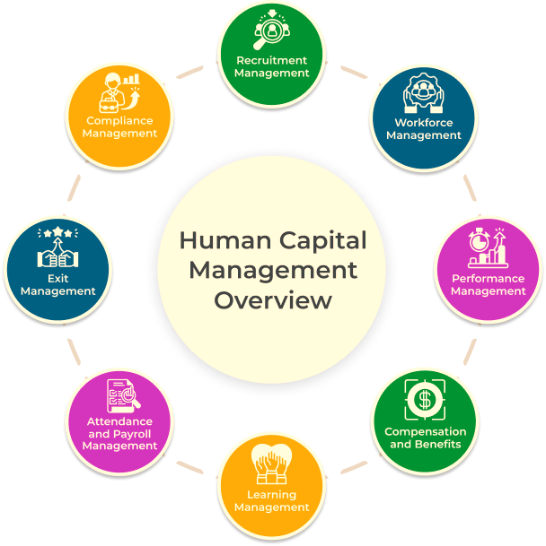
Aether Innovations is a growing technology company that employs around 300 people and is experiencing a number of organisational issues, such as flat business development, the high turnover rate of its employees, and decreasing customer satisfaction. These problems are signs of inconsistency between the organisational strategy and the human capital practices. With the growth of organisations, the failure of the performance systems and improper setup of the job positions may negatively impact the motivation, productivity and innovation of the employees.
To overcome these issues, this report will use Option 1: Re-Engineering Performance and Job Design. The report is a critical analysis of the existing performance appraisal methods and job design methods that are widely applied in technology companies. It then suggests a performance management system in the modern era, which also incorporates the Objectives and Key Results (OKRs) and 360-degree feedback to provide improved employee performance and organisational effectiveness. Moreover, the report also gives better job analysis, job description, and job specifications of key leadership positions, and how consolidated HR systems can produce a performance-driven and innovation-oriented organisational culture.

PART 1 – HR STRATEGY

1.1 Overview of Current HR Practices in Tech Companies
The practices of Human Resource Management in technology firms have undergone significant changes in regard to the rapid change of innovation, intense competition, and balancing highly talented employees. Valentinovna (2024) asserts that strategic human resource management (SHRM) methods are becoming more common in modern tech organisations, and the organisation needs to ensure that people management practices align with organisational objectives, especially innovation, productivity, and customer value creation.
Jarsh (2025) stated that the adoption of continuous performance management systems instead of the traditional annual performance appraisal has been one of the most important developments in the technology sector. Regular feedback systems, goal-oriented performance systems and data-driven assessments are some of the common methods employed by numerous technology companies to promote employee development and corporate performance. Real-time feedback, agile performance review, and a goal alignment system are the methods that help employees know expectations and enhance their productivity. These systems promote accountability, transparency, and betterment in teams.
Along with performance management, job design practices in technology companies are oriented towards flexibility, autonomy, and collaboration. The innovative technology companies often tend towards the agile organisation, cross-functional groups, and models of work organised around the project that enable the employees to exercise various skills and make their own contribution to the problem-solving process (Appoh et al., 2022). The High-Performance Work Systems (HPWS) framework tends to support these practices and incorporates the involvement of staff, improvement of skills, and rewards based on performance to improve organisational performance.
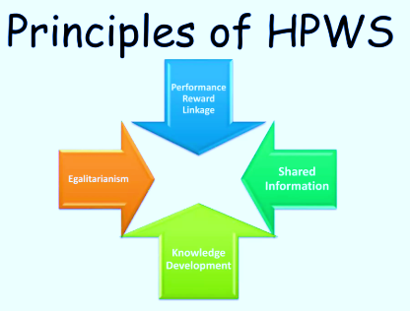
Despite these progressive HR practices, there are also many challenges that technology companies face. The issues that are typical of the demanding workloads and rapid changes in technology include high employee turnover, burnout, and a high level of performance pressure. The lack of engagement of employees and low level of innovation may occur because of poorly designed systems of performance or poorly defined job descriptions.

1.2 Proposed HR Strategy for Aether Innovations
To address the challenges of flat growth, high employee turnover, and declining customer satisfaction in Aether Innovations, a strategic and integrated Human Resource (HR) approach is inevitable. The HR strategy suggested is based on the alignment of people management practices to the business goals of the organisation, specifically, innovation, engagement of the employees, and enhancement of their performance. Human capital is one of the competitive advantages in technology-driven organisations, and therefore developing HR practices that serve both the organisational objectives and the employees is important.
As suggested by Gonzalez-Benito et al. (2022), an alignment of HR strategy with business strategy is also a significant component of the suggested strategy that can be discussed in the light of the Strategic HR Alignment Model. This will make sure that HR policies like performance management, job design, training and talent development will be directly aligned with organisational priorities like innovation, product development and customer satisfaction. By ensuring the HR activities are aligned with the growth targets of the company, Aether Innovations can develop a pool of employees who will help the company to boost its performance.
The AMO Theory (Ability, Motivation, Opportunity) is also considered in the proposed strategy to boost the performance of the employees (Bos-Nehles et al., 2023). This model indicates that the performance of organisations is enhanced when employees have the required skills, are well motivated and given chances to participate. As a way of enhancing capacity, the organisation is advised to invest in recurrent training, leadership and skill-building programmes. Modern performance management systems, recognition programmes and equitable reward systems could help in motivating.

1.3 Modern Performance Management System
To address performance challenges at Aether Innovations, performance management system that is modern and continuous is suggested to substitute the traditional annual methods of appraisal. The conventional systems have been seen to experience criticism due to being not so frequent, looking back, and being too concerned with evaluation, instead of developing the employees (Mabrok, 2026). This may result in a lack of motivation, minimal expectations and decreased innovation. Thus, it needs a more dynamic and people-oriented approach.
One of the major aspects of the proposed system will be the use of Objectives and Key Results (OKRs) (Sultan, 2022). OKRs help organisations to establish specific and quantifiable objectives in line with the overall business objectives. This promotes transparency, accountability and strategic focus at all organisational levels. The employees have a clear understanding of the contribution that they make to organisational success, and this enhances the engagement and performance of the employees. This strategy is justified by Goal Setting Theory (Locke and Latham), which emphasises that the goals should be specific and challenging in order to make the performance high.
The system also includes 360-degree feedback, where the employees are given feedback by the managers, other employees, and their subordinates (Souki, Aad and Karkoulian, 2025). This provides a holistic view of employee performance and helps in the development of leadership, teamwork, and inner self-understanding. It also minimises bias when it comes to conventional top-down assessment and promotes a culture of transparency and constant enhancement.
Follow-up performance reviews will be carried out quarterly or monthly to ensure that the performance is continuously monitored and developed (Idrus, 2025). In contrast to annual reviews, continuous reviews are oriented on coaching, development of skills and solving current problems. This is in line with the Performance Management Theory that emphasises constant monitoring and enhancement of employee performance.

1.4 Job Analysis and Job Design
At Aether Innovations, job analysis and job design can be effective in enhancing the performance, motivation, and efficiency of employees in an organisation. Within a dynamic technology environment, well-defined roles, flexible and enriched job structures would be of great benefit to innovation and productivity.

1.4.1 Job Analysis
Job analysis is a method that entails systematically collecting and evaluating information on a job to comprehend its major aspects (Ahmad and Alqaarni, 2023). Some of the methods that HR should use to carry out job analysis in the Aether Innovations are interviews, observations, and questionnaires, which are the methods of identifying tasks, responsibilities, and the skills required to perform each job. This involves setting out daily activities, decision-making, technical skills, and interpersonal skills to be good performers.

1.4.2 Job Design – Job Characteristics Model
Aether Innovations ought to use the Job Characteristics Model to improve motivation and performance (Hackman and Oldham). The model is concerned with creating meaningful and engaging jobs with regard to five dimensions.
- Skill Variety: Workers are supposed to apply various skills, where creativity and innovation are promoted (Green, 2020).
- Task Identity: The employees are expected to accomplish recognisable portions of work, which will enhance ownership and satisfaction.
- Task Significance: Employees are committed to their job when they have an idea of the significance of their work.
- Autonomy: A sense of responsibility is enhanced by giving them autonomy in decision-making, and innovation is also enhanced (Van Essen, 2025).
- Feedback: Ongoing feedback makes the employees know their performance and make improvement.
Through a combination of these factors, job design has the potential to enhance employee motivation, job satisfaction and innovation. When the employees derive meaning in their work and when they can exercise control over the way they carry out their duties, then they are highly involved. Job analysis and enhanced job design should assist Aether Innovations to design a more productive, innovative and committed workforce.

1.5 Job Descriptions and Specifications for Key Positions
CEO (Chief Executive Officer)
- Focused on the overall strategy, organisational development, and leadership of innovation.
- Specification: Good leadership, strategic approach, decision-making and wide experience in the industry.
CFO (Chief Financial Officer)
- Manages financial planning, budgeting and risk management to maintain financial stability.
- Specification: Knowledge of financial analysis, accounting, risk management, and good analytical skills.
CTO (Chief Technology Officer)
- Drives technological change, digital change, and product innovation.
- Specification: forerunner ability and expertise in the new technologies and creative ability.
CIO (Chief Innovation Officer)
- Pushes innovation plans, research and development of new products.
- Specification: Strategic vision, creative thinking, and good problem-solving.
HR Director
- Handles human resource strategy, talent management, employee engagement, and organisational culture.
- Specification: Good interpersonal skills, leadership quality and familiarity with HRM practices and employment legislations.
Head of R&D (Research and Development)
- Directs research, product development and technology.
- Specification: Expertise, innovation skills, project management and cross-functional leadership.

PART 2 – REFLECTION

2. Reflection on Learning (Gibbs Reflective Cycle)
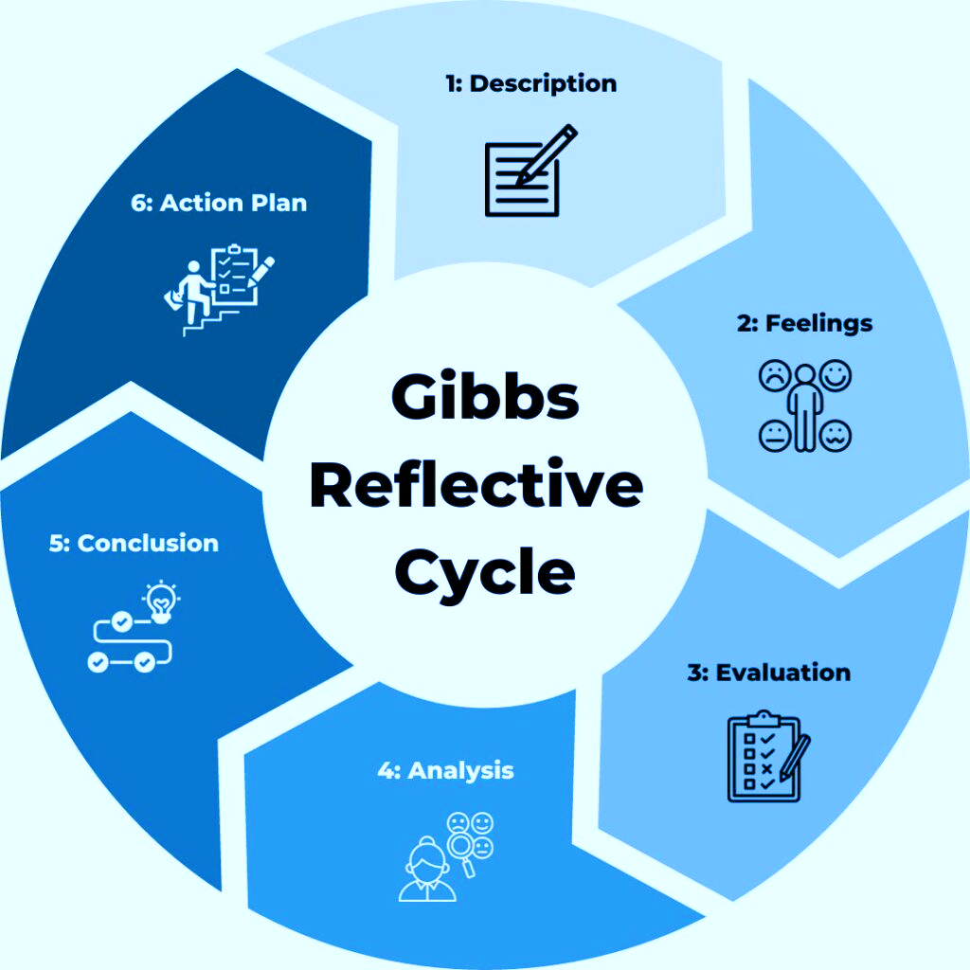

2.1 Description
My Human Capital Management program gave me a better understanding of the importance of strategic HR practices to the long-term performance and success of an organisation. I learned such concepts as talent management, job design, performance management systems, strategic HRM, and employee engagement (Markkanen et al., 2020). The major models that I got to know during this lesson are the AMO theory, Job Characteristics Model, and the latest methods of performance, including OKRs and 360-degree feedback. I explored the connection between human capital strategies and the business objectives of the organisation in an attempt to enhance productivity and innovativeness by using case studies, discussions, and lectures. I got acquainted with practical organisational problems like these. I was exposed to real-life organisational problems such as high employee turnover, low engagement, and unproductive performance systems.

2.2 Feelings
First, I struggled to understand the concepts of human capital management, especially the interdependence of the different HR practices (Adeani et al., 2020). The concepts and models were a little disorienting to me, particularly in terms of their application in real organisational contexts. With the progression of the module, I managed to gain confidence. I realised that HR practices have a significant influence on the performance of employees and the success of an organisation. I was increasingly getting interested in the subject, especially as the theory was applied to real-life situations. By the end of the program, I was far more at ease analysing HR-related problems and providing solutions.

2.3 Evaluation
One of the most useful aspects of the module was the practical implementation of the theory into the real business situation. I was also able to realise that the HR practices are not used in the same way that they should be used in theory, through the use of case studies. The concepts of job design and performance management systems have particularly come in handy as they have illustrated how companies can increase employee motivation and productivity (Awan et al., 2020). Nonetheless, other points were difficult, including the inability to be critical of different HR models as opposed to simply informing them. This module was fairly good in strategic HR thinking. The training experience was, on the whole, positive as it has enabled me to develop my theoretical background and more practical knowledge in HRM.

2.4 Analysis
In learning, I realised that the practices of HR play a crucial role in determining organisational performance. An appropriate performance management programme comprising ongoing feedback and goal congruence may play a significant role in productivity and involvement of employees. Similarly, good jobs with autonomy, skill variety and feedback can enhance motivation and innovativeness (Parker and Grote, 2022). I also understood that HR practices are highly related to the leadership and organisational culture. To give an example, a leadership style as supportive can assist the employees in evolving and collaborating, but the presence of a negative culture can lead to dissatisfaction and turnover. My experience in life, such as my sales internship, confirmed that employee motivation was normally low in the absence of an organised performance feedback system.

2.5 Conclusion
The module has tremendously helped increase my exposure to Human Capital Management and the relevance of the same. I was exposed to the functions of integrated HR practices such as performance management, job design and talent development in organisational success. I was also able to develop my critical thinking skills, which allowed me to analyse the issues of HR and propose solutions that may be effective. Another capacity that the module has equipped me with is an effective ability to connect theory to practice that is crucial in my prospective career.

2.6 Action Plan
To gain further knowledge and skills in the area of HRM, I will carry out the external learning process by enrolling in a few professional development courses and qualifications in Human Resource Management. I will also be informed of the most recent HR tendencies, particularly in the following areas: digital HR and AI in the workplace. I will also endeavour to advance my leadership and communication skills using group projects and professional workshops. I will also be able to apply the theoretical knowledge in practice with the assistance of internships or part-time employment. This continued development will enable me to grow into a good HR professional in future.

3. Staying Relevant in the AI Era
The rapid development of Artificial Intelligence (AI) is transforming the modern working environment, particularly in Human Resource Management. AI is slowly taking over routine HR tasks such as screening resumes, scheduling interviews and processing data regarding the employees (Sundari et al., 2024). Recruitment analytics can be supported by an AI-based application to identify the appropriate candidate and establish what the employees do. Predictive Hr analytics also aids the companies to forecast the turnover of the employees, employee engagement and workforce trends to increase efficiency in decision making.
The human professionals are still essential in organisations despite these advances. Some of the capabilities that AI cannot easily imitate include strategic thinking, emotional intelligence, strategic thinking and creativity (Dwivedi, 2025). Using the example of human judgment and empathy, these are needed in fields where HR professionals work on the formation of the organisational culture and conflict regulation, as well as staff motivation. Therefore, I will need to practice these specifically human skills as well as professional knowledge to become viable.
The application of AI should be used as a supplementary technology, not as a replacement. Even though AI will aid in processing high volumes of data and increase efficiency, human beings should make these decisions, and they ought to rely on ethical aspects. I will be in a position to enhance my productivity and performance through the combination of AI abilities with human knowledge. This middle ground will enable me to be competitive and flexible in the working environment that is more AI-based.

CONCLUSION
The report above has revealed the value of correlation between human capital strategies and organisational objectives to promote performance, innovation, and staff involvement at Aether Innovations. Through a critical analysis of the existing HR practices and the suggestion of a new performance management system and an appropriate job design, the report pinpoints the importance of integrating HR practices to overcome the major challenges facing organisations, which are high turnover and decreasing productivity. The reflection also highlights the importance of lifelong learning and self-improvement in keeping up with the changing workplace requirements. On the whole, strategic HRM is essential in organisational success and long-term survival in a competitive and technology-oriented environment.

REFERENCES
Adeani, I.S., Febriani, R.B. and Syafryadin, S., 2020. Using GIBBS’reflective cycle in making reflections of literary analysis. Indonesian EFL Journal, 6(2), pp.139-148.
Ahmad, S. and Alqaarni, S., 2023. Job analysis in organizations: transition from traditional to strategic. International Journal of Professional Business Review: Int. J. Prof. Bus. Rev., 8(5), p.6.
Appoh, M., Frempong, D., Akinboboye, O., Okoli, I., Afrihyia, E., Umar, M.O., Umana, A.U. and Omolayo, O., 2022. Agile-based project management strategies for enhancing collaboration in cross-functional software development teams. Journal of Frontiers in Multidisciplinary Research, 3(2), pp.49-64.
Awan, S.H., Habib, N., Shoaib Akhtar, C. and Naveed, S., 2020. Effectiveness of performance management system for employee performance through engagement. SAGE open, 10(4), p.2158244020969383.
Bos‐Nehles, A., Townsend, K., Cafferkey, K. and Trullen, J., 2023. Examining the Ability, Motivation and Opportunity (AMO) framework in HRM research: Conceptualization, measurement and interactions. International Journal of Management Reviews, 25(4), pp.725-739.
Dwivedi, D., 2025. Emotional intelligence and artificial intelligence integration strategies for leadership excellence. Advances in Research, 26(1), pp.84-94.
Gonzalez-Benito, J., Suárez-González, I. and González-Sánchez, D., 2022. Human resources strategy as a catalyst for the success of the competitive strategy: an analysis based on alignment. Personnel Review, 51(4), pp.1336-1361.
Green, N.E., 2020. Skill variety and organizational innovation of manufacturing firms in Rivers State. The Strategic Journal of Business & Change Management, 7(1), pp.550-562.
Hoichuk, V. and Lyubomudrova, N., 2024. The impact of strategic human capital management on the competitiveness of an enterprise. Three Seas Economic Journal, 5(2), pp.1-6.
Idrus, S., 2025. Performance management reimagined: Moving beyond annual reviews to continuous feedback. The Journal of Academic Science, 2(1), pp.222-231.
Jarsh, J.H.M.B., 2025. The Future of Performance Management in the Shift from Annual Appraisals to Continuous Feedback. International Journal of Management and Marketing Intelligence, 2(3), pp.30-35.
Mabrok, A., 2026. Beyond the Numbers: Reimagining Human Performance Evaluation in the Age of Industry 5.0.
Markkanen, P., Välimäki, M., Anttila, M. and Kuuskorpi, M., 2020. A reflective cycle: Understanding challenging situations in a school setting. Educational Research, 62(1), pp.46-62.
Parker, S.K. and Grote, G., 2022. Automation, algorithms, and beyond: Why work design matters more than ever in a digital world. Applied psychology, 71(4), pp.1171-1204.
Souki, K., Aad, S.S. and Karkoulian, S., 2025. The impact of 360-degree feedback on innovative behavior within the organization: the mediating role of organizational justice. International Journal of Organizational Analysis, 33(3), pp.584-602.
Sultan, E.W.A.M., 2022. Key performance indicators (KPIs), key result indicator (KRIs) and objectives and key results (OKRs): A new key incorporated results (KIRs) approach. Arabian Journal of Business and Management Review (Kuwait Chapter), 11(4), pp.147-157.
Sundari, S., Silalahi, V.A.J.M., Wardani, F.P., Siahaan, R.S., Sacha, S., Krismayanti, Y. and Anjarsari, N., 2024. Artificial intelligence (AI) and automation in human resources: Shifting the focus from routine tasks to strategic initiatives for improved employee engagement. East Asian Journal of Multidisciplinary Research, 3(10), pp.4983-4996.
Valentinovna, K.T., 2024. Innovations in strategic human resource management planning. Journal of Monetary Economics and Management, (3), pp.141-148.
Van Essen, H.J., 2025. Autonomy with Clear Boundaries Stimulates Innovation Energy of Employees. Journal of Advanced Research in Leadership, 4(2), pp.1-15.

