Ways of Thinking (ADAD4018)

Demi Mitchell
Student number: 1906418
Film and TV BA (hons)

- Task 1- Ryan Moule: Observational Writing

- Task 2- Julia Lockhart: Manifesto Writing

- Task 3- Jon Pugh: Reflective Writing

Word Count

Task 1: 470

Task 2: 549

Task 3: 482

Total (without bibliography): 1,501

Task 1- Ryan Moule: Observational Writing
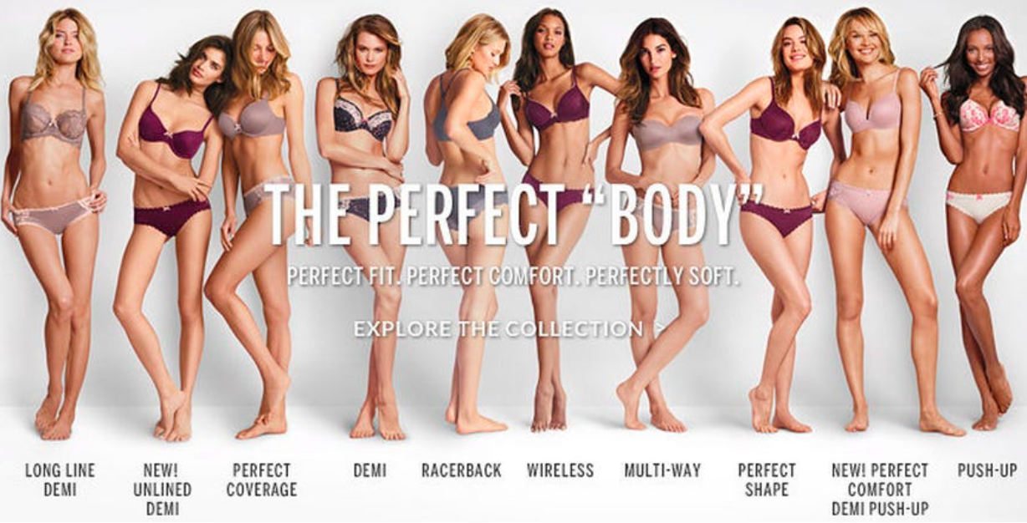

https://www.telegraph.co.uk/women/womens-life/11519041/Victorias-Secret-These-lingerie-firms-think-every-body-is-beautiful.html

The use of semiotics appears everywhere. Briefly, semiotics is the way in which we read and analyse signs and symbols in a text, in order to find a meaning and de-crypt the message within. For example, before semiotics we would only see the literal whereas afterwards we see the symbolic. After reading a section called the ‘Alleorgy of Plato’s Cave’ (book called ‘Republic’), I have learnt that we are all conditioned to see in a certain way. Today’s society has conditioned us to see every single thing in a certain way, as I will prove through my analysis.

The advert I have chosen is a perfect example of how much semiotics effects the way we think. This image was taken from the Victoria’s Secret ‘Perfect Body’ campaign, an advert from a lingerie company. The first thing we notice when we look at this advert are the words ‘the perfect body’ alongside 10 slim sized, young women. This technique is very effective as it draws the readers into the advert by using a problem that has been recently highlighted in our society today. This problem being that we are all conditioned to think that ‘perfect’ has to look a certain way. Aside of the first impression we receive from this image, it actually shows a very powerful message that not everything must revolve around beauty and consciousness over the way we look. This is due to the word ‘body’ referring to a piece of lingerie which highlights that something simple can make such a big impact. We know that the words ‘the. Perfect body’ are a metaphor of this advert due to the smaller subtitles of ‘perfect fit, perfect comfort, perfectly soft’. Although there was a large uproar over this advert due to the ‘perfect body’ remark, I believe it to actually be very strong and powerful for women and to be able to help women overcome having to look a certain way.

I believe that our society today is at risk of falling into ‘The Contemporary Condition’(Amusing ourselves to death by Neil Postman). People are extremely concerned over each other’s beauty that we are forgetting everything important in this world. It shows that such a simple but well-constructed advert like this, about lingerie, can create such an uproar all because it, at first glance, touches on the subject of beauty and also the subject of a woman’s body image. This advert is screaming at our society that we need to change as is encouraged in many different inspiring books (‘Beautiful you’ by Rosie Molinary’). We must change our habitual way of thinking and seeing and we must attempt to see things from a different perspective before thinking so negatively. We need to break the habit and stop living in the shadows, following the way society has conditioned us to think.

Bibliography

Links-

- https://www.telegraph.co.uk/women/womens-life/11519041/Victorias-Secret-These-lingerie-firms-think-every-body-is-beautiful.html

Books-

- Republic by Plato (Penguin Classics)

- Amusing Ourselves to Death by Neil Postman

- Beautiful You by Rosie Molinary
Task 2- Julia Lockheart: Manifesto Writing

- What will be, will be.

- Don’t wait for it, work for it.

- True love will find you, eventually.

- In order to succeed we must conquer our fears.

- Everything happens for a reason.

- Never take advantage of getting a second chance.

- Why wait for tomorrow when you can do it today?

- Kindness is fuel for the soul.

5. Everything happens for a reason
It has been said that this statement was a modern version of the saying ‘it’s god’s will’ (‘Does everything happen for a reason article’ on website Psychology Today). Often with statements that have been repeated as many times people begin to forget their meaning. I believe that this statement brings a calmness to the way I think. It states that some things in life cannot be explained. Even if there is a god, it cannot be explained why the terrible things that happen, happen. Often when I begin to experience stress or panic I say this statement to myself and it makes me think how every single thing that happens to us, the people we meet, places we go, things we eat/do, that it all happens in order for the next thing to happen. It is because of some bad things that have happened, that influence the good things that happen in life. A saying that compliments this statement is that ‘We can’t have a rainbow without any rain’ which is true meaning we have to experience the bad in order to enjoy the good.

2. Don’t wait for it, work for it.
I believe that this statement applies so well to our generation today. Children and teenagers today have grown up with technology leading them and have grown to be dependent on it. If they need answers they google it, or ‘ask siri’, without any stress or effort, they do not have to work for it. I believe that the only way to get the things you’d like in life or to achieve your dreams that you must work hard for it. It is said by Gandhi that ‘My life is my message’ (‘The words of Gandhi’ book by Richard Attenborough). This quote applies perfectly as I believe we should all work for what we want in order to make any sort of representation in our life or to make ourselves remembered. I will contradict myself by saying that I also believe in ‘Good things come to those who wait’ but it is important that we read both statements from different perspectives. We should always work for what we want and aim to achieve all our goals. Also if we are patient in life then the things we can’t make happen ourselves, will eventually come to us.

8.Kindeness is fuel for the soul.
This statement applies always, to everyone, everywhere. We as a society today have gotten so distracted by our lives and careers that we have pushed aside the power of kindness. I regret to state that we as people today have been distracted by the art of making money and the art of high member of society. It has been forgotten how much that being kind to another can not only be a blessing on someone’s day but can benefit your soul and help you grow into a better person (‘The art of being kind’ by Stefan Einhorn). I believe that we should all take the time out of our day to live by this statement and attempt on selfless act each day. This will create a happier, kinder community and also help with, self-love, self, image and self-confidence, which will put a person on the right road to success.

Bibliography

Links-

- https://www.psychologytoday.com/us/blog/hot-thought/201002/does-everything-happen-reason-0

Books-

- The words of Gandhi by Richard Attenborough

- The art of being kind by Stefan Einhorn

Task 3- Jon Pugh: Reflective Writing

https://en.wikipedia.org/wiki/Rosa_Parks

Throughout my educational life I have experienced many different pieces of art, media and inspiring historic hero’s which have moulded me into the person I am today. I believe that being easily influenced by inspiring art pieces and people is a very positive way of thinking as it allows an open mind to consider different perspectives and also allows the mind to adapt and grow (‘Understanding other minds’ book by Simon Cohen). After thorough research into the numerous pieces and people that have inspired me through these past years I made a decision to discuss a woman that changed history for the world. Rosa Parks.

Rosa Parks was an outstanding woman who had actually made a name for herself as being ‘The mother of the Civil Right Movement’ (‘Rosa Parks the woman who ignited a movement’ book by Hourly History). She not only changed history for her race but also changed history for people everywhere, forever. On December 1st 1955, Rosa stood up to racism as she refused to surrender her seat to a white person. Later on that day she was then arrested because of her refusal to do so. This created a social protest which stood up against racial inequality and which lasted 1 year and 16 days and ended on December 20th 1956 (‘Rosa Parks my story’ book by Jim Haskins). Rosa was taken to court on account of her arrest which created an uproar in the society, people of her own race and also some non-racial white people, protesting on her behalf for no charges. As a result, Rosa won the law suit and successfully broke the cycle of racial inequality and broke the habitual way children were made to think of the people that surrounded them (The Contemporary Condition ‘Amusing ourselves to death’ book by Neil Postman). It is because of this act that people of race became free from slavery and free from the control of white people.

I believe that Rosa Parks has had a big impact on the way I think. After researching her story I have learnt that Rosa stood up to what she thought was right even if it defied the law and went against ever other person. I believe that this is the way people from our society needs to be today. We need to stand up against things we think that are wrong instead of letting them pass as it is incidents like this that can grow and worsen and eventually take our community for the wrong turn. I believe we should honour Rosa Parks and every other influencer which died for our right. We should honour these people by fighting back on the habitual ways we have all been programmed to think and start making our own opinions about what is right and how this world should be. We are all at risk of falling into ‘The Contemporary Condition’.

Bibliography

Links-

- https://en.wikipedia.org/wiki/Rosa_Parks

Books-

- Understanding other minds by Simon Cohen

- Rosa Parks: The woman who ignited a movement by Hourly History

- Rosa Parks my story by Jim Haskins

