

Electrical Fault Simulator

by
Ellis Ashton

Supervisor: Jenifer Prince Deveraj

Project submitted as part of the requirements for the award of
BEng (Hons) Electrical and Electronics Engineering

April 2026

Contents
ABSTRACT 6
CHAPTER 1 – INTRODUCTION 7
1.1 Background 7
1.2 Problem Statement 7
1.3 Aim 8
1.4 Objectives 8
1.5 Project Scope 8
1.6 Structure of the Report 9
CHAPTER 2 – RESEARCH AND REVIEW OF LITERATURE 10
2.1 Introduction 10
2.2 Electrical Fault Diagnosis 11
2.3 Educational Training Systems for Engineering 11
2.4 Microcontrollers in Embedded Systems 12
2.5 Circuit Simulation in Engineering Design 13
2.6 Summary 13
CHAPTER 3 – RESEARCH AND DEVELOPMENT METHODOLOGY 15
3.1 Introduction 15
3.2 Research Approach 15
3.3 System Development Process 16
3.4 Hardware Components 18
3.4.1 Microcontroller 18
3.4.2 LED Indicator 19
3.4.3 Push Button 19
3.4.4 Seven-Segment Display 20
3.4.5 Test Points 20
3.5 Software Tools 20
3.5.1 MPLAB X Integrated Development Environment 20
3.5.2 CCS Compiler 20
3.5.3 Proteus Design Suite 21
3.6 Experimental Design 21
3.7 Validity and Reliability 22
3.8 Summary 23
CHAPTER 4 – DESIGN AND IMPLEMENTATION 24
4.1 Introduction 24
4.2 System Architecture 25
4.3 Hardware Design 27
4.3.1 Microcontroller Selection 27
4.3.2 Clock Generation Circuit 29
4.3.3 Reset Circuit 30
4.4 Test Point Design 30
4.5 LED Load Indicator 31
4.6 User Input Interface 32
4.7 Seven Segment Display System 33
4.8 Firmware Design 34
4.9 Fault Control Algorithm 35
4.10 System Operation 36
4.11 Proteus Simulation Implementation 37
4.11.1 Physical Prototype Implementation 38
4.12 Summary 39
CHAPTER 5 – RESULTS AND DISCUSSION 41
5.1 Introduction 41
5.2 Test Environment 41
5.3 System Behaviour During Normal Operation 44
5.4 Power Supply Failure Simulation 44
5.5 Open Circuit Fault Simulation 44
5.6 Load Failure Simulation 45
5.7 Summary of Experimental Results 45
5.8 Diagnostic Reasoning Using Test Points 46
5.9 Evaluation of System Performance 47
5.10 Educational Effectiveness 47
5.11 Limitations of the simulator 48
5.12 Chapter Summary 49
CHAPTER 6 – EVALUATION 50
6.1 Introduction 50
6.2 Evaluation Against Project Objectives 50
6.2.1 Objective 1: Design a simple electrical circuit suitable for fault-finding training 51
6.2.2 Objective 2: Implement a system capable of simulating multiple electrical faults 51
6.2.3 Objective 3: Provide measurable test points for diagnostic analysis 52
6.2.4 Objective 4: Provide a user interface for selecting fault conditions 52
6.2.5 Objective 5: Implement and test the system using simulation software 53
6.3 Strengths of the System 53
6.4 Limitations of the Current Design 54
6.5 Potential Improvements 55
6.7 Chapter Summary 55
CHAPTER 7 – CONCLUSIONS AND RECOMMENDATIONS 57
7.1 Introduction 57
7.2 Summary of Project Work 57
7.3 Key Findings 58
7.4 Achievement of Project Aim 58
7.5 Benefits of the System 59
7.6 Recommendations for Future Work 59
7.7 Final Conclusion 60
References 62
Appendix 65
Appendix A - Proteus Design 65
Appendix B – Source Code Figure: Screenshot of microcontroller firmware. 66
Appendix C – Professional and Engineering Practice Considerations 67

Figures
Figure 1 Project Development process 17
Figure 2 Extract of project Gantt chart 18
Figure 3 Proteus circuit design 25
Figure 4 Fault Simulator system architecture 27
Figure 5 PIC16F877A pin map [1] 28
Figure 6 Fault simulator (user perspective) 33
Figure 7 seven-segment coding error 34
Figure 8 Firmware operation flow chart 37
Figure 9 Fault condition 0 (no fault) 42
Figure 10 Fault condition 1 42
Figure 11 Fault condition 2 43
Figure 12 Fault condition 3 43
Figure 13 Appendix 1 - Proteus system design 65

ABSTRACT
This project presents the design and development of an electrical fault simulation system for educational training. The aim was to create a safe and controlled platform that allows students to practise fault-finding techniques without exposure to hazardous voltages or complex equipment. Although fault diagnosis is a fundamental engineering skill, it is often taught theoretically with limited practical application.
The system simulates a simple circuit consisting of a power supply, switch and LED load. A PIC16F877A microcontroller is used to generate predefined fault conditions, with test points allowing voltage measurements to support diagnostic analysis. Fault scenarios are selected via a push button, while a seven-segment display indicates the active condition. The system was designed and tested using Proteus before final evaluation.
Testing confirmed that the simulator reproduces common faults, including supply failure, open circuit and load failure, with voltage patterns that support realistic diagnostic procedures.
The results demonstrate that the system provides an effective and practical training tool. The project concludes that microcontroller-based fault simulators offer a safe, flexible and scalable approach to engineering education, with potential for further development to support more complex scenarios.

CHAPTER 1 – INTRODUCTION

1.1 Background
Electrical fault finding is a fundamental skill for engineers, requiring analysis of circuit behaviour, voltage measurement and identification of faulty components. However, teaching fault diagnosis presents challenges. Traditional methods often focus on theory and may not reflect real troubleshooting processes, while introducing physical faults can create safety risks and potential equipment damage.
Fault simulation systems provide a solution by allowing students to practise diagnostic techniques in a safe and controlled environment. Advances in microcontroller technology enable flexible systems that simulate circuit behaviour through software, allowing multiple repeatable fault conditions using simple hardware.
This project focuses on the design and development of a microcontroller-based fault simulator representing a basic power supply, switch and load circuit. Test points allow voltage measurements, providing a safe and effective platform for practising fault diagnosis.

1.2 Problem Statement
Electrical engineering students must develop the ability to diagnose faults as part of their training. However, providing realistic fault-finding experiences in laboratory environments presents several challenges. Creating faults in physical circuits can damage equipment, while real systems may involve hazardous voltages that pose safety risks. In addition, producing consistent fault conditions for multiple students can be difficult.
As a result, students often develop strong theoretical knowledge but limited practical troubleshooting experience, creating a gap between understanding and application.
A controlled fault simulation system offers a solution by enabling students to practise diagnosing faults in a safe and repeatable environment. By providing measurable test points and predefined fault conditions, users can apply techniques such as voltage tracing to identify circuit failures.

1.3 Aim
The aim of this project is to design and develop a microcontroller-based electrical fault simulation system that allows students to practise electrical fault-finding techniques in a safe and controlled environment.

1.4 Objectives
To achieve the project aim, the following objectives were defined:
- Design a simple electrical circuit model suitable for teaching fault-finding techniques.
- Develop a system capable of simulating multiple electrical faults within the circuit.
- Implement a microcontroller-based control system to manage fault simulation.
- Provide accessible test points that allow voltage measurements during fault diagnosis.
- Display the active fault condition using a digital output interface.
- Simulate and evaluate the system using Proteus circuit simulation software.
- Assess the effectiveness of the system as a training tool for electrical engineering students.

1.5 Project Scope
The scope of this project is the design and simulation of a microcontroller-based electrical fault simulator. The system models a simple power supply, switch and LED load circuit, with a PIC16F877A microcontroller generating predefined fault conditions.
The simulator operates at low voltage for educational use and does not aim to replicate complex industrial systems, instead demonstrating fundamental troubleshooting principles. It was developed and validated in simulation prior to physical implementation.
A deliberate trade-off was made to use a 5 V DC supply to ensure safety. Although this reduces realism, the core diagnostic principles remain applicable.

1.6 Structure of the Report
This report is organised into several chapters that describe the development of the electrical fault simulation system. Chapter 2 presents a review of relevant literature, including previous research related to electrical fault finding, educational training systems and microcontroller technologies. Chapter 3 describes the methodology used during the project, including the research approach and development process. Chapter 4 details the design and implementation of the simulator, including circuit design and software development. Chapter 5 presents the results of testing and discusses the performance of the system. Chapter 6 summarises the conclusions of the project and suggests potential areas for further development. Finally, Chapter 7 provides a reflective discussion of the skills and knowledge gained during the project.

CHAPTER 2 – RESEARCH AND REVIEW OF LITERATURE

2.1 Introduction
The purpose of this chapter explores existing research and technologies relevant to electrical fault diagnosis, educational training systems and the use of microcontrollers in engineering education. Electrical fault finding is recognised as a core competency for electrical engineers and technicians, particularly within industrial maintenance, power systems and electronics troubleshooting, as discussed by Isermann [6] and further supported by Bird [11]. Understanding how faults occur, how they can be diagnosed and how training systems can support the development of diagnostic skills is essential to the design of an effective educational tool.
This chapter first discusses the principles of electrical fault diagnosis and the types of faults that commonly occur in electrical circuits, drawing on established circuit theory presented by Sedra and Smith [10] as well as Alexander and Sadiku [19]. It then reviews the use of training systems and simulation tools in engineering education, where Biggs and Tang [14] highlight the importance of active learning approaches, supported by practical laboratory-based systems described by Saha [15]. Following this, the role of microcontrollers in embedded systems and educational devices is examined, with Mazidi et al. [2] demonstrating their practical application in control systems and Vahid and Givargis [4] outlining their role within modern embedded system design.
Finally, the chapter reviews circuit simulation tools and their importance in engineering design and testing, with the Proteus Design Suite providing an example of integrated hardware and software simulation [12], while measurement and validation principles are supported by Morris and Langari [21]. The chapter concludes with a summary of the key findings from the literature and how they inform the design of the proposed electrical fault simulator.

2.2 Electrical Fault Diagnosis
Electrical fault diagnosis involves identifying abnormal conditions that prevent a system from operating correctly. Faults may arise from component failure, wiring damage, incorrect installation or environmental factors [6]. Engineers must analyse circuit behaviour and determine fault causes efficiently, a skill emphasised in practical electrical engineering [11].
Diagnosis typically follows a systematic process. Engineers observe symptoms and take measurements at different points in the circuit. By analysing voltage, current and component behaviour, the fault location can be identified using techniques such as voltage tracing, where measurements reveal where normal operation stops [10].
Common faults include open circuits, where a break prevents current flow, and short circuits, where unintended low-resistance paths bypass components. In open circuits, voltage is present before the fault but absent beyond it [19], while short circuits can cause excessive current and potential damage to components or protective devices [29]. Component failure is another major cause, requiring analysis of surrounding electrical conditions to confirm malfunction [21].
Developing fault diagnosis skills requires both analytical ability and practical experience. However, this can be difficult in educational environments due to safety, cost and equipment limitations. Practical, hands-on approaches are therefore essential for effective learning [14], and fault simulation systems provide a safe and controlled way for students to practise diagnostic techniques [15].

2.3 Educational Training Systems for Engineering
Training systems are widely used in engineering education to provide practical experience alongside theoretical learning. Effective learning requires active engagement, where students apply knowledge through experimentation and problem solving [14], [15].
Traditional electrical training systems often use modular circuits and laboratory kits to demonstrate circuit behaviour. While useful, these setups typically focus on normal operation and may not provide realistic fault conditions for troubleshooting practice.
To address this, fault simulation systems introduce predefined faults that allow students to apply diagnostic techniques [6]. Physical fault insertion, such as disconnecting components, can be impractical due to equipment damage and the need for instructor supervision.
Modern approaches use programmable devices such as microcontrollers to simulate faults electronically. This allows multiple fault conditions to be generated without modifying the hardware, improving flexibility and reliability [2], [4]. In addition, faults can be selected or randomised through software, preventing memorisation and encouraging diagnostic reasoning.
Overall, programmable fault simulation systems provide a more flexible and effective learning environment, supporting active learning and the development of problem-solving skills [14].

2.4 Microcontrollers in Embedded Systems
Microcontrollers are widely used in embedded systems as they integrate processing, memory and input/output functions within a single device [24]. Unlike general-purpose computers, they are designed for specific control tasks in constrained environments where efficiency and reliability are essential [5]. Typical applications include monitoring sensors, controlling actuators and processing digital signals [16].
A key advantage of microcontrollers is their ability to control hardware through programmable software. This enables complex functionality to be implemented using relatively simple hardware, supporting rapid prototyping and system modification [23]. As a result, microcontrollers are widely used across automotive, industrial and consumer systems, as well as in robotics [25].
In educational settings, microcontrollers provide an accessible platform for developing practical skills in digital electronics, programming and system design, supporting hands-on learning approaches [15]. The PIC microcontroller family is commonly used due to its simplicity and extensive documentation [2]. In particular, the PIC16F877A offers sufficient input/output capability and integrated peripherals for interfacing with external components such as sensors and displays.
Using a microcontroller to simulate electrical faults enables multiple circuit conditions to be reproduced without modifying hardware. Output signals can represent voltages at different points in a circuit, allowing students to analyse system behaviour through measurement. This approach aligns with fault diagnosis principles, where system conditions are inferred by comparing measured and expected values [8].

2.5 Circuit Simulation in Engineering Design
Circuit simulation is widely used in engineering design to analyse and verify systems before physical implementation, reducing development time and risk [12]. Tools such as Proteus allow circuit schematics and microcontroller firmware to be tested together, enabling system-level validation within a virtual environment.
Simulation provides controlled and repeatable conditions, allowing parameters such as voltage and component values to be adjusted to assess system performance [11]. It is also useful for fault analysis, where simulated faults help evaluate system behaviour and support diagnostic techniques [6].
However, simulation is based on idealised models and may not fully represent real-world effects such as noise and component tolerances [21]. As a result, it is typically combined with physical testing to ensure reliability.
In this project, simulation was used to verify fault conditions and voltage behaviour before hardware implementation

2.6 Summary
This chapter reviewed key concepts relevant to the development of an electrical fault simulation system. Fault diagnosis is a fundamental engineering skill requiring the analysis of circuit behaviour to identify abnormal conditions [6]. However, practical fault-finding training can be limited by safety constraints and equipment availability in educational environments [14].
Fault simulation systems provide an effective solution by allowing students to practise diagnostic techniques in a controlled setting, supporting hands-on learning approaches [15]. Microcontrollers enable this by allowing system behaviour to be defined through software, offering flexibility in simulating fault conditions [2]. The PIC16F877A is widely used in education due to its simplicity and suitability for interfacing with external components [3].
Simulation tools such as Proteus further support development by enabling combined testing of circuits and embedded software prior to hardware implementation, reflecting standard engineering validation practices [21].
Overall, the literature supports the use of microcontroller-based simulation systems for engineering education. These findings informed the design choices in this project, particularly the use of a programmable architecture and simulation-based development.

CHAPTER 3 – RESEARCH AND DEVELOPMENT METHODOLOGY

3.1 Introduction
This chapter outlines the research and development methodology used in the design and implementation of the electrical fault simulation system. A structured approach was adopted to ensure the system is reliable, repeatable and aligned with its intended objectives, consistent with embedded system design frameworks [4].
The project follows a development-based methodology supported by experimental testing. The development phase focuses on system design and implementation, while the experimental phase verifies system behaviour under different simulated fault conditions, reflecting standard engineering validation practices [21].
The methodology integrates engineering design with experimental verification. Microcontroller-based development typically involves iterative stages of design, implementation and testing to ensure correct operation [2], with embedded systems requiring close integration of hardware and software throughout [5].
The process followed a structured sequence including requirements definition, system design, simulation, software implementation and evaluation. Each stage contributed to ensuring the final system met the objectives defined in Chapter 1.

3.2 Research Approach
Engineering projects typically follow investigative, experimental or development-based methodologies depending on the problem. In this project, a development-based approach was selected as the objective was to design and implement a functional electrical fault simulator, consistent with embedded system design practices [4].
This methodology focuses on creating a system that meets defined requirements through iterative stages such as design, prototyping, testing and evaluation. Such iteration is essential in embedded systems, where hardware and software must be refined together to ensure correct operation [5].
An experimental component was also included to verify system behaviour. Controlled testing was carried out within the simulation environment to confirm that fault conditions and voltage measurements matched expected behaviour, supporting system accuracy and reliability [21].
By combining development and experimental methods, the project ensured both effective implementation and validation, reflecting standard engineering practice [2].

3.3 System Development Process
The electrical fault simulator was developed using a structured design process, reflecting standard embedded system methodologies [4]. The project began with defining the system objectives, identifying the need for a safe and practical training tool to support electrical fault diagnosis through measurement-based learning [14].
A literature review and market analysis established the theoretical basis for the design and supported the use of a simplified circuit with microcontroller-based fault simulation [6]. System requirements were then defined, including the ability to simulate multiple faults, provide accessible test points and support user interaction, which are key aspects of embedded system design [5].
The system design utilised a simple circuit consisting of a power supply, switch and LED load to demonstrate fault-finding principles [10]. Test points were incorporated to enable voltage tracing, and a microcontroller was used to simulate fault conditions through programmable outputs. The design was implemented and validated in Proteus, allowing integration of hardware and firmware prior to physical construction [12].
Firmware was developed in C using lookup tables to generate predefined fault conditions, ensuring consistent and repeatable system behaviour [23]. Following simulation, a physical prototype was constructed and tested using a multimeter to verify that measured voltages matched expected results, supporting system reliability [24].
Finally, the system was evaluated in terms of functionality and educational value, confirming its effectiveness as a training tool [15].
Figure 1 Project Development process
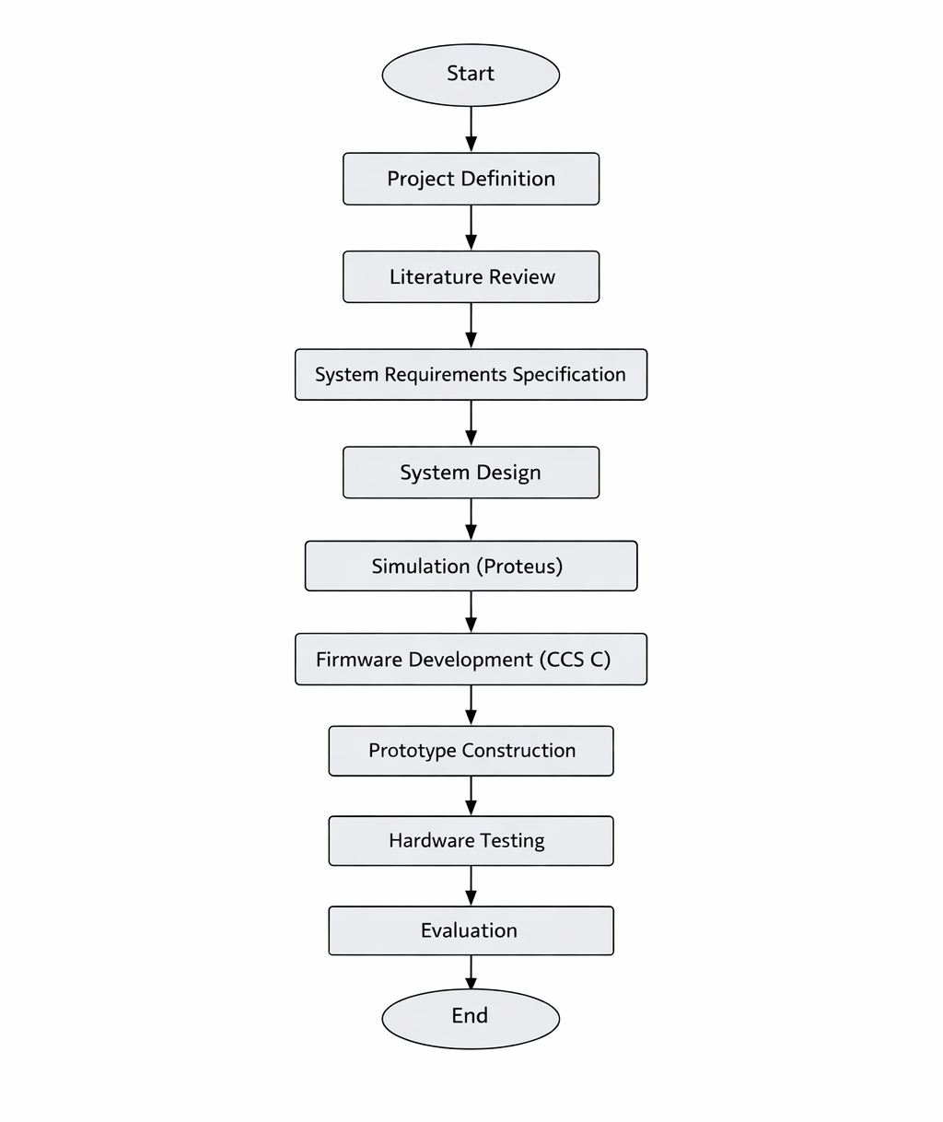
As shown in Figure 2, The planning of the project had a good level of accuracy and assumption. The scheduling of the project aligned well with the project being carried out, although this does not reflect that some delays were not encountered. The key dates of the project were met as the plan considered that there would be delays in certain aspects of the project such as the program development where there were more iterations than initially planned, particularly when implementing the fault indication logic where these refinements influenced the final system architecture. Other delays within the prototype build aspect where the lead-time on several parts was excessive. Fortunately, in the planning phase there were delays forecasted so therefore these delays still meant the project could be delivered within the deadlines.
Figure 2 Extract of project Gantt chart
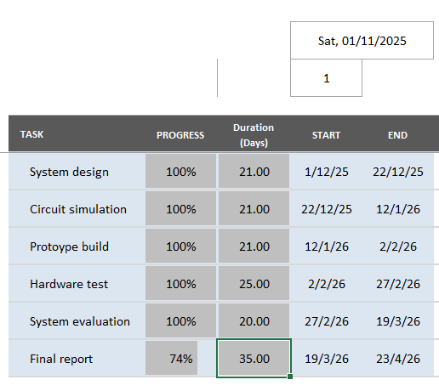

3.4 Hardware Components
Although the project was implemented within a simulation environment, it was designed with real hardware implementation in mind. The following hardware components were selected as part of the system design. The decision between using a PLC system and a microcontroller based system was made due to the size, weight and flexibility advantage of the microcontroller system.

3.4.1 Microcontroller
The central component of the system is the PIC16F877A microcontroller. This device was selected because it gives many digital input and output pins, making it suitable for controlling multiple signals within the simulator. The PIC16F877A is also widely used in educational environments and is supported by extensive documentation and development tools, as detailed by Microchip Technology in the device data sheet [3].
The microcontroller is responsible for controlling the simulated voltages at each test point and managing the fault selection logic. This type of programmable control is a key advantage of microcontroller-based systems, allowing system behaviour to be defined through software rather than hardware modifications, as described by Mazidi et al. [2]. It also controls the output display that indicates the currently active fault scenario, demonstrating the integration of input processing and output control typical of embedded system applications [4].
The PIC16F877A was selected due to it’s number of I/O pins and ease of integration within both simulation and hardware environments. While more advanced microcontrollers could provide additional features and processing capability, the chosen device offers a balance between simplicity and functionality, making it well suited to an educational application. Although, the disadvantage of this component is the lack of integrated clock system, this means that a crystal clock circuit is required as part of the circuit.

3.4.2 LED Indicator
An LED was included in the circuit to represent the electrical load. In normal operating conditions the LED illuminates, indicating that current is flowing through the circuit. When certain fault conditions are simulated, the LED will turn off or behave differently, allowing students to observe the effect of the fault.

3.4.3 Push Button
A push button input was used to allow the user to change the active fault condition. Each press of the button advances the system to the next fault scenario. This allows multiple faults to be simulated using the same hardware configuration.

3.4.4 Seven-Segment Display
A seven-segment display was used to provide visual feedback indicating the currently active fault condition. This allows the instructor or student to identify which fault scenario is being simulated at any given time.

3.4.5 Test Points
Test points were incorporated into the circuit to allow voltage measurements to be taken at key locations. These test points represent points within the simulated electrical circuit where a technician would normally measure voltage during fault diagnosis. By analysing the voltages present at these points, students can determine the location of the simulated fault.

3.5 Software Tools
Several software tools were used during the development of the project. They were chosen due to the compatibility benefits along with being readily available and intuitive.

3.5.1 MPLAB X Integrated Development Environment
MPLAB X is an integrated development environment produced by Microchip Technology for developing software for PIC microcontrollers. It presents tools for writing, compiling and debugging embedded software, supporting the full development lifecycle of microcontroller-based systems. Such integrated development environments are essential in embedded system design, as they enable efficient code development, testing and debugging, as described by Barr and Massa [23].

3.5.2 CCS Compiler
The CCS compiler was used to convert the C language program written for the PIC microcontroller into machine code that can be executed by the device. The compiler generates a HEX file that contains the binary instructions required by the microcontroller. This process is fundamental to embedded system development, where high-level code must be translated into executable instructions for the target hardware, as described by Barr and Massa [23].

3.5.3 Proteus Design Suite
Proteus Design Suite was used to simulate the electrical circuit and microcontroller behaviour. The software allows the microcontroller program to be executed within the simulation while interacting with other electronic components in the circuit. This capability enables integrated hardware and software validation, which is a key aspect of modern embedded system development, as described in simulation-based design practices [12]. This feature makes Proteus particularly suitable for testing embedded systems that combine hardware and software elements, supporting efficient verification prior to physical implementation [21].

3.6 Experimental Design
The experimental component of the project was designed to verify that the electrical fault simulator behaves as expected under different operating conditions. The experiments were conducted within the Proteus simulation environment, allowing both the circuit and embedded software to be evaluated simultaneously. This approach reflects standard engineering practice, where simulation is used to validate system behaviour prior to physical implementation [12].
Each experiment involved activating a specific fault scenario and measuring the voltages present at the test points within the circuit. The measured values were then compared with the expected behaviour of the circuit based on established electrical theory, as described by Sedra and Smith [10]. This comparison ensured that the simulator accurately represents realistic circuit conditions.
The experiments were designed to confirm that the simulator correctly represents the following conditions:
• Normal circuit operation
• Power supply failure
• Open circuit conditions
• Component failure

By analysing the voltages present at different points within the circuit, it was possible to determine whether the simulated behaviour matched the expected characteristics of each fault condition. This method of verification aligns with measurement and validation techniques used in engineering testing to ensure system accuracy and reliability [21].

3.7 Validity and Reliability
In research methodology, it is important to consider whether the experimental results accurately represent the behaviour being studied. In this project, validity refers to whether the simulated fault conditions correctly represent real electrical faults. The use of well-understood circuit models and realistic voltage conditions helps ensure that the simulated behaviour corresponds to real electrical systems, as supported by established circuit analysis principles described by Sedra and Smith [10]. Ensuring validity in this way is essential in engineering design, where models must accurately reflect real-world behaviour.
Reliability refers to whether the experiment produces consistent results when repeated. Because the system is implemented using software-controlled logic within a simulation environment, each fault scenario behaves consistently each time it is activated. This repeatability is a key advantage of simulation-based testing, allowing controlled and reproducible experiments, as discussed in engineering measurement and validation practices by Morris and Langari [21]. Such consistency is particularly beneficial for educational purposes because it allows students to analyse the same fault conditions multiple times and develop a structured understanding of diagnostic techniques.

3.8 Summary
This chapter has described the methodology used to design, develop and evaluate the electrical fault simulation system. The project followed a development-based approach supported by experimental testing to verify system behaviour, reflecting standard embedded system design practices where implementation is combined with validation [4]. A structured development process was used to identify system requirements, design the circuit and control logic, implement the system within a simulation environment and evaluate its performance. This approach ensures that both the functionality and reliability of the system are addressed through systematic testing and refinement, as supported by engineering validation principles [21].
The next chapter describes the design and implementation of the system in detail, including the circuit design, microcontroller control logic and software implementation used to simulate electrical faults.

CHAPTER 4 – DESIGN AND IMPLEMENTATION

4.1 Introduction
This chapter examines the design and implementation of the electrical fault simulation system developed in this project. The simulator is intended as an educational tool to support safe, practical learning of electrical troubleshooting techniques. In real engineering environments, faults are commonly diagnosed by measuring voltages at different points within a circuit and comparing these with expected values, an approach grounded in circuit analysis principles [10].
The system replicates this process using a microcontroller-based circuit that simulates predefined fault conditions. Multiple test points are provided, allowing users to identify faults through voltage measurements. This approach reflects established fault diagnosis techniques and mirrors real-world troubleshooting practices [6].
The simulator is built around a PIC16F877A microcontroller, which generates specific voltage patterns at test points to represent different operating conditions. This software-driven control is characteristic of embedded systems, where system behaviour is defined through programmable logic [2]. A push button enables users to cycle through fault scenarios, while a seven-segment display indicates the active condition.
The system was implemented using the Proteus Design Suite, allowing integrated simulation of both circuit and firmware. This approach aligns with modern engineering practice, where simulation is used to validate system behaviour before hardware implementation [12]. The following sections describe the system architecture, hardware design and software implementation.
Figure 3 Proteus circuit design
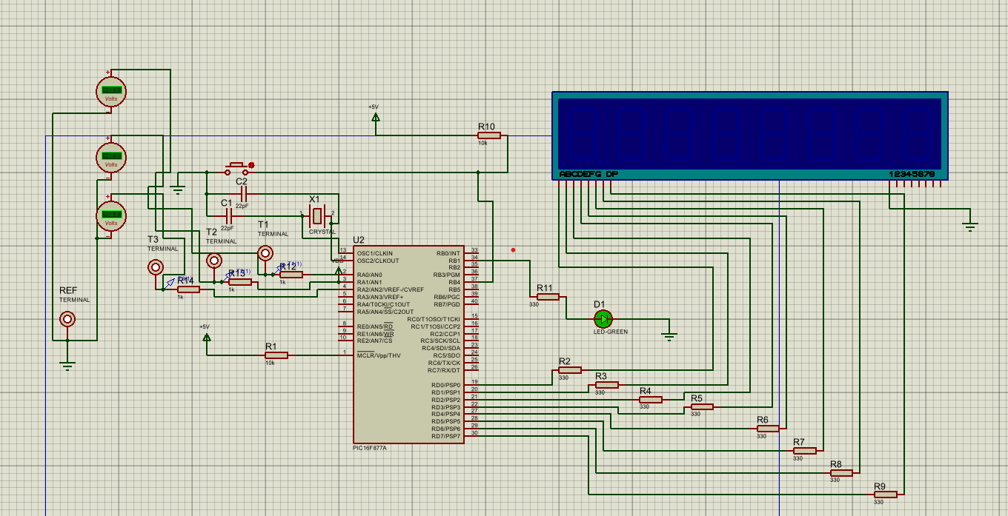

4.2 System Architecture
The electrical fault simulator is designed as a microcontroller-controlled embedded system. The PIC16F877A acts as the central controller that manages the operation of all system components. This type of architecture is typical of embedded systems, where a single microcontroller coordinates input processing and output control, as described by Vahid and Givargis [4].
The architecture of the system is made up of several functional subsystems:
• Microcontroller control unit
• Clock generation circuit
• Reset circuitry
• Test point output interface
• LED load indicator
• User input interface
• Seven segment display system
The microcontroller processes user inputs and generates output signals that represent different circuit conditions. The clock generation circuit ensures that the microcontroller operates at a stable frequency, while the reset circuit ensures that the device starts correctly when power is applied. These supporting subsystems are fundamental to reliable microcontroller operation, as outlined in embedded system design literature [5].
The test point outputs represent the voltage levels at different positions within the simulated electrical circuit. These test points allow the user to measure voltages using simulated measurement instruments in Proteus. By analysing these voltage values, the user can determine the location of the simulated fault, following standard voltage tracing techniques used in electrical fault diagnosis [6].
The LED indicator represents the electrical load within the system. In normal operating conditions the LED is illuminated, indicating that current is flowing through the circuit. When certain faults occur, the LED remains off to simulate a failed load or an interrupted power supply. This behaviour reflects basic circuit operation principles described in electrical engineering theory [11].
The seven-segment display gives feedback to the instructor or system operator by showing the currently active fault number. This allows controlled troubleshooting exercises to be performed where students must identify the fault without being directly told which fault is active. Such approaches support active learning and diagnostic reasoning in engineering education, as discussed by Biggs and Tang [14].
Figure 4 Fault Simulator system architecture
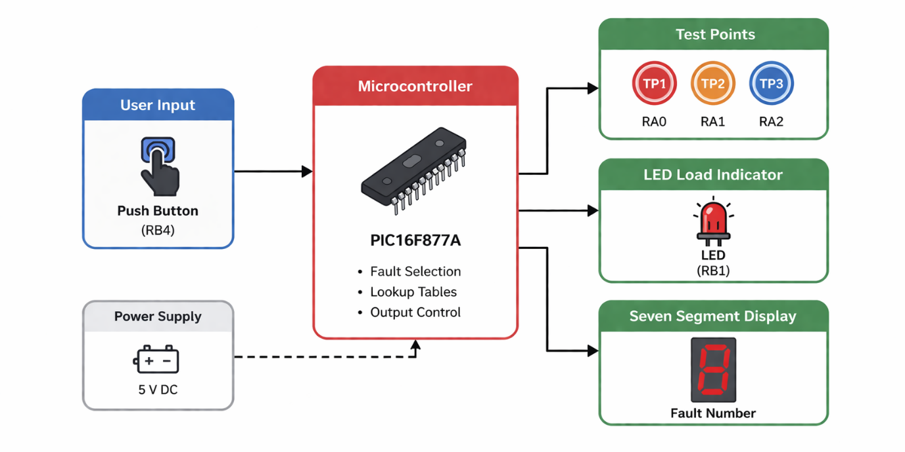

4.3 Hardware Design

4.3.1 Microcontroller Selection
The PIC16F877A microcontroller was selected as the main processing unit for the electrical fault simulator. This microcontroller is part of Microchip Technology’s widely used PIC16 family and specifies several features that make it suitable for embedded control applications, as outlined in the device data sheet [3].
One of the primary reasons for selecting this device is the availability of many input/output pins. The PIC16F877A presents five I/O ports (PORTA to PORTE), allowing multiple components to be connected simultaneously. In this project, the microcontroller must control test point outputs, an LED indicator and a seven-segment display while also reading user inputs. The number of available I/O pins makes the device suitable for this application, supporting flexible hardware interfacing as described by Mazidi et al. [2].
Another advantage of the PIC16F877A is its compatibility with the MPLAB X development environment and the CCS C compiler. These tools provide a convenient platform for writing, compiling and debugging embedded software. Additionally, the PIC16F877A is widely supported within the Proteus simulation environment, making it possible to integrate hardware simulation with software development. This integration reflects common embedded system development practices, where hardware and software are designed and tested together [4].
The microcontroller operates using a Harvard architecture with separate program and data memory. This architecture allows instructions to be executed efficiently while maintaining reliable program operation, a principle widely used in embedded system design [5]. The device also includes features such as timers, interrupt capabilities and analogue-to-digital converters, although not all these features are required for the current project.
Figure 5 PIC16F877A pin map [1]
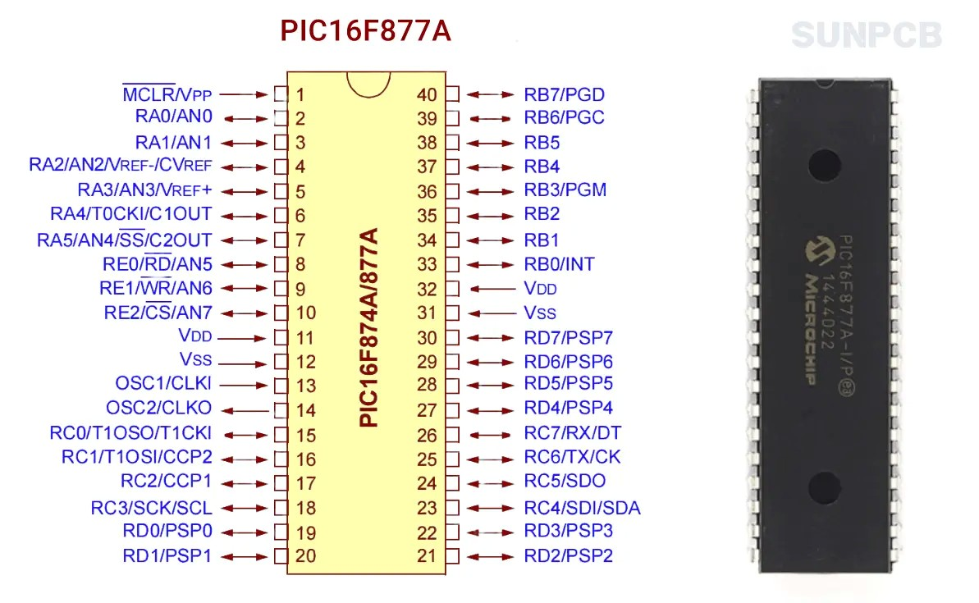

A microcontroller was chosen over a PLC for several reasons, firstly was due to the size and weight requirements of the final project. As this product is intended for use within a classroom or remotely for the students, it needed to be handheld where a PLC system would need to be larger and heavier so would not meet this specification. Also, a microcontroller is a more flexible system as it requires less maintenance and can be easily re-programmed, a PLC system shares this quality but is not as easy and would require more hardware. Although a PLC would add a level of robustness to the system, this would increase the complexity of the system, this transition could be a future consideration for the system to improve the performance and durability.
Using a PIC over a PLC system also allows for a larger selection of Inputs and Outputs making the system easier to expand over time, as the list of faults increases where further hardware is needed, these changes can be incorporated more easily where I/O ports are readily available.
The selection of the PIC16F877A reflects a design decision prioritising simplicity, availability and educational suitability over computational performance. While more advanced microcontrollers offer greater processing capability and integrated features, the PIC16F877A presents sufficient functionality for the required control tasks while maintaining a straightforward architecture. This makes it particularly suitable for teaching environments, where ease of understanding and reliability are more important than system complexity.

4.3.2 Clock Generation Circuit
For the microcontroller to execute instructions correctly, it must be provided with a stable clock signal. The clock determines the speed at which the microcontroller executes instructions and affects the timing behaviour of the entire system, as described in embedded system design principles by Vahid and Givargis [4].
The clock signal in this design is generated using an external crystal oscillator connected to the OSC1 and OSC2 pins of the PIC16F877A. The crystal oscillator offers a precise and stable clock frequency compared to internal oscillator options. Two capacitors are connected between the crystal terminals and ground to stabilise the oscillation and ensure reliable operation, a configuration commonly recommended in microcontroller hardware design [3].
The microcontroller configuration specifies the use of the HS oscillator mode, which is designed for high-speed crystal oscillators. The clock frequency used in this design is 4 MHz, which keeps sufficient processing speed for the required functionality while keeping the system design simple and stable, in line with typical embedded system timing requirements [5].
The clock configuration is defined within the firmware using the following directive:
#use delay(clock=4000000)
This directive informs the compiler of the clock frequency so that accurate timing delays can be generated within the software, supporting precise control of system behaviour [23].

4.3.3 Reset Circuit
The reset circuit ensures that the microcontroller starts in a known state when power is applied. This is achieved using the MCLR (Master Clear) pin on the PIC16F877A, as described in the device configuration documentation provided by Microchip Technology [3].
The MCLR pin is connected to the power supply through a pull-up resistor. This resistor ensures that the reset pin remains at a logic high level during normal operation. When the reset pin is pulled low, the microcontroller resets and restarts the program execution from the beginning. This type of reset configuration is commonly used in embedded systems to ensure reliable startup behaviour [5].
The configuration fuses defined within the program also enable additional features such as the power-up timer and brown-out protection. These features help ensure that the microcontroller does not start executing instructions until the power supply voltage has stabilised, improving system reliability and preventing unintended behaviour during startup conditions [4].

4.4 Test Point Design
A key concept of the electrical fault simulator is the use of test points that allow voltage measurements to be taken during troubleshooting. In real electrical systems, engineers commonly measure voltages at specific locations within a circuit to determine whether components are functioning correctly, following standard diagnostic techniques described by Isermann [6] and supported by circuit analysis principles [10].
Each test point corresponds to a location within the simulated electrical circuit. These outputs generate voltage levels that represent the behaviour of the circuit under different operating conditions. By observing these voltage values, users can apply voltage tracing methods to identify the location of faults within the system [11].
The values applied to these test points are controlled by the microcontroller software using predefined lookup tables. Each fault scenario corresponds to a specific combination of logic levels applied to these outputs. This software-controlled approach to signal generation is a common feature of embedded systems, where system behaviour can be modified without altering the hardware configuration [2].
This design approach allows multiple fault conditions to be simulated without requiring changes to the hardware, providing a flexible and efficient platform for training applications.

4.5 LED Load Indicator
The LED component in the circuit represents the electrical load within the simulated system. In many real-world electrical systems, loads such as lamps or motors provide a visual indication of whether the circuit is functioning correctly, as described in fundamental electrical engineering principles [11].
The LED is connected to pin RB1 of the microcontroller. A current-limiting resistor is connected in series with the LED to prevent excessive current from flowing through the device. This is a standard practice in electronic circuit design to protect components from damage and ensure safe operation [10].
The LED state is controlled by the microcontroller software. When the circuit is operating normally, the LED output is set to logic high and the LED illuminates. When certain fault conditions occur, the LED remains off to simulate a failed load or a broken circuit. This behaviour reflects the relationship between circuit continuity and load operation in practical systems [19].
The behaviour of the LED is defined using a lookup table within the software. This table specifies whether the LED should be on or off for each fault condition. Using software-defined control for output behaviour is a common approach in embedded systems, allowing flexible system operation without requiring changes to the hardware [2].

4.6 User Input Interface
The system includes a push button connected to pin RB4 which allows the user to change the active fault condition. As shown in Figure 1, the push button is mounted on the front panel of the enclosure (bottom right), providing a simple and accessible user interface for cycling through the simulated faults.
The push button is configured as an active-low input, meaning that the input pin normally reads a logic high value due to a pull-up resistor. When the button is pressed, the input is pulled to ground and the microcontroller detects a logic low signal. This configuration is commonly used in embedded systems to ensure stable and reliable input detection, as described in microcontroller interfacing techniques [2].
The program continuously monitors this input within the main program loop. When a button press is detected, the system increments the fault number and updates the outputs accordingly. This polling-based input handling approach is typical in simple embedded control systems where real-time response requirements are minimal [4].
To prevent false triggering caused by switch bounce, a short delay is introduced after detecting a button press. This technique, known as software debouncing, is widely used to ensure that only a single input event is registered for each physical button press, improving system reliability and user interaction [23].
Figure 6 Fault simulator (user perspective)
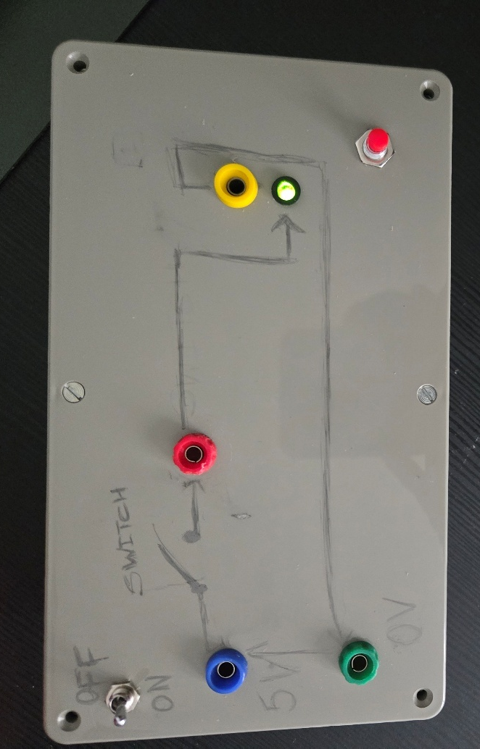

4.7 Seven Segment Display System
The seven-segment display gives a visual indication of the currently active fault condition. This display consists of multiple LED segments arranged to form numerical characters, a common output method in embedded systems for simple numeric feedback [2]. The segments of the display are connected to PORTD of the microcontroller through current limiting resistors. Each segment is controlled individually by the microcontroller, allowing specific patterns to be generated to represent different numbers.
A lookup table within the software defines the segment patterns required to display the numbers 0 to 3. These values are written to PORTD whenever the fault condition changes. This approach simplifies the control logic and ensures consistent output behaviour, as lookup tables are widely used in embedded systems to map input states to predefined outputs [23].
However, lines within the program must be correct for the seven-segment display to function, the current state of the prototype is that the seven-segment display is not on the user interface. This is due to the code display the number on the seven-segment inverted, where the unlit LED’s represent the number being displayed – This is demonstrated in the image below where the display is showing ‘2’ in the un-lit LED’s.
Figure 7 seven-segment coding error
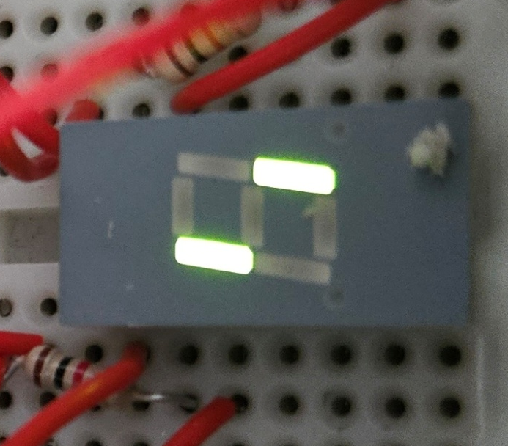
This requires a change in the code and was highlighted during the physical test phase of the system, the decision was made to remove this from the students interface to avoid confusion and present this back to the interface once the error has been corrected.

4.8 Firmware Design
The microcontroller firmware was written in the C programming language using the CCS compiler. The program begins by defining configuration fuses that control the behaviour of the microcontroller hardware. These configuration settings disable unnecessary features such as the watchdog timer and enable the correct oscillator mode for the external crystal, as specified in the device configuration guidelines provided by Microchip Technology [3].
The program defines a variable called fault which stores the currently active fault scenario. This variable cycles through the values 0 to 3, the seven segment display patterns required to display the numbers 0 to 3. The second table defines the logic levels applied to the test point outputs. The third table defines the state of the LED indicator for each fault condition.
Using lookup tables simplifies the program structure and allows fault behaviour to be modified easily. This approach is commonly used in embedded systems to map system states to predefined outputs, improving code efficiency and readability, as described by Barr and Massa [23].

4.9 Fault Control Algorithm
A dedicated function called applyFault() is used to update the system outputs. This function reads values from the lookup tables and writes them to the appropriate microcontroller pins. The test point outputs are updated using the output_bit() function, allowing individual pins to be controlled independently. This type of direct hardware control is a common feature of embedded C programming, where specific I/O pins are manipulated to achieve the required system behaviour [23].
The LED output is updated using the same function based on the values stored in the LED lookup table. Finally, the seven-segment display is updated using the output_d() function, which writes the appropriate segment pattern to PORTD. This structured approach to output control ensures that all system components are updated consistently, supporting reliable and predictable system operation, as expected in embedded system design [4].

4.10 System Operation
After the microcontroller ports are configured, the program enters an infinite loop. Within this loop the system continuously performs three main tasks:
- Apply the current fault condition
- Monitor the push button input
- Update the outputs if the fault condition changes
This type of continuous loop structure is typical in embedded systems, where the microcontroller repeatedly executes a defined sequence of operations to maintain system functionality, as described by Vahid and Givargis [4].
When the button is pressed, the fault number is incremented. If the maximum fault number is reached, the value loops back to zero. This cyclic control structure allows the system to iterate through predefined states efficiently, a common approach in embedded control applications where system behaviour is governed by discrete operating modes [23]. This process allows the system to cycle through all available fault conditions.
Figure 8 Firmware operation flow chart
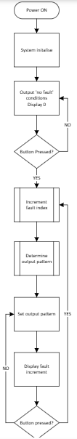

4.11 Proteus Simulation Implementation
The complete system was made using the Proteus Design simulation environment. Proteus allows electronic circuits and microcontroller programs to be simulated together within a single environment, enabling integrated hardware and software test and development as part of the design process [12].
The microcontroller program was compiled using the CCS compiler to generate a HEX file. This file was then loaded into the PIC16F877A component within the Proteus schematic. When the simulation is started, the microcontroller executes the program exactly as it would on physical hardware, reflecting standard embedded system development workflows where compiled code is deployed directly onto the target device [23].
The push button can be pressed during simulation to change the active fault condition. Virtual measurement instruments within Proteus were used to observe voltages at the test points. These measurements confirm that the circuit produces the expected behaviour for each fault scenario, supporting system validation through simulation-based testing [21].
This phase of the project is important to understand and rectify any errors within the system. At this phase it is much easier to rectify an error within the program or the system design as changes can be made quickly and tested.
During simulation, adjustments were required to ensure correct segment mapping and output behaviour. This highlighted the importance of verifying pin configurations before transitioning to hardware.

4.11.1 Physical Prototype Implementation
Following successful simulation within the Proteus environment, a physical prototype of the electrical fault simulator was constructed to validate real-world operation. The circuit was initially assembled on a breadboard, allowing flexibility during development and enabling modifications to be made easily. This approach is commonly used in embedded system prototyping to support rapid iteration and testing before final implementation [4].
The PIC16F877A microcontroller was programmed using a PICkit 3, which allowed the compiled HEX file to be uploaded directly to the device reflecting standard embedded development workflows [23].
To create a user-friendly training device, the main interface components were mounted on the front panel of an enclosure. This layout allows users to interact with the system in a structured manner, like practical laboratory equipment, supporting effective hands-on learning [14].
The breadboard containing the main circuit and a battery power supply were housed within the enclosure. This internal arrangement protects the circuitry while maintaining accessibility for maintenance and modification if required.
Permanent connections for external components such as the test points, display and battery holder were achieved through soldering. This improves mechanical stability and ensures reliable electrical connections during operation, which is essential for consistent system performance in practical applications [21].
The completed prototype shows how the simulated design can be translated into a functional physical training system, suitable for use in educational environments. This transition from simulation to hardware implementation is a key aspect of embedded system design, ensuring that theoretical behaviour is validated under real operating conditions [5].

4.12 Summary
This chapter explored the design and implementation of the electrical fault simulation system developed during this project. The design includes test points that allow voltage measurements to be taken during troubleshooting exercises, an LED load indicator that represents circuit operation and a seven segment display that indicates the active fault number. These features replicate standard diagnostic techniques used in electrical fault analysis, where system behaviour is interpreted through measurement and observation [6].
The firmware controlling the system uses lookup tables and a simple fault selection algorithm to update the system outputs. The complete design was applied and tested using the Proteus simulation environment, before being successfully translated into a physical prototype constructed using a breadboard-based circuit and enclosure-mounted interface components. This progression from simulation to physical implementation reflects established engineering development practices [4].
Challenges encountered included identifying the pinout of the seven-segment display had to be individually determined using a multimeter as there was ambiguity in the pinout models available.

CHAPTER 5 – RESULTS AND DISCUSSION

5.1 Introduction
This chapter presents the results of testing the electrical fault simulator to verify its operation against design specifications [6].
The system was tested in Proteus and validated using a physical prototype [12]. Fault conditions were cycled using a push button, and system behaviour was recorded.
The following were assessed:
• Voltage levels at test points
• LED indicator behaviour
• Seven-segment display output
• Overall circuit response
Measured values were compared with expected results to confirm correct operation [21].

5.2 Test Environment
The simulator was tested in Proteus, including the PIC16F877A microcontroller, oscillator, reset circuit, LED indicator, seven-segment display and push button input. The firmware was compiled into a HEX file and loaded into the microcontroller, enabling realistic system operation [12].
Virtual voltmeters measured voltages at three test points (RA0, RA1, RA2), representing key circuit locations. These measurements reflect standard voltage tracing techniques used for fault diagnosis [6], with readings corresponding to microcontroller output logic levels [21].
A physical prototype was also tested using a digital multimeter, with results compared to simulation data to confirm consistency and validate system behaviour [21].
Figure 9 Fault condition 0 (no fault)
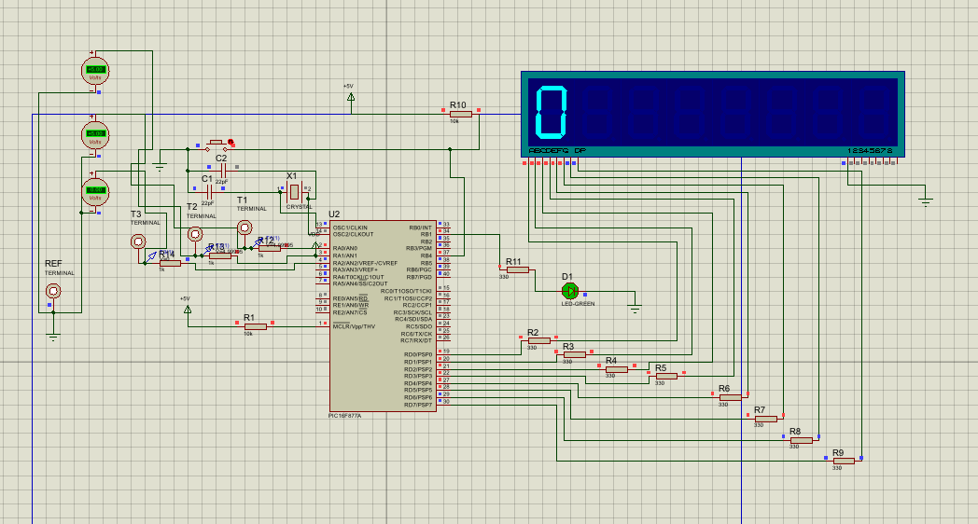
Minor variations were observed during physical testing due to measurement tolerance and component behaviour, although these did not significantly affect system operation. These voltage variations seen were in the order of 0.1V and were determined too small to effect the system or the user experience so were accepted as a system characteristic.
Figure 10 Fault condition 1
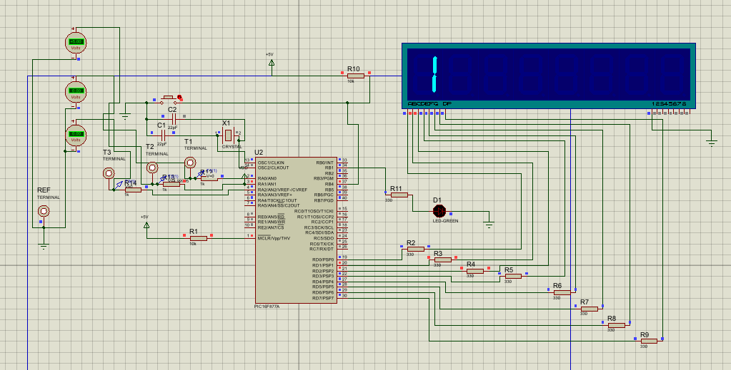
Figure 11 Fault condition 2
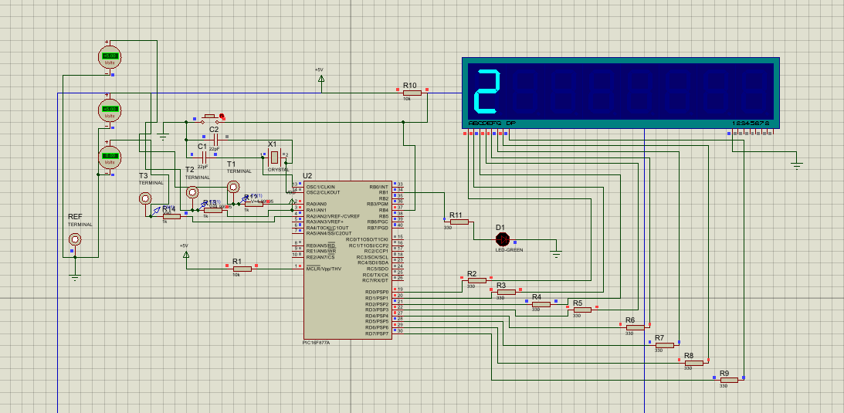
Figure 12 Fault condition 3
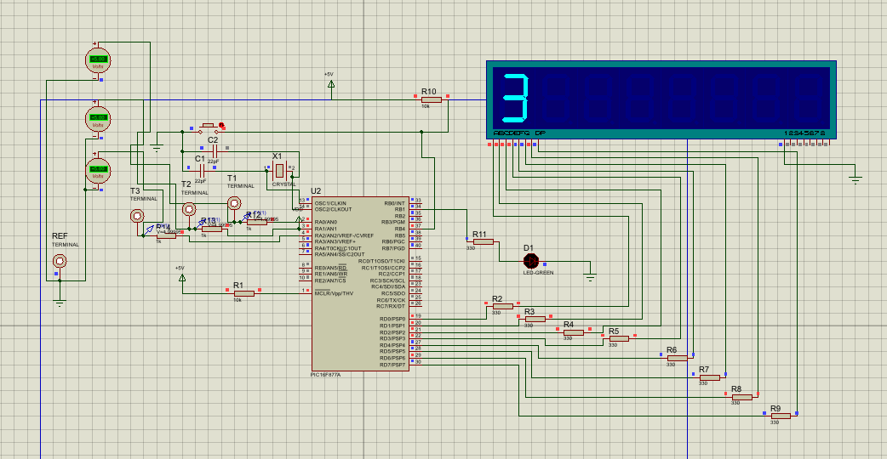
The behaviour observed in the physical prototype closely matched the simulation results, confirming that the design translates effectively from a virtual environment to real hardware. This consistency strengthens the validity of the simulation model used during development

5.3 System Behaviour During Normal Operation
In normal operation, TP1 and TP2 are high while TP3 is low. The LED indicator is on, and the seven-segment display shows “0”. Measurements confirmed approximately 5 V at TP1 and TP2, and 0 V at TP3, indicating correct power delivery to the load [10].
From a diagnostic perspective, the presence of voltage at the expected points and an active load confirms correct circuit operation, consistent with standard voltage tracing methods [6]. Results from the physical prototype matched the simulation, confirming correct system behaviour [21].

5.4 Power Supply Failure Simulation
In this condition, TP1, TP2 and TP3 are all low, and the LED indicator is off. The seven-segment display shows “1”. Measurements confirmed approximately 0 V at all test points, representing a loss of supply consistent with expected circuit behaviour [10].
The absence of voltage at the first test point indicates a power supply fault, which is confirmed by the lack of voltage throughout the circuit [11]. Results from the physical prototype matched the simulation, validating system behaviour [21].

5.5 Open Circuit Fault Simulation
In this condition, TP1 is high while TP2 and TP3 are low. The LED indicator is off, and the seven-segment display shows “2”. Measurements confirmed approximately 5 V at TP1 and 0 V at TP2 and TP3, indicating an interruption in the circuit path [10].
From a diagnostic perspective, the loss of voltage between TP1 and TP2 identifies the location of the fault, consistent with voltage tracing techniques [11]. Results from the physical prototype matched the simulation, confirming accurate fault representation [21].

5.6 Load Failure Simulation
In this condition, TP1, TP2 and TP3 are all high, while the LED indicator remains off. The seven-segment display shows “3”.
Measurements confirmed approximately 5 V at all test points, indicating that voltage is present throughout the circuit [10].
Despite this, the load does not operate, indicating a failure within the load component itself. This reflects a common diagnostic scenario where voltage presence does not guarantee correct operation [11].
Results from the physical prototype matched the simulation, validating system performance [21].

5.7 Summary of Experimental Results
The results obtained from testing the simulator are summarised in Table 5.1.
The results confirm that each fault condition produces a unique combination of voltage values. These patterns allow the fault location to be identified using systematic measurement techniques.
Table 1 Expected behaviour
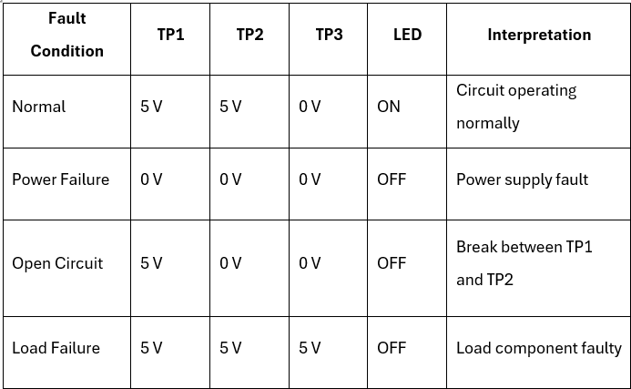
The measured voltage values closely aligned with the expected output patterns defined in the firmware, confirming that the system behaves as intended. This agreement between expected and observed results provides confidence in both the design and implementation of the simulator

5.8 Diagnostic Reasoning Using Test Points
The simulator enables students to practise the diagnostic reasoning process used in electrical troubleshooting. Fault identification typically begins by verifying the power supply and then progressing through the circuit using voltage tracing, where measurements are taken sequentially to locate where voltage is lost [6], [11].
The system replicates this process by providing test points at different stages of the circuit, allowing users to interpret measurements and identify fault locations. This structured, hands-on approach supports effective learning by linking practical experience with theoretical understanding [14].

5.9 Evaluation of System Performance
The testing results indicate that the system performs reliably in both simulation and physical implementation. Each fault scenario produced the expected output pattern, with consistent responses to push button inputs. This deterministic behaviour is characteristic of microcontroller-based systems, where predefined logic ensures predictable and repeatable outputs [2].
The seven-segment display correctly indicated the active fault condition, while the LED load indicator behaved consistently with the simulated circuit. The use of lookup tables ensured stable output patterns across repeated tests, allowing identical fault conditions to be reproduced. This repeatability is particularly important in training applications, where consistent behaviour supports structured learning [14].
Agreement between Proteus simulation and physical testing further validates the design. Measured voltages matched expected values, confirming that the system translates effectively from simulation to hardware. This alignment is a key indicator of successful engineering validation [21].
However, the system operates under controlled conditions and does not account for real-world factors such as electrical noise, component tolerances or environmental variation. While suitable for educational use, additional testing would be required to assess performance in more complex or industrial environments.

5.10 Educational Effectiveness
One of the primary objectives of this project was to develop a training tool that enables students to practise electrical fault-finding techniques. Testing demonstrated that the simulator produces clear and distinguishable fault conditions that can be diagnosed using voltage measurements, consistent with established diagnostic methods [6].
The inclusion of multiple test points encourages a structured troubleshooting approach. By measuring voltages sequentially, users apply logical reasoning to identify fault locations, reflecting standard voltage tracing techniques used in engineering practice [11].
The push button interface allows rapid cycling of fault conditions, improving usability in laboratory settings and supporting interactive teaching. This form of hands-on learning is known to enhance understanding and retention of engineering concepts [14].
The microcontroller-based design also provides flexibility, allowing fault conditions to be modified or expanded through software without altering the hardware [2]. As a result, the simulator supports the development of diagnostic reasoning by requiring users to interpret measurement data rather than relying on predefined indicators.
While the clear distinction between fault conditions is beneficial for learning, it reduces the ambiguity typically present in real systems. Therefore, although the simulator is effective for foundational training, additional complexity or real-world application would be required to fully replicate practical diagnostic challenges.

5.11 Limitations of the simulator
Although the simulator performs effectively for the selected scenarios, several limitations are present. The system represents voltages using digital logic levels rather than true analogue behaviour. In real circuits, voltages may vary continuously and faults often produce partial drops rather than complete loss of power [10]. This simplification reduces the realism of the simulated fault conditions.
The number of fault scenarios is also limited, with only three implemented. While this supports clarity and usability, it restricts the complexity of troubleshooting tasks, reflecting a trade-off between simplicity and functionality common in engineering design [4]. This could be addressed by introducing additional and more varied fault conditions.
The current system cycles through fault states sequentially, which may allow users to predict conditions rather than diagnose them. Randomising fault selection in future iterations would improve the effectiveness of the training by encouraging genuine diagnostic reasoning.
The seven-segment display provides a simple indication of the active fault but offers limited diagnostic feedback compared to real systems, where more detailed interfaces are typically used. Similarly, the absence of analogue variation further limits the system’s ability to represent more complex electrical behaviour, restricting its use to introductory training scenarios.
A further limitation is observed in the power supply fault condition, where a 0 V reading may indicate either no supply or equal potential at both measurement points. This ambiguity could make diagnosis difficult for inexperienced users. While this reflects a real measurement challenge, it was not fully considered in the initial design and could be improved by introducing clearer fault conditions or additional guidance.

5.12 Chapter Summary
This chapter presented the results from testing the electrical fault simulator in both the Proteus simulation environment and the physical prototype. The system successfully reproduced four operating conditions, including normal operation and three common faults. The voltage patterns observed at the test points matched the expected behaviour defined in the firmware, confirming correct operation and validation across both simulated and real-world conditions [21].
The results demonstrate that the simulator provides an effective platform for practising electrical troubleshooting techniques, supporting established diagnostic methods [6]. The system was shown to be consistent, accurate and repeatable, although several limitations were identified. The simplified low-voltage design does not fully represent real electrical systems, and a minor discrepancy was observed between simulation (~5 V) and prototype measurements (~4.8 V). However, this variation did not affect system functionality.

CHAPTER 6 – EVALUATION

6.1 Introduction
This chapter evaluates the electrical fault simulation system against the objectives defined in Chapter 1, analysing its performance, strengths, limitations and potential improvements. Such evaluation is essential in engineering design to assess system effectiveness against defined requirements.
The assessment considers technical performance, reliability, educational value and scalability, with testing results compared to expected behaviour to determine overall system effectiveness.
Key design decisions are also reviewed to assess their impact on the outcome, supporting a reflective approach to identifying areas for improvement.

6.2 Evaluation Against Project Objectives
The simulator was evaluated against the objectives defined in Chapter 1, with the primary aim being to develop a system that enables students to practise electrical fault-finding using a simulated circuit environment.
This objective was successfully achieved. The system generates multiple fault conditions that can be diagnosed through voltage measurements at defined test points, with consistent and predictable behaviour supporting structured troubleshooting.
The simulator demonstrates strong functional reliability in both simulation and physical implementation. The use of deterministic lookup tables ensures repeatable output patterns, which is beneficial for educational use as it allows users to practise diagnostic techniques under consistent conditions.
However, this deterministic behaviour limits realism. In practical systems, faults may be intermittent or exhibit partial failure modes, which are not represented in the current design. While this reduces suitability for advanced training, the simplified behaviour is appropriate for introductory learning, where clarity and repeatability are prioritised.

6.2.1 Objective 1: Design a simple electrical circuit suitable for fault-finding training
The first objective was to design a circuit that represents a simplified electrical system while still allowing meaningful troubleshooting exercises to be performed. This objective was successfully achieved by implementing a circuit consisting of a simulated power supply, switching stage and load indicator. The circuit also includes three test points that allow voltage measurements to be taken during troubleshooting, with a fourth reference being an earth reference point.
The simplicity of this design makes it suitable for educational purposes because students can clearly understand the structure of the circuit. At the same time, the test points provide sufficient diagnostic information to allow faults to be identified using systematic measurement techniques. So, this objective can be considered successfully achieved.

6.2.2 Objective 2: Implement a system capable of simulating multiple electrical faults
The second objective was to create a system that can simulate different fault conditions within the circuit.
The simulator currently implements four operating states:
- Normal operation
- Power supply failure
- Open circuit fault
- Load failure
Each fault condition produces a unique combination of voltage measurements at the test points. These patterns allow the user to determine the fault location through voltage tracing.
Testing confirmed that the microcontroller firmware correctly generates the output patterns required for each scenario. The push button input allows the user to cycle through the available fault conditions, making it easy to demonstrate different troubleshooting situations.
As a result, this objective was also successfully achieved.

6.2.3 Objective 3: Provide measurable test points for diagnostic analysis
A critical requirement of the system was the inclusion of test points that allow voltage measurements to be taken during troubleshooting exercises. The simulator has three test points connected to pins RA0, RA1 and RA2 of the microcontroller. The fourth test point is connected to the negative rail of the breadboard, providing a 0V reference point.
During testing the voltages measured at these points matched the expected behaviour defined in the firmware lookup tables. Each fault condition produces a unique voltage pattern which can be interpreted to determine the fault location. This highlights that the system successfully replicates the measurement process used in real electrical troubleshooting.
Hence, this objective has also been met.

6.2.4 Objective 4: Provide a user interface for selecting fault conditions
Another objective of the project was to provide a simple user interface that allows fault scenarios to be changed during operation. This functionality was realised using a push button connected to pin RB4 of the microcontroller. Each time the button is pressed the fault variable increments and the system switches to the next fault condition.
The seven-segment display connected to PORTD gives feedback indicating which fault scenario is currently active. Testing confirmed that this interface works reliably. Each button press correctly advances the system to the next fault condition and the display updates accordingly.
This objective has been successfully achieved. However, this does include the current limitation of the seven-segment display until this has been corrected.

6.2.5 Objective 5: Implement and test the system using simulation software
The final objective was to design and evaluate the system within a simulation environment. The Proteus Design Suite was used to simulate both the electrical circuit and the microcontroller firmware. This allowed the behaviour of the system to be tested without constructing physical hardware.
The simulation environment provided virtual measurement instruments which allowed the voltage levels at the test points to be observed and analysed. Testing within Proteus confirmed that the system behaves exactly as expected for each fault scenario. This exhibits that the design is functional and has the correct characteristics to then be implemented in a hardware-based prototype.
Hence, this objective has also been achieved.

6.3 Strengths of the System
The electrical fault simulator demonstrates several strengths that make it suitable for educational use. A key advantage is its simplicity, with a straightforward circuit structure that allows students to focus on developing troubleshooting skills without being overwhelmed by complex behaviour.
The use of a microcontroller to generate fault conditions provides significant flexibility, as multiple scenarios can be implemented through software without modifying the hardware. This approach simplifies system expansion and maintains consistent performance. Similarly, the use of lookup tables ensures that each fault condition produces a defined output pattern, supporting repeatability and ease of modification.
The simulator also provides a realistic diagnostic experience by requiring users to interpret voltage measurements, encouraging logical reasoning and reflecting real-world troubleshooting techniques.
Finally, the use of simulation software enables safe and efficient testing, allowing faults to be validated and design issues identified prior to physical implementation.

6.4 Limitations of the Current Design
Although the system performs effectively for the selected scenarios, several limitations are present. A key limitation is the use of digital logic levels to represent voltage, rather than true analogue behaviour. In real circuits, voltages may vary continuously and faults often produce partial drops rather than complete loss of power [10]. This reduces the realism of the simulation.
The number of fault conditions is also limited, with only three scenarios implemented. While sufficient for demonstrating basic troubleshooting principles, this restricts the complexity of training. Expanding the range of faults would improve both realism and educational value.
The user interface is relatively simple, with the seven-segment display indicating only the active fault number. This requires instructor input to confirm correct diagnosis. A more advanced interface allowing user input and feedback would improve interactivity and support independent learning.
In addition, the prototype is breadboard-based, which limits durability and long-term reliability. A printed circuit board (PCB) implementation would be required for practical deployment.
Overall, the abstraction of circuit behaviour into discrete logic levels simplifies implementation and improves clarity but does not capture gradual voltage changes caused by resistance, poor connections or component ageing. As a result, the system is best suited to introductory training rather than advanced fault diagnosis.

6.5 Potential Improvements
Although the system meets its intended objectives, several improvements could enhance its functionality and educational value. Additional fault conditions could be implemented through firmware updates, such as intermittent faults, incorrect switching behaviour or time-dependent faults. This highlights the flexibility of microcontroller-based systems, where functionality can be extended without hardware modification [2].
More advanced fault simulation could be achieved through additional hardware. For example, digital-to-analogue converters or variable resistance networks could introduce gradual voltage changes, improving realism compared to simple logic levels. Additional components such as relays or switching networks could also be used to simulate faults including short circuits or component degradation [10].
The user interface could be improved by replacing the seven-segment display with a more advanced display such as an LCD module. The original choice of a seven-segment display was based on simplicity and ease of integration [2]; however, it was not permanently mounted during prototyping to allow flexibility while refining system behaviour. This reflects a practical development approach, where design decisions remain adaptable until validation is complete [5].
Further improvements include implementing a PCB-based design to improve durability and suitability for long-term use, as well as expanding the system to include multiple interconnected circuits. This would allow more complex, system-level fault scenarios to be introduced, increasing scalability and supporting more advanced training applications [14].

6.7 Chapter Summary
This chapter has evaluated the electrical fault simulation system developed in this project. The evaluation reveals that the system successfully meets the objectives defined at the beginning of the project and provides a functional platform for practising electrical troubleshooting techniques. The simulator exhibits several strengths, including its simplicity, flexibility and educational value. However, certain limitations were also identified, including the limited number of fault scenarios and the use of digital voltage simulation.
Despite these limitations, the system provides a solid foundation for future development and demonstrates the potential of microcontroller-based systems as educational training tools.

CHAPTER 7 – CONCLUSIONS AND RECOMMENDATIONS

7.1 Introduction
This chapter summarises the work carried out and presents the main conclusions from the design, implementation and testing of the electrical fault simulation system. It also outlines potential improvements to enhance system functionality and educational value.
The project aimed to develop a microcontroller-based fault simulator capable of demonstrating common electrical faults in a safe and controlled environment. This objective was achieved through the design and implementation of a system based on the PIC16F877A microcontroller, validated in the Proteus simulation environment and successfully realised as a physical prototype.

7.2 Summary of Project Work
The project began by examining the importance of electrical fault diagnosis in engineering practice, where the ability to identify faults is an essential skill. Traditional teaching methods often focus on theory and provide limited opportunity for practical troubleshooting, leading to the development of a system that enables structured, hands-on learning.
The system simulates a simplified circuit consisting of a power supply, switching stage and load indicator. A PIC16F877A microcontroller controls the circuit by generating voltage patterns at three test points, allowing users to diagnose faults through measurement. Fault conditions are selected using a push button, with a seven-segment display indicating the active scenario. The firmware was developed in C using lookup tables to define system behaviour.
The system was initially validated in the Proteus simulation environment before being implemented as a physical prototype using a breadboard-based design. Testing confirmed that both simulation and hardware produced the expected voltage patterns and responded correctly to user inputs.

7.3 Key Findings
The testing results demonstrate that the electrical fault simulator operates as intended. The microcontroller reliably generates the required voltage patterns for each fault condition, which can be analysed at the test points to identify fault locations using structured troubleshooting techniques. Consistency between simulation and physical testing confirms the reliability of the system design.
The use of lookup tables within the firmware enables multiple fault conditions to be implemented without modifying the hardware, demonstrating the flexibility of microcontroller-based control.
The results also highlight the educational value of the system. By requiring users to interpret voltage measurements, the simulator encourages a logical diagnostic approach rather than guesswork, supporting the development of practical troubleshooting skills. The Proteus environment proved effective for initial validation, while the physical prototype confirmed the system’s suitability as a real-world training tool.

7.4 Achievement of Project Aim
The primary aim of the project was to design and develop a system that allows students to practise electrical fault-finding techniques using a simulated circuit environment. Based on the results obtained during testing, this aim has been successfully achieved.
The system developed during the project provides a realistic representation of electrical faults within a simplified circuit. The inclusion of test points allows voltage measurements to be taken in the same way that an engineer would analyse a real circuit. The push button interface allows multiple fault conditions to be demonstrated, while the seven-segment display provides a clear indication of the current fault scenario. The successful construction and testing of the physical prototype further confirms that the system can be deployed as a practical training tool rather than being limited to simulation.
Overall, the simulator provides a functional and effective platform for teaching basic electrical troubleshooting techniques.

7.5 Benefits of the System
The electrical fault simulator developed in this project offers several benefits for engineering education. One of the most important benefits is safety. Because the system operates at low voltage and within a controlled design, students can practise fault diagnosis without being exposed to hazardous electrical conditions.
Another benefit is repeatability. Each fault condition can be reproduced consistently, allowing students to repeat diagnostic exercises multiple times until they fully understand the troubleshooting process. The system is also flexible. Additional fault scenarios can easily be achieved by modifying the firmware lookup tables. This allows the training system to be expanded as required.
Finally, the system is cost effective. The hardware required for the simulator is relatively simple and inexpensive, meaning that multiple units could potentially be deployed in teaching laboratories.

7.6 Recommendations for Future Work
Although the system meets its intended objectives, several improvements could enhance its functionality and educational value. Identifying such opportunities is a key part of the engineering design process, where systems are refined to better meet user requirements [4].
Additional fault scenarios could be implemented through firmware modifications without changing the hardware. Examples include intermittent faults, incorrect switching behaviour and partial signal loss using timed or conditional logic. These additions would increase diagnostic complexity while demonstrating the flexibility of microcontroller-based systems [2].
Further improvements could be achieved through additional hardware. The inclusion of digital-to-analogue converters or variable resistance networks would allow simulation of gradual voltage changes rather than discrete logic levels. Additional circuitry, such as multiple circuit paths, sensors or relay-based fault injection, could enable more realistic faults including short circuits, overload conditions and component degradation, improving alignment with real-world behaviour [10].
The user interface could also be enhanced by replacing the seven-segment display with a more advanced display such as an LCD module, providing more detailed feedback. The seven-segment display was initially selected for its simplicity and ease of integration [2], and was not permanently mounted during prototyping to maintain flexibility while refining system behaviour. This reflects a practical development approach, where components remain adaptable until fully validated [5].
Further development could include implementing a PCB-based design to improve durability and suitability for long-term use, reducing wiring complexity and improving reliability [21]. Expanding the system to include multiple interconnected circuits would also support more advanced troubleshooting scenarios, increasing scalability and enhancing its value as an educational tool [14].

7.7 Final Conclusion
This project successfully demonstrated the design, implementation and validation of a microcontroller-based electrical fault simulator for educational use. The system uses a PIC16F877A microcontroller to generate simulated circuit behaviour representing common electrical fault conditions. Test points enable voltage measurements, allowing users to diagnose faults using structured troubleshooting techniques.
Results from both simulation and physical testing confirmed reliable operation, with each fault condition producing the expected behaviour. The successful construction of a breadboard-based prototype with enclosure-mounted interface components demonstrates the practicality of the design as a training tool.
The project highlights the effectiveness of microcontroller-based systems for simulating electrical behaviour. By implementing faults through software, multiple scenarios can be generated without modifying the hardware, providing a flexible and scalable platform.
However, several limitations were identified. The seven-segment display operates in an inverted manner, displaying values through unlit segments, which led to its removal from the user interface to avoid confusion. In addition, the breadboard-based design is not suitable for long-term use and would require a PCB implementation to improve durability and consistency.
Despite these limitations, the system meets the objectives defined in Chapter 1 and provides a solid foundation for further development. The design is scalable and can be extended through both firmware and hardware improvements. Overall, the project demonstrates the potential of embedded systems to enhance engineering education by providing safe, flexible and practical learning tools.

References
[1] SunPCB, “PIC16F877A Pinout Diagram,” SunPCB, 2025. [Online]. Available: https://www.sunpcb.com/uploads/20250423/99aa9b32f7d37d411f5f7979664a6c9c.webp. [Accessed: 4 Apr. 2026].
[2] M. Mazidi, R. McKinlay and D. Causey, PIC Microcontroller and Embedded Systems: Using Assembly and C for PIC18, Upper Saddle River, NJ, USA: Pearson, 2008.
[3] Microchip Technology, “PIC16F877A Data Sheet,” 2023.
[4] F. Vahid and T. Givargis, Embedded System Design: A Unified Hardware/Software Introduction, New York, NY, USA: Wiley, 2002.
[5] S. Heath, Embedded Systems Design, 2nd ed. Oxford, U.K.: Newnes, 2003.
[6] R. Isermann, Fault-Diagnosis Systems: An Introduction from Fault Detection to Fault Tolerance, Berlin, Germany: Springer, 2006.
[7] P. M. Frank, “Fault diagnosis in dynamic systems using analytical and knowledge-based redundancy,” Automatica, vol. 26, no. 3, pp. 459–474, 1990.
[8] J. Chen and R. J. Patton, Robust Model-Based Fault Diagnosis for Dynamic Systems, Boston, MA, USA: Springer, 1999.
[9] S. Simani, C. Fantuzzi and R. J. Patton, Model-Based Fault Diagnosis in Dynamic Systems Using Identification Techniques, London, U.K.: Springer, 2003.
[10] A. S. Sedra and K. C. Smith, Microelectronic Circuits, 7th ed. Oxford, U.K.: Oxford University Press, 2015.
[11] J. Bird, Electrical Circuit Theory and Technology, 6th ed. Oxford, U.K.: Routledge, 2017.
[12] Labcenter Electronics, “Proteus Design Suite User Guide,” 2023.
[13] F. P. Incropera et al., Fundamentals of Engineering, 6th ed. Hoboken, NJ, USA: Wiley, 2011.
[14] J. Biggs and C. Tang, Teaching for Quality Learning at University, 4th ed. Maidenhead, U.K.: Open University Press, 2011.
[15] S. K. Saha, “Design of laboratory-based learning systems for engineering education,” IEEE Trans. Educ., vol. 53, no. 4, pp. 610–615, 2010.
[16] D. G. Alciatore and M. B. Histand, Introduction to Mechatronics and Measurement Systems, 4th ed. New York, NY, USA: McGraw-Hill, 2012.
[17] K. Ogata, Modern Control Engineering, 5th ed. Upper Saddle River, NJ, USA: Pearson, 2010.
[18] J. W. Nilsson and S. A. Riedel, Electric Circuits, 10th ed. Boston, MA, USA: Pearson, 2015.
[19] C. K. Alexander and M. N. O. Sadiku, Fundamentals of Electric Circuits, 6th ed. New York, NY, USA: McGraw-Hill, 2017.
[20] P. Horowitz and W. Hill, The Art of Electronics, 3rd ed. Cambridge, U.K.: Cambridge University Press, 2015.
[21] A. S. Morris and R. Langari, Measurement and Instrumentation: Theory and Application, 2nd ed. Oxford, U.K.: Academic Press, 2012.
[22] R. Pallás-Areny and J. G. Webster, Sensors and Signal Conditioning, 2nd ed. New York, NY, USA: Wiley, 2001.
[23] M. Barr and A. Massa, Programming Embedded Systems: With C and GNU Development Tools, 2nd ed. Sebastopol, CA, USA: O’Reilly, 2006.
[24] E. A. Lee and S. A. Seshia, Introduction to Embedded Systems: A Cyber-Physical Systems Approach, 2nd ed. Cambridge, MA, USA: MIT Press, 2017.
[25] H. Kopetz, Real-Time Systems: Design Principles for Distributed Embedded Applications, 2nd ed. Boston, MA, USA: Springer, 2011.
[26] M. J. Pont, Patterns for Time-Triggered Embedded Systems, Harlow, U.K.: Addison-Wesley, 2001.
[27] D. J. Smith, Reliability, Maintainability and Risk: Practical Methods for Engineers, 9th ed. Oxford, U.K.: Butterworth-Heinemann, 2017.
[28] A. Hughes and B. Drury, Electric Motors and Drives: Fundamentals, Types and Applications, 5th ed. Oxford, U.K.: Elsevier, 2019.
[29] R. C. Dorf and J. A. Svoboda, Introduction to Electric Circuits, 9th ed. Hoboken, NJ, USA: Wiley, 2014.
[30] B. Razavi, Fundamentals of Microelectronics, 2nd ed. Hoboken, NJ, USA: Wiley, 2014.

Appendix

Appendix A - Proteus Design
Figure 13 Appendix 1 - Proteus system design
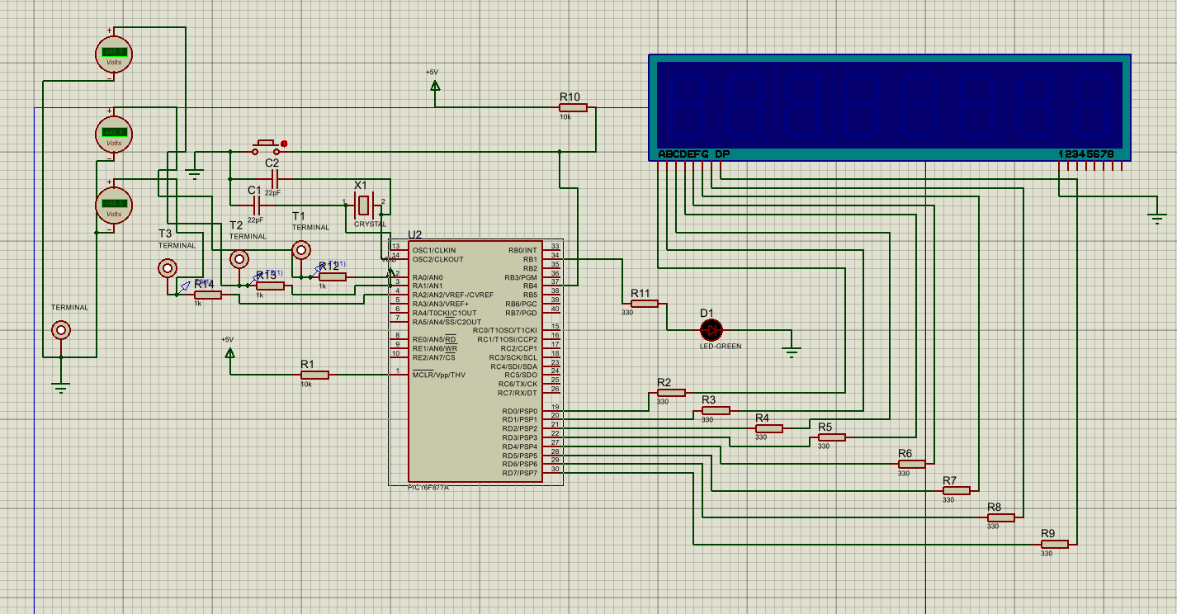

Appendix B – Source Code
Figure: Screenshot of microcontroller firmware.
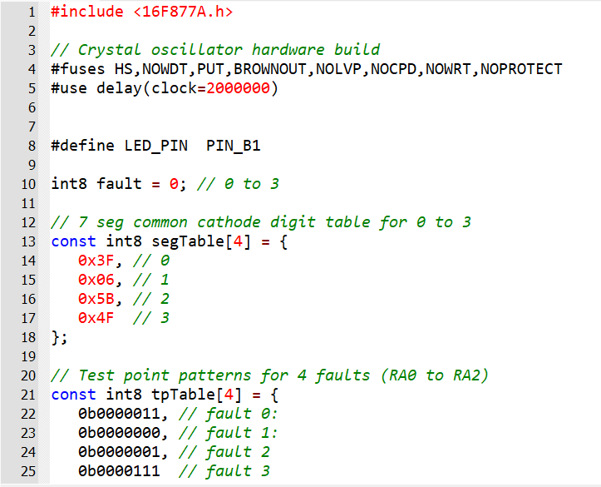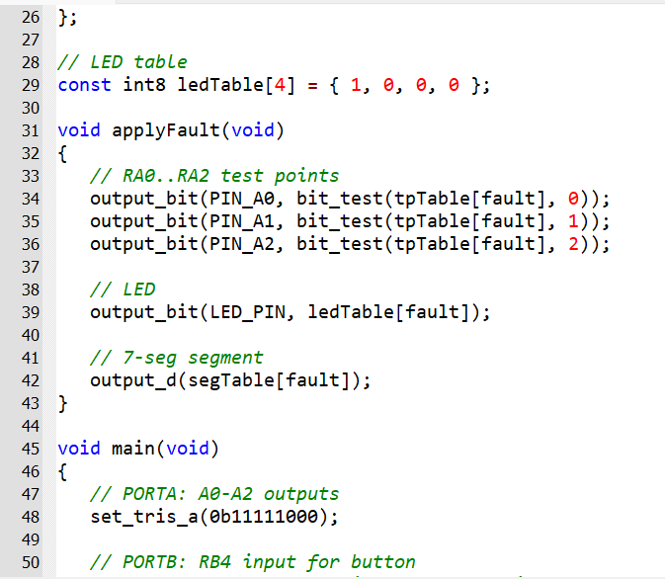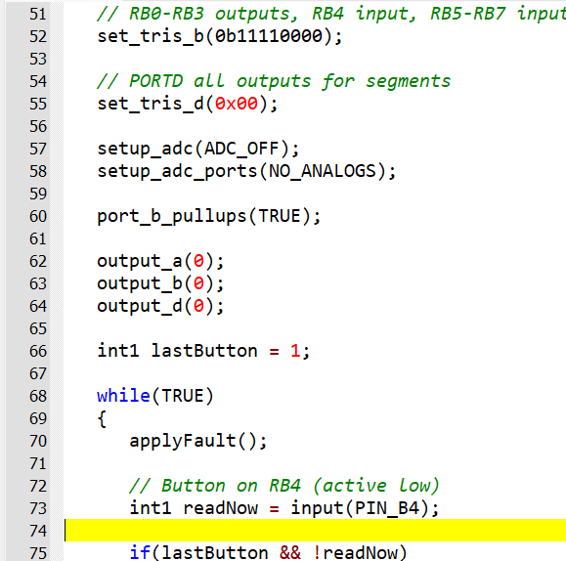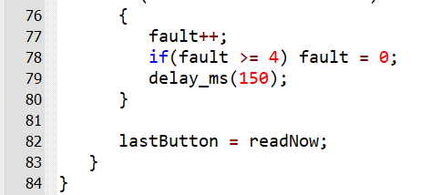

Appendix C – Professional and Engineering Practice Considerations
The project required consideration of ethical, safety and professional responsibilities. A key ethical decision was the use of a low-voltage (5 V) system to eliminate electrical hazards, prioritising user safety over realism. In addition, care was taken to ensure that simulated faults reflect real diagnostic principles, avoiding misleading representations.
A basic risk management approach was applied. Key risks included electrical hazards, incorrect fault behaviour and hardware reliability. These were mitigated through low-voltage design, simulation-based validation and proposed improvements such as PCB implementation.
The system supports inclusive learning by providing a simple and accessible platform for users with varying experience levels. However, reliance on visual indicators may limit accessibility, highlighting an area for future improvement.
Quality was ensured through a structured design process, with simulation followed by physical testing to validate performance. Identified limitations form part of a continuous improvement approach.
Engineering management principles were applied through planning, iterative development and use of low-cost, widely available components. While legal considerations are limited, future development would require compliance with safety standards.
The project also contributed to ongoing professional development, including skills in embedded systems, simulation and system validation, supporting lifelong learning.

