Level 6 Hotel Placement – Weekly Journal Entry

Madalina Imbrea
2127378
Jessica Newport
Managing Guest Service Operations (BMIH6003)

Front Office

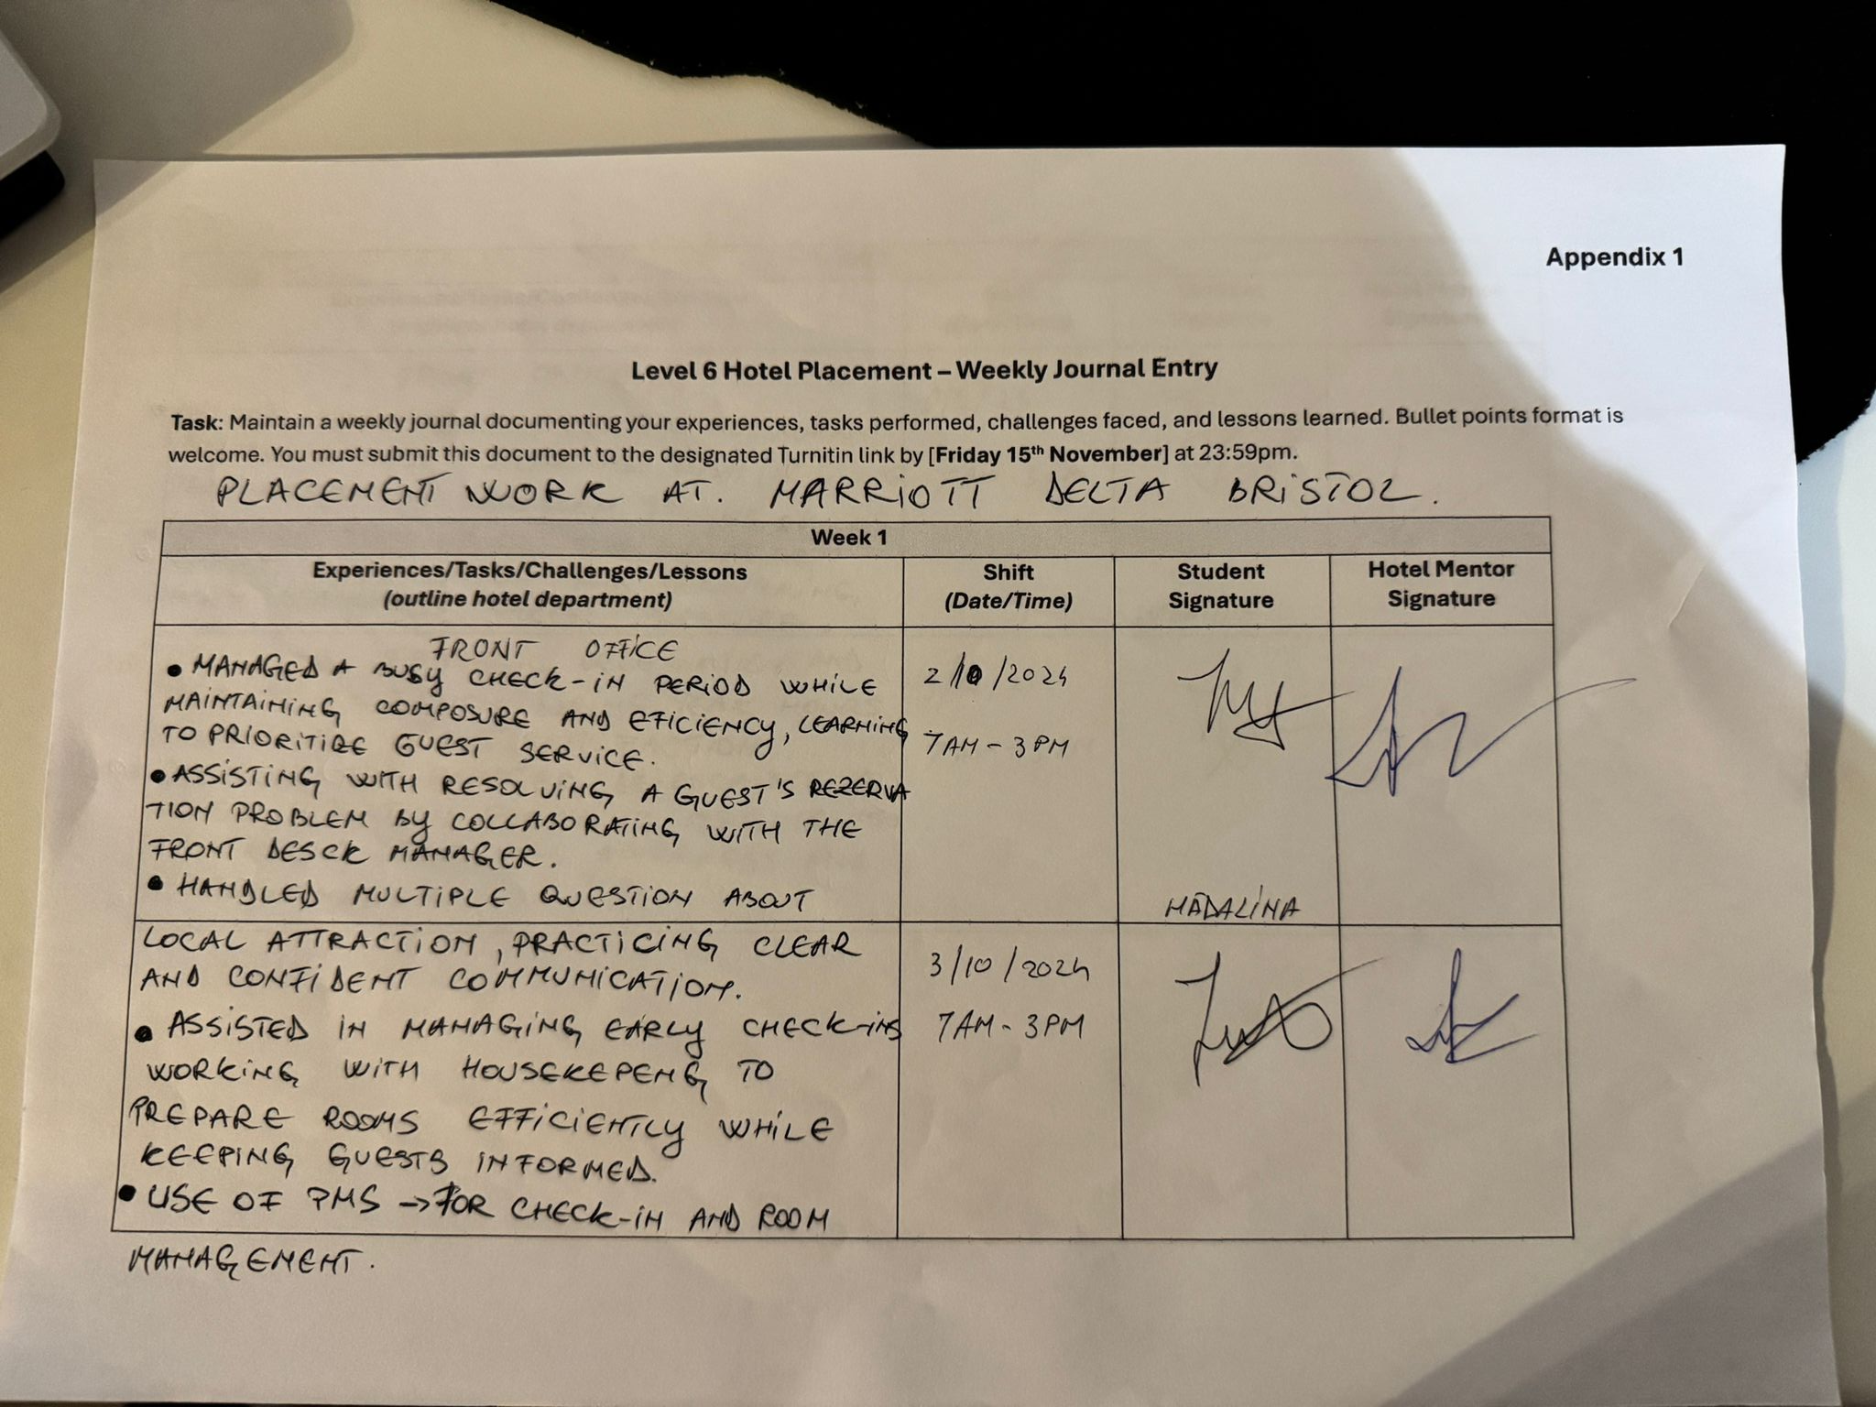

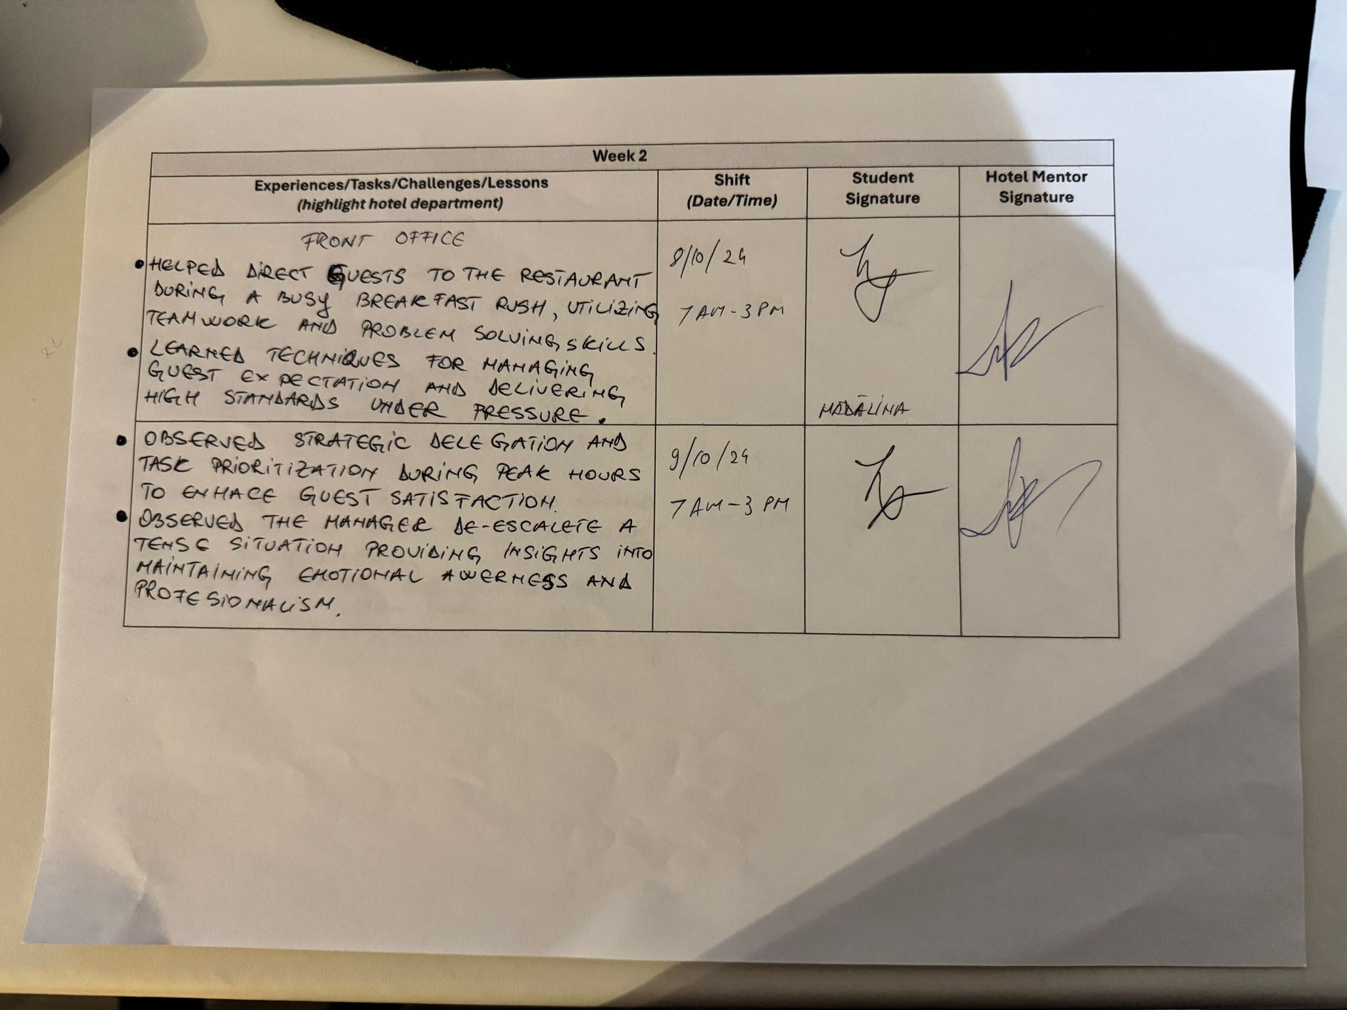

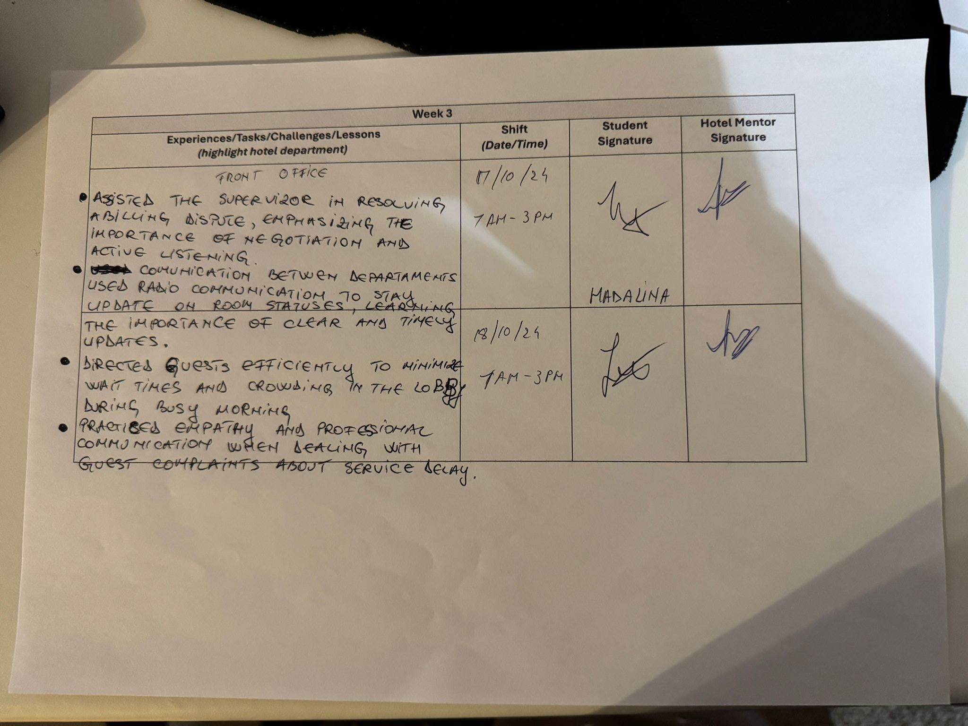

Food and Beverage -Kitchen



