STRATEGIC MANAGEMENT ASSIGNMENT

Name Amanpreet Kaur
Student id 2229957
Executive Summary
In this report, the purpose of the report has been implementing strategic options for a better customer service approach. Background of the company has been illustrated in the report. Definition of the significant concepts like business strategy and strategy has been elaborated in this report. PESTLE analysis has been conducted in order to do an external analysis for RyanAir Holdings PLC. Internal analysis has been done through SWOT analysis. Strategic options like Social penetration theory and Cost leadership strategy has been illustrated in this report. Social penetration theory has been recommended for RyanAir to enhance its customer service.
Table of Contents
2. Introduction 6
2.1 Report remit 6
2.2 Background of the Organisation 6
2.3 Definition of significant concepts 9
3. Main body 13
3.1 External analysis 13
3.2 Internal analysis 18
4. Strategic option 22
5. Conclusion 28
Reference List 30
Appendices 35

List of Figures
Figure 1: The customer growth of Ryanair Holdings 7
Figure 2: Employee base of Ryanair Holdings Plc 8
Figure 3: annual revenue of Ryanair Holdings Plc 9
Figure 4: Strategic framework 11
Figure 5: PESTLE 12
Figure 6: Constructivist theory 22
Figure 7: Simulation theory of empathy 23
Figure 8: Affect theory 24
Figure 9: Social penetration theory 25
Figure 10: Seven C’s of communication 26
Figure 11: Johari window model 27
Figure 12: Cost leadership strategy 28

List of Tables
Table 1: Pestle analysis 17
Table 2: SWOT analysis 20

2. Introduction
Strategic management is an ongoing process that helps a company to set goals and objectives through its various channels. In this strategic management assignment, report remit is provided with the explanation of the purpose of the report. The study has clearly analysis the strategic management operation of Ryanair Holdings PLC which is Airline Company in UK. Background of Ryanair Holdings PLC has been elaborated briefly with the definition of the significant concepts. External analysis is used for identifying the issues and possibilities that affect the company. PESTLE is used for elaborating the possible scenarios of the external factors that affect Ryanair Holding PLC. Internal analysis is discussed in the project for a better understanding of the company. SWOT analysis is taken as a tool for explaining the internal strength, weaknesses, opportunities and threats. Strategic options are to be recommended for the company for a better operation for the company.

2.1 Report remit
Purpose of the report is to focus on a creative reshaping of the organisation's strategic direction for discovering a new way forward to deliver innovative customer care facilities. This can help the company to ensure future resilience and help it for a sustainable competitive advantage. One of the main purposes of this report is to conduct external and internal analysis for identifying the factors that could be improved and things that can affect the company's operations. Strategic options implication that could enhance the operation of the company after incorporating is recommended.

2.2 Background of the Organisation
Ryanair Holdings Plc is the most significant airline group as well as the parent company of Ryanair UK, Ryanair, Laud, Buzz and Malta Air. Ryanair Holdings Plc mainly provides low fares airline-related services (corporate.ryanair.com, 2023). It contains internet, scheduled services, as well as mothers services such as third parties across a “European route network”. Moreover, the organisation has also provided a variety of subsidiary services, and other performance associated with its core air passenger service, as well as non-flight scheduled services, internet-related services, and the in-flight auction of beverages, foodstuff, and products (Forbes.com, 2023). The company was establishing in 1996 in Dublin, Ireland. The chief executive officer of this organisation is Michael O’Leary (Forbes.com, 2023). In addition, the company is the greenest, cleanest airline collection with determined sustainability objective for 2030 (corporate.ryanair.com, 2023). The company has connected almost 240 destinations in over 40 nations along with the organisation providing the lowest fares in Europe (Corporate.ryanair.com, 2023). Accordingly, the organisation operates in almost 40 countries as well as over diverse airports. Therefore, the daily flight amount of this organisation is approximately 3000 (corporate.ryanair.com, 2023). The organisation has invested almost $22 billion in 210 Boeing 737-8200 ‘Game changer’ aircraft which can contain more thasn 4% of guests, 16% less fuel and 40% less noise emission (corporate.ryanair.com, 2023). Significantly, the company has received almost 100th game-changer aircraft in their business operation in 2023 (corporate.ryanair.com, 2023). Apart from that, the company has initiated a new feature which can carry 21% more passengers as well as being capable of burning 20%less fuel (corporate.ryanair.com, 2023). Thus, it has helped to make the company to implement sustainable business operations within the workplace.
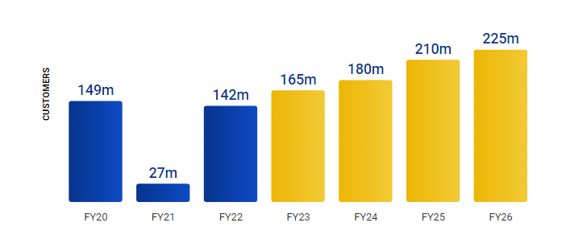

Figure 1: The customer growth of Ryanair Holdings
(Source: corporate.ryanair.com, 2023)
Figure 1 suggests that the customer satisfaction rate of this organisation has increased every year. In the year 2022, the customer base will be 142 million which will increase in 2023 to 165 million (corporate.ryanair.com, 2023). In addition, it can be anticipated that the customer base will be increased by almost 225 million in the year 2026 (corporate.ryanair.com, 2023). The customer satisfaction rate of this organisation is approximately 84% (corporate.ryanair.com, 2023). Thus, the higher rate of customer satisfaction helps the company to increase its brand value and profitability.
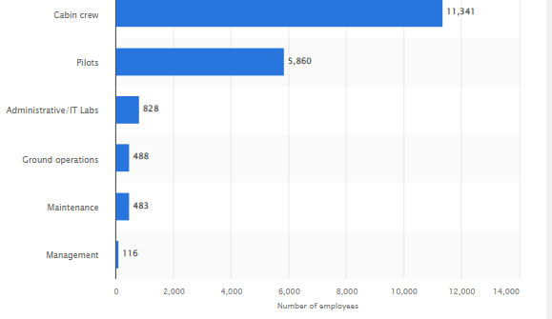

Figure 2: Employee base of Ryanair Holdings Plc
(Source: startista.com, 2023)
As per Figure 2, Ryanair Holdings Plc has employed approximately 198,166 people in its business operation. In addition, the cabin crew employees created more than half of the entire employee’s body along with 11,341 workers (Statista.com, 2023). Moreover, the organisation also hired almost 5,860 pilots which made them the second main group within the employees body (Statista.com, 2023). Thus, high employee support provides the company to increase its productivity and profitability.
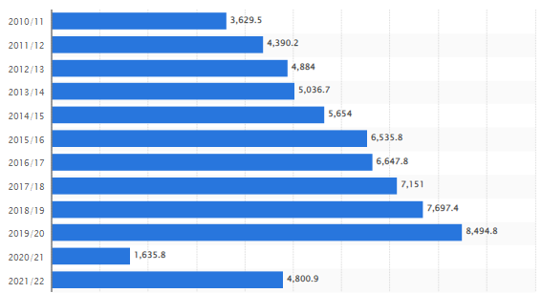

Figure 3: Annual revenue of Ryanair Holdings Plc
(Source: Statista.com, 2023)
The annual revenue of Ryanair Holdings Plc is almost $10.6B, which has dropped almost 1.6 billion in the financial year of 2021 due to Covid pandemic (Statista.com, 2023). In addition, the total assets of this organisation are almost $16.8B (Statista.com, 2023). Significantly, the annual profit of this organisation is almost $1.4B (Forbes.com, 2023). Accordingly, Ryanair Holdings Plc has taken the initiative to make net zero carbon emissions in the year 2050 (corporate.ryanair.com, 2023). Moreover, the organisation initiates the use of 12.5% sustainable aviation fuel by 2030 (corporate.ryanair.com, 2023). Significantly, Ryanair Holdings Plc has invested almost $22 billion in active greener aircraft. Ryanair Holdings Plc took the initiative to reduce almost 66 grams per pax/km by 2030 [Refer to Appendix 1]

2.3 Definition of significant concepts
Strategy
Strategy is the plan of action which fits to achieve desired goals, the destination dictated by a set of decisions. This sets the organisation over its competitors, emanates from the organisation's distinctive features, and is difficult to imitate. According to the comment of Taris and Wandebori (2023), the proper management strategy helps the organisation to execute its goals and objectives by planning and preparing the business context. It clarifies the responsibilities and roles of everyone in the organisation for understanding the purpose of the strategy clearly. Moreover, a clear strategy helps the business organisation to increase its internal stability and management system. According to the study material, strategy is about discover the input issue for the future achievement of organisations operating in competitive marketplaces and ensure they have the resources, competencies and ability for supervision and uphold sustainability.
The study material defines that, the strategy helps to express and define the aim of a company to the stakeholders. According to the comment of El Khatib et al. (2022), the strategy statement contains three major themes such as fundamental goals, scope and advantage. As per the study material, the basic goals which the organisation seeks reflect the stated vision, mission and objectives. In this regard, the domain and scope demonstrate the future capabilities and anticipation of the company's objectives. Thus, the strategy is extremely essential for the business organisation to achieve its desired goals and objectives as well as help to enhance profitability and productivity.
Business level strategy
Business-level strategy is an aggregate of the strategic implementation and planning actions which establish and guide the approach of a particular business unit. In this regard, these actions generally contain how to achieve a competitive advantage and construct consumer value in the exact market the business unit workings. As per the opinion of Gellweiler and Krishnamurthi (2022), the major purpose of a business-level strategy is to enable an organisation to generate more consumer value and achieve a competitive advantage within the market. As per the study material, a business-level strategy encourages the company to it’s the right direction to achieve desired goals and objectives. In this regard, the business-level strategy is mainly focused on product and marketing improvements and permits the development of cost-effective products. According to the study material, Business-level strategy is worried with the means a business seeks to clash productively in its particular market.
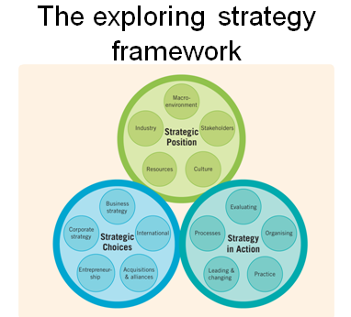

Figure 4: Strategic framework
(Source: Study material)
Based on Figure 4 the strategic framework contains three major factors such as strategic position, strategic choices and strategies in action. This is extremely essential for the organisational business-level strategy to improve products and services because it determines the business process effectively.
Competitive advantage
Competitive advantage guides the factors which permit a company to deliver products or services pleasingly or more cheaply than its competitors. In addition, these elements permit the effective entity to develop more sales or special margins corresponding to its market competitors. According to the opinion of Jahanbakhsh and Amini (2023), a competitive advantage allows a corporation to perform more reasonably than its competitors. It guides the elements by allow a corporation to produce services or products better and for less cost than the competition, which may generate more sales or higher profit limits As per the opinion of Trivedi and Srivastava (2022), becoming a low-cost supplier in the market as well as developing a differentiated and creative service and products can help to increase competitive advantage. Thus, analysing the market, product, service and geography of the business also helps the company to gain a competitive advantage.
The definition of PESTLE analysis

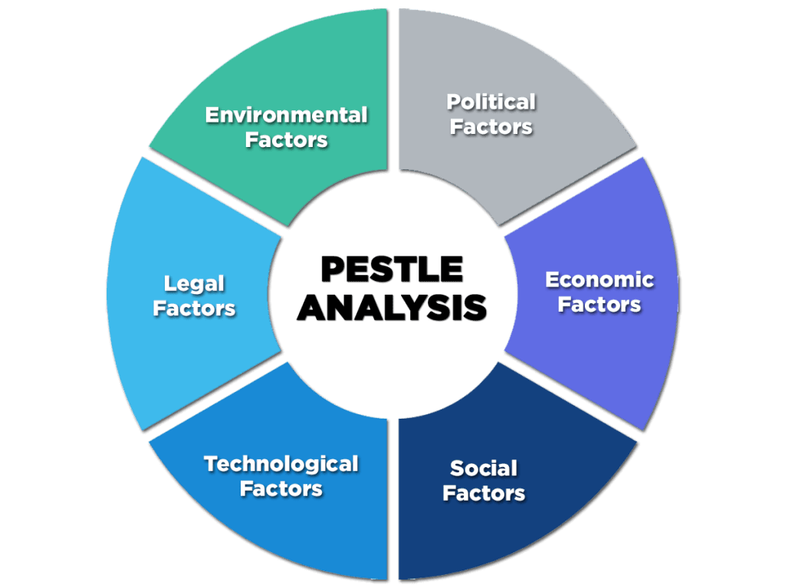

Figure 5: PESTLE
(Source: Yasir et al, 2022)
The PESTLE analysis is an effective business framework which is employed to gain a clear macro vision of an industry environment. As per the comment of Yasir et al. (2022), the PESTLE factor contains six effective characteristics such as “political, economic, social, technological, legal and environmental”. These factors permit a business organisation to construct an effective strategy which helps to create a new industry or business. According to the observation of Zhang and Ponomarenko (2023), the PESTLE analysis provides contextual data regarding the business direction, growth targets, brand position as well as danger to productivity. It can help to decide the soundness of the active products and services as well as describe new product developments.
The definition of SWOT analysis
SWOT analysis is a process for recognize and analyse internal power and flaw and external chance and pressure that form present and prospect operations and help expand strategic goals. The SWOT framework consists of four effective factors such as strengths, Weaknesses, opportunities and threats. As per the opinion of Khamaksorn et al. (2023), SWOT analysis help organisations obtain visibility on their present status, hire them understand and measure overall business performance. In this regard, it lets a business analyse its power, which in turn can help them better go through the market to get together business targets. According to the observation of Yuningsih et al. (2022), the SWOT analysis helps to increase the sales and productivity of a business organisation by analysing and assessing the micro factors which may affect business. Thus, SWOT analysis helps the business organisation to increase its effectiveness in the competitive market.

3. Main body

3.1 External analysis
PESTLE analysis
Factors | Details | Impact on Coca-cola
Political | - The Brexit incident has made an adverse impact on the financial stability of the UK (Economist.com, 2022)  - The UK has achieved political stability with in the nation and its its political stability score is 0.54 (Theglobaleconomy.com, 2022)  - The political stability index m of the UK is -2.5 weak; 2.5 strong  - The rule of law index in the UK has been -2.5 weak; 2.5 strong  - In the UK the political circumstances mainly depend on parliamentary democracy and constitutional monarchy | It can help Ryanair Holdings Plc to execute the business operation in the UK without any political threat.
Economical | - The GDP rate of the UK has massively increased to 0.2% in the April of 2023 (Ons.gov.uk, 2023)  - The rate of inflation in the UK has grown by approximately 6.5% (Ons.gov.uk, 2023)  - The current rate of tax in the UK is almost 20% (Gov. uk, 2023)  - The tax rate has increased by almost 40% in the case of high-income as £50,271 to £125,140 (Gov.uk, 2023)  - The annual revenue of the UK has almost £786.6 billion (Gov.uk, 2023) | The high inflation rate increases the product price as well as affects the purchasing power of consumers resulting in fewer profit margins.
Social | - The rate of population in the UK has almost increased by 0.34% (Macrotrends.net, 2022)  - The present population of the UK has been approximately 67,736,802  - The rate of employment in the UK is approximately 75.5% (Ons.gov.uk, 2023)  - The educational literacy rate in the UK country has been around 99% (Ons.gov.uk, 2023)  - The annual income of the UK population has been £32,300 (Ons.gov.uk, 2023)  - The poverty index of the UK has been 13% (Ons.gov.uk, 2023) | High population increase the sales of Ryanair Holdings
Technological | - The UK is the first technologically advanced country in Europe (Digit Catapult.org.uk, 2022)  - The government of the UK has invested almost £10.4 billion in technological advancement (Digit Catapult.org.uk, 2022)  - In the UK almost 95.7% population are regularly using Internet service (Gov.uk, 2023)  - UK has almost 1300 AI companies which contribute almost £1.47 billion to the economy (Gov.uk, 2023)  - The UK has reached a combined market value of approximately $1 trillion (Gov.uk, 2023) | Permits Ryanair Holdings in the adoption of advanced business strategies
Legal | - The “Employment Act 2002 “ has maintained in the UK to provide proper justice to the workers (Legislation.gov.uk, 2022)  - The “Civil Aviation Act 1982” has been maintained in the UK to regulate, protect and dominate the airport individual information (Legislation.gov.uk, 2022)  - The “Equality Act 2010” has also followed by UK government to prospect population from discrimination and inequality (Legislation.gov.uk, 2022) | Allow Ryanair Holdings to maintain its business ethically
Environmental | - The government of the UK has been concentrates on decreasing climate change by 2030 (Sustainable-environment.org.uk, 2022) | Permits Ryanair Holdings to make a sustainable company

Table 1: Pestle analysis
(Self-created)
Analysis
Based on the above discussion it can be stated that, the political stability of the UK can help Ryanair Holdings Plc to create a proper business strategy and management plan without any political hazard. As per the comment of QUADRI et al. (2023), political stability guides the state of authority being sated and peaceful. A high political stability score increases the financial growth and annual revenue. Moreover, this can effectively boost the Ryanair Holdings Plc's business operation and business efficiency. However, the incident of Bruit has been negatively affecting the financial sectors and stability which can have a direct impact on the Ryanair Holdings Plc business operation. Apart from that, the high inflation rate as well as the high rate of tax is the major drawback of the UK which constantly affects the company's profit margin and sales rate. According to the observation of Zambian et al. (2022), the high inflation rate has decreased the purchasing power of consumers which affects the organisational profitability. The UK has a strong financial stability which is extremely crucial for any business organisation to gain profitability. As per the opinion of Xian et al. (2022), the stable financial stability is effective for properly allocating resources and managing financial rates. The high economical background is extremely effective to enhance the business opportunity to conduct the business operations and can increase the price of its products and can decrease profit margin.
The UK focus on higher technologies and this strength be helpful to Ryanair Holdings Plc to adopt more innovative approaches in its business procedures. As per the statement of Ngoc et al. (2023), a good employ rate can add to the sales proportion of this company as this help in the enhancement of the income level of people. It can adopt an appropriate code of conduct and sustainable approaches in the UK helping to be a sustainable brand. Moreover, a high literacy rate is essential for the business organisation to enhance its profitability because it affects companies positively in the financial stability of a company. The legal circumstances are also essential for this business organization to conduct the operation with ethics. The various initiatives regarding the environmental amenders of the UK government has helped to permit this company to conduct its business sustainability for enhance the health of environment as well as the community. Thus, Ryanair Holdings Plc can effectively maintain its business operation properly because of the peaceful political circumstance and stable economy.

3.2 Internal analysis
Internal analysis is carried out by the SWOT analysis framework.
Strength  - Ryanair Holdings PLC is recognised as Europe’s largest airline group and has been a parent company of Ryanair, Buzz, Ryanair UK, Lauda and Malta Air (corporate.ryanair.com, 2023).  - The company connects over 240 locations in over 40 nations and helps in offering one of the lowest fares in Europe (corporate.ryanair.com, 2023).  - Ryanair’s low cost fare helps trying to implement new customer service techniques for improving attraction of the customers in the long term.  - The company has been able to enhance its annual revenue after experiencing low revenue of £1636 Mn in 2020-2021 (investor.ryanair.com, 2023). | Weaknesses  - Ryanair has been facing a lot of employee strikes throughout the year, such as the employee strike in Belgium (aljazeera.com, 2023).  - Ryanair has been facing negative reviews from their customers for the past 6 years.  - At the time of COVID-19, the CEO of Ryanair said that in the airline industry, it is “idiotic” to maintain social distancing and leave the middle seat empty (bbc.com, 2023).  - Ryanair has experienced 45% of customer satisfaction for 2019 and it is the sixth year consistently Ryanair has come last (bbc.com, 2023).
Opportunities  - Various aviation industry experts have recommended that removal of the restrictions and other bans could help the company to grow in the stock market.  - Answering with taking less time with personalised responses can be a good opportunity for the company to enhance its customer service.  - It has been improving its annual revenue with the lifted bans on travelling for the Pandemic. This improvement in annual revenue can help the company to invest in its customer service management. The organisation earned £4801 Mn in 2022 (investor.ryanair.com, 2023).  - The company received a loan of £600 Mn by the UK government, which has helped the organisation to enhance its revenue after COVID-19 (bnnbloomberg.ca, 2023). | Threats  - Technology has been advancing day by day and this can affect the aviation industry as people now can work from home and travel less. Meetings can be done online only, which can affect Ryanair in earning more revenue.  - Ryanair has lot competitors with better customer service and operations such as EasyJet PLC (forbes.com, 2023).  - Losing customers due to poor customer service when there are many other airlines.  - Rise in inflation is a major threat to the Ryanair as it has just started to recover its losses from the COVID-19 period.

Table 2: SWOT analysis
(Source: Created by Author)
Strengths
Ryanair Holdings PLC is considered as greenest and cleanest airline group. The company has been investing £22 bn in 210 new Boeing 737-820 ‘Gamechnager’ aircraft (corporate.ryanair.com, 2023). The company aims to achieve net-zero carbon emissions by the year 2050. 12.5% sustainable aviation fuel is one of the sustainable approaches that the company eyes on to achieve by 2030 (corporate.ryanair.com, 2023)). These sustainable approaches help the customers to recognise a company with goodwill. Apart from its sustainable approaches, the company has also been offering the lowest fares in Europe. As per the low fares consideration, this helps in attracting more customers towards the airline. The company has been available in more than 40 countries with having a reach of many people in these nations. Company has strong data of the passengers that travel in the aeroplanes, which helps them to identify their buying behaviour.
Weaknesses
Ryanair has been facing issues with the employees and cabin crews as they have been protesting with the strikes. For instance, Ryanair cabin crew has started a five months-long strike in Spain, which caused issues to 1.4 million travellers approximately (euronews.com, 2023). Ryanair’s customer service has been a major weakness of the company and its has been troubling the customers for the last 6 years. Poor customer service has lowered the customer experience as by the conducted survey (bbc.com, 2023). The CEO of Ryanair had given a speech where he said about social distancing being unnecessary. This affected the customers as they were concerned about their health. Customers have been dissatisfied with the service of the company and this resulted in the last ranking of the organisation in a 4000 people survey.
Opportunities
Aviation industry can grow to a new level after the lifting of ban and travel restrictions in the nations. There is an opportunity to gain more revenue for the company with enhancement in its operations for a better future sales performance. Ryanair has been able to increase its revenue after the pandemic as it took a loan, which was backed by the UK government of £600 million (bnnbloomberg.ca, 2023). This is a new opportunity for the company to invest the money in the necessary areas of the organisation so that it can have a major impact on the revenue enhancement. Ryanair has an opportunity to enhance its customer service management with employing new people for customer service. Effective training and development program can be implemented for making the customer service efficient. This can help the company for creating an opportunity for providing a better customer service.
Threats
Technology can be a better aspect and threat to the company as people have started meetings over video calls and people do not travel for meetings as such. People have been able to enhance their working aspect by bringing in meetings over video calls. Competitors have been a major threat to Ryanair, as competitors have been providing very good customer service to their customers. Company might lose customers due to their poor customer service in the long run. Ryanair can be facing issues with generation of revenue as it has major issues in its customer service. People have been rating Ryanair as the worst customer service provider in the aviation industry. The inflation rate as of May, 2023 has been 6.5%, which can increase to 9.7% in the next 12 months (ons.gov.uk, 2023). Ryanair can be influenced by the inflation rate and can reduce efficiency of the company in its operations. It can be concluded that, threats must be focused on as it can hamper the financial performance of a company.

4. Strategic option
Ryanair has been facing issues with the customer service it provides to its customers through various channels, like online, over-call and offline on the airports. Customers are not satisfied and they have termed Ryanair as the worst aviation company with customer service. Few theories can be implemented in the operations of Ryanair for improvement of their customer service.
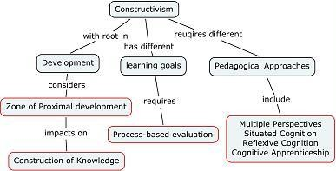

Figure 6: Constructivist theory
(Source: Harland et al., 2019)
Constructivist theory can be implemented for improvement of customer service in the operations of Ryanair. As mentioned by Harland et al. (2019), innovation in customer service with improving engagement with customers can help an organisation with effective customer service. Constructivist theory suggests engagement with customers in such a way that they can understand and it makes sense to them. The customers should be able to understand all the details and things the customer service executive is saying. Strategic implication of the constructivist theory can be helpful for mitigating the issues of customers of Ryanair. Company’s customer service executives should engage in an active dialog for understanding what their customers already know and how the executive can be able to help them. Amount of knowledge of the issues that the customer is having can help the executive by elaborating on the existing knowledge of the customers.
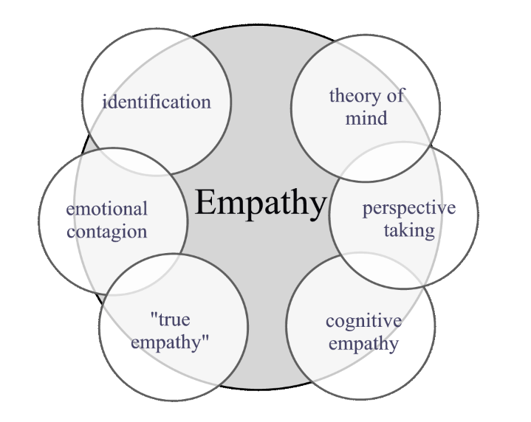

Figure 7: Simulation theory of empathy
(Source: Lee and Madera, 2021)
Simulation theory of empathy is theory, which states that customers feel that they are understood when shown empathy. The idea of the simulation theory of empathy revolves around the fact that brain of a human contains “mirror neurons”, which activates when people are observing and experiencing emotions and actions. As suggested by Lee and Madera (2021), customer centric perspective decrease the negative affect and increased empathy towards customers helps in leading to more customer helping behaviours with deep acting. Regardless of the factors, a customer expects a good customer’s service from Ryanair and the person should be getting that. Ryanair can increase its effectiveness of customer by implementing this theory. Simulation theory of empathy can help the company to understand its customers' problems in detail (Lee and Madera, 2023). Organisation should be implementing this theory for identification of the problems faced by the customer. Ryanair can implement this theory in its customer support team by making them understand this theory. This customer service option should make the customer support more effective and authentic.
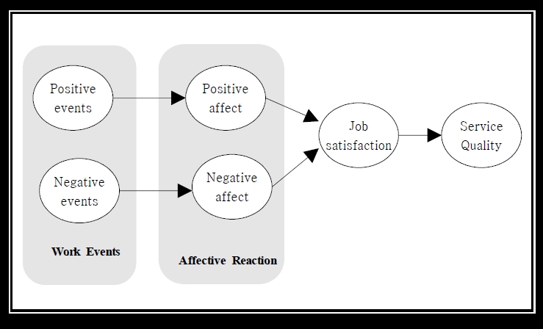

Figure 8: Affect theory
(Source: Guilmette, 2020)
Affect theory is also a customer service theory, which focuses on the subjective and emotions of the customer. As opined by Guilmette (2020), affect theory indicates that affects can be conveyed nonverbally between two people or more. Ryanair should implement this theory in its customer service for an effective customer support team. Smaller actions like picking up the phone quickly, paying utmost attention to the emails and observing small courtesies can improve the customer service as per the theory. Appropriate usage of punctuation and facilitating customer requests can be a good way to enhance the customer service of Ryanair. This theory could be enhancing the customer service of Ryanair with effective implementation in the customer support team.
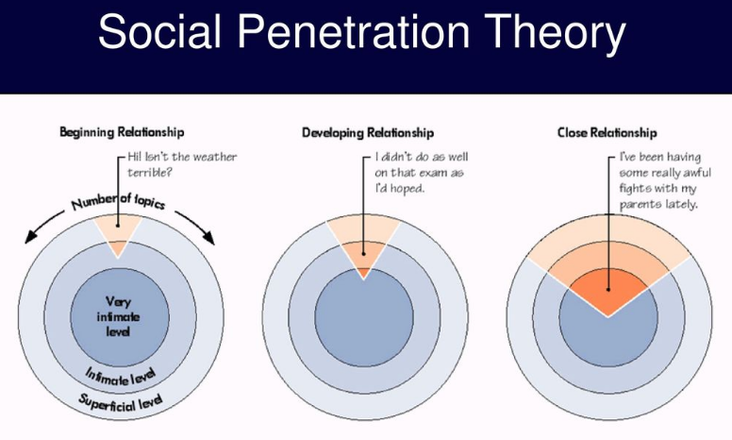

Figure 9: Social penetration theory
(Source: Maldonado, 2021)
It can be recommended that social penetration theory can be helpful for enhancing the customer service team of Ryanair. Social penetration theory states if the company wants to create a long lasting relationship with the customers, then it is essential for the team to understand this theory. As per Mudondo (2021), when both the parties are mutually benefited from a transaction of service then a relationship is created. This theory could be helpful for Ryanair in making valuable relationships with the customer for the future. Creating trust and relationship with the customers helps in creating long time revenue from a customer. This theory should be implemented in the support team of Ryanair through various training sessions for a better implementation. In order to implement this theory, the support must understand it effectively. Development of this theory should help the firm in retaining customers and help in adding a sense of cooperation with all interaction with the customers.
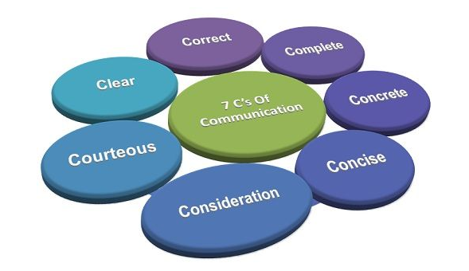

Figure 10: Seven C’s of communication
(Source: Nurullayevna, 2020)
Seven C’s communication is a type of checklist, which helps people in improving the accuracy and quality of the communication in customer service. It helps people in giving the ability to convey their ideas properly and reduces the confusion. As mentioned by Nurullayevna (2020), communication essential in it has an impact on the recipient’s interpretation of the message conveyed. Seven C’s of communication consists of correct, complete, concrete, concise, consideration, courteous and clear communication. In order to improve the quality and accuracy of the customer support of Ryanair PLC these seven C’s should be implemented in the communication skills of customer executives. Training programs should be implemented in the customer support team by exports so that they can perform these effectively. Effective implementation of communication can help the company to achieve the mitigation of the issues that arise in the customer service management (Zorlu and Korkmaz, 2023). This model says that all the messages that are conveyed by the customer support executive should be respectful and polite. Communication should always be easy to understand and clear by the customer support executive of Ryanair.
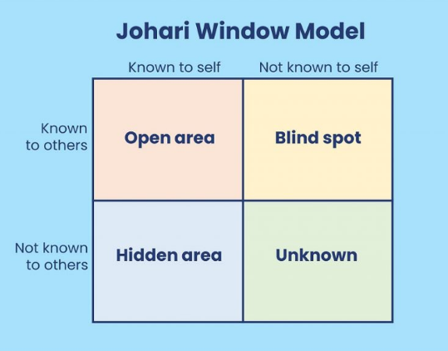

Figure 11: Johari window model
(Source: Nurullayevna, 2020)
Johari window model is a strategic tool that is used for improving personal development and self-awareness between people in a group. As mentioned by Osmanoğlu (2019), Johari window model is a technique which supports the creation of relations, eliminating issues that arise in the communication process. There are four boxes in Johari window model, which are open area, blind spot, hidden area and unknown. Open area of the model suggest that these things are known by both customer and customer executive, whereas hidden area is the issue that is only known by customer. Blind spot and unknown are the information that is not known by the customer also a big part of the effective customer support is to know when to ask for the feedback from customers. Feedback of customers is essential and valuable which helps businesses to learn more about the ways their own services are perceived by customers (Alzoubi et al., 2022). This model can help Ryanair identify the issues in their customer service by taking feedback from its customers.
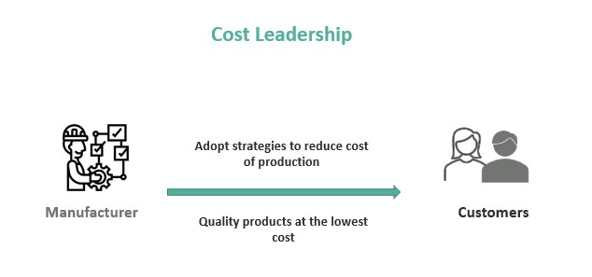

Figure 12: Cost leadership strategy
(Source: Cescon , 2019)
Cost leadership strategy helps a company to maintain its costs\ of production or service and offers the correct price for customers to buy. As mentioned by Cescon (2019), cost leadership strategy offers a strategy that lowers the cost of operations and helps to increase profitability. Ryanair can benefit from this as it was facing issues after COVID-`19 with its revenue earning structure. Customer service of Ryanair can enhance its function by letting people know about this feature of low priced flights. This can help in increasing customers for the company. As flights get higher at the seasonal times, implementation of this strategy can help the firm to get optimum sales.
Social penetration theory is recommended for Ryanair Holding PLC as it can help the company to have long lasting relationships by maintaining all the necessary factors. These factors can be such as clear communication, mitigating issues of the customers and showing empathy. It covers all the necessary factors needed for improvement of customer service. A

5. Conclusion
It can be concluded that Ryanair Holdings PLC has been ineffective with its customer service to the customers. Purpose of the report has been illustrated in this report with the background of the company. Definition of significant concepts is elaborate in this report with the strategy, business level strategy and competitive advantage. External analysis has been done with PESTLE analysis. The study has highlights that, the stable political circumstances have helped this organisation to increase its profitability and brand value in the international platform. In this context, the study has also concluded the definition strategy business level strategy and competitive advantage. Moreover, internal analysis has been done with SWOT analysis framework. Strategic options like constructivist theory strategy and cost leadership strategy has been discussed in this report. Strategic options are recommended for the company for a better customer service approach by Ryanair.

Reference List
aljazeera.com, (2023), About employee strikes, Available at: https://www.aljazeera.com/news/2022/12/30/ryanair-cabin-crews-strike-in-belgium-dozens-of-flights-grounded [Accessed on:5 July 2023]
Alzoubi, H., Alshurideh, M., Kurdi, B., Akour, I. and Aziz, R., (2022). Does BLE technology contribute towards improving marketing strategies, customers’ satisfaction and loyalty? The role of open innovation. International Journal of Data and Network Science, 6(2), pp.449-460.
bbc.com, (2023), About customer dissatisfaction survey, Available at: https://www.bbc.com/news/business-49433807[Accessed on: 5 July 2023]
bbc.com, (2023), About customer satisfaction, Available at: https://www.bbc.com/news/business-49433807 [Accessed on: 1 July 2023]
bbc.com, (2023), About CEO’s controversial speech, Available at: https://www.bbc.com/news/business-52394433 [Accessed on: 9 July 2023]
bnnbloomberg.ca, (2023), About loan from UK government, Available at:https://www.bnnbloomberg.ca/ryanair-taps-u-k-loan-program-as-it-digs-in-for-slow-recovery-1.1437669 [Accessed on: 8 July 2023]
Cescon, F., Costantini, A. and Grassetti, L., (2019). Strategic choices and strategic management accounting in large manufacturing firms. Journal of Management and Governance, 23(3), pp.605-636.
corporate.ryanair.com, (2023), About Ryanair investment in aircrafts, Available at: https://corporate.ryanair.com/about-us/our-fleet/ [Accessed on: 7 July 2023]
corporate.ryanair.com, (2023), About sustainable approach, Available at: https://corporate.ryanair.com/sustainability/ [Accessed on: 1 July 2023]
Corporate.ryanair.com, (2023)Our customer growth Available at: https://corporate.ryanair.com/sustainability/ [Accessed on: 6 July 2023]
corporate.ryanair.com, (2023), About providing lowest fares in Europe, Available at: https://corporate.ryanair.com/#:~:text=Ryanair%20Holdings%20plc%20is%20Europe's,the%20lowest%20fares%20in%20Europe. [Accessed on: 1 July 2023]
El Khatib, M., Al Mulla, A. and Al Ketbi, W., (2022). The Role of Blockchain in E-Governance and Decision-Making in Project and Program Management. Advances in Internet of Things, 12(3), pp.88-109.
euronews.com, (2023), About Ryanair cabin crew strike in Spain, Available at: https://www.euronews.com/travel/2022/08/09/ryanair-strikes-unions-in-spain-call-for-a-five-month-walk-out-starting-in-august[Accessed on: 6 July 2023]
forbes.com, (2023), About competitor of Ryanair. Available at: https://www.forbes.com/sites/jeroenkraaijenbrink/2019/02/01/easyjet-vs-ryanair-how-low-can-low-cost-go/?sh=6561b39f696a[Accessed on: 6 July 2023]
Forbes.com, (2023) Ryanair-holdings Available at: https://www.forbes.com/companies/ryanair-holdings/?sh=38109eba74b0 [Accessed on: 6 July 2023]
Gellweiler, C. and Krishnamurthi, L., (2022). IT business value and competitive advantage: Integrating a customer-based view. Information Systems Management, 39(4), pp.363-385.
Gov.uk, (2023) HMRC tax receipts and National Insurance contributions ... Available at: https://www.gov.uk/government/statistics/hmrc-tax-and-nics-receipts-for-the-uk/hmrc-tax-receipts-and-national-insurance-contributions-for-the-uk-new-annual-bulletin [Accessed on: 6 July 2023]
Gov.uk, (2023) Income and wealth - Office for National Statistics Available at: https://www.ons.gov.uk/peoplepopulationandcommunity/personalandhouseholdfinances/incomeandwealth [Accessed on: 6 July 2023]
Gov.uk, (2023) Income Tax rates and Personal Allowances Available at: https://www.gov.uk/income-tax-rates [Accessed on: 6 July 2023]
Gov.uk, (2023) Recognising the power of literacy when designing services Available at: https://defradigital.blog.gov.uk/2022/09/21/recognising-the-power-of-literacy-when-designing-services/ [Accessed on: 6 July 2023]
Gov.uk, (2023) Technology - great.gov.uk international Available at: https://www.great.gov.uk/international/content/investment/sectors/technology/#:~:text=The%20UK%20is%20a%20powerhouse,of%20almost%20%C2%A31.47%20billion. [Accessed on: 6 July 2023]
Gov.uk, (2023) UK tech sector retains #1 spot in Europe and #3 in world as sector resilience brings continued growth Available at: https://www.gov.uk/government/news/uk-tech-sector-retains-1-spot-in-europe-and-3-in-world-as-sector-resilience-brings-continued-growth[Accessed on: 6 July 2023]
Guilmette, L., (2020). Expression, animation, and intelligibility: Concepts for a decolonial feminist affect theory. The Journal of Speculative Philosophy, 34(3), pp.309-322
Harland, F., Stewart, G. and Bruce, C., (2019). Leading the academic library in strategic engagement with stakeholders: A constructivist grounded theory. College and Research Libraries, 80, pp.319-339.
investor.ryanair.com, (2023), About annual revenue, Available at: https://investor.ryanair.com/wp-content/uploads/2022/07/Ryanair-2022-Annual-Report.pdf [Accessed on:4 July 2023]
Jahanbakhsh Javid, N. and Amini, M., (2023). Evaluating the effect of supply chain management practice on implementation of halal agroindustry and competitive advantage for small and medium enterprises. International Journal of Computer Science and Information Technology, 15((2023)), pp.8997-9008.
Khamaksorn, A., Nimmolrat, A., Mahat, N. and Thinnukool, O., (2023). An IDEF0 Functional Planning Model for the Development of an Asset Management Framework: A Case Study of Chiang Mai University. Journal of Construction in Developing Countries, 28(1), pp.133-150.
Lee, L. and Madera, J.M., (2021). A within-level analysis of the effect of customer-focused perspective-taking on deep acting and customer helping behaviors: The mediating roles of negative affect and empathy. International Journal of Hospitality Management, 95, p.102907.
Mudondo, C.D., (2021). Social media marketing and bank customers’ behaviour: conceptualizing a relationship model. Turkish Journal of Computer and Mathematics Education (TURCOMAT), 12(2), pp.1955-1972..
Ngoc, N.M., Tien, N.H. and Hieu, V.M., (2023). Enhancing efficiency of real estate brokerage activities in Vietnam. International journal of business and globalisation.
Nurullayevna, S.N., (2020). The key of effective communication is pronunciation. European Journal of Humanities and Educational Advancements, 1(4), pp.5-7.
ons.gov.uk , (2023), About inflation rate. Available at: https://www.ons.gov.uk/economy/inflationandpriceindices/bulletins/consumerpriceinflation/may2023#:~:text=The%20CPIH%20inflation%20rate%20is,down%20from%2010.0%25%20in%20April. [Accessed on: 3 July 2023]
Ons.gov.uk, (2023) Gross Domestic Product (GDP) Available at: https://www.ons.gov.uk/economy/grossdomesticproductgdp [Accessed on: 6 July 2023]
Ons.gov.uk, (2023) Consumer price inflation, UK: May 2023 Available at: https://www.ons.gov.uk/economy/inflationandpriceindices/bulletins/consumerpriceinflation/may2023#:~:text=The%20CPIH%20inflation%20rate%20is,down%20from%2010.0%25%20in%20April. [Accessed on: 6 July 2023]
Ons.gov.uk, (2023) Gross Domestic Product (GDP) - Office for National Statistics Available at: https://www.ons.gov.uk/economy/grossdomesticproductgdp [Accessed on: 6 July 2023]
Osmanoğlu, D.E., (2019). Expansion of the open area (Johari Window) and group work directed to enhancing the level of subjective well-being. Journal of Education and Training Studies, 7(5), pp.76-85.
QUADRI, S.S.A., SABIR, M., QAISRANI, F.A., MANJ, M.S., HUSSAIN, M. and SHAH, H.M., (2023). PEACE AND CONFLICT RESOLUTION IN THE LIGHT OF ISLAMIC CONTEXT AND SOLUTION OF CURRENT POLITICAL TURMOIL IN PAKISTAN. Russian Law Journal, 11(1), pp.115-121.
Statista.com, (2022) Annual revenue of Ryanair from 2010 to (2022) Available at: https://www.statista.com/statistics/756060/ryanair-annual-revenue/ [Accessed on: 6 July 2023]
Statista.com, (2022) Ryanair: number of employees by type 2022 Available at: https://www.statista.com/statistics/1038876/ryanair-employement-figures-by-type/ [Accessed on: 6 July 2023]
Taris, G.N. and Wandebori, H., (2023). Proposed Business Strategy to Gain a Competitive Advantage for Construction Consultant Company. Int. J. Curr. Sci. Res. Rev, 6, pp.238-244.
Theglobaleconomy.com, (2023) Political stability index - Country rankings - The Global Economy Available at: https://www.theglobaleconomy.com/rankings/wb_political_stability/ [Accessed on: 6 July 2023]
Theglobaleconomy.com, (2023) United Kingdom Economic Indicators main indicators Available at: https://www.theglobaleconomy.com/United-Kingdom/ [Accessed on: 6 July 2023]
Trivedi, K. and Srivastava, K.B., (2022). The role of knowledge management processes in leveraging competitive strategies to achieve firm innovativeness. The Bottom Line, 35(2/3), pp.53-72.
Xie, Z., Liu, X., Najam, H., Fu, Q., Abbas, J., Comite, U., Cismas, L.M. and Miculescu, A., (2022). Achieving financial sustainability through revenue diversification: A green pathway for financial institutions in Asia. Sustainability, 14(6), p.3512.
Yasir, M., Zafar, A. and Wajid, M.A., (2023). NEP-2020's Implementation & Execution: A Study Conducted Using Neutrosophic PESTEL Analysis. International Journal of Neutrosophic Science (IJNS), 20(2).
Yuningsih, E., Harini, S. and Silaningsih, E., (2022). Strategy for Improving MSMEs Performance Through Stakeholder Involvement. Indonesian Journal of Business Analytics, 2(1), pp.25-40.
Zambrano Farías, F.J., Martínez, M.D.C.V. and Martín-Cervantes, P.A., (2022). Profitability determinants of the natural stone industry: Evidence from Spain and Italy. Plos one, 17(12), p.e0276885.
Zhang, L. and Ponomarenko, T., (2023). Directions for Sustainable Development of China’s Coal Industry in the Post-Epidemic Era. Sustainability, 15(8), p.6518.
Zorlu, K. and Korkmaz, F., (2021). Organizational communication as an effective communication strategy in organizations and the role of the leader. In Management Strategies to Survive in a Competitive Environment: How to Improve Company Performance (pp. 305-320). Cham: Springer International Publishing.

Appendices
Appendix 1: Company background
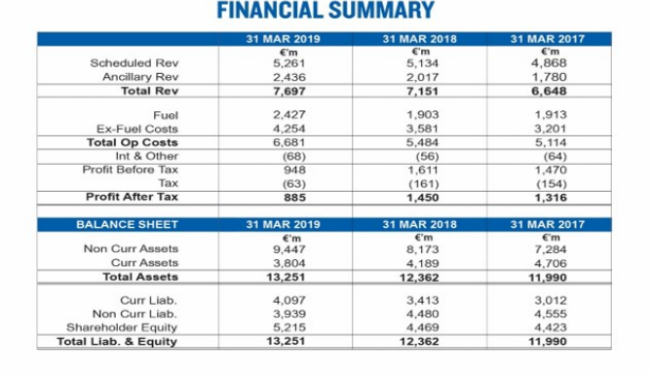(Source: https://investor.ryanair.com/wp-content/uploads/2019/07/Ryanair-2019-Annual-Report.pdf)

